#=============================================================================

#

# Flight Mechanics Analysis Tools Interoperability and Component Sharing (TI-18-01313)

#

# Monte-Copernicus Interface: Use Case 3.2, Copernicus as a trajectory Visualization tool

#

# By: Ricardo L. Restrepo (ricardo.l.restrepo@jpl.nasa.gov)

#

#=============================================================================

Use Case 3.2: Copernicus as a Trajectory Visualization Tool.

monteCop Script to be used: bsp2visualCop.py

Problem Description: This use case represents the SPK to Copernicus data transfer scenario where complex trajectories developed in Monte or any other tool, are visualized in Copernicus. The python script used to generate trajectory visualizations in Copernicus from SPK kernels is called bsp2visualCop.py. The script follows the trajectory recovery process outlined in the previous section. Here, the trajectory contained in the SPK kernel is loaded into Copernicus as an ephemeris file and a segment attached to it as a “static point trajectory” is used for visualization purposes (no optimization is applied here). The python function call requires as input the SPK kernel (.bsp) file. Optional argument inputs, as the spacecraft ID, the central body, the frame to visualize the trajectory are possible. For more complex trajectory visualizations, an optional JSON input file can be passed to the function call to generate a more personalized output with specific frames, central body, number of segments, colors, etc.

Procedure: The steps taken for this use case are to 1) ingest the MONTE generated SPK 2) update the supplement JSON config to setup visualization (optional) 3) scan the file an generate ideck, 4) ingest the ideck file and visualize the trajectory as desired.

Input options :: -sc: spacecraft ID, -c: Center, -f: Frame, -to: Time offset (days) , -tl: Timeline (days), -bl: Body List, -co: color, config.json [optional].

Examples, script calls:

a) >> bsp2visualCop.py lrorg_2009169_2010001_v01.bsp -sc -85

b) >> bsp2visualCop.py lrorg_2009169_2010001_v01.bsp -sc -85 -tl 10 -c Moon -f iau_body_fixed

c) >> bsp2visualCop.py leo_to_nrho.bsp -sc -30100 -c Moon -f iau_body_fixed

d) >> bsp2visualCop.py Voyager_2_m05016u_merged.bsp -sc -32 -c Sun -bl Sun Earth Mars Jupiter Saturn Uranus Neptune -tl 4500 -co cyan

e) >> bsp2visualCop.py 170509AP_SK_17118_17258.bsp -sc -82 -c Ssaturn -bl Saturn Titan -co cyan

f) >> bsp2visualCop.py 21F31_MEGA_L241010_A300411_LP01_V5_pad_scpse.bsp -sc -159 -c Jupiter -bl Jupiter Europa Io Ganymede -co blue -f j2000

Outputs:

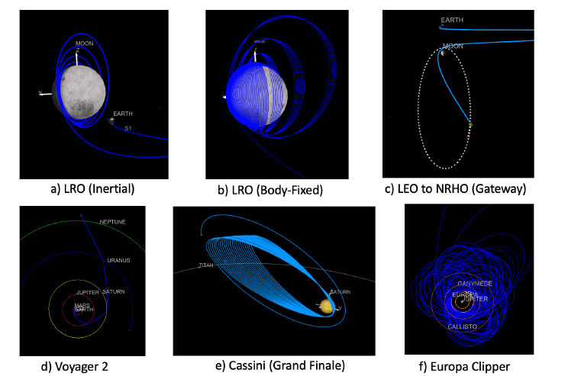

The Figure shows six trajectory examples of past, current, and future missions visualized in Copernicus

by using the function calls shown above. The SPK files for these trajectories have been obtained

from the NAIF website*. Figure 5(a) and (b) show Lunar Reconnaissance Orbiter’s (LRO)† trajectory

in inertial and body-fixed frame, respectively. Figure 5(c) shows a transfer from low-Earth

orbit (LEO) to a near rectilinear halo orbit (NRHO) at the Moon, similar to Gateway’s mission. Figure

5(d) shows Voyager’s 2‡ trajectory, (e) Cassini’s Grand FinaleÅò, and (f) Europa Clipper’s moon

Tour.

*https://naif.jpl.nasa.gov/naif/data_operational.html

†https://lunar.gsfc.nasa.gov/

‡https://solarsystem.nasa.gov/missions/voyager-2/in-depth/

Åòhttps://www.nasa.gov/mission_pages/cassini/main/index.html

Å˜https://europa.nasa.gov/

**Note: A detailed description of a Use Case, using a Windows machine while accessing the MONTE toolkit through a Docker Container, can be found at: *‘/monteCop/doc/NESC_tool_test_summary.docx’*