XML File Formats
The MDMS Komodo client and server applications use XML files to store configuration information. This information is validated via XML schema and parsed using the Document Object Model (DOM).

KomodoDbStmts
The following diagram illustrates the structure of the Database Management System (DBMS) specific configuration XML file.
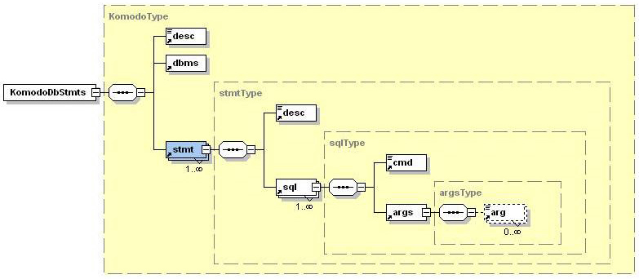

Each DBMS will need to create an XML configuration file using this structure. The document element is <KomodoDbStmts>, which should reference the KomodoDbStmts.xsd schema file.

Element Name | Attributes | Description
<desc> | None | Simple textual description of configuration file or DBMS statement.
<dbms> | name (required),  version (required) | DBMS identification information, name attribute should be ‘Sybase’ or ‘Oracle’, version attribute should be a float like ’12.5’ or ‘9.0’.
<stmt> | name (required),  supported (optional) | DBMS specific statement, name attribute should be in the form ‘db.stmt.StatementName’, supported attribute should be ‘yes’ or ‘no’.
<sql> | None | SQL code used to implement the DBMS statement. A statement can have multiple SQL commands, which is useful for DBMS that don’t support stored procedures.
<cmd> | None | The SQL command minus arguments.
<args> | None | SQL command arguments are contained within this element. This element must exist in the XML file even if the command doesn’t have arguments.
<arg> | optional (optional) | SQL command argument will have a one to one relationship with this tag. The optional attribute should be ‘yes’ or ‘no’. The data contained within this tag should be ‘string’, ‘numeral’ or ‘bit’.

KomodoHelp
The following diagram illustrates the structure of the Komodo client help information XML file.
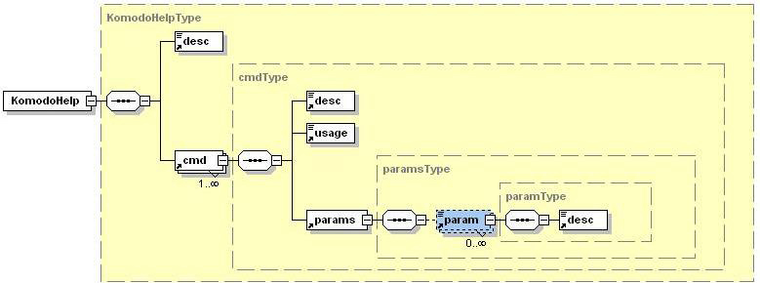

The document element is <KomodoHelp>, which should reference the clienthelp.xsd schema file.

Element Name | Attributes | Description
<desc> | None | Simple textual description of configuration file, help command or command parameter.
<cmd> | name (required),  type (required),  alt (optional),  see_also (optional),  shortcut (optional) | Help information for a Komodo client command, name attribute should be command name, type attribute should be ‘settings’, ‘utility’, ‘filetype’, ‘vft’ or ‘admin’, alt attribute should be an alternate name for command, see_also attribute should reference other commands, shortcut attribute should be a shortcut character like ‘a’ for ‘add’.
<usage> | None | Komodo command usage statement.
<params> | None | Komodo command parameters are contained within this element. This element must exist in the XML file even if the command doesn’t have parameters.
<param> | name (required),  alt (optional) | Komodo command parameter will have a one to one relationship with this tag. The name attribute should be the parameter name, the alt attribute should be an alternate parameter.

