mmacos Manual

MATLAB and MACOS with an AI Assistant
Draft — October 2026
Jet Propulsion Laboratory, California Institute of Technology

Contact
For information on MACOS contact:
Scott Basinger Scott.A.Basinger@jpl.nasa.gov
Jet Propulsion Laboratory 306-438, 4800 Oak Grove Drive, Pasadena CA 91109

Authorship
David C. Redding, Scott Basinger, John Lou, Luis Marchen, Laura Needels, Carl Nissly, Norbert Sigrist and Sam Sirlin

Acknowledgment
The MACOS program was developed at the Jet Propulsion Laboratory, California Institute of Technology.
MACOS software and documentation are copyright 1992-2026 by the California Institute of Technology, Jet Propulsion Laboratory.
U.S. Government sponsorship of parts of MACOS under NASA Contract NAS7-918 is acknowledged.

Installation
mmacos is the MATLAB interface to the MACOS engine. It lives in the MACOS_resources repository beside the engine’s macos repository; build the gfortran engine first (the MACOS Manual, Installation: source ./makems.sh release gfortran), then the interface (mmacos/README.md, Build):
cd MACOS_resources/mmacos
make # the mex, linked against ../macos/build_release_gfortran
./run_mmacos_tests.sh fast # the fast suite
and in MATLAB, once per session:
run('<path-to>/MACOS_resources/mmacos/mmacos_setup.m');

How this manual is made
Every listing, figure and quoted number in this manual is generated: each chapter has a driver (docs/mmacos-manual/tools/transcripts/<chapter>.m) that runs the template the chapter narrates, unchanged, in a scratch directory, and make transcripts writes what it printed and drew into the chapter. A quoted number is pinned (five significant figures on a signal, a bound on a numerical zero), so a change in the engine or a template that moves a number stops the build until the number is re-pinned on purpose. Each chapter speaks in three voices: You ask (the request a user gives the assistant), The assistant reads (the files it reads before it acts, as paths you can hand to any assistant) and It runs (the template, its output, its figures, its numbers).

Contents
(contents -- update the field)

INTRODUCTION
This manual is written for an optical engineer who works with an AI assistant. The assistant types; you decide. Every example in the book is a request you could give the assistant today, followed by what a competent assistant does with it and what came out when it did. Nothing here is a mock-up: the listings, figures and numbers were produced by running the library, and the build stops if a number moves (the front matter, How this manual is made).

The three voices
Each worked example is told in three voices, always in the same order.
- You ask is the request, in the words a user would type. It carries the numbers that matter (aperture, f-number, field, wavelength, a contrast floor) and nothing about how to get there. Treat it as a template for your own request: change the numbers, keep the shape.
- The assistant reads is the list of files the assistant opens before it acts. They are paths in the two repositories (macos, MACOS_resources), so the list is portable: hand it to any assistant and it starts from the same ground. The list is also the manual’s answer to “where is that written down?”
- It runs is what the assistant ran, unchanged, and what it printed and drew. The gray listings are the console output of that run; the figures are the files it wrote; a number in the prose is pinned to the run that produced it.

What the library holds
Part I follows one large segmented telescope, but the library is wider than that thread, and most requests will start from one of its other templates (Part II, in the order of templates/00_INDEX.md).
- Telescopes of several types and sizes: two-mirror Ritchey-Chrétien designers, on-axis and unobscured off-axis; a wide-field two-mirror freeform; three-mirror anastigmats on-axis, off-axis, centered-and-folded, freeform, and sphere-plus-Zernike; the 3+1 coronagraph front end with its pupil relay; the long-slit front end for a slit-fed spectrometer; an offset-field wide-field imager; and afocal telescopes with a controlled interface pupil (the challenges). Each designer takes an aperture, f-numbers and a field and returns a prescription, its first-order properties, and a layout.
- Spectrometers and relays: the concentric Offner relay, used in Section 2 as the telescope’s instrument relay and available from the design layer (offner_layout); the concentric Dyson imaging spectrometer, seeded in closed form and verified by trace (dyson_layout, dyson_scaling, the spectrometer_* scoring chain) and worked through as the dyson5 challenge; and the long-slit TMA page that feeds either one.
- Coronagraphs: the coronagraph testbed bench, a walkthrough, planet injection, and the end-to-end 6 m coronagraph flows.
- Benches and gauges: a Twyman-Green interferometer with phase-shifting data reduction, bench layout and optimization, and the deformable-mirror gauge campaigns against one DM truth: the phase-shifting gauge and its all-reflective variant, the Zernike wavefront sensor, the point-diffraction gauges, and the heterodyne camera interferometer.
- Segmentation, sensitivities, metrology, control and budgets: segmented primaries with physical apertures and edge sensors, the sensitivity harvest, laser metrology, closing the loop, and the error-budget tool, each a template as well as a section of Part I.
- Polarization: ray-level Jones scoring on a bench and the polarization-aware gauges.
One thing the catalog does not yet hold is a refractive design template. Lenses appear only as ideal lenses (ideal_lens) and as single real elements on the benches (collimators, plates, the cube). Lens design is the next addition to the library.

How to use the manual
- To learn the library, read Part I in order. Its eight sections follow one 4 m telescope from a sketch to an error budget, and each section consumes the one before, so the thread shows how the pieces fit: the design layer, the instruments, segmentation, sensitivities, metrology, the control loop, the budget, and the coronagraph.
- To get something done, go to Part II. It is the template catalog, one page per template in the order of templates/00_INDEX.md. Find the page nearest to what you need, paste its closing request to your assistant with your numbers in it, and compare what comes back with the page.
- To check what the assistant did, use the pinned numbers. A number printed in this manual is what the engine measured when the page was built. If your run prints a different one on the same inputs, something changed, and the assistant should be able to say what.
- To find the rules, go to Part III. It points to the references that live beside the code, the design rules and agent guides, the library’s own record, and the engine’s manual, and it has the one chapter written for the assistant rather than for you.

Getting started, step by step
If you have not worked with an AI assistant before, this is the mechanical part. It takes an afternoon the first time and a minute after that.
- Get the code. Clone the two repositories side by side, so that macos/ and MACOS_resources/ share a parent directory; the build scripts and the library find each other by that relative path. Your administrator has the repository addresses and the branch to use.
- Build the engine, then the interface. Follow Installation in the front matter: build the gfortran engine in macos/, then make in MACOS_resources/mmacos/, then run the fast test suite once. A green suite is your proof that the installation works before the assistant touches anything.
- Start MATLAB and run the setup script (mmacos_setup.m, once per session). Type macos.init(128) and then help macos.trace; if both answer, MATLAB sees the engine.
- Open a terminal in the parent directory of the two repositories and start your assistant there. With Claude Code, that is the command claude; in VS Code, open the parent directory as the workspace and open the assistant’s panel; other assistants have their own command. The directory you start in matters: the assistant reads the CLAUDE.md files it finds there (macos/CLAUDE.md, macos/macos_f90/CLAUDE.md, MACOS_resources/mmacos/CLAUDE.md), and those files carry the working rules that this manual’s examples relied on.
- Point the assistant at this manual. Its sources are macos/docs/mmacos-manual/src/*.md, one file per section, and the built copy is macos/docs/mmacos-manual/build/mmacosMan.docx. A first request can be as plain as: Read docs/mmacos-manual/src/00b_introduction.md and src/01_telescope.md, then tell me what you would do with the request in Section 1.
- Make your first request from a page in this book. Copy a You ask paragraph, put your own numbers in it, and send it. Ask the assistant to list the files it will read before it acts; if that list looks like the page’s The assistant reads, you are on the same footing the manual was written from.
- Check the result against the page. Compare what the assistant printed and drew with the page’s It runs. The same template on the same inputs prints the same pinned numbers; a difference is something to ask about, not something to accept.
- Keep MATLAB open. The assistant runs MATLAB for you in batch mode, but the figures, the .mat workspaces and the .in prescriptions it writes are ordinary files beside the template; open them yourself whenever you want to look for yourself.

What to expect from the assistant
A good assistant reads before it writes, runs a template before it writes a script, and reports the numbers it measured rather than the numbers it expected. When it changes an optical rule it reads the reference first; when a check fails it says so, with the output. The requests in this manual were answered that way, and the reading lists under The assistant reads are the shortest route to getting the same from yours.

SECTION 1: A Telescope
Part I follows one telescope from a sketch to an error budget: the e2e flow of the template library (MACOS_resources/mmacos/templates/80_end_to_end/e2e), a 4 m, f/18 folded Korsch three-mirror anastigmat (TMA) at 500 nm, built in seven stages that each consume the one before. This section is the first stage, the telescope. Section 2 adds its instruments, Section 3 segments its primary, Section 4 harvests its sensitivities, Section 5 adds laser metrology, Section 6 closes the loop, and Section 7 hands the error budget to systems engineering.
Each section speaks in three voices. You ask is the request, as a user would type it to the assistant. The assistant reads lists the files the assistant reads before it acts; they are paths in the two repositories, so you can hand the same list to any assistant. It runs is what the assistant runs, with what it printed and drew. Every listing, figure and number below was produced by that run (the front matter, How this manual is made).

1.1 You ask
Design a 4 m visible telescope for me: a three-mirror anastigmat, f/1.75 primary, f/18 overall, with the back end folded behind the primary so the instruments sit on a bench. It should be diffraction-limited over a ±1′ field at 500 nm. Give me the MACOS prescription, its first-order properties and the exit pupil, and show me the layout.

1.2 The assistant reads
- MACOS_resources/mmacos/CLAUDE.md – the mmacos layers, the design layer (+macos/+design/, the Telescope builder) and the gotchas that bite in MATLAB.
- MACOS_resources/optical_design/OPTICAL_DESIGN_AGENT_GUIDE.md – how to use the design reference and its fixtures; the sign and parameterization conventions are fixed, not guessed.
- MACOS_resources/optical_design/TELESCOPE_DESIGN_REFERENCE.md – the closed-form first-order layout and the third-order conditions of the Korsch TMA.
- MACOS_resources/mmacos/templates/00_INDEX.md and MACOS_resources/mmacos/templates/80_end_to_end/e2e/README.md – which template answers the request, and the stage contract (one parameter file; each stage writes its .in, .mat, figures and report beside itself).
- macos/macos_f90/notes/pupil_fex_stop.md – how the engine finds the exit pupil (FEX) and the stop, so the pupil the report names is the one the engine uses.
The request is the e2e flow’s first stage almost word for word, so the assistant does not write a new design script; it runs the template’s, with the request’s numbers in its parameter file. The improved design flow templates/80_end_to_end/e2e2 (a 3 m, f/20 TMA, with stated references and a pupil gate per stage) supersedes this stage as a design example; e2e is the thread here because it carries all seven stages.

1.3 It runs
The knobs are one file, e2e_params.m. Its telescope block, as the run read it:
function P = e2e_params()
%E2E_PARAMS Every user knob of the end-to-end example, in one place.
% The e2e stages (s1_telescope ... s6_simulator) all read THIS file --
% hack it for your system, then re-run the stages in order. Each
% stage consumes the previous stage's saved artifacts, so a knob
% change re-runs from the first stage it affects.
%
% Stage 1 derives the telescope from the BASIC parameters below via
% the first-order solver (macos.design.tma_layout): aperture, both
% f/#s, the Cassegrain-feed magnification and the packaging fractions
% are free inputs. The telescope is an ON-AXIS Korsch TMA taken
% SLIGHTLY OFF-AXIS: the science field is biased just far enough off
% the axis to carry the focal plane out of the beam (the runner
% sweeps the bias and picks the least that clears -- off-axis
% aberration grows ~quadratically with bias, so least is best).
% ================= telescope basics (stage 1) =======================
P.D_m = 4.0; % aperture diameter (m); packaging scales with D
P.lambda_m = 0.5e-6; % design wavelength (m) -- visible telescope
P.fov_arcmin = 1.0; % HALF-field (about the bias) the telescope
% holds; stage 2's imaging instrument pushes
% the corrected field toward P.inst.fov_arcmin
P.primary_fnum = 1.75; % M1 f/# (f1 = fno1*D, R1 = 2*f1)
P.system_fnum = 18; % final f/# at the FP (EFL = fno_sys*D)
P.secondary_mag = 8; % Cassegrain feed magnification m2 (>1).
% Lower mag relaxes M2's curvature (a
% field-aberration source) at the cost of
% a somewhat longer bench; the f/1.25+m2=16
% starting point could not reach VIS blur
% (Dave 2026-07-17: f/1.75, m2=8)
P.int_focus_frac = -0.125; % intermediate-focus z, fraction of D
% (NEGATIVE = in front of M1, between M1
% and M2 -- the field-stop / metrology-
% injection plane stays accessible)
P.m3_behind_frac = 0.6; % M3 vertex z, fraction of D behind M1
P.fold_frac = 0.075; % 90-deg fold (FM) station z, fraction of D
% behind M1: the M2->M3 feed is folded into
% +x there, so M3 and everything after live
% on a flat bench BEHIND M1 (Dave: move the
% back end behind the primary)
P.m3_tilt_deg = 1.2; % EXTRACTION TILT on M3, about the bench
% normal (the builder's tilt axis maps
% there through the fold isometry): the
% M3->FP return leaves the feed axis
% geometrically, so the fold clears WITHOUT
% field bias -- the bias sweep then settles
% near its minimum. (Bias was the VIS
% killer: aberration ~ bias^2.)
P.fold_margin = 1.15; % fold body radius = margin * local feed
% radius. A slim mount: the M3->FP return
% passes the fold body with mm-scale
% daylight at the chosen tilt/bias -- 1.4x
% grazed the clearance judge
P.fp_body_r = 0.075; % focal-plane BODY radius (m) for the
% clearance judge (detector + mount)
P.bias_sweep_arcmin = [1 2 3 4 6]; % off-axis biases to explore; the
% least whose folded design fully CLEARS
% (only M2's central obscuration allowed)
% wins -- aberration grows ~bias^2
P.hole_margin = 1.3; % M1 central hole radius = margin * the
% measured beam radius at the M1 plane
P.hole_min_r_m = 0.232; % FLOOR on the hole radius = the SM radius
% (M2 lMon, see the s2 report): the SM
% shadow obscures this much anyway, and the
% aft MET beams route through the hole to
% the M2 rim fiducials (Dave 2026-07-19).
% ---- freeform refinement on top of the conic solve (the "+FF") -----
P.modes = [3 4 5 9 10 11 12 13 19 20 21 22 23 24 25];
P.ztype = 'BornWolf'; % Zernike ordering for the departure basis
P.max_iters = 150; % CALIB iterations per solve
P.max_iters_ff = 300; % ... for the joint freeform field solve
P.dl_waves = 0.071; % Marechal diffraction-limit bar (waves RMS)
% ---- engine sampling ----------------------------------------------
P.model_size = 256; % stage 1-2 engine model
P.grid_npts = 41; % circular ray-grid points (~1300 rays)
% ================= stage 2: imaging instrument ======================
% A THREE-mirror bench relay behind the telescope focus (M4 weak
% corrector at an intermediate conjugate / M5 collimator / M6 camera,
% unit magnification -> final f/# preserved). Field correction =
% freeform on surfaces at staggered intermediate conjugates; no active
% control in this part of the telescope (Dave 2026-07-17). A 4-mirror
% variant (extra weak corrector near the relayed pupil) was probed and
% conditioned WORSE -- near-pupil weak correctors act common-mode and
% collapse to near-zero field-solve rank.
% The solve is JOINT: M1-M3 keep refining with the instrument.
Then the stage script, unchanged:
run('<path-to>/mmacos/templates/80_end_to_end/e2e/s1_telescope.m')
s1_telescope.m works in eight steps, each printed as it runs: (1) the first-order Korsch layout in closed form from the f-numbers and the feed magnification (macos.design.tma_layout); (2) the 90° fold after the secondary, and a sweep of the off-axis field bias for the least bias at which the folded design clears its own beams – here 2'; (3) a CALIB solve of the three conics at that bias; (4) a freeform refinement, Zernike departures on the three powered mirrors under the sphere-plus-Zernike solve rules; (5) the primary’s central hole sized from the measured beam (0.232 m in radius, the secondary’s shadow as its floor) and the focal plane fitted to a grid of field foci; (6) the standard views and field maps; (7) the prescription saved and reloaded alone as a check; (8) the design report:
==================== DESIGN REPORT ====================
family TMA | D = 4.000 m | lambda = 0.5 um | 7 elements
M1 R = 14.0000 m K = -0.98972 Vpt=[ 0.000 0.000 0.000]
M2 R = 1.6508 m K = -1.51153 Vpt=[ 0.000 0.000 -6.278]
FM Reflector (flat) Vpt=[ 0.000 0.000 0.300]
M3 R = 3.2625 m K = -0.97231 Vpt=[ 2.100 0.000 0.300]
FP_return Return (flat) Vpt=[ -1.628 0.091 0.300]
ExitPupil R = 1.7569 m K = +0.00000 Vpt=[ 0.127 0.014 0.300]
FP FocalPlane (flat) Vpt=[ -1.628 0.091 0.300]
-- first order --
plate-scale EFL at the field point 72.32 m (system EFL 72.14 m) | f/# at M1 1.75 | f/# at FP 18.08
plate scale 350.6 um/arcsec | lambda/D 25.78 mas
-- field performance (RMS WFE about the field center) --
bias +2.0' | field raw -tilt Strehl
center 0.005 0.005 0.999
0.25' ring 0.005 0.004 0.999
0.50' ring 0.006 0.005 0.999
1.00' ring 0.015 0.014 0.992
2.00' ring 0.069 0.065 0.846
(Strehl = far-field peak / unaberrated-aperture peak, exact coherent sum over the
EP-referenced OPD, tilt removed; worst ring point. PSF products: INT at the FP.)
-- focal plane --
FP tilt 0.002 deg wrt the arriving chief ray
aligned from 25 field foci: defocus removed +0.025 mm; field-curvature
sag -1.8 to +1.8 um (rms 1.1 um); best-focus blur 1.40e-07 m (center)
-- exit pupil (add_pupil / FEX) --
1.757 m from the image, at [ 0.127 0.014 0.300] (elt 6)
-- packaging / clearance --
shroud 1.05 x D | train length 6.69 m
clearance: body-in-beam at M2 (FP vs its own pupil-retrace legs excluded)
M1 AOI 0.1 deg (spread 8.0 deg across the beam)
M2 AOI 0.3 deg (spread 9.2 deg across the beam)
FM AOI 45.0 deg (spread 4.1 deg across the beam)
M3 AOI 1.0 deg (spread 0.5 deg across the beam)
=======================================================
-- stage-1 addendum: requested vs achieved --
requested: D 4.00 m | primary f/1.75 | system f/18 | m2 8
first-order: EFL 72.00 m (f/18.00); achieved live EFL 72.32 m (f/18.08)
fold FM at z=+0.300 m -> bench behind M1: M3 [2.10 0.00 0.30], FP [-1.63 0.09 0.30]
bias sweep [1 2 3 4 6]' -> recommended 2' (least whose folded design clears)
conic solve (bias point): K = [-0.98972 -1.51153 -0.97231], 0.0470 waves
freeform: lMon = [2.097 0.219 0.137] m (field-zone), max|coef| = [6.4e-04 9.1e-04 2.4e-03] m
bias point 0.0003 waves (DL); worst-field @ +-1': 0.0138 raw / 0.0137 -tilt waves @ 500 nm
the +-1' spread is the telescope's field differential -- stage 2's instrument widens toward +-2'
M1 hole r 0.232 m | intermediate focus f/14.0 at z=-0.500 m
=======================================================
The report reads top to bottom as the request does: the elements and their conics; the first-order properties; the wavefront error over the field, in waves at 500 nm, with tilt removed and as a Strehl ratio, ring by ring; the focal plane; the exit pupil; the packaging. The ±1′ ring is the request’s field, and it is diffraction-limited (the bar is 0.071 waves, Maréchal). The 2′ ring is there because Section 2 widens the field.
The layout, from macos.view_std:
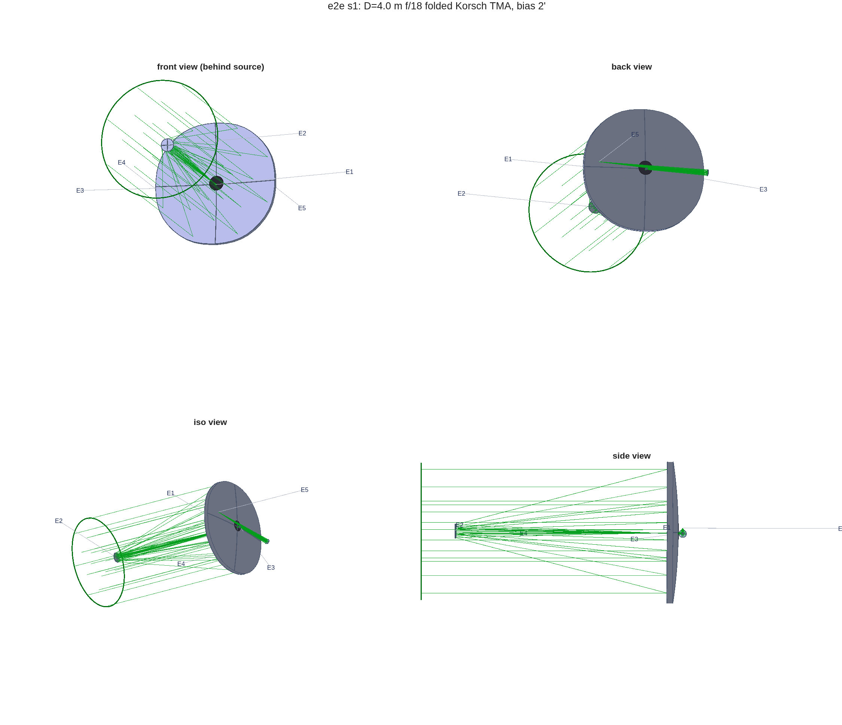
FIGURE 1 The e2e telescope, front, back, isometric and side views (macos.view_std; the elements are labeled by number, E1 the primary with its central hole).
and the wavefront error over the field, the request’s ±1′:
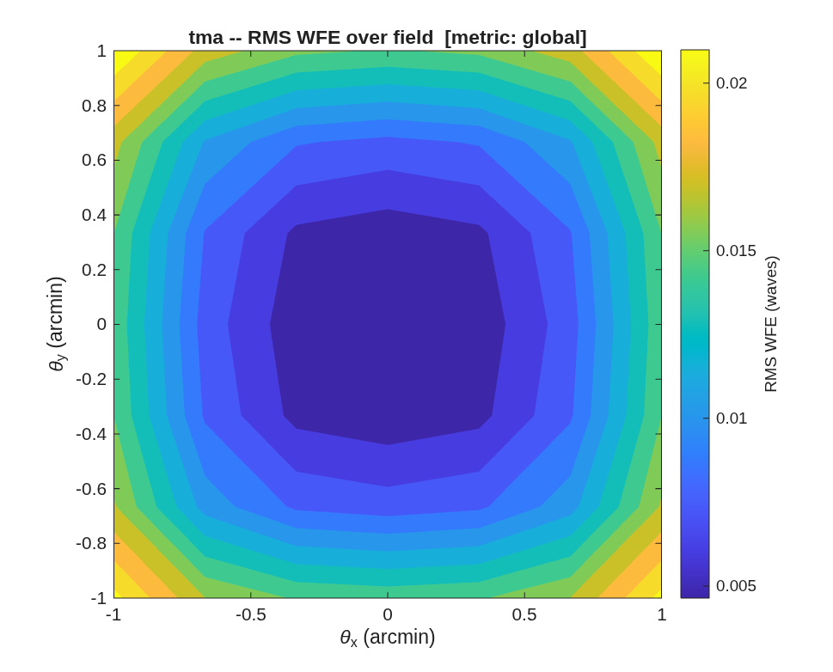
FIGURE 2 RMS wavefront error over the ±1′ field (waves at 500 nm).

1.4 Checking the assistant’s work
The deliverable is the prescription s1_telescope.in; everything else in the run is evidence for it. Its source block and first element, as emitted by the design layer:
% MACOS prescription emitted by macos.design.Telescope (family=tma)
% Source Definition
ChfRayDir= 0.0000000000000000E+00 5.8177638451306754E-04 9.9999983076810495E-01
ChfRayPos= 0.0000000000000000E+00 -4.2340392428451027E-03 -7.2777765461456525E+00
zSource=1.0E+22
BaseUnits= m
WaveUnits= m
IndRef=1.0E+00
Extinc=0.0E+00
Wavelen=4.9999999999999998E-07
Flux=1.0E+00
Aperture=4.0000000000000000E+00
Obscratn=0.0E+00
ApStop= 0.0000000000000000E+00 0.0000000000000000E+00 0.0000000000000000E+00
GridType= Circular
nGridpts= 41
xGrid= 1.0000000000000000E+00 0.0000000000000000E+00 0.0000000000000000E+00
yGrid= 0.0000000000000000E+00 1.0000000000000000E+00 0.0000000000000000E+00
% Element Definitions
nElt= 7
iElt= 1
EltName= M1
Element= Reflector
Surface= Zernike
KrElt=-1.4000000000000000E+01
KcElt=-9.8971605167789212E-01
ZernType= BornWolf
nZernCoef= 15
ZernModes= 3 4 5 9 10 11 12 13 19 20 21 22 23 24 25
ZernCoef= 6.4431975367695209E-04 7.4600106123688586E-07 -5.0514386970317090E-07 6.1012924541100985E-06 1.1438167037609406E-06 5.0606512881737867E-08
5.4187184606531805E-08 -2.4537671610924675E-07 1.4201268991860195E-09 -1.2300086226316243E-09 1.9497834469989603E-09 2.0535569999955563E-09
7.2147094256077966E-09 -4.2015179492566545E-09 -8.1340574006937009E-10
lMon=2.0966004407961263E+00
pMon= 0.0000000000000000E+00 0.0000000000000000E+00 0.0000000000000000E+00
xMon= -1.0000000000000000E+00 0.0000000000000000E+00 0.0000000000000000E+00
yMon= 0.0000000000000000E+00 1.0000000000000000E+00 0.0000000000000000E+00
zMon= 0.0000000000000000E+00 0.0000000000000000E+00 -1.0000000000000000E+00
psiElt= 0.0000000000000000E+00 0.0000000000000000E+00 -1.0000000000000000E+00
VptElt= 0.0000000000000000E+00 0.0000000000000000E+00 0.0000000000000000E+00
RptElt= 0.0000000000000000E+00 0.0000000000000000E+00 0.0000000000000000E+00
IndRef=1.0E+00
Extinc=0.0E+00
nObs= 1
ObsType= Circle
ObsVec= 2.3200000000000001E-01 0.0000000000000000E+00 0.0000000000000000E+00
ApType= None
PropType= Geometric
zElt=6.2777777777777777E+00
nECoord= 6
TElt= -1.0000000000000000E+00 0.0000000000000000E+00 0.0000000000000000E+00 0.0000000000000000E+00 0.0000000000000000E+00 0.0000000000000000E+00
0.0000000000000000E+00 1.0000000000000000E+00 0.0000000000000000E+00 0.0000000000000000E+00 0.0000000000000000E+00 0.0000000000000000E+00
0.0000000000000000E+00 0.0000000000000000E+00 -1.0000000000000000E+00 0.0000000000000000E+00 0.0000000000000000E+00 0.0000000000000000E+00
0.0000000000000000E+00 0.0000000000000000E+00 0.0000000000000000E+00 -1.0000000000000000E+00 0.0000000000000000E+00 0.0000000000000000E+00
0.0000000000000000E+00 0.0000000000000000E+00 0.0000000000000000E+00 0.0000000000000000E+00 1.0000000000000000E+00 0.0000000000000000E+00
0.0000000000000000E+00 0.0000000000000000E+00 0.0000000000000000E+00 0.0000000000000000E+00 0.0000000000000000E+00 -1.0000000000000000E+00
A reader checks it the way the stage does: a fresh engine session, the file alone, a trace, and the engine’s own first-order analysis (macos.first_order_properties, the SYSPROP command of the MACOS Manual):
>> macos.init(256);
>> n = macos.load_rx('s1_telescope.in'); s = macos.trace(n);
7 elements, 1168 of 1185 rays pass
>> p = macos.first_order_properties()
efl_baseunits 72.14 (m: the deck's BaseUnits)
fno 18.035
dpup_m 4
obscuration 0
lamD_arcsec 0.025783
The engine reads an effective focal length of 72.14 m (f/18.04) from the emitted file. The request asked for f/18, and the closed-form layout of step (1) gave exactly that before the conics and the freeform departures were solved. The design report’s own “EFL” line is a different measurement and reads a little longer: it is the chief ray’s image displacement per unit field angle over ±0.1′ about the 2′ field bias (design_report.m), the local plate scale at the field point, which carries the off-axis design’s distortion; SYSPROP is the engine’s chief- and marginal-ray analysis. Quote the one that answers the question: SYSPROP for the f-number, the report’s for the plate scale on the detector. λ/D is 25.78 mas. Of the 1185 rays, 1168 reach the focal plane; the rest fall through the primary’s central hole, which the prescription declares on the primary itself (nObs= 1, ObsType= Circle in the listing above) rather than as a source obscuration (Obscratn= 0), so the first-order obscuration ratio reads zero.

1.5 What to ask next
- “Widen the field to ±2′ and put an imager behind it.” – Section 2.
- “Change the primary to f/1.5 and rerun.” – one line of e2e_params.m; the radii re-derive.
- “Use the e2e2 flow instead.” – templates/80_end_to_end/e2e2, its own parameter file.

SECTION 2: Instruments
A telescope delivers a focus; an instrument decides what is done with the light there. This section puts the thread’s imager behind the Section 1 telescope (the e2e flow’s second stage), then puts the library’s coronagraph testbed behind the same telescope, and steps off the thread once for a bench built optic by optic. The imager and the bench are templates run unchanged; the coronagraph is a template with one focal length and one spacing changed, both measured here. A last paragraph says when not to split a design into a telescope and an instrument.

2.1 You ask
Widen the field to ±2′ and put an imaging relay behind the telescope, re-imaging its focus onto a detector. Keep it diffraction-limited over the whole ±2′ at 500 nm, and tell me where the science field should be centered.

2.2 The assistant reads
- MACOS_resources/mmacos/templates/80_end_to_end/e2e/README.md, the s2_instrument.m row – the stage’s inputs (the stage-1 .mat), the relay types it offers, and the dead ends already walked (kept in s2_instrument.m so nobody re-walks them).
- MACOS_resources/mmacos/templates/00_INDEX.md, tier T3 – the imager rung is this stage until a standalone template is extracted.
- MACOS_resources/optical_design/OPTICAL_DESIGN_AGENT_GUIDE.md – the sphere-plus-Zernike solve rules again, now for a joint telescope-and-relay solve.

2.3 It runs
The instrument’s knobs are the P.inst block of the same e2e_params.m:
P.inst = struct( ...
'type', "offner", ... % "offner" (concentric ring-field 1:1
... % relay -- no tilted powered surfaces,
... % zero Seidel over the ring; the biased
... % patch is a ring arc, and several
... % small-field instruments can pick off
... % arcs of the same ring) | "zigzag"
... % (the tilted-sphere bench relay)
'offner_R', 2.0, ... % Offner concave radius (m); convex = R/2
'offner_h', 0.25, ... % ring radius (m): object/image offset
'fov_arcmin', 2.0, ... % widened half-field target
'field_center', "auto", ... % "auto" (Dave 2026-07-18): after the
... % pass-1 solve, point the nominal chief
... % at the y-CENTROID of the region where
... % raw WFE < field_center_thresh on the
... % +-map_fov map, and re-solve once (the
... % [4f] scan then verifies optimality).
... % "manual" keeps field_dy_arcmin as-is.
... % set_field_bias is a +y scalar, so
... % only the y-centroid is adoptable; the
... % x-centroid is reported.
'field_center_thresh', 0.02, ... % waves, the "good region" bar
'map_fov_arcmin', 3, ... % WFE-map half-width (Dave: +-3')
'map_n', 13, ... % map sampling (13x13 = 0.5' pitch)
'field_dy_arcmin', -0.7, ...% STARTING science-field-center shift
... % (+y bias
... % units) applied to the s1 bias for the
... % instrument stage: the s2 WFE map's
... % sweet spot sat below (0,0) (Dave
... % 2026-07-18: center at (0,-0.7)' or
... % lower). BOTH candidates were solved
... % end-to-end and kept (s2_variants/):
... % -0.70' -> best FIELD EDGE: worst +-2'
... % 0.0231 -tilt, 2' ring Strehl 0.965
... % -1.05' -> FLATTER interior (Strehl
... % >=0.985 through 1.5') but the 2'
... % edge pays (0.038 -tilt, 0.945)
... % Adopted -0.7 on the worst-field
... % criterion; switch here if the
... % instruments live inside the ring.
... % The runner prints a center-scan table
... % after the solve; clearance is
... % re-checked at the shifted bias.
'dpast_m', 0.45, ... % M4 corrector past the telescope focus
'R_m', [], ... % [] = DERIVE: M4 weak (20 m); M5 from
... % the collimator condition f5 = dpast +
... % leg1 (exact, whatever the telescope
... % conjugates); M6 = M5 (unit mag)
'legs_m', [1.5 2.0], ... % M4->M5, M5->M6 (M6->FP derives)
'tilt_deg', [5 -5 5], ... % bench zigzag tilts (astig ~
... % tilt^2; 6 deg OVERLAPS the in/out
... % beams at these legs and diverges)
'modes', [], ... % relay Zernike modes ([] -> P.modes)
'nfield_svd', 5, ... % NxN dense field grid for the SVD solve
... % stages + final scoring (CALIB caps at 12)
'max_iters_ff', 150); % joint freeform field-solve iterations
The default relay is an Offner: two passes off one concave sphere (R = 2 m) about a convex sphere of half its radius at the stop, all concentric. There are no tilted powered surfaces, so the astigmatism a tilted-sphere relay pays grows from nothing, and coma and distortion cancel by symmetry; the usable field is a ring, and the biased science field is an arc of it. The other choice, "zigzag", is the tilted-sphere bench relay. Then the stage script, unchanged, in the directory where Section 1 left its products:
run('<path-to>/mmacos/templates/80_end_to_end/e2e/s2_instrument.m')
The stage reloads the stage-1 design, appends the relay, and solves the telescope and the relay together (the conics of M2 and M3 keep refining as the field widens). It then fits the best detector plane through a grid of measured field foci and finds the science-field center itself: one solve at a starting guess, a ±3′ map of the wavefront error, the chief ray moved to the centroid of the region under 0.02 waves, and one solve again there. Its report is the Section 1 report with an addendum:
==================== DESIGN REPORT ====================
family TMA | D = 4.000 m | lambda = 0.5 um | 11 elements
M1 R = 14.0000 m K = -0.98972 Vpt=[ 0.000 0.000 0.000]
M2 R = 1.6508 m K = -1.51153 Vpt=[ 0.000 0.000 -6.278]
FM Reflector (flat) Vpt=[ 0.000 0.000 0.300]
M3 R = 3.2625 m K = -0.97231 Vpt=[ 2.100 0.000 0.300]
M4 R = 1000000.0000 m K = +0.00000 Vpt=[ -2.079 0.000 0.300]
M5 R = 2.0000 m K = +0.00000 Vpt=[ -0.569 -0.266 0.300]
M6 R = 1.0000 m K = +0.00000 Vpt=[ -1.494 0.153 0.300]
M7 R = 2.0000 m K = +0.00000 Vpt=[ -0.481 0.234 0.300]
FP_return Return (flat) Vpt=[ -2.436 0.553 0.300]
ExitPupil R = 1.8489 m K = +0.00000 Vpt=[ -0.606 0.291 0.299]
FP FocalPlane (flat) Vpt=[ -2.436 0.553 0.300]
-- first order --
plate-scale EFL at the field point 73.88 m (system EFL 72.71 m) | f/# at M1 1.75 | f/# at FP 18.47
plate scale 358.2 um/arcsec | lambda/D 25.78 mas
-- field performance (RMS WFE about the field center) --
bias +0.3' | field raw -tilt Strehl
center 0.008 0.007 0.998
0.50' ring 0.009 0.007 0.998
1.00' ring 0.018 0.010 0.996
1.50' ring 0.043 0.014 0.994
2.00' ring 0.086 0.022 0.982
(Strehl = far-field peak / unaberrated-aperture peak, exact coherent sum over the
EP-referenced OPD, tilt removed; worst ring point. PSF products: INT at the FP.)
-- focal plane --
FP tilt 0.309 deg wrt the arriving chief ray
aligned from 25 field foci: defocus removed +0.046 mm; field-curvature
sag -5.6 to +5.6 um (rms 3.3 um); best-focus blur 2.64e-07 m (center)
-- exit pupil (add_pupil / FEX) --
1.849 m from the image, at [ -0.606 0.291 0.299] (elt 10)
-- packaging / clearance --
shroud 1.25 x D | train length 6.69 m
clearance: body-in-beam at M2, FM (FP vs its own pupil-retrace legs excluded)
M1 AOI 0.1 deg (spread 8.0 deg across the beam)
M2 AOI 0.5 deg (spread 9.3 deg across the beam)
FM AOI 45.0 deg (spread 4.1 deg across the beam)
M3 AOI 1.0 deg (spread 0.5 deg across the beam)
M4 AOI 2.3 deg (spread 3.1 deg across the beam)
M5 AOI 5.4 deg (spread 0.1 deg across the beam)
M6 AOI 11.0 deg (spread 0.1 deg across the beam)
M7 AOI 6.1 deg (spread 0.0 deg across the beam)
=======================================================
-- stage-2 addendum: the imaging instrument --
relay: M4 corrector 0.45 m past the telescope focus / M5 collimator / M6 corrector / M7 camera
relay R = [1e+06 2 1 2] m, K = [0 0 0 0] (M5/M7 solved at the bias point)
joint solve: CALIB M2/M3/M5/M6 (11 pts) + SVD M4 + polish M2..M6 + M1 common mode (5x5 grid)
field-zone lMon (m): [2.1 0.221 0.166 0.0767 0.167 0.0564 0.0629] (s1: [2.1 0.219 0.137])
baseline +-2': 0.101 -tilt -> after joint solve 0.0561 raw / 0.0232 -tilt waves (DL)
bias point 0.0178 -tilt waves | max|coef| [0.00064 0.00084 0.00061 5.3e-08 0.0004 0 0.00065] m
field center (auto): s1 bias 2' start -0.7' -> adopted 0.261538' (chief at the <0.02-waves-region centroid; residual [+0.00 -0.03]'); center scan [dy' raw -tilt]:
+0.70/0.063/0.038 +0.35/0.036/0.029 +0.00/0.056/0.023 -0.35/0.096/0.031 -0.70/0.146/0.056
distortion (M4 reflective field-corrector solve): 207.6 -> 207.6 um rms at the detector
=======================================================
The ladder is in waves at 500 nm, with tilt removed, about the adopted field center (bias at the top of the field table). Every ring through 2′ is under the Maréchal bar of 0.071 waves, with room to spare: compare the 2′ row, and its Strehl ratio, with the Section 1 report’s, where the telescope alone was just inside the bar. The last line of the addendum is what the relay does not fix: the distortion at the detector, which the M4 field-corrector solve leaves where it found it.
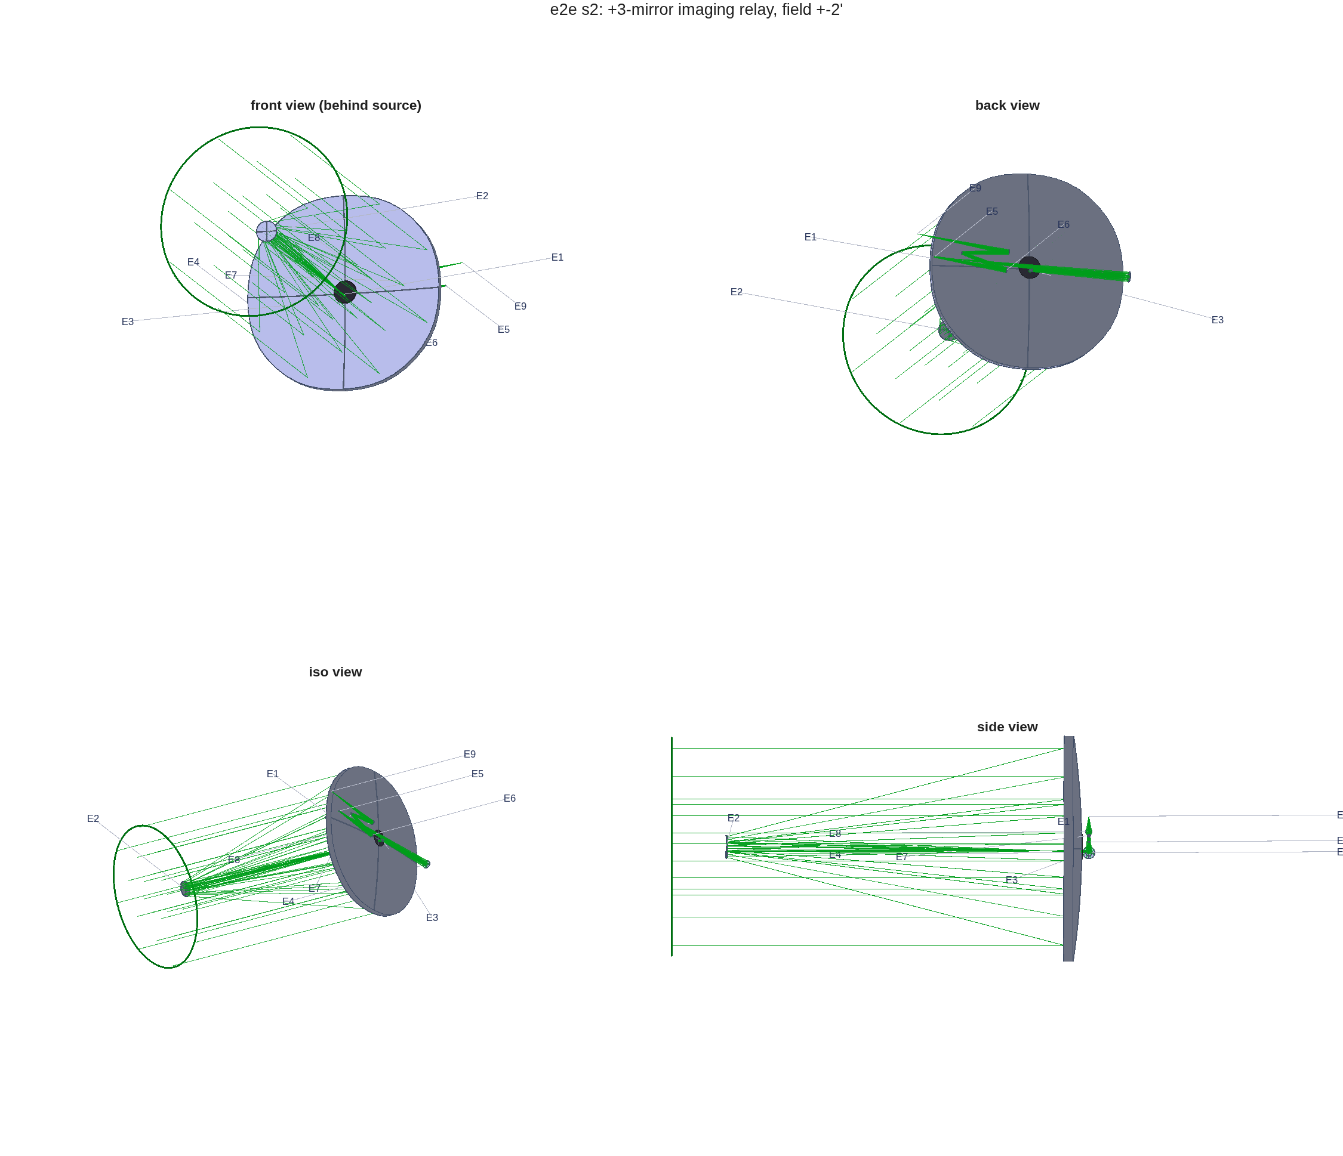
FIGURE 3 The telescope with its Offner relay (macos.view_std): front, back, isometric and side views, the elements labeled by number.
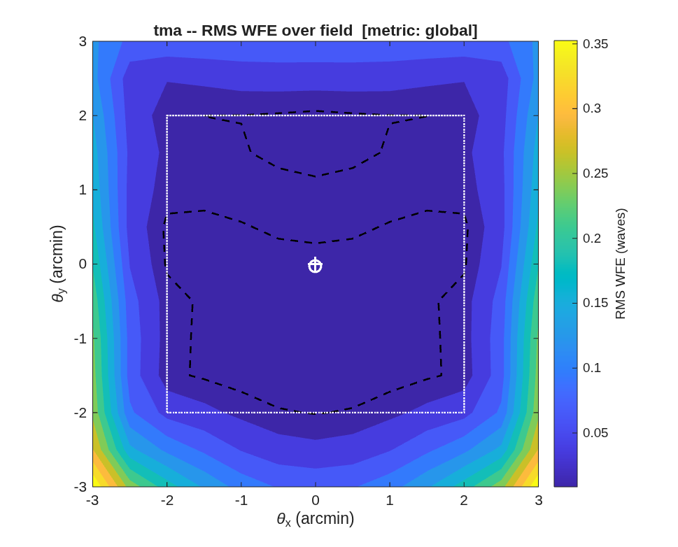
FIGURE 4 RMS wavefront error over ±3′ of field about the adopted center (waves at 500 nm); the white box is the ±2′ science field.

2.4 A coronagraph behind the telescope
Back to the telescope, for a second instrument: a coronagraph does not image the star; it removes it. The library’s best coronagraph is the CTB, templates/30_instruments/bench_ctb: eight off-axis parabolas (OAPs) and two deformable mirrors, laid out with the design layer’s macos.design.Bench. The question is whether it takes the telescope’s beam as it stands.
Put the CTB behind the stage-2 telescope. Does it take the telescope’s beam as built? If not, change as little as you can, and tell me how far off axis it can look before the beam walks on the deformable mirrors.
- templates/30_instruments/bench_ctb/example_ctb.m – its parameter block and its build: OAP1 collimates onto DM1, DM2 follows 500 mm on, then the focal-plane mask, the Lyot stop and the detector, every OAP at 5° incidence.
- templates/30_instruments/bench_ctb/README.md and deck_ctb.md – the beam on the DMs (21.38 mm across) and the dark zone’s inner edge, 8 λ/D.
- macos.design.append_rx, its help text – splicing a bench onto a telescope’s prescription at its focus.
- MACOS_resources/optical_design/CORONAGRAPH_DESIGN_RULES.md – the coronagraph rules for prescriptions.
It runs on the thread’s stage-2 prescription, with the CTB’s knobs read from the template, which is left unchanged:
P.F_OAP = [2500 1524 1143 1350 675 635 635 762]; % DST2R parent focal lengths
P.AOI = 5; % OAP/DM angle of incidence, deg
P.R_OAP = 75; % OAP clear-aperture radius, mm
P.R_DM = 22.5; % DM aperture radius, mm (stop)
P.FILL = 0.95; % source NA fills FILL of DM
P.WAVLEN= 500e-6; % 500 nm in mm
P.r = P.F_OAP / cosd(P.AOI)^2; % conjugate distances (mm)
% free (collimated-space) leg lengths -- set generously, no overlap:
P.L_DM1=600; P.L_DM2=500; P.L_O2=700; P.L_APOD=350; P.L_O4=500;
P.L_LYOT=350; P.L_O6=450; P.L_BACK=300; P.L_O8=450;
P.AP = P.R_DM*P.FILL / P.r(1); % source numerical aperture
% aluminium coating for the polarization study (index n - i*kappa):
P.AL_N = 1.2; P.AL_K = 7.0; P.AL_T = 1e-4; % ~100 nm Al
It builds that chain behind the telescope’s focus three times: as built, with OAP1 matched to the telescope, and with DM1 moved as well. Each one is spliced onto the stage-2 prescription with append_rx and traced:
the telescope (s2_instrument.in), as the coronagraph sees it
11 elements, 1168 of 1185 rays; field center +0.2615' (the chief ray's offset)
marginal ray f/17.87; along the two pupil axes f/17.69 x f/18.47 (EFL 70.75 / 73.88 m)
lambda/D 25.78 mas; the CTB's 8 lambda/D dark-zone edge = 0.206"
the CTB as built (OAP1 f = 2.500 m): 104 of 1185 rays reach DM1
OAP1 matched, f = f/17.87 x 21.375 mm = 0.3819 m
the telescope stop images 0.4651 m after OAP1 (first order 0.4608 m); DM1 there, DM2 0.500 m past it
OAP1 1168 of 1185 rays, beam radius 10.78 mm
DM1 1168 of 1185 rays, beam radius 10.78 mm
DM2 1168 of 1185 rays, beam radius 10.78 mm
Lyot 1168 of 1185 rays, beam radius 4.04 mm
FPA 1168 of 1185 rays, beam radius 0.01 mm
DM1 beam 20.66 x 19.77 mm on the 32-actuator grid (21.300 mm across, pitch 0.666 mm; mirror clear aperture 45.0 mm)
FPA rms wavefront 0.0103 waves at 500 nm
pupil walk, 8 field points per ring about the field center (max footprint-centroid walk)
ring DM1 mm /r_pup DM2 mm /r_pup /pitch rays DM2 rays FPA
0.206" 0.001 0.000 0.097 0.009 0.15 1168..1168 1168..1168
0.500" 0.002 0.000 0.236 0.022 0.35 1168..1168 1168..1168
1.000" 0.005 0.000 0.472 0.044 0.71 1168..1168 1168..1168
3.000" 0.015 0.001 1.416 0.133 2.13 1168..1168 1168..1168
10.000" 0.052 0.005 4.734 0.443 7.11 1168..1168 1168..1168
30.000" 0.199 0.019 13.606 1.273 20.44 1080..1120 1080..1120
60.000" 0.521 0.049 20.775 1.944 31.21 128.. 286 128.. 286
As built, the CTB does not take the beam: its OAP1 is a 2.5 m collimator for the much slower beam of its own source, so the telescope’s beam leaves OAP1 several times wider than DM1, and only 104 rays reach it. The fix is the textbook match, a collimator focal length equal to the f-number times the beam diameter on the DMs: 0.382 m at the marginal ray’s f/17.87. The CTB’s legs were laid for its own source, though, and with that OAP1 the telescope’s stop is imaged 465.1 mm after OAP1, not at DM1’s 600 mm. A DM away from the stop’s image sees the beam walk across it as the field moves, so DM1 moves there. That is one focal length and one spacing changed, and the system the rest of this section measures.
DM2 keeps its 500 mm past DM1, out of the pupil, by design. Light that crosses the gap between the two mirrors spreads out by diffraction, which lets the pair correct amplitude as well as phase and dig a dark zone on both sides of the star. A DM2 at a second image of the pupil would reduce the pair to one phase corrector.
On axis, 1168 of 1185 rays reach the detector, the same rays the telescope passes on its own, and the wavefront there is 0.0103 waves rms. The beam on DM1 is an ellipse, 20.7 × 19.8 mm, not a circle: the telescope’s beam is slightly anamorphic, f/17.69 and f/18.47 along the two axes of its pupil, because the science field sits off the telescope’s axis.
The walk table answers the last question. The telescope’s aperture is 187 times the beam on the DMs, so a field angle on the sky is that many times larger at the DMs. At the CTB’s dark-zone edge, 8 λ/D or 0.21″ on this telescope, the beam moves 0.001 mm on DM1, which sits at the stop’s image, and 0.15 of an actuator spacing on DM2. At 10″ it has moved 44% of the pupil’s radius on DM2; by 30″ DM2 clips the beam, and by 60″ few rays pass. So the coronagraph is an instrument with a field of arcseconds. The imager’s ±2′ cannot pass through it, and no realignment would change that: a beam 21 mm across cannot carry that field (the Lagrange invariant). The telescope keeps its arcminute field for its other instruments, each with a slightly offset field of view. The coronagraph takes an arcsecond sub-field about the field center that stage 2 adopted, 0.26′ off axis.
The walk table measures the chain unfolded, in the CTB’s own zigzag, where it reaches 6.7 m from the telescope’s axis against the 5.0 m the telescope itself needs. The realized instrument folds into that envelope. The thread’s stage 8 (templates/80_end_to_end/e2e/s8_coronagraph.m) searched the fold’s knobs under the design drivers (every surface under 15° of incidence, a numeric clearance, a small relay) and recorded its pick in e2e_params; the figures draw that pick replayed on this telescope by the library’s ctb_fold_build, and ctb_fold_measure gates it:
the fold: e2e stage 8's pick (e2e_params P.coro.pick) on this telescope, by ctb_fold_build / ctb_fold_measure
F0, a flat 0.30 m before the focus, deviation 8 deg (AOI 4.0) out of the bench plane toward +z;
the accordion's plane 90 deg from the bench plane, first turn +1, the pattern inverted after turn 4; relay scale 1.00
unfolded (case C, the library's build): CTB bodies to r = 6.701 m; DM2 walk at 10" 4.734 mm
OAP1 1168 of 1185 rays, beam radius 10.78 mm
DM1 1168 of 1185 rays, beam radius 10.78 mm
DM2 1168 of 1185 rays, beam radius 10.78 mm
Lyot 1168 of 1185 rays, beam radius 4.05 mm
FPA 1168 of 1185 rays, beam radius 0.01 mm
FPA rms wavefront 0.0102 waves (unfolded 0.0103); lambda/D at the FPM 31.6 um (unfolded 31.6)
AOI (deg): F0 4.0 OAP1 5.0 DM1 5.0 DM2 5.0 OAP2 5.0 OAP3 5.0 OAP4 5.0 OAP5 5.0 OAP6 5.0 OAP7 5.0 OAP8 5.0
walk at 10": DM2 4.701 mm (unfolded 4.734, -0.69 %); rays DM2 1168..1168, FPA 1168..1168
envelope: the telescope's own hardware union 4.997 m = 1.25 x D, gate radius 2.499 m; CTB bodies to r = 2.265 m, margin +0.234 m
train 7.185 m (the telescope alone 6.584); CTB bodies from z = 0.300 to 0.901 m behind the primary's vertex (the bench at 0.30)
clearance (mm, signed): CTB vs telescope +148.5 (leg from M7 vs M6); within the CTB +31.3 (FieldStop vs Backend), bodies and legs over the 1" field;
the telescope's own worst pair -22.0 (M3 vs FM), as built
in the bench alone: E1 F0, E2 OAP1, E3 DM1, E4 DM2, E10 FPM, E12 Lyot, E18 FPA
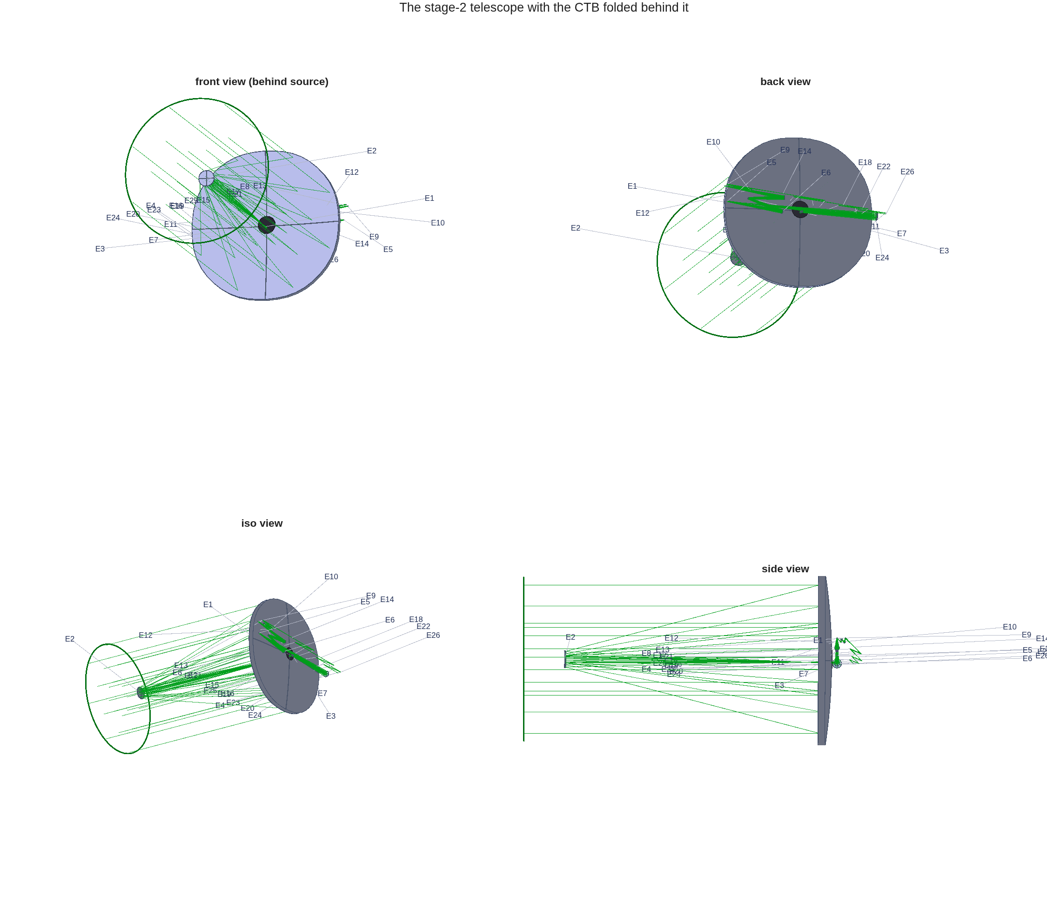
FIGURE 5 The stage-2 telescope with the CTB folded behind it (macos.view_std). At this scale the CTB is the small accordion behind the primary, standing up from the bench plane.
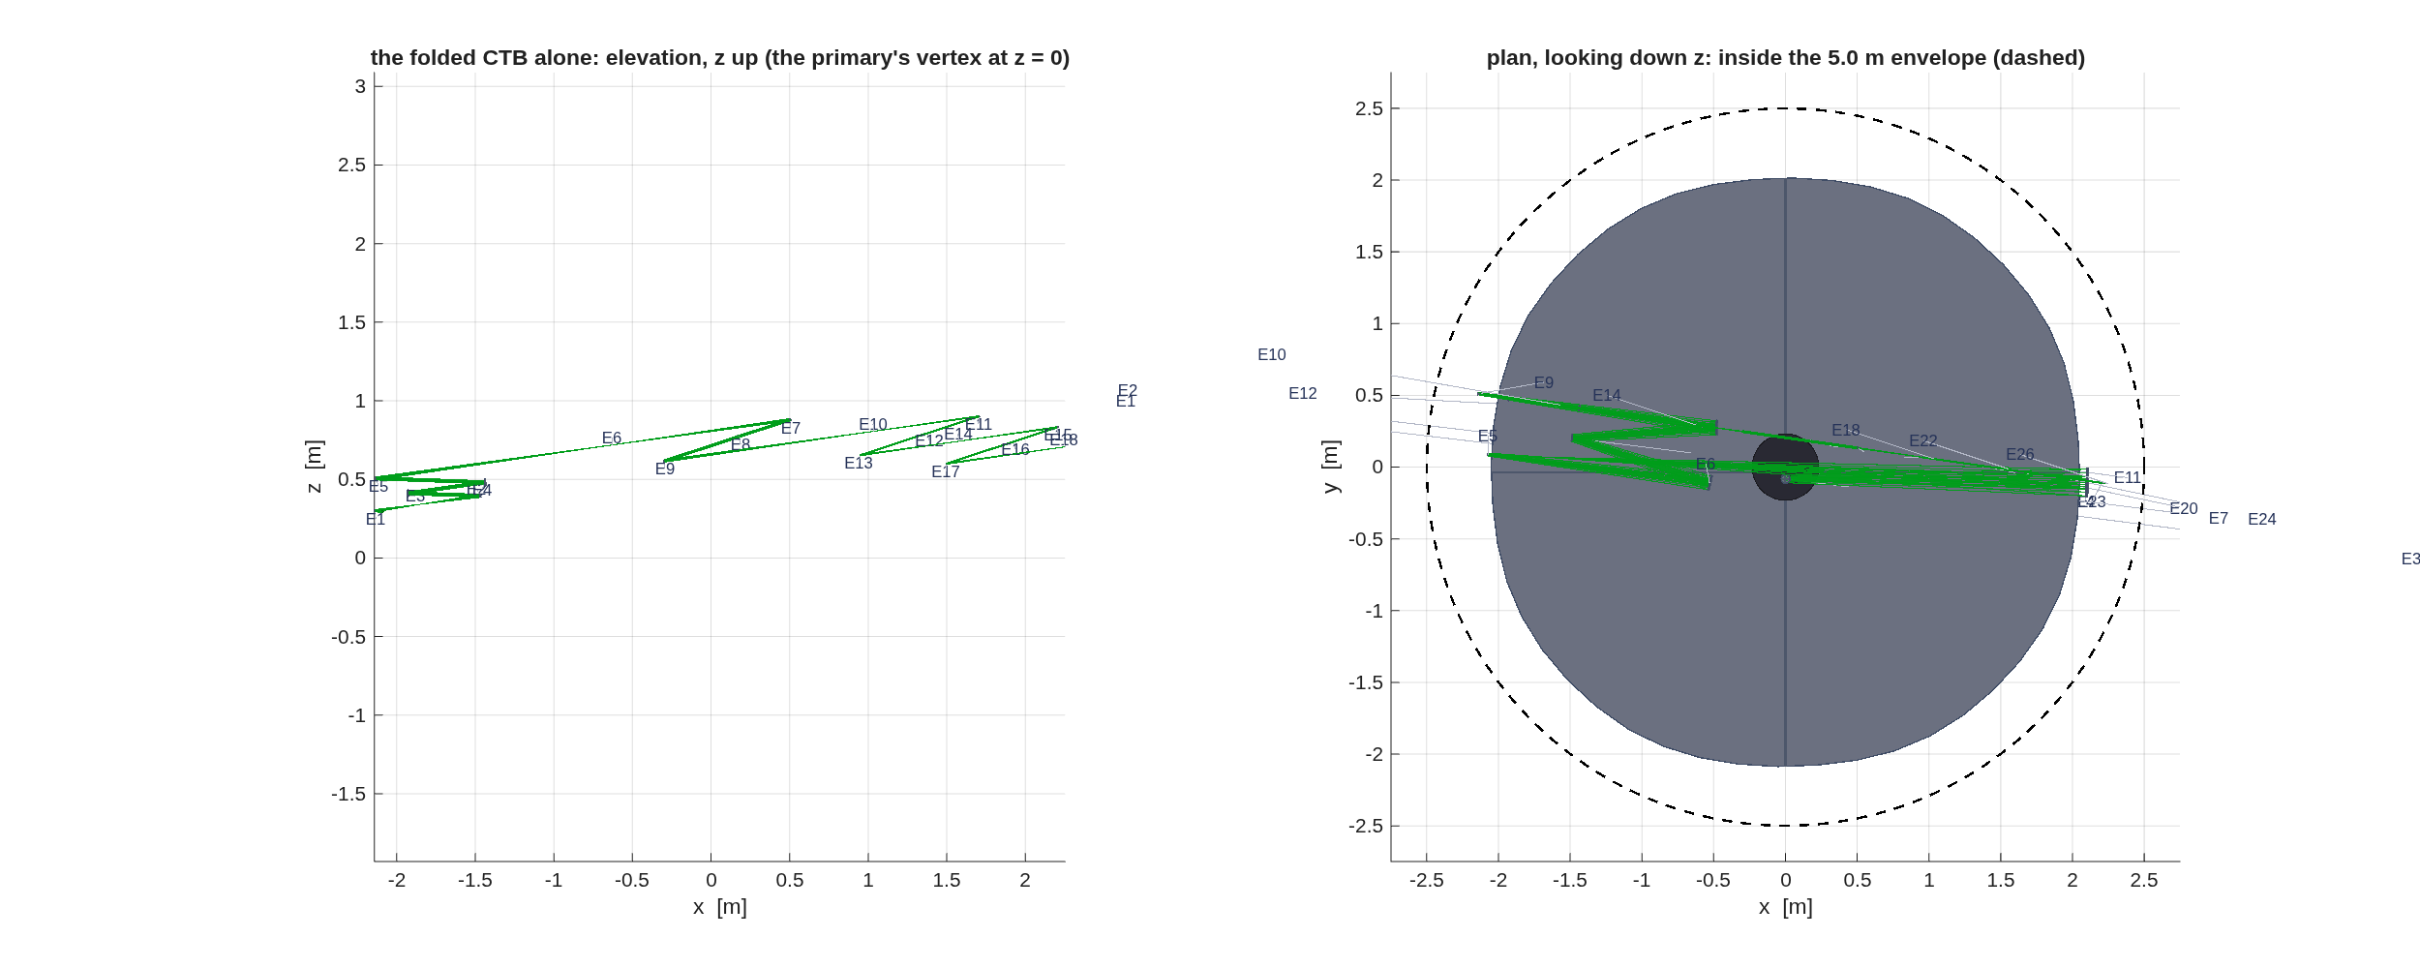
FIGURE 6 The folded CTB (macos.view_rx). Left, the bench alone in elevation, z up and the primary’s vertex at z = 0: E1 the added fold F0 on the converging feed, E2 OAP1, E3 DM1, E4 DM2, E10 the focal-plane mask, E12 the Lyot stop, E18 the detector. Right, the whole train in plan, looking down z, inside the telescope’s own 5.0 m envelope (dashed).
One near-normal flat 0.30 m before the focus on the converging feed, at 4° of incidence, lifts the chain and turns it back across the aperture. The CTB’s accordion then runs in the vertical plane behind the instrument bench, with its turn pattern inverted once after DM2 so that the chain climbs to 0.90 m behind the primary’s vertex and then comes back down; every other surface stays at the template’s 5°, and the relay is the template’s. Each gate is a number. 1168 rays reach the detector, the same rays as the unfolded train, and the wavefront there is 0.0102 waves, the difference from the unfolded one < 0.0002 waves: a flat fold is an isometry. The DM2 walk at 10″ is 4.70 mm, < 1 % from the unfolded table’s and not identical, because turning the accordion into the vertical plane rotates each OAP’s off-axis direction against the telescope’s anamorphic beam. The CTB’s bodies stay 0.234 m inside the envelope, 149 mm from every telescope body and beam and 31 mm from each other, the bodies sized over the coronagraph’s 1″ field; the train grows from 6.58 m to 7.19 m. The same measure puts the telescope’s own fold flat -22 mm inside its M3-to-M4 return, the body the stage-2 report flags without a number (below): a finding about the telescope as built, not about the fold. The dark zone is measured on the coupled diffraction model, the step after the fold.

2.5 A bench on its own
Off the thread again: an optical bench built from nothing, optic by optic, with the design layer’s macos.design.Bench builder. The library’s worked example is the classic test-arm bench of a surface gauge: a point source, a baffle as the stop, a collimating singlet, a beam splitter to a deformable mirror and back through the plate, two folds, an imaging singlet, an internal focus at a mask, and a detector at the image of the DM pupil.
Lay out a folded test-arm bench in the X-Y plane with real angles of incidence: collimate onto the DM, focus at a field mask, and put the detector at the DM’s pupil image. Then optimize it.
- MACOS_resources/mmacos/CLAUDE.md, the Bench entries – among them, ask Bench.station where an element sits on the bench; an off-axis section’s vertex is its parent’s.
- templates/40_benches/bench_layout/example_bench_layout.m – its header: why the solve is staged, one conjugate condition per plane, so that a single wavefront solve at the detector cannot mis-collimate at the DM and hide it at the focus.
It runs the example unchanged:
bench_layout: 13 elements, chief path 2286.320 mm
1 Baffle Obscuration s= 250.000 vpt=[ 250.000 0.000 0.000]
2 L1flat Refractor s= 496.193 vpt=[ 496.193 0.000 0.000]
3 L1pow Refractor s= 500.000 vpt=[ 500.000 0.000 0.000]
4 BSrefl Reflector s= 650.000 vpt=[ 650.000 0.000 0.000]
5 DM Reflector s= 900.000 vpt=[ 650.000 -250.000 0.000]
6 BStxf Refractor s= 1150.000 vpt=[ 650.000 0.000 0.000]
7 BStxb Refractor s= 1159.071 vpt=[ 652.633 8.681 0.000]
8 Fold1 Reflector s= 1459.071 vpt=[ 652.633 308.681 0.000]
9 Fold2 Reflector s= 1759.071 vpt=[ 952.633 308.681 0.000]
10 L2pow Refractor s= 1959.071 vpt=[ 952.633 108.681 0.000]
11 L2flat Refractor s= 1964.609 vpt=[ 952.633 103.143 0.000]
12 FocalMask Reference s= 2209.071 vpt=[ 952.633 -141.319 0.000]
13 Detector FocalPlane s= 2286.320 vpt=[ 952.633 -218.569 0.000]
seed prescription: <work>/bench_layout_seed.in
parameter schematic: <work>/bench_layout_params.png
rays: 3002 at baffle, 3002 at detector
builder-vs-engine chief agreement: max < 1e-09 mm
=== Stage A: collimate at DM (elt 5), solve L1 ===
L1: Kr 250 -> 236.866, Kc 0 -> -0.5829; ray spread 1.71 -> < 1e-06 mrad rms
=== Stage B: focus at mask (elt 12), solve L2 ===
L2: Kr -125 -> -124.076, Kc -2.25 -> -0.5826; focus spot 403 -> 0.0177 um rms
=== Stage C: detector at the DM pupil image ===
thin-lens seed off by -0.824 mm; tilt-induced beam shift 1.07 -> < 1e-05 um
pupil: 22.47 mm radius at DM -> 6.96 mm at detector (mag 0.310, thin-lens 0.309)
rendered: <work>/bench_layout_view_rx.png
<work>/bench_layout_view_std.png
DONE. Optimized prescription: <work>/bench_layout_opt.in
The builder tracks the chief ray in closed form (mirror turns, refraction through the tilted plate), so every element is emitted on the beam; the first check in the run is that the engine’s chief ray agrees with the builder’s. Then three solves, each a geometric cost on its own plane: L1 for collimation at the DM (the ray-direction spread), L2 for the focus at the mask (the spot), and the detector’s position for the pupil image (the beam shift a field tilt causes). Numbers that solve to zero print as a bound (<): their last digits differ between machines.
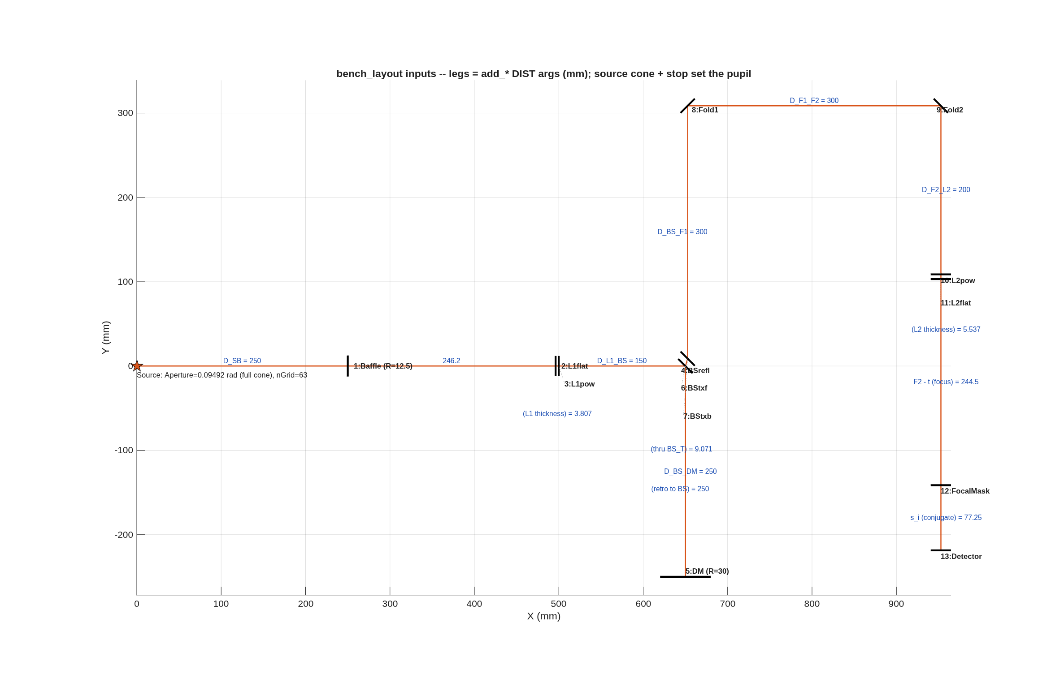
FIGURE 7 The bench’s inputs (bench_layout_params.png): the legs, in millimetres, are the add_* distance arguments; the source cone and the stop set the pupil.
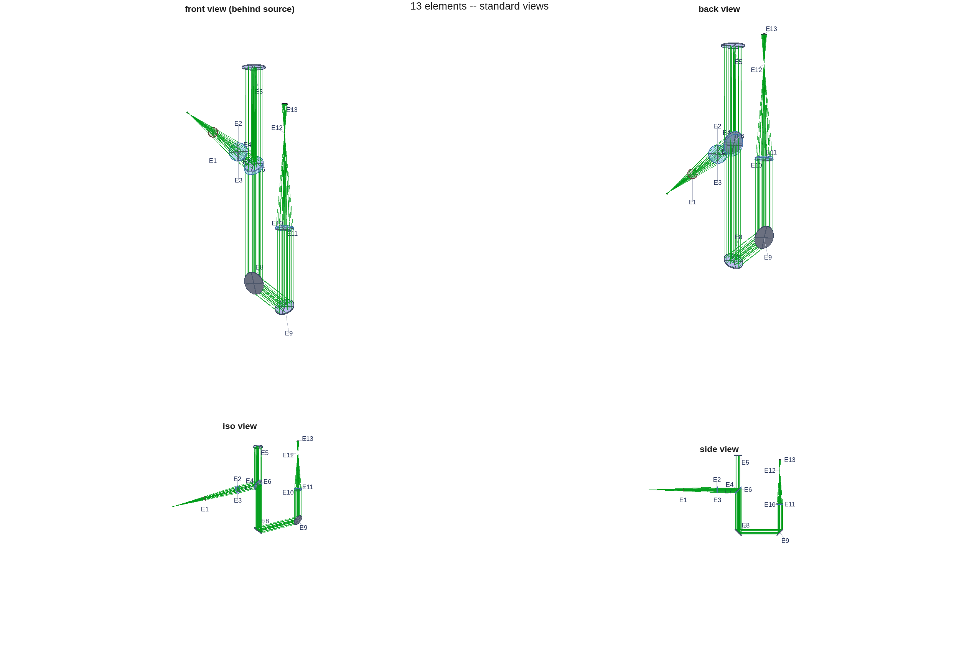
FIGURE 8 The optimized bench, 13 elements (macos.view_std).

2.6 When not to split: a small dedicated imager
The thread splits its design into a telescope and an instrument because the telescope feeds several instruments over a wide field, and each instrument takes an arc of it. A small camera that is its own telescope does not split. ImageDemo.in, the MACOS Manual’s Appendix A example (after the Mars Observer Camera), is 13 elements traced as one design, telescope and camera together; loaded and asked the same question as the stages above:
>> macos.init(256); n = macos.load_rx('ImageDemo.in'); s = macos.trace(n);
13 elements, 578 of 741 rays pass
>> p = macos.first_order_properties()
efl_baseunits 3505
fno 9.2236
dpup_m 380
obscuration 0
It reads f/9.22, with an obscuration of 0.00. Two cautions for an assistant reading it. The deck declares no BaseUnits, so the engine’s metre conversion factor is 1 and dpup_m prints the deck’s own millimetres (380); quote it as 380 mm, or add BaseUnits= mm to the deck. And the primary’s obscuration is declared on the elements, not on the source, so the first-order obscuration ratio reads zero for the same reason as in Section 1.

2.7 Checking the assistant’s work
The stage-2 prescription reloaded alone in a fresh session:
>> macos.init(256);
>> n = macos.load_rx('s2_instrument.in'); s = macos.trace(n);
11 elements, 1168 of 1185 rays pass
>> p = macos.first_order_properties()
efl_baseunits 72.714
fno 18.179
11 elements, and 1168 of 1185 rays pass, the same rays as the Section 1 telescope: the relay clips nothing the primary’s hole does not. SYSPROP reads 72.71 m (f/18.18); the report’s “EFL” is again the local plate scale at the field point and reads longer. The report’s clearance line flags bodies in the beam at M2, which is the secondary’s own shadow on the incoming beam, as in Section 1, and now at FM, the fold flat; that the trace passes the same rays says the fold blocks no traced ray, but the report does not say how close the body comes, so ask (below). Read the dead-ends paragraph of the e2e README before asking for a wider or flatter field: a per-field corrector at a focus and a fourth weak mirror near the relayed pupil were both tried and both rejected.

2.8 What to ask next
- “Why does the clearance check flag the fold flat, and by how much?” – t.check_clipping on the stage-2 design is the call the report makes; the number is deck_clearance’s, -22 mm on the exact leg-to-body measure (the fold listing above).
- “Center the science field lower, inside the ring.” – P.inst.field_dy_arcmin with field_center = "manual"; the variants kept in s2_variants/ are the two already solved.
- “Segment the primary.” – Section 3.
- “A spectrograph instead of an imager.” – not on the thread. templates/10_telescopes/tma_longslit is the slit-fed spectrometer’s front end (telecentric, long working distance), and challenges/dyson5 is the VSWIR Dyson imaging spectrometer built behind it.

SECTION 3: Segmentation
A 4 m primary is one piece of glass in Sections 1 and 2. This section cuts it into segments, two ways, and keeps both: a 1-ring pie (7 segments, a center hexagon and six chorded wedges) and a 2-ring hex (19 hexagons). The pie is the one Sections 4 to 7 carry forward. Segmentation changes no optics. It adds the bodies whose motions the later sections sense and control: every segment becomes an element with its own frame and its own six degrees of freedom.

3.1 You ask
Segment the primary of the stage-2 design two ways, a pie of seven and a hex of nineteen, with 25 mm gaps and real segment edges, so that light falling in a gap is lost. Keep the primary’s figure on every segment, check each segmented deck against the monolithic one, and tell me which one the rest of the flow should use.

3.2 The assistant reads
- MACOS_resources/mmacos/templates/80_end_to_end/e2e/README.md, the s3_segmentation.m row – the two variants, the knob that picks the one stages 4 to 6 consume, and the gotchas this stage flushed out (a Zernike parent’s figure that SegMirMaker would drop; the heritage xGrid frame the tiling contract needs).
- MACOS_resources/mmacos/design/runners/run_segmentation.m, its help text – the general stage runner the e2e stage is a thin driver over, its artefacts, and its verification ladder: a parent baseline, a bare segmentation trace, engine-truth footprints, the trace with physical apertures, and a standalone reload of the emitted deck.
- MACOS_resources/mmacos/templates/20_segmentation/ (e5_pie, e5_seg) – the segmentation templates of the library, at twice this aperture.

3.3 It runs
The knobs are the P.seg block of e2e_params.m. Segment size is not among them: SegMirMaker sizes a segment as the aperture over (2 × rings + 1), so the tiling scales with the aperture.
P.seg = struct( ...
'variants', ["pie" "hex2"], ... % s3 builds ALL of these ->
... % e2e_pie.in / e2e_hex2.in
'variant', "pie", ... % the one stages 4-6 consume (one-knob
... % switch; both artifacts always exist)
'gap_mm', 25, ... % inter-segment gap (BaseUnits are m in
... % this family -- the runner converts)
'dofs', 6, ... % per-segment DOFs
'meas_config', 2, ... % edge sensors: 1 inner edges, 2 all
'emit_apertures', true, ... % declare physical PolyApVec boundaries
'ap_pad', 0, ... % 0 = physical edge (gap rays clip)
'grid_npts', 128, ... % segmented-source sampling (e5-corpus
... % density; the parent's 41 gives only
... % ~50 rays/segment at 2 rings -- Dave
... % 2026-07-18: sampling seemed coarse)
'model_size', 512); % segmented stages need the big model
Then the stage script, unchanged, in the directory Sections 1 and 2 left their products in:
run('<path-to>/mmacos/templates/80_end_to_end/e2e/s3_segmentation.m')
Each variant goes through run_segmentation once. The stage report:
==== e2e stage 3: segmentation of M1 (parent s2_instrument.in) ====
parent: D = 4 m, BaseUnits=m; gap 25 mm; per-variant detail in
e2e_<variant>_seg_report.txt (run_segmentation runner reports)
---- variant "pie": rings=1, grid=Pie ----
-> e2e_pie.in VERIFIED (11950/12128 pass, 0 clipped)
---- variant "hex2": rings=2, grid=Hex ----
-> e2e_hex2.in VERIFIED (9698/9876 pass, 0 clipped)
==== stage-3 summary ====
name nseg width_m pass/src clipped rmsWFE d%
pie 7 1.333 11950/12128 0 +3.44
hex2 19 0.8 9698/9876 0 -25.48
(rmsWFE deltas vs parent = pupil-sampling coverage: the segment tilings
sample the pupil differently from the parent Circular grid)
downstream variant (P.seg.variant) = "pie" -> stages 4-6 consume e2e_pie.in
and the runner’s own report for the pie, the verification ladder step by step:
==== run_segmentation: <thread>/s2_instrument.in (elt 1, Pie rings=1, gap 0.025) ====
[0] parent: 1185 src rays, 1168 pass, rmsWFE 4.057e-09 (WaveUnits)
[1] 7 segments, width 1.333 flat-to-flat, 17 elements
parent obscurations carried onto the center segment: 1
Seg1 center [ +0 +0 -2.61e-07] lMon 0.7698
Seg2 center [ -0.6667 +1.155 -0.06385] lMon 0.7698
Seg3 center [ +0.6667 +1.155 -0.06385] lMon 0.7698
Seg4 center [ +1.333 +0 -0.06349] lMon 0.7698
Seg5 center [ +0.6667 -1.155 -0.06314] lMon 0.7698
Seg6 center [ -0.6667 -1.155 -0.06314] lMon 0.7698
Seg7 center [ -1.333 +0 -0.06349] lMon 0.7698
bare segmented: 12128 src rays, 11950 pass, rmsWFE 4.197e-09 (parent 4.057e-09, +3.44%)
[3] physical apertures (pad 0): 11950 pass (bare 11950) -- 0 gap/rim rays clip
first-fail elements 1; rmsWFE 4.197e-09 (+3.44% vs parent)
footprint/aperture figure: <thread>/e2e_pie_footprints.png
[4] standard views: <thread>/e2e_pie_views.png
[5] artifact <thread>/e2e_pie.in: standalone reload 17 elts, 11950/12128 rays pass -> VERIFIED
Segment widths are flat to flat: 1.33 m for the pie, 0.8 m for the hex. The primary’s central hole rides on the pie’s center segment (step [1], one obscuration carried over). The rmsWFE change against the parent is a sampling effect, not an optical one, as the report says: the segmented deck’s source grid samples the pupil differently from the parent’s circular grid.
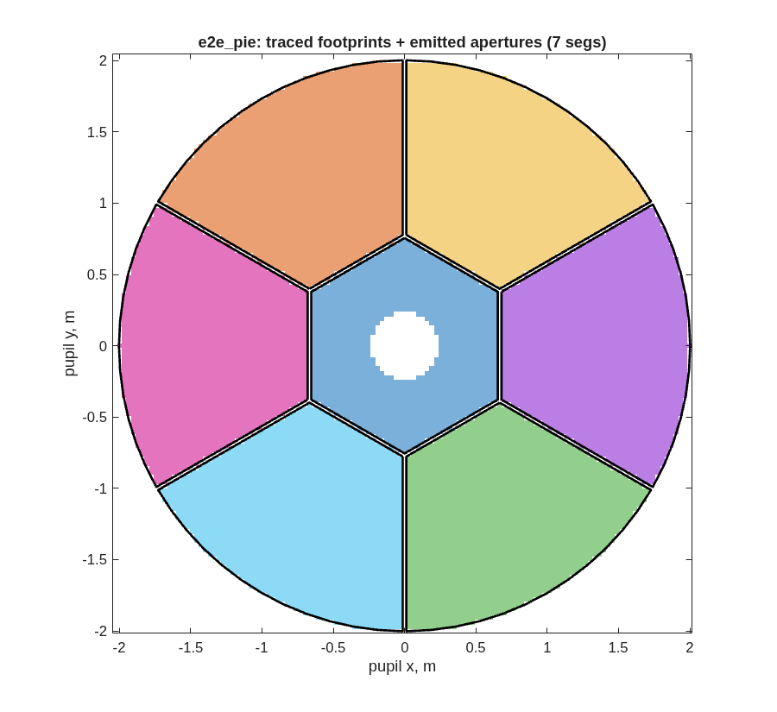
FIGURE 9 The pie: each segment’s traced footprint (macos.design.seg_footprints, found by poking each segment and differencing the trace) and the aperture polygons emitted into the deck (black).
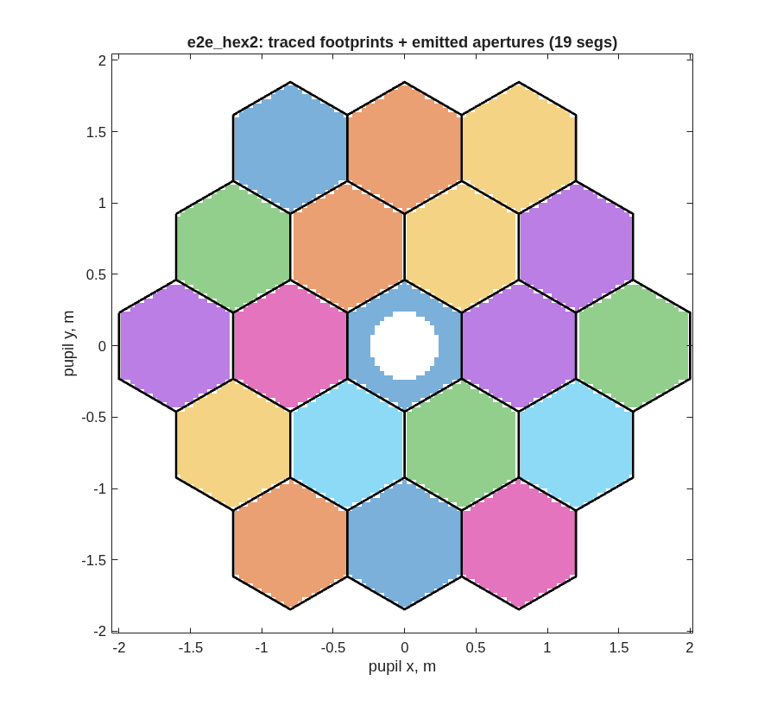
FIGURE 10 The hex, the same way.
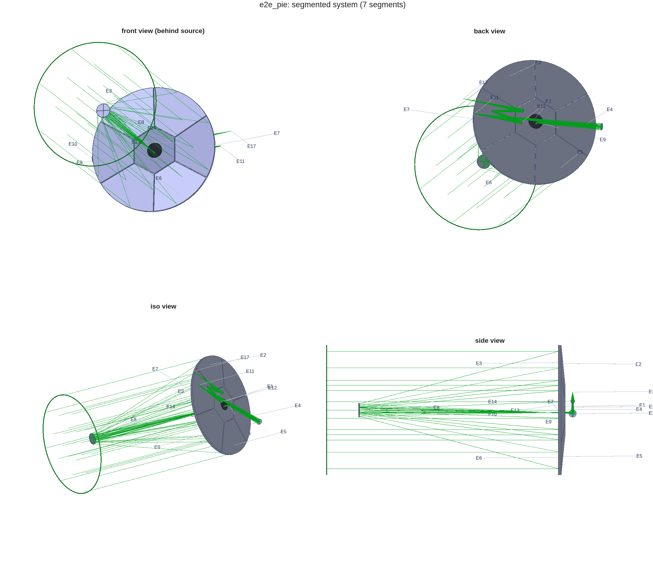
FIGURE 11 The segmented system, e2e_pie.in (macos.view_std).

3.4 Checking the assistant’s work
The deliverable is e2e_pie.in. Reloaded alone in a fresh session, at the model size the segmented stages need:
>> macos.init(512);
>> n = macos.load_rx('e2e_pie.in'); s = macos.trace(n);
17 elements, 11950 of 12128 rays pass
rmsWFE 4.197e-09 m
17 elements, 11950 of 12128 rays passing: the counts the runner verified in session (step [5]). Check two things more in the runner’s report.
First, where the lost rays are lost. The census of step [3] names element 1, the center segment, which carries the primary’s hole; the bare segmented trace and the trace with apertures pass the same rays (0 clipped). In this run, then, no traced ray falls in a gap. The footprint figure agrees: the gaps are empty and every footprint fills its polygon. A gap that clipped nothing because the apertures were missing would look different: footprints spilling over the black lines.
Second, that the segments sit where the parent’s surface is. The frames table of step [1] puts each wedge’s center a few centimetres behind the center segment’s: that is the parent’s sag at the wedge’s radius, not an error, since every segment carries the parent’s figure.

3.5 What to ask next
- “Use the hex for the rest of the flow.” – P.seg.variant = "hex2"; both decks always exist.
- “Narrow the gaps to 10 mm.” – P.seg.gap_mm; rerun from this stage.
- “How sensitive is the image to each segment’s motion?” – Section 4.

SECTION 4: Sensitivities
Sections 5 to 7 sense the segmented telescope, estimate its state and control it, and none of them traces a ray to do so. They work on a linear model of the telescope, harvested once in this section: how the wavefront over the science field moves for a unit motion of every body, a unit of every figure mode of every segment, and a unit of every grid influence function. Each channel is a matrix in one stacked form, w = J·x + w0: a column per degree of freedom, a row per ray per field point.

4.1 You ask
Harvest the linear model of the segmented telescope over the ±2′ science field: rigid-body sensitivities for every optic, segment figure in low-order Zernike modes, and per-segment grid influence functions. Tell me how well conditioned each one is.

4.2 The assistant reads
- MACOS_resources/mmacos/templates/80_end_to_end/e2e/README.md, the s4_jacobians.m row – the three channels, the field set (the center and the four corners of the ±2′ field), and why the figure channel uses each segment’s own Zernike basis rather than the parent’s.
- MACOS_resources/mmacos/design/runners/run_sensitivities.m – the runner over the production macos.dw_d*_multi supervisors, the grid augmentation (macos.design.grid_augment_rx), and the report it writes.
- MACOS_resources/mmacos/tests/tDwDx.m, the comments on its pins – the noise floor of a finite-difference sensitivity (about 1e-6 absolute, up to 3e-5 on columns that are nearly zero), which decides which numbers below are signals and which are bounds.

4.3 It runs
The stage script, unchanged, in the thread directory:
run('<path-to>/mmacos/templates/80_end_to_end/e2e/s4_jacobians.m')
It takes e2e_pie.in from Section 3 and writes s4_jacobians.mat (the three matrices, for the later stages), a fingerprint of them (s4_jacobians.fp.json, committed where the matrices are too large to be), one page of maps per element, and the report. As this manual prints it, numbers set by the noise floor are shown as the bound they are known to sit under or over (<, >):
==== run_sensitivities: <thread>/e2e_pie.in ====
field set: center + 4 corners at +-0.0005818 rad
OPD conventions: orient=raw sign=opl opd_ref=chief
piston: saved columns kept, analyses removed (macos.piston)
segments: 7
[dwdx] rigid-body 6-DOF per element, LOCAL triads...
dwdxall 59750 x 90 over 5 fields
[dwdz] segment-LOCAL MonZernike modes [4 5 6 7 8 9 10 11]...
dwdzall 59750 x 56
[dwdgrid] grid-augmenting in the clocked Mon frames...
s4_grid.in: 17 elts, 11950/12128 rays, gdx 0.01569
dwdgall 59750 x 42 (influence basis saved in og.sgb)
[conditioning] finite rows only, piston removed:
channel size rank sv_max sv_min+ cond+
dwdx 59750x90 <90 1.988e+02 < 5e-05 > 1e+06
dwdx segment-only: 59750x42 cond+ > 1e+06
dwdz 59750x56 56 1.817e+02 3.385e+01 5.368e+00
dwdgrid 59750x42 42 1.934e+02 1.384e+02 1.398e+00
dwdx per-segment column norms (rms native-unit per unit DOF):
seg rx ry rz tx ty tz
1 2.39e-01 2.40e-01 < 5e-05 1.71e-02 1.70e-02 6.20e-01
2 3.32e-01 2.70e-01 1.01e-04 1.90e-02 2.35e-02 7.07e-01
3 3.32e-01 2.70e-01 1.01e-04 1.90e-02 2.35e-02 7.07e-01
4 3.33e-01 2.69e-01 1.02e-04 1.89e-02 2.36e-02 7.07e-01
5 3.32e-01 2.70e-01 1.03e-04 1.90e-02 2.35e-02 7.07e-01
6 3.32e-01 2.70e-01 1.03e-04 1.90e-02 2.35e-02 7.07e-01
7 3.33e-01 2.69e-01 1.02e-04 1.89e-02 2.36e-02 7.07e-01
figures: s4_opdall/svspec + 90 dW pages in s4_pages/ (>= 3.5 in per OPD map, 1.2 in per field tile) -- index: s4_pages_index.txt
Done: <thread>/s4_sens.mat + s4_sens_report.txt
Each channel has 59750 rows: the rays that pass, at five field points. The rigid-body channel dwdx has 90 columns, six for each of the fifteen bodies that move (the seven segments, then the optics behind them). The figure channel dwdz has 56, Zernike modes 4 to 11 on each segment, and the grid channel dwdgrid has 42, six influence functions on each segment.
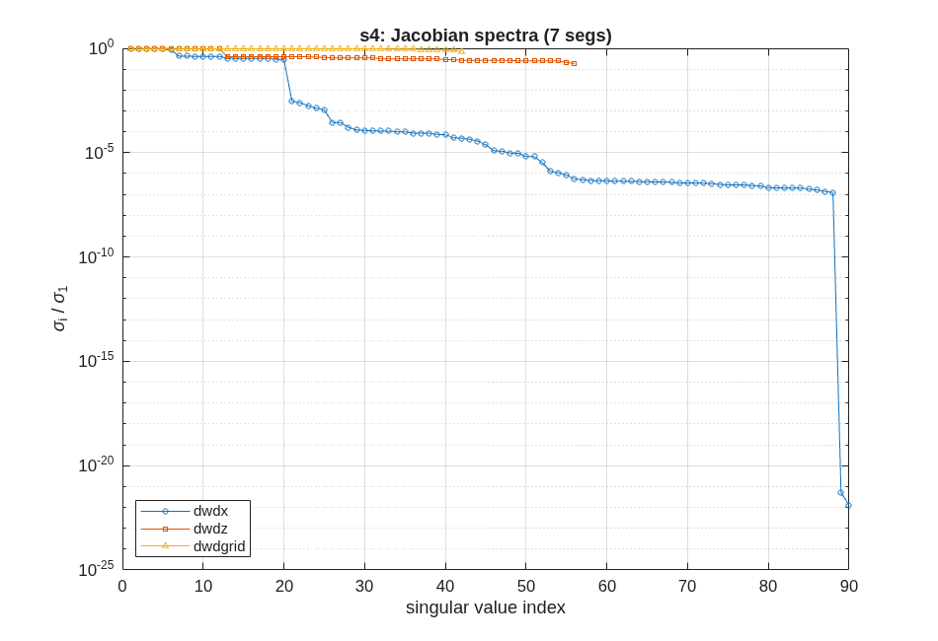
FIGURE 12 The singular-value spectra of the three channels, each normalized to its largest.
The spectrum says what the conditioning table says, and more. dwdz and dwdgrid are flat: full rank (56 and 42), condition numbers 5.368e+00 and 1.398e+00. Every mode is seen, and seen about equally. dwdx is not. About twenty modes are strong, the segments’ pistons and tilts; a cliff of more than two decades follows, then a long tail at the floor, then two columns that are exactly zero. The channel pages show which:
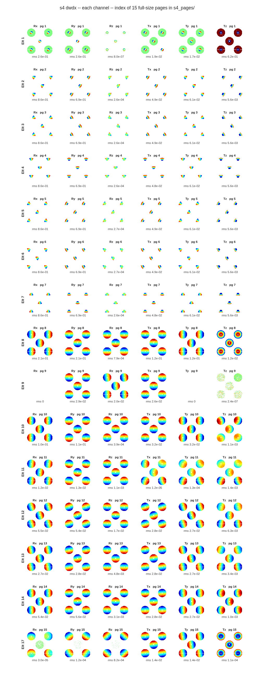
FIGURE 13 The rigid-body channel, one row per element and one column per degree of freedom (the index page of s4_pages/; each tile is the center-field wavefront change, with its rms).
The two exact zeros are the fold flat’s (element 9) in-plane motions, Rx and Ty, which move a flat mirror within its own plane. The segments’ clocking, Rz, is near the floor too: rotating a segment about its own axis on a nearly flat parent moves almost nothing, the center segment least of all.

4.4 Checking the assistant’s work
Two checks, both on numbers in the report.
The first is units. The column norms are in the deck’s native units per unit motion, metres of wavefront per radian or per metre (BaseUnits are metres here). A segment’s piston, Tz, reads about 0.7, and that can be checked by hand: a mirror moved along its normal changes the reflected path by twice the motion, on about a seventh of the rays; with the mean removed (the report’s analyses remove each field’s piston, its piston: line says so, Section 6 says why), the rms is 2·√(1/7 · 6/7) ≈ 0.70. (The center segment reads less: the primary’s hole takes some of its rays.) A units slip would show as a factor of a thousand.
The second is what the floor means. A finite-difference sensitivity cannot resolve a column smaller than its own noise, and that noise differs between machines in the last digits. A condition number divided by a singular value at the floor is not a property of the telescope, which is why this manual prints the dwdx condition numbers as bounds, and why the segment-only figure in the report is no better: segment clocking is in it. For estimation and control the later stages do not invert dwdx raw; Section 6 regularizes it with a prior, and the README says what happens when it is not (the pose estimate diverges).

4.5 What to ask next
- “Leave out the degrees of freedom the telescope cannot see.” – the clocking and the fold’s in-plane motions; run_sensitivities takes the element and DOF lists ('elts', 'dofs').
- “Show me one segment’s maps at full size.” – s4_pages/, indexed by s4_pages_index.txt.
- “Add laser metrology.” – Section 5.

SECTION 5: Laser Metrology
A segmented telescope drifts: each segment, the secondary and the fold move a little, all the time, by much less than the wavefront can afford to lose between corrections. This section adds the sensors that watch those motions: capacitive edge sensors across every gap, and a laser truss (MET), beams from launchers on the back of each segment to fiducials on the secondary’s rim, with an aft ring on the fold watching the secondary through the primary’s hole. Then it asks how well the sensors see the motions that matter to the wavefront, and moves the launchers to see them better.

5.1 You ask
Add laser metrology to the segmented telescope: six launchers on each segment, six fiducials on the secondary’s rim, and an aft ring on the bench-side fold watching the secondary through the hole. Use the edge sensors from the segmentation. Score how much of the drift wavefront each sensor set leaves after control, then optimize the launcher layout on the metrology alone.

5.2 The assistant reads
- MACOS_resources/mmacos/templates/80_end_to_end/e2e/README.md, the s5_met.m row – the truss, the edge-sensor model (two locations per shared edge, three axes each: piston, gap, shear), why the headline metrics are dimensionless, and the 50 mm separation rule a layout must keep.
- MACOS_resources/mmacos/templates/80_end_to_end/e2e/s5_met.m, its header – the geometry note: the aft ring sits on the fold, at the secondary’s radius, because a ring at M3 would have no line of sight through the hole.
- MACOS_resources/mmacos/design/runners/run_met.m – the stage runner: the as-built truss, the dldx engine check, the scoring, the shape-class layout optimizer, the Monte-Carlo acceptance.

5.3 It runs
The knobs are the P.met block of e2e_params.m:
P.met = struct( ...
'nf', 6, ... % fiducials on the hub (>=3, likely 6)
'fid_rim_inset_mm', 25, ... % fiducial ring inset inside the hub rim
'edge_off_mm', 5, ... % launcher clearance outward of seg edge
'min_sep_mm', 50, ... % min separation between ANY 2 launchers
'aft_ring_r_mm', 232, ...% aft launcher ring radius (on the FOLD,
... % the on-axis bench body behind M1: its
... % beams reach the M2 fiducials THROUGH
... % the M1 hole -- a ring at M3's lateral
... % position has no hole line of sight).
... % Dave 2026-07-19: the stable aft
... % structure extends to the SM RADIUS
... % (M2 lMon = 0.232 m) -- maximizes the
... % ring lever arm.
'hole_r_mm', 232, ...% EFFECTIVE central-hole radius for the
... % aft-beam clearance check: the SM
... % shadow radius (Dave: the hole will be
... % that large anyway -- the SM obscures
... % more than the current 0.122 m hole).
... % Enlarging the REAL Rx hole to match is
... % a P.tel change cascading s1->s5.
... % SCENARIO (Dave 2026-07-19): MET tracks
... % the post-WFSC DRIFT state, not deploy
... % errors -- HWO-class drift is << 1 nm
... % between updates, and the MET accuracy
... % roadmap runs to ~1 pm. The HEADLINE
... % run_met numbers are dimensionless
... % (WEM + floor fraction) and invariant
... % to these scales; the sigmas below set
... % only the absolute forecast column.
'sig_rot', 1e-10, ... % prior drift sigma, rad per rot DOF
'sig_trans', 1e-10, ... % ... metres per trans DOF (0.1 nm class)
'sig_edge', 1e-11, ... % edge-sensor noise, metres (10 pm class)
'sig_met', 1e-12, ... % MET gauge noise, metres (1 pm target)
'mc_draws', 200); % Monte-Carlo acceptance draws
Then the stage script, with one change. Its last block copies the optimized layout into the library’s shared preset folder (design/runners/presets/), where future builds of the same tiling start from it. That block writes a record other work depends on, so the manual runs a copy of the script with that block, and only that block, removed. The presets were checked by checksum before and after the run: this manual’s run does not touch them.
run('<path-to>/mmacos/templates/80_end_to_end/e2e/s5_met.m') % less its preset promotion
The report (numbers that are numerical zeros are printed as their bounds):
==== run_met: <thread>/e2e_pie.in ====
[0] e2e_pie: 7 segments (Pie tiling), 17 elements; 11950/12128 rays pass
[1] as-built truss: 48 beams (6 launchers/segment + aft ring on elt 9), 6 fiducials at r=0.1963 on elt 8
trace parity: 11950/12128 rays pass (bare 11950/12128), rmsWFE 4.197e-09 (bare 4.197e-09)
aft-beam hole clearance (effective hole r=0.232 (design override)):
crossing radii [0.1798 0.226 0.1807 0.182 0.226 0.1763] -> min margin 0.005971 (CLEAR)
[2] dedx 72x54 (SI); dldx 48x54 engine-FD vs analytic: < 1e-05 max rel PASS
[3] dwdx: 54 columns for bodies [1 2 3 4 5 6 7 8 9] from the sensitivities .mat
OPD reference chief (the harvest's), piston removed
post-control wavefront residual (fraction of prior; nm at the
configured scenario: prior 1e-10 rad / 1e-10 m, noise 1e-11 / 1e-12 m):
prior (no sensing) 1.0000 (0.2173 nm)
edge sensors only 0.4348 (0.09447 nm)
MET only 0.1357 (0.02949 nm)
edge + MET 0.0944 (0.0205 nm)
as-built WEM (per unit gauge noise, suite ratios held;
prior split: < 1e-12 nm tilt / 0.2173 nm non-tilt):
config WEM_full WEM_tilt WEM_ntilt floor_ntilt
MET only 15.322 0.000 15.322 0.1159
edge+MET 3.943 0.000 3.943 0.0926
observability: H 120x54, sv(H*sqrt(X)) 7.185e-10 .. < 1e-15 (cond 3.24e+06)
products: dxde 54x72, dxdl 54x48, dwde 59750x72, dwdl 59750x48
[4] met_layout_opt (one pattern per shape class; MET-only, NON-TILT merit):
class 1 (1 members, cluster): angs [170 190 50 70 -70 -50] deg
class 2 (6 members, cluster): angs [175 185 55 65 -65 -55] deg
engine-FD validation (non-tilt merit): 0.0204 nm (analytic 0.0204, 0.00% off)
[4b] configuration comparison (WEM per unit gauge noise):
config | MET_full MET_tilt MET_nt | e+M_full e+M_tilt e+M_nt | flr_nt min_sep
as-built | 15.322 0.000 15.322 | 3.943 0.000 3.943 | 0.0926
optimized | 3.877 0.000 3.877 | 1.782 0.000 1.782 | 0.0922
corner_pairs | 4.102 0.000 4.102 | 1.799 0.000 1.799 | 0.0922 0.01502
[5] Monte-Carlo (200 draws): 0.020 nm rms (analytic 0.020) [2.0%]
metric chart (w_post / w_prior):
prior 1
edge only 0.4348
MET only 0.1357
edge+MET 0.09435
edge+MET opt 0.09252
[6] figures: <thread>/e2e_pie_met_layout.png, <thread>/e2e_pie_metopt_layout.png, <thread>/e2e_pie_met_view_rx.png, <thread>/e2e_pie_met_metric.png
preset saved: <thread>/e2e_pie_met_preset.mat (reusable as-built for future Pie builds)
artifacts: e2e_pie_met.in, e2e_pie_metopt.in, e2e_pie_met.mat, this report + figures
next stage: run_compare (linear model vs mmacos on x/z/grid states).
Read it in order. Step [1] builds the as-built truss, 48 beams, and checks that it changes no traced ray, and that the aft beams clear the hole, by 0.005971 m at the closest. Step [2] is the gate on the measurement model: the derivative of every beam length with respect to every body motion (dldx), by finite differences in the engine and in closed form, agree to the noise of the difference. The edge-sensor matrix (dedx) has 72 rows for the 54 sensed degrees of freedom (seven segments, the secondary and the fold, six each).
Step [3] scores the sensors. “Fraction of prior” is the wavefront drift left after control, as a fraction of the drift with no sensing at all. The WEM is the same wavefront per unit of gauge noise, a number free of any assumed noise level, which is why it heads the comparison: the drift the truss tracks is the slow drift between wavefront corrections, far below a nanometre. The tilt columns read zero by construction, since the sensitivities of Section 4 were taken with the focal plane tracking the image.
Step [4] is the layout search: one launcher pattern per segment shape class, the center hexagon and the six congruent wedges, on the metrology-only, non-tilt merit (the truss has to stand without the edge sensors). Step [4b] compares the as-built truss, the optimized one, and a hand-placed layout of launcher pairs at each class’s corners. The optimizer takes the metrology-only WEM from 15.322 to 3.877, and with the edge sensors from 3.943 to 1.782.
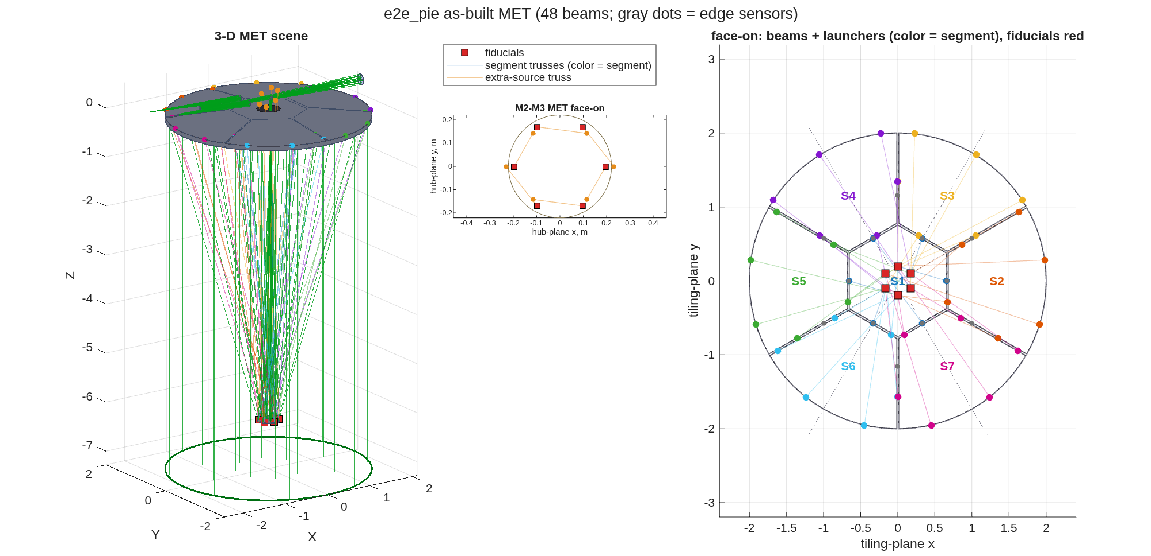
FIGURE 14 The as-built truss (e2e_pie_met_layout.png): the 3-D scene, the fiducials on the secondary’s rim (the inset’s axes are labeled mm; the deck’s units are metres), and the face-on view of the beams and launchers, colored by segment, with the edge sensors as gray dots.
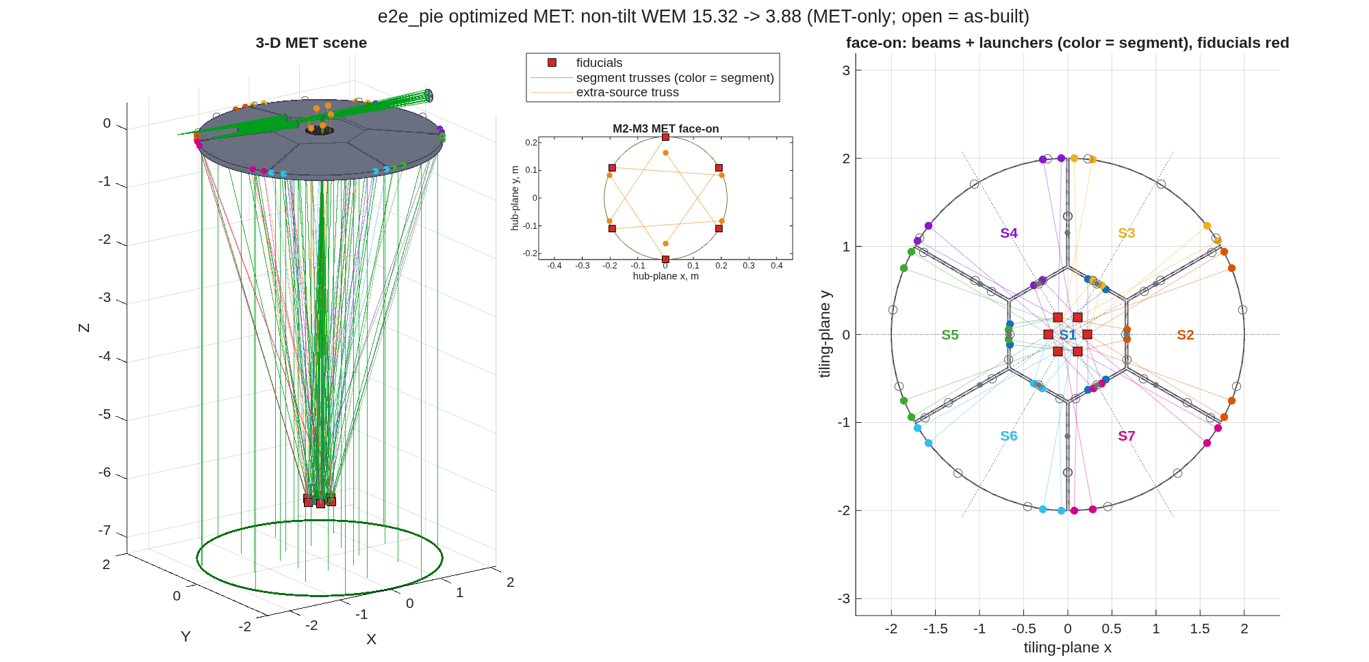
FIGURE 15 The optimized truss, the same views (open circles: the as-built launchers).

5.4 Checking the assistant’s work
Two things to check, both in the report.
The search’s answer has to be a layout the hardware can build. The corner-pairs row of [4b] is close to the optimizer’s score, but its last column is the closest separation of two launchers, 15 mm, and the rule is 50 mm. The optimizer searches only layouts that keep the rule (min_sep; if none did, it would keep the as-built truss and say so). A score next to a layout that cannot be built is not a result.
The statistics have to agree. Step [5] draws 200 drifts from the prior, each with a noisy reading of the edge sensors and the optimized truss, corrects each by its estimate, and measures the wavefront left: 0.020 nm rms, against the analytic 0.020 nm. The draws are seeded, so this run repeats.
The library’s committed record of this stage was not produced by its committed script: its report says the layout was held from a saved preset, and the script as committed searches afresh. The search lands on a different pattern for the center hexagon than the preset holds, and the committed optimized WEM reads lower than this run’s (the open questions list has both). This manual prints the search the script runs.

5.5 What to ask next
- “Hold the layout from the preset and just score it.” – run_met(..., 'opt_preset', <file>).
- “Optimize with the edge sensors in the merit.” – 'optimize_with_edge', true.
- “Does the linear model match the engine?” – Section 6.

SECTION 6: Closing the Loop
Sections 4 and 5 built a linear model of the telescope and its sensors. This section asks two questions of it. Is the linear model the engine? Poke every degree of freedom in the engine, and compare the response with the model’s prediction. And does the loop built on it hold the wavefront? Play a disturbance history through the engine, with wavefront control and the metrology loop running, and watch the wavefront for 500 seconds.

6.1 You ask
Check the linear model against the engine, degree of freedom by degree of freedom, for the wavefront, the metrology and the edge sensors. Then simulate 500 s of drift with image-based wavefront control, the metrology loop holding pose, and a maintenance recontrol at 400 s: once with a metrology bias the loop cannot see, once with a figure drift it cannot sense.

6.2 The assistant reads
- MACOS_resources/mmacos/templates/80_end_to_end/e2e/README.md, the s6_compare.m and s7_simulate.m rows – what each pokes or plays, the two scenarios, and the two-pass rule: the engine runs the uncorrected and the corrected histories as two passes, because plus and minus the control do not commute through the engine’s incremental perturbation path.
- MACOS_resources/mmacos/design/runners/run_compare.m and run_simulator.m – the runners: the engine truth for each measurement, the estimator (a weighted least-squares pose estimate with a prior) and the controller.
- MACOS_resources/mmacos/src/+macos/opd_ref.m, its help text – the OPD map’s reference, the chief ray (the default) or the aperture mean. The harvest records which one it used, and the comparison follows it (below).

6.3 It runs: the linear model against the engine
The stage-6 script, unchanged, in the thread directory:
run('<path-to>/mmacos/templates/80_end_to_end/e2e/s6_compare.m')
It pokes each of the 54 rigid-body degrees of freedom by 100 nrad or 100 nm, each of the 56 figure modes and each of the 42 grid influence functions by 100 nm, and for every poke draws the engine’s response beside the model’s: the center-field wavefront change, the metrology beam lengths, and the edge sensors’ piston, gap and shear. The report’s header and its summary (the per-poke table is in s6_report.txt):
==== run_compare: <thread>/e2e_pie.in ====
[0] 9 bodies (7 segments), channels [x z grid]; met Rx <thread>/e2e_pie_metopt.in
jac: center field 11950 x 54 x-cols; dedx 72x54; dldx 48x54
baseline: 11950 OPD pixels (jac mask mismatch 0 px), 48 met beams, 72 edge rows
OPD reference: chief (the harvest's), piston removed on both sides
[3] worst engine-vs-linear agreement per channel:
x ( 54 pokes): w 2.83e-03 (Seg 3 Rz +100 nrad), l < 1e-05, e < 1e-06
z ( 56 pokes): w 9.61e-04 (Seg 4 Z8 +100 nm), l null, e null
grid ( 42 pokes): w 2.63e-01 (Seg 7 G5 +100 nm), l null, e null
(4 poke(s) below the 0.001 nm response floor -- no physical
response, engine delta is FD noise; rel = null)
(rel = engine-vs-linear residual over the engine response;
at these poke sizes this measures the linearization error.
z/grid l/e: the LINEAR side shows the dmdz/dmdgrid figure-
sensing model (mode shape at each mount point); the ENGINE
METcalc/Hx hold met and sensor points RIGID, so its bars
read zero -- a known engine-model gap, not a failure.)
dmdz: |l| model up to 409.4 nm, |e_piston| up to 92.97 nm per 100 nm figure
dmdgrid: |l| model up to 463.3 nm, |e_piston| up to 432.5 nm per 100 nm figure
NOTE (grid w rel): the truth is a plain forward poke at 100 nm;
the harvest Jacobian is central-FD at 1e-06 (BaseUnits). The
engine's grid-surface response is NOT proportional across
sub-um amplitudes on metre-based prescriptions (central FD at
the harvest delta reproduces the Jacobian to ~2e-5; forward
100 nm deviates ~15-25% on e2e, <5% on the mm fixture) --
flagged for engine review (FreeForm grid intersection path,
2026-07-19). x and z channels do not show this.
control u = bodies [1 2 3 4 5 6 7 8] -> dwdu 59750 x 48 (multi-field stack) for the simulator
artifacts: s6_compare.mat, frames in s6_frames/, s6_compare.gif, this report
next stage: run_simulator (single-step static estimator + controller over a time history).
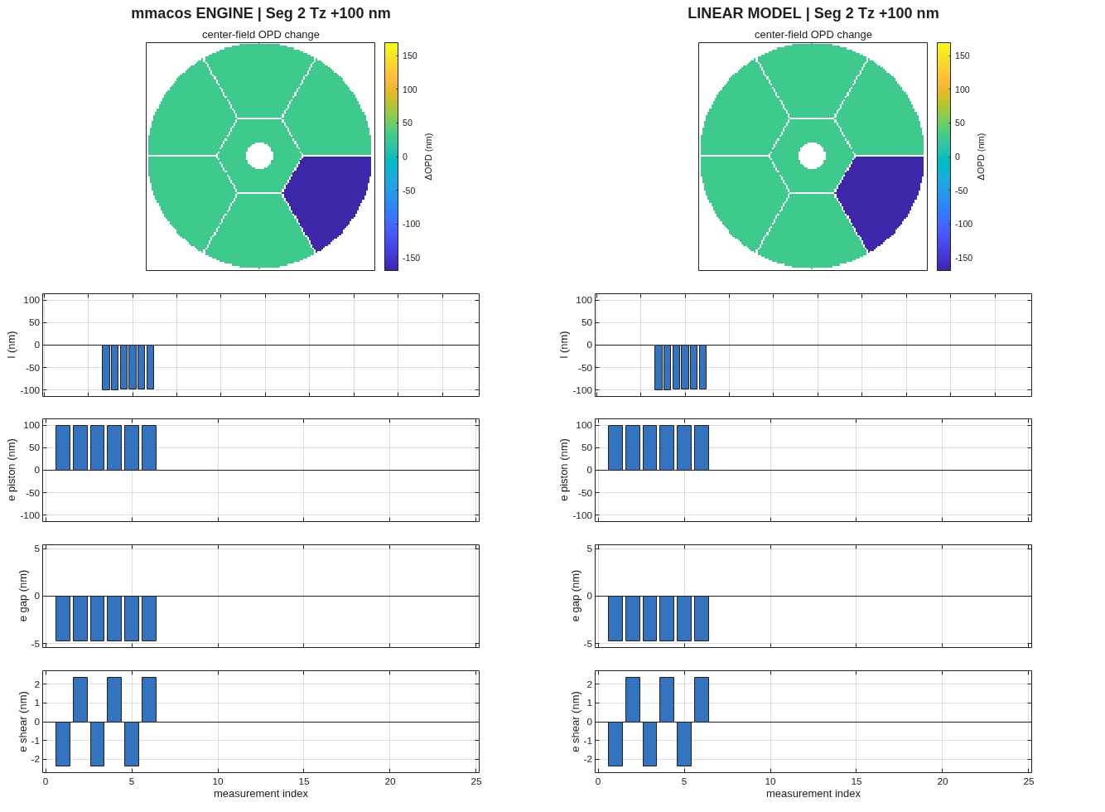
FIGURE 16 One rigid-body poke, segment 2 piston +100 nm: the engine (left) and the linear model (right), both referenced to the chief ray.
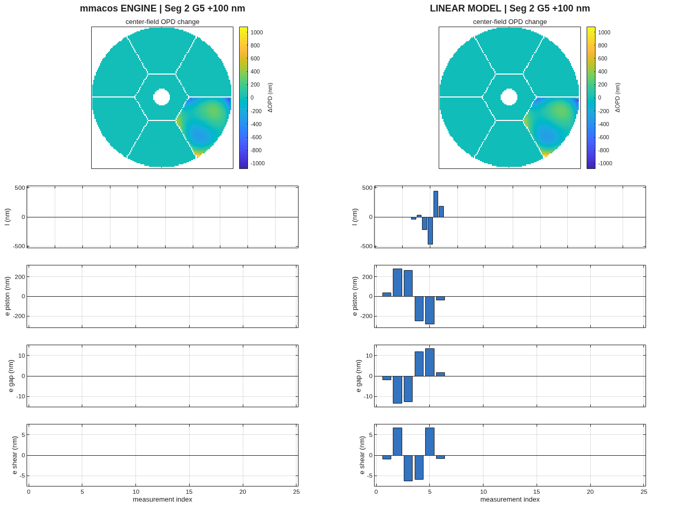
FIGURE 17 One grid poke, segment 2 influence function 5: the wavefront agrees in shape; the engine’s measurement bars read zero, because the engine holds the metrology and sensor points rigid for figure states (the report says so), while the model shows what the figure-sensing model predicts.

6.4 Checking the assistant’s work
The measurements agree to the noise of the comparison: the metrology beams to < 1e-05 and the edge sensors to < 1e-06, relative. So does the wavefront: the worst rigid-body poke reads 2.83e-03 and the worst figure mode 9.61e-04, relative, the linearization error at these poke sizes.
Both sides use the same OPD reference, and that matters. The engine references the OPD map to the chief ray by default. The Section 4 harvest used the same reference and recorded it in its output, and the comparison reads that record and sets the engine to match (the report’s header line). Under the chief-ray reference, a poke that moves the chief ray’s own path adds a constant across the whole map: a piston. Here is one poke, segment 1 piston +100 nm, measured under each reference, beside the linear column:
>> macos.init(512);
>> n = macos.load_rx('e2e_pie_metopt.in'); macos.opd_ref('chief');
>> macos.trace(n-1); W0 = macos.opd(); macos.perturb(1, 'translation', [0;0;1e-7]); macos.modify();
>> macos.trace(n-1); d = macos.opd() - W0;
chief rms 188.9 nm mean 178.4 nm rms about the mean 61.98 nm
>> n = macos.load_rx('e2e_pie_metopt.in'); macos.opd_ref('mean');
>> macos.trace(n-1); W0 = macos.opd(); macos.perturb(1, 'translation', [0;0;1e-7]); macos.modify();
>> macos.trace(n-1); d = macos.opd() - W0;
mean rms 61.98 nm mean < 1e-09 nm rms about the mean 61.98 nm
>> the Section 4 column (Elt 1 Tz, center field, harvested at 'chief') x 100 nm:
linear rms 188.9 nm mean 178.4 nm rms about the mean 61.98 nm
The engine under the chief-ray reference gives 188.9 nm rms, 178.4 nm of it a constant; under the mean reference 61.98 nm. The linear column carries the same constant (188.9 nm rms, mean 178.4 nm), and about its mean it is 61.98 nm, the engine’s change under either reference. (The macos.modify() after the perturb matters: without it the next trace reuses the cached geometry and the change reads zero.)
A corrector cannot see piston, and an image does not depend on it. So every tool that uses these columns removes piston over each field’s pupil by default, on both sides of every comparison: the comparison above, the simulator below, the metrology runner of Section 5, the conditioning of Section 4 and the budget of Section 7. With piston removed, a harvest under either reference gives the same control, the same metrology prior and the same simulation, so the numbers in this section and in Section 5 do not depend on the choice. Each tool takes the option 'piston', 'remove' by default or 'keep' for an interferometer, which does read the piston between fields or arms; the e2e thread sets it once, P.piston in e2e_params.m, and every report prints the choice beside the OPD reference. The lesson: an engine-against-model check is only as good as the conventions both sides share, and a quantity no sensor or image can see should not reach the estimator.
The grid channel’s miss, 2.63e-01, has a second cause the report names in its note: the engine’s grid-surface response is not proportional across sub-micrometre amplitudes on a metre-based prescription, an open engine question.

6.5 It runs: the loop
The stage-7 script, unchanged. Its random draws are seeded (rng(7) in s7_simulate.m), so a rerun from this page gives these numbers:
run('<path-to>/mmacos/templates/80_end_to_end/e2e/s7_simulate.m')
Both scenarios start from the as-deployed telescope, about 100 µm of wavefront error, mostly segment piston and tilt; image-based wavefront control comes on at 20 s, the metrology loop holds pose from then on, and a wavefront-maintenance recontrol runs at 400 s. Scenario A, the metrology bias: the metrology’s zero point drifts, so the loop faithfully holds a biased reading while the true pose walks away, unseen.
==== run_simulator: <thread>/e2e_pie.in ====
[0] 9 bodies (7 segments), T = 50 frames, dt = 10 s
states: x 54x50; sim Rx <thread>/e2e_pie_metopt.in
OPD reference chief (the harvest's), piston removed on both sides
[1] baseline on <thread>/e2e_pie_metopt.in: 11950 rays in pupil; psf @ elt 17, peak 6.53e+03;
COMPOSE band [4.85e-07 5e-07 5.15e-07] WaveUnits, 128 px @ 2.18 um; engine l cross-checked (corrected leg)
[2] channels in motion: 48 rigid, 0 zernike, 0 grid
[3] pass 1 (uncorrected): 10 20 30 40 50 done
initial wavefront control @ frame 2 (t=20 s): uncorrected w rms 100.8 um -> predicted residual 6.556 nm
(u on 8 bodies, ridge 0.0003, 21/48 directions with sv > lam, |u| max 0.0001353)
wfc iteration 2: engine residual 2159 nm -> update |du| max 2.158e-06
wfc iteration 3: engine residual 1.155 nm -> update |du| max 1.313e-06
[3b] metrology loop ON (RBCS weighted-LS estimator + pose-error controller):
R_meas = (H'N^-1 H + Rx^-1)^-1 H'N^-1, kp 0.5, rho 0; sensor sigma [1e-12 1e-09] m;
state prior sigma 2.1e-11..2.1e-08 m (auto from drift stats); loop senses figure: 1; meas bias: 1
WF-maintenance recontrol at t = 400 s (reset ridge 0.0003)
[5] final: rms WFE 1.008e+05 nm uncorrected vs 11.81 nm corrected;
Strehl 0.0000 uncorrected vs 0.9782 corrected (1.0140 broadband); worst w_rel 2.14e-02
engine-l cross-check (corrected leg): worst l_rel 3.47e-05
artifacts: s7A_sim.mat, frames in s7A_sim_frames/, s7A_sim.gif, this report
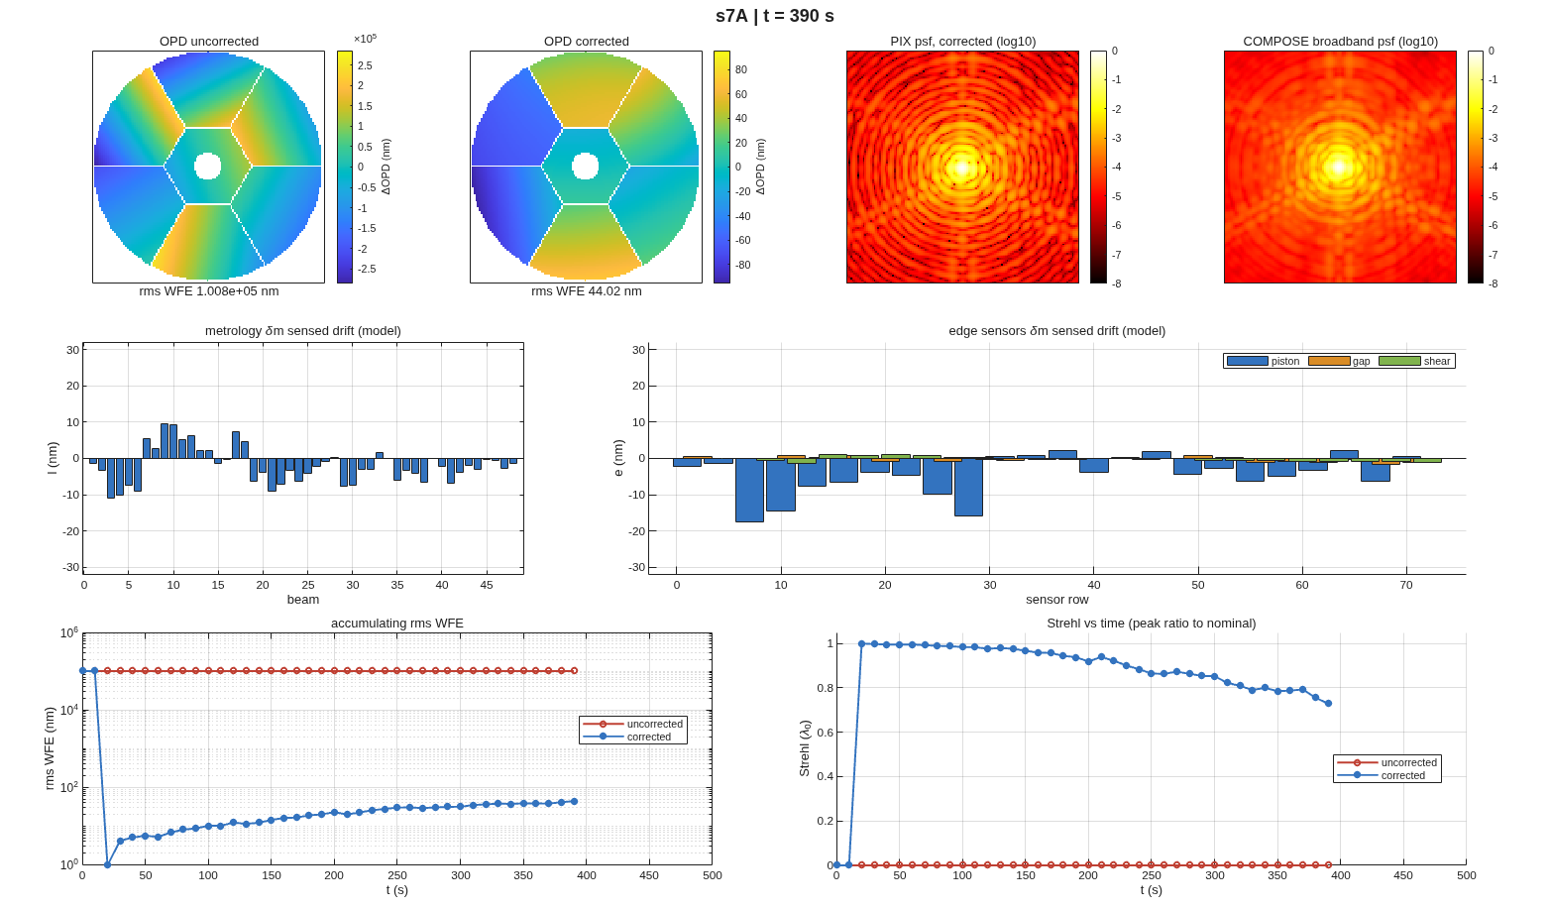
FIGURE 18 Scenario A at 390 s, just before the recontrol: the uncorrected and corrected wavefronts, the corrected point-spread functions (monochromatic and broadband), the sensed drift of the metrology and the edge sensors, and the history of the wavefront error and the Strehl ratio.
The corrected wavefront drifts to 44.02 nm by 390 s; the recontrol at 400 s takes it to 0.843 nm, and it re-accumulates to 11.81 nm by 500 s. Scenario B, a figure drift: each segment’s focus and astigmatism trend, the low-order modes that drift thermally, while the truss reads only rigid pose.
==== run_simulator: <thread>/e2e_pie.in ====
[0] 9 bodies (7 segments), T = 50 frames, dt = 10 s
states: x 54x50, z 56x50, g 42x50; sim Rx <thread>/s4_grid.in
OPD reference chief (the harvest's), piston removed on both sides
[1] baseline on <thread>/s4_grid.in: 11950 rays in pupil; psf @ elt 17, peak 6.53e+03;
COMPOSE band [4.85e-07 5e-07 5.15e-07] WaveUnits, 128 px @ 2.18 um; (grid Rx: no metrology) engine l model-only
[2] channels in motion: 48 rigid, 21 zernike, 42 grid
[3] pass 1 (uncorrected): 10 20 30 40 50 done
initial wavefront control @ frame 2 (t=20 s): uncorrected w rms 100.8 um -> predicted residual 24.33 nm
(u on 8 bodies, ridge 0.0003, 21/48 directions with sv > lam, |u| max 0.0001354)
wfc iteration 2: engine residual 2159 nm -> update |du| max 6.671e-06
wfc iteration 3: engine residual 19.78 nm -> update |du| max 6.011e-06
[3b] metrology loop ON (RBCS weighted-LS estimator + pose-error controller):
R_meas = (H'N^-1 H + Rx^-1)^-1 H'N^-1, kp 0.5, rho 0; sensor sigma [1e-12 1e-09] m;
state prior sigma 2.1e-11..2.1e-08 m (auto from drift stats); loop senses figure: 0; meas bias: 0
WF-maintenance recontrol at t = 400 s (reset ridge 1e-05)
[5] final: rms WFE 1.008e+05 nm uncorrected vs 30.15 nm corrected;
Strehl 0.0000 uncorrected vs 0.8695 corrected (0.9830 broadband); worst w_rel 2.14e-02
m bars are the LINEAR measurement model (grid Rx declares no metrology;
the engine METcalc/Hx hold met/sensor points rigid for figure states)
artifacts: s7B_sim.mat, frames in s7B_sim_frames/, s7B_sim.gif, this report
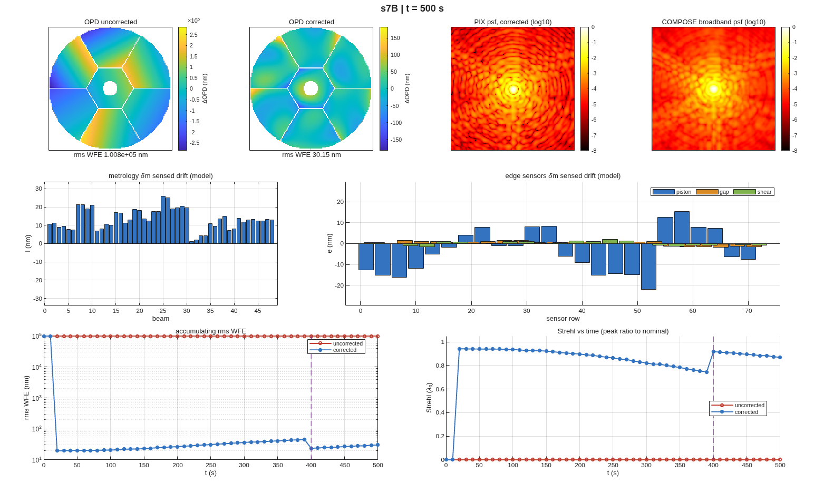
FIGURE 19 Scenario B at 500 s, the same panels; the dashed line marks the recontrol.
The figure accumulates unseen to 45.35 nm; the recontrol, with a tight ridge that engages the segments’ lateral motions (a decentered segment on a curved parent changes its own best-fit radius), removes the focus and part of the astigmatism, to 23.64 nm. What is left, the higher orders and the static grid figure, no rigid-body control removes; it reads 30.15 nm at 500 s. (The broadband Strehl ratio can read slightly above 1: it is a peak ratio against a nominal image, not the exact aperture form.)

6.6 What to ask next
- “Harvest at the mean reference and rerun Sections 5 and 6.” – run_sensitivities’s opd_ref option; the piston-free tools give the same control, prior and simulation.
- “Keep the piston, as an interferometer would.” – P.piston = "keep": the tilt share of the metrology prior and the uncorrected wavefront now count it.
- “Give the loop the figure states.” – the README’s next step: a steady-state Kalman form with the figure-sensing matrices of Section 6 in the estimator.
- “What does all this cost in the error budget?” – Section 7.

SECTION 7: An Error Budget
The last product of the design is not an optic; it is a table that systems engineering can carry: every error source, its allowed size, how much wavefront it costs, and the total against the requirement. With linear sensitivities in hand, that table is a covariance calculation (Redding 2014, Optical error budgeting using linearized ray-trace models). A properly formed RSS budget is a covariance analysis, and a Monte-Carlo of the same model gives the same answer.
This section steps off the thread. The e2e flow has no budget stage, and a budget for it needs its group table, one allowed sigma per error line, which is a design decision rather than a computation (the open questions list asks for it). The library’s worked budget is on e5hex1.in, a public seven-segment hex telescope, the same class as the thread’s pie, budgeted after wavefront control with the seven segments and the secondary as the actuators.

7.1 You ask
Build the error budget for the seven-segment telescope after wavefront control: alignment errors on every optic, the segments and the secondary controlled, 3 nm of sensing noise, 1 nm of actuator noise. Give me the covariance total, a Monte-Carlo check, and a workbook the systems engineer can edit.

7.2 The assistant reads
- MACOS_resources/mmacos/templates/50_sensitivities/e5hex1_budget/README.md – the method, the group table as the interface, the WFC stage (which rows a controller removes, and the two kinds of rows it adds: sensing error and actuator noise), and the live-formula workbook.
- MACOS_resources/mmacos/design/runners/run_budget.m, its help text – the stage runner: the options for the controlled budget and for the metrology stage, the artefacts.
- budget_spec_e5hex1.m – the group table itself, printed below.

7.3 It runs
The budget’s inputs are one file, the group table, with the controller’s noise inputs at its end:
function [T, act, wfs] = budget_spec_e5hex1()
%BUDGET_SPEC_E5HEX1 Example error-budget group table for e5hex1.
% [T, ACT, WFS] = budget_spec_e5hex1() returns the group table T, one row
% per budget line, grouped by element ROLE (PM segments, SM, lens,
% detector) x rigid-body DOF type -- the canonical macos.budget schema
% (authorable equally as this .m, a CSV, or an Excel sheet; see
% macos.budget.read_spec) -- plus the WFC stage's noise inputs:
% ACT actuator noise per control group (run_budget 'act_sigma')
% WFS WFS noise per wavefront sample (run_budget 'wfs_sigma')
% Consumed by run_budget_e5hex1.m / run_budget.
%
% Sigmas: the same illustrative alignment-class values per DOF type as
% the v1 table (tilt 50 nrad, clocking 100 nrad, decenter 100 nm,
% despace uniform +/-200 nm), split by role -- so the UNCONTROLLED total
% is v1's to round-off (the coefficients are additive over columns).
% Edit for a real budget.
%
% Control set (Dave 2026-10-15): 6 DOF per PM segment + the SM's 6 DOF
% (Control = 'WFC'); this deck has no DM / FCA. Noise (Dave's ruling):
% WFS 3 nm rms per wavefront sample (phase retrieval on image data)
% actuator 1 nm per DOF; a ROTATION takes 1 nm of EDGE motion,
% theta = 1 nm / r_edge, with r_edge the optic's edge radius:
% PM segment: hex vertex radius (width - gap)/sqrt(3)
% = (2666.667 - 50)/sqrt(3) = 1510.73 mm
% -> 0.66193 nrad
% SM: ApVec radius 615 mm -> 1.62602 nrad
% (clocking uses the same radius: the vertex moves r*theta).
%
% Columns: Name Elements DOFs Modes Param Channel Dist Sigma Units
% Min Max Cov Control Section (Section = the workbook's column
% A grouping: Primary Mirror / Secondary Mirror / Lens /
% Detector -- a proposed layout, Dave's to change).
seg = '1 2 3 4 5 6 7';
rows = { ...
'PM Seg Tilt', seg, 'tilt', '', '', 'dwdx', 'normal', 50, 'nrad', NaN, NaN, 'iid', 'WFC', 'Primary Mirror'; ...
'PM Seg Clocking', seg, 'clock', '', '', 'dwdx', 'normal', 100, 'nrad', NaN, NaN, 'iid', 'WFC', 'Primary Mirror'; ...
'PM Seg Decenter', seg, 'decenter', '', '', 'dwdx', 'normal', 100, 'nm', NaN, NaN, 'iid', 'WFC', 'Primary Mirror'; ...
'PM Seg Piston', seg, 'despace', '', '', 'dwdx', 'uniform', NaN, 'nm', -200, 200, 'iid', 'WFC', 'Primary Mirror'; ...
'SM Tilt', '8', 'tilt', '', '', 'dwdx', 'normal', 50, 'nrad', NaN, NaN, 'iid', 'WFC', 'Secondary Mirror'; ...
'SM Clocking', '8', 'clock', '', '', 'dwdx', 'normal', 100, 'nrad', NaN, NaN, 'iid', 'WFC', 'Secondary Mirror'; ...
'SM Decenter', '8', 'decenter', '', '', 'dwdx', 'normal', 100, 'nm', NaN, NaN, 'iid', 'WFC', 'Secondary Mirror'; ...
'SM Despace', '8', 'despace', '', '', 'dwdx', 'uniform', NaN, 'nm', -200, 200, 'iid', 'WFC', 'Secondary Mirror'; ...
'Lens Tilt', '9 10', 'tilt', '', '', 'dwdx', 'normal', 50, 'nrad', NaN, NaN, 'iid', '', 'Lens'; ...
'Lens Clocking', '9 10', 'clock', '', '', 'dwdx', 'normal', 100, 'nrad', NaN, NaN, 'iid', '', 'Lens'; ...
'Lens Decenter', '9 10', 'decenter', '', '', 'dwdx', 'normal', 100, 'nm', NaN, NaN, 'iid', '', 'Lens'; ...
'Lens Despace', '9 10', 'despace', '', '', 'dwdx', 'uniform', NaN, 'nm', -200, 200, 'iid', '', 'Lens'; ...
'FPA Tilt', '13', 'tilt', '', '', 'dwdx', 'normal', 50, 'nrad', NaN, NaN, 'iid', '', 'Detector'; ...
'FPA Clocking', '13', 'clock', '', '', 'dwdx', 'normal', 100, 'nrad', NaN, NaN, 'iid', '', 'Detector'; ...
'FPA Decenter', '13', 'decenter', '', '', 'dwdx', 'normal', 100, 'nm', NaN, NaN, 'iid', '', 'Detector'; ...
'FPA Despace', '13', 'despace', '', '', 'dwdx', 'uniform', NaN, 'nm', -200, 200, 'iid', '', 'Detector'};
T = cell2table(rows, 'VariableNames', {'Name','Elements','DOFs','Modes', ...
'Param','Channel','Dist','Sigma','Units','Min','Max','Cov','Control', 'Section'});
r_seg = (2666.666666666667 - 50) / sqrt(3) * 1e-3; % m
r_sm = 615e-3; % m
e = 1e-9; % 1 nm edge motion
act = { ...
'PM Seg Tilt', e / r_seg * 1e9, 'nrad'; ...
'PM Seg Clocking', e / r_seg * 1e9, 'nrad'; ...
'PM Seg Decenter', 1, 'nm'; ...
'PM Seg Piston', 1, 'nm'; ...
'SM Tilt', e / r_sm * 1e9, 'nrad'; ...
'SM Clocking', e / r_sm * 1e9, 'nrad'; ...
'SM Decenter', 1, 'nm'; ...
'SM Despace', 1, 'nm'};
wfs = {3, 'nm'};
end
Every row names elements, a degree-of-freedom type, a distribution and its size. The Control column tags the rows the controller acts on. The actuator noise for a rotation is stated as 1 nm of motion at the optic’s edge, converted to an angle by its radius in the file.
The template’s runner, unchanged, harvests the rigid-body sensitivities (macos.dw_dx_multi, five field points, model size 128) and calls run_budget. It writes its products beside itself, among them the committed workbook, so the manual runs a copy of the template’s folder: the library’s files were checked by checksum before and after and are untouched.
run('<path-to>/mmacos/templates/50_sensitivities/e5hex1_budget/run_budget_e5hex1.m')
The report:
MACOS error budget: e5hex1
metric=opd base_units= cbm=0.001 nw=51225 Nz=66
piston removed (harvest opd_ref chief)
control: 48 DOFs projected (post-WFC)
group class sigma alpha WFE(nm)
PM Seg Tilt angle 5e-08 < 1e-06 < 1e-06
PM Seg Clocking angle 1e-07 < 1e-06 < 1e-06
PM Seg Decenter length_si 1e-07 < 1e-06 < 1e-06
PM Seg Piston length_si 1.155e-07 < 1e-06 < 1e-06
SM Tilt angle 5e-08 < 1e-06 < 1e-06
SM Clocking angle 1e-07 < 1e-06 < 1e-06
SM Decenter length_si 1e-07 < 1e-06 < 1e-06
SM Despace length_si 1.155e-07 < 1e-06 < 1e-06
Lens Tilt angle 5e-08 0.003225 0.0001613
Lens Clocking angle 1e-07 0.0006174 6.174e-05
Lens Decenter length_si 1e-07 0.001631 0.0001631
Lens Despace length_si 1.155e-07 0.01162 0.001342
FPA Tilt angle 5e-08 0.00345 0.0001725
FPA Clocking angle 1e-07 0.1152 0.01152
FPA Decenter length_si 1e-07 0.001635 0.0001635
FPA Despace length_si 1.155e-07 0.0003083 3.56e-05
WFS Sensing Error wfs 3e-06 0.03061 0.09183
PM Seg Tilt Actuator act 6.619e-10 1936 1.281
PM Seg Clocking Actuator act 6.619e-10 0.7881 0.0005216
PM Seg Decenter Actuator act 1e-09 37.47 0.03747
PM Seg Piston Actuator act 1e-09 1834 1.834
SM Tilt Actuator act 1.626e-09 769.2 1.251
SM Clocking Actuator act 1.626e-09 0.6792 0.001104
SM Decenter Actuator act 1e-09 86.54 0.08654
SM Despace Actuator act 1e-09 12.67 0.01267
pre-WFC TOTAL 236.2
TOTAL (RSS) 2.567
Monte-Carlo (1000 draws) total: 2.573 nm (cov 2.567 nm)
summary preWFC postWFC preMET postMET Total
Primary Mirror WFE 232.9 < 1e-06 0 0 < 1e-06
Secondary Mirror WFE 39.45 < 1e-06 0 0 < 1e-06
Lens WFE 0.0859 0.001363 0 0 0.001363
Detector WFE 1.485 0.01152 0 0 0.01152
WFC WFE 0 2.567 0 0 2.567
Everything Else 39.48 2.567 0 0 2.567
TOTAL 236.2 2.567 0 0 2.567
Design WFE NaN NaN NaN NaN 0
Payload WFE NaN NaN NaN NaN 2.567
WFE Requirement NaN NaN NaN NaN NaN
WFE Margin NaN NaN NaN NaN NaN
method: Redding 2014, linearized ray-trace covariance budget.
The controlled rows (the segments and the secondary) are gone after control; what is left of them is a projection residual at the floor of the arithmetic, printed as a bound. The lens and the detector are not controlled, and their alignment errors pass through, small here because their sensitivities are small. The total, 2.567 nm against 236.2 nm before control, is the cost of control itself: the actuator rows (segment piston 1.834 nm, segment tilt 1.281 nm, secondary tilt 1.251 nm) and the sensing error (0.09183 nm, the part of 3 nm of white noise the controller can see).
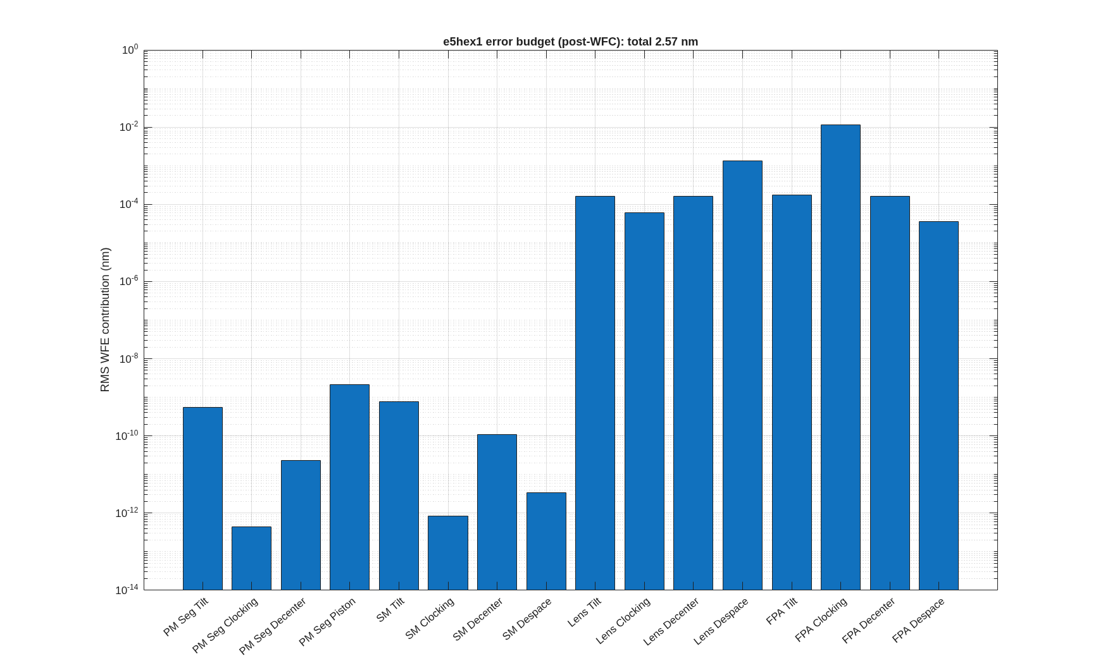
FIGURE 20 The per-group chart the runner draws (e5hex1_budget.png). It shows the alignment groups only: the actuator and sensing rows, which make up the 3.16 nm in its title, are not in it, and the controlled groups’ bars are the projection residuals, numerical zeros (the report prints them as < 1e-06).
The budget a systems engineer uses is the workbook the runner writes beside the report, e5hex1_wfe_budget.xlsx, in the form of the HabEx budget: white cells are inputs (the sigmas), gray cells formulas, so a changed sigma re-rolls the payload total without MATLAB. Its README records that LibreOffice’s recalculated total matches the MATLAB total to 5.6e-16.

7.4 Checking the assistant’s work
The check is built in: the Monte-Carlo line. 1000 draws of every error source, each put through the same controller with sensing and actuator noise drawn in the loop, give 2.573 nm against the covariance’s 2.567 nm. They are the same model computed two ways; an assistant that changed the controller in one and not the other would see them part.
A second check is the units of the rotation rows: the actuator sigma for segment tilt is 1 nm / 1510.73 mm = 0.662 nrad, and the file shows the arithmetic. A budget whose rotation inputs had been typed in degrees, or per millimetre, would be off by orders of magnitude, and the table would say so line by line.

7.5 What to ask next
- “Budget the thread’s telescope.” – run_budget takes any sensitivities artefact: the s4_sens.mat of Section 4 and a group table for e2e (macos.budget.suggest_groups proposes a skeleton, with placeholder sigmas to replace).
- “Add the metrology stage.” – run_budget(..., 'met', ...) with the drift table and the metrology Jacobian of Section 5 (macos.budget.project_met) fills the workbook’s drift columns.
- “Change a sigma.” – in the workbook, no MATLAB.

SECTION 8: Coronagraph Analyses on the CTB
Section 2 put the coronagraph testbed, the CTB, behind the thread’s telescope and checked that the beam gets through it. This section asks what the coronagraph does with the light: how dark a focal-plane mask makes the region around the star on its own, how much darker the two deformable mirrors make it under control, what the mirrors’ coatings cost through polarization, and how well the field can be sensed from images alone, as a lab must. Each answer is a template in templates/30_instruments/bench_ctb, run unchanged on a scratch copy.
These analyses run first on the CTB’s own diffraction model: the bench fed by its own point source, from the committed decks ctb_dcr.in and ctb_dm.in (the reference spheres as committed). The last part of the section runs the same chain, control matrix and loop on the thread’s telescope with the CTB folded behind it, the thread’s stages 9 to 11.

8.1 You ask
On the CTB, show me how dark each coronagraph mask gets on its own, then dig a dark hole with the two deformable mirrors, and tell me what the mirror coatings’ polarization costs. Then close the loop on fields estimated from probe images instead of the model’s. Then put the CTB behind the thread’s telescope and do it all again there, down to 10⁻⁸.

8.2 The assistant reads
- templates/30_instruments/bench_ctb/README.md, the “Diffraction layer” and “DM layer” parts – how the field is carried from the source to the detector, why masks are applied in MATLAB and not declared in the deck, and the one trap in the control loop (below).
- ctb_mask_compare.m, its help text – the six mask families, scored on the same deck, grid, dark zone and normalization.
- ctb_dm_jacobian.m and ctb_efc.m, their help texts – the sensitivity matrix measured through the engine, and the control loop that uses it.
- ctb_efc_physics.m, its help text – how the coatings’ polarization enters as pupil screens.
- ctb_probe_estimate.m, its help text – the pairwise-probe estimator, and ctb_efc’s 'sensing' option that closes the loop on it.
- MACOS_resources/optical_design/CORONAGRAPH_DESIGN_RULES.md – the coronagraph rules.
- templates/80_end_to_end/e2e/README.md, the rows for stages 9 to 11 – the coupled model, probing on it, and the recompute-and-restart cycles.

8.3 The dark zone before control
A coronagraph is scored by its contrast: the light left in a region near the star, the dark zone, as a fraction of the star’s peak without the coronagraph. Here the dark zone is the ring from 3 to 15 λ/D around the star. ctb_mask_compare puts six published focal-plane masks on the same bench and scores them the same way:
[cmp] N=1024 lamD_fpa=4.031 px annulus 3-15 lam/D bare peak=6.994e-02
mask kind | DZ mean | DZ median | suppress | thruput
------------------------------------------------------------------------
hard occulter | 2.465e-07 | 6.486e-08 | 6.10e+04 | 25.0%
band-limited | 2.717e-08 | 1.267e-08 | 4.27e+05 | 36.0%
APLC | 2.111e-10 | 7.702e-11 | 2.47e+06 | 27.2%
vortex (matched) | 1.413e-08 | 6.724e-09 | 5.27e+05 | 81.0%
Roddier \pi-mask | 2.401e-06 | 6.665e-07 | 1.42e+03 | 81.0%
dual-zone | 6.820e-06 | 1.883e-06 | 4.03e+02 | 81.0%
------------------------------------------------------------------------
(annulus 3-15 lam/D, Strehl-normalised to bare peak; throughput = off-axis proxy)
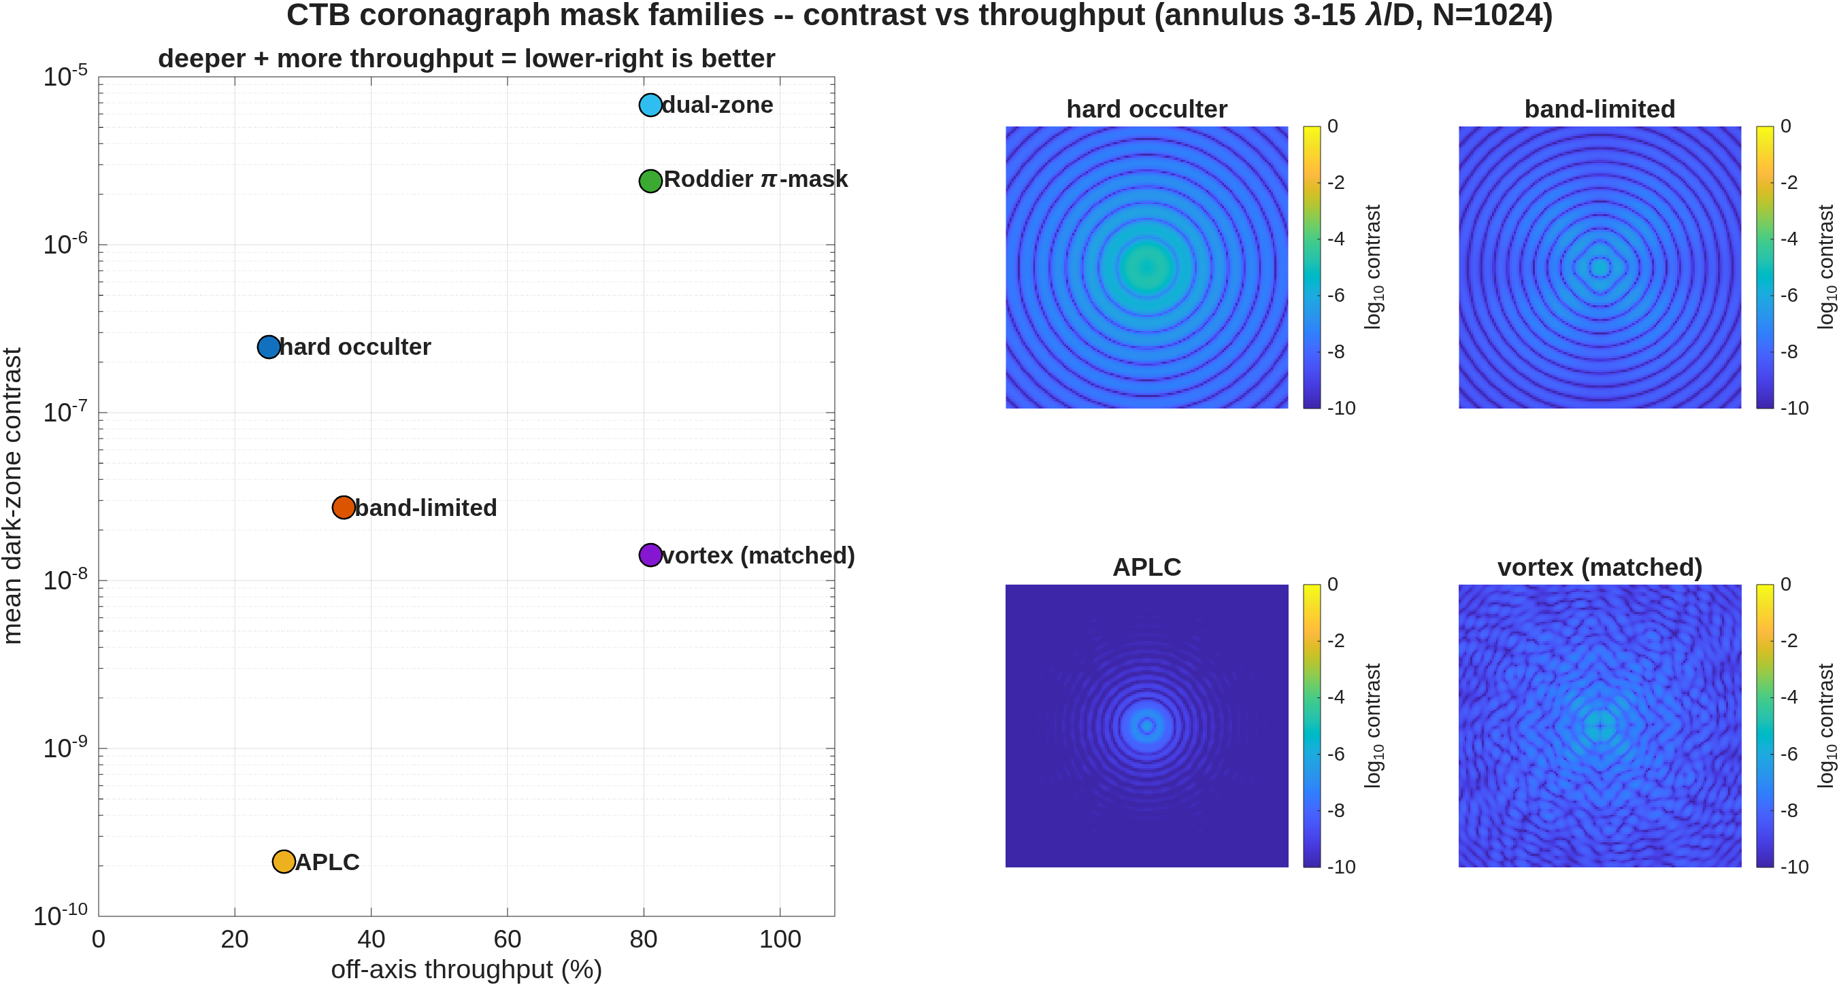
FIGURE 21 The six mask families on the CTB (ctb_mask_compare): dark-zone contrast against off-axis throughput, lower right is better, and the detector image for four of them (log contrast).
Two numbers describe each mask, and they trade against each other. The contrast is how dark the ring is; the throughput is how much of a planet’s light gets through the masks. The simple opaque spot, the hard occulter, reaches 2.5e-7 at 25% throughput. The apodized pupil Lyot coronagraph (APLC) is the darkest, 2.1e-10, at 27%. The charge-6 vortex keeps 81% of the planet at 1.4e-8. The two phase masks, the Roddier π-mask and the dual-zone mask, pass as much light as the vortex but leave the ring two decades or more brighter. The throughput column is a first-order proxy (the area of the Lyot stop, times the apodizer’s fill), good for ranking and not for a photometric budget.

8.4 Closing the loop
No mask on a real bench reaches its design contrast: the optics’ errors scatter starlight into the ring. The two deformable mirrors (DMs) correct that, by electric-field conjugation (EFC). Each actuator of each DM is poked up and down through the full chain, masks and all, and the change in the complex field on the dark-zone pixels is recorded (a central difference: half the difference over the poke). That sensitivity matrix, the Jacobian, then gives the DM commands that cancel the field. The run uses the hard occulter, and measures the Jacobian first (the copy carries none: the 37 MB file is not committed):
[jac] dark zone 3-15 lam/D (annulus): 2748 px, initial mean contrast 2.934e-07
[jac] done: 1760 actuators, central differences, 3520 pokes in <t> min (<t> s/poke)
[efc] G: 2748 px x 1760 acts (real-stacked), s_max=9.995e+02 cond=1.29e+15
[efc] iter 0: contrast 2.934e-07
[efc] iter 1: contrast 1.001e-07 (alpha 1.0e-04, stroke rms [6.98 5.42] nm)
[efc] iter 2: contrast 1.791e-08 (alpha 1.0e-04, stroke rms [8.30 6.82] nm)
[efc] iter 3: contrast 1.155e-08 (alpha 1.0e-03, stroke rms [8.41 7.00] nm)
[efc] iter 4: contrast 1.084e-08 (alpha 1.0e-03, stroke rms [8.56 7.16] nm)
[efc] iter 5: contrast 1.036e-08 (alpha 1.0e-03, stroke rms [8.69 7.30] nm)
[efc] iter 6: contrast 9.974e-09 (alpha 1.0e-03, stroke rms [8.82 7.44] nm)
[efc] iter 7: contrast 9.654e-09 (alpha 1.0e-03, stroke rms [8.94 7.57] nm)
[efc] iter 8: contrast 9.385e-09 (alpha 1.0e-03, stroke rms [9.05 7.69] nm)
[efc] iter 9: contrast 9.157e-09 (alpha 1.0e-03, stroke rms [9.16 7.80] nm)
[efc] iter 10: contrast 8.964e-09 (alpha 1.0e-03, stroke rms [9.27 7.91] nm)
[efc] iter 11: contrast 8.803e-09 (alpha 1.0e-03, stroke rms [9.37 8.02] nm)
[efc] iter 12: contrast 8.668e-09 (alpha 1.0e-03, stroke rms [9.47 8.13] nm)
[efc] iter 13: contrast 8.558e-09 (alpha 1.0e-03, stroke rms [9.56 8.23] nm)
[efc] iter 14: contrast 8.471e-09 (alpha 1.0e-03, stroke rms [9.66 8.33] nm)
[efc] iter 15: contrast 8.404e-09 (alpha 1.0e-03, stroke rms [9.75 8.43] nm)
[efc] iter 16: contrast 8.355e-09 (alpha 1.0e-03, stroke rms [9.84 8.52] nm)
[efc] iter 17: contrast 8.324e-09 (alpha 1.0e-03, stroke rms [9.93 8.62] nm)
[efc] iter 18: contrast 8.298e-09 (alpha 1.0e-02, stroke rms [9.94 8.63] nm)
[efc] iter 19: contrast 8.297e-09 (alpha 1.0e-02, stroke rms [9.94 8.64] nm)
[efc] iter 20: contrast 8.297e-09 (alpha 1.0e-02, stroke rms [9.95 8.65] nm)
[efc] iter 21: contrast 8.297e-09 (alpha 1.0e-02, stroke rms [9.96 8.66] nm)
[efc] iter 22: contrast 8.297e-09 (alpha 1.0e-02, stroke rms [9.97 8.67] nm)
[efc] iter 23: contrast 8.296e-09 (alpha 1.0e-02, stroke rms [9.98 8.68] nm)
[efc] iter 24: contrast 8.296e-09 (alpha 1.0e-02, stroke rms [9.99 8.69] nm)
[efc] iter 25: no alpha improves (best 8.296e-09) -- stop
[efc] final: 2.934e-07 -> 8.296e-09 (35.4x) in 24 iterations
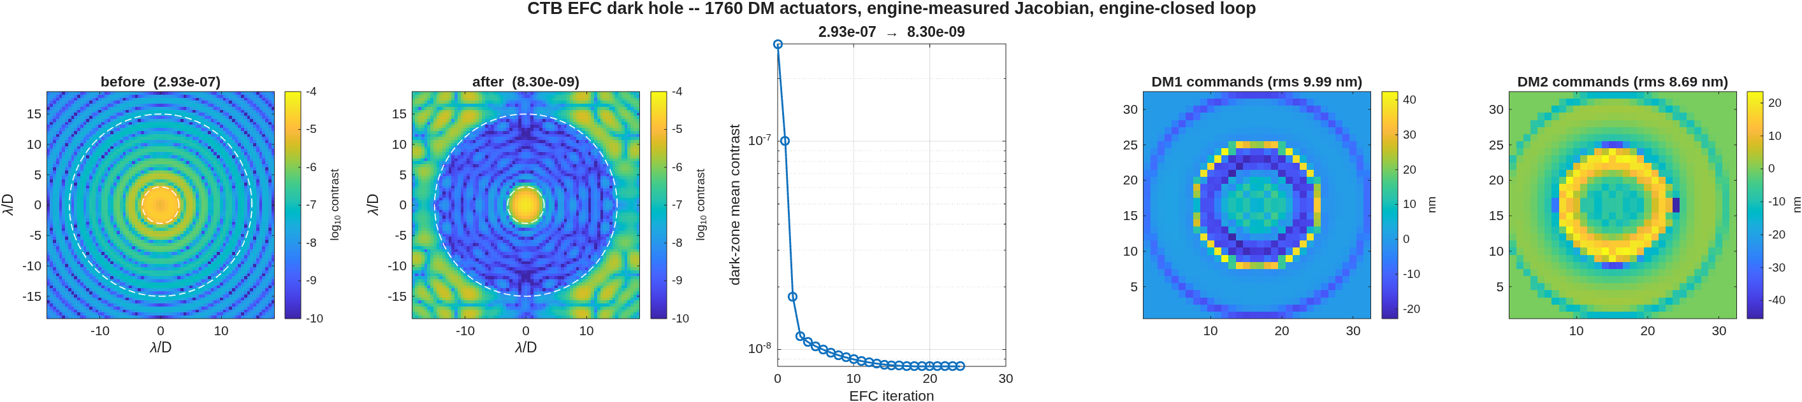
FIGURE 22 The EFC dark hole (ctb_efc): the detector before and after, log contrast with the dark zone’s edges dashed; the contrast at each iteration; and the commands on the two DMs.
1760 actuators on the two DMs dig the ring from 2.93e-7 to 8.30e-9, 35 times darker, in 24 iterations. The loop stops itself when no regularization makes the measured contrast better. The strokes it needs are small: 10.0 nm rms on DM1 and 8.7 nm on DM2. The commands in the figure concentrate in a ring: with a Lyot stop at half the pupil, a ripple across the full beam lands in the dark zone at half its spatial frequency, so the 32-actuator mirrors control cleanly only to about 8 λ/D.
The condition number in the first line, about 1e15, says that some combinations of actuators move nothing in the dark zone. The regularization, line-searched at every iteration, keeps the solve away from them. The loop reads the complex field straight from the engine: it assumes perfect sensing (below).

8.5 What polarization costs
Every reflection off a coated mirror treats the two polarizations slightly differently. The CTB’s ten reflectors are protected aluminium, and ctb_efc_physics computes their combined effect at the exit pupil (macos.jones_pupil) and applies it as four pupil screens, one per component of the Jones matrix, for unpolarized light. One DM setting serves all four components, so what it cannot cancel is the spread between them. The run is the vortex chain (charge 4, Lyot stop at 0.60 of the pupil), twice: without the coatings, and with them:
% scalar vortex, no coatings
[phys] iter 0: contrast 1.716e-08 (band=0 pol=0)
[phys] final: 1.716e-08 -> 5.812e-13 (29522.4x)
% the same, coated train, unpolarized light
[phys] computing coated-train Jones screens...
[phys] iter 0: contrast 2.190e-08 (band=0 pol=1)
[phys] final: 2.190e-08 -> 5.772e-13 (37939.3x) pol floor 1.065e-15
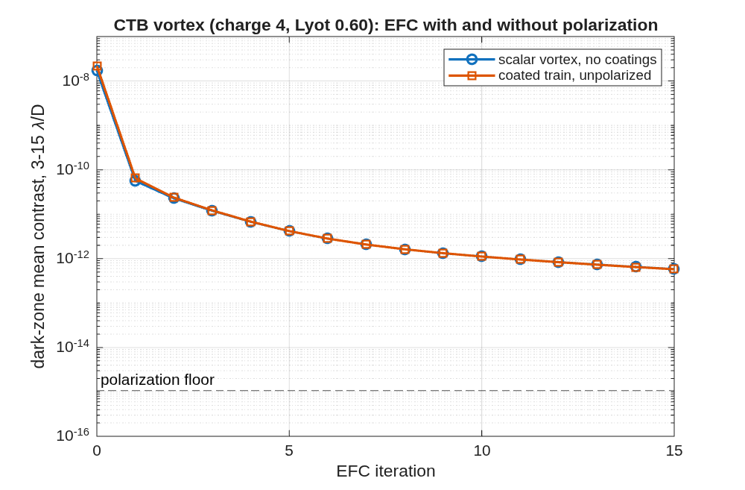
FIGURE 23 EFC on the CTB vortex with and without the coatings’ polarization (this chapter’s driver plots the two runs); the dashed line is the polarization floor.
The coatings make the starting point worse, 2.2e-8 against 1.7e-8 without them: they add a small, smooth aberration that is nearly the same for both polarizations, and the DMs remove it like any other. After the loop’s 15 iterations the two runs reach the same depth, 5.8e-13, with the coatings or without them, and neither has stopped improving. What the DMs cannot reach is the polarization floor, 1.1e-15, about five hundred times below the depth reached here. On this bench polarization does not limit the contrast. The CTB folds gently, every mirror at 5° incidence, and its coatings change little between the polarizations. The floor would rise with steeper folds, which is one reason the fold that puts the CTB in the telescope’s shroud (Section 2) must keep every incidence angle under 15°.

8.6 Sensing
The control loop above reads the complex field directly from the model. A real bench sees only intensity. It estimates the field by pairwise probing (Give’on, Kern and Shaklan, 2011): it puts a small known pattern on a DM, takes the image with the pattern added and with it subtracted, and does this for three patterns. Each difference of a pair is linear in the unknown field, with the Jacobian’s prediction of the probe’s own field as the coefficient, so three pairs give every dark-zone pixel three equations for two unknowns, the field’s real and imaginary parts. ctb_probe_estimate does this through the full masked chain and reads the engine’s true field only to score the estimate. ctb_efc('sensing', ...) closes the loop on the estimate; its default stays perfect sensing. The run measures the Jacobian, estimates the field at the flat DMs, sweeps the probe amplitude and the photon count, repeats the sweep with the probe DM’s columns built the pre-2026-10-28 way (one-sided pokes) for comparison, and then runs ten EFC iterations three ways:
[probe] flat DMs: true contrast 2.934e-07, estimated 2.950e-07
[probe] 3 pairs, default amplitude 9.27 nm peak: estimation floor 4.13e-10, relative field error 3.75e-02
[probe] diagnostic ratios 1.018 1.016 1.016; worst pixel conditioning 9.3
[probe] per-pixel error |dE|^2/peak: median 1.59e-10, 90% 1.30e-09, 99% 2.24e-09, max 2.51e-09
[amp] 0.28 nm: floor 7.29e-15, relative error 1.58e-04, ratios 1.025 1.020 1.019
[amp] 0.93 nm: floor 4.95e-14, relative error 4.11e-04, ratios 1.025 1.020 1.019
[amp] 2.78 nm: floor 3.38e-12, relative error 3.39e-03, ratios 1.025 1.019 1.019
[amp] 9.27 nm: floor 4.13e-10, relative error 3.75e-02, ratios 1.018 1.016 1.016
[amp] 27.81 nm: floor 3.12e-08, relative error 3.26e-01, ratios 0.962 0.986 0.986
[photons] none at the bare peak: floor 4.13e-10, relative error 3.75e-02
[photons] 1e+10 at the bare peak: floor 4.42e-10, relative error 3.88e-02
[photons] 1e+08 at the bare peak: floor 4.09e-09, relative error 1.18e-01
[photons] 1e+06 at the bare peak: floor 3.69e-07, relative error 1.12e+00
[jac] one-sided 2 nm columns vs the central differences, probe DM: median 1.23e-02, max 1.53e-02
[amp, one-sided] 0.28 nm: floor 5.24e-11, relative error 1.34e-02, ratios 1.020 1.015 1.015
[amp, one-sided] 0.93 nm: floor 5.23e-11, relative error 1.33e-02, ratios 1.020 1.015 1.015
[amp, one-sided] 2.78 nm: floor 5.36e-11, relative error 1.35e-02, ratios 1.019 1.014 1.015
[amp, one-sided] 9.27 nm: floor 4.39e-10, relative error 3.87e-02, ratios 1.013 1.011 1.011
[efc] perfect sensing: 2.934e-07 -> 8.964e-09 in 10 iterations
[efc] on the noiseless estimate: 2.934e-07 -> 9.084e-09 in 10 iterations
[efc] on the estimate, 1e+08 photons: 2.934e-07 -> 9.373e-09 in 10 iterations
At the default amplitude, 9.3 nm peak, the probes are as bright as the speckle. The estimate is off by 4.1e-10 of the peak, 3.8% of the field, against a dark zone of 2.93e-7.
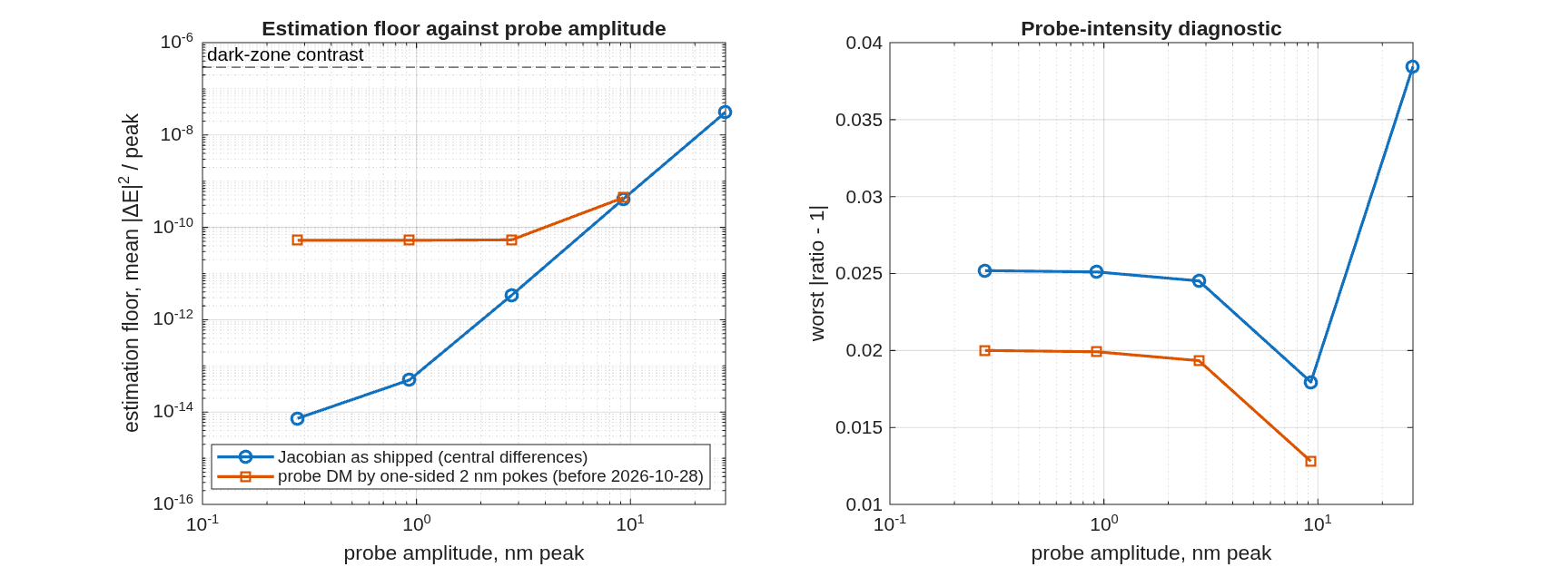
FIGURE 24 Estimation floor and the probe-intensity diagnostic against probe amplitude (this chapter’s driver plots the sweep), with the Jacobian as shipped (central differences) and with the probe DM’s columns from one-sided pokes.
Figure 24 has the main lesson. Large probes fail as the DM’s response stops being linear: at three times the default the error is a third of the field. Small probes reach 1.6e-4 with the Jacobian as ctb_dm_jacobian measures it, central differences at 2 nm. That residual is the Jacobian’s own. One-sided pokes, the method before 2026-10-28, differ from the derivative by up to 1.5%, and the small-probe error then levels off at 1.3%: the Jacobian’s bias, not the probes, sets it. The default amplitude sits at the knee, where the probe’s second-order response is about a tenth of its linear one.
The diagnostic ratio, the probes’ measured intensity over the Jacobian’s prediction, stays within 1.8% of 1 at the default and swings off it only for the largest probe. It does not reveal the one-sided Jacobian’s bias, and with the central-difference Jacobian it reads about 1.02 at every small amplitude. The probe’s second-order field adds to the image in proportion to the probe intensity itself, so the ratio has a floor of its own. Treat a ratio within a few percent of 1 as a sign of no gross mismatch, not as a measure of the estimate’s error.
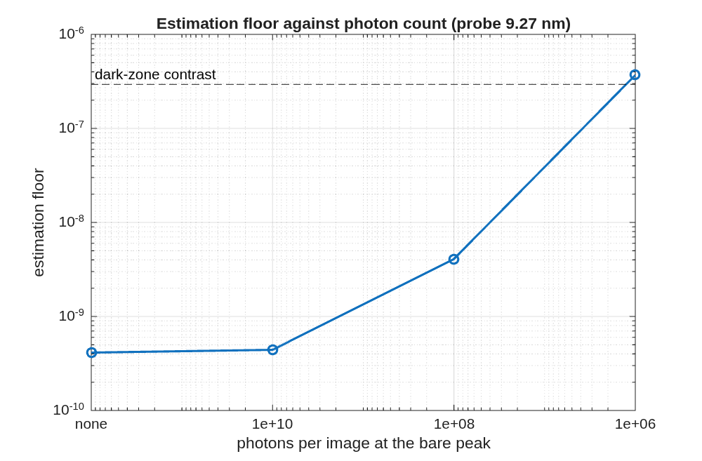
FIGURE 25 Estimation floor against photons per image at the bare peak, default probes.
Photon noise matters below about 1e10 photons per image at the bare peak. At 1e8 the floor is 4.1e-9; at 1e6 it is 3.7e-7, larger than the dark zone itself.
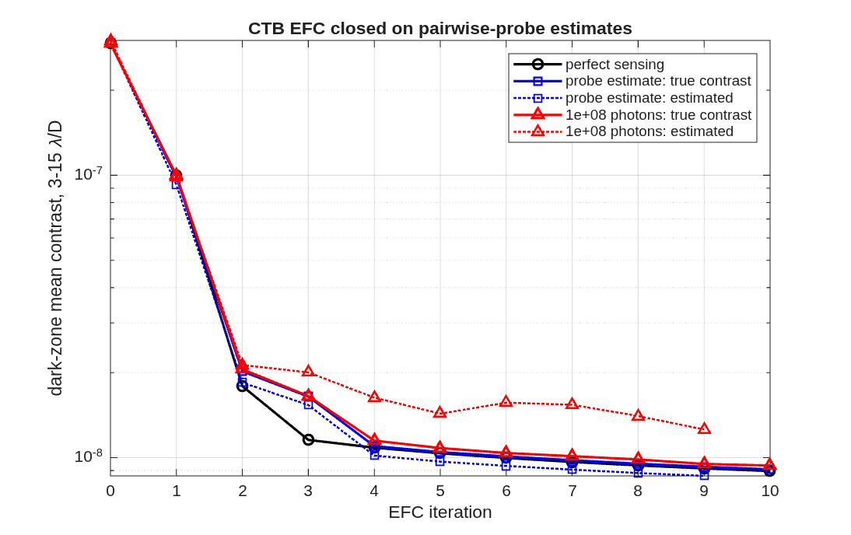
FIGURE 26 EFC closed on probe estimates: the true contrast (solid) and the controller’s estimate (dotted) for noiseless probes and for 1e8 photons, against perfect sensing. The estimate is taken before each iteration, so the estimated curves end one step before the true ones.
Closed on the noiseless estimate, ten iterations reach 9.1e-9, against 9.0e-9 with perfect sensing. With 1e8 photons per image they reach 9.4e-9. The line search still scores each step on the measured contrast, so an estimate that is wrong costs depth, never stability. With noise, the estimated contrast sits above the true one: the noise adds its own power to the estimate.
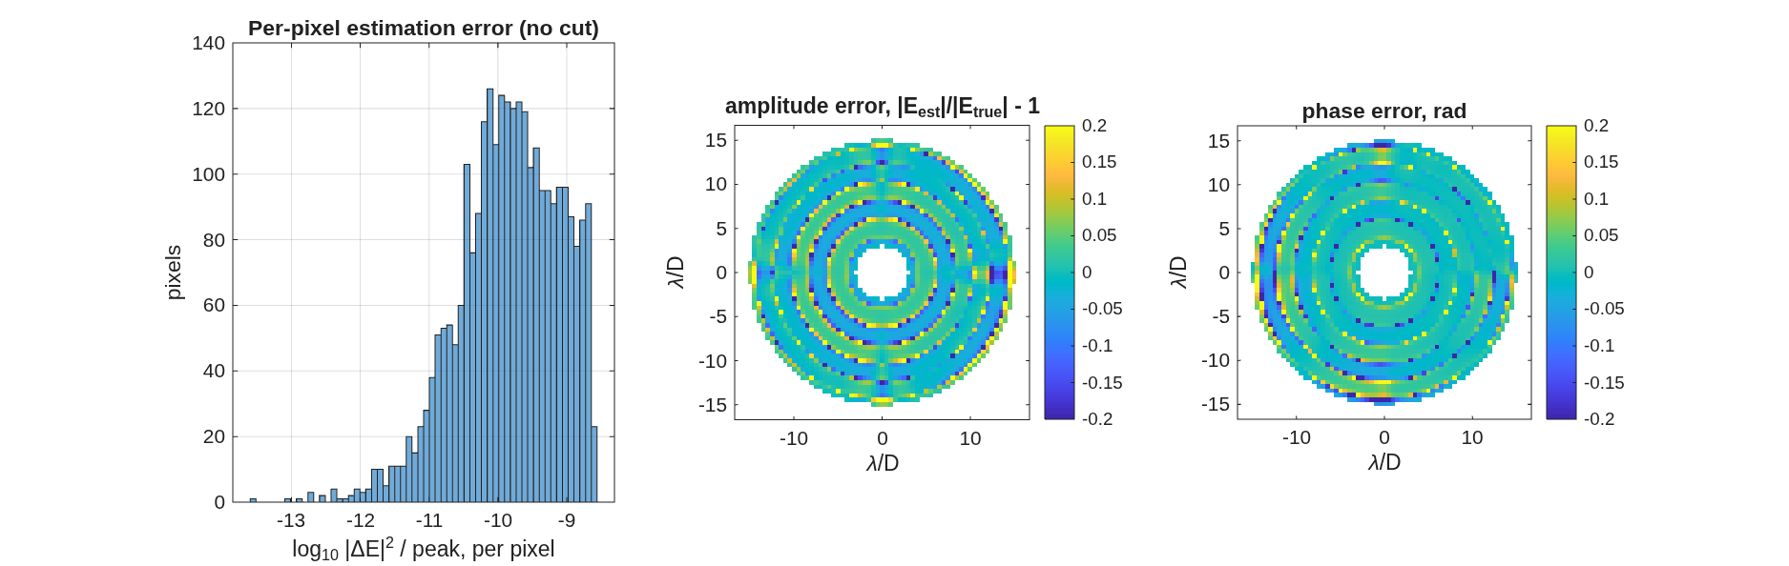
FIGURE 27 The default estimate, pixel by pixel: the error’s histogram with no pixel cut, and the amplitude and phase errors over the dark zone.
The error maps carry the coronagraph’s ring structure. The relative errors are largest where the true field is weakest, between the rings of the occulter’s diffraction.
What the library also has is the other kind of sensing: measuring the DM’s own surface. The gauge benches of Section 9 do that, each a template run unchanged there, most of them on a 96 × 96 actuator DM: a polarization phase-shifting Twyman-Green (tg_psi_dm96, and tg_psi_dm at bench scale), a Zernike wavefront sensor (zwfs_dm96), point-diffraction gauges (pdi_dm96) and a heterodyne camera interferometer (cophi_dm96).

8.7 The coronagraph on the telescope
Section 2 folded the CTB behind the thread’s telescope. The thread’s stages 9 to 11 (templates/80_end_to_end/e2e: s9_diffraction.m, s10_sensing.m, s11_cycles.m) put this section’s diffraction model behind it and run the same chain, control matrix and loop there. The three stages cost about eight hours, most of it six control matrices of 3520 chain runs each, so this page reads their products instead of running them; the driver says how to refresh it.
[s9] coupled model: static dark zone 5.795e-06 with the bench's plain Lyot disk (bench alone 2.934e-07)
[s9] the secondary's shadow is 0.38 % of the pupil area; the same deck without it: 2.363e-07
[s9] central Lyot blocker, pupil radii [0 0.08 0.12 0.16 0.2] -> 5.795e-06 5.267e-07 6.295e-07 7.013e-07 6.923e-07
[s9] the pick 0.08: static 5.267e-07; flattening DM1 (0.0024 -> 0.0001 waves rms on the pupil, 0.90 nm rms on DM1): 5.267e-07
[s9] model limit: pupil axis ratio 1.0417, PSF core axis ratio 1.0001; static 5.912e-06 .. 6.146e-06 over the occulter bracket
[s9] EFC, control matrix at the flat mirrors: 5.267e-07 -> 1.441e-07 in 7 iterations, strokes 7.79 / 6.19 nm rms
[s9] re-measured about that state: 1.441e-07 -> 6.701e-08 in 10 more, strokes 8.56 / 8.42 nm rms
[s10] the default amplitude rule: 37.4 nm peak (0.94 rad), estimate 6.583e-07 against the field's 5.267e-07, floor 1.18e-07, relative error 0.473, ratios 1.237 1.034 1.028
[s10] amplitude 0.1x = 3.74 nm: noiseless floor 1.38e-11, relative error 5.11e-03; at 1e10 photons floor 3.24e-07, error 7.84e-01
[s10] amplitude 0.3x = 11.22 nm: noiseless floor 1.03e-09, relative error 4.41e-02; at 1e10 photons floor 7.02e-09, error 1.15e-01
[s10] amplitude 1.0x = 37.39 nm: noiseless floor 1.18e-07, relative error 4.73e-01; at 1e10 photons floor 1.35e-07, error 5.06e-01
[s10] amplitude 3.0x = 112.17 nm: noiseless floor 5.97e-06, relative error 3.37e+00; at 1e10 photons floor 5.98e-06, error 3.37e+00
[s10] the pick 0.3x = 11.2 nm (0.28 rad): relative error 0.044, floor 1.03e-09
[s10] photons none : floor 1.03e-09, relative error 4.41e-02
[s10] photons 1e+10 : floor 7.02e-09, relative error 1.15e-01
[s10] photons 1e+08 : floor 8.10e-07, relative error 1.24e+00
[s10] photons 1e+06 : floor 5.74e-05, relative error 1.04e+01
[s10] the dug state 6.701e-08 with the matrix measured about the flat state: relative error 0.328; at that matrix's own point (1.441e-07): 0.0117
[s10] EFC on the estimate, matrix fixed: 5.267e-07 2.623e-07 2.001e-07 1.927e-07
[s10] perfect sensing (stage 9): 5.267e-07 2.633e-07 1.913e-07 1.585e-07 1.464e-07 1.455e-07 1.444e-07 1.441e-07
[s10] re-measured on the estimate: 1.927e-07 9.279e-08 7.699e-08 7.682e-08
[s10] perfect sensing (stage 9): 1.441e-07 7.931e-08 6.976e-08 6.776e-08 6.743e-08 6.723e-08 6.709e-08 6.702e-08 6.701e-08 6.701e-08 6.701e-08
[s11] cycles to 10, stop below x1.05 per cycle, goal 1.0e-08; probe 0.3x the default
[s11] perfect sensing: 4 cycles, 57 iterations, 5.267e-07 -> 9.685e-10, stop 'goal'
[s11] probed: 5 cycles, 31 iterations, 5.267e-07 -> 5.646e-09, stop 'goal'
The coupled model. The CTB’s generator inserts its three mask quartets, the DM leg and the far-field terminal behind the nine telescope elements of the folded train; the chief ray at every optic is within 10⁻¹³ mm of the bare train, and the point image lands on the centre pixel. With the bench’s plain Lyot disk the static dark zone is 5.8e-6, twenty times the bench’s own 2.9e-7. It is not the wavefront: the pupil carries 0.0024 waves rms, and flattening it with DM1 changes the dark zone by nothing. It is the secondary’s shadow, 0.4 % of the pupil area, whose diffraction the occulter throws into the Lyot plane around the shadow’s image, where a plain disk passes it; the same deck without the obscuration sits at 2.4e-7, below the bench. A central blocker of 0.08 pupil radii in the Lyot stop covers the shadow’s image: 5.3e-7 at 97 % of the stop’s throughput, the best of the scan in the listing (a larger blocker’s own edge diffracts). The model’s limit is on record: the telescope’s beam is 4.2 % anamorphic and the engine carries the field on the ray lattice with one spacing, so the model’s point image is round; scaling the occulter over that ratio moves the static number between the bracket’s ends in the listing.
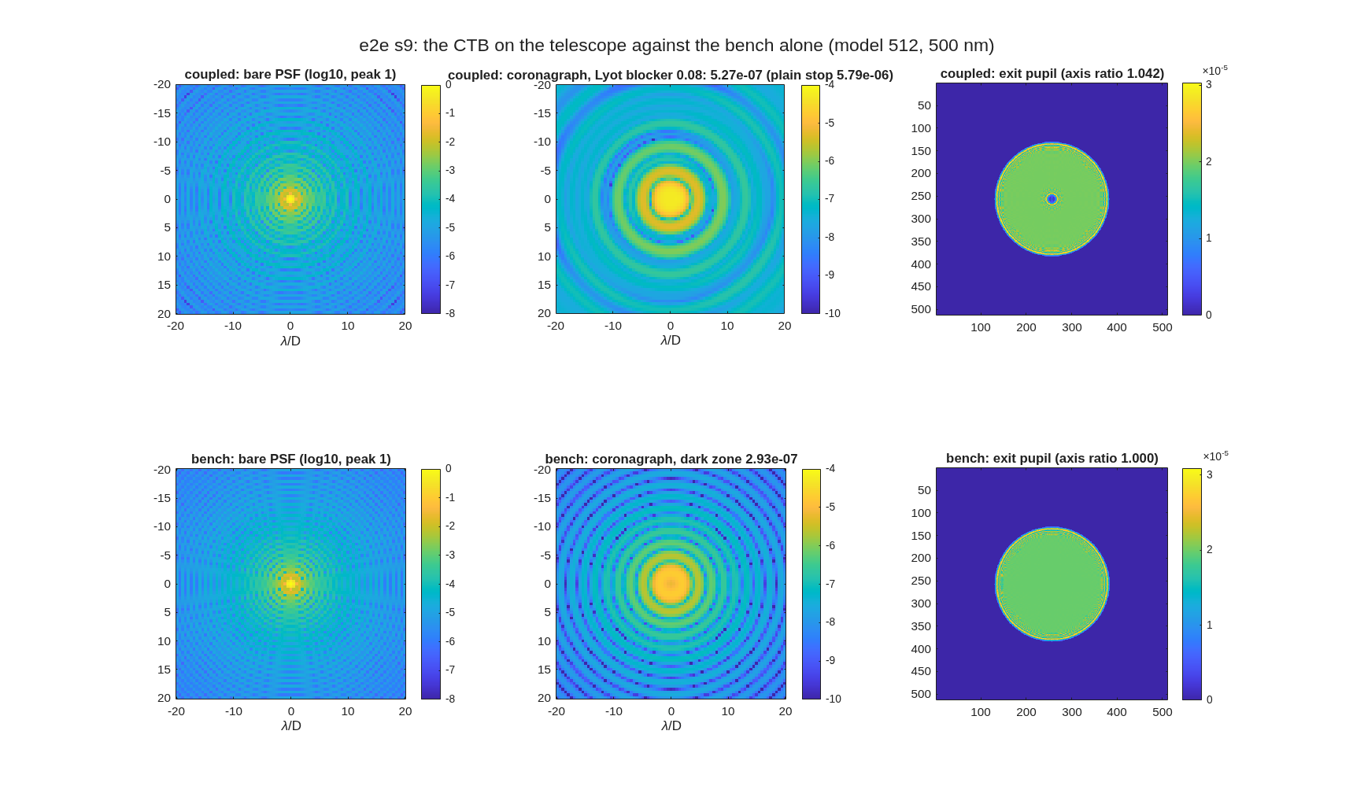
FIGURE 28 The telescope (top) against the bench alone (bottom): the bare point image, the coronagraph image over 3-15 λ/D, and the exit pupil with the secondary’s shadow (s9_diffraction).
The loop runs as on the bench, given the deck and its station map. The control matrix measured at the flat mirrors digs 5.3e-7 to 1.4e-7 in 7 iterations; measured again about that state, to 6.7e-8 in 10 more: 8 times, where the bench alone digs 35. What remains is the shadow’s diffraction outside the blocker, an amplitude hole at the pupil’s centre that the mirrors fill only with strokes past their linear range; the step the bench’s regularization grid proposes overshoots on this brighter halo, so the loop takes smaller steps.
Sensing the field on it. Stage 10 closes the loop on pairwise-probe estimates, as on the bench above, and finds three things the bench did not show. The estimator’s default amplitude, probe intensity equal to the speckle level, is a 37 nm probe (0.94 rad of wavefront phase) on the shadow’s halo, and its second-order response leaves the estimate 47 % off the field; the error falls as the amplitude squared, and 0.3 times the default (11 nm; ctb_probe_estimate’s 'probe_rel') brings it to 4.4 %, the smallest probe tried to 0.5 %. The probe-intensity ratio reads 0.22 above 1 at every amplitude there: the probe’s second-order field projected on the halo, which the pairwise difference cancels and the sum keeps, so on a bright halo the ratio flags a gross mismatch and does not meter the control matrix. And the estimate needs a matrix measured about the current state: at the dug state of the previous paragraph the flat-state matrix estimates the field 33 % off, the matrix about its own point 1.2 %. The loop closed on the estimate with the matrix held fixed stalls after three iterations at 1.9e-7, against perfect sensing’s 1.4e-7; re-measured on the estimate it reaches 7.7e-8 against 6.7e-8. The line search still scores the measured contrast, so a wrong estimate costs depth, never stability. With 10¹⁰ photons per image at the bare peak the pick’s error is 12 %; with 10⁸ the floor is 8.1e-7, above the dark zone itself.
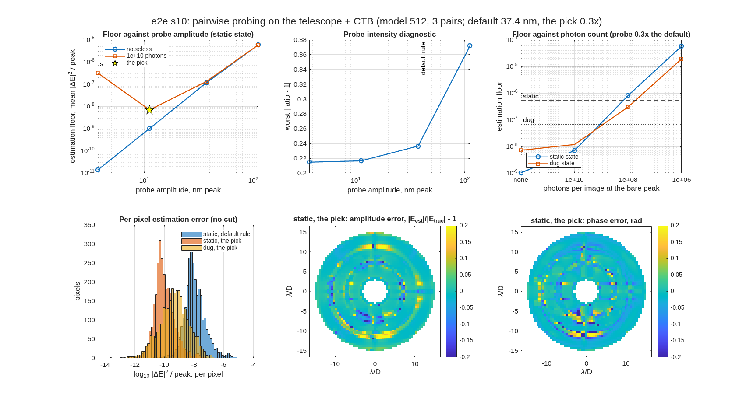
FIGURE 29 Pairwise probing on the telescope (s10_sensing): the estimation floor against probe amplitude, noiseless and at 10¹⁰ photons; the probe-intensity diagnostic; the floor against photon count at the static and dug states; the per-pixel error with no cut; the amplitude and phase error maps at the pick.
Recompute-and-restart cycles. Stage 11 does what a testbed does: measure the control matrix about the loop’s own state, run the loop until it stalls, measure again from where it ended, and repeat until the dark zone reaches a goal, here 1.0e-8 (e2e_cycles, resumable from a state file; each matrix about 69 minutes here). With perfect sensing the goal takes 4 cycles and 57 iterations, ending at 9.7e-10; the last cycle alone gains 25 times. On probe estimates it takes 5 cycles and 31 iterations, ending at 5.6e-9: one cycle more and fewer iterations than perfect sensing, since a cycle on estimates stalls sooner. Strokes stay under 12 nm rms on both mirrors.
chain cycle matrix start end iterations gain strokes nm rms estimate error
perfect 0 reused 5.267e-07 1.441e-07 7 x 3.66 7.79 / 6.19
perfect 1 reused 1.441e-07 6.701e-08 10 x 2.15 8.56 / 8.42
perfect 2 measured 6.701e-08 2.398e-08 20 x 2.79 10.50 / 9.71
perfect 3 measured 2.398e-08 9.685e-10 20 x24.76 11.14 / 10.72
probed 0 reused 5.267e-07 1.927e-07 3 x 2.73 7.04 / 5.40 0.044
probed 1 measured 1.927e-07 7.421e-08 7 x 2.60 8.32 / 7.90 0.031
probed 2 measured 7.421e-08 4.709e-08 15 x 1.58 9.76 / 8.40 0.015
probed 3 measured 4.709e-08 1.676e-08 3 x 2.81 10.81 / 10.36 0.033
probed 4 measured 1.676e-08 5.646e-09 3 x 2.97 11.64 / 10.69 0.173
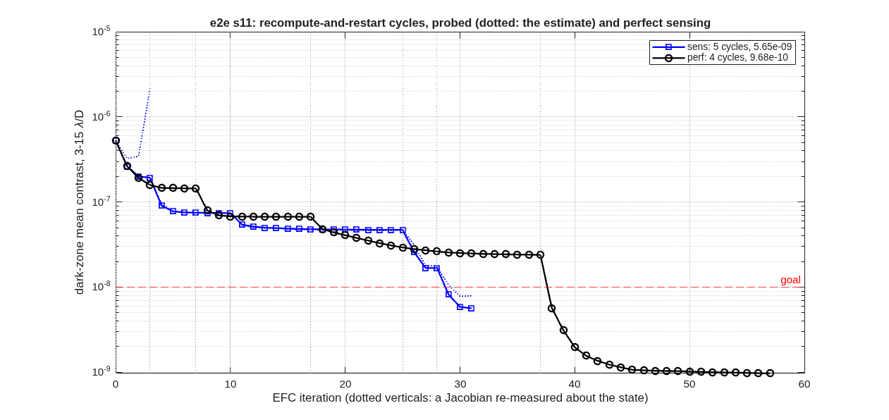
FIGURE 30 The cycles (s11_cycles): dark-zone contrast against iteration for the probed loop (squares; dotted, its own estimate) and for perfect sensing (circles); each dotted vertical is a control matrix re-measured about the state; the goal dashed.
The estimate at each fresh matrix is within 4.4 % of the field through the first four cycles and 17 % at the fifth, from 1.7e-8. The stage’s report marks that check as failed and says why: at that depth no probe amplitude tried estimates the field within the bound. The loop dug to the goal on that estimate anyway. The cause was then run down to the engine, not the estimator: the deformable mirrors are grid surfaces, and between its nodes a grid was interpolated bilinearly, so a ray whose footprint on the second mirror crosses a cell edge under a sub-nanometre change of the first takes the two cells’ slope difference as a kink and steps its path by tens of nanometres. The engine now offers a continuous-slope interpolation (GridSrfOrder= 3 in the mirror’s block; the emitter’s 'order', 3); at the same state with a control matrix measured on it the estimate reads 0.3% of the field, and the loop from that state reaches 1.1×10⁻⁹ in twenty iterations. The stage records above were measured on the bilinear surface; re-measuring them on the continuous one is the open item.

8.8 Checking the assistant’s work
The hard occulter appears twice in this section, scored at two grid sizes: 2.5e-7 on the comparison’s 1024 grid and 2.93e-7 at the start of the loop on 512. They are the same mask on the same optics (ctb_dcr.in, and ctb_dm.in with its DMs flat), sampled differently. A loop that started far from the static number would mean the Jacobian was measured on a different chain, and the drivers refuse such a cache. ctb_efc_physics and ctb_study refuse a cached Jacobian whose stored chain configuration differs from the one requested (ctb_jac_check:mismatch). ctb_efc refuses its default cache when it was measured on another chain (the same error), and any cache that disagrees with the fingerprint truth committed beside it (ctb_efc:fingerprint). A cache from another deck, mask or engine is never used silently; ctb_dm_jacobian will not overwrite a committed truth unless asked to (ctb_dm_jacobian:fpTruth).
The control trap the README records is the one to know about: DM commands are real numbers, and a complex least-squares solve returns complex commands, which pass MATLAB’s type check while the interface silently drops their imaginary part. The loop then crawls. ctb_efc solves the real and imaginary parts as one stacked real system, and ctb_dm.apply refuses complex commands.

8.9 What to ask next
- “Re-measure the Jacobian at the dug state and continue.” – ctb_efc('a0', ...), the relinearization; the README gives its depth.
- “Repeat the loop over a 10 % band.” – ctb_efc_physics('band', true).
- “Run the whole study for another vortex charge or Lyot stop.” – ctb_study('charge', 6, 'r_lyot_frac', 0.70), the 25-step study from one configuration.
- “Close the loop on probe estimates with fewer photons, or with smaller probes.” – ctb_efc('sensing', struct('photons', 1e7, 'probe_nm', 3)).
- “Run the cycles on the telescope to a deeper goal, or more of them.” – s11_cycles.m with P.sens.cycles in e2e_params.m (goal, max, stop_gain); a run resumes from its state file.
- “Probe with five pairs, or a smaller probe.” – P.sens.npairs and P.sens.amp_rel in e2e_params.m; s10_sensing.m picks the largest amplitude whose noiseless error is within the bound.

SECTION 9: The Template Catalog
Part I followed one telescope through the library. This part is the library itself, one page per design template, in the order of the template index (templates/00_INDEX.md). Each page says what the template is (from its own README), shows the knobs it exposes, what it prints and draws when it runs, and the number it reproduces, and ends with a request you can paste to an assistant to adapt it. Every listing, figure and number on these pages comes from running the template, unchanged, the way Part I’s did (the front matter, How this manual is made).

9.1 freeform_unobscured: sphere+Zernike unobscured telescope: the visible 3+n front end
The sphere+Zernike (freeform) strategy applied to the visible-band (500 nm) front end for a coronagraph, imager, and spectrometer — the direction chosen after the conic eccentric-pupil section (../tma_unobscured, kept as the trade study) proved shroud-expensive and coupling-bound (Dave, 2026-07-06).
Why sphere+Zernike wins here:
- Geometry and correction decouple. The 0th-order layout is three base SPHERES placed for packaging; the fold TILTS unobscure the beam with M2 staying close to the source→M1 beam — the tilted-fold topology is the shroud-cheap alternative the eccentric section cannot reach (its AOI-safe decenter cost 3.6×D of shroud).
- All correction lives in the Zernike departures (CALIB OptZern, staged center → field). The departures are micron-scale sags that do not move the chief ray: once the layout packages, the optimizer cannot break the packaging — none of the conic/telecentric coupling that bogged the Korsch searches.
- It holds at 500 nm. The e5mono-derived geometry corrects from ~71,000 waves (all-sphere, uncorrected) to 0.03 waves RMS at the field center — diffraction-limited at the visible bar (35 nm RMS). The FIELD is where the visible fight is: a small corrected field is fine for the coronagraph; the wide imaging field is what the +n mirrors are for (the standing rule: a wide field needs a 4th powered mirror, not more freeform on three).
Run it.
cd('<path-to>/mmacos/templates/10_telescopes/freeform_unobscured');
run(fullfile(pwd,'freeform_unobscured.m'));
The knobs (freeform_unobscured.m):
% ==================== KNOBS ========================================
D = 8.0; % aperture diameter (m) -- e5mono heritage
LAM = 0.5e-6; % 500 nm center wavelength: VISIBLE telescope
MODEL = 256; % engine model size
GRIDN = 41; % circular ray-grid points (~1300 rays)
FOV_ARCMIN = 1.0; % design HALF-field (arcmin) -- the visible DL
% bar is 35 nm RMS; hold a tighter field than
% sz_tma's 1-um +-2' and let [7] show the cost
DIFFRACTION_LIMIT = 0.071;
% --- 0th-order all-sphere layout (|radii| m, spacings m, fold tilts deg)
% M1 f/3.2 (slower than the centered j18's f/1.2 -- gentle AOI), convex
% M2 slows the cone to a real f/21 intermediate image between M2 and M3
% (the metrology-injection point), M3 reimages it clear of the beam.
R = [51.534, 8.871, 3.0]; % M1 concave, M2 CONVEX, M3 concave
TBET = [22.0, 28.0]; % M1->M2, M2->M3 along the folded chief
TILT = [-7.2, 8.46, 12.0]; % fold about x (M1/M2 = e5mono)
% --- correction: e5mono's BornWolf Zernike set (piston dropped) ------
MODES = [3 4 5 9 10 11 12 13 19 20 21 22 23 24 25];
ZTYPE = 'BornWolf';
ITERS = 200;
% =====================================================================
What it prints:
[1] all-sphere layout: real intermediate focus between M2 and M3 (met injection);
uncorrected baseline 57987 waves @ 500 nm
[2] staged Zernike correction (waves RMS @ 500 nm):
S0 center : 59072 -> 0.0108 waves
S1 inner 2-D : worst 972.956 -> 0.3270 waves
S2 full 2-D +-1': worst 0.8525, area-wtd 0.5906 waves -> residual
[3] true FP from 5x5 field foci (+center): tilt 1.514 deg, defocus removed -5.146 mm,
field-curvature sag -27.2 to +28.8 um
[4] clearance (bodies vs beams): 4/4 optics clear -> UNOBSCURED
[5] saved: <work>/templates/10_telescopes/freeform_unobscured/freeform_unobscured.in
+ <work>/templates/10_telescopes/freeform_unobscured/freeform_unobscured.mat
standalone reload: 6 elts, 1185/1185 rays pass -> VERIFIED
figures: wfe + layout + fpmap PNGs in the example dir
[6] design report:
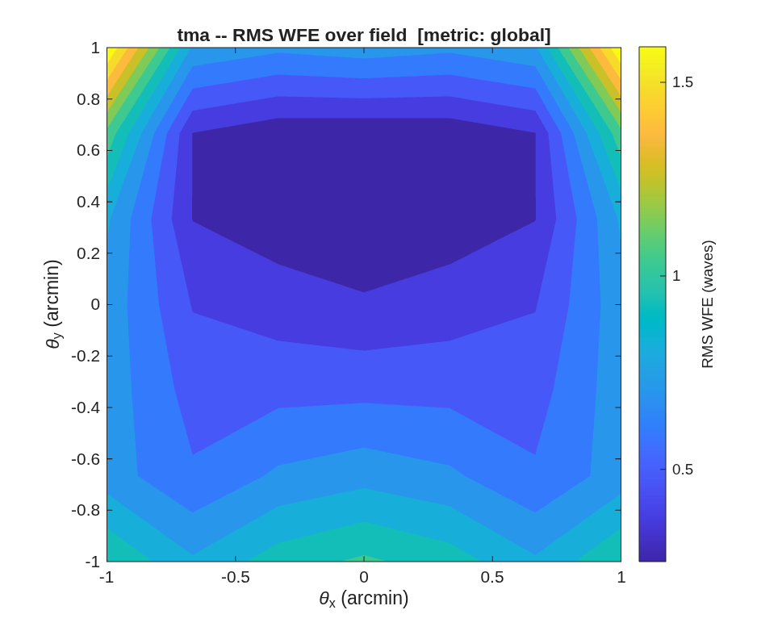
FIGURE 31 RMS wavefront error over the ±1’ field after the full-field stage (freeform_unobscured_wfe.png), waves at 500 nm.
The number it reproduces. The center stage takes the all-sphere layout to 0.0108 waves at the field center; the full-field stage trades that for the field, ending at 0.8525 waves worst and 0.5906 area-weighted over ±1’: a small corrected field on three mirrors, which is why the README sends a wide field to a fourth powered mirror.
Adapt it. “Using templates/10_telescopes/freeform_unobscured, rerun the staged Zernike correction for a 6 m aperture at 600 nm over a ±0.5’ field, and tell me the worst and area-weighted residual after the full-field stage.”

9.2 offset_imager: wide-field imager with an offset field
A parameterized, illustrated five-stage design flow for the recurring problem: a wide field box that must sit far off the optical axis (packaging, stray light, or scan geometry demand it), and what each class of design freedom buys back. The flow is the product; the challenges/rodgers3 instance (Mike Rodgers’ 22°-offset imager ladder) is the validation.
Run it.
cd('<path-to>/mmacos/templates/10_telescopes/offset_imager');
OUT = offset_imager();
The knobs (offset_imager_params.m):
% ---- the rodgers3 challenge instance (defaults) ---------------------
P.name = 'rodgers3';
P.tag = 'oi';
P.EPD_m = 0.075;
P.Fno = 4.0;
P.lambda_m = 1.0e-6;
P.box_deg = [20 20];
P.offset_deg = 22;
P.nsolve = 3;
P.map_n = 11;
P.z_m1_m = 0.6649568;
P.spacings_m = [-0.7228968 0 0.7408280];
P.bfd_m = [];
P.exit_dir = []; % report-only by default; T3 sets Mike's
P.exit_tol_deg = 1.0;
P.exit_wt = 1e4; % exit-direction residual weight, nm/deg
% (an EQUALITY constraint solved in the
% least-squares sense from S3 on -- a
% boolean wall would freeze any stage
% that STARTS outside tolerance)
P.clear_m = [0.050 0.035];
What it prints:
=================================================================
S1 coaxial symmetric-asphere solve, on-axis box
=================================================================
oi_solve S1 : 15 vars, 9 fields, start 13461.974 nm
it 1: 575.770 nm (lam 3.7e-05)
it 2: 345.616 nm (lam 1.4e-06)
it 3: 47.374 nm (lam 1.0e-07)
it 4: 25.755 nm (lam 1.0e-07)
it 5: 23.812 nm (lam 1.0e-07)
it 6: 23.694 nm (lam 1.0e-07)
it 7: 23.691 nm (lam 8.0e-07)
s1: map max 37.8 nm avg 25.8 (gates: exit PASS, clear FAIL)
=================================================================
S2 the SAME mirrors at the offset box -- FPA refit only
=================================================================
oi_solve fpa : 2 vars, 9 fields, start 37196.566 nm
it 1: 24341.528 nm (lam 3.7e-05)
it 2: 24340.765 nm (lam 9.9e-05)
it 3: 24340.765 nm (lam 2.6e-04)
s2: map max 40824.4 nm avg 17815.8 (gates: exit PASS, clear FAIL)
=================================================================
S3 re-solve symmetric aspheres/conics AT the offset field
=================================================================
S3 start candidates: carry 37196.6 nm, fresh seed 40247.3 nm -> carry
oi_solve S3 : 16 vars, 9 fields, start 37196.566 nm
it 1: 36682.801 nm (lam 3.7e-05)
it 2: 36400.947 nm (lam 1.4e-06)
it 3: 35805.323 nm (lam 1.0e-07)
it 4: 35591.201 nm (lam 1.0e-07)
it 5: 35292.592 nm (lam 1.0e-07)
it 6: 35001.959 nm (lam 1.0e-07)
it 7: 34002.207 nm (lam 1.0e-07)
it 8: 33425.758 nm (lam 1.0e-07)
it 9: 33261.885 nm (lam 1.0e-07)
it 10: 33217.751 nm (lam 1.0e-07)
it 11: 32685.632 nm (lam 1.0e-07)
it 12: 32452.454 nm (lam 1.0e-07)
s3: map max 41849.9 nm avg 34306.9 (gates: exit PASS, clear FAIL)
=================================================================
S4 open tilt/decenter + radii under the constraint set
=================================================================
oi_solve S4 : 23 vars, 9 fields, start 32452.454 nm
it 1: 27806.439 nm (lam 3.7e-05)
it 2: 26061.602 nm (lam 1.4e-06)
it 3: 25812.950 nm (lam 1.0e-07)
it 4: 25708.455 nm (lam 1.0e-07)
it 5: 25064.465 nm (lam 1.0e-07)
it 6: 24513.854 nm (lam 1.0e-07)
it 7: 24168.321 nm (lam 1.0e-07)
it 8: 23783.168 nm (lam 1.0e-07)
it 9: 23581.144 nm (lam 1.0e-07)
it 10: 23144.110 nm (lam 1.0e-07)
it 11: 22759.569 nm (lam 1.0e-07)
it 12: 22393.959 nm (lam 1.0e-07)
s4: map max 28907.4 nm avg 23649.9 (gates: exit PASS, clear FAIL)
=================================================================
S5 open Zernike departures (BornWolf, lMon frozen)
=================================================================
oi_solve S5 : 83 vars, 9 fields, start 11810.889 nm
it 1: 10305.818 nm (lam 3.7e-05)
it 2: 9789.750 nm (lam 1.4e-06)
it 3: 9431.743 nm (lam 1.0e-07)
it 4: 9237.638 nm (lam 1.0e-07)
it 5: 9086.290 nm (lam 1.0e-07)
it 6: 8892.939 nm (lam 1.0e-07)
it 7: 8734.527 nm (lam 1.0e-07)
it 8: 8506.421 nm (lam 1.0e-07)
it 9: 8258.537 nm (lam 1.0e-07)
it 10: 8051.323 nm (lam 1.0e-07)
it 11: 7835.824 nm (lam 1.0e-07)
it 12: 7604.716 nm (lam 1.0e-07)
s5: map max 12415.1 nm avg 5993.6 (gates: exit PASS, clear FAIL)
LADDER (dense 11x11 map max / avg / std, strict centroid nm)
s1 37.8 25.8 9.2
s2 40824.4 17815.8 10945.5
s3 41849.9 34306.9 6248.0
s4 28907.4 23649.9 4368.8
s5 12415.1 5993.6 3421.9
saved <work>/templates/10_telescopes/offset_imager/oi_run.mat + <work>/templates/10_telescopes/offset_imager/oi_REPORT.md
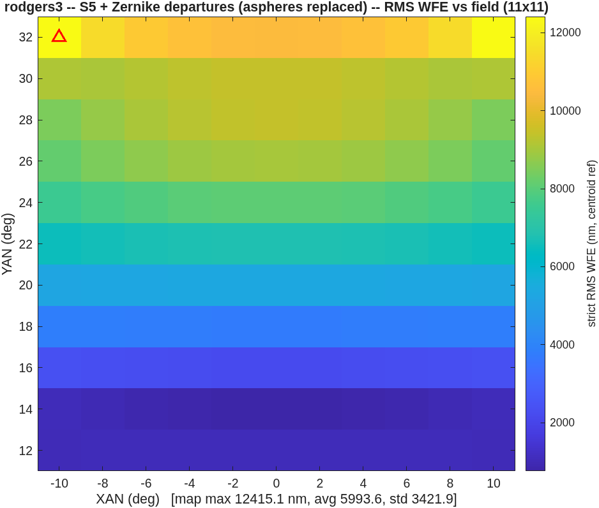
FIGURE 32 The S5 field map the default run draws (oi_s5_map.png): strict rms wavefront error at 11 x 11 points over the 20 x 20 degree box centered 22 degrees off axis, centroid reference; the triangle marks the worst field.
The number it reproduces. The on-axis stage reproduces the challenge’s record exactly: S1, the coaxial symmetric aspheres, reads 37.8 nm maximum and 25.8 nm mean over the dense map, as in challenges/rodgers3/t3/r3t_REPORT.md. The offset stages do not: run with the template’s defaults today, S3 ends at 41849.9 nm against the record’s 252.0 and S5 at 12415.1 nm against 118.2 (and 45.4 nm for the 25-field re-solve). The record was made by run_t3, which pins the exit beam (0.1 degree) and runs 30 iterations a stage where the defaults run 12, but the two already part at S2, a focal-plane refit alone, so those differences are not shown to be the cause. Not diagnosed; the open questions list has it, and this page prints the run as it is.
Adapt it. “Using templates/10_telescopes/offset_imager, run the five-stage ladder for a 150 mm F/3.3 imager with a 15 x 15 degree box offset 22.5 degrees, walking the box open with oi_walk if a cold solve stalls, and report each stage’s map maximum and clearance.”

9.3 rc_onaxis: Parameterized on-axis Ritchey-Chretien designer
The classical Cassegrain-form RC: a two-mirror APLANAT (zero 3rd-order spherical AND coma by construction), so it is diffraction-limited on-axis. Its field is limited by ASTIGMATISM, which two conics cannot null – that limit is precisely why wide-field telescopes add a third mirror (a TMA). This driver builds the RC from your aperture + f-numbers, reports its first-order properties (including the central obscuration the secondary casts), shows WFE vs field, then field-balances the conics for a WIDER corrected field and saves that as the deliverable (better-across-the-field usually beats perfect-on-axis for a real instrument). This is the OBSCURED baseline. For the unobscured (coronagraph-feed) version that decenters to an eccentric pupil, see ../rc_unobscured.
Run it.
cd('<path-to>/mmacos/templates/10_telescopes/rc_onaxis');
run(fullfile(pwd,'rc_onaxis.m'));
The knobs (rc_onaxis.m):
% ==================== USER DESIGN CHOICES ==========================
APERTURE_M = 1.0; % aperture diameter D (m)
PRIMARY_FNUM = 2.0; % M1 f/#
SYSTEM_FNUM = 10.0; % system f/#
BFD_M = 0.30; % back focal distance: focus this far behind M1 (m)
FOV_ARCMIN = 4.0; % evaluate WFE out to this field half-angle (arcmin)
BALANCE_FIELD = true; % field-balance the conics (radius+conic) for a WIDER
% corrected field -- giving up a little on-axis WFE to
% gain performance across the field is usually the better
% deal for a real instrument than a perfect-on-axis
% aplanat. This balanced design is the saved deliverable.
BALANCE_FOV = 4.0; % balance over +-this; keep it SHORT of FOV_ARCMIN
% ---------------------------------------------------------------------
LAM = 633e-9; % wavelength (m)
MODEL = 256; % diffraction grid model size
DIFFRACTION_LIMIT = 0.07; % ~lambda/14 (waves)
% =====================================================================
What it prints:
====================================================================
On-axis Ritchey-Chretien | D=1.00 m | primary f/2.0 | system f/10.0 | BFD=300 mm
====================================================================
[1] on-axis RC built (3 elements): RMS WFE = 0.0019 waves (aplanat)
[2] first-order properties:
EFL = 10.000 m (f/10.0) secondary mag m = 5.00
plate scale = 20.63 arcsec/mm back focal dist = 300 mm (behind M1)
central obscuration ~ 0.19 (secondary diam / aperture)
[3] WFE vs field (as-built RC, +y):
field(arcmin): 0.0 0.7 1.3 2.0 2.7 3.3 4.0
WFE (waves) : 0.002 0.001 0.010 0.024 0.045 0.072 0.107
diffraction-limited (< 0.07 lambda) out to 2.7 arcmin
[4] field-balanced (radius+conic over +-4'):
WFE (waves) : 0.018 0.015 0.009 0.009 0.027 0.053 0.086
diffraction-limited out to 3.3 arcmin (was 2.7)
[5] saved: <work>/templates/10_telescopes/rc_onaxis/rc_onaxis.in
+ <work>/templates/10_telescopes/rc_onaxis/rc_onaxis.mat
WFE-vs-field figure: <work>/templates/10_telescopes/rc_onaxis/rc_onaxis_wfe.png
layout (YZ side view): <work>/templates/10_telescopes/rc_onaxis/rc_onaxis_layout.png
--------------------------------------------------------------------
D=1.00 m | f/10 | EFL 10.00 m | mag 5.0 | central obscuration 0.19
aplanatic: diffraction-limited on-axis; field-limited by astigmatism
diffraction-limited out to 3.3 arcmin (field-balanced)
====================================================================
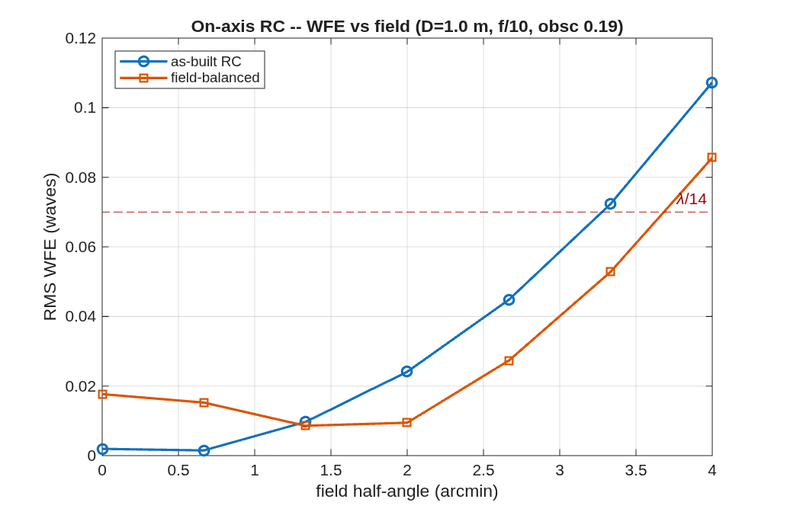
FIGURE 33 RMS wavefront error against field for the as-built aplanat and the field-balanced design (rc_onaxis_wfe.png), with the λ/14 line.
The number it reproduces. The aplanat is diffraction-limited on axis and out to 2.7 arcmin, where the astigmatism two conics cannot null crosses λ/14; balancing the radius and conic over ±4′ trades a little on-axis quality for a field diffraction-limited out to 3.3 arcmin. The secondary’s central obscuration is 0.19 of the aperture.
Adapt it. “Using templates/10_telescopes/rc_onaxis, design a 2 m f/12 Ritchey-Chretien with an f/2.5 primary and 400 mm back focus, and tell me the central obscuration and the diffraction-limited field before and after field balancing.”

9.4 rc_unobscured: Parameterized unobscured off-axis Ritchey-Chretien designer
Pick the four design knobs below; the script builds the on-axis RC parent, takes an UNOBSCURED off-axis section (eccentric pupil), refigures + field-optimizes it to diffraction-limited, verifies it is unobscured, and saves the deliverable (.in + .mat + figures).
Run it.
cd('<path-to>/mmacos/templates/10_telescopes/rc_unobscured');
run(fullfile(pwd,'rc_unobscured.m'));
The knobs (rc_unobscured.m):
% ==================== USER DESIGN CHOICES ==========================
APERTURE_M = 1.0; % aperture diameter D (m)
PRIMARY_FNUM = 1.5; % M1 f/# (FASTER -> smaller secondary -> less off-axis)
SYSTEM_FNUM = 20.0; % system f/# (SLOWER -> smaller secondary -> less off-axis)
OFF_AXIS_M = []; % off-axis decenter (m). [] = AUTO (minimum to clear);
% a number sets it explicitly (>= the minimum).
% ---- secondary choices ----------------------------------------------
BFD_M = 0.30; % back focal distance: focus this far BEHIND M1 (m)
FOV_ARCMIN = 0.5; % design HALF-field (arcmin): optimize + evaluate over +-this
LAM = 633e-9; % wavelength (m)
MODEL = 256; % diffraction grid model size
DIFFRACTION_LIMIT = 0.07; % ~lambda/14 (waves)
% =====================================================================
What it prints:
====================================================================
Unobscured off-axis RC | D=1.00 m | primary f/1.5 | system f/20.0 | BFD=300 mm
====================================================================
[1] on-axis RC built: RMS WFE = 0.0000 waves (aplanatic)
[2] off-axis decenter = 0.642 m (0.64 D) [floor ~0.50 D]
auto: minimum to clear the secondary shadow
eccentric-pupil WFE (un-refigured) = 0.002 waves
[3] axial optimize (radius+conic): RMS WFE = 0.0002 waves -> DIFFRACTION-LIMITED
[4] field optimize (+-0.5' area, tip/tilt/dy+radius+conic):
worst-field WFE 0.046 -> 0.0281 waves -> DIFFRACTION-LIMITED
[5] field scan over the +-0.5' field -> WFE map + apertures
[6] clearance: 3/3 optics clear -> UNOBSCURED
[7] saved: <work>/templates/10_telescopes/rc_unobscured/rc_unobscured.in
+ <work>/templates/10_telescopes/rc_unobscured/rc_unobscured.mat
[8] WFE field map: <work>/templates/10_telescopes/rc_unobscured/rc_unobscured_wfe.png
orthographic layout: <work>/templates/10_telescopes/rc_unobscured/rc_unobscured_layout.png
--------------------------------------------------------------------
D=1.00 m | primary f/1.5 | system f/20.0 (mag 13.3) | BFD=300 mm
off-axis decenter = 0.642 m (0.64 D) [geometric floor ~0.50 D]
RMS WFE: on-axis 0.0000 -> eccentric 0.00 -> axial 0.0002 -> field 0.0281 waves
UNOBSCURED, focus 300 mm behind M1, diffraction-limited over +-0.5 arcmin
====================================================================
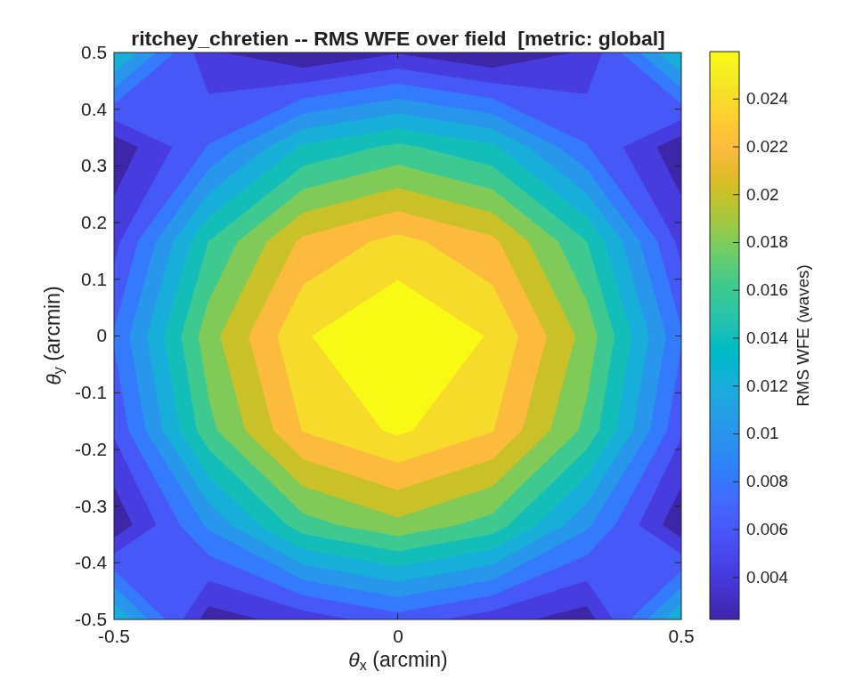
FIGURE 34 RMS wavefront error over the ±0.5′ field of the delivered unobscured section (rc_unobscured_wfe.png).
The number it reproduces. With an f/1.5 primary at f/20 the eccentric pupil clears the secondary’s shadow at a decenter of 0.642 m, and after the axial refigure and the field optimization the worst field over ±0.5′ is 0.0281 waves, diffraction-limited, with all three optics clear.
Adapt it. “Using templates/10_telescopes/rc_unobscured, design an unobscured 1.5 m off-axis RC at f/16 with an f/1.8 primary, and report the decenter it needs and the worst-field wavefront error over ±0.5 arcmin.”

9.5 sz_tma: Sphere + Zernike unobscured three-mirror telescope (e5mono-derived)
A wide-field design strategy where GEOMETRY and CORRECTION fully decouple: 0th-order layout = three BASE SPHERES (Kc=0). The sphere radii set first-order power (f/#, EFL); the fold tilts unobscure the beam and keep it compact. No conics -> none of the conic/ telecentric coupling that bogs down a Korsch search. CORRECTION = Zernike departures on each mirror, optimized by MACOS’s native multi-field design optimizer (CALIB OptZern). Because the departures are tiny sag perturbations they don’t move the chief-ray geometry, so once the layout meets packaging the optimizer cannot break it.
Run it.
cd('<path-to>/mmacos/templates/10_telescopes/sz_tma');
run(fullfile(pwd,'sz_tma.m'));
The knobs (sz_tma.m):
% ==================== KNOBS ========================================
D = 8.0; % aperture diameter (m) -- e5mono
LAM = 1e-6; % wavelength (m) -- 1 um
MODEL = 256; % engine model size
GRIDN = 41; % circular ray-grid points (-> ~1300 rays)
FOV_ARCMIN = 2.0; % design HALF-field (arcmin)
DIFFRACTION_LIMIT = 0.07;% "well-corrected" RMS WFE (waves)
% --- 0th-order all-sphere layout (|radii| m, spacings m, fold tilts deg)
R = [51.534, 8.871, 3.0]; % M1 concave, M2 convex, M3 concave
TBET = [22.0, 28.0]; % M1->M2, M2->M3 along the folded chief ray
TILT = [-7.2, 8.46, 12.0]; % fold about x (M1/M2 reproduce e5mono)
% --- correction: e5mono's BornWolf Zernike set (piston dropped) ------
MODES = [3 4 5 9 10 11 12 13 19 20 21 22 23 24 25];
ZTYPE = 'BornWolf';
ITERS = 200;
% =====================================================================
What it prints:
[1] all-sphere baseline (Kc=0, no Zernikes): RMS WFE = 28994 waves (uncorrected)
[2] S0 center : 29536 -> 0.0054 waves -> DIFFRACTION-LIMITED
[3] S1 inner 2-D : worst 1108.939 -> 1.0242 waves
[4] S2 full 2-D +-2' : worst 4.1915, area-wtd 2.3925 waves -> residual
[5] field scan over +-2' -> WFE map + apertures
[6] clearance: 4/4 optics clear -> UNOBSCURED
[7] saved: <work>/templates/10_telescopes/sz_tma/sz_tma.in
+ <work>/templates/10_telescopes/sz_tma/sz_tma.mat
[8] WFE field map: <work>/templates/10_telescopes/sz_tma/sz_tma_wfe.png
orthographic layout: <work>/templates/10_telescopes/sz_tma/sz_tma_layout.png
--------------------------------------------------------------------
D=8.0 m | f/21.3 | 3 spheres + Zernike departures (15 modes/mirror)
RMS WFE: baseline 28994 -> center 0.0054 -> 2-D +-2' worst 4.1915 / area-wtd 2.3925 waves
real intermediate focus between M2 and M3 (metrology injection); FP out of beam
====================================================================
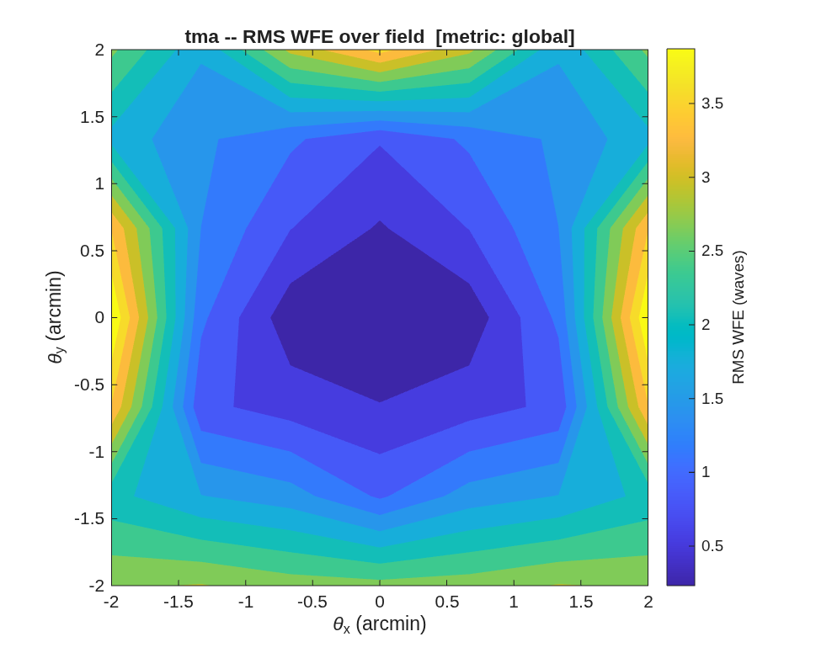
FIGURE 35 RMS wavefront error over the ±2′ field after the full-field stage (sz_tma_wfe.png).
The number it reproduces. The Zernike departures take the all-sphere layout to 0.0054 waves at the field center, diffraction-limited, but over the full ±2′ field the worst point is 4.1915 waves and the area-weighted mean 2.3925: on this 8 m layout the 15 modes per mirror do not hold the field.
Adapt it. “Using templates/10_telescopes/sz_tma, rerun the sphere-plus-Zernike design over a ±1 arcmin field with 21 Zernike modes per mirror, and tell me whether the full-field stage reaches the diffraction limit.”

9.6 tma_3plus1: 3+1 coronagraph front end – unobscured conic TMA + M4 pupil relay
Three conic mirrors (j18mono-geometry Korsch, 6.6 m f/20, unobscured eccentric-pupil section) form the SCIENCE FOCUS – the shared focal plane where instrument pickoffs live (the 3-mirror holds a 5’-diameter circular field at ~0.095 waves @ 1 um; see ../tma_centered). A 4th FIELD MIRROR just past that focus relays the CORONAGRAPH CHANNEL (a ~30 arcsec patch) to FP2 and – the point – relays the exit pupil to an accessible plane and FLATTENS it (the bare TMA pupil carries +0.7 mm defocus / 1.1 mm astig, macos.pupil_quality; the relayed pupil comes out ~10x flatter with M4 varying in the patch balance). A relay cannot carry the wide field: at EFL=132 m a 2.5’ half-field walks +-96 mm across M4 – wide field stays at the TMA focus, the relay serves the small-field channel.
Run it.
cd('<path-to>/mmacos/templates/10_telescopes/tma_3plus1');
run(fullfile(pwd,'tma_3plus1.m'));
The knobs (tma_3plus1.m):
% ==================== USER DESIGN CHOICES ==========================
D = 6.605; % aperture (m) -- j18mono parent
R = [15.879722 1.778913 3.016227]; % |radii| M1 / M2(convex) / M3
TBET = [7.169041556 7.965313479]; % spacings (m)
LAM = 1.0e-6; % score at 1 um
DPAST = 1.2; % M4 past the TMA focus (m); > f4!
R4 = 1.5; % M4 radius (concave; f4 = 0.75 m)
PATCH_RAD_ASEC = 15; % coronagraph patch RADIUS (arcsec)
SECT_MARGIN = 0.01; % clearance margin (fraction of D)
% =====================================================================
What it prints:
====================================================================
3+1 coronagraph front end | D=6.61 m f/20 | 30" patch | j18 parent
====================================================================
[1] TMA: axial 0.0037 waves; K=[-0.9950 -1.6350 -0.8514]; M3->focus 4.862 m
[2] 3+1 coaxial, conics carried: 0.0034 waves on-axis at FP2
[3] compact section (0.84 D) + axial refigure: 0.0143 waves
[4] 30"-dia patch balance: worst 0.0337 waves
[5] clearance: 5/5 clear -> UNOBSCURED
exit-pupil surface @ elt 6 vertex [0.002 0.068 -4.361] m diam 32.4 mm
defocus -0.133 astig [+0.199 +0.000] coma [+0.000 +0.001] sph +0.000 (mm)
sag 1.574 mm RMS (4.133 P-V) fit resid 0.000 mm chief-vs-FEX 1.0e-03 m
[6] relayed pupil: dia 32.4 mm, defocus -0.133 mm, astig 0.199 mm (bare TMA: +0.7 / 1.1)
aoi_report (limit 15 deg, 11 field(s))
mirror chief(deg) min max SPREAD(deg) ok
M1 19.30 8.09 29.02 20.93 ** >limit
M2 21.97 9.15 33.23 24.07 ** >limit
M3 1.35 0.41 2.25 1.84 yes
M4 1.11 0.49 1.73 1.24 yes
[7] worst AOI spread 24.1 deg -- OUT of the 15-deg preference on
M1/M2 (f/1.2 parent; see tma_3plus1_aoi_search.m).
[8] saved: <work>/templates/10_telescopes/tma_3plus1/tma_3plus1.in
+ <work>/templates/10_telescopes/tma_3plus1/tma_3plus1.mat
layout: tma_3plus1_layout.png
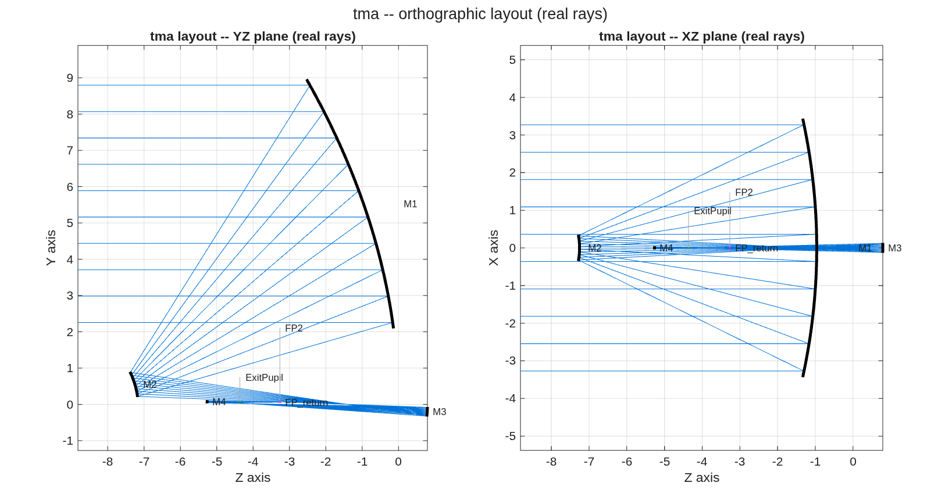
FIGURE 36 The 3+1 chain with real rays, YZ and XZ planes (tma_3plus1_layout.png): the three-mirror telescope to its focus, and M4 just past it relaying the coronagraph channel to FP2 and the exit pupil.
The number it reproduces. The 30″ coronagraph patch is balanced to 0.0337 waves worst, and the relayed pupil carries 0.199 mm of astigmatism against the bare TMA’s 1.1 mm. The template reports its own limit: the worst AOI spread is 24.1 degrees, outside the 15-degree preference on M1 and M2, which its sibling tma_3plus1_aoi_search.m addresses.
Adapt it. “Using templates/10_telescopes/tma_3plus1, run tma_3plus1_aoi_search for a 6.6 m f/20 front end that keeps every mirror’s AOI spread under 15 degrees, then rebuild the 3+1 chain on the result and report the patch balance and the relayed pupil.”

9.7 tma_centered: centered (obscured) Korsch TMA: the A/B answer + the buildable folded variant
The centered three-mirror anastigmat — concave M1, convex M2 on axis (central obscuration accepted), concave M3 behind the primary — versus its off-axis-section cousin, and then the packaging problem the coaxial form hides: the focal plane lands on the axis in the middle of the beam. This directory carries the full arc from parent choice to a buildable, clearance-verified, focus/tilt-aligned folded design.
Run it.
cd('<path-to>/mmacos/templates/10_telescopes/tma_centered');
run(fullfile(pwd,'tma_centered.m'));
The knobs (tma_centered.m):
% ==================== USER DESIGN CHOICES ==========================
D = 6.605; % aperture (m) -- j18mono
R = [15.879722 1.778913 3.016227]; % |radii| M1/M2(convex)/M3
TBET = [7.169041556 7.965313479]; % spacings (m)
LAM = 1.0e-6; % score at 1 um (j18's own
% band is 2.3 um: /2.3)
FIELD_RAD = 2.5; % circular-field RADIUS (arcmin)
% (= 5' diameter)
DIFFRACTION_LIMIT = 0.071; % Marechal, waves RMS
% =====================================================================
What it prints:
[1] CENTERED: axial 0.0037 | worst ring field 0.0575 waves -> DIFFRACTION-LIMITED
field(arcmin x,y) raw -tilt -focus -astig Z4(nm) |Z5,6|(nm)
( +2.50, +0.00) 0.0558 0.0558 0.0372 0.0147 +72.2 85.0
( +1.77, +1.77) 0.0555 0.0555 0.0375 0.0146 +71.0 83.9
( +0.00, +2.50) 0.0546 0.0546 0.0365 0.0146 +70.6 83.2
( -1.77, +1.77) 0.0555 0.0555 0.0375 0.0146 +71.2 83.9
( -2.50, +0.00) 0.0558 0.0558 0.0372 0.0147 +72.4 85.1
( -1.77, -1.77) 0.0572 0.0572 0.0385 0.0147 +73.6 86.3
( -0.00, -2.50) 0.0570 0.0570 0.0378 0.0148 +74.1 86.7
( +1.77, -1.77) 0.0572 0.0572 0.0385 0.0148 +73.5 86.3
( +1.25, +0.00) 0.0477 0.0260 0.0128 0.0094 -39.3 21.5
( -1.25, +0.00) 0.0476 0.0259 0.0128 0.0094 -39.2 21.5
worst: 0.0572 0.0572 0.0385 0.0148 (waves @ 1 um)
[2] ladder: the centered family's residual survives the astig fit
only at high order -- symmetric anastigmat behaviour.
[3] clearance: 2/4 optics clear -- the CENTERED price is the
central obscuration (M2 shadows the pupil).
[4] SECTION (unobscured, decenter 0.66 D): worst ring field 0.0807 waves
================== A/B: 5'-dia circular field @ 1 um ==================
worst -tilt -focus -astig (waves)
CENTERED (obscured) 0.0575 0.0572 0.0385 0.0148
SECTION (unobscured) 0.0807 0.0730 0.0686 0.0198
Read: the section's wavefront collapses once ASTIG is removed --
the unobscured cut buys its clear pupil with induced field
astigmatism. j18's remaining edge is its 2.3 um yardstick
(divide the waves by 2.3).
==========================================================================
[5] saved: <work>/templates/10_telescopes/tma_centered/tma_centered.in
+ <work>/templates/10_telescopes/tma_centered/tma_centered.mat
figures: tma_centered_wfe.png + tma_centered_layout.png
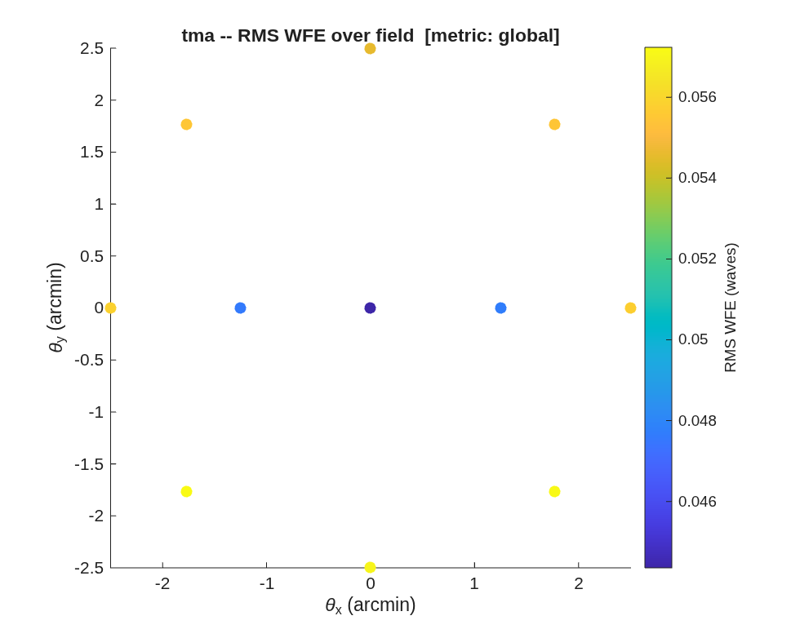
FIGURE 37 The centered design’s RMS wavefront error over its 5’ circular field at 1 µm (tma_centered_wfe.png).
The number it reproduces. Over a 5’ circular field at 1 µm the centered (obscured) design’s worst field is 0.0575 waves, diffraction-limited; the unobscured section of the same mirrors reads 0.0807 waves, and the A/B table shows where it goes: field astigmatism, the price of the clear pupil.
Adapt it. “Using templates/10_telescopes/tma_centered, take my centered TMA (radii and spacings below) and score it against its unobscured section over a 4’ circular field at 1.6 µm, with the same A/B table.”

9.8 tma_freeform: Off-axis unobscured three-mirror freeform designer
The companion to wf2_freeform, where freeform genuinely earns its keep. Pick the knobs below; the script seeds a coaxial Korsch TMA (3 conics null 3rd-order S_I/II/III), takes an UNOBSCURED off-axis section (eccentric pupil), refigures the 3 conics + rigid bodies to the best a 3-mirror can do over the field, then layers freeform Zernike departures on M2 + M3 – holding every radius and conic – and re-optimizes. Verifies it is unobscured and saves the deliverable (.in + .mat + figures).
Run it.
cd('<path-to>/mmacos/templates/10_telescopes/tma_freeform');
run(fullfile(pwd,'tma_freeform.m'));
The knobs (tma_freeform.m):
% ==================== USER DESIGN CHOICES ==========================
APERTURE_M = 1.0; % aperture diameter D (m)
% Coaxial Korsch TMA seed (validated proof_korsch f/8 fixture, scales with D):
M1_RADIUS_M = 8.0; M1_SPACING_M = 3.0; % M1 radius + M1->M2 spacing
M2_RADIUS_M = 2.0; M2_SPACING_M = 4.5; % M2 radius + M2->M3 spacing
M3_RADIUS_M = 4.0; % M3 radius (M3->focus derived)
FOV_ARCMIN = 3.0; % design HALF-field (arcmin): optimize + evaluate over +-this
FREEFORM_ELT = [2 3]; % mirrors to make freeform (M2, M3 -- both off the pupil)
FREEFORM_MODES = [5 6 7 8 11]; % ANSI Zernike DOF: defocus, astig, coma, spherical
LAM = 633e-9; % wavelength (m)
MODEL = 256; % diffraction grid model size
DIFFRACTION_LIMIT = 0.071; % ~lambda/14 (waves RMS) -- the Marechal criterion
% =====================================================================
What it prints:
====================================================================
Off-axis unobscured 3-mirror freeform | D=1.00 m | half-field +-3'
====================================================================
[1] coaxial Korsch TMA seeded: on-axis 0.0103 waves (4 elts)
[2] unobscured off-axis: decenter 0.89 m (0.89 D); eccentric-pupil WFE 3.8 waves
[3] 3-conic + rigid optimize: worst-field 0.0213 waves (3-mirror limit)
[4] + freeform M[2 3] (modes [5 6 7 8 11], CALIB OptZern, radii/conics held):
worst-field 0.0213 -> 0.0176 waves (1.2x) -> DIFFRACTION-LIMITED
[5] clearance: 4/4 optics clear -> UNOBSCURED
[6] WFE-across-field map: <work>/templates/10_telescopes/tma_freeform/tma_freeform_wfe.png
per-field before/after: <work>/templates/10_telescopes/tma_freeform/tma_freeform_fields.png
orthographic layout: <work>/templates/10_telescopes/tma_freeform/tma_freeform_layout.png
[7] saved: <work>/templates/10_telescopes/tma_freeform/tma_freeform.in
+ <work>/templates/10_telescopes/tma_freeform/tma_freeform.mat
--------------------------------------------------------------------
D=1.00 m | off-axis 0.89 D (unobscured) | half-field +-3'
worst-field RMS WFE: 3-conic limit 0.0213 -> + freeform 0.0176 waves (1.2x)
freeform on M[2 3] holds all radii/conics; the 3rd mirror gives the field-
dependent control a 2-mirror cannot (cf. wf2_freeform: ~1x over a wide field)
====================================================================
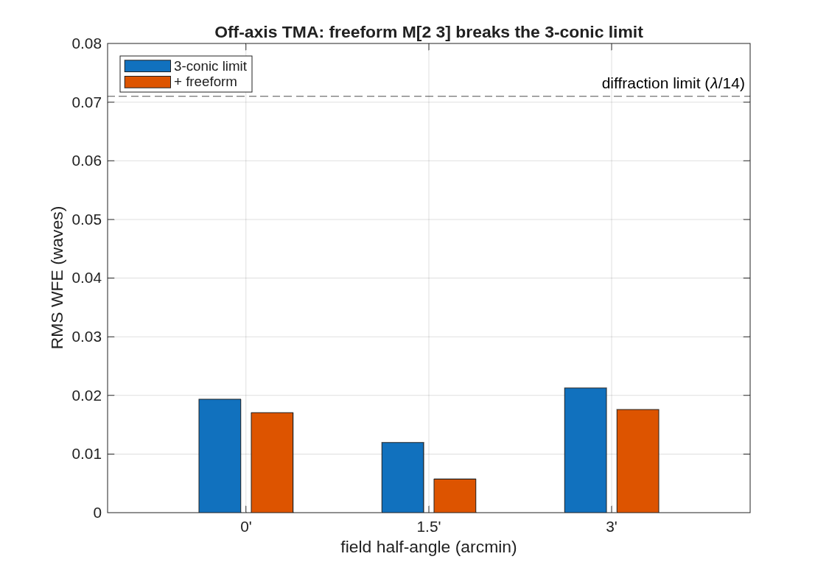
FIGURE 38 Per-field wavefront error at 0, 1.5′ and 3′, the three-conic limit against the freeform design (tma_freeform_fields.png).
The number it reproduces. Taken off axis by 0.89 m to clear its beams, the three-conic design reaches 0.0213 waves at its worst field over ±3′; freeform departures on M2 and M3, every radius and conic held, take it to 0.0176 waves. On this field the conic limit is already diffraction-limited, so the freeform’s gain is small; wf2_freeform shows why a third mirror is what makes the freeform useful at all.
Adapt it. “Using templates/10_telescopes/tma_freeform, widen the half-field to 6 arcmin and rerun, and tell me how much the freeform M2 and M3 buy over the three-conic limit there.”

9.9 tma_longslit: the long-slit TMA front end for a slit-fed spectrometer
A parameterized design flow for a three-mirror telescope that feeds a long slit: - a wide strip of sky imaged onto a straight slit; - telescentric at the slit, so the spectrometer behind it sees every field the same way; - with a bounded cone: no marginal ray faster than the spectrometer accepts, the F/# the same in both directions; - and a long working distance behind the last mirror, so the spectrometer fits in it.
The form is the SBG VSWIR zig-zag TMA (Bradley et al., Finalized optical design of the SBG VSWIR Wide Swath Imaging Spectrometer, ICSO 2024, Proc. SPIE 13699, 1369945, Fig. 4b): - a weak concave M1; - a small convex M2 that is the stop; - M3 carrying nearly all of the power; - the slit 300 mm behind M3.
The beam turns the same way at M1 and M3 and back at M2. It is a zig-zag, not a Korsch ring, and it has no intermediate focus.
The default run is the dyson5 3k front end at Joe’s spec: f 330 mm, D 183 mm, F/1.8, a ±4.7° strip onto a 54 mm slit.
Run it.
cd('<path-to>/mmacos/templates/10_telescopes/tma_longslit');
OUT = tma_longslit_run({'first_order','section'});
The knobs (tma_longslit_params.m):
% ---- spec (Joe's sheet, deck_dyson spec slide)
P.f_m = 0.330;
P.D_m = 0.183;
P.strip_half_deg = 4.7;
P.slit_m = 0.054;
P.pixel_m = 18e-6;
P.telecentric_deg = 0.5;
P.cone_fnum = [1.7 1.8];
P.work_dist_m = 0.250;
P.spec_joe = struct('smile_px', 0.1, 'keystone_px', 0.1, 'crf_px', 1.5, 'srf_px', [1.5 2.0], 'eip', 0.75);
% Bradley 2024 Table 1, in MICROMETRES (its own units: SRF in CO-ADDED pixels of 2 x 18 um -- "64.8 um (1.8 co-added
% pixels)"; smile "1.8 um (5 % of co-added pixel)" = 0.10 of OUR 18-um pixel, not 0.05; keystone 1.8 um (10 % of a
% pixel); ARF / CRF 50.4 um (2.8 px)). Until 2026-10-07 these were compared in our 18-um pixels: every "fail (1.8)" on
% SRF and the "< 0.05" smile were units errors (addendum 49 step 0).
P.spec_paper = struct('smile_um', 1.8, 'keystone_um', 1.8, 'srf_um', 64.8, 'crf_um', 50.4, 'arf_um', 50.4);
% ---- seed: SBG VSWIR Fig. 4b (f 345), digitised +-5 mm / +-2 deg
P.seed_f_m = 0.345;
P.seed_legs_m = [0.270 0.257 0.313];
P.aoi_deg = [30 37 15];
P.turn = [+1 -1 +1];
P.stop = 'M2';
P.axis_side = [+1 +1 +1];
P.axis_theta_deg = [];
What it prints:
tma_longslit section -- the zig-zag as three off-axis conic sections, measured in the engine (<date>)
DECK <work>/templates/10_telescopes/tma_longslit/tls_section.in (model 256, 41-pt grid, 633 nm)
AOI R_t mm R_s mm R par mm K theta h mm pole (mm)
M1 30.00 +2338.3 +1753.7 1518.8 -1.0000 30.00 876.9 [0 0 0]
M2 37.00 -1132.0 -722.0 576.6 -1.0000 37.00 434.5 [0 -223.7 -129.1]
M3 15.00 +509.0 +474.9 458.7 -1.0000 15.00 122.9 [0 -283.1 109.4]
slit at [0 -365.7 -178.4] mm, normal [0 0.2756 0.9613]; stop = element 2 (M2), ApStop offset [0.00 445.55] mm
PER FIELD (strip along x; chief aimed through the M2 pole for each field):
field | pass | chief spread | x mm y mm bow um | F/# x F/# y | rms um bf um | stop um
-4.700 | 1.000 | 0.0933 0.0933 | -27.121 -0.445 +0.0 | 1.934 1.956 | 2230.4 2057.5 | 1.3e-07
-3.525 | 1.000 | 0.0524 0.0524 | -20.324 -0.251 +194.3 | 1.929 1.955 | 2079.4 1940.2 | 7.3e-08
-2.350 | 1.000 | 0.0233 0.0233 | -13.541 -0.112 +333.5 | 1.925 1.954 | 1968.0 1850.7 | 3.5e-08
-1.175 | 1.000 | 0.0058 0.0058 | -6.768 -0.028 +417.1 | 1.923 1.954 | 1899.6 1794.4 | 1.5e-08
+0.000 | 1.000 | 0.0000 0.0000 | +0.000 +0.000 +445.1 | 1.922 1.955 | 1876.4 1775.2 | 3.1e-10
+1.175 | 1.000 | 0.0058 0.0058 | +6.768 -0.028 +417.1 | 1.923 1.954 | 1899.6 1794.4 | 1.5e-08
+2.350 | 1.000 | 0.0233 0.0233 | +13.541 -0.112 +333.5 | 1.925 1.954 | 1968.0 1850.7 | 3.5e-08
+3.525 | 1.000 | 0.0524 0.0524 | +20.324 -0.251 +194.3 | 1.929 1.955 | 2079.4 1940.2 | 7.2e-08
+4.700 | 1.000 | 0.0933 0.0933 | +27.121 -0.445 +0.0 | 1.934 1.956 | 2230.4 2057.5 | 1.4e-07
(chief = angle to the slit normal (chx along the slit = cross-track, chy across it = along-track); spread = to the centre chief; F/# = 1/(2 sin u) of the passing rays; rms = as placed;
bf = at the field's own best focus; stop = chief miss of the M2 pole)
PLATE SCALE: local 329.99 mm, to the edge 329.87 mm (spec 330.0); image of the strip 54.24 mm (slit 54.0)
FOOTPRINTS (passing rays, all fields, section frame):
M1 x 234.6 mm (strip) x y 201.3 mm (fold), enclosing radius 123.3 mm about the pole
M2 x 131.7 mm (strip) x y 161.4 mm (fold), enclosing radius 84.7 mm about the pole
M3 x 212.0 mm (strip) x y 163.5 mm (fold), enclosing radius 109.2 mm about the pole
CLEARANCE (footprint + 5 mm mount, every leg vs every body it does not touch; worst first):
M3 -> Slit vs M2 +10.2 mm
input -> M1 vs M2 +61.9 mm
M2 -> M3 vs M1 +96.6 mm
M1 -> M2 vs SlitMask +102.1 mm
M2 -> M3 vs SlitMask +102.1 mm
M1 -> M2 vs M3 +104.1 mm
M3 -> Slit vs M1 +118.8 mm
input -> M1 vs M3 +119.3 mm
input -> M1 vs SlitMask +276.9 mm
-> CLEAR, min +10.2 mm
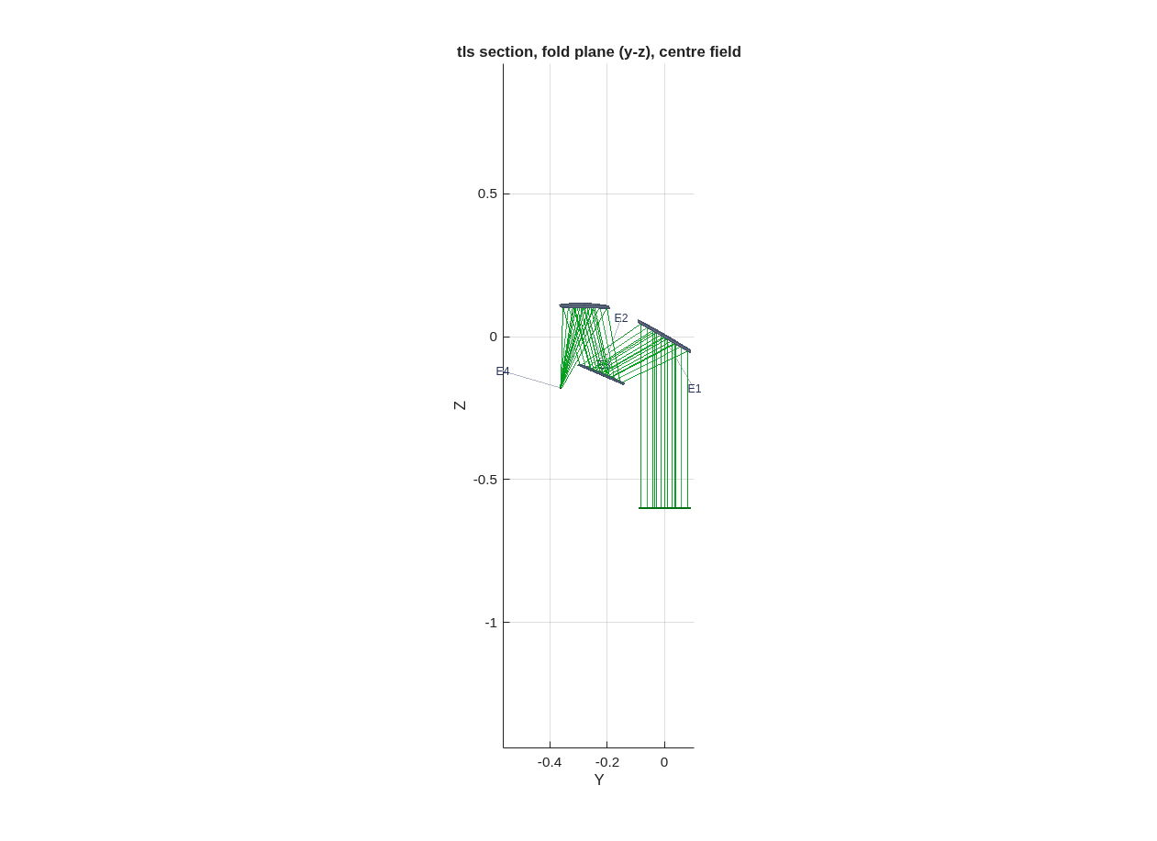
FIGURE 39 The engine section, fold plane, center field (tls_section_layout.png): the input beam rises to the weak concave M1 (E1), turns to the small convex M2 (E2), the stop, then to M3, which brings it to the slit (E4).
The number it reproduces. The first order is closed-form: with the stop at M2, the slit is telecentric when M3’s focal length is the M2-to-M3 leg, and each mirror must carry R_t/R_s = 1/cos^2 i at its chief, which an off-axis paraboloid does natively. Traced in the engine, the three off-axis sections hold the spec: a plate scale of 329.99 mm against 330.0, the strip imaged onto 54.24 mm of the 54.0 mm slit, and every leg clear of every body by at least 10.2 mm, with a 5 mm mount allowance. The image quality is the figure stage’s job, not this page’s: the section is the seed, with 2 mm rms spots.
Adapt it. “Using templates/10_telescopes/tma_longslit, run the first-order and section stages for a 250 mm focal length, 125 mm aperture long-slit TMA with a +-3 degree strip onto a 26 mm slit, and tell me whether every leg clears.”

9.10 tma_offaxis: Unobscured off-axis convex-secondary TMA
j18mono-geometry 3-mirror anastigmat (M1 concave, M2 CONVEX, M3 concave, f/20): exercise the convex-secondary seidel_seed fix (K=0 seed + correct unfolded focus), conic-optimize to a diffraction-limited on-axis anastigmat, then take it OFF-AXIS as an eccentric-pupil section, clear the beam, and re-balance over a 2-D field.
Run it.
cd('<path-to>/mmacos/templates/10_telescopes/tma_offaxis');
run(fullfile(pwd,'tma_offaxis.m'));
What it prints:
====================================================================
Unobscured off-axis convex-secondary TMA (j18mono geometry, f/20)
====================================================================
[0] built: f/20.04 (EFL=132.4 m); convex-fix seed K=[-0.996618 -1.65905 -0.661431] + correct focus
[1] all-sphere baseline: RMS WFE = 0 waves (uncorrected)
[2] on-axis conic optimize: 0 -> 0.0016 waves -> DIFFRACTION-LIMITED (K=[-0.9950 -1.6350 -0.8496])
[3] set_offaxis('all'): decenter 4.359 m (0.66*D); eccentric-pupil WFE = 0.060 waves
[4] off-axis axial refigure (radius+conic): 0.0006 waves -> DIFFRACTION-LIMITED
[5] +-2' AREA (3x3): worst 0.304 -> 0.044 waves -> DIFFRACTION-LIMITED
[6] clearance: 4/4 optics clear -> UNOBSCURED
[7] saved: <work>/templates/10_telescopes/tma_offaxis/tma_offaxis.in
+ <work>/templates/10_telescopes/tma_offaxis/tma_offaxis.mat
[8] WFE field map: <work>/templates/10_telescopes/tma_offaxis/tma_offaxis_wfe.png
orthographic layout: <work>/templates/10_telescopes/tma_offaxis/tma_offaxis_layout.png
--------------------------------------------------------------------
D=6.6 m | f/20.0 | convex-secondary TMA, j18mono geometry, unobscured off-axis lambda=2.3 um
RMS WFE: baseline 0 -> on-axis 0.0016 -> off-axis +-2' worst 0.0438 waves
convex-secondary fix: K=0 seed + correct f/20 focus; conics from optimize.
====================================================================
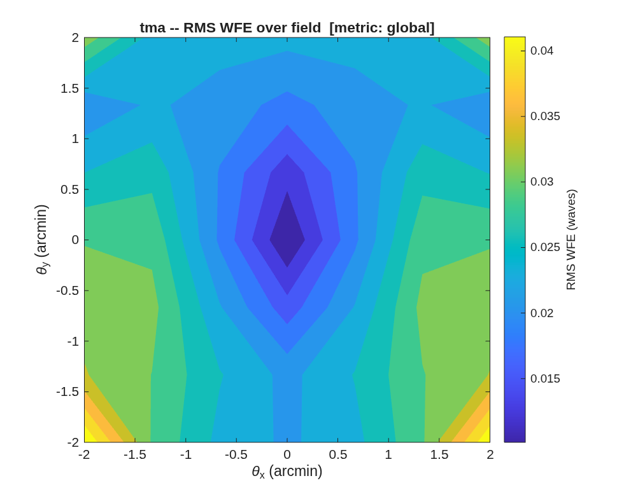
FIGURE 40 RMS wavefront error over the ±2′ field of the delivered off-axis design at 2.3 µm (tma_offaxis_wfe.png).
The number it reproduces. The convex-secondary seed conic-optimizes on axis to 0.0016 waves; taken off axis by 4.359 m and re-balanced over a 3 x 3 grid on the ±2′ field, its worst field is 0.044 waves at 2.3 µm, just outside λ/14, which the run prints as a residual. Its all-sphere baseline line reads 0 waves, which an uncorrected sphere cannot be; not traced.
Adapt it. “Using templates/10_telescopes/tma_offaxis, rebalance the off-axis design over a ±1.5 arcmin field and tell me whether it becomes diffraction-limited at 2.3 µm.”

9.11 tma_onaxis: on-axis three-mirror anastigmat designer (Korsch / j18mono form)
A parameterized Korsch TMA — concave M1, convex secondary (convex by geometry: it sits before the M1 focus, KrElt=-|R|), concave M3 behind M1 — with the three j18mono features:
- a real intermediate focus BETWEEN M1 and M2 (the field-stop / metrology- injection plane);
- a slight off-axis bias that tips the focal plane OUT of the M2→M3 beam (the j18 “slightly off-axis detector”); the M2 central obscuration remains — this is the obscured baseline, whose unobscured eccentric-pupil cousin is ../tma_offaxis;
- the exit pupil after M3 is ASSESSED (FEX), not constrained.
Run it.
cd('<path-to>/mmacos/templates/10_telescopes/tma_onaxis');
run(fullfile(pwd,'tma_onaxis.m'));
The knobs (tma_onaxis.m):
% ==================== USER DESIGN CHOICES ==========================
APERTURE_M = 1.0; % aperture diameter D (m)
PRIMARY_FNUM = 1.5; % M1 f/# (f1 = PRIMARY_FNUM*D, R1 = 2*f1)
SYSTEM_FNUM = 8.0; % system f/# (EFL = SYSTEM_FNUM*D)
SECONDARY_MAG = 8.0; % Cassegrain feed magnification (> 1)
INT_FOCUS_D = -0.125; % intermediate-focus z, units of D (between M1 & M2)
M3_BEHIND_D = 0.6; % tertiary this far behind the primary, units of D
FOV_ARCMIN = 2.0; % half-field optimized/evaluated about the bias
BIAS_SWEEP_ARCMIN = [1 2 3 4 6]; % off-axis biases to explore (arcmin)
% ---------------------------------------------------------------------
LAM = 633e-9; % wavelength (m)
MODEL = 256; % diffraction grid model size
DIFFRACTION_LIMIT = 0.07; % ~lambda/14 RMS (waves)
% =====================================================================
What it prints:
[1] layout: R=[3.000 0.349 0.580] m t=[1.347 1.947] m EFL=8.000 m (f/8.00)
intermediate focus z=-0.125 m (between M1 at 0 and M2 at -1.347); M3 z=0.600 m behind M1
[2] bias sweep (least bias that clears the FP wins -- WFE grows ~bias^2):
bias(arcmin) RMS WFE(waves) FP out of beam?
1.0 0.0059 YES
2.0 0.0098 YES
3.0 0.0164 YES
4.0 0.0296 YES
6.0 0.0716 YES
[3] RECOMMENDED bias = 1' (least bias that clears the FP and is diffraction-limited)
[4] design @ bias 1': 0 -> 0.0059 waves -> DIFFRACTION-LIMITED (K=[-0.9828 -1.4158 -0.6067])
clearance (obscured baseline -- M2 central obscuration expected):
M1 : OBSTRUCTS beam
M2 : OBSTRUCTS beam
M3 : clear
FP : clear
exit pupil after M3 (FEX, assessed): z=0.264 m (0.26*D from M1), radius=0.147 m
[5] saved: <work>/templates/10_telescopes/tma_onaxis/tma_onaxis.in
+ <work>/templates/10_telescopes/tma_onaxis/tma_onaxis.mat
layout: tma_onaxis_layout.png
--------------------------------------------------------------------
D=1.00 m | f/8 | EFL 8.00 m | Cass focus between M1 & M2 | bias 1' | WFE 0.0059 wv
obscured baseline (M2 central obscuration); FP biased out of beam; EP after M3 assessed.
Unobscured eccentric-pupil cousin: templates/10_telescopes/tma_offaxis.
====================================================================
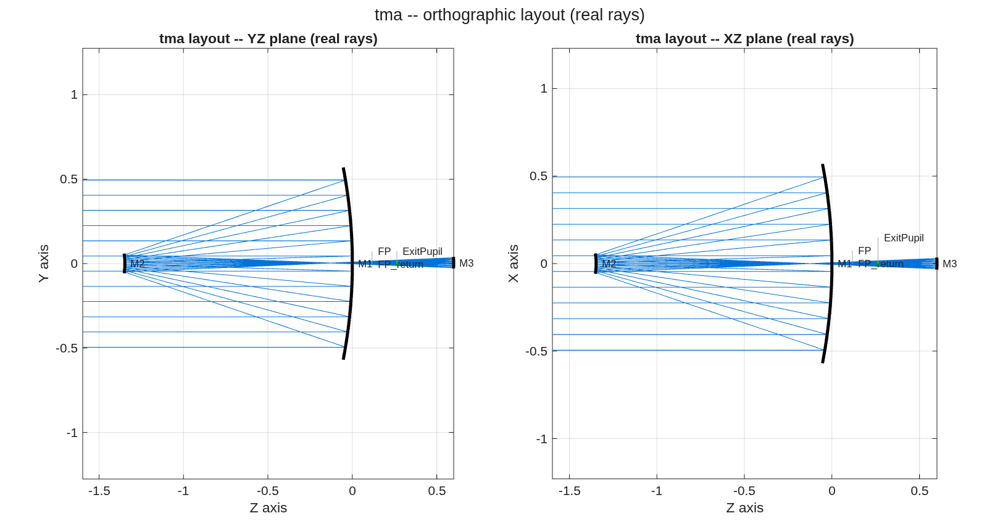
FIGURE 41 The recommended design, the YZ and XZ planes with real rays (tma_onaxis_layout.png): the convex secondary before the primary’s focus, the tertiary behind the primary, the focal plane biased out of the beam.
The number it reproduces. The least off-axis bias that clears the focal plane, 1', is diffraction-limited at 0.0059 waves rms at 633 nm.
Adapt it. “Using templates/10_telescopes/tma_onaxis, design an on-axis Korsch TMA with a 2 m aperture, an f/1.2 primary and an f/10 system at 633 nm, sweep the off-axis bias from 0.5’ to 4’, and build the least bias that clears the focal plane and is diffraction-limited.”

9.12 tma_unobscured: visible-band unobscured TMA: the coronagraph / imager / spectrometer front end
An eccentric-pupil (unobscured) three-mirror anastigmat for a visible telescope — 500 nm center wavelength — built with the same finder-then-demo approach as ../tma_centered: a constraint finder chooses the geometry against the packaging and polarization rules, and the demo runs the visible correction ladder, aligns the true focal plane, places the exit pupil, and emits the design report.
The brief (Dave, 2026-07-06):
- Slower M1 than the centered j18’s f/1.2: a slower primary makes the section’s per-mirror AOI spread gentler — the coronagraph polarization preference is < 15° across the beam on every mirror — and shrinks the clearing decenter. The price is tube length.
- M2 close to the source→M1 beam (launch-shroud packaging): the minimal-clearance eccentric section (set_offaxis('all')) is this rule — the decenter stops the moment every body clears with margin.
- The deliverable is a front end: unobscured pupil + accessible exit pupil (PropType=FarField — PSF/Strehl metrics live) for the coronagraph, and a flat, correctly-tilted focal plane for the imager and spectrometer pickoffs.
Run it.
cd('<path-to>/mmacos/templates/10_telescopes/tma_unobscured');
run(fullfile(pwd,'tma_unobscured_search.m')); run(fullfile(pwd,'tma_unobscured.m'));
The knobs (tma_unobscured_search.m):
% ==================== USER DESIGN CHOICES ==========================
D = 6.605; % aperture (m)
LAM = 0.5e-6; % center wavelength: 500 nm (visible)
SYS_FNUM = 20; % system f/# (EFL = 132 m; lambda*F = 10 um
% -> Nyquist at ~5 um detector pixels)
F1_STEPS = [1.5 2.0 2.5 3.0]; % the slower-M1 ladder (primary f/#)
F1_PICK = 2.5; % the design point (Dave 2026-07-06:
% "go with f/2.5" -- comfortably under
% the AOI rule with margin for the
% coronagraph, at acceptable tube)
FEED_FNUM = 10; % Cassegrain FEED f/# (= f1 * m2), held
% constant across the ladder (j18: 1.2 x
% 8 = 9.6). Holding m2 instead drives
% the feed toward the system f/# as M1
% slows -- the M3 relay degenerates to
% 1:1 and the clearing decenter blows up
% (seen at m2=8: f/2.5 needs > 2.5*D).
FIELD_RAD = 0.5; % science-field RADIUS (arcmin) for the
% conic solve + the demo's FOV ladder
AOI_MAX = 15; % per-mirror AOI SPREAD preference (deg,
% coronagraph polarization rule)
MARGIN = 0.05; % section clearance margin (x D)
% =====================================================================
What it prints:
[1] chain (eccentric-pupil sections, decenter 5.245 m):
M1 Reflector Vpt=[ 0.000 0.000 0.000]
M2 Reflector Vpt=[ 0.000 0.000 -13.375]
M3 Reflector Vpt=[ 0.000 0.000 3.963]
FP FocalPlane Vpt=[ < 0.0001 0.000 -5.614]
[2] correction ladder (waves RMS @ 500 nm, field center):
[2a] as found: raw 0.604 | -tilt 0.306 | -focus 0.214 | -astig 0.098
[2b] off-axis refigure: raw 0.001 | -tilt 0.001 | -focus 0.001 | -astig 0.001
[2c] field balance: raw 0.004 | -tilt 0.004 | -focus 0.003 | -astig 0.003
[2d] + freeform M1: raw 0.006 | -tilt 0.003 | -focus 0.003 | -astig 0.002
field center: 0.006 waves @ 500 nm -> DIFFRACTION-LIMITED
[2e] true FP from 5x5 field foci (+center): tilt 1.208 deg, defocus removed -1.439 mm,
field-curvature sag -0.5 to +0.5 um
[3] FOV ladder (worst on ring, waves RMS @ 500 nm; blur on -tilt):
ring raw -tilt
0.10' 0.009 0.004 <- DL
0.25' 0.010 0.005 <- DL
0.50' 0.018 0.008 <- DL
1.00' 0.047 0.022 <- DL
check_clipping (family=tma, 4 elements)
name kind ap_r foot_r margin clearnce obstruct status
M1 Reflector 3.633 3.302 0.3309 1.894 0 OK
M2 Reflector 3.303 0.6354 2.667 0.2972 0 OK
M3 Reflector 3.303 0.2383 3.064 -- 0 OK
FP FocalPlane 1.982 < 0.0001 1.981 0.2804 0 OK
=> layout is CLEAR (no body-in-beam, beams fit apertures)
[4] clearance: UNOBSCURED -- every body clear (minimal decenter = M2 as close to the
source->M1 beam as the 5%-of-D margin allows)
[5] saved: <work>/templates/10_telescopes/tma_unobscured/tma_unobscured.in
+ <work>/templates/10_telescopes/tma_unobscured/tma_unobscured.mat
figures: tma_unobscured_layout.png + tma_unobscured_fpmap.png
[6] design report:
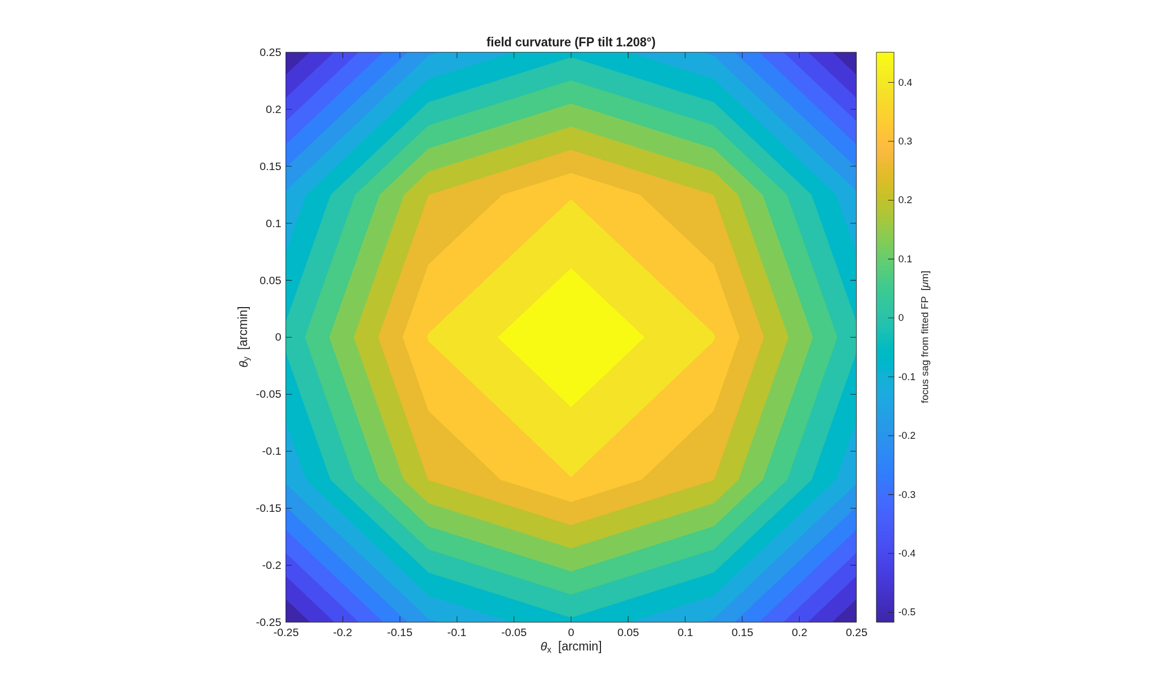
FIGURE 42 Field curvature on the fitted focal plane (tma_unobscured_fpmap.png): the sag of the best focus from the tilted, refocused plane, over ±0.25’.
The number it reproduces. The correction ladder reaches 0.006 waves rms at the field center at 500 nm with the freeform primary, and the field ladder stays diffraction-limited out to the 1’ ring (0.022 waves, tilt removed). The template’s closing design report (step [6], not printed) reads NaN on every field ring on this run, the open questions list has it.
Adapt it. “Using templates/10_telescopes/tma_unobscured, run the finder and the demo for a 4 m unobscured visible TMA with an f/3 primary, keeping every mirror’s AOI spread under 15 degrees, and report the field ladder to 1’.”

9.13 tma_widefield: Does each mirror earn its keep? Wide-field 2-mirror (Ritchey-Chretien) vs 3-mirror (Korsch TMA)
Multi-mirror telescopes exist to widen the corrected field of view. This example makes that quantitative: it builds a 2-mirror RC and a 3-mirror TMA at the same aperture and f/#, optimises BOTH over the same wide field, and compares the residual wavefront error vs field. The physics: an RC nulls 3rd-order spherical AND coma with its two conics, so it is excellent on-axis – but it has NO degree of freedom left for field astigmatism, which grows ~field^2. A TMA’s third conic supplies exactly that DOF (a Korsch anastigmat nulls spherical + coma + astigmatism). So as the field opens up the 2-mirror hits a “wall” and the 3-mirror sails past it.
Run it.
cd('<path-to>/mmacos/templates/10_telescopes/tma_widefield');
run(fullfile(pwd,'example_tma_widefield.m'));
What it prints:
Stage 4 -- residual RMS wavefront error vs field
------------------------------------------------------------------
field(arcmin) RC 2-mirror(lambda) TMA 3-mirror(lambda) gain
0.0 0.4519 0.0313 14.4x
2.0 0.4839 0.0303 15.9x
5.0 0.6315 0.0261 24.2x
10.0 0.8111 0.0263 30.8x
15.0 0.8303 0.0613 13.5x
20.0 1.6600 0.1200 13.8x
well-corrected field (< 0.10 lambda RMS): RC <= 0' , TMA <= 15'
=> the 3rd mirror's conic nulls field astigmatism the RC cannot:
the 2-mirror walls at ~0.5-1.6 lambda; the TMA holds the field.
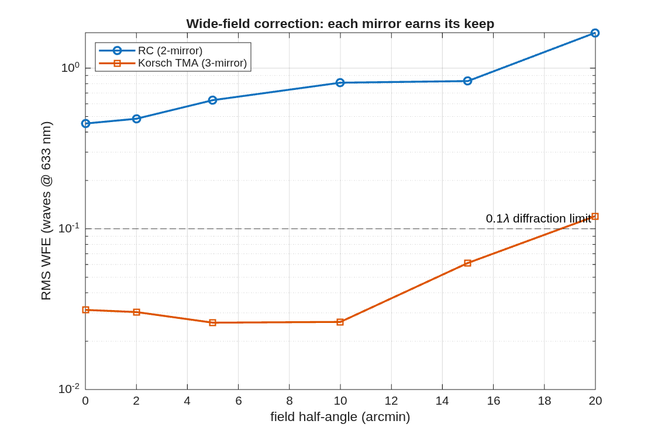
FIGURE 43 Residual RMS wavefront error against field for the 2-mirror RC and the 3-mirror Korsch, both optimized over the same 0 to 20′ field (tma_widefield_wfe.png).
The number it reproduces. Optimized over the same 20′ field at f/8, the 3-mirror design holds 0.0613 waves at 15′ (0.1200 at 20′), while the 2-mirror, its two conics spent across the whole field, sits at 0.4519 waves even on axis: the third conic is what buys the field.
Adapt it. “Using templates/10_telescopes/tma_widefield, rerun the RC-against-TMA comparison over a 10 arcmin field at f/12 and tell me where each one stops being well corrected.”

9.14 wf2_freeform: Wide-field 2-mirror freeform designer
Pick the knobs below; the script builds an aplanatic Ritchey-Chretien and shows what a freeform Zernike departure on the secondary buys – in two views, holding every radius and conic (the layout) FIXED: A. PER-FIELD POWER. At a single off-axis field, freeform NULLS the astigmatism the 2-mirror conics leave behind – ~25x, to diffraction-limited. B. WIDE-FIELD REALITY. Over a symmetric +-FOV field, freeform extends the diffraction-limited field only modestly: a 2-mirror has just ONE surface away from the pupil, so its departure gives field-LINEAR astigmatism control, which cannot cancel the field- SQUARED astigmatism across a wide field. That is exactly what a THIRD mirror buys (-> the off-axis 3-mirror freeform driver).
Run it.
cd('<path-to>/mmacos/templates/10_telescopes/wf2_freeform');
run(fullfile(pwd,'wf2_freeform.m'));
The knobs (wf2_freeform.m):
% ==================== USER DESIGN CHOICES ==========================
APERTURE_M = 1.0; % aperture diameter D (m)
PRIMARY_FNUM = 2.0; % M1 f/#
SYSTEM_FNUM = 8.0; % system f/# (mag = SYSTEM/PRIMARY)
BFD_M = 0.25; % back focal distance: focus this far behind M1 (m)
FOV_ARCMIN = 7.0; % design HALF-field (arcmin): optimize + evaluate over +-this
FREEFORM_ELT = 2; % mirror(s) to make freeform (2 = secondary, away from pupil).
% Try [1 2] for both; M1 is at the pupil (field-constant).
FREEFORM_MODES = [5 6 11]; % ANSI Zernike DOF: 5 defocus, 6 astig, 11 spherical
LAM = 633e-9; % wavelength (m)
MODEL = 256; % diffraction grid model size
DIFFRACTION_LIMIT = 0.071; % ~lambda/14 (waves RMS) -- the Marechal criterion
% =====================================================================
What it prints:
====================================================================
Wide-field 2-mirror freeform | D=1.00 m | primary f/2.0 | system f/8.0 | +-7'
====================================================================
[1] aplanatic RC: on-axis 0.0081 waves; nominal field scan (astig wall)
[2] conic field-balance (radius+conic): worst-field 0.1540 waves (2-mirror astig limit)
[3] + freeform on M2 (modes [5 6 11], CALIB OptZern, radii/conics held):
worst-field 0.1428 waves; diffraction-limited field 5.0' -> 5.0' (1.00x area)
[4] single off-axis field (7'): conic-limit 0.0801 -> freeform 0.0023 waves (34x, DIFFRACTION-LIMITED)
[5] WFE-across-field map: <work>/templates/10_telescopes/wf2_freeform/wf2_freeform_wfe.png
before/after field curve: <work>/templates/10_telescopes/wf2_freeform/wf2_freeform_fieldcurve.png
orthographic layout: <work>/templates/10_telescopes/wf2_freeform/wf2_freeform_layout.png
[6] saved: <work>/templates/10_telescopes/wf2_freeform/wf2_freeform.in
+ <work>/templates/10_telescopes/wf2_freeform/wf2_freeform.mat
--------------------------------------------------------------------
D=1.00 m | primary f/2.0 | system f/8.0 | BFD=250 mm | half-field +-7'
PER-FIELD : a single off-axis field nulls 0.0801 -> 0.0023 waves (34x, diffraction-limited)
WIDE-FIELD: diffraction-limited half-field 5.0' -> 5.0' (1.00x area), worst 0.154->0.143 waves
freeform on M2 holds all radii/conics (layout unchanged); full wide-field needs a 3rd mirror
====================================================================
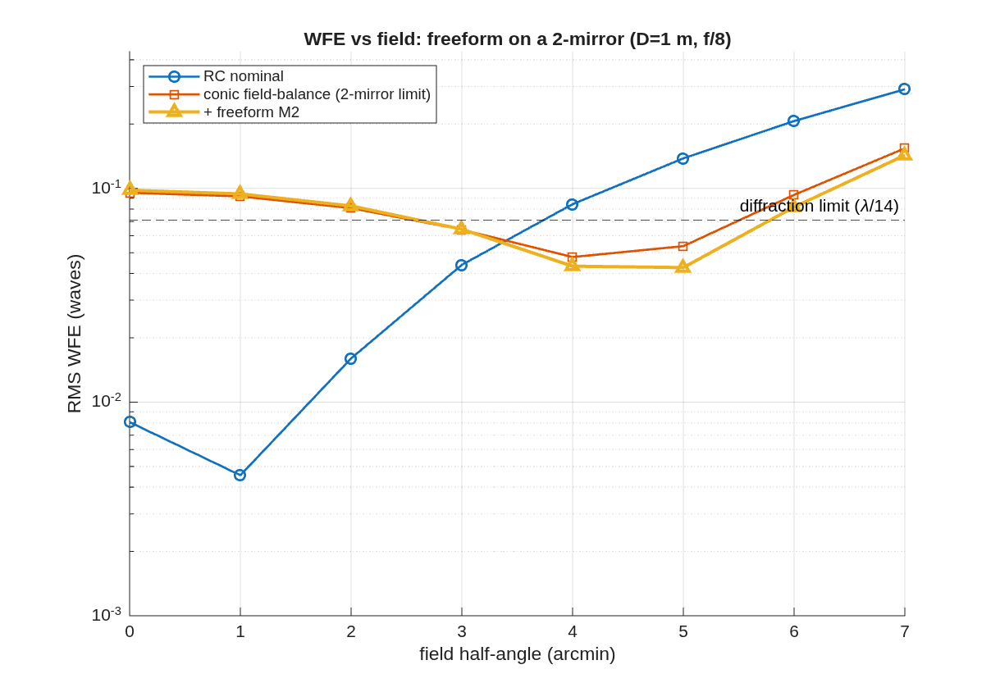
FIGURE 44 RMS wavefront error against field for the nominal RC, the conic field-balance (the 2-mirror limit) and the freeform M2 (wf2_freeform_fieldcurve.png).
The number it reproduces. At a single off-axis field (7′) a freeform departure on the secondary nulls the conics’ residual, 0.0801 to 0.0023 waves; over the whole ±7′ field it buys almost nothing (worst 0.143 waves, the diffraction-limited field unchanged at 5′), because a 2-mirror has one surface away from the pupil. The header’s “~25x” per-field figure reads 34x on this run.
Adapt it. “Using templates/10_telescopes/wf2_freeform, add the freeform modes to M1 as well as M2 and rerun, and tell me whether the diffraction-limited field over ±7 arcmin grows.”

9.15 e5_pie: pie segmentation with physical polygonal apertures
A segmented prescription built by macos.design.segment_rx carries segment-ness in the SOURCE tiling only: every segment element is a full mathematical surface with no aperture, and rays are assigned to segments by the tiling. That is trace-exact at nominal but physically dishonest under perturbation — a ray can walk off its segment and keep tracing against a surface that has no glass there. This example declares each segment’s PHYSICAL boundary as a polygonal aperture in the Rx, and then uses those declared polygons as the basis for MET launcher placement — the general case, which also covers segmentations imported from .in files (Dave 2026-07-16).
Run it.
cd('<path-to>/mmacos/templates/20_segmentation/e5_pie');
run(fullfile(pwd,'e5_pie.m'));
The knobs (e5_pie.m):
PAD = 0; % aperture clearance beyond the physical edge, mm.
% 0 = the physical segment (gap rays clip); gap/2 would
% put the aperture at the tiling midline (trace-neutral).
POKE = 0.100; % wedge decenter for step 5, metres
NF = 6; % fiducials on the M2 rim (step 6)
R_FID = 590; % fiducial ring radius, mm (~25 inside M2's 615 rim)
R_EXTRA = 100; % aft/M3 launcher ring radius, mm (that truss's size)
What it prints:
step 1: pie system, 7 segments, width 2666.7 mm, gap 50 mm
baseline: 12128 src rays, 12128 pass, rmsWFE 3.91181e-05 mm
step 2: footprint map + boundary overlay -> e5pie_step2_footprints.png
step 3: apertures emitted (pad 0 mm): center hexagon with 6 vertices, wedges 15 each -> e5pie_polyap.in
step 4: with apertures: 12008 pass (baseline 12128), rmsWFE 3.88557e-05 mm (-0.67%)
120 rays clipped; first-fail element(s): [1 2 3 4 5 6 7]
step 5: 100 mm wedge decenter: 10265 rays pass with apertures, 10351 without --
the aperture-less trace keeps 86 rays that have no glass under them
step 6: seg_boundary source = rxpoly (auto-detected from the Rx)
48 MET beams; launchers sampled from the aperture polygons -> e5pie_step6_met.png
findings.txt + 5 figures written to <work>/templates/20_segmentation/e5_pie
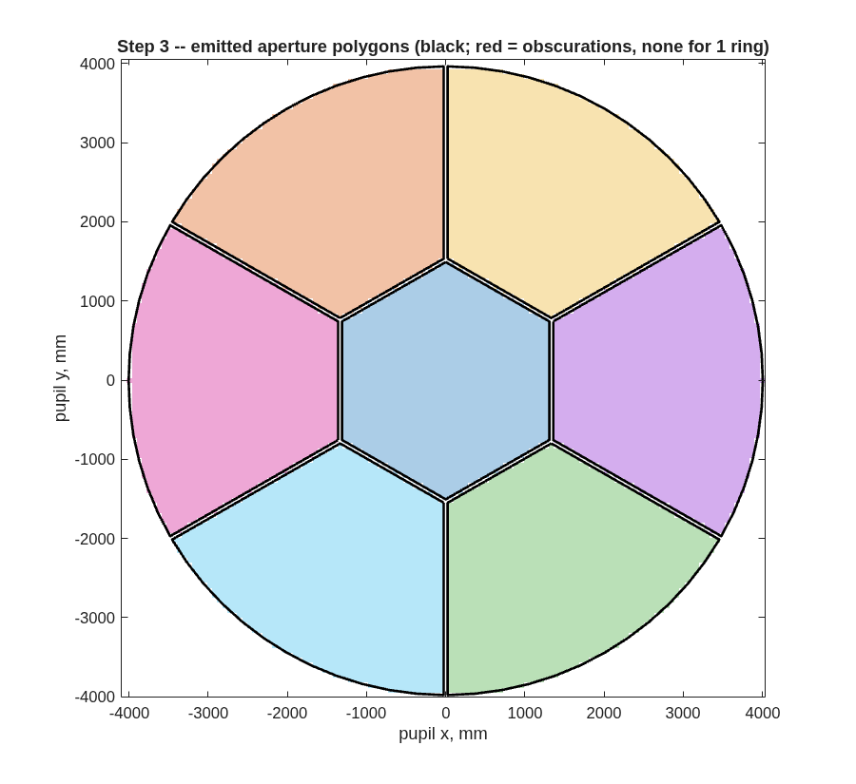
FIGURE 45 The apertures step 3 emits (e5pie_step3_apertures.png): the center hexagon and six chorded wedges, each a convex polygon, with the 50 mm gaps as uniform slots; one ring needs no obscurations.
The number it reproduces. Declared in the prescription, the polygons clip the 120 gap rays the source tiling had placed where there is no glass (of 12128), and under a 100 mm wedge decenter the aperture-less trace keeps 86 rays that the apertured one loses at the segment’s edge. The template’s committed findings.txt (August) reads 502 clipped and 403 kept, of 12520 source rays, and the README says about 400: the live source grid is smaller, the same change as Part I’s pie (finding (fff)).
Adapt it. “Using templates/20_segmentation/e5_pie, segment the e5 primary into a 2-ring pie with a 30 mm gap, emit the physical apertures, and tell me how many rays the gaps clip and how many the aperture-less trace wrongly keeps under a 100 mm decenter.”

9.16 e5_seg: segmented primary + edge sensors + laser-MET truss
One modifiable runner (e5_seg.m): e5mono.in (monolithic parent) → segmented .in including the MET points → dedx (SegMirMaker Hx), dldx (FD over the engine METcalc), dwdx → MET metric performance = post-control wavefront residual trace(dwdx·P_δx·dwdxᵀ) vs the prior baseline W = dwdx·X·dwdxᵀ, with a Monte-Carlo estimate/control cross-check.
Pipeline: macos.design.segment_rx → macos.design.add_met (Stewart trusses: 6 launchers/segment + 6 around the aft body → hub fiducials) → macos.design.edge_sensors + macos.design.dmet_dx + a local dwdx FD block (column convention [rot|trans] per body in its LOCAL triad, SI units, identical across all three Jacobians by construction).
Knobs at the top: rings/grid/gap, edge-sensor config, truss geometry (nf, radii), prior X (deploy tolerances), sensor noises R, MC draws.
Reference output (rings=1 Hex, 7 segs + m2 + fpa = 54 DOF, 20 edge + 48 MET measurements, 1 µrad/1 µm priors, 1 nm sensors) under the PHYSICAL mounting constraints (Dave 2026-07-16): launchers at the segment edges + 5 mm clearance, 6 fiducials mounted ON M2 ~25 mm inside its 615 mm rim, aft (“M3”) launcher ring hugging that body (100 mm — it has no structure at larger radius):
Monte-Carlo (200 draws) 229 nm vs analytic 232 nm (1.3%).
The dominant residual is the AFT-BODY (fpa) uncertainty: its ring shrank to the physically-mountable 100 mm radius, so its rotational lever arms are weak. (An earlier, unphysical configuration with free-floating 300 mm fiducial/aft rings scored 4.3 nm — mounting reality costs real performance and is exactly what the layout optimizer must work within.) The tier-3 optimizer (e5_seg_metopt.m) currently optimizes the SEGMENT truss only (its merit covers the 42 segment DOFs; hub/aft analytic rows are the queued follow-on) and reaches 3.36 nm on that sub-merit, engine-validated to 0.00%.
Artifacts land beside the script: e5_seg_met.in (+ flat.txt it needs in the cwd at load), e5_segHx.m, e5_seg.mat (all Jacobians), e5_seg_metric.png, and two layout views:
- e5_seg_met_layout.png — macos.design.met_view: 3-D MET scene (segment hex tiles, launchers, hub fiducials, gauge beams, hub disc, real-ray envelope from the engine trace) + face-on launcher layout with per-segment radial centerlines.
- e5_seg_view_rx.png — the same system through the GENERAL viewer macos.view_rx (works on ANY loaded Rx: traced beam + per-element ray-footprint patches + MET paths via macos.met_geom).
The optimizer runner (e5_seg_metopt.m) additionally writes e5_seg_metopt_layout.png: the optimized launcher/fiducial layout with the baseline edge ring overlaid as open circles and the 5 mm edge-clearance hex dashed.
Notes: the engine MET model is straight-line point-to-point length (no LOS/obscuration check); macos.modify() after each poke is load-bearing (cached trace/OPD otherwise reads unchanged); OPD is in WaveUnits (mm here). Next step (recorded in the plan): optimize the MET layout against this metric — see PLAN_DESIGN_LAYER §6.6 tier 3.
Run it.
cd('<path-to>/mmacos/templates/20_segmentation/e5_seg');
run(fullfile(pwd,'e5_seg.m'));
The template finds the library’s segmirmaker folder four levels above itself, so the manual runs its copy under a scratch mmacos/ folder with segmirmaker linked beside it; that is the only difference from running it in place.
The knobs (e5_seg.m):
RINGS = 1; % 1 -> 7 segments, 2 -> 19
GRID = 'Hex'; % segment tiling / ray grid (Hex|Pie|...)
GAP = 50; % inter-segment gap, mm
MEASCFG = 2; % edge sensors: 1 inner edges, 2 all adjacencies
NF = 6; % MET fiducials on the hub (Dave: >=3, likely 6)
R_FID = 590; % hub fiducial ring radius, mm -- fiducials must
% MOUNT ON M2 near its edge (~25 mm inside the
% 615 mm ApVec rim; no structure beyond)
R_EXTRA = 100; % aft ("M3") launcher ring radius, mm -- must hug
% that body (elt 11 is a Return with no ApVec/
% lMon to auto-size from; aft bench is ~90 mm)
EDGE_OFF = 5; % launcher clearance outward of the segment edge, mm
SIG_ROT = 1e-6; % prior (deploy) uncertainty: rad per rot DOF
SIG_TRANS = 1e-6; % ... metres per trans DOF
SIG_EDGE = 1e-9; % edge-sensor noise, metres
SIG_MET = 1e-9; % MET gauge noise, metres
NMC = 200; % Monte-Carlo draws for the cross-check
MODEL = 512;
What it prints:
[1] segmenting e5mono (rings=1, Hex, gap=50)
[2] MET truss: 6 launchers/seg + 6 around elt 11 -> 6 fiducials on elt 8
[3] segmented+met system: 13 elts, 10246 rays, rmsWFE 3.62e-05
[3b] dwdx FD over 54 DOFs x 10244 OPD samples
[4] post-control wavefront residual (rms, control = -pinv(dwdx)*w_hat):
prior (no sensing) 12860.131 nm rms
edge sensors only 55.322 nm rms
MET only 472.908 nm rms
edge + MET 4.704 nm rms
sensing removes 100.0% of the prior wavefront variance (edge+MET)
Monte-Carlo (200 draws): 4.759 nm rms (analytic 4.704) [1.2%]
[5] artifacts saved beside the script (e5_seg_met.in, .mat, metric + layout png)
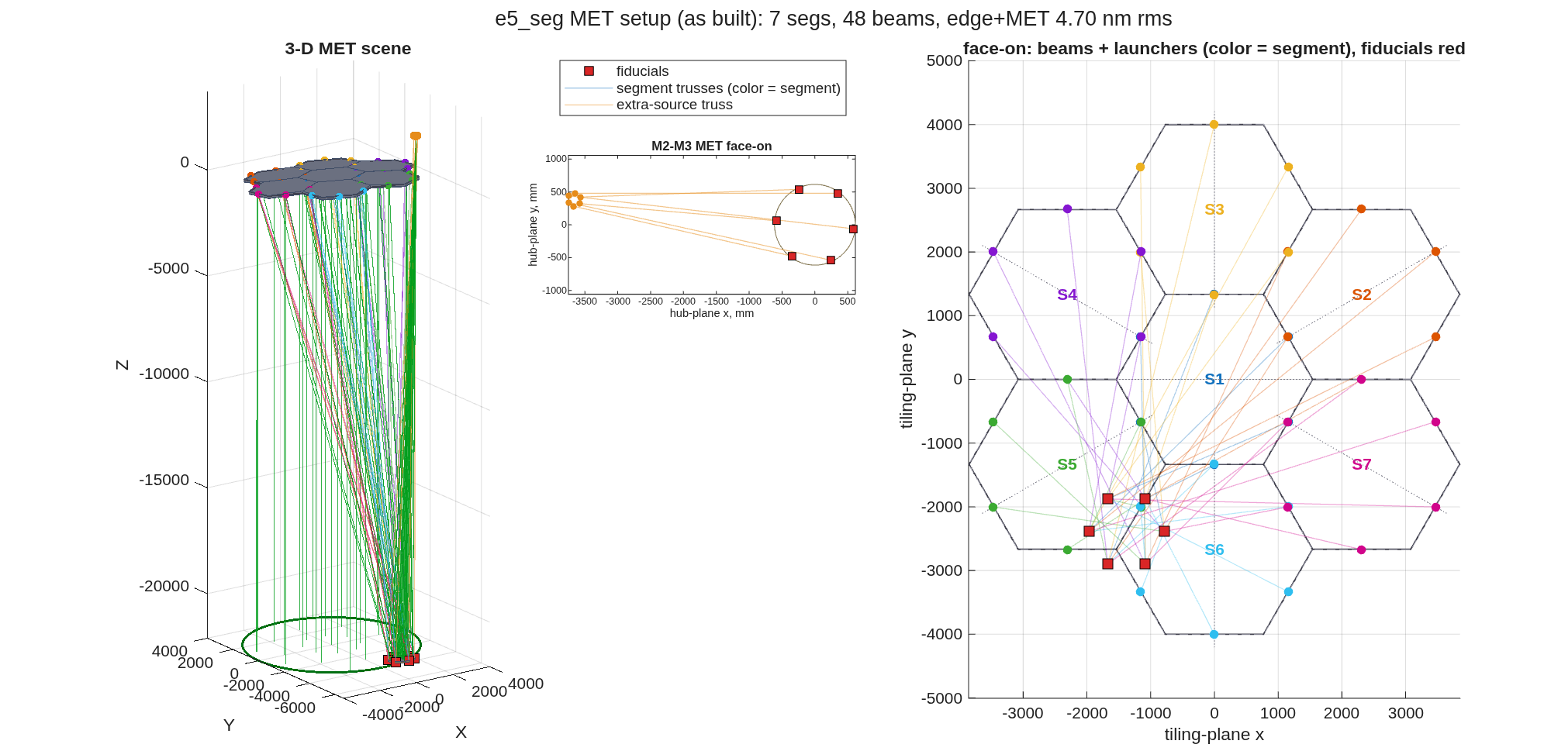
FIGURE 46 The MET setup as built (e5_seg_met_layout.png, macos.design.met_view), its title carrying this run’s edge+MET residual: left, the 3-D scene, the seven hex segments, the launchers at their edges and the gauge beams down to the six fiducials (red); center, the aft truss’s beams face-on in the hub plane; right, the launchers and beams face-on over the tiling, colored by segment.
The number it reproduces. Sensing the 54 rigid-body degrees of freedom (seven segments, the secondary, the aft body) against a 1 urad / 1 um deployment prior, the post-control wavefront residual is 12860.131 nm rms with no sensing, 55.322 nm with the edge sensors alone, 472.908 nm with the metrology truss alone, and 4.704 nm with both; a 200-draw Monte-Carlo gives 4.759 nm, the same model computed the other way. The README’s table (9577 / 3641 / 450 / 232 nm) predates the edge-sensor rework, as its banner says, and the banner’s prediction holds: with the in-plane motions now edge-observable, the combined residual drops by a factor of about fifty. The prior moved too (12860.131 against 9577 nm), so the wavefront sensitivities themselves are not the README’s; that part is not traced here.
Adapt it. “Using templates/20_segmentation/e5_seg, rerun the edge-plus-metrology sensing study for the 2-ring, 19-segment hex primary with the same priors and noises, and tell me which body dominates the residual.”

9.17 bench_ctb: coronagraph-testbed Bench example
A worked macos.design.Bench example: build a DST2R-like, all-reflective coronagraph relay sequentially, then optimize it in physically-staged steps. Teaching example — every block in the runner states its parameters, the add-optic call, the objective (form a pupil here, focus there), and the test that confirms it.
Run it.
cd('<path-to>/mmacos/templates/30_instruments/bench_ctb');
run(fullfile(pwd,'example_ctb.m'));
The knobs (example_ctb.m):
P.F_OAP = [2500 1524 1143 1350 675 635 635 762]; % DST2R parent focal lengths
P.AOI = 5; % OAP/DM angle of incidence, deg
P.R_OAP = 75; % OAP clear-aperture radius, mm
P.R_DM = 22.5; % DM aperture radius, mm (stop)
P.FILL = 0.95; % source NA fills FILL of DM
P.WAVLEN= 500e-6; % 500 nm in mm
P.r = P.F_OAP / cosd(P.AOI)^2; % conjugate distances (mm)
% free (collimated-space) leg lengths -- set generously, no overlap:
P.L_DM1=600; P.L_DM2=500; P.L_O2=700; P.L_APOD=350; P.L_O4=500;
P.L_LYOT=350; P.L_O6=450; P.L_BACK=300; P.L_O8=450;
P.AP = P.R_DM*P.FILL / P.r(1); % source numerical aperture
% aluminium coating for the polarization study (index n - i*kappa):
P.AL_N = 1.2; P.AL_K = 7.0; P.AL_T = 1e-4; % ~100 nm Al
What it prints:
pupil beam DIAMETERS (mm) -- the source Aperture is the full cone angle, so R_DM*FILL lands as the diameter: DM 21.38 apod 16.03 Lyot 8.02 backend 8.02
ctb: 17 elements, chief path 13494.603 mm
1 OAP1 Reflector s= 2519.136 vpt=[ 2462.019 434.120 0.000]
2 DM1 Reflector s= 3119.136 vpt=[ 1928.251 -104.189 0.000]
3 DM2 Reflector s= 3619.136 vpt=[ 2428.251 -104.189 0.000]
4 OAP2 Reflector s= 4319.136 vpt=[ 1773.704 -490.382 0.000]
5 Focus23 Reference s= 5854.801 vpt=[ 3274.551 -225.743 0.000]
6 OAP3 Reflector s= 7006.550 vpt=[ 4400.186 -27.263 0.000]
7 Apodizer Reference s= 7356.550 vpt=[ 4081.617 -286.519 0.000]
8 OAP4 Reflector s= 7856.550 vpt=[ 3620.056 -607.769 0.000]
9 FPM Reference s= 9216.883 vpt=[ 4949.546 -373.344 0.000]
10 OAP5 Reflector s= 9897.049 vpt=[ 5614.291 -256.131 0.000]
11 Lyot Reference s=10247.049 vpt=[ 5285.030 -434.120 0.000]
12 OAP6 Reflector s=10697.049 vpt=[ 4856.374 -622.529 0.000]
13 FieldStop Reference s=11336.910 vpt=[ 5481.727 -512.262 0.000]
14 OAP7 Reflector s=11976.770 vpt=[ 6107.080 -401.996 0.000]
15 Backend Reference s=12276.770 vpt=[ 5826.145 -564.357 0.000]
16 OAP8 Reflector s=12726.770 vpt=[ 5400.391 -774.818 0.000]
17 FPA FocalPlane s=13494.603 vpt=[ 6150.814 -642.498 0.000]
ok/elt [3002 3002 3002 3002 3002 3002 3002 3002 3002 3002 3002 3002 3002 3002 3002 3002 3002] chief max < 1e-09 mm
RMS WFE 0.001423 waves | DM1->FPA zone spot med 0.02713 um worst 0.05121 um
pol @ FPA: ret mean 0.02109 (var 4.90e-05), diatten mean 0.00362 (var 8.41e-06)
=== POLARIZATION at FPA (Al-coated mirrors) ===
retardance : mean 0.02109 rad var_rms 4.896e-05 rad
diattenuat.: mean 0.00362 var_rms 8.414e-06
NOTE: fold polarization compensation is non-trivial -- in-plane fold
alternation does NOT cancel retardance, and naive crossed-plane folding
cuts diattenuation but not retardance-variation and costs WFE. Proper
compensation pairs equal-AOI folds with exactly-crossed planes AND
balances the induced astigmatism (flagged follow-up).
=== PIL DESIGN STEP (pupil-imaging lens) ===
PIL f=150mm: pupil image diam 3.29 mm, camera +0.0 mm vs f=150mm (<work>/templates/30_instruments/bench_ctb/ctb_pil150.in)
PIL f= 75mm: pupil image diam 1.23 mm, camera -100.7 mm vs f=150mm (<work>/templates/30_instruments/bench_ctb/ctb_pil75.in)
(size ratio 2.68x and camera move ~101 mm mirror Marx's 150mm/75mm 1000/500-px, +106mm trade)
DONE. Optimized source-imaging Rx: <work>/templates/30_instruments/bench_ctb/ctb_planar_opt.in
PIL pupil-imaging Rx: <work>/templates/30_instruments/bench_ctb/ctb_pil150.in, <work>/templates/30_instruments/bench_ctb/ctb_pil75.in
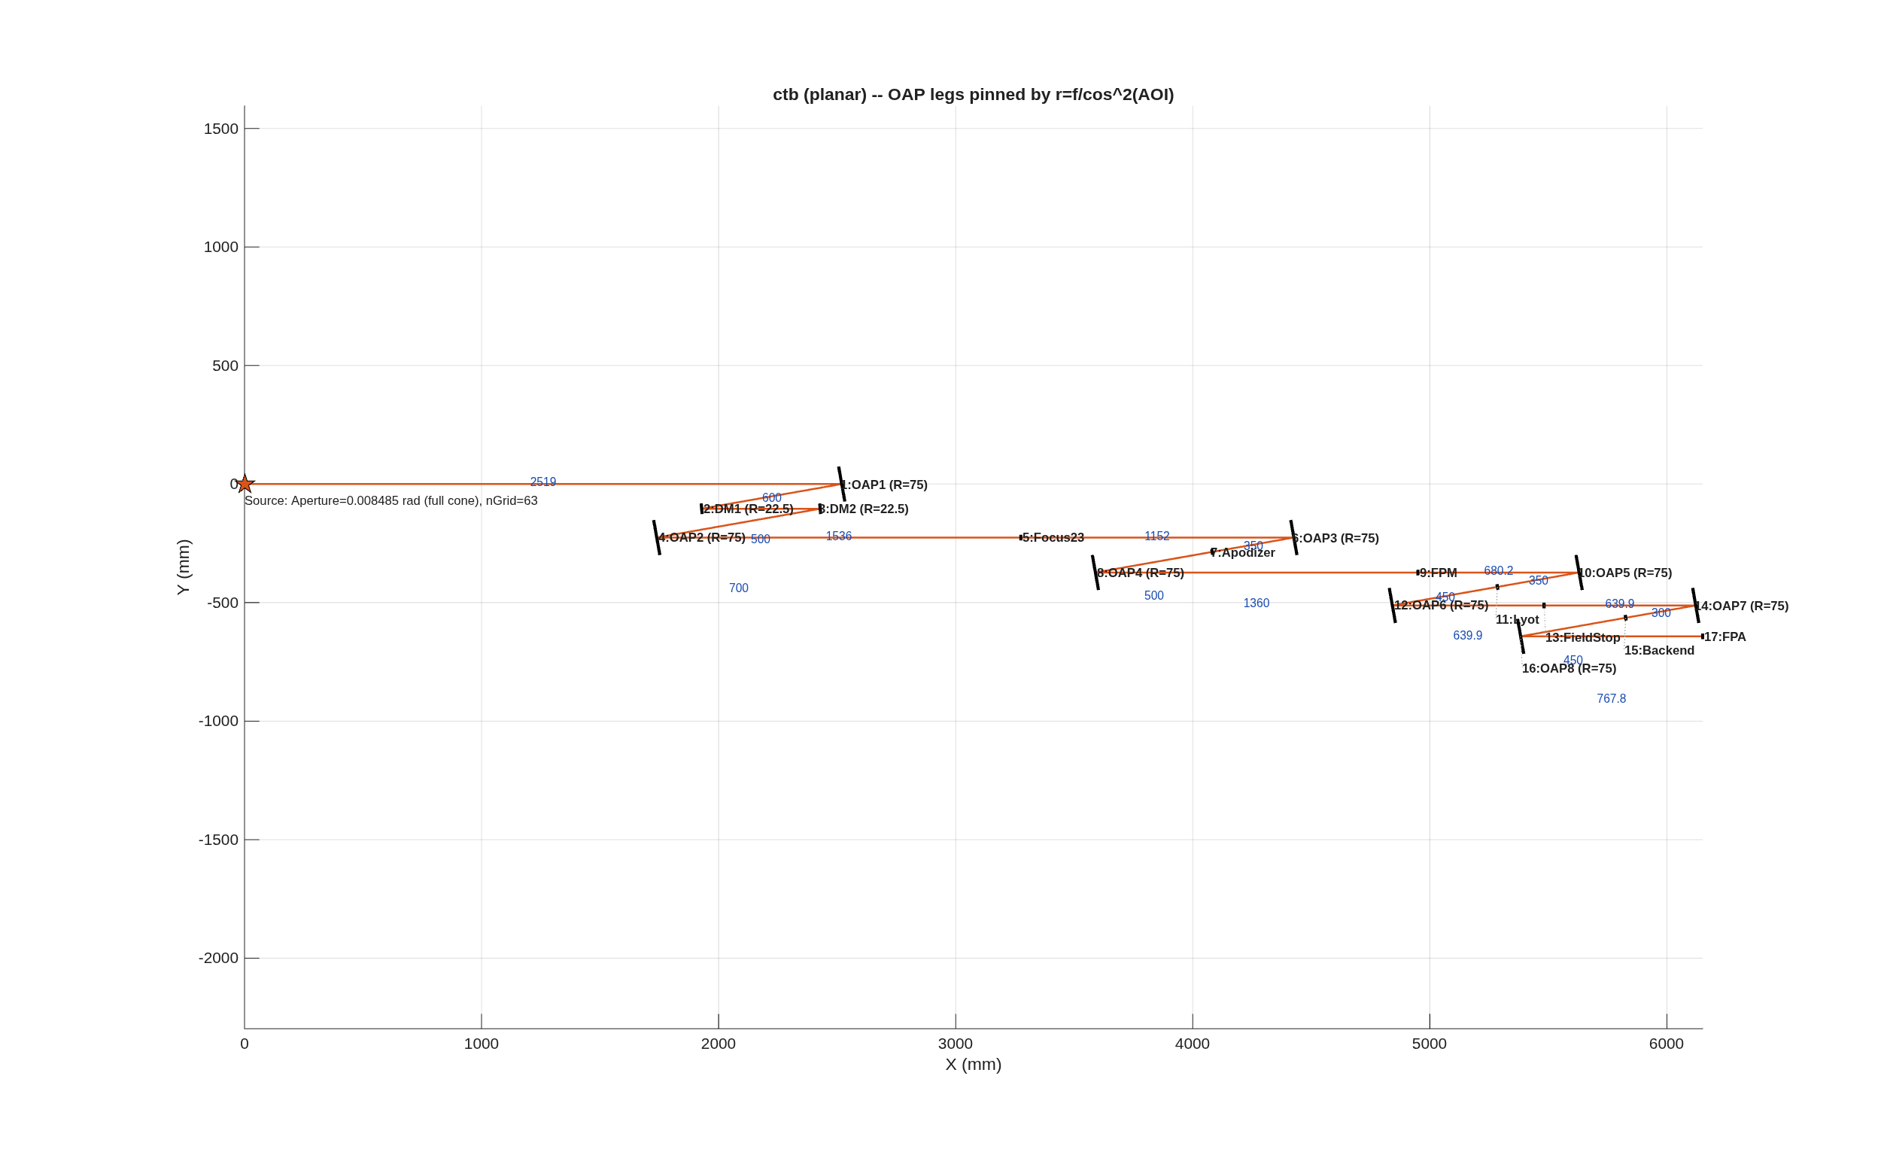
FIGURE 47 The bench in its plane (ctb_planar_params.png), drawn from the parameter block: the source, eight off-axis parabolas (R = 75 mm) and the two DMs, with the pupil and focus markers between them, every OAP leg set by r = f/cos^2(AOI) at AOI 5 degrees; the blue numbers are the leg lengths in mm.
The number it reproduces. Built and optimized in physically staged steps (each conjugate on its own plane, in light order), the relay reaches 0.001423 waves rms at the detector at 500 nm, the README’s 0.0014, with all 3002 rays traced at every element and a median zone spot of 0.02713 um. The builder’s chief ray and the engine’s agree to the floor of the arithmetic (printed as a bound). The first line of the printout is the README’s fill finding: the source’s Aperture is a full cone angle, so the beam lands on the DMs 21.38 mm in diameter, filling 47 percent of their 22.5 mm clear radius where the sheet intends 95. Section 2 builds this bench behind the thread’s telescope, with OAP1’s focal length matched to the telescope’s f-number and DM1 moved to the image of the telescope’s stop.
Adapt it. “Using templates/30_instruments/bench_ctb, rebuild the bench with a 42.75 mm beam on the DMs (the intended 95 percent fill) at the same OAP focal lengths, and report the staged optimization’s final wavefront error and whether any beam overfills.”

9.18 coro_planet_demo: Illustrated coronagraph + off-axis planet injection
coro_planet_demo() runs the canonical CoroExample recipe through the mmacos framework and writes two 4-panel figures (matching the CoroExample.jou “pgp 4” plot pages) into the example folder: coro_surfaces.png the coronagraph surfaces (jou: int 1/6/11/16) [entrance pupil | star occulted at FPM | pupil at Lyot | star at det] coro_planet.png the planet injection (jou: ffp + add) [suppressed star | planet alone | star+planet | difference]
Run it.
cd('<path-to>/mmacos/templates/30_instruments/coro_planet_demo');
out = coro_planet_demo();
What it prints: Part I does not run it: Section 2’s coronagraph is the CTB behind the thread’s telescope. Run with its defaults (model 512, CoroExample.in), it writes its surfaces page and its planet page and prints only the file names.
Its figure: none printed. Its surfaces page is sound (the Lyot pupil’s bright rim is the mask working); its planet page is finding (ddd), below.
The number it reproduces. The template prints no number: its product is two pictures. The surfaces page is sound (the Lyot pupil’s bright rim is the mask working). The planet page is not: asked for a planet at sky-angle cosines [+2e-5 +2e-5], it composes a shifted, clipped speckle field rather than a planet image, finding (ddd), and Part I prints only the surfaces page.
Adapt it. “Using templates/30_instruments/coro_planet_demo, find why the planet page shows no planet image by printing where the engine puts the planet’s chief ray at the detector for the requested sky angle, before changing anything.”

9.19 coro_walkthrough: Coronagraph walkthrough (illustrated manual example)
A fully-illustrated end-to-end propagation through the HCIT-style Lyot coronagraph (Rx_Coro_FPM.in), with MATLAB figures at the key surfaces of the relay. Intended as the manual’s worked coronagraph example; reproducible from one script.
Run it.
cd('<path-to>/mmacos/templates/30_instruments/coro_walkthrough');
coro_walkthrough();
What it prints:
[walkthrough] wrote coro_surfaces.png
[walkthrough] wrote coro_darkzone.png (dz mean 1.49e-09, floor 1.45e-13)
[walkthrough] wrote coro_beforeafter.png
[walkthrough] wrote coro_broadband.png
[walkthrough] planet at 3 lambda/D -> tilt 1.159e-02 rad (lamD_rad=3.864e-03)
[walkthrough] wrote coro_planet.png (planet tilt 1.16e-02 rad)
[walkthrough] done -> <work>/templates/30_instruments/coro_walkthrough/figures
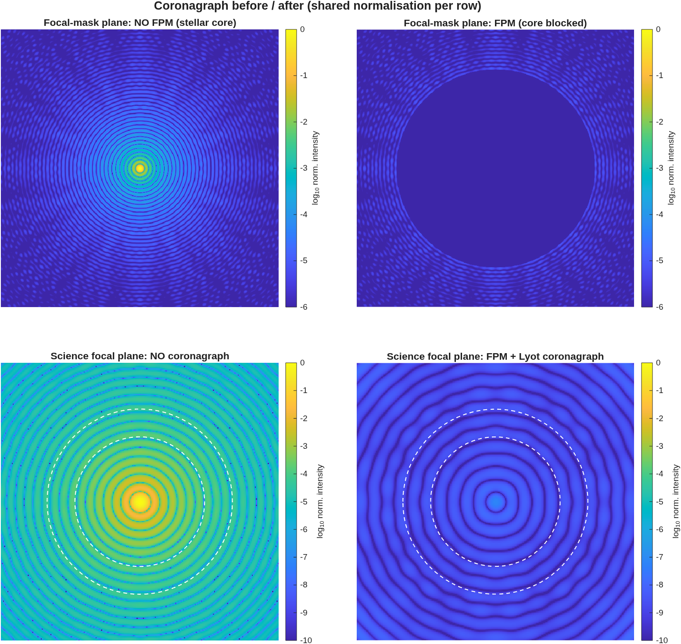
FIGURE 48 The before/after panel the walkthrough draws (figures/coro_beforeafter.png), shared normalization per row; the dashed rings are the 7 and 10 lambda/D edges of the dark zone. The focal mask (top right) covers nearly the whole computed field, and the science-plane image with the coronagraph (bottom right) is the bare image’s ring pattern, scaled down: no dark hole.
The number it reproduces. This page prints what the template does today, which is not what its README describes. The dark-zone mean contrast it reports, 1.49e-09, comes from a focal mask that covers nearly the whole computed field: the coronagraph image is the bare image scaled down everywhere, with no dark hole between 7 and 10 lambda/D, and the Lyot-plane panel is a filled disk rather than the bright edge ring. The README’s surfaces are right in kind; the deck and the template have not changed in git since June, so something under them did. That is finding (ccc), open, and Part I’s coronagraph example (Section 2) uses coro_planet_demo’s surfaces page instead.
Adapt it. “Using templates/30_instruments/coro_walkthrough on Rx_Coro_FPM.in, find why the focal-plane mask covers the whole computed field, by printing the mask’s radius in lambda/D against the field of view at the mask plane, before changing anything.”

9.20 bench_ifo: Twyman-Green interferometer on a bench, with phase-shifting (de Groot) data processing
A generic Twyman-Green IFO built with the macos.design.Bench add-optic utilities, then RUN as an instrument: simulate 7 phase-shifted interferograms and recover the test-optic surface with windowed phase-shifting-interferometry (PSI) processing – the full simulate -> detect -> process -> compare-to-truth loop.
Run it.
cd('<path-to>/mmacos/templates/40_benches/bench_ifo');
run(fullfile(pwd,'example_bench_ifo.m'));
What it prints:
glass path: test 14.4465 mm, ref 14.4465 mm (diff 0)
beam radius at test optic: 22.47 mm
realized PZT phase steps (want |step| = pi/2 = 1.571): [1.571 1.571 1.571 1.571 1.571 1.571] rad
recomb-plane injection ACTIVE: complex add at the BS, then propagate
fringe visibility (median in pupil): 0.833
deGroot-7 vs Hariharan-5 agreement: < 1e-08 rad rms (in pupil)
=== recovered test-optic figure (deGroot-7) ===
sphere radius: |R_hat| = 2e+07 mm (truth |R| = 2e+07; 0.00% error)
tilt term: 2.283e-16 rad (injected 0 -- null check, expect ~0)
post-fit residual: 0.0014 nm rms surface (2.21e-06 waves)
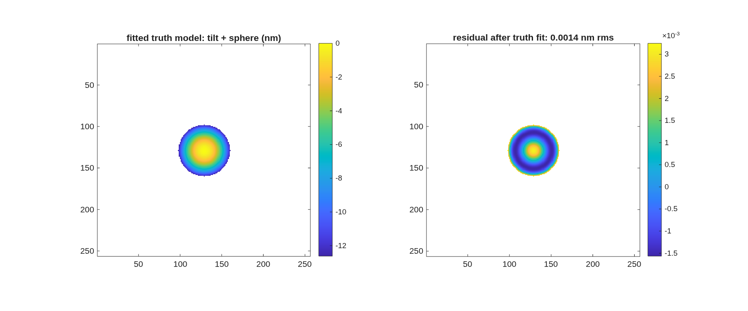
FIGURE 49 The surface the interferometer recovers (ifo_surface_recovery.png): the fitted truth model (tilt plus sphere) and the residual after the fit, in nm.
The number it reproduces. With the test optic a flat (the injected sphere radius is effectively infinite), the phase-shifted interferometer recovers it to a post-fit residual of 0.0014 nm rms surface, at a median fringe visibility of 0.833; the two phase-recovery algorithms (de Groot 7-frame and Hariharan 5-frame) agree to the floor of the arithmetic, printed as a bound.
Adapt it. “Using templates/40_benches/bench_ifo, make the test optic a 5 m radius sphere with 20 urad of tilt and rerun, and tell me the recovered radius and tilt errors and the post-fit residual.”

9.21 bench_ifo_dm: Twyman-Green IFO testbed, phase 1: measure a DM (PROPER model)
Follow-on to templates/40_benches/bench_ifo (read that first): the same compensated Twyman-Green rig – now built in ONE call with macos.design.twyman_green – with the test optic replaced by a DEFORMABLE MIRROR carrying random actuator pokes. The DM surface comes from the PROPER DM model (proper.prop_dm influence functions, |command| < POKE_NM), is loaded into MACOS as a GridData surface in the optic’s own local frame, and the 7-frame de Groot PSI pipeline recovers the surface map, which is then compared point-by-point against the PROPER truth map.
Run it.
cd('<path-to>/mmacos/templates/40_benches/bench_ifo_dm');
run(fullfile(pwd,'example_bench_ifo_dm.m'));
What it prints:
dm_map_gen: 256x256 map, surface p-v 85.0 nm, rms 11.5 nm
beam radius at DM: 22.47 mm
fringe visibility (median in pupil): 0.858
static (baseline) wrapped-phase rms in pupil: 1.22e-05 rad
PSI vs direct differential field phase (detector mode): 2.368e-05 pm rms
array sizes: OPDMat 63x63, WF 256x256
PSI vs ray-traced OPD truth (disc-registered, axes +c+r): corr 1.000000, residual 0.000 nm rms
=== pupil image quality (detector -> DM, per-ray) ===
magnification 10.5252, anamorphic stretch 0.000%, rotation 3141.593 mrad
shear axis -88.3 deg; nonlinear distortion 0.0068 mm rms (0.03% of beam)
registration refine: offset [-0.0000 -0.0332] mm, rot 3.4463 mrad, scale +4.90e-04
-> corr 0.99842628 (was 0.947302)
=== DM recovery (deGroot-7 vs PROPER truth through the ray map) ===
pixel axes: x=-row,y=+col correlation 0.998426
truth rms 16.92 nm; recovered rms 16.70 nm; residual 0.969 nm rms
DONE (phase 1). DO_ABERR=0 DO_NEARFIELD=0 staged for next phases.
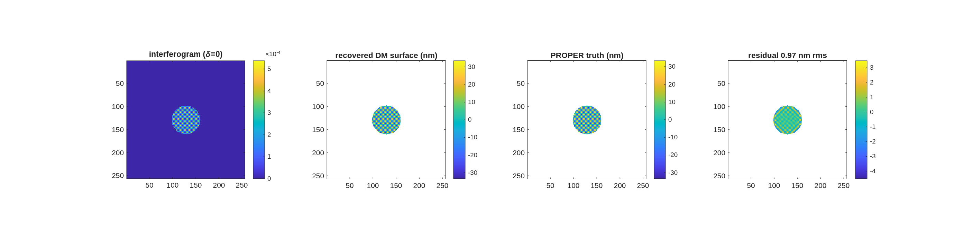
FIGURE 50 The DM recovery (ifo_dm_recovery.png): the interferogram, the recovered DM surface, the PROPER truth carried through the ray map, and the residual, in nm.
The number it reproduces. A DM surface of 16.92 nm rms, made with PROPER, is recovered through the traced pupil map with correlation 0.998426 and a residual of 0.969 nm rms; the phase-shifting itself is exact (the PSI against the direct field phase reads in the 1e-5 pm range), so the residual is the pupil imaging: its magnification, its distortion, and the registration the run refines.
Adapt it. “Using templates/40_benches/bench_ifo_dm, turn on the aberration phase (DO_ABERR=1) and rerun, and tell me how much the DM recovery’s residual grows.”

9.22 bench_layout: Laying out and optimizing an optical bench
A generic folded-bench worked example: build a complete test-bench train SEQUENTIALLY with the macos.design.Bench add-optic utilities, then optimize it in three physically-staged steps. The bench is the classic surface-gauge / interferometer test-arm topology: point source -> baffle (pupil stop) -> L1 (collimating singlet) -> beam-splitter REFLECT -> DM (test mirror, retro) -> beam-splitter TRANSMIT (through the tilted plate, real walk-off) -> Fold1 -> Fold2 -> L2 (imaging singlet) -> focal-mask Reference (internal focus) -> Detector at the DM-PUPIL IMAGE.
Run it.
cd('<path-to>/mmacos/templates/40_benches/bench_layout');
run(fullfile(pwd,'example_bench_layout.m'));
What it prints: Section 2 ran it unchanged: the builder’s chief ray against the engine’s, the staged solve, and the optimized bench.
Its figure: the inputs are FIGURE 7 and the optimized bench FIGURE 8, in Section 2.
The number it reproduces. The optimized bench is 13 elements, and the builder’s chief ray and the engine’s agree to < 1e-09 (Section 2).
Adapt it. “Using templates/40_benches/bench_layout, rebuild the test-arm bench for a 48 mm DM with the same fold angles, and tell me the optimized element count and whether the builder’s and the engine’s chief rays still agree.”

9.23 cophi_dm96: COPHI, the heterodyne camera interferometer, as the fifth DM gauge
The campaign plan is macos/BRIEF_cophi_campaign.md (Dave’s rulings in its §7); Feng Zhao’s proposal is ~/dev/MACOS_sandbox/DM_gauge/COPHI_for_DM_gauge.pptx (purpose: HOLD — each DM in a local control loop); the first look is macos/NOTE_cophi_first_look.md; the cameras macos/NOTE_detectors_survey.md.
Run it.
cd('<path-to>/mmacos/templates/40_benches/cophi_dm96');
out = cophi_run('stages',{'bench','figs'});
The bench stage with its figures, the README’s cophi_run('stages',{'bench','figs','clearance'}) without the clearance table. The manual copies the template with the siblings it reads by relative location: tg_psi_dm96_oap (the runner it builds on), dm_gauge_lib, and 90_polarization/tg_psi_dm.
The knobs (cophi_params.m):
P.tag = 'cophi';
P.outdir = ''; % '' = <this dir>/runs/<tag>
P.stages = {'bench'}; % bench | battery | noise | loop | capture | format | figs (+ tg96_run's figs / clearance)
P.bench.ref_arm = 'lo'; % the flat's seat -> the traced LO arm (twyman_green 'ref_arm','lo'; ruling 1)
P.cophi.record_tail = struct('lens', 'redo96_lens_tail.mat', 'oap', 'redo96_oap_tail.mat'); % the deck's IFO rows ran on these (RUNBOOK_mac_cycle3b)
P.cophi.oap_record = true; % 'bench.optics','oap' => the MIRROR RIG OF RECORD (POL_IN source, AOIs 20/25, sides +1/-1, D_RC_L2 125)
P.bench.LO_DX = [0;0;0]; % fiber-tip offset, global mm (the LO drift knob: lateral = tilt d/F1, axial = defocus)
What it prints:
=== COPHI on the TG96 bench (lens optics), model 1024, grid 385, tag "cophi" ===
tg96_run bench stages {bench,figs}: <t> s; decks cophi_test.in (test arm) + cophi_ref.in (the LO arm)
LO arm: fiber tip at [2457.68 1.39 0.00] mm, collimator powered face AT the flat's seat [1575.53 1.39 0.00] mm (elt 3 of 21)
Test-arm launch (laser at the input polarizer): Ex 0.7071-0.0000i, Ey 0.7071+0.0000i (open-analyzer power Ex-only 0.1356, Ey-only 0.1356, solved 0.2712)
Analyzer: test-arm power at 0/45/90 deg = 0.143022 / 0.271043 / 0.128222 -> passes at 43.436 deg (0.271245; extinction -1.00e-06)
LO launch (PM fiber axis): Ex 0.7324+0.0000i, Ey -0.6809+0.0000i (power through the analyzer: Ex-only 0.3129, Ey-only 0.2705, solved 0.5834; linearity check 5.9e-16)
LO placement: the LO field's path phase measured as -1 k W (residual phase rms 3.1e-09 rad; the other sign 1.79 rad)
Detector grid: N 1024 both decks; engine pitch test 0.0295188809 mm, LO 0.0295188805 mm (ratio - 1 = -1.44e-08)
-> the LO field is placed on the test arm's pixels BY CAMERA POSITION (the rows below are on that one grid);
the two decks' same-index camera points differ by 158.295 px rms (316.825 max) -- the index map the placement removes
Chief-ray pixel [col row]: test [512.500 512.500], LO [512.500 512.500] -> LO - test = [-0.000 +0.000] px
Magnification (object mm per detector mm): DM->camera 10.275537, seat->camera 10.258609 (ratio 0.998353)
Footprints (camera position, test pixels): test pupil image centroid [513.000 513.000] px, radius 158.10 px; LO [513.000 513.000] px, radius 192.00 px
centroid LO - test = [-0.000 -0.000] px; LO/test radius 1.2144 -- the LO overfills by 33.9 px, so an
offset under that is a fill question, not a registration one (the test pupil is the DM STOP's image)
LO over the test pupil (78525 px): covered 1.0000 (I_LO > 0.5 max), I_LO rms/mean 0.0032, min/max 0.9847
Null (flat DM): interference phase 0.000 nm rms of SURFACE after piston (h = phi lambda/4pi); tilt 0.000, defocus 0.000, rest 0.000
Fringe contrast g over the test pupil: median 0.9825, min 0.9825 (lo_ratio at the camera: median I_LO/I_t 1.4584)
LO power through the analyzer at the solved launch: 0.9997 of the LO at the camera without it
REGISTRATION PASS: chief 0.000 px, LO footprint offset 0.000 px (inside its 33.9 px overfill), LO coverage 1.0000,
null 0.000 nm (spec: chief < 1 px, offset < overfill, coverage > 0.99, null < 1 nm)
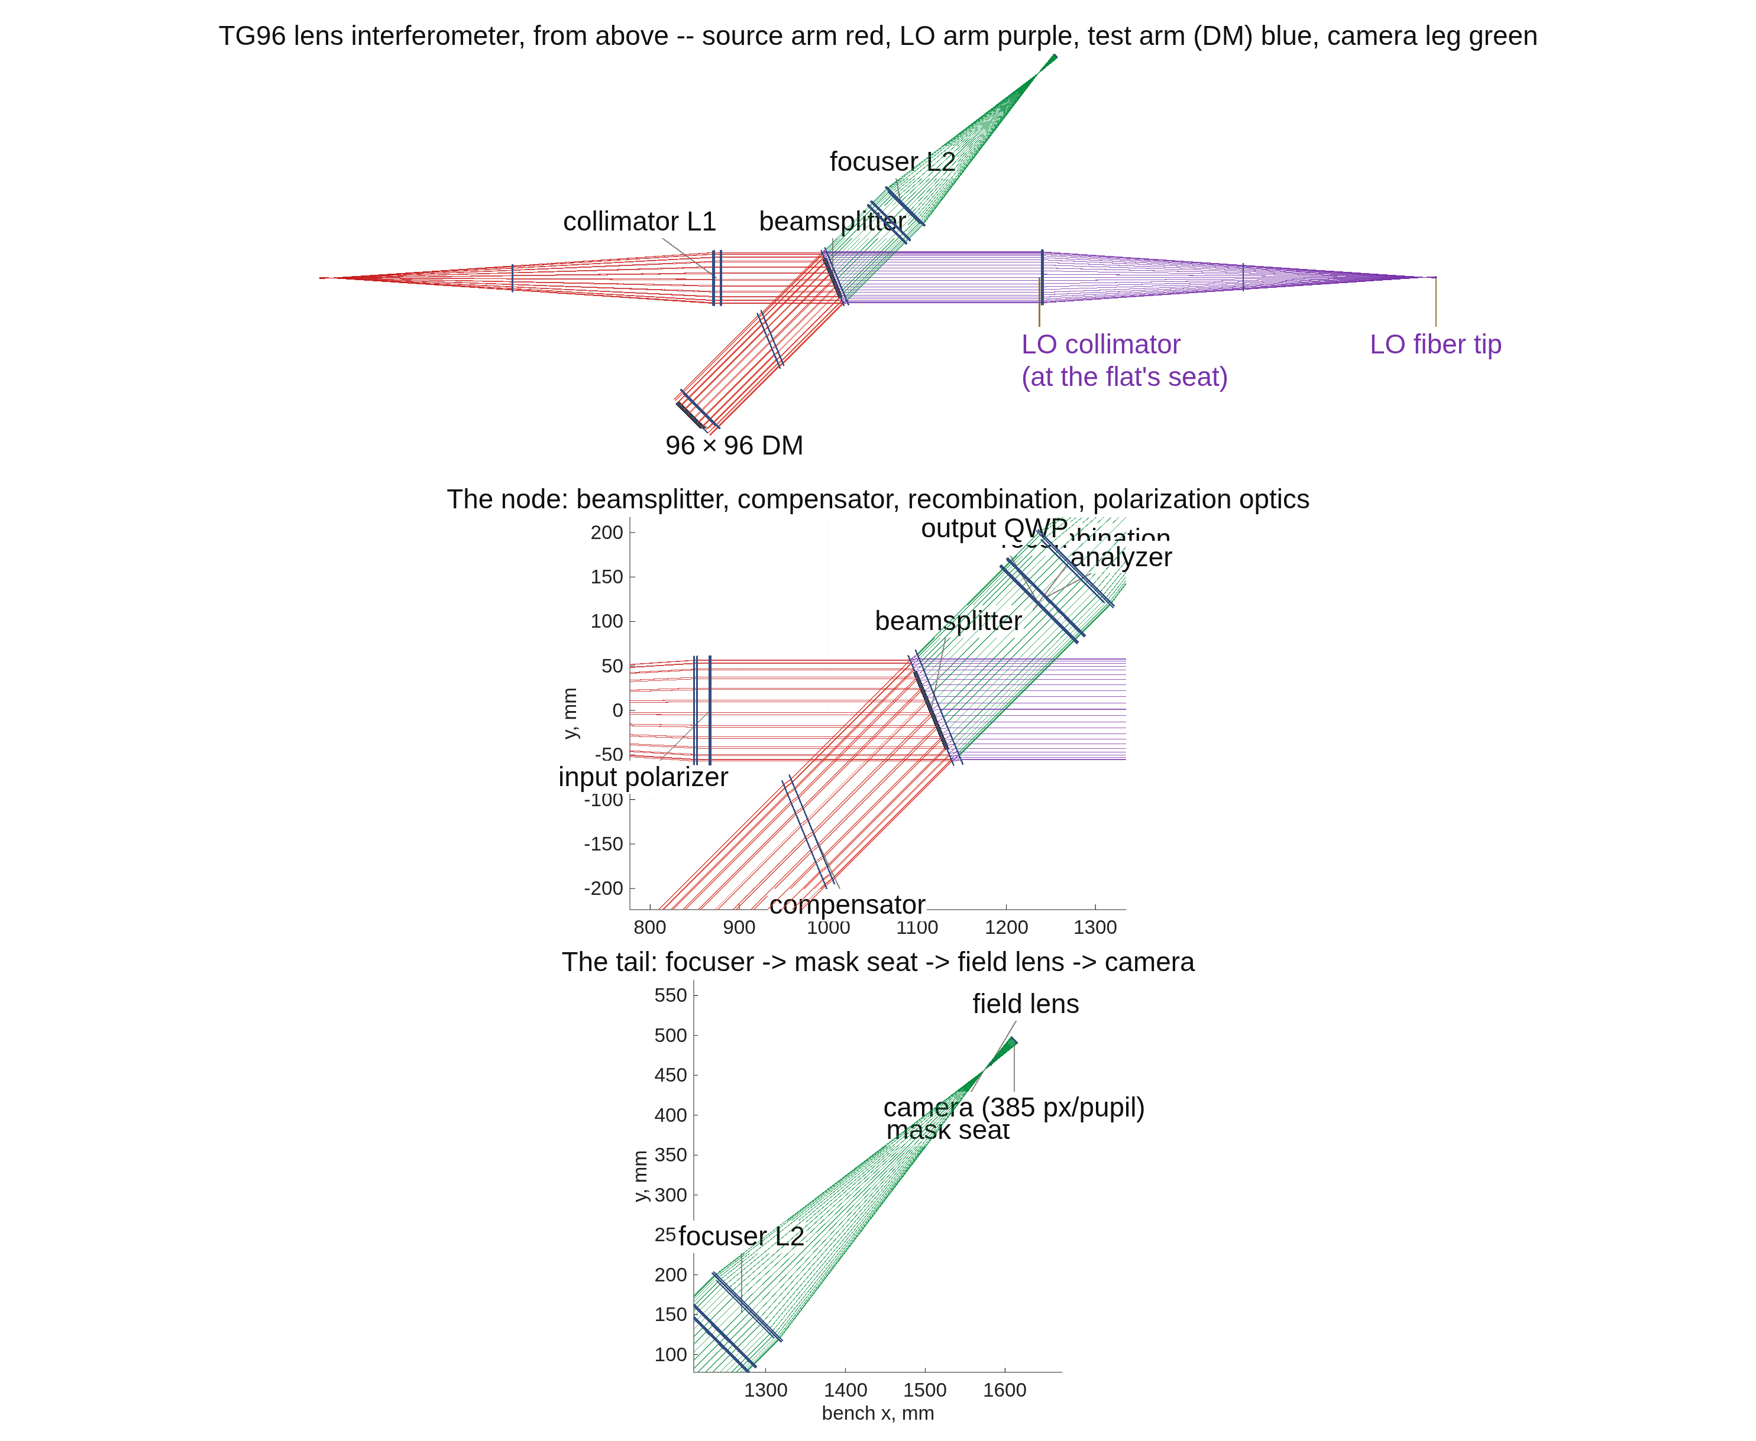
FIGURE 51 The COPHI bench from above (runs/cophi/cophi_vlayout.png, drawn by tg96_run): the TG96 lens rig with the reference flat’s seat taken by the traced, fiber-fed local-oscillator arm (purple), the camera leg green. The title says the test arm (DM) is blue; it is drawn red, like the source arm, the mislabel tg_psi_dm96_oap’s figure carries too (the open questions list).
The number it reproduces. The bench stage registers the LO arm on the test arm before any reading, and gates it: the chief rays land on the same pixel, the LO overfills the test pupil’s image by 33.9 px, the two arms’ magnifications agree to a ratio of 0.998353, and the fringe contrast over the pupil is 0.9825 (median). The report’s last line is the gate: REGISTRATION PASS.
Adapt it. “Using templates/40_benches/cophi_dm96, run the bench stage on the mirror rig of record (bench.optics ‘oap’) and tell me whether the LO arm registers, with its overfill and fringe contrast.”

9.24 pdi_dm96: the point-diffraction DM surface gauges (P, PF), same DM truth
The point-diffraction readings of the DM-gauge campaign, split out of ../zwfs_dm96/ on 2026-09-13 (Dave’s ruling: the PDI gets its own directory). The code stays shared — zwfs_run and ../dm_gauge_lib, nothing is copied; this directory holds the parameter sheet, the runner, the P/SRI bench decks and figures, and the records. Records taken before the move (pdi193*, ploop193, pcam193*) are still in ../zwfs_dm96/runs/, where deck_pdi cites them; everything from 2026-09-13 is in runs/ here.
Two readings, both point-diffraction interferometers, both scored in the campaign’s one currency (actuator-space rows on a 96×96 DM at a 30 nm working surface, photons per measurement, the closed-loop hold, the capture range to 10%):
- P — the stepped pinhole, common path: a pinhole substrate with an attenuating surround in the mask seat at the internal focus, its phase stepped. Same bench as the Zernike sensor; the plate is the only difference.
- PF — the P/SRI of Dube, Nejadriahi, Sidick, Jewell, Redding, Lou and Basinger, Proc. SPIE 13092, 130926F (2024): the reference is the mode of a single-mode waveguide in its own arm, phase-shifted thermo-optically, recombined with the unfiltered beam. Two benches: the reference synthesized on the ZWFS test arm (the record through 2026-09-12), and, since 2026-09-13, the reference traced through a buildable two-arm bench (macos.design.psri_bench; pdi.bench 'psri').
Run it.
cd('<path-to>/mmacos/templates/40_benches/pdi_dm96');
out = pdi_run('stages',{'bench'});
The bench stage of the bare call; pdi_run runs through zwfs_run and takes its rig-dependent coating default (finding (nnn)). The manual copies the template with zwfs_dm96, dm_gauge_lib and 90_polarization/tg_psi_dm.
What it prints:
sampling budget (P.samp, enforce = warn):
dimple 13.08 px across at the mask plane (min 6) -> PASS
pinhole 13.08 px across at the mask plane (min 6; the dimple's rule) -> PASS
DM 96x96: 1.66 detector px per actuator (min 2) -> NOT MET
DM 48x48: 3.31 detector px per actuator (min 2) -> PASS
G3 30 nm rms working state (DM 96x96, lit 5048): detector |E|/|E_flat| on msk std 3.708e-16 (gate < 1e-12: A = |E0| is exact)
G4 vector pair on 100 nm single-actuator pokes every 8th actuator (12117 pm rms on msk, peak 1.92 rad; 3.03% of msk beyond the one-frame fold): V rms error 2.574 pm (gate < 0.1% of the figure), one-frame exact I 9132 pm (non-vacuity: must exceed 10x) -> PASS
stations figure pdi_stations_S.png: residual vs the engine's field on msk 0.00 pm (flat), 7063.27 pm (30 nm rms working surface), gain 0.7829
stations figure pdi_stations_V.png: residual vs the engine's field on msk 0.00 pm (flat), 272.12 pm (30 nm rms working surface), gain 0.9954
stations figure pdi_stations_P.png: residual vs the engine's field on msk 0.00 pm (flat), 744.20 pm (30 nm rms working surface), gain 0.9808
P: pinhole 2.00 lam/D, surround t 0.8626, 4 steps, |b|^2 flat, NITER 3; frames per measurement 4; eta_pin 0.8228; throughput (detected/incident, flat) 0.9493; visibility on the flat 0.5021; surrogate vs engine reference 2.11e-15; the flat reads 1.86e-15 rad rms, amplitude 2.81e-16 rel
G5 P on 100 nm single-actuator pokes every 8th actuator (12117 pm rms on msk, 3.03% of msk beyond the one-frame fold): rms error 4.508 pm (gate < 0.1% of the figure) -> PASS
PF: P/SRI, reference = LP01 mode V 2.30 b 0.50 core radius 0.50 lam/D, coupling eta_c 0.7414 on the flat; pickoff 0.60, a 0.003506 (match 0.003719, budget 0.003506), 4 steps (ls), |kappa| flat; frames per measurement 4; eta_pin 0.8228; throughput (detected/incident, flat) 0.8448; visibility on the flat 0.8608; surrogate vs engine reference 2.11e-15; the flat reads 3.16e-16 rad rms, amplitude 1.59e-16 rel
G5 PF on 100 nm single-actuator pokes every 8th actuator (12117 pm rms on msk, 3.03% of msk beyond the one-frame fold): rms error 0.000 pm (gate < 0.1% of the figure) -> PASS
G6 P/SRI fiber reference under the 30 nm rms working state: shape FIXED by construction (the mode's); coupling relative to the flat |kappa| 0.86262, arg +0.0200 rad (an amplitude scale + a piston; the solver takes kappa = 1 in |kappa| 'flat' mode)
G6 reference motion under the 30 nm rms working state (pinhole-diffracted reference, flat -> state, on msk), by pinhole diameter:
lam/D total |scale| SHAPE (total = |b1-b0|/|b0|; scale = best complex factor, a Strehl-class amplitude drop the |b|^2 frame / iteration absorbs; shape = the rest, what the solve must iterate out)
0.50 0.1240 0.8771 0.0002
1.00 0.1284 0.8728 0.0007
1.50 0.1350 0.8662 0.0024
2.00 0.1429 0.8586 0.0076
3.00 0.1519 0.8534 0.0342
2.00 0.1429 0.8586 0.0076 <- the ZWFS dimple
G7 the pinhole reading at t = 1, 2.00 lam/D, frozen reference vs the stepped Zernike reading S on 20 nm sparse pokes: rel rms diff 3.02e-15 (gate < 1e-2: same instrument, same frames)
registration: center-poke anchor at detector px (512.19, 512.19) <-> DM (-0.42, -0.42) mm
parity search on the off-center poke (60,40): winner [1 2 1 1] sign +1, |corr| 0.980, runner-up 0.009 (gates >= 0.40, sep >= 0.30); all 8: 0.98 -0.00 -0.00 -0.01 -0.01 -0.00 -0.00 -0.00
center poke in the DM frame: raw peak gain 0.6948, corr(map, truth) 0.9832
bench stage <t> min
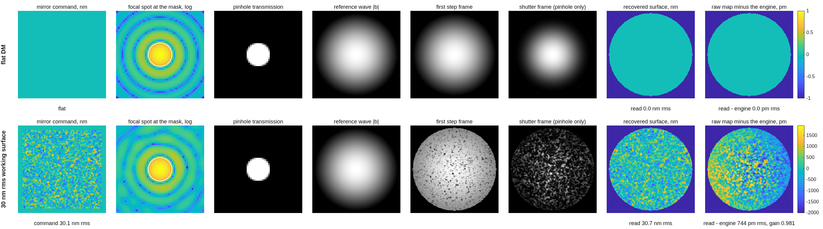
FIGURE 52 The stations of the stepped-pinhole reading P (runs/pdi/pdi_stations_P.png), the flat DM and a 30 nm rms working surface: the mirror command, the focal spot, the pinhole, the reference wave, the first step frame, the shutter frame, the recovered surface, and the recovered map minus the engine’s own field (pm).
The number it reproduces. The stepped pinhole reads the 30 nm rms working surface with gain 0.9808 and a residual of 744.20 pm against the engine’s own field; on 100 nm single-actuator pokes its gate G5 reads 4.508 pm rms error. The P/SRI reading PF passes the same gate with its error at the floor of the printout, its reference’s shape fixed by the waveguide mode.
Adapt it. “Using templates/40_benches/pdi_dm96, rerun the bench stage with a 1.0 lam/D pinhole (‘pdi.DIA_LAMD’,1.0) and compare P’s gain and G5 error with the 2 lam/D record.”

9.25 tg_psi_dm96: the optimized-plate gauge for a Xinetics 96×96 DM
The shallow-plate (option-3) polarization-PSI Twyman–Green, laid out for a 96×96-actuator, 1.0 mm-pitch DM (96 mm beam — the aperture class where a PBS cube goes custom). tg96.m is the whole campaign: Stage A clearance solve (margins printed as numbers), Stage A2 sampling budget (asserted — Dave 2026-09-03: sampling is part of the design), Stage B scaled build, Stage C battery, Stage D actuator-lattice transfer curve.
Run it.
cd('<path-to>/mmacos/templates/40_benches/tg_psi_dm96');
out = tg96();
The script runs whole (Stages A to E, about ten minutes at model 1024). The manual copies it with 90_polarization/tg_psi_dm, which it adds to the path by relative location.
The knobs (tg96.m):
% ---- the DM and the scale ----------------------------------------
NACT = 96; PITCH = 1.0; DM_MM = NACT*PITCH; % 96 mm aperture
s = DM_MM/56; % uniform scale vs v1
LAM = 6.328e-4; QWP = 0.25; THETAS = [0 45 90 135];
MODEL = 1024; NGRID = 385; N_G = 384; DX_G = 0.28; % 3.57 px/actuator
% NGRID 385 (Dave 2026-09-03, 'a detector capable of resolving the
% imagery, up to 1 Mpix square'): the wavefront seed inherits the ray
% grid's sampling, so the pupil image spans ~NGRID px at the detector.
% 63 px gave detector Nyquist 31.5 cyc/pupil -- BLIND at the 96x96 DM's
% 48 (the run of record for that finding is tg96_report_ng63.txt).
% 385 px -> ~4 px/actuator, Nyquist ~192 cyc/pupil, inside the 1024^2
% (1 Mpix) grid with FFT padding.
% MODEL 1024 is LOAD-BEARING: mGridMat is NOT the model size -- 512 caps
% grids at 256 (macos_param.txt) and the nGridMat= parse is unguarded
% (BRIEF_gridmat_guard.md), so a 384 grid on model 512 corrupts the heap.
POKE = 50e-6; % mm (50 nm commands)
What it prints:
=== TG96: optimized plate gauge for a Xinetics 96x96 (96 mm) ===
uniform scale s = 1.7143 from the 56 mm v1 rig; model 1024, grid 384x0.28 mm
Stage A -- clearance solve (beam_r 51.4, margin 25, leg cap 700):
binding angle 6.88 deg -> BS_AOI = 7 deg
DM arm vs ref beam need 166.4 mm sep -> leg >= 688 mm
ref arm vs DM beam need 136.4 mm sep -> leg >= 564 mm
camera leg vs source beam need 126.4 mm sep -> leg >= 523 mm
chosen DM leg 700 mm; achieved separations and margins there:
DM arm vs ref beam separation 169.3 mm, margin +27.9 mm (spec >= 25)
ref arm vs DM beam separation 169.3 mm, margin +57.9 mm (spec >= 25)
camera leg vs source beam separation 169.3 mm, margin +67.9 mm (spec >= 25)
Stage A2 -- sampling budget (finest feature: actuator Nyquist 48 cyc/pupil):
detector: ~385 px across pupil -> Nyquist 192.5 cyc/pup margin 4.0x (need >= 2)
DM surface grid: 3.57 px/actuator (need >= 3)
diffraction grid: 1024^2 for a 385-px image (padding 2.7x)
Tail: RE-TUNED set (null 0.134 nm at opt res; seed was 9.100)
Stage B -- rig built at BS_AOI 7 deg; emitted tg96_{test,ref}.in
Stage C -- battery (design azimuths, unaligned):
arm azimuths: test -44.8566, ref +45.0000 -> departure +0.1434 deg
null: 0.1345 nm rms surface (134.5 pm) with nothing aligned
20 nm piston: |gain| 1.00145 (unaligned scale error +0.145%)
single actuator at 150 nm: recovered peak 146.1 nm
registration by two pokes: parity 5 of 8, meas sign -1; |pokeB corr| 0.9341 (runner-up 0.0021)
parity corr table: 0.001 0.001 0.001 -0.002 -0.934 0.001 0.001 0.001
96x96 checkerboard closure: truth 6.409 nm rms, measured 6.031, residual 6.006 nm rms, corr 0.535262
registration: mag 9.8793, anamorphism 0.00%, nonlinearity 0.1360 mm
Stage D -- transfer curve on the 96x96 lattice (Nyquist 48 cyc/pupil):
12 modes x 3 traces in <s> s
mode(p,q) cyc/pup gain cross-talk
1,1 0.7 1.0184 0.0018
2,2 1.4 1.0060 0.0093
4,4 2.8 1.0003 0.0296
8,8 5.7 0.9984 0.0145
16,16 11.3 0.9845 0.0130
24,24 17.0 0.9604 0.0176
32,32 22.6 0.9311 0.0222
48,48 33.9 0.8509 0.0227
64,64 45.3 0.7433 0.0067
80,80 56.6 0.6052 0.0040
96,96 67.9 0.5039 0.0138
48,0 24.0 0.9013 0.0100
held-out random: 11.8914 -> 11.8898 nm rms (input 30.59 nm rms, resid/truth corr -0.21)
Stage E -- differential metric (deviation measured about a working state):
base deviation gain resid nm resid % corr
flat single act 10 nm 0.9654 0.0210 13.3% 0.9906
flat random 10 nm rms 0.9203 3.6696 37.4% 0.9264
random 30 nm single act 10 nm 0.9772 0.0235 14.9% 0.9886
random 30 nm random 10 nm rms 0.9209 3.6783 37.5% 0.9261
wrote tg96_report.txt + tg96_run.mat + figures
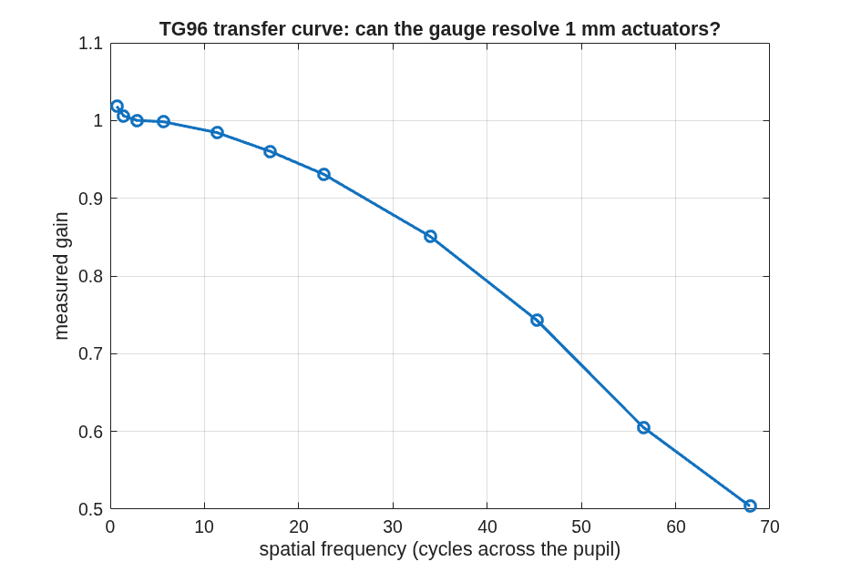
FIGURE 53 The transfer curve Stage D draws (tg96_transfer.png): the gauge’s measured gain for each checkerboard mode on the 96 x 96 actuator lattice against its spatial frequency, out to past the DM’s Nyquist (48 cycles across the pupil).
The number it reproduces. Run unchanged, the campaign script reproduces its committed report line for line (only Stage D’s wall time differs, masked here): the null with nothing aligned is 0.1345 nm rms, the README’s run-10 0.1345, and a 10 nm single-actuator deviation reads to 0.0210 nm rms (correlation 0.9906) about the flat and 0.0235 nm about a 30 nm working surface, the README’s 0.021 and 0.024. The 1 mm actuators are resolved, with roll-off: the gain at 33.9 cycles across the pupil is 0.8509. By the README’s own reckoning these map-space numbers are 20-50x above the 1 pm target; the campaign’s road to it continues in the parameterized runner, tg_psi_dm96_oap.
Adapt it. “Using a copy of templates/40_benches/tg_psi_dm96, rerun tg96 for a 48 x 48 actuator DM at 2 mm pitch (the same 96 mm aperture), and compare its transfer curve and differential rows with the 96 x 96 run.”

9.26 tg_psi_dm96_oap: the 96×96 Twyman–Green DM gauge, all-reflective (OAP) variant
The reflective sibling of ../tg_psi_dm96: the two lenses of the polarization phase-shifting Twyman–Green DM surface gauge (L1 collimator, L2 focuser) become off-axis parabolas (OAPs). The refractive rig in ../tg_psi_dm96 is the untouched record; this directory is the variant beside it, driven by the same builder (macos.design.twyman_green, new option 'optics') and one parameterized runner that runs both rigs.
Run it.
cd('<path-to>/mmacos/templates/40_benches/tg_psi_dm96_oap');
out = tg96_run('stages',{'bench','figs'});
The bench stages only (bench, figs); the default also runs the actuator battery (battery), which is the campaign’s hours-long product. The manual copies the template with its dm_gauge_lib sibling and 90_polarization/tg_psi_dm (for dm_influence_map), which the runner adds to the path by relative location.
The knobs (tg96_params.m):
% ---- the bench (macos.design.twyman_green options; s = 96/56 applied
% in tg96_run so the whole rig scales uniformly off the 56 mm v1) --
P.bench.polarizing = true;
P.bench.BS_AOI = 22.5; % Dave 2026-09-15: pinned (the Stage-A solve's 7 deg cleared only the
% end bodies; the node parts need >= 22.5: dmg_bench_clearance)
P.bench.D_RECOMB = 150; % physical mm (NOT scaled by s): the recomb plane and the output
P.bench.D_RC_L2 = 55; % optics 150 mm behind the splitter, L2 at 150 + 55 = 205 as before
P.bench.F1 = 500; P.bench.F2 = 250; % *s in the runner
What it prints:
=== TG96 gauge (lens optics) : Xinetics 96x96, model 1024, grid 384x0.28 ===
uniform scale s = 1.7143; tag "lens"
Stage A -- clearance solve (beam_r 59.0, margin 25, leg cap 700):
binding angle 25.63 deg (end bodies 7.20, node 25.63) -> BS_AOI = 22.5 deg (pinned)
DM arm vs ref beam need 174.0 mm sep -> leg >= 246 mm
ref arm vs DM beam need 144.0 mm sep -> leg >= 204 mm
camera leg vs source beam need 134.0 mm sep -> leg >= 190 mm
chosen DM leg 450 mm; achieved separations and margins:
DM arm vs ref beam separation 318.2 mm, margin +169.2 mm (spec >= 25)
ref arm vs DM beam separation 318.2 mm, margin +199.2 mm (spec >= 25)
camera leg vs source beam separation 318.2 mm, margin +209.2 mm (spec >= 25)
node parts (d from the splitter; the separation in the part's own plane, d*tan(2*AOI), or d*sin(2*AOI) for a plate parallel to the splitter):
collimator L1 d 257.1, part r 56.6 -> separation 257.1 mm, margin +133.6 mm (spec >= 25)
input polarizer d 247.1, part r 64.0 -> separation 247.1 mm, margin +116.1 mm (spec >= 25)
compensator d 200.0, part r 64.0 -> separation 141.4 mm, margin +10.4 mm (spec >= 25)
output QWP d 160.0, part r 64.0 -> separation 160.0 mm, margin +29.0 mm (spec >= 25)
analyzer d 170.0, part r 64.0 -> separation 170.0 mm, margin +39.0 mm (spec >= 25)
focuser L2 d 205.0, part r 56.6 -> separation 205.0 mm, margin +81.4 mm (spec >= 25)
1 of 6 node parts under the 25 mm margin; beam radius 59.0, mount +8
Stage A2 -- sampling budget (actuator Nyquist 48 cyc/pupil):
detector Nyquist 192.5 cyc/pup margin 4.0x (need >= 2)
DM surface grid 3.57 px/actuator (need >= 3)
diffraction grid 1024^2 padding 2.7x
Tail: RE-TUNED set from <work>/templates/40_benches/tg_psi_dm96_oap/lens_tail.mat (null 0.134 nm at opt res; seed 9.100)
Stage B -- lens rig built (BS_AOI 22.5); emitted lens_{test,ref}.in
Parts (test arm; station = distance along the chief from the source):
element type station clear r notes
Baffle Obscuration 428.6 30.9
L1flat Refractor 874.4 --
L1pow Refractor 882.1 --
Sub1f Refractor 891.1 --
PolIn TrPolarizer 892.1 --
Sub1b Refractor 893.1 --
BSrefl Reflector 1140.3 -- flat mirror
Comptxfd Refractor 1329.5 --
Comptxbd Refractor 1339.8 --
Sub2f Refractor 1553.8 --
QWPtestIn WavePlate 1554.8 --
Sub2b Refractor 1555.8 --
TestOptic Reflector 1580.8 48.0 flat mirror
Sub3f Refractor 1604.8 --
QWPtestOut WavePlate 1605.8 --
Sub3b Refractor 1606.8 --
Comptxfu Refractor 1821.8 --
Comptxbu Refractor 1832.1 --
BStxfo Refractor 2021.3 --
BStxbo Refractor 2031.7 --
Recomb Reference 2181.7 --
Sub4f Refractor 2190.7 --
OutQWP WavePlate 2191.7 --
Sub4b Refractor 2192.7 --
Sub5f Refractor 2201.7 --
Analyzer TrPolarizer 2202.7 --
Sub5b Refractor 2203.7 --
L2pow Refractor 2238.7 --
L2flat Refractor 2250.0 --
MaskSubf Refractor 2665.5 --
MaskSubb Refractor 2667.5 --
FocalMask Reference 2668.5 --
FLpow Refractor 2708.2 --
FLflat Refractor 2714.5 --
Detector FocalPlane 2747.3 -- camera (see the sampling budget for the pixel count)
wrote lens_sketch.png + lens_sketch_ref.png (Bench.sketch)
wrote lens_vlayout.png (3 panels: train / node / tail, both arms, mirror symbols)
control set capped at r <= 47.00 mm (aperture 48.00 - margin 1.00): 5064 -> 5064 lit actuators
stations: four-step sign set by a +50 nm push on actuator (48,48): -1
stations figure lens_stations.png: recovered minus the engine's field on msk 0.00 pm (flat), 422.19 pm (30 nm rms, gain 0.9929, four-step sign -1); PZT four-step 0.00 pm (flat), 0.00 pm, gain 1.0000, sign +1
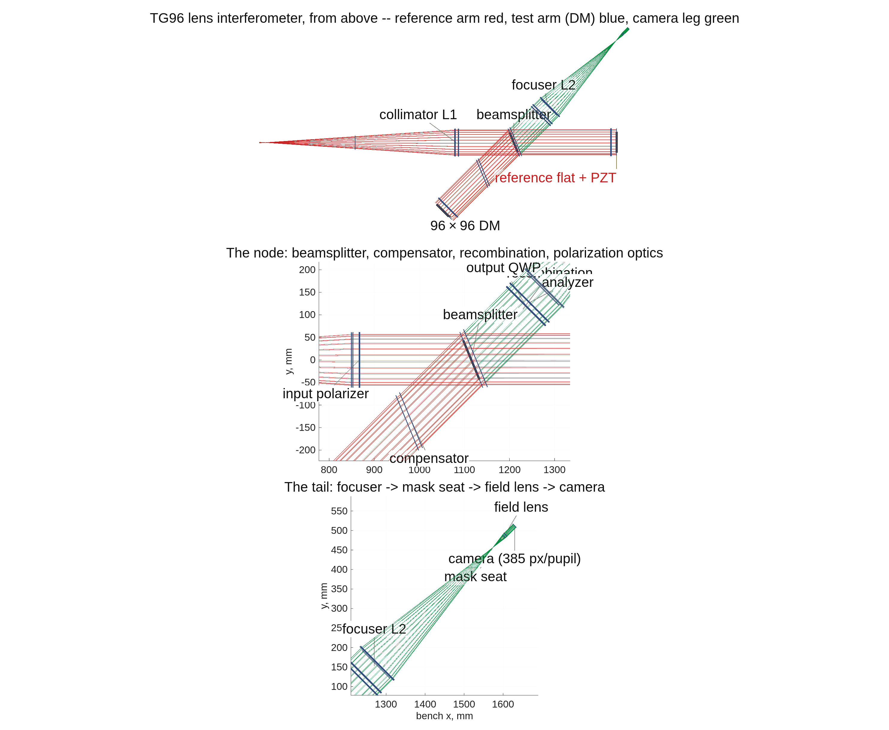
FIGURE 54 The lens rig from above (runs/lens/lens_vlayout.png): the whole interferometer, then the node (beamsplitter, compensator, recombination and the polarization optics) and the tail (focuser, mask seat, field lens, camera). The title’s legend reads “test arm (DM) blue”, but the figure draws the reference and test arms both in red; the open questions list has it.
The number it reproduces. The bench stage measures what the build needs before any reading: Stage A’s clearances (the beamsplitter at 22.5 degrees, pinned by Dave’s 2026-09-15 ruling; the compensator, the tightest node part, clears by 10.4 mm, under the 25 mm spec, as the report says), the sampling budget (a detector Nyquist margin of 4.0x against the DM’s), and the stations check: the polarization four-step recovers the engine’s own field on a 30 nm working surface with gain 0.9929 (422.19 pm residual), the PZT four-step exactly. The run committed in runs/lens/ (2026-09-12) predates the pin and shows the Stage-A solve’s 7 degrees.
Adapt it. “Using templates/40_benches/tg_psi_dm96_oap, run the bench stages for the all-reflective rig (bench.optics ‘oap’) and compare its clearances, sampling budget and four-step gain with the lens rig’s.”

9.27 zwfs_dm96: a Zernike wavefront sensor against the PSI gauge, same DM truth
The ZWFS campaign (plan: macos/BRIEF_zwfs_campaign.md). Question: does a Zernike sensor beat the TG96 polarization-PSI gauge on the differential benchmark (10 nm actuator deviation read to 0.021 nm, base-independent — tg_psi_dm96 run 10)?
Run it.
cd('<path-to>/mmacos/templates/40_benches/zwfs_dm96');
out = zwfs_run('stages',{'bench'});
The bench stage of the bare call: the sheet’s bench.coat_oap 'auto' resolves to none on the lens rig (protected aluminum on the OAP rig; finding (nnn)). The default also runs the reading battery and the figures. The manual copies the template with dm_gauge_lib and 90_polarization/tg_psi_dm, which the runner adds to the path by relative location.
What it prints:
---- bench ----
MASK_TRIM re-scanned: 1.2342 mm (mask-plane peak/sum 1.868e-02); the sheet asked for a scan. <s> s
deck run_test.in: TO elt 7, FocalMask 18, Detector 22; mask sandwich spheres zElt 355.720 / 355.720 mm (SYMMETRIC)
mask: phase 1.5710 rad (|c| 1.414), dimple 2.000 lam/D = 5.6500e-03 mm = 13.08 px at the mask plane; msk 19601 px
focal spot: 0.432 um per px at the mask plane, 6.54 px per lam F/D; the dimple encloses 82.6% of the flat DM's focal-plane light
G1 mask-sandwich round trip (unmasked, entrance -> exit sphere): 1.849e-15 (gate < 1e-12)
G2 reference-wave surrogate T(D Ti(E0)) vs the engine's Eb on msk: 2.107e-15 (gate < 1e-10)
reference wave |Eb|/|E0| vs pupil radius (20 bins, 0..1): 1.3075 1.3015 1.2895 1.2717 1.2488 1.2200 1.1859 1.1469 1.1038 1.0577 1.0075 0.9543 0.8989 0.8421 0.7834 0.7233 0.6629 0.6029 0.5440 0.4857
frame: ray magnification 9.9752 DM-mm per detector-mm, detector px 6.0492e-02 mm -> 0.6034 DM-mm per px
camera: pupil image 9.56 mm across (158 modeled px at 60.5 um); sCMOS 2048x2048 at 6.50 um -> 1470 raw px across the pupil; binned 4 = 368, and binning 9 = 163 lands nearest the modeled 158
snapshot analyzer: polarization sCMOS (micro-polarizer array, 0/45/90/135) at 3.45 um -> 2770 px across the pupil, 1385 per orientation (every 2nd pixel in each direction on the 2x2 superpixel -- N/2 across a line, not N/4); four simultaneous frames, no rotating stage
sampling budget (P.samp, enforce = warn):
dimple 13.08 px across at the mask plane (min 6) -> PASS
DM 96x96: 1.66 detector px per actuator (min 2) -> NOT MET
DM 48x48: 3.31 detector px per actuator (min 2) -> PASS
G3 30 nm rms working state (DM 96x96, lit 5048): detector |E|/|E_flat| on msk std 3.708e-16 (gate < 1e-12: A = |E0| is exact)
G4 vector pair on 100 nm single-actuator pokes every 8th actuator (12117 pm rms on msk, peak 1.92 rad; 3.03% of msk beyond the one-frame fold): V rms error 2.574 pm (gate < 0.1% of the figure), one-frame exact I 9132 pm (non-vacuity: must exceed 10x) -> PASS
stations figure run_stations_S.png: residual vs the engine's field on msk 0.00 pm (flat), 7063.27 pm (30 nm rms working surface), gain 0.7829
stations figure run_stations_V.png: residual vs the engine's field on msk 0.00 pm (flat), 272.12 pm (30 nm rms working surface), gain 0.9954
registration: center-poke anchor at detector px (512.19, 512.19) <-> DM (-0.42, -0.42) mm
parity search on the off-center poke (60,40): winner [1 2 1 1] sign +1, |corr| 0.980, runner-up 0.009 (gates >= 0.40, sep >= 0.30); all 8: 0.98 -0.00 -0.00 -0.01 -0.01 -0.00 -0.00 -0.00
center poke in the DM frame: raw peak gain 0.6948, corr(map, truth) 0.9832
bench stage <t> min
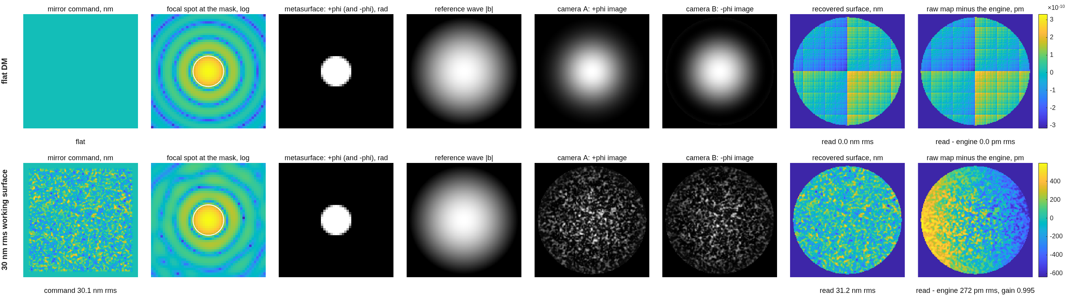
FIGURE 55 The vector reading’s stations (runs/run/run_stations_V.png), the flat DM and a 30 nm rms working surface: the mirror command, the focal spot at the mask, the metasurface, the reference wave, the two camera images, the recovered surface, and the recovered map minus the engine’s own field (pm).
The number it reproduces. On a 30 nm rms working surface the vector reading (the polarized dimple’s +phi and -phi images at once) recovers the engine’s own field with gain 0.9954 and a residual of 272.12 pm, where the single phase-stepped scalar reading S reads gain 0.7829. Every bench gate passes (the mask sandwich and the reference surrogate at the floor of the arithmetic); the sampling budget’s 96 x 96 line is NOT MET at 1.66 detector px per actuator, a warning by the sheet’s own enforce = warn.
Adapt it. “Using templates/40_benches/zwfs_dm96, rerun the bench stage with NGRID 385 (the 1 Mpix-class detector) and tell me whether the 96x96 sampling line is met and how the V and S gains change.”

9.28 e2e: the complete end-to-end worked example
Design → instrument → segmentation → sensitivities → MET → compare → simulator, built from the parameterized design-layer runners and utilities, for users to hack for their own systems (Dave 2026-07-17). Every stage runner produces a thorough design report (saved sN_report.txt) and graphics (macos.view_std standard views + the stage’s metric figures) beside this file.
The product is the general stage runners (Dave 2026-07-19), which live in design/runners/ (see its README for the pipeline and the .in-plus-declared-sidecars handoff contract); the sN_*.m scripts here are thin narrative drivers over them. s3–s6 already work this way (run_segmentation/run_sensitivities/run_met/run_compare); s1–s2 promote to run_design in a later recast pass.
All user knobs live in e2e_params.m — one file, commented. Each stage consumes the previous stage’s saved artifacts (.in + .mat + sidecars), so a knob change re-runs from the first stage it affects.
Run it.
cd('<path-to>/mmacos/templates/80_end_to_end/e2e');
run(fullfile(pwd,'s1_telescope.m')) % then s2_instrument ... s7_simulate, in order
What it prints: Part I is this template’s run: Sections 1 to 6 follow its seven stages, each run unchanged in one thread directory, every listing and number generated (Section 1 prints stage 1’s design report; Section 7 steps off the thread for the budget). This page adds the one stage-1 figure Part I did not print.
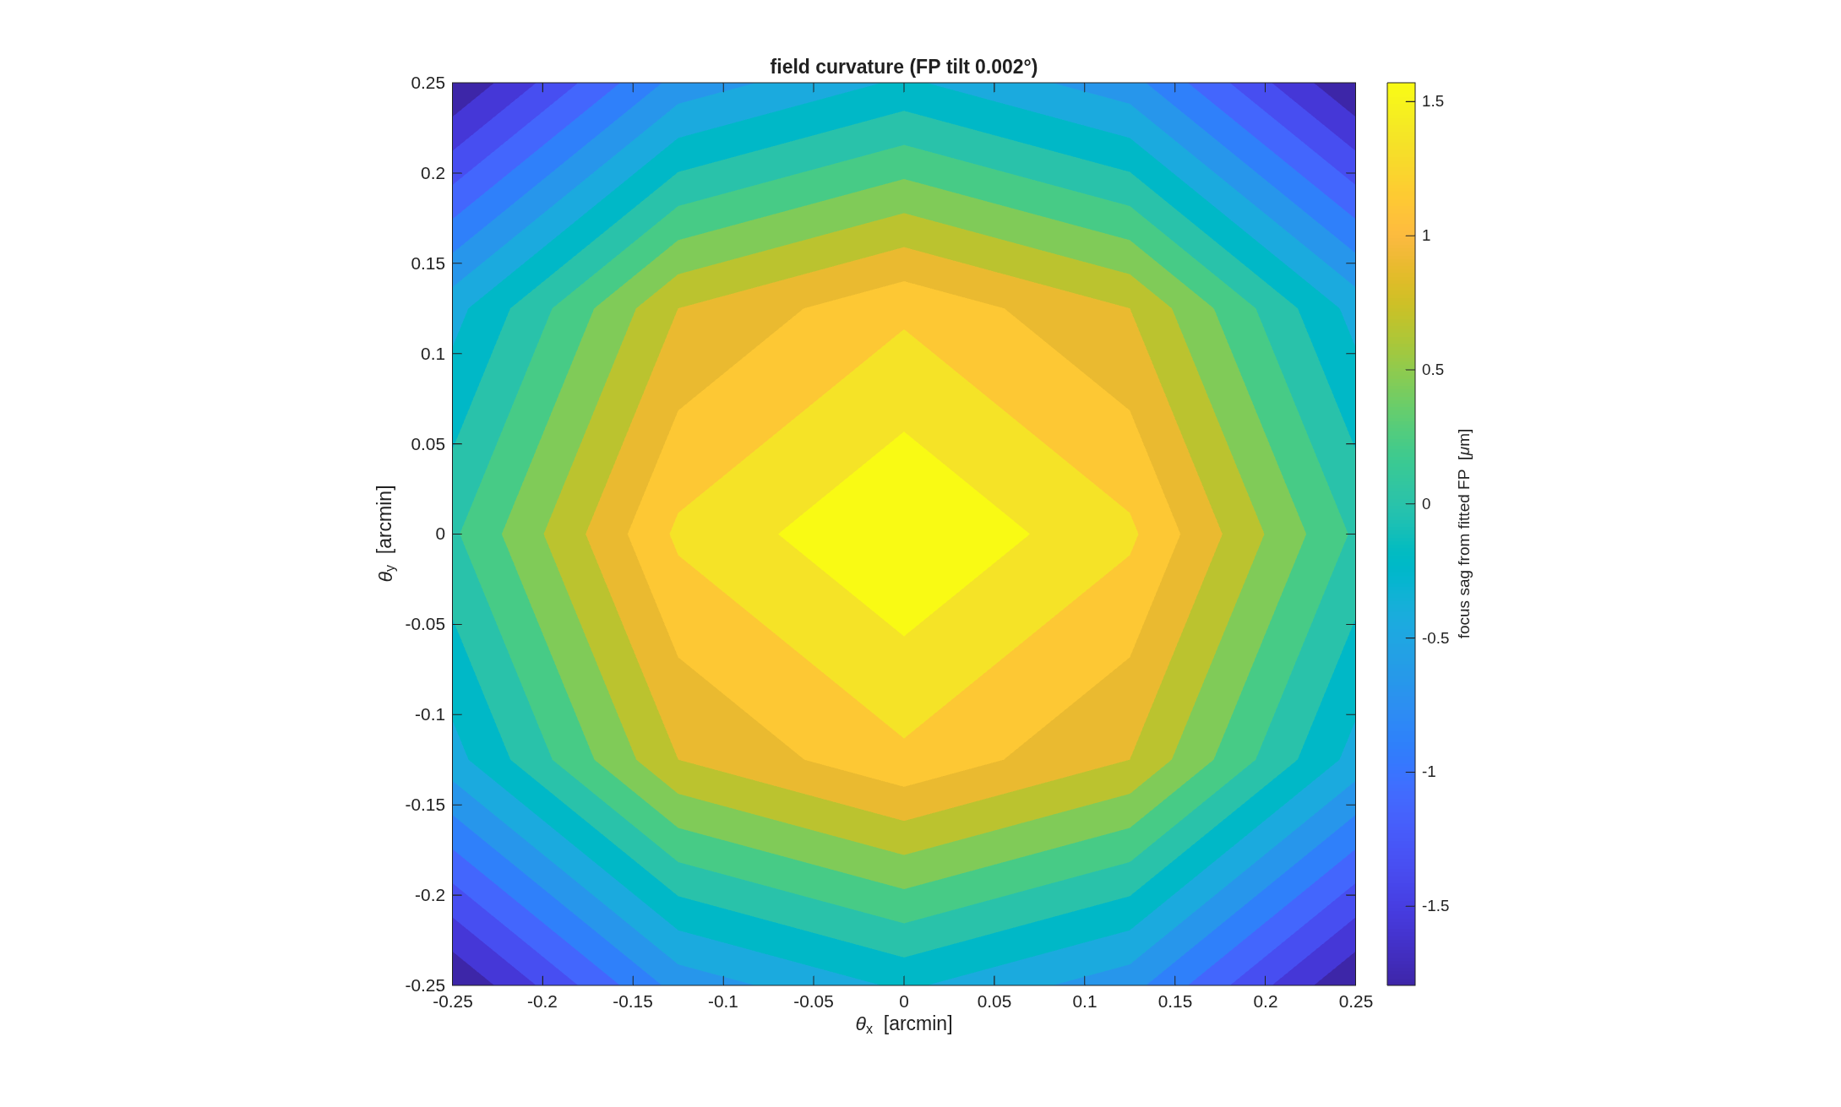
FIGURE 56 Stage 1’s field-curvature map (s1_fpmap.png, from the Section 1 run): the sag of each field point’s best focus from the fitted, tilted focal plane over the ±0.25′ map, in micrometres.
The number it reproduces. Stage 1 delivers an effective focal length of 72.14 m (f/18.04), λ/D 25.78 mas, with the fold cleared at a 2' field bias and a primary hole 0.232 m in radius (Section 1). The thread’s later numbers are Sections 2 to 6’s; its committed outputs are stale against these live runs, finding (bbb).
Adapt it. “Using templates/80_end_to_end/e2e, change e2e_params for a 6 m f/16 version of the telescope and rerun stages 1 and 2, telling me the delivered f-number, the field ladder and whether the fold still clears.”

9.29 e2e2: the improved TMA design flow
Input parameters → Korsch axial starting point → off-axis → fold → relay and focal plane → scoring, each stage a gated step that emits a committed .in, a parameter-provenance table, a thorough report, and standard views. The product is the FLOW — reusable stage drivers a user can re-parameterize — not one telescope.
Sibling of ../e2e/, which this supersedes as the design-flow example. It folds in everything the Rodgers offset-field reproduction taught us (../../rodgers1/PACKET.md, Addenda 8–10): joint solve, stated references, solve set ≠ scoring set, pupil gate, parameter provenance per stage. e2e remains the reference for the stages e2e2 does not duplicate — segmentation onward.
All user knobs live in e2e2_params.m — one file, commented. Nothing is computed there: a number in that file was chosen, a number in a report was derived.
Run it, as it stands today.
cd('<path-to>/mmacos/templates/80_end_to_end/e2e2');
run(fullfile(pwd,'s1_axial.m'));
It refuses:
====================================================================
E2E2 stage 1: axial Korsch TMA | D=3.00 m | f/20 | 500 nm | box 0.4 deg
====================================================================
[1] conic-solver fixture gate (tma_fixture.json)
K fixture = [ -0.9747480 -1.0345250 -4.5527288]
K solved = [ -1.0004068 -1.3371575 -4.4894914] max|dK| = 3.03e-01 (bar 1e-06)
EFL 49.0000 m (fixture 5.0342), t_focus -1.866667 m (fixture 1.064384)
REFUSED: CONIC SOLVER GATE FAILED: max|dK| = 3.026e-01 > 1e-06. STOP AND FIX -- do NOT widen this bar and do NOT hand-edit the fixture; regenerate it with optical_design/make_tma_fixture.py and explain what moved.
Its figure: none: stage 1 stops at its first gate, before it builds the telescope.
The number it reproduces. There is no number to reproduce today. Stage 1’s first gate checks the conic solver against the shared TMA fixture, and the solver now misses it by max|dK| = 3.03e-01. The solver was replaced on 2026-10-03 by the signed fixed-frame form, and its own test re-targeted to the Ritchey-Chretien closed form, which says the fixture’s conics are no longer a truth; this gate was not re-targeted (finding (ppp)). The README’s delivered telescope (30.001 nm maximum at the strict-centroid reference) is the committed run’s.
Adapt it. “Using a copy of templates/80_end_to_end/e2e2, re-target s1_axial’s conic gate the way tests/tE2E2Axial was (the Ritchey-Chretien closed form), run the three stages, and compare the delivered ladder with the README’s.”

9.30 e2e6m: the 6 m unobscured coronagraph end-to-end example
Design an unobscured 6 m visible telescope, segment its primary, hang an imager and an APLC coronagraph off it with macos.design.Bench, harvest the linear-model sensitivities, and play a random time series through the engine — the Keysight end-to-end use case, built entirely from the committed stage runners.
Every knob lives in e2e6m_params.m. Each stage consumes the previous stage’s saved .in + .mat, so a knob change re-runs from the first stage it affects. The narrative — every question raised, every decision and its result, every gate outcome — is in e2e6m_LOG.md; read that first if you are picking this up.
Run it.
cd('<path-to>/mmacos/templates/80_end_to_end/e2e6m');
s1_layout_search(); s1_telescope(); s2_segmentation();
The README’s three calls, run in order on a copy: the layout search (whose 216-row table is not printed here; it ends, as committed, with no geometry meeting all three gates), the telescope, and the segmentation. The page prints the telescope stage.
What it prints:
==================== e2e6m S1 -- the 6 m unobscured telescope
D = 6.00 m | lambda = 500 nm | model 256 | grid 41
metric: RMS WFE @ 500 nm, exit-pupil referenced (add_pupil FarField),
on the stage's fitted focal plane; raw keeps tilt, -tilt removes
piston+tip/tilt. TELESCOPE-ONLY config, anchored at the
TELESCOPE best-focus exit pupil.
gates : f/# in [12 20] | shroud <= 8.0 m (deployed, diameter-only)
| UNOBSCURED | DL <= 0.071 waves | AOI spread < 15 deg (preference)
apertures OFF (rule 1); clearance from check_clipping footprints
[1] all-sphere layout R = [38.400 3.800 2.000] m, T = [17.500 14.000] m,
tilt = [-5.60 5.90 8.00] deg -> uncorrected 8219 waves
[2] staged Zernike (freeform) correction, waves RMS @ 500 nm:
full-field footprint radius (m): 3.0164 0.2972 0.4162
lmon mode "auto" -> 3.4688 0.3418 0.4786
modes (BornWolf): [3 4 5 9 10 11 12 13 19 20 21 22 23 24 25]
S0 centre : 8345 -> 0.8594
S1 inner 2-D : worst 166.503 -> 0.3512
S2 full 2-D +-0.35' : worst 0.0702, area-weighted 0.0430 -> DIFFRACTION-LIMITED
EFL after correction 70.573 m -> f/11.76 (spheres alone: see [4])
[3] fitted FP from a 5x5 field-foci grid: tilt 0.835 deg,
defocus removed +1.332 mm, field-curvature sag -6.1 to +6.5 um
[4] first order + packaging
EFL 70.579 m -> f/11.76 [FAIL]
shroud 7.332 m diameter (1.222 x D), train 17.37 m [PASS]
clearance 4/4 bodies clear [PASS]
dense 7x7 map over +-0.35': raw max 0.1059, -tilt max 0.0930 waves [FAIL]
AOI spread per mirror: 8.9 9.8 3.3 deg (preference < 15)
per-element radial extent (m): M1 2.970 M2 3.666 M3 3.442 FP 3.218
[5] saved <work>/templates/80_end_to_end/e2e6m/s1_telescope.in (+ .mat)
RELOAD GATE (rule 3): 6 elements, 1185/1185 rays pass [PASS]
[6] figures: layout, WFE field map, FP curvature, shroud fit
shroud figure measures 7.361 m against the 8.0 m gate [PASS]
check_clipping (family=tma, 6 elements)
name kind ap_r foot_r margin clearnce obstruct status
M1 Reflector 3.3 2.999 0.3006 -- 0 OK
M2 Reflector 3 0.2738 2.726 0.1657 0 OK
M3 Reflector 3 0.03424 2.966 0.2821 0 OK
FP_return Return 3.3 5.698e-07 3.3 -- 0 OK
ExitPupil Return 3.3 0.02268 3.277 -- 0 OK
FP FocalPlane 1.8 6.045e-07 1.8 -5.976e-07 159 ** CLIP
=> layout has CONFLICTS: margin<0 = own beam overfills aperture; clearance<0 = body cuts a foreign beam
aoi_report (limit 15 deg, 1 field(s))
mirror chief(deg) min max SPREAD(deg) ok
M1 5.66 1.15 10.03 8.88 yes
M2 5.68 0.69 10.49 9.79 yes
M3 8.55 6.92 10.24 3.33 yes
[7] design report -> s1_design_report.txt
S1 DONE in <t> min
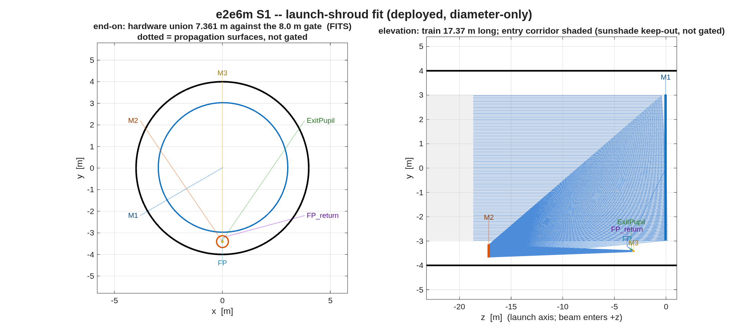
FIGURE 57 The launch-shroud fit the telescope stage draws (s1_shroud.png): end-on, every body’s radial extent about the incoming-beam axis against the 8.0 m deployed shroud (black); in elevation, the 17.37 m train with the entry corridor shaded (the sunshade keep-out, not gated).
The number it reproduces. The flow’s three hard numbers are 500 nm, an OTA f/# of 12 to 20, and an 8 m shroud. Today’s run starts where the committed one did, the same all-sphere layout and the same center-field correction (S0, 0.8594 waves), and then parts from it: the inner-field stage ends at 0.3512 waves against the committed 0.0200, the full-field solve at 0.0702 (committed 0.0355, both inside the 0.071-wave bar), the dense 7 x 7 map at 0.1059 waves raw, which fails the bar the committed 0.0502 passed, and the corrected telescope at f/11.76 against the committed f/25.39. Both f-numbers miss the 12 to 20 band, which is why the flow has s1_close_fno. The template’s own files have not changed in git since 2026-08-25; the library under them has, and which change moved this is not traced (the open questions list has it). The segmentation stage runs on the live telescope, 19 segments, and its one-segment poke gate passes.
Adapt it. “Using templates/80_end_to_end/e2e6m, run s1_telescope and then s1_close_fno to bring the corrected f/# into the 12-20 band, and report the dense-map maximum and the shroud fit at the closed f/#.”

9.31 e2e6m_r2: e2e6m round 2, R1: the DM-bearing coronagraph back end
Round 1’s back end carried apodizer / FPM / Lyot only; its close-out named the missing capability and called the extension parameter work. This runner does that work: the CTB topology (8 OAPs + two flat-fold DMs, DST2R-class near-normal folds) instanced at observatory scale behind the 6 m telescope, built in METRES with macos.design.Bench and spliced with macos.design.append_rx so ONE train carries a telescope perturbation to a contrast number.
Run it.
cd('<path-to>/mmacos/templates/80_end_to_end/e2e6m_r2');
r1_backend();
The first round-2 stage only (r1_backend); the rest of the round (r2_* to r4_*, and the cf* coronagraph-family studies) builds on it. It reads round 1’s committed telescope from ../e2e6m, which the manual copies beside it.
What it prints:
==================== e2e6m R1 -- the DM-bearing back end
base deck <work>/templates/80_end_to_end/e2e6m_r2/../e2e6m/s2_segmented.in
[1] telescope exit: 24 elements, 983/985 rays
focus at [0.0000 -3.5128 -3.8697] m, chief along [0.0000 0.2849 -0.9586]
feeding f/25.39 -> collimated pupil 0.0473 m at OAP1 f = 1.200 m
[2] bench (metres): 16 elements -> <work>/templates/80_end_to_end/e2e6m_r2/r1_seg_back.in
OAP parents (m): 1.2000 + 7 x 0.9000 (1:1 relays)
DM legs: OAP1 -0.25-> DM1 -0.15-> DM2 -0.20-> OAP2 (pupil 47.3 mm on 60 mm DMs)
[3] spliced: 21 telescope + 16 bench = 37 elements -> <work>/templates/80_end_to_end/e2e6m_r2/r1_seg_full.in
[4] gates
loads at 37 elements (expected 37) [PASS]
983/985 rays pass (telescope alone 983) [PASS]
DM1 elt 23: beam radius 0.023771 m (pupil)
DM2 elt 24: beam radius 0.023771 m (pupil)
Apodizer elt 27: beam radius 0.023748 m (pupil)
FPM elt 29: beam radius 8.7113e-07 m (focus)
Lyot elt 31: beam radius 0.023749 m (pupil)
FieldStop elt 33: beam radius 8.7307e-07 m (focus)
Backend elt 35: beam radius 0.023749 m (pupil)
Science elt 37: beam radius 8.7113e-07 m (focus)
[5] shroud on the full train: 7.451 m against the 8.0 m gate [PASS]
train length 17.31 m (launch axis)
R1 backend (seg) DONE in <t> min
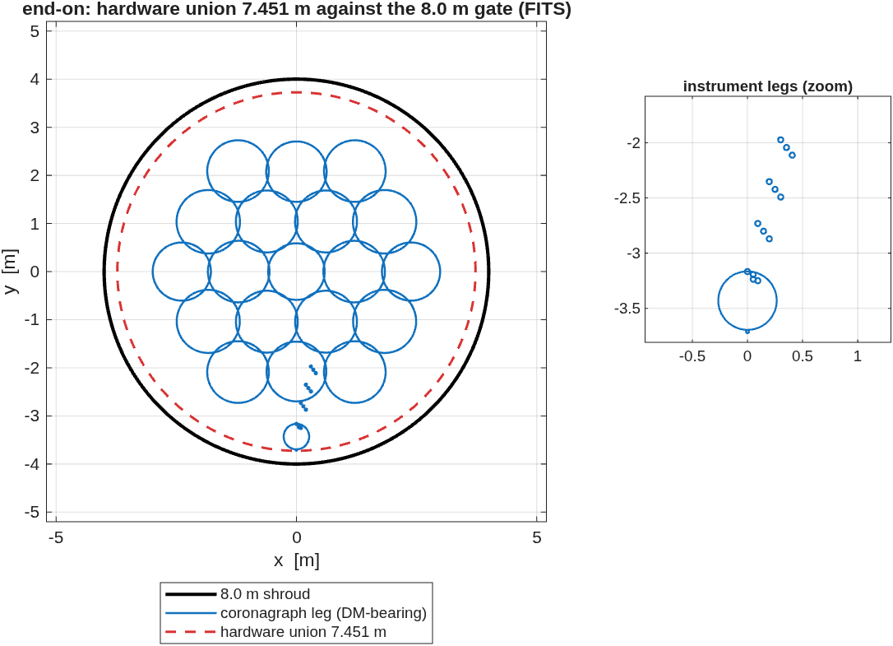
FIGURE 58 The shroud fit on the full train (r1_seg_shroud.png): end-on, the 19-segment primary, the coronagraph leg’s bodies and the hardware union against the 8.0 m shroud, with a zoom on the instrument legs.
The number it reproduces. Round 2 hangs the coronagraph testbed’s topology (8 OAPs, two DMs) at observatory scale off round 1’s segmented telescope: the spliced train is 37 elements, all of the telescope’s 983 passing rays reach the science focus, and the whole train fits a 7.451 m union inside the 8.0 m shroud. It reads round 1’s committed telescope, the f/25.39 design, not the live one of the previous page (finding (qqq)).
Adapt it. “Using templates/80_end_to_end/e2e6m_r2, rerun r1_backend with 48 mm DMs and 1.0 m relay OAPs, and tell me whether every pupil still fits its DM and the train still fits the shroud.”

9.32 bench_ifo_pol: Bench IFO polarization: ray-level Jones scoring (slice 1 of 3)
Polarization-honest Twyman-Green: a real Al coating on the beam-splitter face, ifPol on, scored with the GATED Phase-2 layer (jones_pupil + pol_maps). The coated BS face is hit as an EXTERNAL reflection in the test arm (air->Al, element ‘BSrefl’) and as an INTERNAL reflection in the reference arm (glass->Al, two glass transits, element ‘BScrefr’) – genuinely different Jones – so the arm-differential diattenuation / retardance at recombination is a MEASURED result, and its pupil variation is the polarization-induced PSI phase-error contribution.
Run it.
cd('<path-to>/mmacos/templates/90_polarization/bench_ifo_pol');
run(fullfile(pwd,'example_bench_ifo_pol.m'));
What it prints:
Building Twyman-Green rig...
test arm: coated BSrefl = elt 4, Recomb = elt 12
ref arm: coated BScrefr = elt 8, Recomb = elt 10
=== GATE 1: single-surface 45-deg Fresnel analytic (BS reflect) ===
3001 rays good at BS
BS mean AOI : 45.000 deg
RS/RP magnitude resid : < 1e-12
RS/RP phase resid (rad): 3.318e-14
GATE 1 PASS: coated BS reflection matches Fresnel to < 1e-12
Building arm Jones pupils at recombination...
test leak=5.47e-23 ref leak=4.82e-23 (longitudinal residual)
3001 rays good in both arms
Arm-differential polarization at recombination (3001 rays):
Diattenuation D : mean=7.2133e-02 var(rms)=2.0099e-08 max=7.2133e-02
Retardance (rad): mean=8.3521e-02 var(rms)=3.5997e-08 max=8.3521e-02
PSI phase-error contribution (co-pol fringe, x-pol input):
RMS phase : 2.2848e-08 rad = 3.6364e-09 waves = 2.3011e-06 nm @ 632.8 nm
=== GATE 2: pol-off bit-identity (coated vs uncoated) ===
test-arm OPD max-diff: 0.000e+00 mm
ref-arm OPD max-diff: 0.000e+00 mm
GATE 2 PASS: coating is inert when polarization is off (<1e-12 mm)
=== ALL GATES PASS ===
Its figure: none: slice 1 prints its gates; the figures beside it belong to slices 2 and 3 (example_bench_ifo_pol_slice2.m, _slice3.m).
The number it reproduces. The coated beamsplitter’s reflection matches the Fresnel equations to the floor of the arithmetic at 45 degrees (gate 1), and the coating is inert with polarization off (gate 2). Between the arms at recombination the plate leaves a diattenuation of 7.2133e-02 and a retardance of 8.3521e-02 rad, uniform across the pupil, so it costs the co-polarized fringe almost nothing.
Adapt it. “Using templates/90_polarization/bench_ifo_pol, run slice 2 to trade the beamsplitter’s angle of incidence against clearance, and tell me the angle that keeps the arm-differential retardance under 0.05 rad.”

9.33 tg_psi_dm: a DM surface gauge
A surface-figure gauge built end to end in MACOS: a compensated Twyman-Green interferometer with a deformable mirror as the test optic, whose fringe phase is stepped by rotating an analyzer rather than by translating a reference mirror. Four analyzer angles are a standard four-step PSI; the recovered map is compared against the DM map that was injected.
Gates live in mmacos/tests/tTgPol.m (9 tests, model 128, SUITE_FAST).
cd <this dir>
matlab -batch "run('example_tg_psi_dm.m')" # gated, ~2 min
matlab -batch "run('demo_tg_psi.m')" # the beats + PNGs
demo_tg_psi # interactive: pauses per beat,
# and animates the analyzer sweep
Run it.
cd('<path-to>/mmacos/templates/90_polarization/tg_psi_dm');
run(fullfile(pwd,'example_tg_psi_dm.m'));
On 2026-10-24 this page was a refusal (gate 2’s centroid read NaN, finding (ooo)); the engine fix, macos c6c83d55, made it run, and the page now prints the run.
What it prints:
=== GATE 1: Tranche-1 element order + the grid carries the pol train ===
tg_test.in polarizing elements at [4 8 10 16 17]; 0 physical-optics legs
tg_ref.in polarizing elements at [4 7 9 14 15]; 0 physical-optics legs
grid power at analyzer 90 / at 0 = 0.5897 (1.0 would mean the grid is blind)
GATE 1 PASS
=== GATE 2: detector registration between the two arms ===
pixel pitch test 0.068842384 mm | ref 0.068842386 mm | relative diff 3.11e-08
flux-weighted centroid offset 1.11e-06 px | second-moment radius diff 1.94e-07 px
GATE 2 PASS: pitch matches to 3.1e-08, beams registered to 1.1e-06 px
=== ALIGNMENT: measure the arms, then null the beamsplitter rotation ===
reference arm azimuth at recomb +45.0000 deg (design +45.0000)
test arm azimuth at recomb, QWP @0 -37.5214 deg (design -45.0000)
--> the arms are 7.4786 deg from orthogonal; the beamsplitter has
rotated the TEST arm by 7.4786 deg
solved test-arm QWP azimuth +3.7680 deg -> arm azimuth -45.0000 (want -45.0000), 5 traces
output QWP azimuth set to +90.0000 deg (bisector + 45)
after the output QWP: test |b/a| 1.00000 arg -90.00 | ref |b/a| 1.00000 arg +90.00
(circular is |b/a| = 1 and arg = -+90); |<test|ref>| = 2.98e-07
ALIGNED
=== GATE 3: analyzer-basis synthesis is exact (and why) ===
9 traces (3 per arm x 3 decks) in <t> s -- every analyzer angle now free
theta 23.70 deg : synthesized vs direct trace, rel 7.541e-11
theta 71.30 deg : synthesized vs direct trace, rel 7.337e-11
theta 137.20 deg : synthesized vs direct trace, rel 3.507e-10
theta -18.00 deg : synthesized vs direct trace, rel 1.422e-10
non-vacuity: the O(beta^2) law (beta = ray angle at the analyzer)
test optic Kr= 4000 : beta 1.1233e-02 rad, rel 1.8397e-05, rel/beta^2 0.1458
test optic Kr= 2000 : beta 2.2467e-02 rad, rel 7.3446e-05, rel/beta^2 0.1455
DM deck : beta 2.2728e-05 rad (the DM slope error itself)
quadratic-law check: (rel ratio)/(beta ratio)^2 = 1.0020 (1 = exactly 2nd order)
GATE 3 PASS: exact to 3.5e-10 collimated; degrades as 0.149*beta^2 with power
=== GATE 4: analyzer sweep modulates as cos(2 theta) ===
from 12 TRACED angles (<t> s): visibility 0.998310 | 4t/2t 8.8951e-04 | 6t/2t 2.9871e-14
from the synthesized basis : visibility 0.998310 | 4t/2t 8.8951e-04 | 6t/2t 5.0647e-17
(the synthesized 6t is zero BY CONSTRUCTION -- the traced one is the gate)
GATE 4 PASS
=== GATE 5: a grid value is a SURFACE height (sign + scale) ===
uniform grid piston 20 nm -> +0.397167 rad (expect +0.397167), gain 1.00000
rigid optic shift 20 nm -> +0.397167 rad
grid vs rigid shift 8.730e-11 rad => a grid value IS the surface height
scale error 0.00002 nm of surface (0.0001%), pupil rms 5.74e-04 rad
COUNTERFACTUAL, same rig with the waveplates at their DESIGN angles:
gain 1.11661 (11.7% high) with visibility 0.996612
aligned: gain 1.00000 with visibility 0.998304
-> the misalignment costs 11.7% of SCALE and 0.17% of CONTRAST; a fringe
monitor is ~69x less sensitive to it than the measurement is
GATE 5 PASS: h = +1 * psi * lambda/(4 pi), gain 1.00000
=== MEASUREMENT: four-step polarization PSI (differential) ===
fringe visibility 0.9983 | recovered surface 6.271 nm rms in the pupil
four-step vs 64-angle least squares: < 1e-10 nm rms of surface
(the 4-theta systematic is COMMON to the poked and baseline runs, so
the differential cancels it -- it survives only in a single-shot map)
=== CLOSURE: recovered surface vs the injected DM map ===
pixel-axis check (score = truth-vs-recovery corr. before refinement):
x=+col,y=+row +0.997211 <- specified
x=+col,y=-row -0.997211
x=-col,y=+row -0.997211
x=-col,y=-row +0.997211 <- its 180-deg partner
x=+row,y=+col +0.997211
x=+row,y=-col -0.997211
x=-row,y=+col -0.997211
x=-row,y=-col +0.997211
TIE: x=+col,y=+row and its 180-deg partner x=-col,y=-row score within 1.0e-06 -- the injected pattern is centrosymmetric and cannot resolve the orientation; the specified convention is used, not confirmed
also within 1.0e-06 of x=+col,y=+row: x=-col,y=-row, x=+row,y=+col, x=-row,y=-col
pupil image: mag 10.5252 (det->DM), anamorphic 0.000%, rotation -180.000 deg,
nonlinear distortion 0.0068 mm rms (0.03% of the beam)
pixel axes x=+col,y=+row, correlation 0.998434
truth 6.35 nm rms | recovered 6.27 nm rms
RESIDUAL 0.363 nm rms whole pupil | 0.304 nm rms interior (rim excluded)
CLOSURE PASS: 95.3% of the injected map recovered (interior)
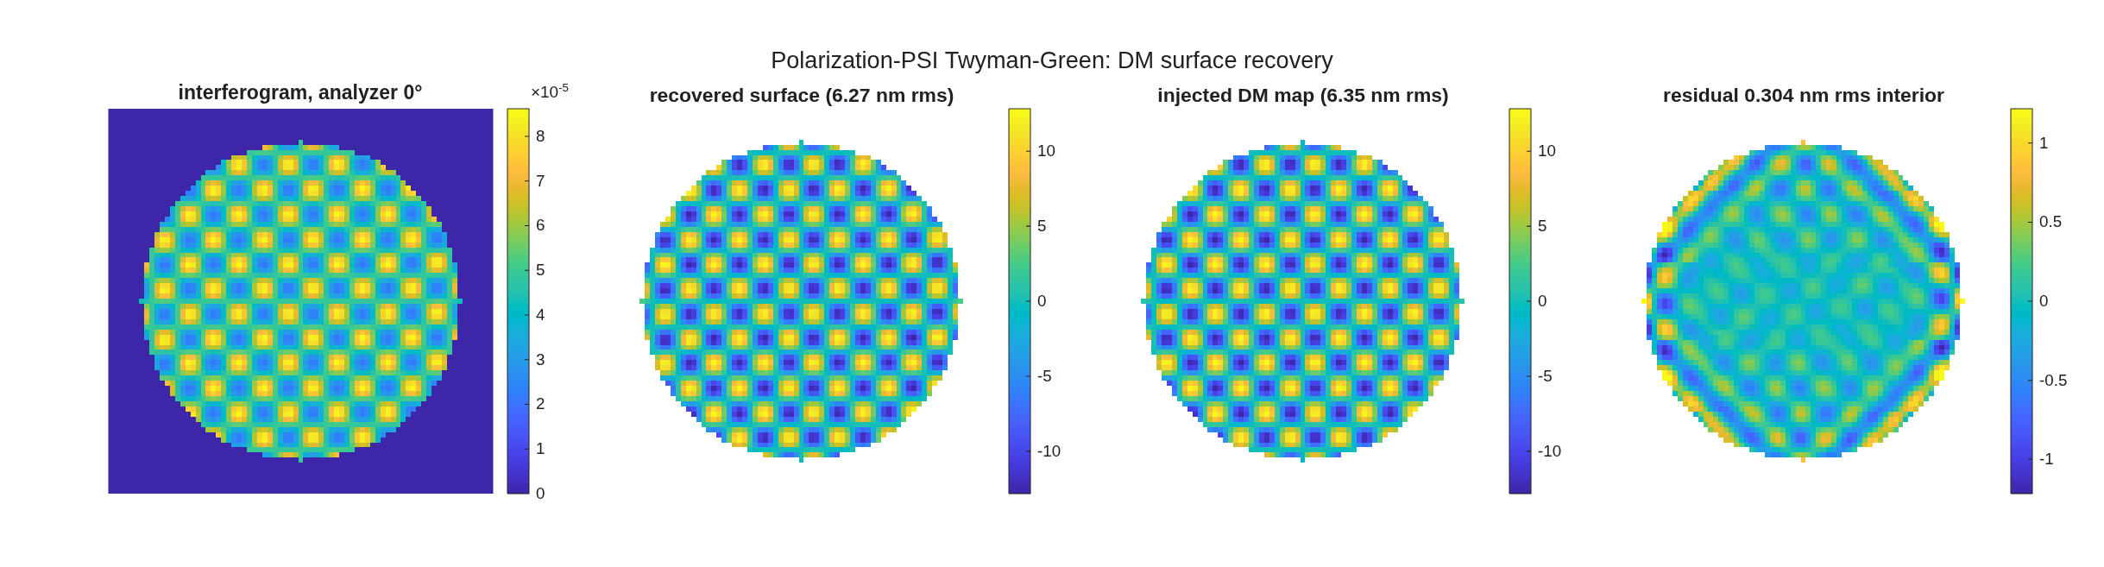
FIGURE 59 The DM surface recovery (tg_psi_dm_recovery.png): an interferogram at analyzer 0 degrees, the recovered surface, the injected DM map, and the residual (nm).
The number it reproduces. The bench measures its own polarization defect before it measures the DM: the beamsplitter’s diattenuation rotates the test arm 7.4786 degrees from orthogonal, so the unaligned gauge reads 1.11661 times the true surface (11.7 percent high); turning the arm’s waveplate nulls it. Aligned, the four-step polarization PSI recovers the injected DM map with correlation 0.998434 and a residual of 0.304 nm rms in the interior, and the four-step agrees with a 64-angle least-squares fit to the floor of the arithmetic.
Adapt it. “Using templates/90_polarization/tg_psi_dm, run the example with an uncoated beamsplitter and tell me how far the arms rotate from orthogonal and what the unaligned gain becomes.”

9.34 tg_psi_dm_v2: the MacNeille cube (TG v2)
The v1 rig carries the polarization conceptually: the splitter is a perfect-conductor plate plus a compensator, and each arm opens with an ideal TrPolarizer at normal incidence. That model earned its keep — it found a real defect, the beamsplitter rotating the test arm 7.479° and the gauge reading 11.7% high.
v2 replaces the concept with the component: a cemented MacNeille polarizing cube, one coated interface at 45° between two prisms of the same glass, built out of ordinary coated engine surfaces. Then it asks what is left of the v1 error, and what has taken its place.
Nothing here is new engine capability. MACOS has carried trustworthy coated s/p physics at arbitrary AOI since 2026-07-27/28 (the r_p sign fix, the incident-medium fix, the transmission radiometric factor, anchored to published Mueller data at ~1e-14). So a PBS is coating physics: no ray splitting, no RfPolarizer element, still two decks — the engine does not split rays.
New builder pieces, all in mmacos/src/+macos/+design/:
Gates: mmacos/tests/tTgPol2.m (9 tests, model 128, SUITE_FAST, ~6 s). v1’s tTgPol (9 tests) is unchanged and still green — v2 is a sibling, not a replacement, and v1 remains the rehearsed demo default.
cd <this dir>
matlab -batch "run('example_tg_psi_dm_v2.m')" # gated, ~4 min
matlab -batch "run('demo_tg_psi_v2.m')" # the beats + PNGs, ~40 s
demo_tg_psi_v2 # interactive: pauses per beat

Run it.
cd('<path-to>/mmacos/templates/90_polarization/tg_psi_dm_v2');
run(fullfile(pwd,'example_tg_psi_dm_v2.m'));
On 2026-10-24 this page was a refusal (gate 1, the same cause as tg_psi_dm’s, finding (ooo)); the engine fix, macos c6c83d55, made it run. The manual copies it with its sibling tg_psi_dm, which it reads for dm_influence_map.
What it prints:
=== the coating ===
prism index (MacNeille condition) n_g = 1.655468
internal angles: theta_H 29.8760 theta_L 60.1240 (sum 90.000000, Brewster)
9 layers, symmetric, 8 quarter waves
layer thickness (nm): 38.82 235.25 77.64 235.25 77.64 235.25 77.64 235.25 38.82
ANALYTIC (Macleod characteristic matrix, glass in / glass out):
symmetric (1/2H L 1/2H)^4 : R_s 0.99958011 R_p 2.601e-30 T_p 1.00000000
odd-QW H(LH)^4 : R_s 0.99981430 R_p 2.112e-02 T_p 0.97888307
-> Brewster at the H/L interfaces equalizes the tilted p admittances
(both 2.7101), so for p the whole stack is ONE HOMOGENEOUS SLAB.
Its two boundaries with the prism are NOT Brewster, so what is
left depends only on the slab's total p phase: 8 quarter waves
is a half-wave ABSENTEE (R_p = 0); 9 is a quarter-wave layer
(R_p = 2.11%). Both satisfy the textbook condition.
DM map: 5.598 nm rms, 65.717 nm PtV, 89.2 mm span, 2.98 mm influence radius
v2 test arm 22 elements | cube faces+diagonal at [5 6 7] (out) / [11 12 13] (back)
v2 ref arm 22 elements | [5 6 7] (out) / [11 12 13] (back)
v1 test arm 23 | v1 ref arm 21 elements (the plate rig, for comparison)
arm geometric path difference: 2.274e-13 mm (no compensator plate in the rig)
=== GATE 1: Coating= round-trips, and Tranche-1 order holds ===
v2_test.in pol elements at [4 8 10 15 16]; 0 physical-optics legs
v2_ref.in pol elements at [4 8 10 15 16]; 0 physical-optics legs
diagonal (elt 6): 9 layers | thickness round-trip 1.75e-16 | index 0.00e+00
face (elt 5): 1 layer n 1.380, 114.64 nm (MgF2 quarter wave = 114.64 nm)
grid power at analyzer 90 / at 0 = 2.4855e+11 (1.0 would mean the grid is blind)
detector pitch test 0.068838097 mm | ref 0.068838097 mm | relative diff 0.00e+00
centroid offset 1.75e-06 px | second-moment radius diff 2.72e-11 px
GATE 1 PASS
=== GATE 2: engine coated diagonal vs the Macleod analytic ===
engine analytic rel err
T_s 4.198875192923e-04 4.198884783816e-04 2.28e-06
T_p 9.999999999960e-01 1.000000000000e+00 3.97e-12
R_s 9.995801124807e-01 9.995801115216e-01 9.59e-10
R_p 3.976191109163e-12 2.600962280092e-30 3.98e-12 (abs)
ENERGY (the two arms' decks measure R and T of the SAME coating):
R_s + T_s = 1.000000000000 R_p + T_p = 1.000000000000
extinction T_p/T_s = 2382 : 1 (a real MacNeille cube is ~1e3)
NON-VACUITY, the odd-QW stack: engine R_p = 2.1116e-02 (analytic 2.1117e-02), T_p = 0.978884
GATE 2 PASS
=== GATE 3: arm states at the recombination plane ===
v2 cube : test -89.999997 deg | ref -0.000002 deg | from orthogonal -5.264e-06 deg
v1 plate: test -37.521390 deg | ref +45.000000 deg | from orthogonal -7.4786 deg
-> the cube removes the beamsplitter rotation by a factor 1.42e+06
after the output QWP (fixed at 45 deg): test |b/a| 1.000000 arg -90.00
ref |b/a| 1.000000 arg +90.00
circular is |b/a| = 1, arg = -+90; |<test|ref>| = 8.17e-08
GATE 3 PASS
=== GATE 4: the analyzer basis is still exact on the cube rig ===
9 traces (3 per arm x 3 decks) in <t> s
theta 23.70 deg : synthesized vs direct trace, rel 7.553e-11
theta 71.30 deg : synthesized vs direct trace, rel 7.348e-11
theta 137.20 deg : synthesized vs direct trace, rel 3.512e-10
theta -18.00 deg : synthesized vs direct trace, rel 1.424e-10
12 TRACED angles (<t> s): visibility 1.000000 | 4t/2t 8.895e-04 | 6t/2t 2.987e-14
synthesized : visibility 1.000000 | 4t/2t 8.895e-04 | 6t/2t 4.753e-17 (0 by construction)
GATE 4 PASS
=== GATE 5: PSI scale on a known 20 nm surface piston ===
grid piston 20 nm -> +0.397167 rad (expect +0.397167) gain 0.999999, err 0.0000 nm
rigid optic shift -> +0.397167 rad (grid vs rigid 4.95e-10 rad)
visibility 1.000000
--- arm-waveplate azimuth error: what each rig does with it ---
eps | v2 |sep|-90 (ref-arm err) | v1 |sep|-90 | v2 gain v2 vis
0.0 | -5.264e-06 -5.264e-06 | -7.4786 | 0.999999 1.000000
2.0 | -2.337e-06 -7.093e-02 | -3.5520 | 0.999999 1.000000
3.8 | -8.459e-06 -1.342e-01 | -0.0001 | 0.999999 0.999980
5.0 | -1.275e-05 -1.789e-01 | -2.5215 | 0.999999 0.999926
10.0 | -3.101e-05 -3.692e-01 | -13.1490 | 1.000000 0.998447
-> the cube's REFLECTING arm is cleaned to r_p (= 0): 3.1e-05 deg at 10 deg of error.
Its TRANSMITTING arm is cleaned only to t_s/t_p = 0.0205: 0.369 deg.
v1, with no cleanup at all: 13.15 deg.
(the v1 column is NON-MONOTONIC on purpose: v1 STARTS 7.479 deg off, so
its curve dips through a minimum near eps = 3.768 -- which IS the
waveplate clock v1 has to solve for. v2 has no such minimum to find.)
-> and in v2 the error costs CONTRAST (1.000000 -> 0.998447), not SCALE
(gain 0.999999 -> 1.000000). That is the INVERSE of the v1 finding:
the PBS turns an invisible systematic into a visible one.
GATE 5 PASS: h = +1 * psi * lambda/(4 pi), gain 0.999999
=== GATE 6: output-port efficiency ===
detected power v2 cube 0.383616 | v1 plate 0.169079 | ratio 2.2689
per-arm coating budget T_p*R_s = 0.999580, four AR faces at T = 0.995110 each
-> predicted per-arm throughput 0.980172 (bare glass would be 0.777342)
GATE 6 PASS
=== MEASUREMENT: four-step polarization PSI (differential) ===
fringe visibility 1.000000 | recovered surface 6.259 nm rms in the pupil
four-step vs 64-angle least squares: < 1e-10 nm rms of surface
=== CLOSURE: recovered surface vs the injected DM map ===
detector->DM magnification 10.5258, rotation +0.00 deg, anamorphic 0.0000%,
nonlinear distortion 0.0068 mm rms; axis convention x=-col,y=-row
truth 6.35 nm rms | recovered 6.26 nm rms | correlation 0.999573
residual 0.183 nm rms interior (0.207 whole pupil)
=========================================================
SUMMARY -- v1 plate (ideal polarizers) vs v2 MacNeille cube
=========================================================
v1 plate v2 cube
arm rotation from orthogonal (deg) -7.4786 -5.26e-06
PSI scale gain, as designed 1.11661 0.999999
fringe visibility 0.996612 1.000000
delivered power (arb, same source) 0.1691 0.3836
sep after 10 deg WP error (deg) 13.1490 0.3692
alignment step needed yes (+3.768 deg) none
compensator plate required 2.274e-13
coating: engine vs Macleod R_s 9.59e-10 | T_p 3.97e-12 | R_p 3.98e-12 (null)
DM closure: corr 0.999573, residual 0.183 nm rms interior on 6.35 nm
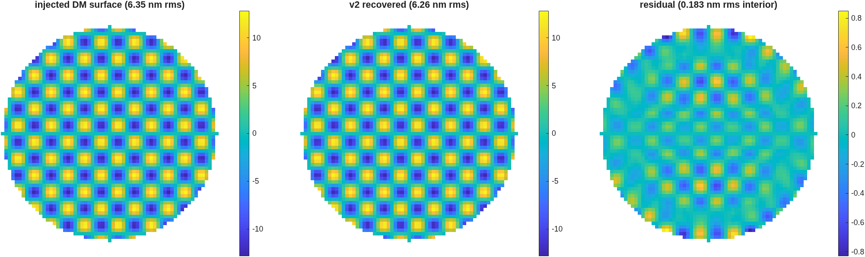
FIGURE 60 The v2 rig’s DM surface recovery (tg_psi_dm_v2_recovery.png): the injected DM surface, the recovered surface, and the residual (nm).
The number it reproduces. With the coated cube in place of v1’s plate, the gauge’s scale is right as designed, gain 0.999999 against v1’s 1.11661, because the cube’s reflecting arm is cleaned to pure s; an arm-waveplate error now costs contrast, not scale. It recovers the same DM map with correlation 0.999573 and a residual of 0.183 nm rms in the interior.
Adapt it. “Using templates/90_polarization/tg_psi_dm_v2, sweep the arm-waveplate azimuth error to 20 degrees and tell me where the fringe contrast falls below 0.99 and whether the gain moves.”

SECTION 10: The Tool Templates
The other seventeen templates are tools, not designs: examples of an interface, a method, or a driver that the design templates and the runners call. Two are the entry points of Section 1’s thread and get a page each; the table lists all seventeen, each described by its own README’s title or, where it has none, by its main script’s header. A last table lists the library functions no template calls.

10.1 The seventeen tools
Template | Section | What it is | Described by
design_layer_api | 10_telescopes | Design-layer API examples (+macos/+design) | README
pupil_id | 10_telescopes | beyond FEX: the exit pupil as a SURFACE | README
grid_surface | 20_segmentation | GRID-DATA SURFACE API walkthrough on FFSegDemoAll.in | grid_surface_example.m header
coro_experiments | 30_instruments | Coronagraph division-of-labor experiments (Sprint 1, E1–E4) | README
dm_gauge_lib | 40_benches | the ONE copy of the DM-gauge scoring machinery | README
e5hex1 | 50_sensitivities | graphical dw/d(grid-data) sensitivity demo + verification | run_dwdgrid.m header
e5hex1_budget | 50_sensitivities | the live-formula WFE calculator (Excel or LibreOffice; regenerate with run_budget_e5hex1). | README
e5hex2_refzern | 50_sensitivities | conforming Reference → GS Zernike basis → dw/d(grid) | README
gen_segment_gridmat | 50_sensitivities | per-segment Zernike GridMat generator | README
run_dwdgrid_multi | 50_sensitivities | multi-field dw/d(grid-data) sensitivity (example) | run_dwdgrid_multi.m header
run_dwdgrid_multi_multisegbasis | 50_sensitivities | dw/d(grid) with a PER-SEGMENT basis | run_dwdgrid_multi_multisegbasis.m header
run_dwdgrid_multi_singlesegbasis | 50_sensitivities | dw/d(grid) with ONE shared basis | run_dwdgrid_multi_singlesegbasis.m header
run_dwdsurf_multi | 50_sensitivities | multi-field dw/d(Kr,Kc) POWERED-SURFACE sensitivity (example) | run_dwdsurf_multi.m header
run_dwdx_multi | 50_sensitivities | multi-field dw/dx RIGID-BODY sensitivity (example) | run_dwdx_multi.m header
run_dwdz_multi | 50_sensitivities | multi-field dw/dz ZERNIKE-COEFFICIENT sensitivity (example) | run_dwdz_multi.m header
zoom_5x5 | 50_sensitivities | multi-configuration × multi-field sensitivities | README
view_rx_demo | 60_visualization | the general prescription visualizer | README
40_benches/vsg_wip is a planning folder (a VSG2 model plan and review notes), not runnable; it has no page.

10.2 design_layer_api: Design-layer API examples (+macos/+design)
Runnable worked examples for the MATLAB design layer – the four scripts that introduce the two front-ends. The bench / coronagraph / interferometer rows below moved to their own thread directories in the 2026-08 reorganization (see ../../00_INDEX.md); their descriptions are kept here until the Week-2 rewalk absorbs this file into that index. Two front-ends, one analysis core (PLAN_DESIGN_LAYER §1.0): import an existing prescription (macos.design.System, Sprint 2A-i) or build one from design intent (macos.design.Telescope, Sprint 2A-ii). Both feed the same vary → evaluate → optimize surface and the bitwise-verified Phase 7 sensitivity machinery. Each script ends in exit(0) (batch-mode rule, ../../../CLAUDE.md).
The builder examples derive geometry from closed-form optics (../../../../optical_design/ reference + fixtures); the import examples run against the committed e5hex1.in in ../../50_sensitivities/e5hex1/ and run unchanged on a CodeV/Zemax-converted prescription (the expected dominant entry point, §1.0).
Run one:
matlab -batch "run('$(pwd)/example_telescope_design.m')"
These are distinct from ../../50_sensitivities/ (lower-level macos.dw_dx / macos.dw_dz_zernike driver demos); the design-layer examples wrap that machinery behind the +macos/+design API. The telescope-design progression (rc_* -> tma_* -> freeform) is the rest of ../.
Run it.
cd('<path-to>/mmacos/templates/10_telescopes/design_layer_api');
run(fullfile(pwd,'example_telescope_design.m'));
The README’s design-template example, example_telescope_design.m, the builder front end from design intent to a saved deliverable. Its three siblings are the import front end (example_sensitivities_from_rx.m, example_align_from_rx.m) and a focused alignment loop.
What it prints:
Stage 3 — single-point evaluation (on-axis)
------------------------------------------------------------------
on-axis RMS WFE (nominal) = < 1e-09 m (RC: spherical + coma corrected)
Stage 4 — same layout, different conics (RC vs classical Cassegrain)
------------------------------------------------------------------
shared layout : R1 = 24.0000 m R2 = 2.6263 m M1-M2 sep = 10.8182 m
RC : K1 = -1.002185 K2 = -1.524259 (primary slightly hyperbolic)
Cassegrain : K1 = -1.000000 K2 = -1.493827 (parabolic primary)
=> RC trades a slightly-hyperbolic primary to also null coma (aplanat),
widening the usable field; the classical Cass is simpler but coma-limited.
Stage 5 — align a perturbed secondary (M2 despace)
------------------------------------------------------------------
perturbed (+2.000 mm) : RMS WFE = 1.752e-05 m
recovered : RMS WFE = < 1e-09 m at despace = 0.0000 mm
(optimizer returned the secondary to within 0.0 um of nominal)
Stage 6 — add an accessible exit pupil (deliverable)
------------------------------------------------------------------
exit pupil @ z = -11.9892 m, reference radius = 12.9892 m
elements now: image-return #3, exit-pupil #4, detector #5
Its figure: none: the example prints its stages and saves the deliverable (rc_6m_f20.in, .mat).
The number it reproduces. From design intent (6 m, f/20) the builder derives a Ritchey-Chretien with K1 = -1.002185 and K2 = -1.524259, diffraction-limited on axis (its rms wavefront error is at the floor of the arithmetic, printed as a bound). A 2 mm despace of the secondary costs 1.752e-05 m rms, and the optimizer returns it to nominal, again to the floor.
Adapt it. “Using templates/10_telescopes/design_layer_api/example_telescope_design.m, build a 4 m f/15 Ritchey-Chretien instead, despace the secondary by 1 mm and let the optimizer recover it, and report the conics and the recovered wavefront error.”

10.3 pupil_id: beyond FEX: the exit pupil as a SURFACE
tma_onaxis’s own note is that “the exit pupil after M3 is ASSESSED (FEX), not constrained.” This template is the next chapter. FEX reduces the exit pupil to a single chief-ray conjugate sphere — one field point, forced Kc=0, one radius. It gives the XP location and the far-field propagation distance and nothing about pupil-imaging quality: no pupil spherical aberration, no pupil astigmatism, no pupil walk across field.
It is a general-purpose driver: give it any telescope Rx (defaults to tma_onaxis), it runs the grid-of-cone-sources method to find the exit pupil as a fitted surface, writes a revised Rx (the XP reference sphere re-placed at the fitted-surface / chief-ray crossing – an on-chief vertex at the measured pupil station, with the radius following the vertex so the sphere center stays on the propagation-target plane), cross-checks against the engine’s two-ray XPS, reports how sharply the EP images to the XP, and tracks the pupil walk vs field.
It composes existing, test-gated tools — design/src/pupil_map.m (cone convergence), macos.pupil_quality (engine XPS), macos.pupil_zone_map (zone spots), macos.fex/macos.set_xp (the XP sphere). No new engine or veneer code.
Run it.
cd('<path-to>/mmacos/templates/10_telescopes/pupil_id');
run_pupil_id('tma_onaxis');
The runner’s one-case form on the bundled tma_onaxis deck; the manual copies the template with its tma_onaxis sibling, which the runner reads.
What it prints:
[2] EP at element 1 via anchor='rim' (EP as the beam rim -- classic telescope)
[3] cone field grid: 9 cones (3x3, +/-2 arcmin); blur.rms=7.651e-06 m blur_ratio=0.010
[4] XP sphere -> Rx: vertex=[-0.00000 -0.00000 0.26358] m (fit_chief), rad=-0.146931 m (follows vertex)
pupil-quality: convergence curvature R=0.07653 m, departure-from-sphere RMS=1.843e-07 m
(bundle diag vs FEX: 5.22e-06 m; written vs FEX along chief: 0.00e+00 m)
[5] XPS cross-check (pupil_map anchor='stop' vs engine pupil_quality):
defocus 2.735e-04 vs 2.734e-04 (0.02%) astig -3.068e-04 vs -3.068e-04 (0.00%) [rescale s=1.0511]
[6] EP->XP imaging: 25 zones, median spot=1.737e-03 m, worst=3.002e-03 m
[7] pupil walk over -2..+2 arcmin: XP z 0.263558..0.263582 m, rad -0.147057..-0.146915 m
[8] revised Rx written: <work>/templates/10_telescopes/pupil_id/results/tma_onaxis/tma_onaxis_xp.in (fit_chief vertex + vertex-following radius)
wrote <work>/templates/10_telescopes/pupil_id/results/tma_onaxis/pupil_id_cloud.png
wrote <work>/templates/10_telescopes/pupil_id/results/tma_onaxis/pupil_id_zernikes.png
wrote <work>/templates/10_telescopes/pupil_id/results/tma_onaxis/pupil_id_walk.png
=====================================================================
PUPIL ID -- tma_onaxis, beyond FEX
FEX (1 chief ray): XP z=0.26358 m propagation rad=-0.146931 m
cone-convergence : blur=7.65e-06 m departure-from-sphere=1.84e-07 m
pupil aberration : defocus=2.66e-04 astig=-2.17e-08 spherical=8.65e-08 (rim anchor)
XPS cross-check : defocus 0.02% / astig 0.00% vs engine pupil_quality
EP->XP imaging : median zone spot=1.74e-03 m (25 zones)
revised Rx : <work>/templates/10_telescopes/pupil_id/results/tma_onaxis/tma_onaxis_xp.in
=====================================================================
=====================================================================
PUPIL-ID RUNNER SUMMARY (1 case)
=====================================================================
case | FEX rad | conv rad | dep RMS | XPS df% | XPS as% | revised Rx
--------------------------------------------------------------------------------------------
tma_onaxis | -0.14693 | 0.07653 | 1.84e-07 | 0.02 | 0.00 | tma_onaxis_xp.in
--------------------------------------------------------------------------------------------
(FEX rad = XP->detector propagation radius, written to the Rx; conv rad =
pupil-imaging convergence-surface curvature, a QUALITY diagnostic, NOT the Rx
radius. XPS df/as% = pupil_map anchor=stop vs engine pupil_quality (% rel).)
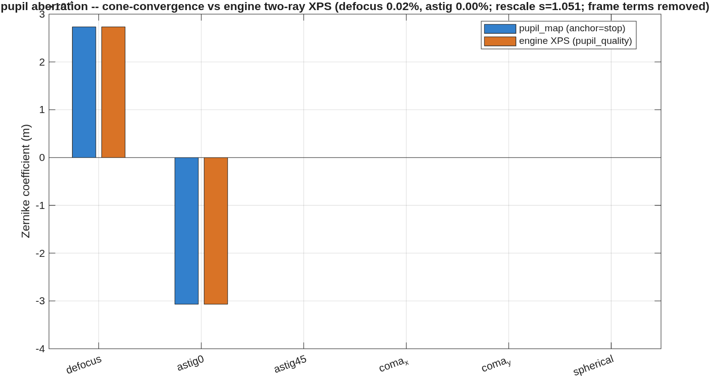
FIGURE 61 The exit pupil’s own aberration (results/tma_onaxis/pupil_id_zernikes.png): the cone-convergence pupil map against the engine’s two-ray XPS command, term by term. The axis multiplier (×10⁻⁴ m) sits under the title, cut off by it.
The number it reproduces. The pupil, found as a surface from the convergence of ray cones rather than from one chief ray, departs from a sphere by 1.843e-07 m rms, and its aberration agrees with the engine’s own pupil-quality command: defocus 2.735e-04 against 2.734e-04, 0.02 percent, astigmatism to the printed digit. The revised prescription carries the exit pupil the method finds.
Adapt it. “Using templates/10_telescopes/pupil_id, run pupil_id on the sz_tma deck with a 4 arcmin field, and tell me the exit pupil’s departure from a sphere and whether it agrees with the engine’s pupil_quality.”

10.4 The functions no template calls
Counted by a word-boundary search of every template script for each function’s name: design/src, 40 of 80; sensitivities, 12 of 24. They are kept (Dave, 2026-10-26): a runner or a test may still call them. Entry scripts are listed apart from the functions: a script is run by a user, not called, so no template naming it says nothing about it.
design/src (the design layer’s helpers, 40 of 80: 40 functions, 0 entry scripts)
Function | What its help line says
afocal_first_order | Paraxial marginal AND chief trace of an N-mirror train.
afocal_ladder_deck | The 3-rung afocal reference ladder on a COMMITTED deck.
afocal_plane_opl | Exact OPL from the source to a flat reference.
afocal_refs | The flat wavefront reference for an AFOCAL exit beam, plus
afocal_rungs | The three reference-freedom rungs of the AFOCAL WFE metric.
afocal_score_psf | Score an AFOCAL deck with a focus, without touching it.
afocal_wfe_deck | The afocal WFE metric evaluated on a COMMITTED .in deck.
calib_blind_fields | Which CALIB fields did the solve not see? Gated on RAYS, not on the size of the seed’s WFE.
chain_aim | Launch POINT on a plane whose ray along d hits surface iStop at its vertex.
chain_bundle | The multi-field, multi-lambda COLLIMATED bundle through a chain.
chain_footprints | Per-surface beam footprint of a bundle, in the APERTURE frame.
chain_trace | Sequential exact 3-D trace through a surface chain.
dyson_layout | Closed-form seed + exact-trace verification of a concentric Dyson.
dyson_scaling | The block radius a concentric Dyson needs for a given field.
e2e_geom | Telescope + spectrometer as ONE chain, the grating its stop.
focal_surface | Measure a system’s best-focus SURFACE and emit the deck
optic_footprints | Trace all fields x all configs; per-optic footprint geometry.
spectrometer_layout_fig | Deck-standard layout of a spectrometer_geom chain.
spectrometer_maps_fig | Performance maps of one scored deck, deck standard.
spectrometer_score_chain | The same spectrometer metrics from the exact chain.
spectrometer_sens | The tolerance ladder of a spectrometer deck: one perturbation at a time, scored by the engine.
spectrometer_sens_defaults | The addendum-49 tolerance list for a Dyson deck (spectrometer_rx emission).
spectrometer_sens_dn | The index change the lens_index row actually applies, over wavelength: the Sellmeier B
spectrometer_slit_loss | The slit-width diffraction loss, measured vs sinc^2.
spectrometer_wave | The propagation twin of spectrometer_score.
spectrometer_wave_fig | The propagation twin’s evidence, deck standard.
strict_sphere_opl | Exact OPL from the source to a reference sphere.
telescope_clear_quick | A cheap clearance wall for the telescope solve.
telescope_cloud | The spectrometer’s bodies as a point cloud for the telescope’s clearance wall.
telescope_geom | The fore-optics chain that feeds the slit: an off-axis section of a coaxial three-mirror anastigmat.
telescope_ladder | The telescope’s departure ladder on the exact chain, under the slit scorer.
telescope_maps_fig | The telescope’s score at the slit, deck standard.
telescope_score | The telescope scored at the slit in the ENGINE.
telescope_score_chain | The telescope scored at the slit on the exact chain.
telescope_seed | First-order PNP three-mirror layout + Seidel conics, closed form.
tma_screen | First-order (paraxial, engine-free) clearance screen of a coaxial three-mirror train.
tms_clear | Beam-leg vs body clearances of a two-mirror TMS chain (tms_geom), exact rays, signed.
tms_firstorder | General first order of the two-mirror TMS: EFL held by eliminating R1, the stop telecentric.
tms_geom | The two-mirror modified Schwarzschild (TMS) that feeds the slit, as an exact chain.
tms_paraxial | Closed-form first order of the two-mirror modified Schwarzschild (flat, telecentric).
sensitivities (the sensitivity drivers, 12 of 24: 11 functions, 1 entry script)
Function | What its help line says
dw_block_keys | Per-channel PAGE BLOCK: which element / group / source a
dw_canvas_tiles | [rows cols] of FIELD TILES in a harvest’s canvas.
dw_draw_map | One dW map in one panel, in the pinned display convention.
dw_page_axes | Axes for one panel slot of a DW_PAGE_LAYOUT page.
dw_page_fig | An invisible figure whose PRINTED size is FIG_IN inches.
dw_page_layout | Size-FIRST page plan for the dw_d* channel plotters.
dw_page_title | Page header at a FIXED distance from the top of the page.
dw_panel_label | Short panel title from a channel name.
per_field_indx | m2v bookkeeping for ONE field of a dw_d*_multi harvest, in
plot_dw_index | Contact sheet: every channel as a thumbnail, page-labelled.
write_page_index | The harvest’s page index: one line per figure written.

Entry script | What its help line says
run_dwdx_multi_zoom | multi-CONFIGURATION x multi-field dw/dx (GENERIC).

SECTION 11: Reference
Part III is short by design. Its references already exist and are maintained with the code, so this part points to them rather than copying them, and adds the one chapter the MACOS manual does not have: how an assistant is expected to work with this library.

11.1 Where the reference lives
- The API catalog is the Command Reference, Part II (docs/macos-manual/cmdref/, rendered as macosCmdRef). It is generated, and it lists every engine command with its MATLAB binding, the macos.<name> function that wraps it, and the test that exercises it. The help text of a macos.* function (help macos.trace) is the binding’s own account, and the catalog is built from the same source (macos_api_mod.F90, read by the code generator).
- The design rules and the agent guides live in MACOS_resources/optical_design/. They are the equations and conventions of the design layer (TELESCOPE_DESIGN_REFERENCE.md, SPECTROMETER_DESIGN_REFERENCE.md), the coronagraph rules (CORONAGRAPH_DESIGN_RULES.md), the two agent guides (OPTICAL_DESIGN_AGENT_GUIDE.md, CORONAGRAPH_DESIGN_AGENT_GUIDE.md), and the regression fixtures the conic solvers are checked against (fixtures/*.json). Read them before changing any optical mathematics in the design layer.
- The library’s own record is MACOS_resources/mmacos/CLAUDE.md. It covers the layering, the package conventions, the gotchas that were closed, and the test that pins each one. The design-layer and runner entries are the first thing to read before changing them.
- The engine is documented by the MACOS manual. Section 4 is the prescription language; Sections 5 to 8 are the analysis commands that the bindings wrap.

11.2 Working with the library: a chapter for the assistant
This chapter is written for an AI assistant asked to run, adapt or extend mmacos, and for the person who sets one to work. It is the MATLAB reader’s version of the MACOS manual’s Appendix D. Read that appendix too: it covers driving the engine directly, and everything it says about evidence holds here.

11.2.1 Where the facts live
- The templates are the worked answers. templates/00_INDEX.md lists them by thread, and Part II of this manual has a page for each. A request (“design an unobscured 3 m telescope”) usually matches a template whose parameter block already has the knobs. Adapting a template beats writing a new script.
- The runners in design/runners/ are the product, and the stage scripts of a template are thin narrative drivers over them. A runner’s help text states its inputs (the .in prescription plus the sidecars it declares) and its artefacts.
- The test suites are the specification: mmacos/tests/ (run by run_mmacos_tests.sh), the engine’s cli_tests/, and the pymacos suite. A behavior no test pins is not yet a promise.
- A template’s README is a record of its last run, not a guarantee of the next. Part II found READMEs whose tables predate the engine they run on, and templates whose defaults are not the inputs of the run their README quotes. Run the template, then compare.

11.2.2 Driving it
- Start each MATLAB session with run('<path-to>/mmacos/mmacos_setup.m'). It puts src, the design layer and the sensitivity helpers on the path, anchored to its own location. Templates are not on the path; addpath the one you run.
- Run a template on a copy when its outputs are not yours to commit. Most templates write their decks, reports and figures beside themselves, and some write further. One stage script of the e2e thread writes a library preset (Section 5 says how this manual handled it). Before running a stage, search it for writes outside its own folder.
- The model size is the first decision. macos.init(N) fixes the largest ray grid of the session. It must be at least the prescription’s nGridpts: below that, the engine resets the grid with a message and can crash later. Changing size within a session is not reliable, so use one size per MATLAB process.
- Trace before you read. macos.opd, macos.intensity, macos.complex_field and macos.dx_at read the state a trace leaves, and a modification wipes it. A perturbation (macos.perturb) is not seen by the next trace until macos.modify() marks the prescription changed: without it the change reads as zero (Section 6).
- Session modes survive a load. POLARIZATION, VECTOR diffraction and the OPD reference persist across macos.load_rx, and the binding warns at every load while one is in force. Set them deliberately, per measurement.
- The OPD reference decides what a wavefront comparison measures. The engine’s default is the chief ray; some runners harvest at the aperture mean. Section 6 shows a 188.9 nm “disagreement” that was entirely a reference mismatch. Put both sides of any comparison on the same reference, and say which.
- Units: translations are SI metres at the binding. trace().rmsWFE and macos.opd() are metres, not waves, and the dw_dx translation columns are per base unit by default. Read the help text’s units line before you convert.
- Headless runs go through matlab -batch "...; exit(0)", with the exit in the command, not inside the template. A batch MATLAB that has loaded the mex can hang at an implicit exit. Kill a hung one by its process ID.

11.2.3 Conventions that bite
- Mirror signs. The design layer emits KrElt = -|R| for every mirror; the concave or convex sense is in the geometry, not the sign. An off-axis section’s VptElt is the parent’s vertex; ask Bench.station where an element really sits.
- Grid files. A GridFile= is read from the working directory at load, and its lines are columns, so a naive MATLAB load gives the transpose. Run with the working directory set where the grid lives.
- Numbers that are numerically zero (a collimated system’s rms near 1e-12, a chief-ray coordinate near 1e-11) share no digits across machines. Pin a real signal to five significant figures; bound a numerical zero in magnitude, and check the bound.
- A large linear model has quadratic forms that are computed as trace(P*G) with G = D'*D, never as the outer product D*P*D', which runs out of memory on a tall Jacobian.

11.2.4 Working rules
These are the house rules this project holds its own assistants to, each one learned the hard way.
- Measure before you guard. Before adding a check, find the value’s other writers. Guards warn and count; a new refusal of behavior a long-standing tool tolerated needs the maintainer’s decision.
- Every fix ships with a test that fails before it. A test that cannot fail measures nothing, and a toy input that bypasses the code path is not a test of it.
- A gate that cannot measure must refuse, and must ship with a case that passes. A gate that fails open looks like it works. This manual’s own bound pins once printed a bound they had not checked.
- One parameterized runner per system: a <sys>_params sheet and a <sys>_run driver. A number in the sheet was chosen; a number in a report was derived.
- No exit inside an example. The batch wrapper supplies it. Save the inputs and the outputs (the .in and a .mat) beside the example, and give every design an accessible exit pupil (add_pupil).
- Figures are the tool’s own output, unmodified. Look at every figure before printing it. A figure producer can rot silently, and this manual found legends and charts that misstate their data. Say so in the caption rather than redraw.
- Read the frame before calling a mismatch, and look at the raw per-ray data before blaming a solver: a histogram of per-ray OPD finds what an outlier cut hides.
- Characterize before another ladder. After two failed hypotheses, read the residual’s structure before trying a third.
- Report outcomes faithfully. A number comes from a run on a named build with the prescription and commands that produced it. Quote it from the run’s output, never from memory. A failed test is reported with its output, and a skipped step is reported as skipped.
- Write the resolution where the next reader will find it, at the time it is resolved: in the template’s README, the library’s record, or the plan’s findings list.

11.2.5 What to ask next
- “Find the template closest to my telescope and adapt its parameter block; run it on a copy and compare the result with its README before telling me anything.”
- “Before you change this runner, read its help text, the library record’s entry for it, and the test that pins it, and tell me which test your change could move.”

