Federated Registries
Distributed Infrastructure Design Team
June 4, 2009

Registries are pervasive components in most information systems. For example, data dictionaries, service registries, LDAP directory services, and even databases provide “registry-like” services, including an account of informational items that are used in large-scale information systems. These items range from data values such as names and codes, to vocabularies, services and software components. The content of this paper has been extracted from the yet to be released CCSDS Registry and Repository Reference Model, Draft White Book. The intent of this paper is to introduce the concept of a Federated Registry/Repository.

A registry and repository need to support the registration and discovery of data artifacts (e.g., document, data products, etc.) and services by providing interfaces for their submission, approval, and publishing. It should also include powerful query capabilities for searching, rich metadata management capabilities for classification and association, governance and control authorities for maintaining integrity, change control processes for management, and effective access by both people and computer systems. The following diagram details the features of a federated registry/repository:

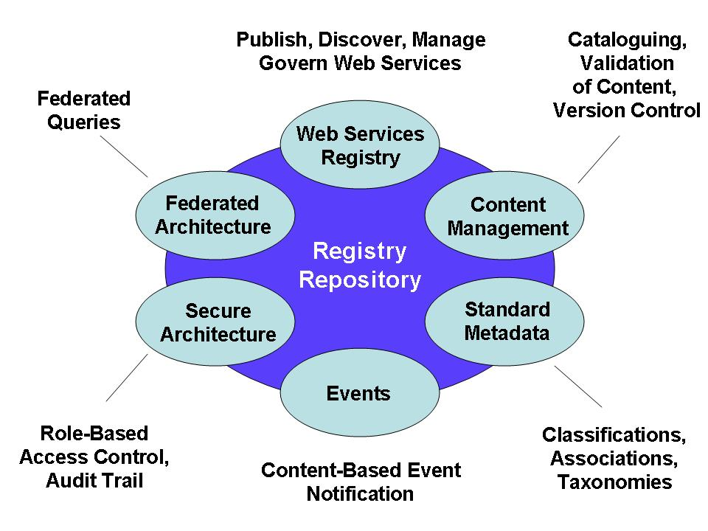

A federated registry provides services for sharing content and metadata between cooperating registries in a federated environment; and allows cooperating registries to be federated together to appear and act as a single virtual registry/repository within the federated model. The benefits of a federation include seamless information integration and sharing while preserving local autonomy over data (e.g., federated search seamlessly returns results from multiple stores).

Several registry/repository instances have been identified for PDS 2010 during the architecture definition and design process. They include the following:
- A registry for catalog-level information (e.g., Mission, Instrument, Target, etc.).
- A registry for data dictionary definitions (e.g., Objects/Groups and Elements).
- A registry/repository for PDS documents and software.
- A registry for service descriptions (e.g., web services, other registries, etc.).
- A registry of data products at each Node.

Many of the registry/repository instances listed above exist in the current PDS system. The problem is that they all follow a different model for capturing metadata as well as providing access to that metadata thus making it difficult or nearly impossible to achieve interoperability between the registries. The recommendation for PDS 2010 is that the concept of Federated Registries (summarized in this paper) be applied to the design of the system enabling seamless search across the registries while retaining local governance over data where appropriate.

