Module 4 directions to use notebooks

1. Login in to your Google account, and make sure to use the same account for all your hands-on exercises.
2. We made a new copy of the methods notebook, so you’ll need to delete your old “Copy of methods.ipynb” first before proceeding, assuming you have one. If this is your first time using these notebooks, you can skip this step and go to step 3.
   1. In the top right of your Google account login browser window, click the “nine dot square icon.

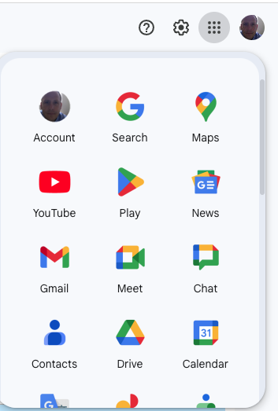

* 1. Select the “Drive” icon.

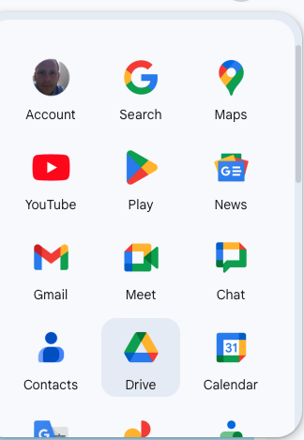

* 1. In the left navigation pane of your “Drive” window, click the arrow next to “My Drive” to expand that directory.

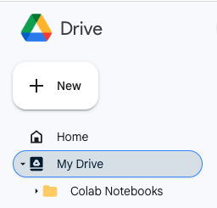

* 1. Then click on the “Colab Notebooks” folder. You should see the contents of that folder display in the main window.

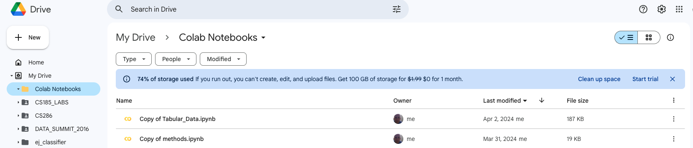

* 1. Click the “3 vertical dots” to the far right side of “Copy of methods.ipynb” and you’ll see a drop-down list.



* 1. Select “Move to trash” to delete the notebook.

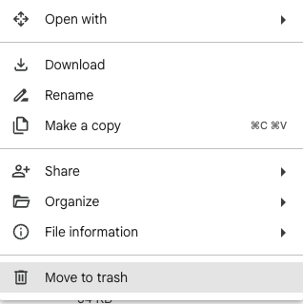

* 1. You’re all set now to get a new copy of the methods.ipynb notebook.

1. Open this [methods.ipynb](https://colab.research.google.com/drive/1u8zhD55OOqq6WWVrY0WjiFJDBLDDS_R5?usp=sharing) notebook
   1. Open the notebook as “Colab notebook”
   2. Make a copy in Drive (File → Save a copy in Drive).
   3. Close both the original notebook and the copy of the notebook - you do not need to do anything more than create this copy.

When you’re ready to do your hands-on activity, do the following steps (same steps as modules 1 and 2):

1. In a different browser, navigate to the canvas page for this course and navigate to the assignment for the hands-on session you are going to do.
2. Click on the link under where it says “Complete this CoLab notebook”.
   1. Open the notebook as “Colab notebook”
   2. Make a copy in Drive (File → Save a copy in Drive).
   3. This is the notebook you’ll be working with - close the original notebook and use the copy of the notebook for the rest of these steps.
3. Clear the output of the notebook (Edit → Clear all outputs).
4. Run all the cells in the notebook (Runtime → Run all).
5. You will be prompted to let the notebook access your Google drive.
   1. In the “Permit this notebook to access your Google Drive files?” pop-up, click “Connect to Google Drive”
   2. In the “Choose an account” pop-up, select your account.
   3. In the “Sign in to Google Drive for desktop” pop-up, click “Continue”
   4. In the “Google Drive for desktop wants additional access to your Google Account” pop-up, click “Continue”.
      1. If you are prompted for multiple things that Google Drive for desktop can access, click the “Select all” checkbox.
      2. ***The notebooks we run will not access any existing files on your Google Drive. They only use the files they download to your Google Drive which are required for the hands-on activities.***
6. When the notebook is done running, click on the “>” symbols to expand the notebook cells. Double-click on the text areas that say “**Double click here to enter your answers to the questions in this text box”** to answer the questions inside the notebook.
7. Note that the “Read in Methods” section gives a lot of output, and you don’t need to read through it. The interesting part of the notebook begins in the following cell, so please begin reading the notebook there.
8. If you close your notebook in your Web browser and want to resume working on it at a later time, you’ll find it in your Google Drive by navigating to “My Drive/Colab Notebooks”.