MULTIVARIATE NORMALITY OF CARTESIAN-FRAMED COVARIANCES: EVALUATION AND OPERATIONAL SIGNIFICANCE
(Preprint) AAS 19-671
Travis F. Lechtenberg
Collision avoidance relies on representative Cartesian uncertainty volumes in order to calculate probabilities of collision. Among the potential shortcomings of a covariance matrix representation of state errors, the most worrisome is the coordinate mismatch between the Cartesian framework in which these matrices are distributed and the curvilinear path that satellite orbits actually follow. The present study compares curvilinear-based and Cartesian covariance representations for ~50,000 conjunctions to determine the frequency in which significant deviations from Gaussianity are observed, then compares the 2-D Pc result from the Cartesian covariance to a Monte Carlo Pc conducted in element space to assess operational significance.

Introduction
Conjunction risk assessments commonly make use of inertial-frame Cartesian position/velocity orbital states estimated at the time of closest approach (TCA) between two tracked satellites, along with associated TCA state uncertainties as parameterized by covariance matrices to estimate probabilities of collision. The two objects are referred to as the primary, which is typically the satellite asset, and the secondary, which is typically non-maneuverable, and presents a collision risk to the primary. The Cartesian covariance matrices for these two objects are summed in a common reference frame. This combined covariance matrix is then used to assess the probability of collision between two objects using a 2-D probability of collision calculation such as that proposed by Foster and Estes.
Satellite conjunctions are predicted based on best available orbit determination results and associated epoch covariance matrices. However, it is well known that satellite state uncertainties tend to grow with propagation times (in the absence of additional tracking data) which is largely due to uncertainty and limitations in modelling non-conservative forces such as atmospheric drag. This growth is most apparent in the intrack component of the satellite state uncertainty, but may be observed in other components as well. This uncertainty growth is more frequently observed with LEO satellites which operate in a significantly higher drag regime.
This increase in the intrack position uncertainty with propagation is more accurately characterized as mean anomaly uncertainty due to the curvilinear nature of satellite orbits. As such, satellite position uncertainty distributions can become non-Gaussian relatively quickly in Cartesian reference frames. This degradation occurs in all reference frames, but can at least be partially mitigated by rendering satellite state uncertainties in curvilinear state representations such as equinoctial elements as shown by Sabol et al. The drawback to using these state representations, however, is that they do not lend themselves to combined state covariance matrices, and hence pose difficulties to the probability of collision estimation processes.
Determination of a method to identify when state uncertainty distributions can no longer safely be assumed to be Gaussian (i.e., multivariate normal) in Cartesian reference frames is of interest as it helps formulate decision criteria wherein more robust (but computationally intensive) methods of probability of collision calculation must be used. These more robust methods typically consist of Monte Carlo probability of collision assessments utilizing satellite state sampling in an equinoctial element state representation. A proposed starting point for assessment of multivariate normality is to begin by analyzing the secondary object and to compare the state distribution of a set of Monte Carlo sampled states to an expected Cartesian state uncertainty distribution. This establishes when secondary Cartesian covariance matrices may no longer be considered Gaussian due to curved orbit paths. The secondary object is used for assessment as primary objects are typically well tracked in comparison, meaning that the secondary object covariance matrix is likely to be larger and less likely multivariate normal.
The method proposed in this paper is to use the Henze-Zirkler test of multivariate normality for any amount of variables, as recommended among several comparable tests studied by Mecklin and Mundfrom, to assess multivariate normality for a large data set of predicted conjunctions using secondary object covariance to determine when the Cartesian multivariate normality assumption is likely invalid. In addition to the Henze-Zirkler test, a second test was implemented using the Kolmogorov-Smirnov Two-Sample test comparing the distribution of state elements for two sample distributions and testing the hypothesis that both sets of samples came from the same underlying distribution. One set was sampled using a Cartesian state and covariance matrix, and the other was sampled using an equinoctial state and covariance matrix.

Methodology
To assess the frequency of multivariate normality test failures, an initial set of ~50,000 recent conjunction records including state and covariance information for each secondary object were retrieved from Conjunction Assessment Risk Analysis (CARA) operational data. This covariance information reported in the satellite centered Radial-Intrack-Crosstrack (UVW/RIC) frame in delivered products such Conjunction Data Messages (CDMs) must be transformed into either Earth Centered Inertial (ECI) or equinoctial state representations before sampling. These conjunctions spanned a range of altitudes from 400 km altitude LEO orbits to GEO orbits with a similarly large range of propagation times for secondary objects between orbit determination epochs and reported times of close approach. Some of these nearly 50,000 object covariance matrices were discarded, predominantly for reasons associated with non-positive definite covariance matrices.
Because these conjunctions span a broad range of operational altitudes, for examination, the intrack uncertainties were transformed to a dimensionless measure in the form of mean anomaly uncertainty (radians) for consistency. This allowed each secondary object’s multivariate normality test results to be examined for correlation with the intrack uncertainty.
For each conjunction’s secondary object, two sets of Monte Carlo state samples are generated for the Gaussian assumption assessment. First, the equinoctial satellite state is sampled using an equinoctial covariance and each sample is transformed back to ECI coordinates for Gaussian assumption testing. Second, the ECI satellite state is sampled using an ECI covariance. This second sample set is used as a Gaussian, Cartesian state distribution for use in the Kolmogorov-Smirnov Two-Sample test. The first distribution generated using equinoctial elements is compared to the Cartesian distribution for the Kolmogorov-Smirnov test and directly used in the Henze-Zirkler test to assess multivariate normality as it relates to the difference between curvilinear distributions and Cartesian distributions.
For each of these two Monte Carlo sets, 10,000 samples were produced as proposed by Flegel et. al. This number of samples was prescribed in order to achieve a sampling confidence level of 99.7%.
Due to the differences in the scale of the uncertainties in the position and velocity components, only the multivariate distribution of satellite states in the position components was assessed using the Henze-Zirkler tests as the test often fails if the velocity components are also included. This is due to computational constraints arising from the large orders of magnitude differences in the scales of the uncertainty components between position and velocity.
For the Kolmogorov-Smirnov Two-Sample test, the equinoctial and Cartesian state samples are individually compared in each of the three ECI Cartesian position elements. The two distributions are compared to determine whether the two data sets are likely to come from the same underlying distributions for each position element. The most unfavorable of these three component, two-sample tests was then used as an overall pass/fail criterion.
Following this preliminary investigation, a data set identical to that used by Hall was examined for additional statistics on multivariate normality test passage, and the detection rate of probability of collision (Pc) underestimation events. These underestimations were determined by generating Monte Carlo assessments of the probability of collision and comparing this “truth” value to the 2D-Pc value. This data set included nearly 44,000 conjunctions, with 2D probability of collision estimates greater than 1.00E-07 and omitting data points with excessive state vector epoch age.

results
Each of the two distribution tests is modified to output a P-Value test statistic to assess the hypothesis that the equinoctial state samples represent a normal distribution in Cartesian element space. The standard P-Value significance threshold for these sorts of tests is 0.05, though others were also examined. Figure 1 displays a CDF for both tests with regards to the pass criteria at a significance level of 0.05.
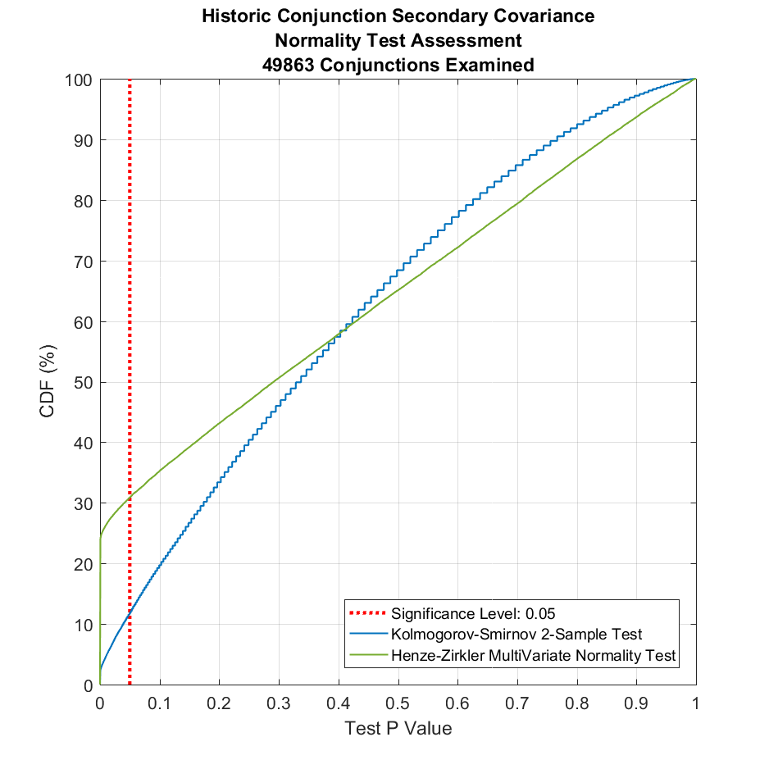
Figure 1: CDF of Multivariate Normality Test Assessment for K-S and H-Z Tests
The two tests show little obvious commonality, with the Henze-Zirkler Test showing roughly a 70% pass rate, while the Kolmogorov-Smirnov test shows about a 88% pass rate. To further examine this, the two tests’ P-Values were then plotted in comparison to the dimensionless mean anomaly uncertainty of the object in Figure 2.
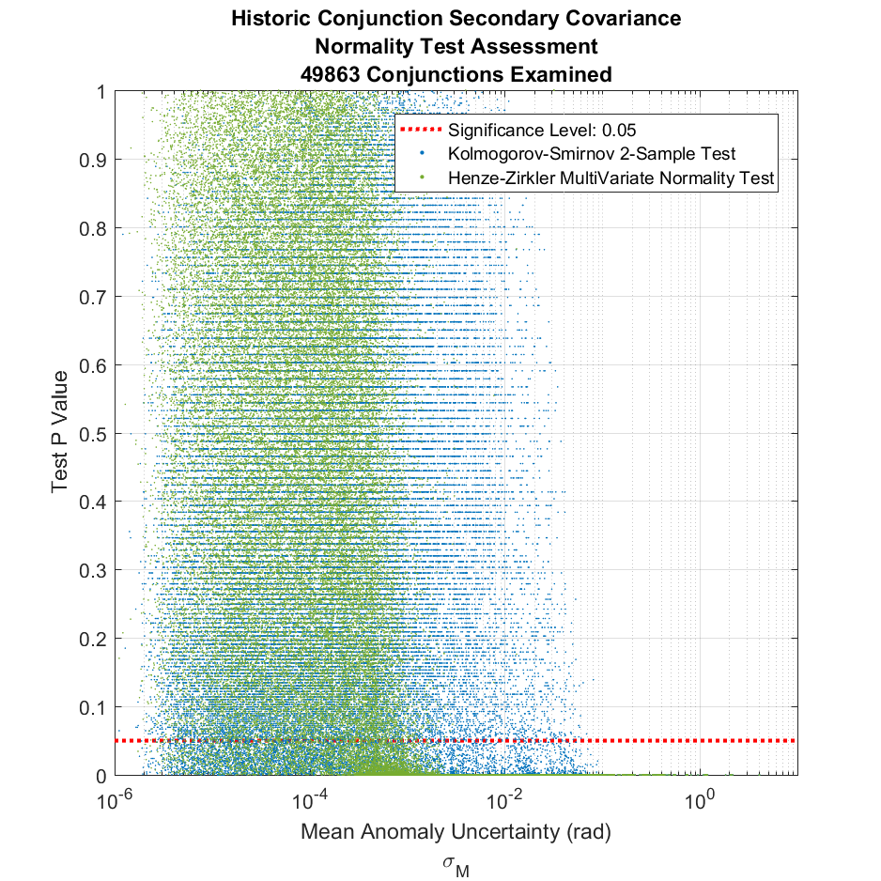
Figure 2: Mean Anomaly Uncertainty Dependence for Multivariate Normality Test
Assessment for K-S and H-Z Tests
From Figure 2, it is apparent that the Henze-Zirkler test is the more stringent test, with far fewer secondary object covariance matrices passing the test criteria for objects with large mean anomaly uncertainties. Figure 2 shows numerous example conjunctions passing the Kolmogorov-Smirnov multivariate normality test with mean anomaly uncertainties on the order of 0.05 radians. This corresponds to being roughly an order of magnitude more tolerant of large intrack uncertainties in multivariate normality assessment than the Henze-Zirkler test.
It is of additional interest to observe the commonality in results between the two tests, and Figure 3 demonstrates the correlation between the two P-Value statistics.
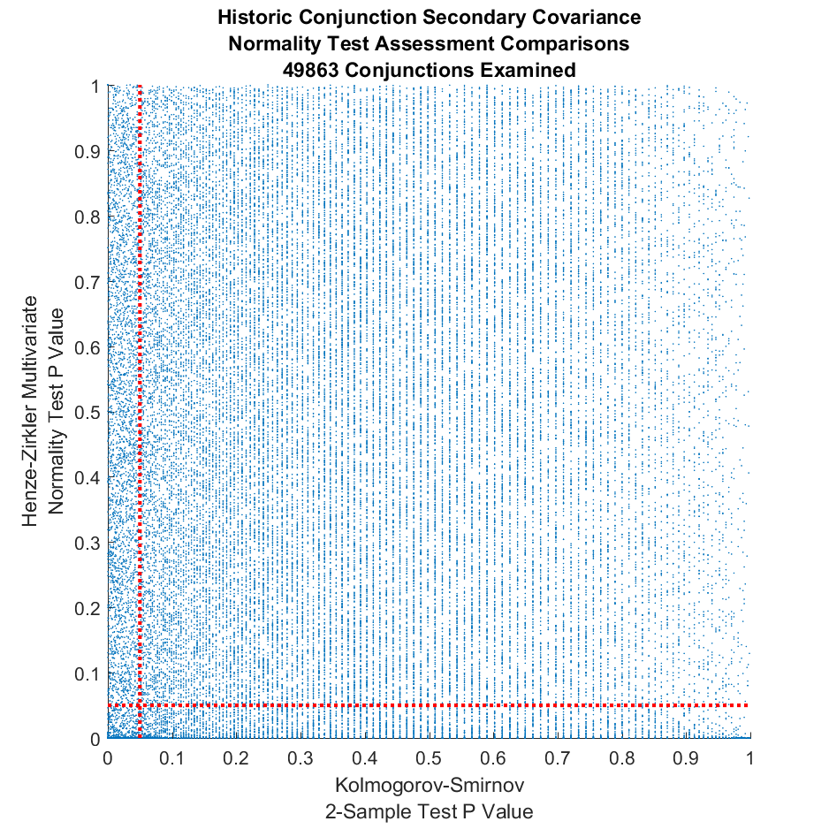
Figure 3: Kolmogorov-Smirnov Two-Sample Test to Henze-Zirkler Test Comparison
There is little observable correlation, or commonality, in Figure 3 between the two tests in their P-Values for comparison to desired significance levels, the correlation coefficient between the two is roughly 0.008. Ideally this comparison would yield results indicative of both tests yielding common P-Values with a strong 1-1 correlation. Or, at a minimum, a semi-linear relationship with few data points passing one test but failing the other. As the Henze-Zirkler test is more stringent, it was used as primary decision criteria in subsequent results examinations.
Removing the Kolmogorov-Smirnov Two-Sample Test Data from Figure 2, as shown in Figure 4, reveals a reasonable basis for determining a cut-off value of mean anomaly uncertainty above which an object’s state uncertainty can be near definitively considered non-Gaussian in Cartesian elements.
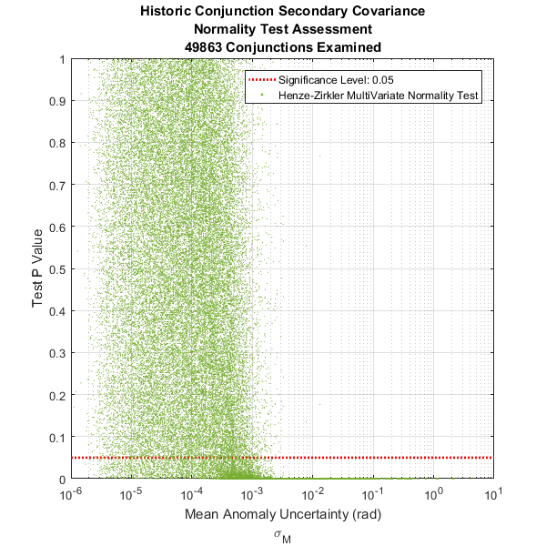
Figure 4: Mean Anomaly Uncertainty Dependence for H-Z Multivariate Normality Test
From inspection, the likelihood of a secondary object to have a Cartesian oriented covariance that is realistically Gaussian drops sharply around the 1.2E-03 to 1.3E-03 radian mean anomaly uncertainty range, with a few outliers. Given the presence of outliers, it is advisable to examine the threshold not in the context of an absolute threshold, wherein all mean anomaly uncertainties which exceed a given cutoff are definitively non-gaussian, but rather in the context of mean anomaly uncertainty quantiles, whereby a more reasonable cutoff value may be proposed where almost all mean anomaly uncertainties which exceed a given cutoff are definitively non-gaussian. The relatively uniform distribution of test P-Values with regards to the mean anomaly uncertainty in Figure 4 means that, regardless of significance level, this mean anomaly uncertainty cutoff likely remains relatively constant. Table 1 lists the recommended mean anomaly uncertainty cutoffs determined in this analysis.
Table 1: Recommended Mean Anomaly Uncertainty Cutoffs
Significance  Level | 95%  Quantile | 99%  Quantile | 99.9%  Quantile | 100%  Quantile
0.1 | 6.9E-04 | 1.3E-03 | 2.7E-03 | 3.2E-02
0.05 | 6.5E-04 | 1.3E-03 | 2.6E-03 | 3.2E-02
0.01 | 6.2E-04 | 1.3E-03 | 2.6E-03 | 3.2E-02

Given the greater than an order of magnitude difference between the 100% quantile cutoff threshold and the 99% quantile cutoff threshold it is recommended to use the 99% quantile cutoff threshold to improve computational efficiency in future code developments. Should a secondary object mean anomaly uncertainty be less than this cutoff, it is recommended to execute the Henze-Zirkler test on an individual conjunction basis to assess multivariate normality, with a sampling size of 10,000.
Table 2 lists test passage statistics for significance levels of 0.10, 0.05, and 0.01, using a mean anomaly cutoff threshold based on the 99% quantile of mean anomaly uncertainties that pass the Henze-Zirkler test.
Table 2: Multivariate Normality Test Statistics on 49,863 Conjunctions
Significance  Level | Henze-Zirkler  Pass Rate | Kolmogorov-  Smirnov  Pass Rate | Dual Test  Pass Rate | Mean  Anomaly  Cutoff  (Rad) | Percentage Events  Above  Cutoff | Percentage Events  Below Threshold  Failing H-Z Test
0.1 | 73.67% | 95.31% | 72.15% | 1.3E-03 | 18.78% | 10.16%
0.05 | 69.12% | 88.19% | 62.78% | 1.3E-03 | 18.78% | 15.59%
0.01 | 64.75% | 80.29% | 53.57% | 1.3E-03 | 18.78% | 20.87%

The results of this test were also assessed against a data set of ~44,000 conjunctions used by HallError: Reference source not found, to examine the detection rate of events which had large-amplitude 2D probability of collision estimation inaccuracies. Within the data set, 35 conjunctions were identified where the 2D probability of collision overestimated the actual probability of collision by a factor of 2.5 or more, and 22 conjunctions were identified where the probability of collision was underestimated by a factor of 2.5 or more. Of these two variations of Pc inaccuracies, the underestimation is the more worrisome of the two, as the overestimation only results in a more conservative posture being taken by satellite operators. This data set also provided an additional data source from which to examine the multivariate normality failure rates for a more restrictive set of conjunctions which are limited by propagation time and maximum Pc values. Figure 1 is mirrored using this data in Figure 5, and shows a much lower pass rate of the Henze-Zirkler multivariate normality test. This implies that high probability of collision events are largely driven by secondary object covariance matrices which fail multivariate normality tests and hence have suspect probability of collision estimates.
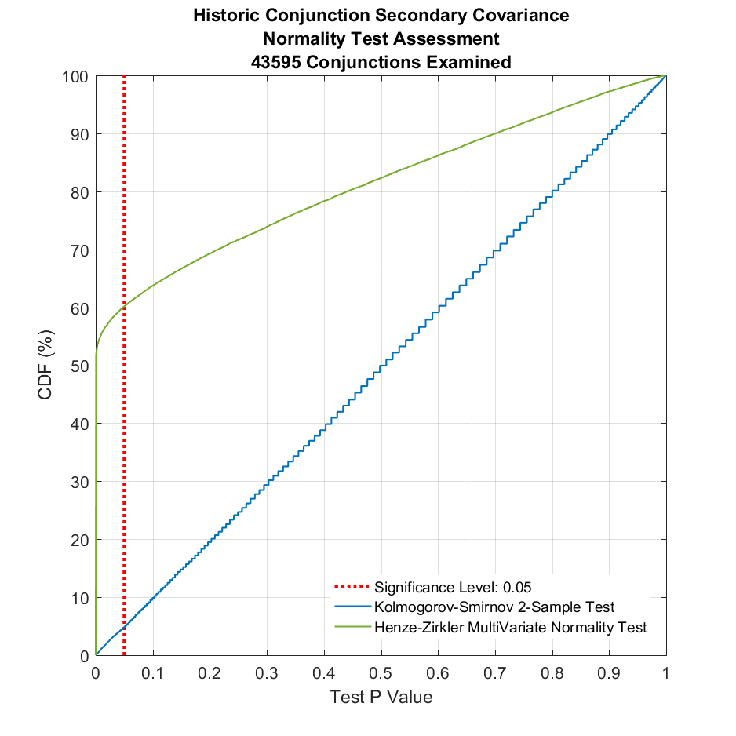
Figure 5: CDF of Multivariate Normality Test Assessment for K-S and H-Z Tests
Examining Only Conjunctions with 2D Pc Estimates of >1.00E-07
Examination of the CDF for these events with respect to multivariate normality pass rate and mean anomaly uncertainty found similar results to those shown in Figure 1, with a recommended mean anomaly uncertainty cutoff of 2.60E-03 radians, which is more tolerant than the cutoffs found for the unconstrained data set. As such, it is recommended to use the more conservative cutoff value of 1.30E-03 radians. This examination also found that the rate at which events exceeded the recommended cutoff was significantly higher for the high probability of collision data set than for the unconstrained data set (~30% as opposed to ~20%).
The Henze-Zirkler test was then limited to examination of probability of collision inaccuracies of a factor of 2.5 or more in either under or overestimation. This allowed for an examination of the ability of this test to detect these events as shown in Figure 6.
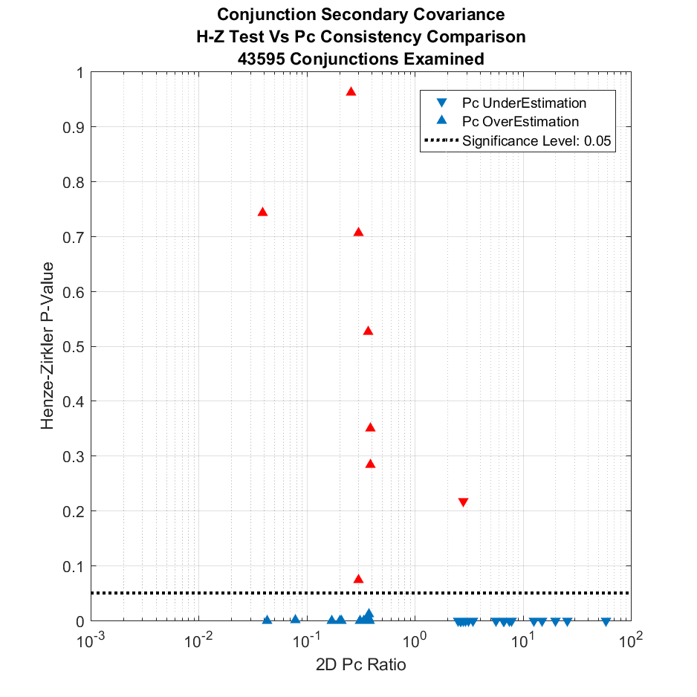
Figure 6: 2D-Pc Inaccuracy Detection Rate Utilizing the Henze-Zirkler Test.
Successfully Identified Events are Rendered in Blue
Using the Henze-Zirkler multivariate normality test, all but one of the Pc underestimation miscarriages was identified, though several of the Pc overestimation miscarriages were not. This lends credence to the hypothesis that the Henze-Zirkler test can be utilized in conjunction with other tests to identify at least Pc underestimation miscarriages.
ConclusionS AND fUTURE wORK
Secondary objects with mean anomaly uncertainties exceeding 1.3E-03 radians should be considered to have non-Gaussian covariance matrices while mean anomaly uncertainties below this threshold should be examined using the full Henze-Zirkler multivariate normality test, as illustrated in Figure 7.
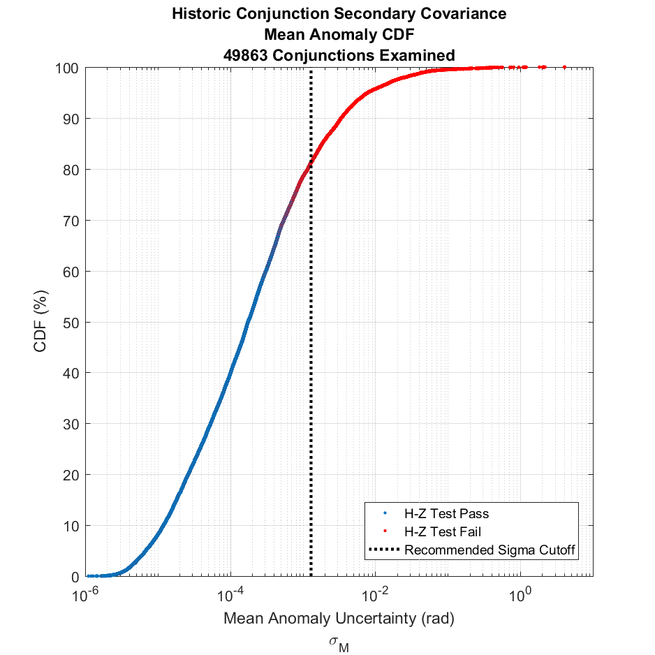
Figure 7: Henze-Zirkler Multivariate Normality Test Pass Rate CDF Plot for Events Not Constrained by Pc Threshold
Implementing a cutoff on these events is of importance as it reduces the computational load imposed on a system, given the large number of trials required to generate reliable results. Excessive computational load could prove detrimental to future operations if such testing is required for large numbers of prospective conjunctions.
This 1.3E-03 radian cutoff corresponds to different levels of intrack uncertainty in different orbital regimes. This is depicted in Table 3, which provides example cutoff values of intrack uncertainty, above which Cartesian covariance matrices must be treated as suspect and unlikely to be valid for 2-D probability of collision calculations and may be more accurately determined using Monte Carlo probability of collision methods.
Table 3: Recommended Intrack Uncertainty Cutoff Values for
Predefined Orbit Regimes
Orbit Regime | Regime Definition | Intrack Uncertainty Cutoff
LEO1 | Perigee ≤ 500 km  Eccentricity < 0.25 | 8.94 km
LEO2 | 500 km < Perigee ≤ 750 km  Eccentricity < 0.25 | 9.27 km
LEO3 | 750 km < Perigee ≤ 1200 km  Eccentricity < 0.25 | 9.85 km
LEO4 | 1200 km < Perigee ≤ 2000 km  Eccentricity < 0.25 | 10.89 km
MEO | 600 min < Period < 800 min  Eccentricity < 0.25 | 37.11 km
GEO | 1300 min < Period < 1800 min  Eccentricity < 0.25  Inclination < 35º | 54.81 km

This method of asserting multi-variate normality may be used in the future in combination with other tests to assess when reported conjunctions may have suspect 2D probability of collision estimations and, more definitively, when Cartesian covariance matrices cannot provide accurate representations of Cartesian state uncertainties. Future work may examine more directly the sensitivity of 2D probability of collision estimates to object covariance matrices which fail multivariate normality tests, sample size dependency and incorporation of additional test criteria to identify conjunctions where the 2D probability of collision assumptions do not hold.
Acknowledgments
The author would like to thank Doyle Hall and Matthew Hejduk for several helpful discussions and analyses. In addition, code base for the Henze-Zirkler multivariate normality test was retrieved from the “Matlab File Exchange” as developed by Trujillo-Ortiz et. al.
NOTATION

CDF | Cumulative Distribution Function
CDM | Conjunction Data Message
ECI | Earth Centered Inertial Reference Frame (J2000)
GEO | Geosynchronous Earth Orbit
HEO | Highly Elliptical Orbit
LEO | Low Earth Orbit
MEO | Medium Earth Orbit
Pc | Probability of Collision
RIC | Radial-Intrack-Crosstrack Reference Frame

Conjunction Assessment Analyst, Omitron Inc., 555 E. Pikes Peak Ave. #205 Colorado Springs, CO, USA
J. L. Foster and H. S. Estes, “A Parametric Analysis of Orbital Debris Collision Probability and Maneuver Rate for Space Vehicles,” NASA/JSC-25898 (August 1992)
Sabol, C., Sukut, T., Hill, K., Alfriend, K. T., Wright, B., and Schumacher, P., “Linearized Orbit Covariance Generation and Propagation Analysis via Simple Monte Carlo Simulations”, AFRL-RD-PS, TP-2010-1009.
Mecklin, C. J., and Mundfrom, D.J., “A Monte Carlo comparison of the Type I and Type II error rates of tests of multivariate normality”, 2005, Journal of Statistical Computation and Simulation, 75:2, 93-107, DOI: 10.1080/0094965042000193233
Flegel, S. K., Möckel, M., and Bennet, J., “Covariance Size and Breakdown of Gaussianity in GEO Uncertainty Predictions”, 7th European Conference on Space Debris. 2017. https://conference.sdo.esoc.esa.int/proceedings/sdc7/paper/348/SDC7-paper348.pdf
Hall, D.T., “Implementation Recommendations and Usage Boundaries for the Two-Dimensional Probability of Collision Calculation,” 2019 AAS/AIAA Astrodynamics Specialist Conference, Portland ME, August 11-15, 2019.
Trujillo-Ortiz, A., R. Hernandez-Walls, K. Barba-Rojo and L. Cupul-Magana. (2007). HZmvntest:Henze-Zirkler's Multivariate Normality Test. A MATLAB file. URL http://www.mathworks.com/matlabcentral/fileexchange/loadFile.do?objectId=17931

