

NASA GSFC Flight Software Systems Branch

Application Requirements Document

cFS Data Storage (DS) Application

1.0 Introduction
1.1 Document Purpose
The purpose of this requirements specification is to define the requirements to be satisfied by the Data Storage (DS) Application. This application is developed for re-use. For this reason, several nomenclatures are used in this document to identify configurations for a mission. Mission-specific features and customization requirements which are applicable for all platforms are tagged with <MISSION_DEFINED>. Platform-specific features and customizations requirements are tagged with either “<PLATFORM_DEFINED>” or “<OPTIONAL>.” Additional nomenclature is used along with the tag to specify a cFS default value for the platform-specific feature: “<PLATFORM_DEFINED, Default_Value>”.
1.2 Document Scope
The scope of this document is limited to the specification of requirements for the Data Storage software requirements. These include functional, performance, qualification, and design requirements.
1.3 Document Organization
This document is organized into three additional sections and an appendix.
Section 2 gives the Data Storage context.
Section 3 documents the Data Storage system design decisions and constraints.
Section 4 contains the Data Storage functional and performance requirements.
Appendix A contains a list of abbreviations and acronyms used in this document.
2.0 cFS Data Storage Application Context
The Data Storage application is responsible for storing messages in files. These files are generally stored on a storage device such as a solid-state recorder, but they could be stored on any file system. Another application such as CFDP must be used in order to transfer the files created by DS to the ground.
Figure 1 shows the context diagram for the CFS Data Storage (DS) Application. During initialization, DS subscribes to messages from other applications as defined in the Data Storage Filter Table. The Scheduler Application (SCH) sends periodic commands to DS as defined in the SCH Schedule Table which requests housekeeping from DS (note that a mission must define this request in the SCH table). Ground commands come from the Command Ingest task (CI). Messages are routed to DS by the cFE SB Application. DS learns of ground updates to the DS tables through the cFE Table Services application.
DS defines 2 tables:
- Filter Table –for each message ID, specifies filter scheme, filter parameters and which file or files to write the message to. Note that each message can be written to a <PLATFORM_DEFINED> number of destination files.
- File Table –specifies information about each Destination File.

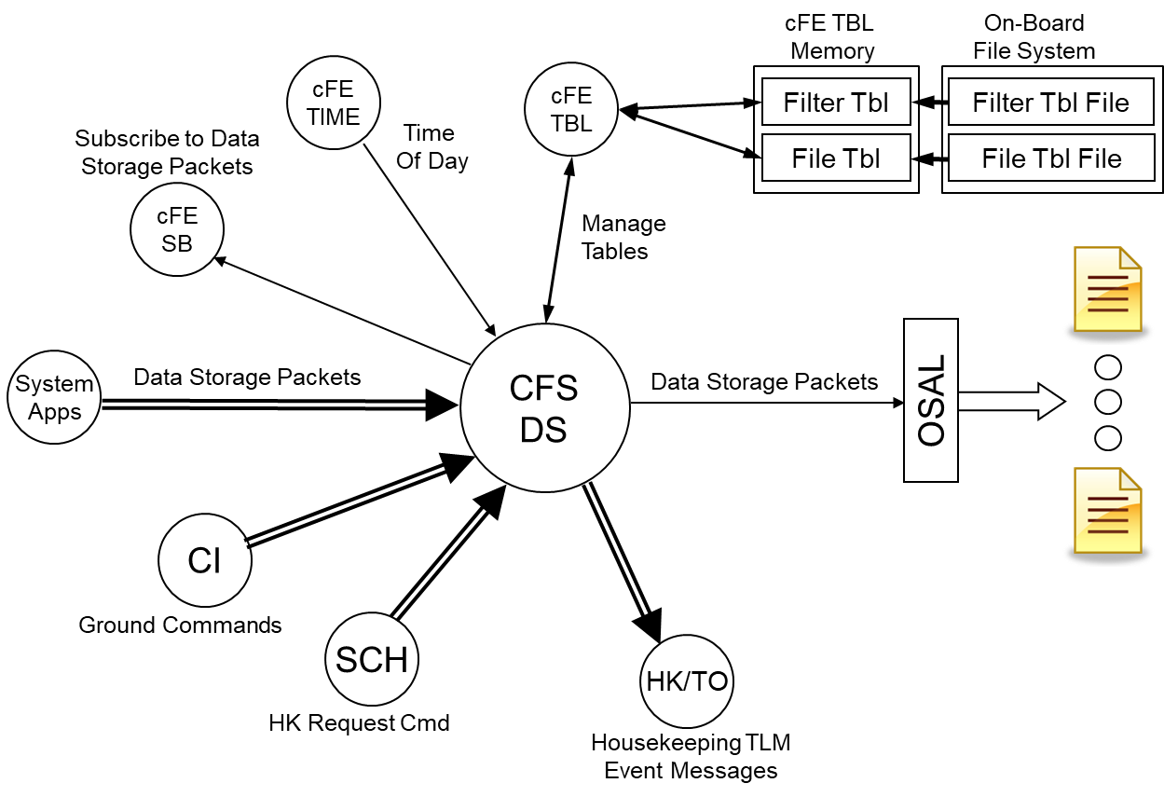
Figure 1 – DS Context Diagram
2.1 Assumptions
The following list summarizes the assumptions made by the cFS Data Storage Application:
- A scheduler or similar application will send out a housekeeping request at a periodic rate.
- cFE API’s are available for use.
- OSAL API’s are available for use.
- Data Storage is not responsible for uploading or downloading files. Files generated by or loaded for Data Storage are transferred using a file transfer application such as CFDP
- DS does not provide the interface to the hardware used for storing the data. DS simply writes to files and assumes that the interfaces required to write to the devices/partitions are available. EEPROM generally requires that writing be enabled prior to writing.DS does NOT provide this capability.
- Destination files defined in the DS Destination File Table should be disabled until a disk is created for DS to use to store the destination file. Once the disk has been created the Enable commands should be sent to enable the use of that Destination File.

3.0 Design Specifications
The Data Storage Application’s requirements and design are based on the results of reviewing the requirements, design and code of LRO’s Data Storage Application. No formal heritage analysis was done on the application since LRO was the only mission that used a file system where we had enough details to evaluate. There are, however, some features that were available on SDO that are referenced in the “heritage reference” column of the requirements. Data Storage provides the ability to store messages at different rates using 2 possible filtering schemes allowing "N of X" housekeeping data messages to be stored starting at offset O:1) Sequence Based Filtering, 2) Time Based Filtering .Filter Tables are identified by a Filter Table ID. Each Filter Table contains Filter Table data that includes a Message ID and filter factors along with a filter type for four destinations. Each of the four destinations is identified by a Destination Table Index. Filter Tables are indexed by the Message ID. The filter factors are specified with three (3) 16-bit parameters (N, X, O). The filter allows "N of X" housekeeping data messages to be stored starting at offset O. The DS software supports two methods of filtering: 1) sequence-based filtering and 2) time-based filtering.
Sequence based filtering-uses the message sequence number to determine if the message should be filtered or not. If X is greater than zero, the message shall be stored if and only if the sequence number of the message modulo X is less than N.
Time based filtering-uses the spacecraft time. Messages will be stored if and only if message time stamp modulo X is less than N. Data Storage supports 2 different schemes that control when to close/open files for storage – 1) Size and 2) Time. Note that messages are stored in a file (or files) in their entirety (i.e. messages are not segmented between files).
- Size –messages are written to a file until the maximum file size has been reached (size of the input message + current file size >= max size).If that is true, DS closes the file, creates a new file and writes the message to the new file.
- Time –messages are written to a file until the current time (seconds) is greater than or equal to the file creation time + file time maximum. Once the time is reached or exceeded, DS closes the file.DS opens a new file upon receipt of the next message slated for the Destination File.

4.0 Requirements
Summary | Description | Requirement Rationale
DS1000 | Upon receipt of a No-Op command, DS shall increment the DS Valid Command Counter and generate an event message. | Debug command to verify application is alive.
DS1001 | Upon receipt of a Reset Counters command, DS shall reset the following housekeeping variables to a value of zero:  a) Valid Command Counter  b) Command Rejected Counter  c) Packets discarded (DS was disabled) Counter  d) Packets discarded (pkt has no filter) Counter  e) Packets discarded (failed filter test) Counter  f) Packets that passed filter test Counter  g) Good destination file I/O Counter  h) Bad destination file I/O Counter  i) Good updates to secondary header Counter  j) Bad updates to secondary header Counter  k) Destination file table loads Counter  l) Failed attempts to get table data pointer Counter  m) Packet filter table loads Counter  n) Failed attempts to get table data pointer Counter | Important for testing and on-orbit flight operations in order to start with  a “clean slate”.
DS1002 | For all DS commands, if the length contained in the message header is not equal to the expected length, DS shall reject the command and issue an event message. | Basic command verification in the event of SEU or memory corruption
DS1004 | If DS accepts any command as valid, DS shall execute the command, increment the DS Valid Command Counter and issue an event message. | Operators require feedback on command execution.
DS1005 | If DS rejects any command, DS shall abort the command execution, increment the DS Command Rejected Counter and issue an error event message. | Operators require feedback on command execution.
DS2000 | Upon receipt of a message, if the Packet Processing State is ENABLED, DS shall determine if the message shall be stored based on the contents of the Packet Filter Table and the Destination File Table.
DS2000.1 | The Packet Filter Table contents shall include:  a) Message ID  b) Destination file table index  c) Filter type (time/sequence count)  d) Algorithm N value  e) Algorithm X value  f) Algorithm O value
DS2000.2 | The Destination File Table contents shall include:  a) Pathname  b) Basename  c) Extension  d) Filename type (time/sequence)  e) Default Destination enable state  f) Max file size (in bytes)  g) Max file age (in seconds)  h) Initial Sequence Count:
DS2001 | DS shall store "N of X" messages starting at offset O.
DS2001.1 | If either the X value or the N value is zero, then the message shall not be stored. | Gracefully handle "0" parameters and provide a way to specify no storage.
DS2002 | DS shall store each message in up to <PLATFORM_DEFINED> different destination files.
DS2002.1 | Destination files shall be created when the first message is received that is passed by the filter algorithm for that particular message and selects that particular destination file. | Preserve space and create files only as needed.
DS2003 | The input argument to the filter algorithm shall be determined by the Filter Type indicator.
DS2003.1 | If Filter Type indicates Sequence based filtering then the algorithm input argument is a value equal to the packet sequence count.
DS2003.2 | If Filter Type indicates Time based filtering then the algorithm input argument is a value created from the lower 11 bits of packet timestamp seconds plus the high 4 bits of timestamp subseconds.
DS3000 | DS shall construct filenames based on the following definitions provided in the Destination File Table:
DS3000.1 | If Filename Type indicates naming based on Sequence the constructed filename will include a character representation of the Sequence Count value from the Destination File Table.
DS3000.1.1 | If Filename Type indicates naming based on Sequence the value of Sequence Count shall be incremented each time a file is created.
DS3000.2 | If Filename Type indicates naming based on Time the constructed filename will include a character representation of the packet timestamp.
DS3000.2.1 | If Filename Type indicates naming based on Time the file date and time shall be represented in the following format: "YYYYDDDHHMMSS".
DS3001 | Prior to writing a packet to an existing destination file, DS shall verify that the resulting file size (after the write) shall not exceed the file size limit as defined in the Destination File Table.
DS3001.1 | If the resulting file size would exceed the file size limit then DS shall close the existing file and open another file.
DS3001.2 | A minimum of one packet shall be written to a file | Preserve space and create files only as needed.
DS3002 | Periodically, DS shall test the age of all open destination files. If any file age exceeds the maximum age defined for that file in the Destination File Table, then DS shall close the file.
DS3002.1 | DS shall update file age and test age limits every time DS processes its housekeeping telemetry request command.
DS3003 | Each DS destination file shall contain a primary cFE file header with the following information:  a) Content Type  b) SubType  c) Primary header length  d) Spacecraft ID  e) Processor ID  f) Application ID  g) File creation time (seconds)  h) File creation time (sub-seconds) | Standard cFE file header
DS3004 | Each DS destination file shall contain a secondary file header with the following information:  a) File close time (seconds)  b) File close time (sub-seconds)  c) File table index  d) Qualified Filename
DS3005 | For every file write error, DS shall:  a) Send an event message  b) Increment total number of file write errors  c) Close the destination file  d) Disable the destination | Notify operators of error and prevent ongoing future errors caused be writing to the same destination file.
DS5000 | Upon receipt of a Disable command, DS shall stop filtering and storing messages.  Note: This command will set the Packet Processing State to DISABLED.
DS5001 | Upon receipt of an Enable command, DS shall begin filtering and storing messages.  Note: This command will set the Packet Processing State to ENABLED.
DS5002 | Upon receipt of a Close File Command, DS shall close the command-specified files.
DS5003 | Upon receipt of a Set File Basename command, DS shall set the file basename for the command-specified destination file.
DS5004 | Upon receipt of a Set Next File Sequence Counter command, DS shall set the command-specified file counter for the command-specified Destination File.
DS5005 | Upon receipt of an Enable Destination File command, DS shall enable file collection for the command-specified Destination File.
DS5006 | Upon receipt of a Disable Destination File command, DS disable file collection for the command-specified Destination File.
DS5008 | Upon receipt of a Set File Index for a Packet Filter Table entry command, DS shall update the destination file index.
DS5009 | Upon receipt of a Set Filter Type for a Packet Filter Table entry command, DS shall update the filter type to the command-specified filter type.
DS5010 | Upon receipt of a Set Filter Parameter for a Packet Filter Table entry command, DS shall update the N, X, O Parameters to the command-specified values | Allow on-orbit modification of filtering parameters without requiring a table update.
DS5011 | Upon receipt of a Set Destination Type for a destination file type command, DS shall update the Destination type to the command-specified destination type.
DS5012 | Upon receipt of a Set Path for a destination filename command, DS shall update the path to the command-specified path.
DS5013 | Upon receipt of a Set Extension for destination filename command, DS shall update the file extension to the command-specified extension.
DS5014 | Upon receipt of a Set Maximum Size for a destination file command, DS shall update the maximum file size to the command-specified maximum
DS5015 | Upon receipt of a Set Maximum Age for a destination file command, DS shall update the maximum destination file age to the command-specified maximum age.
DS5016 | Upon receipt of an Add Message ID to Packet Filter Table command, DS shall add the command-specified Message ID to the next unused entry in the Packet Filter Table. | Allow on-orbit modification of Packet Filter Table without requiring a table update.
DS5016.1 | If the command-specified Message ID is invalid DS will reject the command and send an event message.
DS5016.2 | If the Packet Filter table is not loaded DS will reject the command and send an event message.
DS5016.3 | If the command-specified Message ID is already specified in the Packet Filter Table DS will reject the command and send an event message.
DS5016.4 | If there are no unused entries in the Packet Filter Table DS will reject the command and send an event message.
DS5017 | Upon Receipt of a Get File Info command, DS shall generate a telemetry packet containing the following information for each destination file:  1) File age  2) File size  3) File rate  4) Sequence count  5) Enable state  6) Open state  7) Filename | Provides information on file status
DS8000 | DS shall generate a housekeeping message containing the following:  a) Valid Command Counter  b) Command Rejected Counter  c) Packets discarded (DS was disabled) Counter  d) Packets discarded (pkt has no filter) Counter  e) Packets discarded (failed filter test) Counter  f) Packets that passed filter test Counter  g) Good destination file I/O Counter  h) Bad destination file I/O Counter  i) Good updates to secondary header Counter  j) Bad updates to secondary header Counter  k) Destination file table loads Counter  l) Failed attempts to get table data pointer Counter  m) Packet filter table loads Counter  n) Failed attempts to get table data pointer Counter  o) Application State  p) Filename of last loaded Filter Table | Housekeeping telemetry to indicate basic DS status.
DS9000 | Upon cFE Power-On DS shall initialize the following Housekeeping data to Zero (or value specified):  a) Valid Command Counter  b) Command Rejected Counter  c) Packets discarded (DS was disabled) Counter  d) Packets discarded (pkt has no filter) Counter  e) Packets discarded (failed filter test) Counter  f) Packets that passed filter test Counter  g) Good destination file I/O Counter h) Bad destination file I/O Counter  i) Good updates to secondary header Counter  j) Bad updates to secondary header Counter  k) Destination file table loads Counter  l) Failed attempts to get table data pointer Counter  m)Packet filter table loads Counter  n) Failed attempts to get table data pointer Counter | Start from a known "clean" state.
DS9001 | Upon cFE Power-On DS shall initialize the DS tables from the default files. | Start from a known "good" state.
DS9002 | Upon a cFE Processor Reset or DS Application Reset, DS shall close all files. | Orderly shutdown of files in a reset.
DS9003 | Upon a cFE Processor Reset or DS Application Reset , DS shall restore the following if the associated <PLATFORM_DEFINED> Preserve Flag is set to TRUE:  a) Packet Filter Table  b) Destination File Table  c) File Sequence number for all Destination File Sets  d) Packet Processing State (ENABLED or DISABLED)
DS9004 | Upon a cFE Processor Reset or DS Application Reset , DS shall restore the following if the associated <PLATFORM_DEFINED> Preserve Flag is set to FALSE:  a) File Sequence Counters  b) <PLATFORM_DEFINED> Packet Processing State
DS9005 | Upon any initialization and/or Packet Filter Table Update, DS shall validate the Packet Filter Table:  a) table descriptor text for each packet entry:  b) message ID (0 = unused, else ok)  c) destination file table index  d) filter type (time/sequence)  e) filter parms (N,X,O) | Valid the items that can be validated when an table is updated (some items cannot be validated until runtime).
DS9006 | Upon any initialization and/or Packet Filter Table Update, DS shall subscribe to the messages defined in the Data Storage Packet Filter Table. | Must subscribe to all of the messages defined in the Data Storage Packet Filter Table after any reset.
DS9007 | Upon any initialization and/or Destination File Table Update, DS will validate the Destination File Table:  a) table descriptor text for each destination file entry  b) pathname  c) basename  d) extension  e) filename type  f) file enable/disable state  g) max file size  h) max file age  i) sequence count | Valid the items that can be validated when a table is updated (some items cannot be validated until runtime).
DS9008 | Upon cFE Power-On DS shall set the Packet Processing State to the <PLATFORM_DEFINED> state (ENABLED or DISABLED).

Acronyms
ACS Attitude Control System
C&DH Command and Data Handling
cFS…………………………………………………………………………………………………..Core Flight System
CM Configuration Management
COTS Commercial Off-The-Shelf
CPU Central Processing Unit
DCR Discrepancy/Change Request
DS Data Storage
ETU Engineering Test Unit
FSB Flight Software Branch
FSW Flight Software
GSFC Goddard Space Flight Center
HK ……………………………………………………………………………………………………….. Housekeeping
I&T…………………………………………………………………………………………………….Integration & Test
JSC Johnson Space Center
POSIX Portable Operating System Interface
RTOS Real-Time Operating System
SMP Symmetric Multiprocessing
T&C Telemetry and Command
TBD To Be Determined
URL Universal Resource Locator
VDD Version Description Document

