 |  |  | 
 |  | File Exchange Interface 5
Users Guide

Version 5.0.8
Release May 2003

 |  |  |  | 
 |  |  |  | 

Table of Contents

Introduction 1
Komodo Operation Architecture 1
Installation and Configuration 2
Client Platform Supports 2
FEI5 Client Distribution 2
Unix Installation 3
Windows Installation 3
A Quick Overview 5
Starting FEI5 Client 5
File Types 6
Capabilities 6
Getting Help 7
Ending an FEI5 Session 7
Working With File Types 8
Adding, Replacing, Deleting and Renaming Files 8
Using Wildcards with File Names 8
Showing Lists of Files and Getting Files 8
Date/Time Specific Commands 9
Date Formats 9
The Latest File 9
FEI5 Environment Options 10
Verbosity Modes 10
Insuring File Integrity 10
Resume Transfer 11
Process Invocation 11
Session Logging 12
Using the Batch Command and Settings 12
Repeating Batch Files 13
A Pull Subscriber 13
Virtual File Type (VFT) 14
Working With Virtual File Types 15
Create VFTs 15
Create References 16
Setting Reference Values 16
Committing VFT Updates 16
Acquiring Files Using VFT 16
Changing References 17
Historical Records 17
Komodo Command Reference 18
Troubleshooting 25

Table of Figures

Figure 1 The FEI5/Komodo architecture 1
Figure 2 The FEI5 standalone distribution structure 2
Figure 3 List of FEI5 commands 7
Figure 4 A sample batch file. 12
Figure 5 A sample puller subscriber batch file. 13
Figure 6 Example build log file type 14
Figure 7 A sample timeline for file type evolution. 15
Figure 8 Using virtual file type to manage build logs. 15

Introduction
The MIPL File Exchange Interface (FEI) service offers secure file transaction, store, transport, and management services. The latest distribution FEI5, code name Komodo, is a complete redesign from its predecessors by adopting the latest computing technologies and standards. This document explains the Komodo client installation and configuration, and the command utilities to interact with the Komodo servers.

Komodo Operation Architecture
Komodo is a client-server application that is driven by the backend data store and file system. We used the term data store and not database here because the architecture enables the service to be decoupled from the specified backend data store. The service uses standard input/output to interact with the back end file system to enable portable support across various file systems. The operation architecture’s main focuses include security, location transparent, automatic file archiving, and high-speed file transfer. The diagram also illustrated the portability of the Komodo software that is being supported on all current popular operating systems.

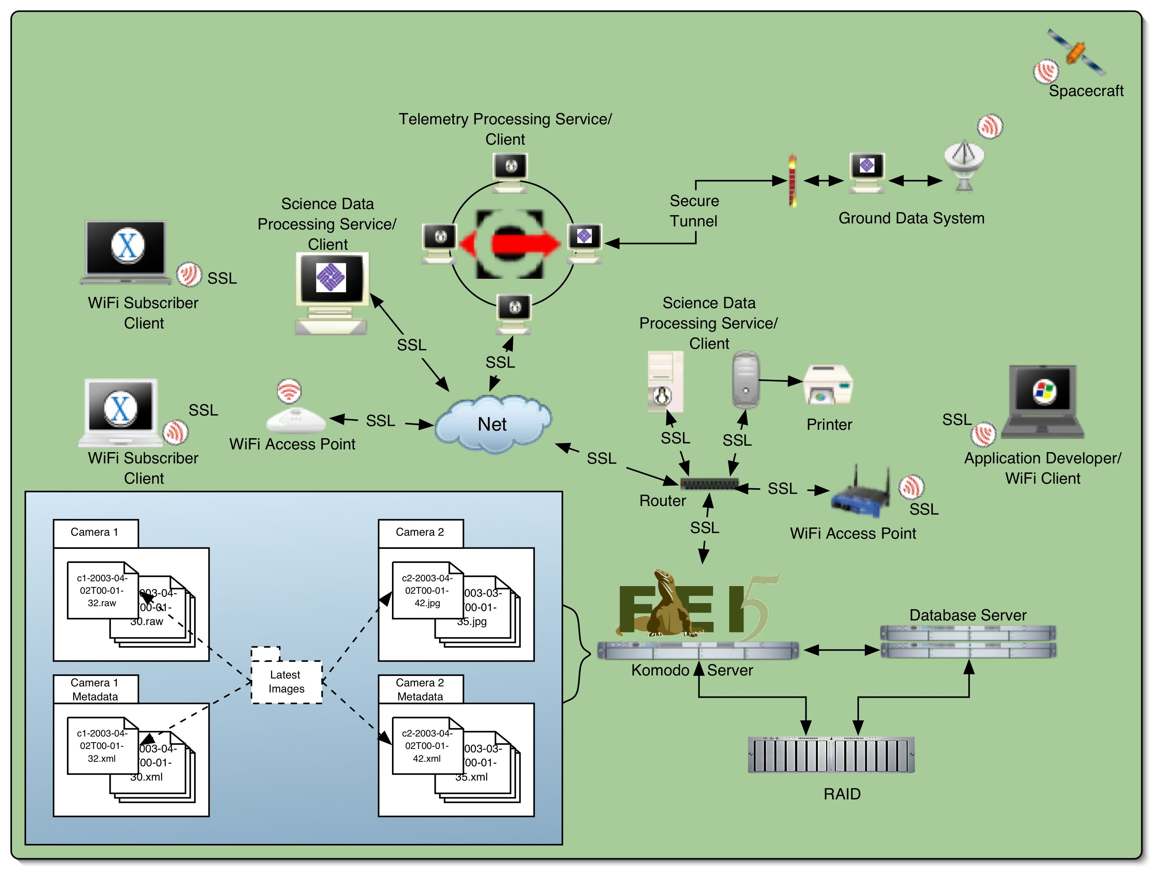
Figure 1 The FEI5/Komodo architecture

Installation and Configuration

Client Platform Supports
Komodo client and server are developed with pure Java™ 2 technology (see http://java.sun.com) in order to maximize its portability among popular operating systems. The current distribution is developed using Secure Socket Layer (SSL) for communication and utilize the latest standard XML technology (see http://www.w3c.org) as the standard service configuration facility.

Required Java™ Runtime: Java™ 2 Runtime Environment, Standard Edition v1.4.x

Current Client OS Supports:
 | OS | Version
 | Sun Solaris | 7, 8
 | RedHat Linux | 7.x, 8.0, 9.0
 | Mac OS X | 10.2.x
 | Microsoft Windows | NT, 2000, XP

FEI5 Client Distribution
FEI5 is distributed with the standard VICAR distribution, and can be configured using the standard VICAR startup scripts. We also distribute FEI5 as standalone archive bundle and this is theme of this section. The goal of this the standalone distribution is to assist our external users to quickly utilize our FEI5 service with minimum configuration overheads. The standalone distribution unpacks into a directory with the following hierarchies.

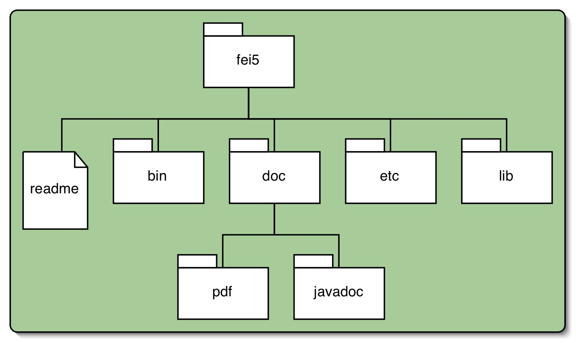
Figure 2 The FEI5 standalone distribution structure

 | Directory/File | Description
 | fei5 | The root directory.
 | fei5/readme | A text file contains version and contact information.
 | fei5/bin | Contains client application executables.
 | fei5/doc | Contains documentations related to the client distribution.
 | fei5/doc/pdf | Contains PDF formatted client documentations such as this document.
 | fei5/doc/javadoc | Contains the complete Java Doc for the FEI5 APIs.
 | fei5/etc | Contains the FEI5 domain file and the required SSL certificate.
 | fei5/lib | Contains all required JAR files for the client applications.

Unix Installation
This section discusses installation instructions specific to the Unix environments. The instructions discussed in this section covers Sun Solaris, RedHat Linux, and Mac OS X operating systems.

Distribution archive file: mdms-komodo.tar.gz

Required environment variables:
 | Variable | Description | Default
 | FEI5 | The location of the FEI domain file | none
 | JAVA_HOME | The location of the local Java 2 Standard Edition location | /usr/java

Sample installation instructions (for tcsh) to install FEI5 distribution under /usr/local
- % cd /usr/local
- Unzip the FEI5 distribution at user’s home directory
% gunzip $HOME/mdms-komodo.tar.gz
- Unpack the Komodo archive file
% tar –xvf $HOME/mdms-komodo.tar
- Configure the local session FEI5 environment variable
% setenv FEI5 /usr/local/fei5/etc
- Configure the local session execution path
% setenv PATH /usr/local/fei5/bin:$PATH
- Configure the local session Java 2 Standard Edition location. By default, the FEI5 client assumes the Java 2 Standard Edition is not installed under /usr/java directory.
% setenv JAVA_HOME /usr/local/java/java_1.4.1_01

Note, MAC OS X has a specific Java installation location.
% setenv JAVA_HOME \
/System/Library/Frameworks/JavaVM.framework/Versions/1.4.1/Home

Windows Installation
This section discusses installation instructions specific to the Microsoft Windows™ environment.

Distribution archive file: mdms-komodo.zip

Required environment variables:
 | Variable | Description | Default
 | FEI5_ROOT | The location of the FEI5 installation | none
 | FEI5 | The location of the FEI domain file | none
 | JAVA_HOME | The location of the local Java 2 Standard Edition location | none

Sample installation instructions (for DOS shell) to install FEI5 distribution under C:\Program Files directory
- Unzip the FEI5 distribution into the C:\Program Files directory.
- Windows NT and 2000 do not support zip file natively. WinZip™ (see http://www.winzip.com) is required to unpack the komodo distribution.
- Windows XP supports zip file natively, therefore, users should only required to double-click on the mdms-komodo.zip file icon and drag the unzipped contents into the C:\Programs File directory.
- Open a DOS shell window
- On Windows NT/2000:

Start→Programs→Accessories→Command Prompt
- On Windows XP:

Start→All Programs→Accessories→Command Prompt
- Configure the local session FEI5_ROOT environment variable
C:\ set FEI5_ROOT=C:\Program Files\fei5
- Configure the local session FEI5 environment variable
C:\ set FEI5=C:\Program Files\fei5\etc
- Configure the local session execution path
C:\ set PATH=%PATH%;C:\Program Files\fei5\bin
- Configure the local session Java 2 Standard Edition location.
C:\ set JAVA_HOME=C:\Program Files\java_1.4.1_01

A Quick Overview
After successfully installing the FEI5 client distribution, there are a few command line programs to interact with the software. This section discusses how to start and end an FEI5 section, how to get help, and how to access the current file types. The interactive client session of FEI5 is equipped with a well-documented user help facility to provide online help information to each of the interactive commands within the client software.

 | Program | Description
 | fei5 | The general FEI5 user session application.
 | fei5admin | The FEI5 administrator session appliation.
 | fei5encrypt | Utility application to generate a one-way hash of any input message string.

Starting FEI5 Client
The command line utility fei5 is the launcher for the FEI5 client session. On the command line prompt, type the command fei5 launch the application
% fei5

The FEI5 session begin by displaying the current domain file reference and the current FEI5 version information.
Domain file: /project/dev/servers/fei5/domain.fei
FEI Version 5.0.8 May, 2003
Komodo API version 2.5.2 01 May 2003
Copyright 2002-2003 Jet Propulsion Laboratory, Caltech, NASA

The software begins by requesting for user login information to the FEI5 server. This information will be cached and will be used when the user initiates connection to the FEI5 server.
User name>> operation_user
Password>> ********

Again, the inputted user login information is being cached for future connections to any FEI5 file types. At this point, the user is not yet connected to the FEI5 server; it is only an indication that the user has successfully started the FEI5 client application. To establish connection to a given file type, for example image1, the user should used the ‘change type’ command, ct.
>> ct image1

File type set to: image1
image1>>

The ct command initiates connection to the FEI5 server that hosts the file type image1. There are several criteria need to be verified by the server before authorize the connection request.
- The file type exists in the client domain file.
- The client distribution has the valid SSL certificate to communicate with the server.
- The user exists in the FEI5 data store.
- The cached user password matches the password registered with the FEI5.
- The user is authorized to connect to the specified file type.

Upon successful authentication, the client session command prompt is changed to display the connected file type name. The user is now able to perform the common FEI5 operations, add, delete, get, replace, rename, etc.

For example
- To add a file
image1>> add jupiter.jpg
File added: jupiter.jpg
image1>>

- To get a file
image1>> get jupiter.jpg
Got: jupiter.jpg
image1>>

File Types
FEI5 organizes files by base file types or simply file types, which is a virtual interface to the file system. Users don’t have to know the physical location of the file types and the files they manage, because of the FEI5 file type abstraction. FEI5’s data store also keeps metadata about each file within a file type.

From within the FEI5 client session, the user can see the list of file types that are registered within the domain file
>> showTypes
image1
image2
image3
image4

In this example, there are four file types. These file types come from the domain file. If a new file type is added, the FEI5 administrator will send a new domain file to users of the software.

Capabilities
A capability specifies the action(s) the user can perform on a given file type and the files within. A user can view their capabilities by typing the ‘showCapabilities’ command.
>> showCapabilities
image1: add, get, replace
image2: add, delete, get, rename, replace
image3: get
image4: get

In this example, the file type name is left of the colon in the output. The capabilities associated with that file type are on the right of the colon in the output. The following table shows the available capabilities.

 | Capabilities | Allows user to…
 | add | add, get, show, comment
 | archive | archive
 | delete | delete
 | get | get, show
 | locktype | lockFileType, unlockFileType
 | receipt | set receipt
 | rename | rename
 | replace | add, replace, get, show, comment
 | vft | vft operations

Getting Help
Type ‘help’, or ‘?’, at the FEI5 prompt to list all available FEI5 commands. The listing organizes the commands into four categories: Set (environment), Utility, File Type, and Virtual File Type.
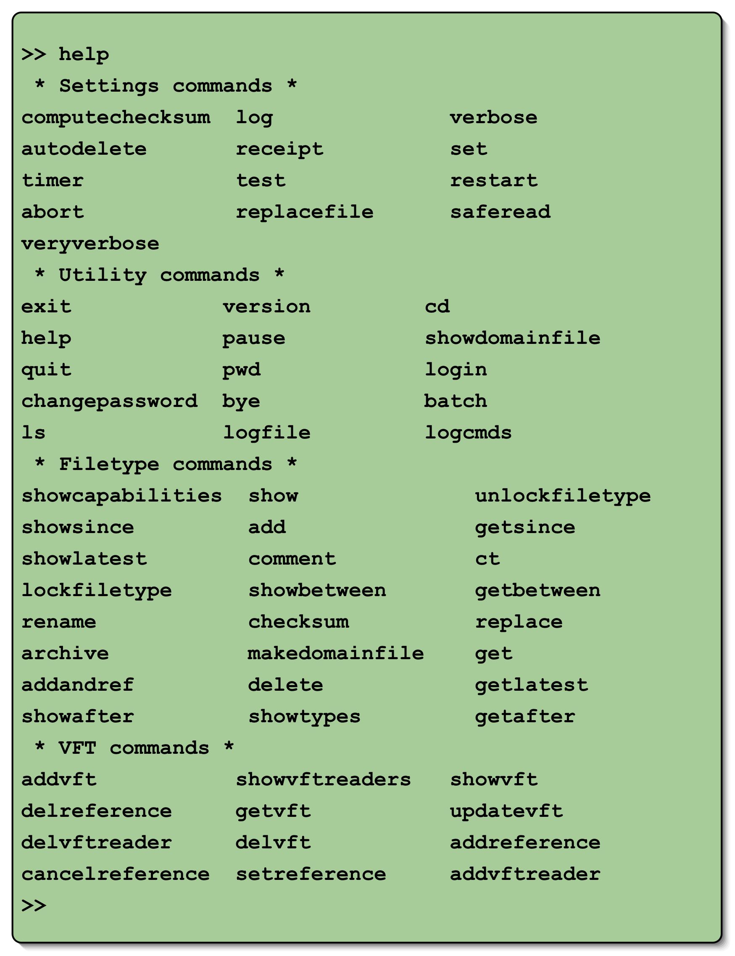
Figure 3 List of FEI5 commands

More information about a specific command is available by specifying the command name with help.
>> help ct
Command: ct
Description: Change file type
Usage: ct <file type>
Type: filetype

Ending an FEI5 Session
The user can end an FEI5 session by typing any of the following commands
>> exit
>> bye
>> quit

Working With File Types
The file type abstraction is a FEI5’s way of encapsulation and provides location transparent capability.

Users can use the change type command to connect to a file type.
>> ct image1
File type set to : image1
image1>>

FEI5 displays the name of the file type behind the prompt to inform the user of the file type they are currently connected to. All file type commands (i.e. add, get, delete) will be within the context of this file type.

Adding, Replacing, Deleting and Renaming Files
The command to add a file (e.g. jupiter.jpg) to a file type is:
image1>> add jupiter.jpg
File added: jupiter.jpg

FEI5 responds to the command to indicate what occurred. In the example, the file was added successfully. If the user tried to add a file with the name jupiter.jpg again, the command will fail. FEI5 will not add a file that is already exists in the system, but we can replace it using the command:
image1>> replace jupiter.jpg

File replaced: jupiter.jpg

The replace command can also add a file if it is not already exist in the FEI5 server. Therefore, replace is like add without the protection of stopping users from overwriting an existing file.

The command to delete a file (e.g. jupiter.jpg) from a file type is:
image1>> delete jupiter.jpg
File deleted.

The command to rename a file is:
image1>> rename jupiter.jpg io.jpg
File renamed.

Using Wildcards with File Names
FEI5 supports a simple form of file globing that allows adding or replacing a group of files without typing in each file’s name. The asterisk character ‘*’ stands for zero or more characters in a file name. To add all files from a local directory to an FEI5 file type, issue the following command:

image1>> add *

To show all files in a file type that match an expression (i.e. jupiter*), issue the following command:
image1>> show jupiter*

Showing Lists of Files and Getting Files
FEI5 provides commands to show and get files in a file type. These operations are carried out by two collections of commands. The commands that show what is in a file type, begin with ‘show’ and those that get files begin with ‘get’. FEI5 has commands to show and get single files, files using wildcard, and files that fall into sometime frame reference.
image1>> show
jovianMoons.jpg
jovianRings.jpg
jupiter.jpg
io.jpg

image1> get jovianMoons.jpg
Got: jovianMoons.jpg

Date/Time Specific Commands
FEI5 supports commands for adding and showing files based on a specific time or date inputs. The date and time used by FEI5 is the time at which the file entered the FEI5 file system.

The date/time based commands are: getAfter, getBetween, getLatest, getSince, showAfter, showBetween, showLatest, showSince

The date input can be specified without a time, which implies midnight for that date.

Date Formats
FEI5 accepts date input in the CCSDS ASCII calendar segmented time code format:
YYYY-MM-DDThh:mm:ss.ddd

 | Date Part | Description
 | YYYY | Year in four-character subfield with values 0001-9999 (two-character year input is not supported)
 | MM | Month in two-character subfield with values 01-12
 | DD | Day of month in two-character subfield with values 01-28, -29, -30, or -31
 | ‘T’ | Calendar-Time separator
 | hh | Hour in two-character subfield with values 00-23
 | mm | Minute in two-character subfield with values 00-59
 | ss | Second in two-character subfield with values 00-59
 | ddd | Decimal fraction of a second in one to three-character subfield where each d has a value of 0-9

Note: The hyphen ‘-‘, colon ‘:’ letter ‘T’ and ‘.’ are used as specified subfield separators. All subfields must include leading zeros if the input date does not use all available characters. Times can be truncated, but truncated parts are given a value of zero.

Examples of date/time input

image1>> showSince 2001-05-14T14:23:00.384
image1>> showSince 2001-05-14T14:23
image1>> showSince 2001-05-14

The Latest File
Sometimes the user is only interested in the latest files
image1>> showLatest
io.jpg
image1>> getLatest
Got file: io.jpg

File name expression can also be used when querying for the latest files
image1>> showLatest jupiter*
jupiter.jpg
image1>> getLatest jupiter*
Got file: jupiter.jpg

FEI5 Environment Options
The FEI5 client supports user options that change the expected output of FEI5 commands. FEI5 environment options use the following syntax:

set <command> {on, off}

Verbosity Modes
Setting the verbosity modes within the FEI5 client determines what information is displayed by ‘show’ commands (i.e. show, showAfter, showBetween, etc). There are three verbosity modes:

- default (Non-Verbose): Displays the file name only. This is the default state of verbosity.
- Verbose: Displays the file name, file size in bytes and the date and time the file was received.
- VeryVerbose: Displays verbose output and any comment, archive note and checksum data associated with the file.

Users can enable verbosity by issuing the following commands:
image1>> set verbose on
image1>> set veryVerbose on

Users can disable verbosity by issuing the following command (setting verbose off will set verVerbose off as well):
image1>> set verbose off

Insuring File Integrity
FEI5 uses file checksums to ensure a files integrity. Checksums are not enabled by default in FEI5 due to overhead required to compute the checksum. If enabled, a checksum is computed for a file as it is being transmitted. The receiver also calculates the checksum as the data is receiving. The checksum is saved and transmitted to the receiver along with the files meta-data. After transmission, the sender and receiver checksums are compared. If the file was altered during transmission, the checksum values will not match and the file will be rejected.

FEI5 file types can be configured to automatically compute checksums on all added files. Users can also enable file checksums by setting the computeChecksum environment option.

image1>> set computeChecksum on
image1>> add jovianMoons.jpg
File added: jovianMoons.jpg Checksum: "fa5b4314a6d71614c4ca65b224cbdfe4434d4992"

To see a file’s checksum, enable the veryVerbose environment option and use any of the ‘show’ commands. The checksum will appear before any file comment or archive note.

image1>> set veryverbose on
image1>> show
jovianMoons.jpg 5422bytes 2003-04-24T10:40:04.876
Checksum: "fa5b4314a6d71614c4ca65b224cbdfe4434d4992"
Comment: "Image of Ganymede, Io, Europa and Callisto"

Resume Transfer
FEI5 has the capability to allow clients to resume the acquisition of a file in the event that communication was severed before file transfer completes. Setting the restart environment option enables resume transfer. Resume transfer requires file checksum data to detect file corruption; therefore the computeChecksum environment option must be enabled. The resume transfer capability benefits users who must transfer large files and don’t have time to retransfer the entire file if communication is severed.

User logs on to FEI5 and connects to image file type.
image1>> set restart on
image1>> set computeChecksum on
image1>> get largefile.jpg

*** communication is severed before transfer completes ***

User logs on to FEI again and connects to image file type.
image1>> set restart on
image1>> set computeChecksum on
image1>> get largefile.jpg

*** file transfer resumed from the point where communication was severed ***
Transfer was resumed for file largefile.jpg at byte 3789568.

Process Invocation
FEI5 user may perform additional processing to the file it has just acquired from FEI5. A special keyword ‘invoke’ is built into all FEI5 get operations to allow user to invoke external process. There are two predefined parameters to the invoke string to serve as variable to the invoke command. Variable $filename represents the name of the file just acquired. Variable $fileType represents the file type name.

image1>> help get
Command: get
Description: Get one or more files from current file type. If external system process invocation is specified, then it executes the system command for each file received.

Usage: get <file name expression> [invoke "<system command>"]
Type: filetype

image1>> get mission_images.tar.gz invoke "tar -zxvf $fileName"
Invoke command 'tar -zxvf /home/operation/output/mission_images.tar.gz'

Session Logging
Users can create a log of their FEI5 session, which will capture all inputs and outputs to a file. A log file must be specified and opened before logging can occur. Once the log file is open, logging can be enabled or disabled at any time during the session.

Create a log file (implicitly enables logging):
image1>> log /tmp/log_fille

Once the log file has been created, users can turn logging on or off with the following commands:
image1>> set log off
image1>> set log on

Setting logging off leaves the log file open, but FEI5 does not write to it. Creating a new log file closes the existing log file if one exists.

Using the Batch Command and Settings
The batch command reads a file containing a sequence of FEI5 command and executes them. For example, the contents of file addFiles.fei looks like this

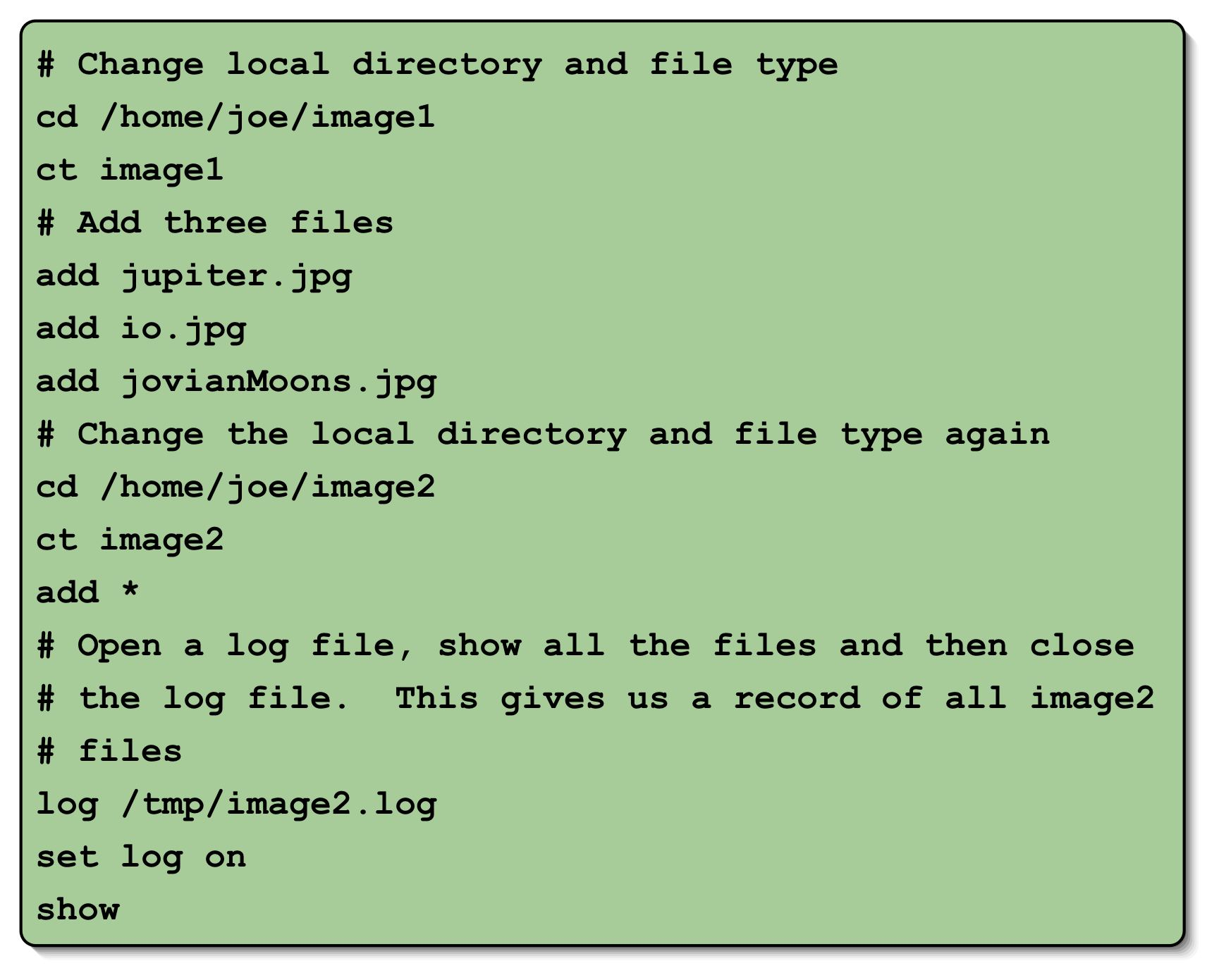
Figure 4 A sample batch file.

Lines that begin with the ‘#’ character are comments. Often a user would like to test a set of batch commands before actually executing them against the server. There is a ‘test’ configuration option to do just that

>> set test on
>> batch addFile.fei
Executing batch file /home/operation/scripts/addFile.fei
>> # Change local directory and file type
>> cd /home/operation/image1
Directory /home/operation/image1 not found
Batch execution aborted

After correcting the error via a simple text editor
>> set test on
>> batch addFile.fei
Executing batch file /home/operation/scripts/addFile.fei
…
Batch file test completed

To run the batch against the server
>> set test off
>> batch addFile.fei
…

Repeating Batch Files
A batch file can be scheduled for future execution(s) within the FEI5 session. The repeatAt keyword is used to schedule a batch file to be executed at the specified time. The repeatEvery keyword is used to schedule a batch file to be executed at the specified time interval.

To schedule a batch file to be executed a 5:00pm
>> batch mybatch.fei repeatAt 05:00 pm

To schedule a batch file to be executed every 5:00 pm
>> batch mybatch.fei repeatEvery 05:00 pm

A Pull Subscriber
By combining the FEI5 batch and restart capabilities and the getAfter command, we can construct a simple pull subscriber. A pull subscriber is essentially a getAfter command within a batch file that is scheduled for a specified time interval. Here is a simple puller.fei batch

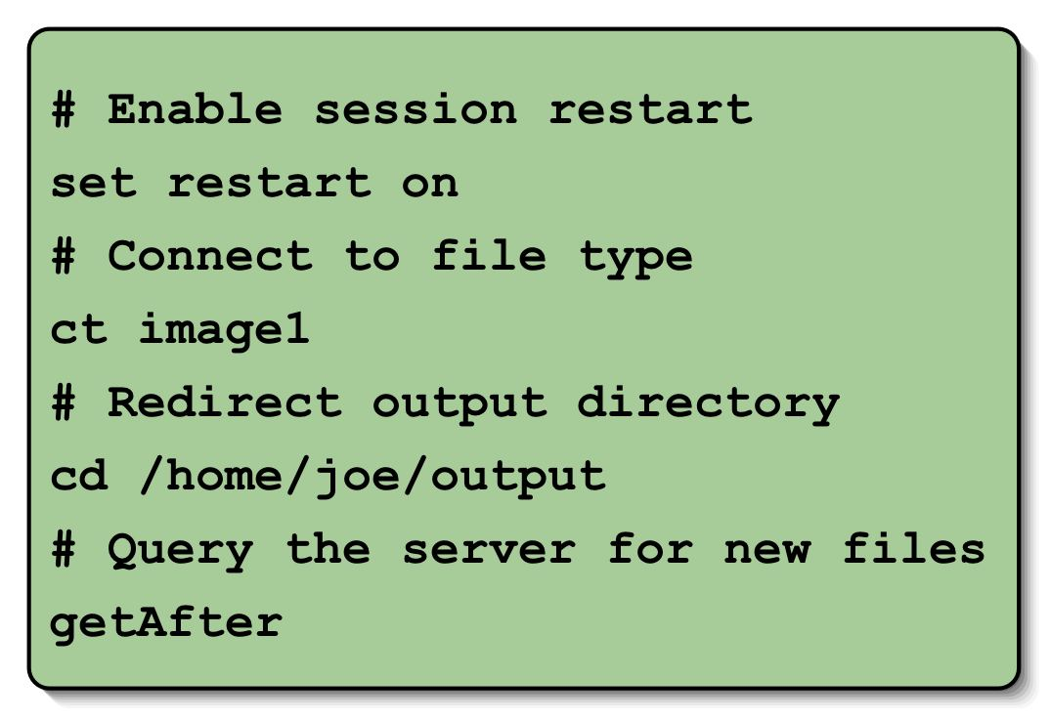
Figure 5 A sample puller subscriber batch file.

When executing in a restart batch mode, the getAfter command does not require input time value. The time value is being stored in a hidden directory in the user’s local machine. Now to schedule this batch file to be executed every 1 minute:

>> batch puller.fei repeatEvery 00:01
Batch file will be executed every 60000 (ms)
[2003-04-29 16:59:57.894] Scheduled batch execution start
Executing batch file /home/operation/scripts/puller.fei
>> set restart on
>> ct image1
File type set to : image1
image1>> cd /home/operation/output
Current directory set to /home/operation/output
imagel1>> getAfter
Got: jupiter.jpg
Got: io.jpg
Got: jovianMoon.jpg
[2003-04-29 17:00:07.062] Scheduled batch execution end

[2003-04-29 17:00:57.882] Scheduled batch execution start
Executing batch file /home/operation/scripts/puller.fei
image1>> set restart on
image1>> ct image1
File type set to : image1
image1>> cd /home/operation/output
Current directory set to /home/operation/output
image1>> getAfter
No files found.
[2003-04-29 17:00:58.323] Scheduled batch execution end
…

Virtual File Type (VFT)
FEI5 offers a second method in organizing files. A virtual file type (VFT), as its name has indicated, is not a base file type but a file type that is derived from existing file(s) within existing file type(s). A virtual file type is a collection of references, or alias, to files in the FEI5 server repository. A virtual file type can be derived from files from various base file types. In addition, a virtual file type also keeps a history of its past references to enable query and acquisition of virtual file type data at a particular moment in time.

MDMS is using VFT to organize our nightly build logs for web presentation and query. In configuration and management, we are often only interested in the latest build results for all current supported platforms. We might look at past build logs when the latest build fails to see what has changed. In addition, the number of support platforms can also vary due to revisions to project requirements. With such dynamic environment, organizing files with base file types may solve the problem but with the overhead of domain file distribution, querying each latest supported build log file types with static FEI5 get file time queries.

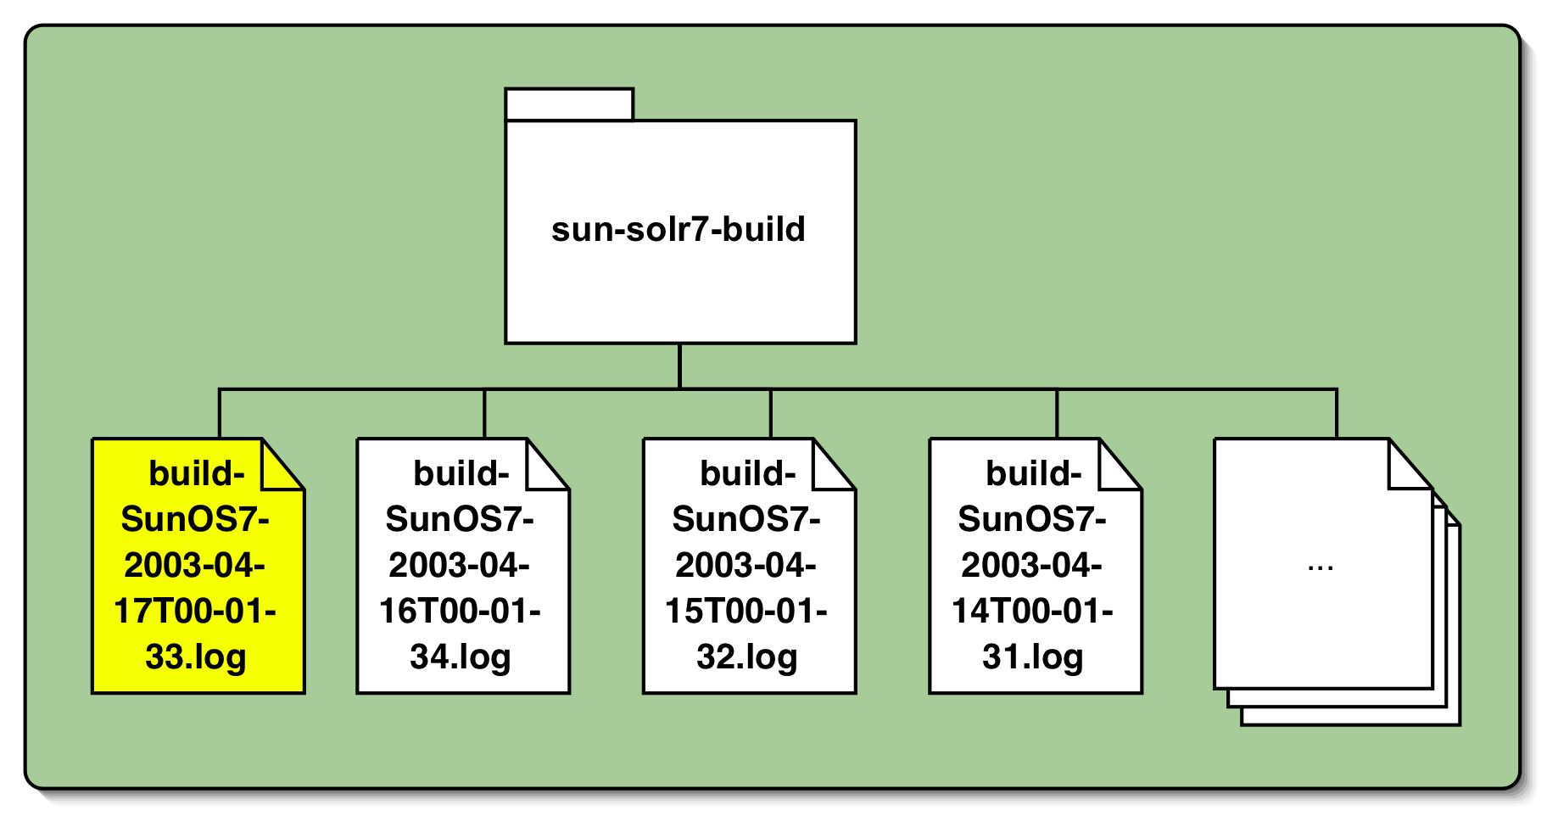
Figure 6 Example build log file type

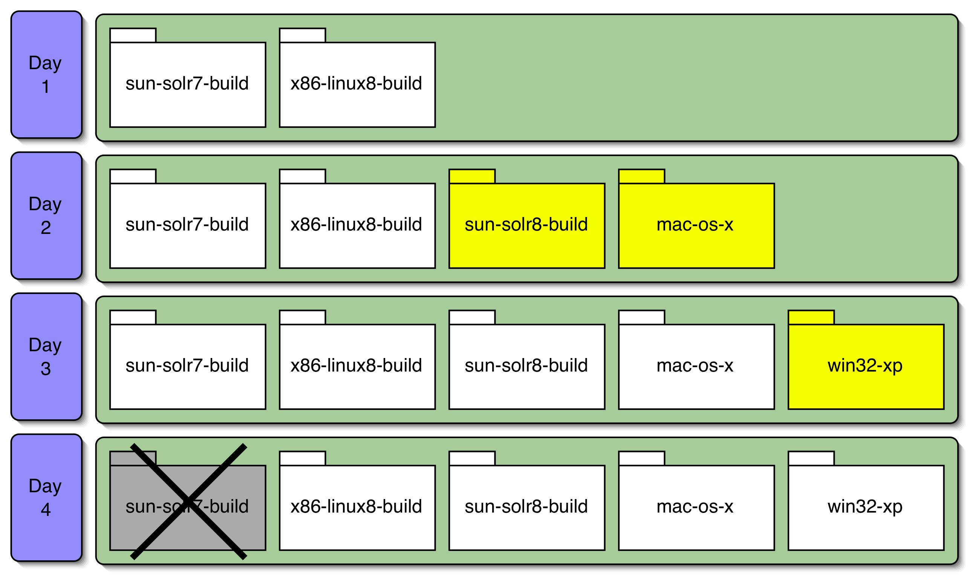
Figure 7 A sample timeline for file type evolution.

VFT manages a collection of file references and enable users to access a collection of related files via a single file type name. The references it manages can be updated over time, but the updates are transparent to the users.

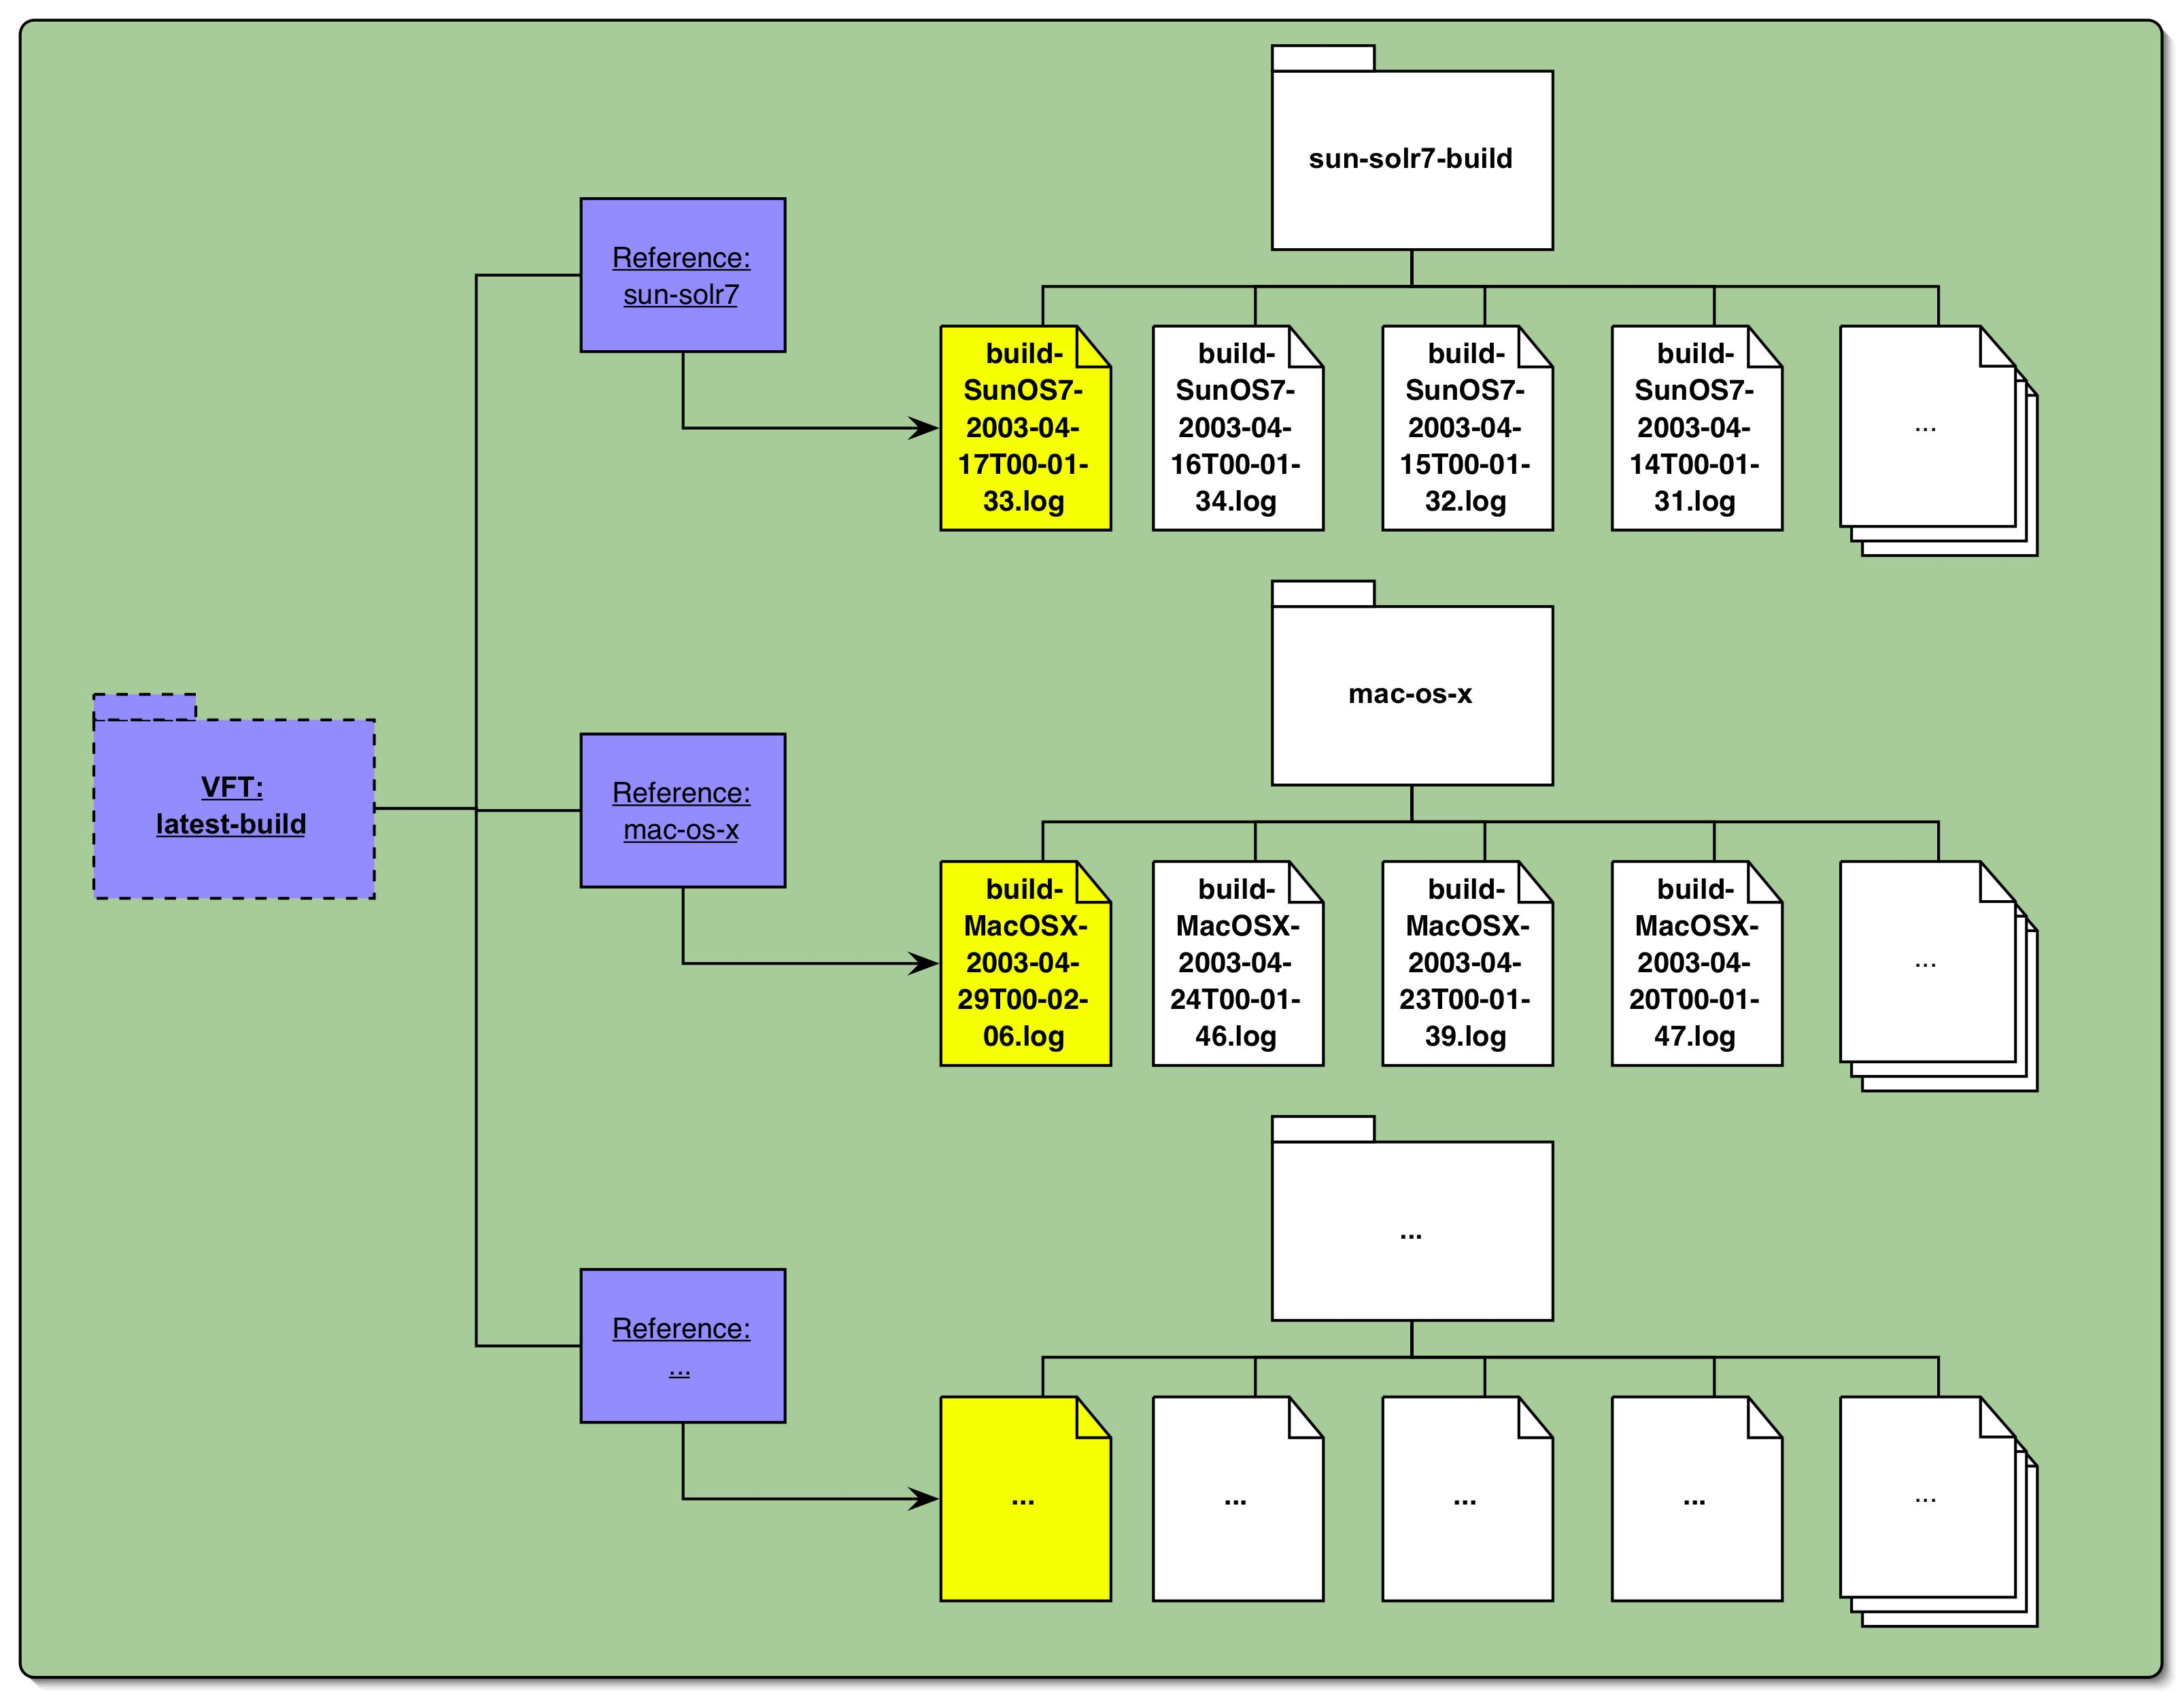
Figure 8 Using virtual file type to manage build logs.

Working With Virtual File Types

Create VFTs
Creating VFTs requires special user capability that is not enabled by default for FEI5 users.
>> addVFT latest-build “The latest build logs.”

Create References
Once the VFT is defined, it is time to associate file references to it. The reference name is the nominal name by which the file will be known. For example, we can use the name ‘sun-solr7.log’ to refer to the current Solaris 7 build log, and we can use the name ‘mac-os-x.log’ to refer to the current Mac OS X build log, and so on. If we have decided to rename an existing reference, it can be done at the VFT reference management level that is transparent to the VFT users.

>> addReference latest-build sun-solr7.log sun-solr7.link
>> addReference latest-build mac-os-x.log mac-os-x.link

The commands above have just created two virtual reference names. The *.link files are created at the server-side as symbolic links to the physical files when the physical files are assigned. At this point, these references have not been associated to any physical files in the base file types, so their reference value is NULL.

Setting Reference Values
The command below associates a physical file to an existing reference.

>> setReference latest-build sun_solr7.log sun-solr7
build-SunOS7-2003-04-17T00-01-33.log
>> setReference latest-build mac-os-x.log mac-os-x
build-MacOSX-2003-04-29T00-02-06.log

The setReference command also creates physical symbolic links to the physical files that the references are associated to.

Committing VFT Updates
In order for a VFT to recognize the update references, the user must commit the changes. This is required to ensure consistency in VFT values.

>> updateVFT latest-build

Acquiring Files Using VFT
Once files are bounded to references, the complete set can be gotten using the getVFT command.

>> getVFT latest-build
got: sun-solr7.log =>
sun-solr7/build-SunOS7-2003-04-17T00-01-33.log
got:mac-os-x.log =>
mac-os-x/build-MacOSX-2003-04-29T00-02-06.log
…

While the getVFT command is being executed, the updateVFT command cannot be run on the specific VFT. This prevents users from getting an inconsistent set of referenced files.

The getVFT command creates one additional file in the user’s local directory, the VFT manifest. This file’s name is the name of the VFT followed by ‘.vft’ extension. This file gets over-written each time the getVFT command is executed on the specific VFT. The file contains:
- The name of the VFS and any associated descriptive information.
- The date and time at which the getVFT command was executed.
- If the getVFT command was provided a historical time, that time is included as vftHistoricalTime, otherwise this line does not appear.
- The time the updateVFT command was executed to create this VFS.
- If a receipt was requested, the receipt number is included.
- A list file names received. Each file description includes:
  - Reference name
  - Actual file type and file name referenced
  - File’s checksum (if requested)

Changing References
Users can update a reference to VFT to a different file. Use the setReference command to add a new reference to an existing VFT. Use cancelReference command to remove any out-of-date reference. The final step, of course, is to commit any changes to the VFT by using the updateVFT.

win32-xp >> add build-Win32XP-2003-04-30T00-02-10.log
win32-xp >> addReference latest-build win32-xp.log win32-xp.link
win32-xp >> setReference latest-build win32-xp.log win32-xp
build-Win32XP-2003-04-30T00-02-10.log
win32-xp >> updateVFT latest-build “Added latest Win32 XP build”

Historical Records
Users can query for all past VFT information by using the showVFT command with a specified time value. In addition, users can also acquire historical VFT using getVFT command with the similar interface for date/time query.

>> showVFT latest-build 2003-05-01
>> getVFT latest-build 2003-05-01

Komodo Command Reference

 | Setting Commands
 | Command | Description | Default
 | abort | During processing of batch file abort when encountered an error. | off
 | autoDelete | Deletes the local copy of a file after adding or replacing it in the FEI5 data store. | off
 | computeChecksum | Compute a checksum before and after files are transmitted. If not the checksum values do not match, then the transaction will be aborted and issue and error message. | off
 | log | When on, FEI5 commands and responses are logged to a file. Default is on, but if log file is not assigned, there is no logging. | on
 | receipt | When getting a file, a confirmation of receipt is logged in the data store. Upon completion of the transfer a receipt ID is returned. This identified the record kept within the data store.  When this is enabled, the FEI5 client always computes a checksum on the transferred files contents and places it in the receipt record stored in the data store.  This requires the user to have file registration capability. | off
 | replaceFile | By default it won't overwrite a file in current working directory. | off
 | restart | When on, getAfter command will track date of last download for given file type. | off
 | safeRead | During get operations, the files are written to a shadow directory while being transferred. Upon completion, the files are moved to final destination. | off
 | set <parameter> {on,off} | Sets session settings. Parameters: abort, autoDelete, computeChecksum, log, receipt, replaceFile, restart, safeRead, test, timer, verbose, veryVerbose, … | N/A
 | test | When executing a batch file, check commands syntax but do not execute. | off
 | timer | When turned on each command is timed. | off
 | verbose | Include files' size in bytes and date and time file was received along with the name. | off
 | veryVerbose | Along with verbose information show any comment, archive note or checksum associated with a file. | off

 | Utility Commands
 | Command | Description | Default
 | batch <file name>  [{repeatAt hh:mm {am,pm},  repeatEvery hh:mm [hh:mm {am,pm}}] | Reads a sequence of FEI5 commands from a file and execute them as though they were typed in.  repeaseAt: the batch file executes at the specified time of day.  repeaseEvery: the batch file executes repeatedly at the specified time interval until the session exits or is killed. The first batch executes immediately unless a start time is specified (time value with am/pm specified).
 | bye | Exits FEI5 client.
 | cd [<local directory>] | Change local working directory.
 | changePassword | Change user password in the FEI5 server.
 | exit | Exits FEI5 client.
 | help [<command name>] | Outputs all available commands.  Help <command name> returns info on specific command.
 | logcmds <fle> | Log commands to a file
 | logFile <file> | Assign name of a log file.
 | login [<name>] [<password>] | Enter user name and password, will prompt interactively if not in batch mode
 | ls | List contents of local directory.
 | pause | Stops executing a batch script until the <return> key is pressed.
 | pwd | Show local working directory.
 | quit | Show local working directory.
 | showDomainFile | Echoes current domain file to screen.
 | version | Show version of FEI5 client.

 | File Type Commands
 | Command | Description | Default
 | add <file name expression>  [<"comment">] | Add files matching file name expression to current file type.
 | addAndRef <file name expression>  <vft> <link directory> | Add files matching file name expression to current file type. Each file's name is made unique, and a vftReference, using the source file name is added to the given VFT.
 | archive <file name> | Update archive information for the specified file.
 | checksum <local file name> | Computes checksum on a local file.
 | comment <file name> <"comment"> | Update comment for the specified file.
 | ct <file type> | Change file type.
 | delete <file name> | Delete a registered file.
 | get <file name expression>  [invoke "<system command>"] | Get one or more files from current file type.  If external system process invocation is specified, then it executes the system command for each file received. Use $fileName within the invoke string to refer to the name of the file just received. Use $fileType within the invoke string to refer to the name of the current file type.
 | getAfter [<yyyy-MM-ddThh:mm:ss.SSS>]  [invoke "<system command>"] | Get files registered after date given. If no date is given and setting "restart" is on, use date in restart file.  If external system process invocation is specified, then it executes the system command for each file received. Use $fileName within the invoke string to refer to the name of the file just received. Use $fileType within the invoke string to refer to the name of the current file type.
 | getBetween <yyyy-MM-ddThh:mm:ss.SSS>  and <yyyy-MM-ddThh:mm:ss.SSS>  [invoke "<system command>"] | Get files added to current file type during specified time period.  If external system process invocation is specified, then it executes the system command for each file received. Use $fileName within the invoke string to refer to the name of the file just received. Use $fileType within the invoke string to refer to the name of the current file type.
 | getLatest [<file name expression>]  [invoke "<system command>"] | Get latest file for current file type.  If external system process invocation is specified, then it executes the system command for each file received. Use $fileName within the invoke string to refer to the name of the file just received. Use $fileType within the invoke string to refer to the name of the current file type.
 | getSince <yyyy-MM-ddThh:mm:ss.SSS>  [invoke "<system command>"] | Get files added to current file type since given date.  If external system process invocation is specified, then it executes the system command for each file received. Use $fileName within the invoke string to refer to the name of the file just received. Use $fileType within the invoke string to refer to the name of the current file type.
 | lockFileType [{group,owner}] | Lock current file type to prevent modification.
 | show <file name expression> | Show registered files in current file type.
 | showAfter <yyyy-MM-ddThh:mm:ss.SSS> | Show files registered after given date.
 | showCapabilities <file type> | Show user's capabilities for given file type
 | showBetween <yyyy-MM-ddThh:mm:ss.SSS>  and <yyyy-MM-ddThh:mm:ss.SSS> | Show files added to current file type during specified time range.
 | showLatest [<file name expression>] | Show latest files added to current file type.
 | showSince <yyyy-MM-ddThh:mm:ss.SSS> | Show files added to current file type since specified time.
 | showTypes | Show available file types.
 | unlockFileType {group,owner} | Unlock current file type for given group or owner.

 | VFT Commands
 | Command | Description | Default
 | addVFT <name> [<"comment">] | Create a new vft
 | addVFTReader <virtual file type>  <file system user> | Allow file system user to read vft.
 | addReference <vft name>  <reference name> <link> [<"comment">] | Add a reference to a VFT, with optional file system link.
 | cancelReference <vft name>  <reference name> | Cancel a vft reference change.
 | delReference <vft name>  <reference name> | Delete reference file name from vft
 | delVFT <vft name> | Delete current vft
 | delVFTReader <virtual file type>  <file system user> | Disallow file system user from reading vft.
 | getVFT <vft name>  [<yyyy-MM-ddThh:mm:ss.SSS>] | Get files referenced within vft. Optionally restrict to specified date.
 | setReference <vft name>  <reference name>  [<file type> <file name>] | Reference a file in the FEI5 DB
 | showVFT [<vft name>]  [<yyyy-MM-ddThh:mm:ss.SSS>] | Show available vfts. If vft is specified, show details.
 | showVFTReaders [<file system user>] | Show list of file system users allowed to read vft. If user specified, show details
 | updateVFT <vft name> ["<comment>"] | Update VFT by setting references to point to new files.

Troubleshooting
 | Message | Details
 | Invalid login | User has supplied invalid login information (user name and/or password). Type login again to input correct login information.
 | File type not selected. | The user is not connected to any file type at this point. Use ‘ct’ command to connect to a file type.
 | File type “<file type>” not found in domain. | The file type is not listed in the FEI5 domain file. Use showDomainFile and showTypes for the list of file types in the domain file.
 | Cannot add “<file name>”: addFile: File already exists. | The file is already registered under current file type. Use replace command to replace any existing files in the server.
 | Access denied. (for add, replace, delete) | The user does not have write access to the targeted file type.
 | File: “<file name>” already exits. (for get…) | The file already exists under the user’s current working directory. Use ‘set replaceFile on’ if the user is intended to have the file replaced.
 | Connection attempt failed: <host name> | The server is offline. Please contact FEI5 administrator on server status.
 | IO exception while … | The client has lost its communication with the FEI5 server. Please contact FEI5 administrator on server status.
 | Connection attempt failed: java.security.cert.CertificateException: Couldn't find trusted certificate | The user has an invalid SSL certificate. Please make sure the certificate is installed under the fei5/config directory. Contact FEI5 administrator for SSL certificate update.
 | Access denied. (for vft) | VFT requires special user capability. Please contact FEI5 administrator on VFT access.
 | getVFTInfo – can’t find vft ‘<vft name>’ | The user has supplied an invalid VFT name. Use ‘showVFT’ command to list all existing VFTs.
 | Can't make file reference: … : File exists  Unexpected EOF from network peer. | The FEI5 server is unable to create the reference link, because the link already exists in the server file system.

