README
- To enable access to GMAT functionality in the CSALT test problems the CMakeLists.txt file must be updated. Figure 1 shows how to add GmatBase as a target link library to this file.
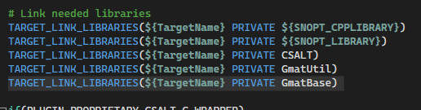
Figure 1 - Add GmatBase to CMakeLists.txt file.
- After CMakeLists.txt is updated the CMake process must be repeated to rebuild GMAT.
- Next, several additions must be made to the file TestOptCtrl.cpp beginning by including the Moderator.hpp header file. Additionally, a static Moderator object is added prior to the declaration of the main function. These updates are shown in Figure 2.
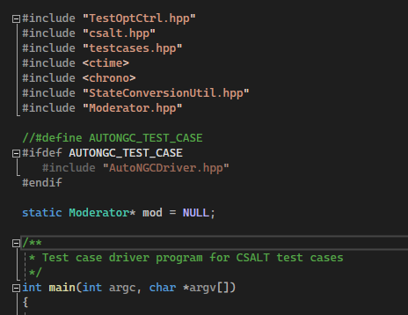
Figure 2 - The Moderator.hpp file must be included in TestOptCtrl.cpp and a static Moderator object much be declared.
- Code is added to TestOptCtrl.cpp that enables the gmat_startup_file.txt to be read in. This code is highlighted in Figure 3.
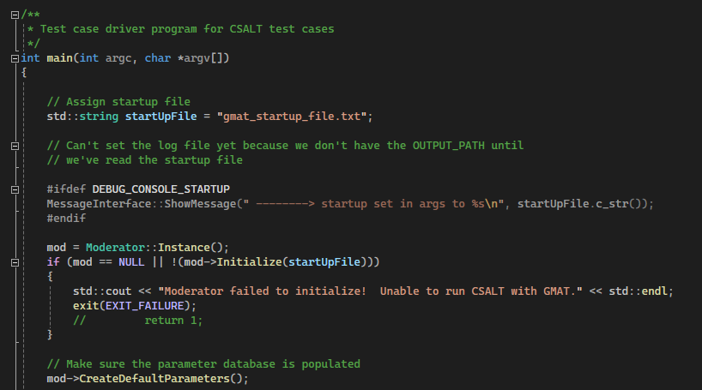
Figure 3 - All code shown here should be added to the main function of TestOptCtrl.cpp except for the three lines beginning with #ifdef.
- Finally, the code shown in Line 687 in Figure 4 must be added at the end of the main function in TestOptCtrl.cpp.
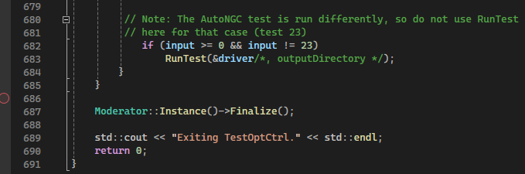
Figure 4 - Finalize the Moderator Instance.
- Once these changes have been made to TestOptCtrl.cpp build the CSALTTester project in Release and Debug mode and check that the test problems still run as expected.
- Finally, you can replace the HohmannTransferDriver.cpp function in the CSALTTester project with the file included along with this README document. This updated Driver function includes code that demonstrates several GMAT utilities including:
  - Defining celestial bodies and reference frames
  - Creating an ephemeris smoother object that reduces the computational burden of querying ephemeris positions and velocities.
  - Converting between state representations, time systems, and coordinate frames.

