GTM-T2 Model Workspace Parameters:
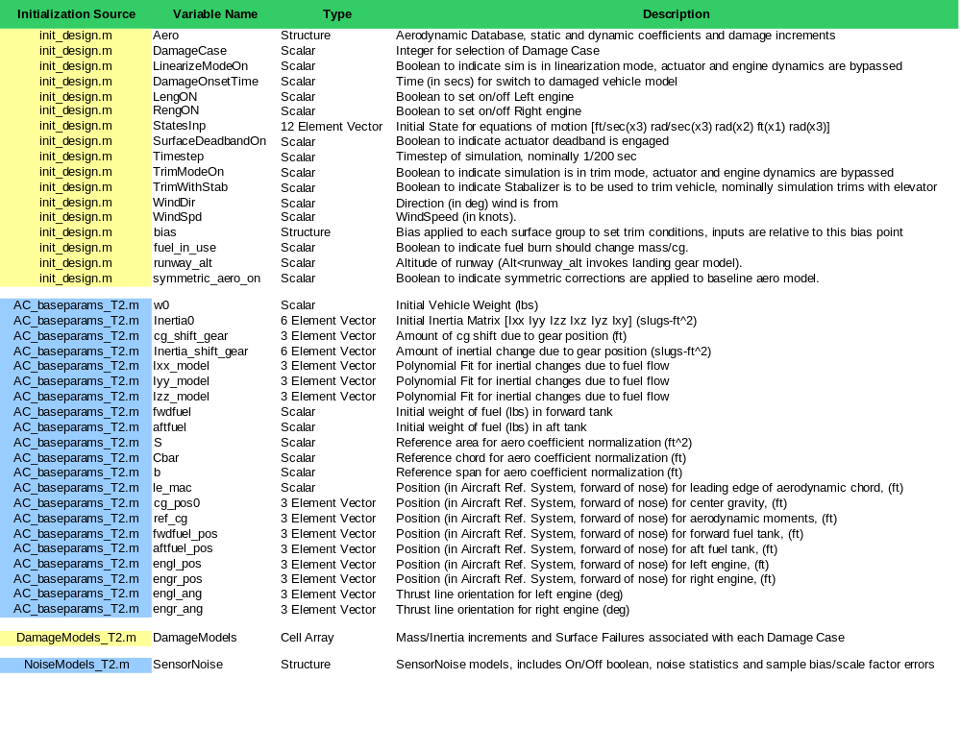

AeroDatabase:
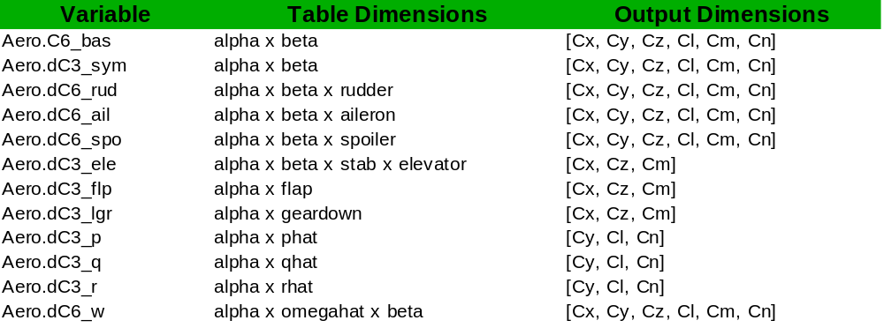

Axis and Sign Conventions:

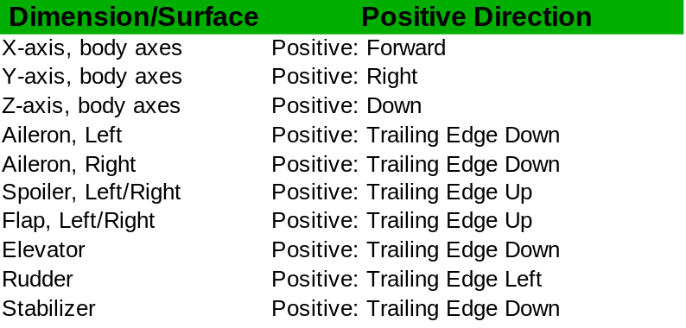

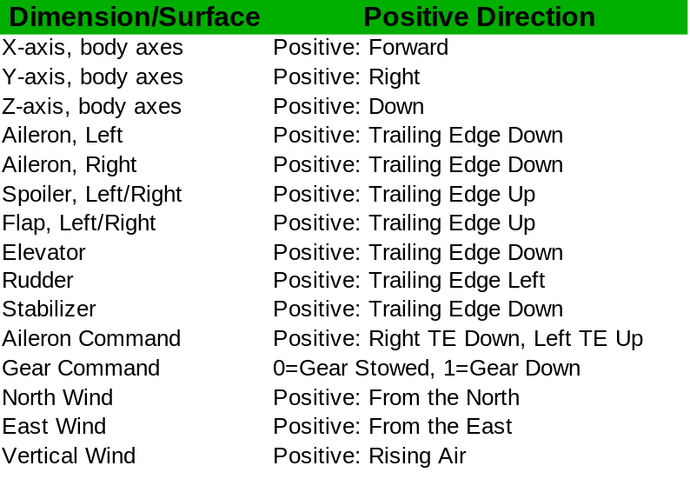

M-file Documentation:

function appendmws(MWS,model)
Appends model workspace with variables given by the fields of the structure MWS.
Inputs:
MWS - Model Workspace Structure, contains simulation parameters
model - Name of model to load into, default is 'gtm_design'

function clearmws(model)
Clears the current model workspace.
Inputs:
model - name of model, defaults to 'gtm_design'

function DCM = euler321(p);
Creates directional cosine matrix for euler 321 rotation sequence.
Inputs:
p - phi/theta/psi vector, in radians
Outputs:
DCM - Directional cosine matrix

function expand(structure)
Given a data structure this expands each field into a separate named variable in the callers workspace

function MWS = grabmws(model);
Grabs current model workspace and returns as fields in a structure
Inputs:
model - name of model, defaults to 'gtm_design'

Outputs:
MWS - simulation parameters from the model workspace

function MWS = init_design(vehicle);
Creates Model Workspace Structure for gtm_design simulation.
Inputs:
vehicle - type of vehicle, either 'GTM' or 'S2' (default = 'GTM')
sensors_on - flag for turning sensor models on (default = 0)
noise_on - flag for turning sensor noise models on (default = 0)
fuelburn_on - flag for turning fuel burn model on (default = 0)

Outputs:
MWS - Simulation parameters, to be loaded into Model Workspace
with loadmws(MWS) or appendmws(MWS).

function [sys,londyn,latdyn] = linmodel(MWS)
Linearize gtm_design simulation at current trim point

Inputs:
MWS - simulation parameters, defaults to pre-loaded model workspace
vab_flag - flag to get linear models in terms of V, alpha, beta (0 default)
use_all_inputs - for specifying use of the full set of inputs or grouping(default) the inputs.
Ts - timestep for a discrete linear model (0 for a continuous model, default)

Outputs:
sys - 6dof system with control surface inputs/state outputs
londyn - Approximate (4th order) longitudinal dynamics
latdyn - Approximate (4th order) lateral dynamics

function loadmws(MWS,model)
Clears model workspace and replaces with variables given by the fields of the input.

Inputs:
MWS - Model Workspace Structure, contains simulation parameters
model - Name of model to load into, default is 'gtm_design'

function MWS_out = seteomic(MWS,statename,value,...)
This function allows the initial condtions of the gtm_design simulation's equation of motion (MWS.StatesInp) to be specified by named values.

Specifically statename is one of:
tas - total airspeed (knots)
alpha - angle of attack (deg)
beta - sideslip (deg)
p - body rate (deg/sec)
q - body rate (deg/sec)
r - body rate (deg/sec)
lat - latitude (deg)
lon - longitude (deg)
alt - altitude (ft)
phi - Euler angle (deg)
theta - Euler angle (deg)
psi - Euler angle (deg)

Values not explictly specified remain at the value they had in MWS

Examples:
MWS=seteomic(init_design(),'alt',3000);
MWS=seteomic(MWS,'tas',90,'beta',3,'p',15);

function [MWS,Xtrim,Trimcond,Err] = trimgtm(target,PitchSurf,verbose);
Trims gtm_design simulation to target conditions.

Inputs:
Target is a structure which has some subset of the following fields:
eas - Equivalent air speed (knots)
tas - True airspeed (knots)
alpha - Angle of attack (deg)
beta - Sideslip (deg), defaults to zero
gamma - Flight path angle (deg)
roll - Roll angle (deg)
pitch - Pitch angle (deg)
yaw - Heading angle (0-360)
rollrate - d/dt(phi) (deg/sec), defaults to zero
pitchrate - d/dt(theta) (deg/sec), defaults to zero
yawrate - d/dt(psi) (deg/sec), defaults to zero
pdeg - Angular velocity (deg/sec)
qdeg - Angular velocity (deg/sec)
rdeg - Angular velocity (deg/sec)

PitchSurf - 'elev' for elevator (default) or 'stab' for stabalizer
verbose - 0(quiet), 1(soln disp), or 2(iterations), defaults to 2

Outputs:
MWS - simulation parameter set, updated to be at trim condition
Xtrim - simulation full-state, at trim
Trimcond - values of state and control surfaces at trim.
Err - max error in trim condition

Unspecified variables are free, or defaulted to the values shown above.
To force a defaulted variable to be free define it with an empty matrix.
For example, by default beta=0 but "target.beta=[];" will allow beta
to be free in searching for a trim condition.

Examples:
MWS=trimAirSTAR(struct('eas',95,'gamma',0));
[MWS,Xt,Tc,Er]=trimAirSTAR(struct('alpha',3,'gamma',0,'yaw',120),1);
[MWS,Xt,Tc,Er]=trimAirSTAR(struct('tas',100,'gamma',3,'yawrate',10),0,0);

