

NASA GSFC Flight Software Systems Branch

Application Requirements Document

cFS Housekeeping (HK) Application

1.0 Introduction
1.1 Document Purpose
The purpose of this requirements specification is to define the requirements to be satisfied by the housekeeping Application. This application is developed for re-use. For this reason, several nomenclatures are used in this document to identify configurations for a mission. Mission-specific features and customization requirements which are applicable for all platforms are tagged with <MISSION_DEFINED>. Platform-specific features and customizations requirements are tagged with either “<PLATFORM_DEFINED>” or “<OPTIONAL>.” Additional nomenclature is used along with the tag to specify a cFS default value for the platform-specific feature: “<PLATFORM_DEFINED, Default_Value>”.
1.2 Document Scope
The scope of this document is limited to the specification of requirements for the Housekeeping software requirements. These include functional, performance, qualification, and design requirements.
1.3 Document Organization
This document is organized into three additional sections and an appendix.
Section 2 gives the Housekeeping context.
Section 3 documents the Housekeeping system design decisions and constraints.
Section 4 contains the Housekeeping functional and performance requirements.
Appendix A contains a list of abbreviations and acronyms used in this document.

2.0 cFS Housekeeping Application Context
The Housekeeping (HK) component of the Core Flight System (cFS) is responsible for building and sending combined telemetry messages from individual system applications. Combining messages is performed in order to minimize downlink telemetry bandwidth. Combining certain data from multiple messages into one message eliminates the message headers that would be required if each message was sent individually. HK provides the capability to generate multiple combined packets so that data can be organized and output at different rates (e.g. a fast, medium and slow packet).
Figure 1 shows the context diagram for the cFS Housekeeping (HK) Application. During initialization, HK subscribes to housekeeping messages from other applications. The Scheduler Application (SCH) sends periodic commands to HK. Ground commands come from the Command Ingest task (CI). Combined output messages and events messages are routed to the appropriate task(s) by the cFE Software Bus (SB) service. The copy table defines the output message formats. HK learns of ground updates to the copy table through the cFE Table Service.
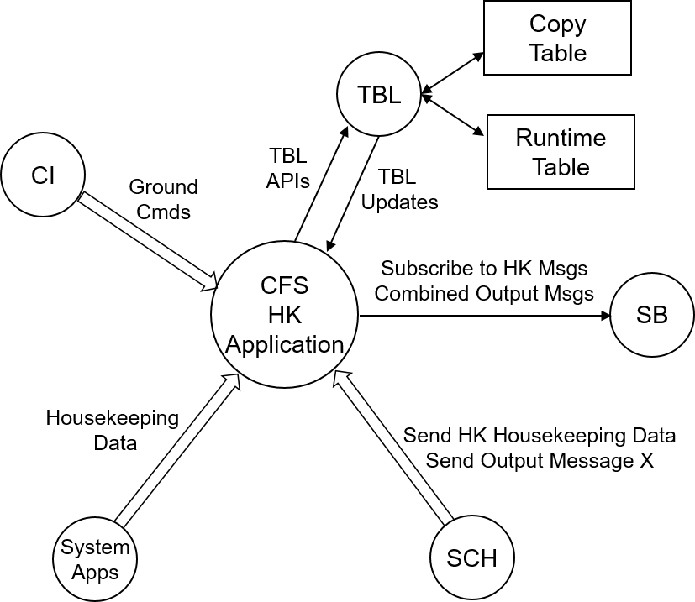

Figure 1 – HK Context Diagram
2.1 Assumptions
The following list summarizes the assumptions made by the cFS Housekeeping Application:
- A scheduler or similar application will send out a housekeeping request at a periodic rate.
- A scheduler or similar application will send commands to inform HK to send the output messages.
- cFE API’s are available for use.
- OSAL API’s are available for use.
- Housekeeping is not responsible for uploading or downloading files. Files generated by or loaded for Housekeeping are transferred using a file transfer application such as CFDP

3.0 Design Specifications
The Housekeeping Application’s requirements and design is based on the results of the cFS heritage analysis effort. The results of the heritage analysis are document in the cFS Housekeeping Application Heritage Analysis document. The Housekeeping Application is based on the Core Flight Executive (cFE) and the OSAL. In addition, HK exists in the context of the cFS architecture. The Housekeeping application does most of its processing based on the contents of the Copy Table. The Copy Table is made up of a list of entries. Each entry includes five items, input message id, input message offset, output message id, output message offset and number of bytes to copy. During initialization, the Housekeeping application subscribes to the system application housekeeping messages (input message ids) that are listed in the Copy Table. When the system application housekeeping messages are received by HK, the entire Copy Table is scanned to determine where the data in the received message is to be copied. When the Housekeeping application does not receive an expected message from an application, HK will increment the missing data counter and send an event message to the ground
4.0 Requirements
Summary | Description | Requirement Rationale
HK1000 | Upon receipt of a No-Op command, HK shall increment the HK Valid Command Counter and generate an event message. | Debug command to verify application is alive.
HK1001 | Upon receipt of a Reset command, HK shall reset the following housekeeping variables to a value of zero:  a) HK Valid Command Counter  b) HK Command Rejected Counter  c) Number of Output Messages Sent  d) Missing Data Counter | Important for testing and on-orbit flight operations in order to start with a “clean slate”
HK1002 | For all HK commands, if the length contained in the message header is not equal to the expected length, HK shall reject the command. | Basic command verification in the event of SEU or memory corruption.
HK1003 | If HK accepts any command as valid, HK shall execute the command, increment the HK Valid Command Counter and issue an event message. | Provides basic verification of each HK command (i.e. HK command parameters are acceptable)
HK1004 | If HK rejects any command, HK shall abort the command execution, increment the HK Command Rejected Counter and issue an error event message. | Provides indicator of erroneous command
HK2000 | HK shall collect flight software housekeeping data from table-specified input messages. | Use of tables makes it easier to modify/maintain
HK2001 | HK shall output table-defined messages, at the scheduled rate, by combining input message data starting at the table-defined offset and table-defined number of bytes to the table-defined offset in the output message. | Useful to group telemetry from multiple apps into a single message
HK2001.1 | Upon a table update, HK shall update the output message formats specified in the table during normal execution. | Supports the capability to adding and removing applications at runtime (or modifying messages)
HK2001.2 | If the <PLATFORM_DEFINED> parameter Discard Combo Packets is set to NO and HK does not receive a message from an application, HK shall use all values associated with last received message for that application in the combined message for that telemetry collection period. | Zeroing data could have undesirable effects.
HK2001.3 | If HK does not receive a message from an application, HK app shall increment the missing data counter and send an event specifying the message ID for the missing message. | Important to inform the ground of any failure detection.
HK2001.5 | If the <PLATFORM_DEFINED> parameter Discard Combo Packets is set to NO and the input message offset + bytes for any input message specified in the HK table is greater than the received message length then HK shall use the last received data associated with that message and issue no more than one event message per input message. | Prevents reading past the end of message (If there is an error in the HK table where the offset + bytes for a specific message exceeds the total message length)
HK2001.6 | If the <PLATFORM_DEFINED> parameter Discard Combo Packets is set to YES and HK does not receive a message from an application, HK shall discard the combined message containing the values associated with the missing application message for that telemetry collection period. | Prevents ground processing of combination packets
HK2001.7 | If the <PLATFORM_DEFINED> parameter Discard Combo Packets is set to YES and the input message offset + bytes for any input message specified in the HK table is greater than the received message length then HK shall discard the combined message containing the values associated with the illegal length application message for that telemetry collection period. | Prevents reading past the end of message (If there is an error in the HK table where the offset + bytes for a specific message exceeds the total message length). Prevents ground processing of combination packets containing stale data.
HK3000 | HK shall generate a housekeeping message containing the following:  a) Valid Command Counter  b) Command Rejected Counter  c) Number of Output Messages Sent  d) Missing Data Counter | Housekeeping telemetry to indicate basic HK status.
HK4000 | Upon initialization of the HK Application, HK shall initialize the following data to Zero  a) Valid Command Counter  b) Command Rejected Counter  c) Number of Output Messages Sent  d) Missing Data Counter | HK does not preserve data across any type of reset

Acronyms
ACS Attitude Control System
C&DH Command and Data Handling
cFS…………………………………………………………………………………………………..Core Flight System
CM Configuration Management
COTS Commercial Off-The-Shelf
CPU Central Processing Unit
DCR Discrepancy/Change Request
ETU Engineering Test Unit
FSB Flight Software Branch
FSW Flight Software
GSFC Goddard Space Flight Center
HK ……………………………………………………………………………………………………….. Housekeeping
I&T…………………………………………………………………………………………………….Integration & Test
JSC Johnson Space Center
POSIX Portable Operating System Interface
RTOS Real-Time Operating System
SMP Symmetric Multiprocessing
T&C Telemetry and Command
TBD To Be Determined
URL Universal Resource Locator
VDD Version Description Document

