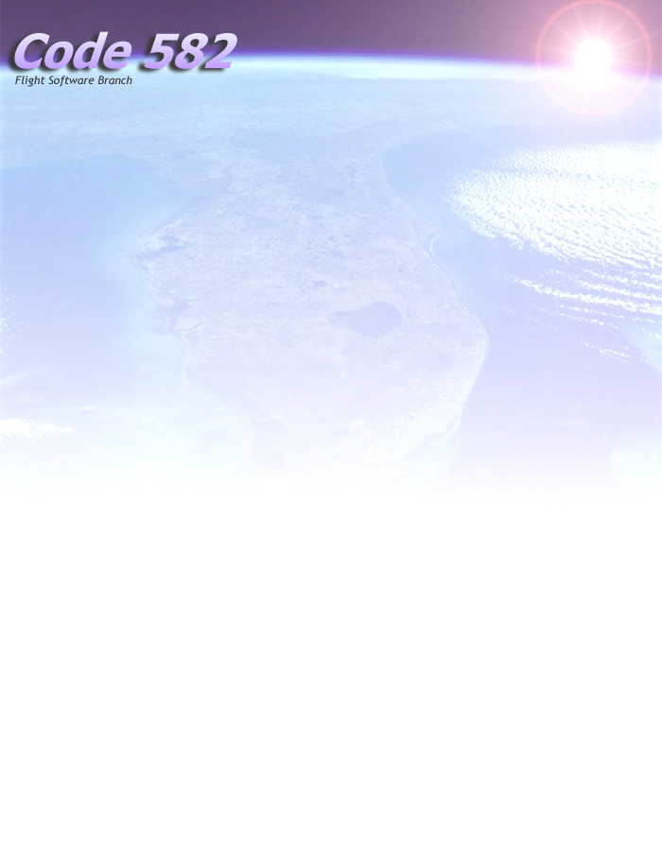

Core Flight Executive (cFE)

Software Timing Analyzer Integration Guide

September 25, 2007 (Version 1.0)
Steven Slegel, Raytheon

Author:

_____________________________________________________ _______________
Steven Slegel Date

Approved By:

_____________________________________________________ _______________
Maureen Bartholomew Date
Core Flight Executive (cFE) PDL

Acknowledgements
The cFE Software Timing Analyzer (STA) tool is based on software developed by Steve Slegel.

Revision History

Version | Date | Description | Affected Pages
1.0 | 08/10/06 | Initial Version | All

Table Of Contents

Acknowledgements 3
Revision History 3
Introduction 5
Scope 5
Background 5
Getting Started 5
1. Add Performance Markers to the targets source code 5
2. Collect Timing Data 7
Starting a Data Collection 7
Performance ID Filtering 7
Performance ID Triggering 8
3. Load the data file into the Software Timing Analyzer GUI Application 8
Setting Configuration Parameters 8

Introduction

Scope
This document describes how to integrate and collect software timing data using the cFE Performance Software included in the cFE Executive Services task. The Software Timing Analyzer GUI application is documented separately and is included with the installation of the application software.

Background
The Software Timing Analyzer is a Microsoft Windows program that provides visibility into the real-time performance of embedded systems software.
The software has the following key features:
- Graphically displays task execution as waveforms
  - Rising edge indicates that a task is running, Falling edge indicates that a task is pending
  - Can display the execution state of multiple tasks simultaneously
- Calculates Statistics
  - Measures task execution interval (how often a task runs) and execution width (how long it takes to run)
  - Measures Min, Max, and Average CPU Utilization.
- Analyzes/searches timing data for user specified conditions.

Software timing is measured by adding entry and exit function calls, also referred to as Performance Markers, to the targets source code. These Performance Markers time tag entry and exit events as they occur. Each Performance Marker is uniquely identified by a Performance ID which is simply a number associated with some event that you want to measure.

Typically Performance Markers are added to:
- Every application task in the system to measure how much time is spent in each task.
- Interrupt service routines to show when interrupts are occurring.
- Anywhere in the code to measure anything of interest.

Performance Marker data is collected and buffered on-board using flight software and is saved to a file that can be imported into the Software Timing Analyzer GUI application.

Getting Started

1. Add Performance Markers to the targets source code
Software timing is measured by adding entry and exit function calls to the targets source code. A call to the function CFE_ES_PerfLogEntry(Performance ID) marks the start of a measurement and a call to the function CFE_ES_PerfLogExit(Performance ID) marks the end of a measurement. These function calls can be placed anywhere in the source code to measure anything of interest.

Each “thing” that you want to measure is identified by a unique Performance ID that is passed as an argument to the CFE_ES_PerfLogEntry and CFE_ES_PerfLogExit function calls. Performance IDs are defined in the file “build/cpu/inc/app_perfids.h”. The first 32 Performance IDs are reserved for the CFE Core, therefore numbers starting with 0x20 are available to be used by applications. The maximum Performance ID is limited to the value of the define CFE_ES_PERF_MAX_IDS. See the section on Setting Configuration Parameters for more information.

/*
** The first 32 Performance Monitor IDs are reserved for the cFE Core
*/

/*
** Application Performance Ids
*/
#define SCH_MAIN_TASK_PERF_ID 0x00000020
#define CI_MAIN_TASK_PERF_ID 0x00000021
#define TO_MAIN_TASK_PERF_ID 0x00000022
#define TO_SOCKET_SEND_PERF_ID 0x00000023
#define CI_SOCKET_RCV_PERF_ID 0x00000024

/*
** Test Application Performance Ids
*/
#define TST_EVS_MAIN_TASK_PERF_ID 0x00000030
#define TST_SB_MAIN_TASK_PERF_ID 0x00000031
#define TST_TIME_MAIN_TASK_PERF_ID 0x00000032
#define TST_TBL_MAIN_TASK_PERF_ID 0x00000033
#define TST_TBL2_MAIN_TASK_PERF_ID 0x00000034
#define TST_QQ_APPMAIN_PERF_ID 0x00000035
#define TST_ES_MAIN_PERF_ID 0x00000036

Performance Markers can be added anywhere in the targets source code to measure anything of interest. The following guidelines suggest places where Performance Markers should be added at a minimum:

All application tasks should have their own Performance ID. A call to CFE_ES_PerfLogEntry should be made at the start of the task. Any CFE or OS function call that will cause the task to go to sleep should be bracketed with CFE_ES_PerfLogExit -- CFE_ES_PerfLogEntry function calls. The idea is to call CFE_ES_PerfLogEntry when the task wakes up and call CFE_ES_PerfLogExit when the task goes to sleep. See the example below:

void XX_task_main(void)
{

CFE_ES_PerfLogEntry (XX_MAIN_TASK_PERF_ID);

CFE_ES_RegisterApp();
CFE_XX_TaskInit();

while(1) {

CFE_ES_PerfLogExit (XX_MAIN_TASK_PERF_ID);

SB_Status = CFE_SB_RcvMsg(&CFE_XX_TaskData.MsgPtr,
CFE_XX_TaskData.CmdPipe,
CFE_SB_PEND_FOREVER);

CFE_ES_PerfLogEntry (XX_MAIN_TASK_PERF_ID);

. . .
}
}

All interrupt service routines should have their own Performance ID. A call to CFE_ES_PerfLogEntry should be made at the start of the interrupt service routine and a call to CFE_ES_PerfLogExit should be made at the end of the interrupt service routine. See the example below:

void OS_XX_isr_shell(void)
{
OldLevel = OS_IntLock();
CFE_ES_PerfLogEntry (XX_ISR_PERF_ID);

. . .

CFE_ES_PerfLogExit (XX_ISR_PERF_ID);
OS_IntUnlock(OldLevel);
}

2. Collect Timing Data
The data collection software uses an onboard data buffer to collect timing data. An onboard timer is also used to time stamp the timing data. The data buffer is implemented as a circular buffer and supports filtering and triggering of individual Performance IDs.

Starting a Data Collection
The data collection software does not do anything until a data collection is started. A data collection is started by sending the \ES_STARTLADATA command. Once a data collection is started and triggered (see triggering below) the data collection will automatically stop when the log is full or when the \ES_STOPLADATA command is received. Once the data collection is complete the data buffer is written to a file that can be transferred to a ground system. Note that if the data collection automatically stops because the buffer is full, the \ES_STOPLADATA command must still be issued to write the data buffer to a file.

Performance ID Filtering
Individual Performance IDs can be filtered or excluded from the log. A filter mask is used to define which Performance IDs to filter. Setting the filter mask bit to a 1 will include a Performance ID in the log, setting the filter mask bit to a 0 will exclude a Performance ID from the log. The filter mask is implemented as an array of 32 bit words. The array is viewed as one big bit mask where each bit position corresponds to a Performance ID. So for example filter mask word 0 of the array corresponds to Performance IDs 0-31, filter mask word 1 of the array corresponds to Performance IDs 32-63. The maximum number of Performance IDs that can be supported is defined by the size of this array and is configured by setting the CFE_ES_PERF_MAX_IDS macro. Performance IDs that are outside of this range will be ignored and will be flagged as an error. See section Setting Configuration Parameters for more information. The filter mask can be modified by sending the \ES_LAFILTERMASK command.

Performance ID Triggering
Triggering makes it possible to wait until an event occurs before data is collected. Events can only be triggered by an existing Performance ID. A trigger position can be specified as Start, Center, or End. If the trigger position is the Start then the trigger Performance ID will be at the beginning of the log. If the trigger position is the Center then the trigger Performance ID will be in the center of the log. If the trigger position is the End then the trigger Performance ID will be at the end of the log. A trigger mask is used to define which Performance IDs to trigger on. Setting the trigger mask bit to a 1 will enable triggering for a Performance ID, setting the trigger mask bit to a 0 will disable triggering for a Performance ID. The trigger mask is implemented as an array of 32 bit words. The array is viewed as one big bit mask where each bit position corresponds to a Performance ID. So for example trigger mask word 0 of the array corresponds to Performance IDs 0-31, trigger mask word 1 of the array corresponds to Performance IDs 32-63. The maximum number of Performance IDs that can be supported is defined by the size of this array and is configured by setting the CFE_ES_PERF_MAX_IDS macro. Performance IDs that are outside of this range will be ignored and will be flagged as an error. See section Setting Configuration Parameters for more information. To trigger on any Performance ID set all trigger masks to 0xFFFFFFFF. To allow the data collection software to continuously collect data, set all trigger masks to 0x00000000. In this case the data collection software will not stop collecting data until the stop command is issued. The trigger mask can be modified by sending the \ES_LATRIGGERMASK
command.

3. Load the data file into the Software Timing Analyzer GUI Application
After a data collection has completed, the log (including the header) should be transferred to the ground system. The data can then be imported into the Software Timing Analyzer GUI Tool. See the Software Timing Analyzer Users Guide for more information.

Setting Configuration Parameters
Several user configurable parameters are available in the file “build\cpu\cfe\config\inc\cfe_platform_cfg.h” to customize the size of the performance log buffer and the maximum number of Performance IDs.

The define CFE_ES_PERF_DATA_BUFFER_SIZE determines the maximum size of the data buffer specified as the number of entries in the buffer. Each entry occupies 12 bytes of memory. So a buffer size of 10000 entries takes up about 120000 bytes. Note that in addition to the size of the data log there is a log header that will take up an additional 76 bytes of memory. Note that the size of the header will vary depending on the size of the filter and trigger mask arrays.

/*
** CFE_ES_PERF_DATA_BUFFER_SIZE:
**
** The following constant defines the maximum size of the perf data buffer.
*/
#define CFE_ES_PERF_DATA_BUFFER_SIZE 10000

The define CFE_ES_PERF_MAX_IDS determines the maximum number of Performance IDs. See the section of Filtering and Triggering for more information.

IMPORTANT: the number chosen MUST be divisible by 32.

/*
** CFE_ES_PERF_MAX_IDS:
**
** The following constant defines the maximum number of perf ids allowed.
** This number must always be divisible by 32.
*/
#define CFE_ES_PERF_MAX_IDS 128

