  ., | [  Flight Software Unit Test  Tool User’s Guide  Flight Software Branch – Code 582  Version 0.9 – 09/10/09  582-2009-xxx
document control and update History
This document is a Flight Software (FSW) Branch Library controlled document. Proposed changes shall be submitted to FSW Reuse Library (FSRL) Configuration Control Board (CCB).

Version | Date | Description | Affected Pages
1.0 | mm/dd/09 | Initial Release | All

Contents
1.0 Introduction 1
1.1 Document Organization 1
1.2 Relevant Documents 1
2.0 Unit Test Tools Overview 2
2.1 General Tools 2
2.2 Math Tools 5
2.3 cFE Tools 7
2.4 GN&C Application Framework Tools 8
3.0 Building Unit Tests 11
3.1 Build FSW Libraries 11
3.1.1 Cygwin 12
3.1.2 Visual-C 12
3.2 Build Unit Test Tool Libraries 13
3.2.1 Cygwin 13
3.2.2 Visual-C 14
3.3 Develop Unit Tests 14
3.1.1 Cygwin 16
3.1.2 Visual-C 16

1.0 Introduction
The unit test tools provide a unit test framework and a collection of utilities that are designed to facilitate unit testing. The establishment of the FSW Reuse Library (FSRL) has made it obvious that the development and maintenance of unit tests is critical to the success of the FSRL. Unit tests are an essential part of the FSRL and they must be developed and maintained in a cost effective manner.

The unit test framework relieves developers from repeatedly implementing common unit testing functions and they enforce a common look-and-feel that helps test maintenance. These tools implement an assertion-based testing philosophy that requires the developer to explicitly write verification statements that assert whether a condition is true or false. This approach is much different than a unit test that creates a log file that requires a developer to analyze in order to determine whether a test passed or failed.

The use of a third party unit test tool such as cunit (http://cunit.sourceforge.net/) was considered. However, this option was rejected because it added unnecessary complexity to the FSRL unit testing. A tool such as cunit is written to accommodate many different users which increases its complexity and obscures the basic functionality required by the FSRL unit tests. For example, cunit supports the generation of XML reports which is not seen as a valuable feature for the FSRL. In addition, little effort is required to implement and maintain the unit test framework. Therefore by developing our own unit test framework we have complete control over the framework’s features, complexity, and growth path. We also do not rely on an outside party to implement enhancements and/or bug fixes.

1.1 Document Organization
This document is organized into the following additional sections and appendices:
Section 2 describes the design of the unit test tools
Appendix A contains design policies that were used to design the library.

1.2 Relevant Documents
Number | Title | Rev | Date
582-2007-001 | cFE FSW Application Developer’s Guide | 5.3 | 05/05/09
582-2000-005 | FSSB C Coding Standards | 1.1 | 11/29/05
2.0 Unit Test Tools Overview
The tools can be grouped into the following categories which are the basis for the organization of this section:
- Core
- Math
- cFE

Many of the tools can be used independently, however, the idea of a log file, using asserts, and a unit test driver framework should be understood before using any tools. These are described in the general tools.

The general tools and math tools can at most have dependencies on ANSI C, cFE’s common_types.h, and the GN&C Math Library. This allows framework-independent objects (see GN&C FSW Developer’s Guide) to have unit tests that are also framework-independent making it easier for non-FSW personnel to produce and use objects from the object library.

Each utility has one of two types of design. If there is no state information that is maintained by the utility then it is simply a collection of functions. Most math utilities fall into this category because each function performs an operation on a math type. If state information exists then an object-based design is used as described in the GN&C FSW Developer’s Guide. The utility will have a constructor function and an optional destructor function. For file utilities such as utdat the constructor may be named open() or create() and the destructor will be named close(). Regardless of the function names, the object-based convention of passing a pointer to the object instance as the first parameter is always used.

2.1 Core Tools
All unit tests must create a log file as required by the Flight Software Branch (FSB) Unit Testing standards. The job of creating, writing various types of data to the log, and closing a log file are managed by utlog. As you’ll soon read, you may not need to access utlog directly for many unit tests.

The next basic tool is utassert. Utassert defines MACROS that can be used to verify whether a basic condition is true or not and it logs the result in the log file. For example, the following assertion

UTASSERT_EQUAL(LimVal, 101,"Scalar_Limit()","LimVal == 101");

creates the following log file entry assuming it the assertion is tru

PASSED: Function - Scalar_Limit(), Test - LimVal == 101

If the check failed an error message will be logged which includes line number of the failed assert statement.

Since these two tools are fundamental to all unit tests, utdriver was created to simplify the job of writing a unit tests. Figure 2-1 shows an object diagram of a framework-independent unit test. Utdriver contains (indicated by the diamond) a utlog and a utassert objects. A unit test contains a utdriver object and it can contain or use other objects from the general and math packages.

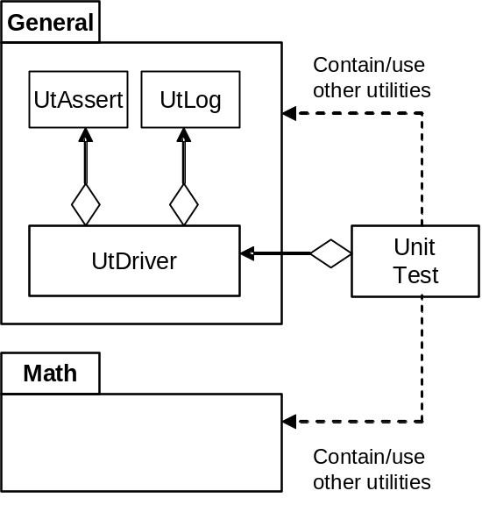

Figure 2-1, Framework-Independent Unit Test

The following code illustrates a unit test’s basic structure using utdriver (taken from gnc-fsw/doc/templates/ut_XXX.c):

#include "utdriver.h"
#include "XXX.h"

#define UT_FILE_NAME "XXX" /* No file extension */

void TestXXXFunction1(void)
{

UTASSERT_BOOL(Boolean,"Function Under Test","Test Description");

} /* End TestXXXFunction1() */

/* Unit Test Function Database */

static UtDriver_Test TestArray[] =
{

{ "Function1", TestXXXFunction1 },
{ "Function2", TestXXXFunction2 } /* Function not shown */

};

#define UT_TEST_CNT (sizeof(TestArray)/sizeof(UtDriver_Test))

int main (void)
{

int RetStatus = UTDRIVER_FAIL; /* Assume failure */

if ( UtDriver_ConstructorWithTests(UT_FILE_NAME, NULL, NULL, TestArray, UT_TEST_CNT) )
{

UtDriver_Execute();

RetStatus = UtDriver_Destructor(); /* Returns assertion status */

} /* End if constructed */

return RetStatus;

} /* End main() */

The following steps explain the usage of utdriver in the above example:

- Include utdriver.h and the header file of the unit being tested.
- Define a macro for the test’s log file without a file extension.
  - This is not required but if you always use the same macro name then the main() function can be used verbatim from test to test.
- Define test functions to test the FSW unit.
  - Multiple tests are not required but in many instances it helps readability and maintainability if test functions are focused on a particular aspect of a unit.
  - The test functions must be defined with a void parameter list and void return type.
- Create a function table (of type UtDriver_Test)with pointers to the test functions.
  - This step is only required if you are using UtDriver_ConstructoWithTests (). If you are using UtDriver_Constructor () then this table is not needed and test function(s) must be registered using UtDriver_AddTest().
  - Using this table along with a standard test count macro such as UT_TEST_CNT allows main() to be reused verbatim from test to test.
- Create a main() function that returns an int.
  - The return isn’t required unless the unit test is part of the GN&C FSW development environment. The return value allows unit revalidation to be automated.
- Call UtDriver_ConstructorWithTests () to create the test framework.
  - This will only fail if the log file could not be created.
- Call UtDriver_Execute () to execute the tests.
- Call UtDriver_Destructor () to complete the test.
  - A log entry is automatically created that states whether all asserts passed. This status is also reflected in the return status from UtDriver_Destructor ().
- Return a value from main(). Returning a unit test status allows automated unit test regression scripts to be written.

For framework independent units it is recommended to use the above template for unit testing. If you start with the unit test template and you are familiar with the assertions provided by utassert then you can immediately focus on testing the unit. The remaining general and math tools provide additional services for writing unit tests. The following table summarizes the files in the general test tools (html\group__ut__tools__gen.html):

Utility | Description
Utassert  html\utassert_8h.html | Provides assertion macros to verify whether a condition is valid. The constructor is automatically called by utdriver. Only the macros should be used so no direct calls to utassert’s function should be performed.
Utdat  html\utdat_8h.html | Provides functions for reading and writing textual data files. This utility is handy when using test data generated by another tool as a unit test input. Section 2.2 contains an example using utdat. Typically unit tests don’t write data files, but the feature may be useful for GN&C FSW development/analysis.
Utdaterr  html\utdaterr_8h.html | Data error can be used to tracked maximum and minimum errors when processing data. This tool is useful for GN&C FSW development/analysis as well.
Utdatrec  html\utdatrec_8h.html | This tool supports utdat. Utdat reads data into an array of doubles. A unit test configures Utdatrec can copy this data to multiple variables that a unit test has setup prior to reading the data.
Utdriver  html\utdriver_8h.html | Provides a unit test driver framework for framework-independent units.
Utlog  html\uttools_8h.html | Provides unit test log file management functions. Many unit tests never need to call log file functions directly but in some cases it is convenient. Section 2.2 contains an example using direct calls to utlog.
Utstr  html\utstr_8h.html | Provides some very simple functions for converting things like a Boolean into string for us

2.2 Math Tools
All of the math utilities are collections of functions that operate on math types except for utmathlog which has a reference to the log file. The following example shows a typical usage of some math utilities in conjunction with utdat. This is essentially the contents of one of the unit test functions contained in the math library’s quaternion unit test. It’s job is to verify the Quaternion_Mult() using data imported from a data file. This is a code snippet so not all macro and variable definitions are shown (note TD equals test data).

boolean TestPassed = TRUE;
UtDat_Class UtDatObj;
double FileData[TD_REC_LEN];
Quaternion QuatLeft, QuatRight;
Quaternion DupQuatLeft, DupQuatRight;
Quaternion ExpQuatResult, CalcQuatResult;

if (UtDat_Open(&UtDatObj, TD_FILE, 0) == UTDAT_VALID)
{
while( UtDat_ReadDataSample(&UtDatObj, FileData, TD_ REC_LEN) == TD_REC_LEN)
{
UtQuaternion_InitQuat(&QuatLeft,&FileData[TD_LEFT_COMP_0]);
UtQuaternion_InitQuat(&QuatRight,&FileData[TD_RIGHT_COMP_0]);

UtQuaternion_InitQuat(&ExpQuatResult,&FileData[TD_RESULT_COMP_0]);

Step++;
DupQuatLeft = QuatLeft;
DupQuatRight = QuatRight;
Quaternion_Mult(&CalcQuatResult, &QuatLeft, &QuatRight);

/* Verify correct answer is calculated */
if (UtQuaternion_EqualComp(&ExpQuatResult, &CalcQuatResult, DATA_TOL) != TRUE)
{
UtLog_VarLine(UtDriver->Log, "Error message text goes here at step %d",Step);
TestPassed = FALSE;
}

/* Verify input quaternions not modified */
if ((UtQuaternion_IdenticalComp(&QuatLeft, &DupQuatLeft) != TRUE) ||
(UtQuaternion_IdenticalComp(&QuatRight, &DupQuatRight) != TRUE))
{
UtLog_VarLine(UtDriver->Log, "Error message text goes here at step = %d",Step);
TestPassed = FALSE;
}

} /* End while file data */

UtDat_Close(&UtDatObj);

} /* End if data file opened */
else
{
UtLog_VarLine(UtDriver->Log, "Couldn't open test data: %s",TD_FILE);
TestPassed = FALSE;
}

UTASSERT_BOOL(TestPassed,"Quaternion_Mult","Complete function");

There are several noteworthy items about the example code above:

- Data file management is very straight forward. A UtDat_Class object is defined, the data file is opened using UtDat_Open (), the data file is read using UtDat_ReadDataSample (), and the data file is closed using UtDat_Close ().
  - The zero in the open call indicates the number of lines to skip in the file before reading data samples. It was not used in this case but it is a handy feature that allows a data file prologue to be present that describes the data.
  - The read data sample returns the number of data items on the line that were read. Checking the return count is an easy way to know when you’ve reached the end of the file and it also ensures the excepted number of data samples is read.
  - Macros are defined that indicates the starting indices for a particular variable in the data array read from the file. Macros help in the code’s readability.
- Three UtQuaternion functions are used in this example. These types of functions are common to all of the math utilities for each math data type.
  - UtQuaternion_InitQuat() is used to initialize quaternions from an array of doubles. Utdatrec could also be used to perform this function.
  - UtQuaternion_InitQuat() is to verify whether each component of two quaternions is equal to within a tolerance.
  - UtQuaternion_IdenticalComp() is used to verify that two quaternions are identical. This is typical done to verify something has not changed or that a bit-by-bit copy was performed. It should not be used to verify the results of numerical comparisons.
- This test function only performs one assert at the end. The results of UtQuaternion_InitQuat() and UtQuaternion_IdenticalComp() could have been used in assertions as well. This would require a little more effort in the code to put the step number in the assert string. In addition if the data file is large then there would be many assertions in the log file. It’s mostly a matter of style and the tools provide the programmer some flexibility.
- The unit test is easy to read and understand. The utilities are not complicated but they provide enough functionality to make tests easier to write and maintain.

The following table summarizes the files in the general test tools (html\group__ut__tools__math.html):

Utility | Description
utlogmath  html\utlogmath_8h.html | Utilities for formatting math library types to a log file. Implemented as an object that references the unit test’s log file.
utmatrix3x3d  html\utmatrix3x3d_8h.html | Collection of functions for initializing and comparing 3x3 matrices of doubles.
utmatrix3x4d  html\utmatrix4x3d_8h.html | Collection of functions for initializing and comparing 3x4 matrices of doubles.
Utmatrix4x3d  html\utmatrix4x3d_8h.html | Collection of functions for initializing and comparing 4x3 matrices of doubles.
Utmatrix6x6d  html\utmatrix6x6d_8h.html | Collection of functions for initializing and comparing 6x6 matrices of doubles.
utmatrixmxnd  html\utmatrixmxnd_8h.html | Collection of functions for initializing and comparing MxN matrices. of doubles.
Utquaternion  html\utquaternion_8h.html | Collection of functions for initializing and comparing quaternions.
Utscalar  html\utscalar_8h.html | Collection of functions comparing scalars.
Utvector3d  html\utvector3d_8h.html | Collection of functions for initializing and comparing 3 dimensional vectors of doubles.
Utvector4d  html\utvector4d_8h.html | Collection of functions for initializing and comparing 4 dimensional vectors of doubles.
Utvector6d  html\utvector6d_8h.html | Collection of functions for initializing and comparing 6 dimensional vectors of doubles.

2.3 cFE Tools
There is one cFE object that corresponds to each cFE subsystem: Executive Services (ES), Event Services (EVS), Software Bus (BS), Table Services (TBL), and Time Services (TIME). Each object’s file name is utcfeXXX.* where XXX is the cFE’s subsystem abbreviation. The main function of each utility is to emulate cFE API’s. Typically GN&C FSW application utilize very few cFE services so these utilities are rather simple. The functionality provided by these tools are a subset of the cFE’s Unit Test Facility (UTF). There has been discussion as to whether these tools should be discontinued in favor of the UTF. Due to the small scope of these tools and the effort required to recode existing unit tests a decision has not been made.

Other than emulating the cFE functions there are a couple of design features specifically added to help unit testing that need some additional description. All cFE subsystem object function return value overrides have the same design. They each provide a function UtCfeXXX_SetReturnOverride()(XXX = cFE subsystem) that allows a user to set the return value for a specific function. The function is identified by passing an enumerated type as a parameter to UtCfeXXX_SetReturnOverride(). The override is only applied once when the specified function is called by the FSW being tested so the user does not have to disable the override.

The tools also provide helpful functions that allow a tool to explicitly and autonomously determine whether the cFE was used in a particular manner. For example the event service tool contains a function UtCfeEvs_SetLastEvent() that let’s a user set the last event message sent ID to a particular value. They can then run a test and then call UtCfeEvs_LastId()to verify what the last event ID issued was allowing them to explicitly verify that the code path that issues a particular event message properly executed. Other subsystems like utcfesb provide similar functions for verifying the last SB message sent. Refer to each tools API for details.

Utcfesb has a helper function that is a little more complex than other features and requires some explanation. The function UtCfeSb_RegisterRcvFunc( ) is used to register a function with utcfesb that will be called the next time the unit being tested calls CFE_SB_RcvMsg().This allows the unit test to send whatever message it needs to perform the test. A developer may choose to have one callback function for a unit test that can be configured for a particular test or he/she may choose to have a separate callback function for each unit test situation. The box below illustrates a callback function that returns a reset command with a CFE_SUCCESS return status. Refer to the GN&C framework unit tests for more examples.

static UtCfeSb_RcvStruct UT_SbRcvCallback(CFE_SB_PipeId_t PipeId,
int32 TimeOut)
{

UtCfeSb_RcvStruct SbRcv;

static UT_NoArgCmd ResetCmd;

ResetCmd.CmdHeader[0] = (uint8)(0x00FF & UT_MSG_ID);
ResetCmd.CmdHeader[1] = (uint8)((0xFF00 & UT_MSG_ID) >> 8);
ResetCmd.CmdHeader[2] = 0x00;
ResetCmd.CmdHeader[3] = 0xC0;
ResetCmd.CmdHeader[4] = 0x01; /* Length */
ResetCmd.CmdHeader[5] = 0x00;
ResetCmd.CmdHeader[6] = 0x00;
ResetCmd.CmdHeader[7] = APP_CMDMSG_FC_RESET_CNT;
CFE_SB_GenerateChecksum((CFE_SB_MsgPtr_t)&ResetCmd);
SbRcv.MsgPtr = (CFE_SB_MsgPtr_t)&ResetCmd;
SbRcv.SbReturnStatus = CFE_SUCCESS;
return SbRcv;

} /* End UT_SbRcvCallback() */

Since the utilities are designed as objects they all have constructors. Just as utdriver simplifies using the common general tools, another tool utframe described in the next section, simplifies using the cFE tools.

Utility | Description
utcfees.h  html\utcfees_8h.html | Emulate the cFE’s executive services API.
utcfeevs.h  html\utcfeevs_8h.html | Emulate the cFE’s event services API.
utcfesb.h  html\utcfesb_8h.html | Emulate the cFE’s software bus services API.
utcfetbl.h  html\utcfetbl_8h.html | Emulate the cFE’s table services API.
utcfetime.h  html\utcfetime_8h.html | Emulate the cFE’s time services API.
Utlogccsds  html\utlogccsds_8h.html | Provide functions to assist a test in logging formatted CCSDS message.

2.4 GN&C Application Framework Tools

The GN&C application framework tool package contains tools that assist testing framework-dependent objects and complete applications. There are two tools in the package: utgncapp and utframe. Utgncapp is used to help verify that an application was properly integrated. Developing applications using an object library with an application framework creates an integration phase that is different from non-reuse based development. For example event message numbering in non-reuse development is straight forward because a single header file can be created that contains all of the event messages as they are created. In a reuse library environment a scheme has to be devised that allows objects to use relative event message number and it must be verified that the reusable objects are properly integrated. This tool is still under development and it may be incorporated as part of the Integrated Development Environment (IDE).

Utframe is analogous to utdriver in its unit testing role but with a broader scope. Figure 2-2 shows utframe is used for unit testing framework-dependent units. Utframe is a subclass of utdriver (which is really containment in a C implementation) and like utdriver’s inclusion of common general tools, utframe contains all of the cFE tools so a unit test does not have to construct each tool. Most if not all framework-dependent unit test configure the cFE tools for their testing which is why a solid arrow is used for the unit test-to-cFE package association.
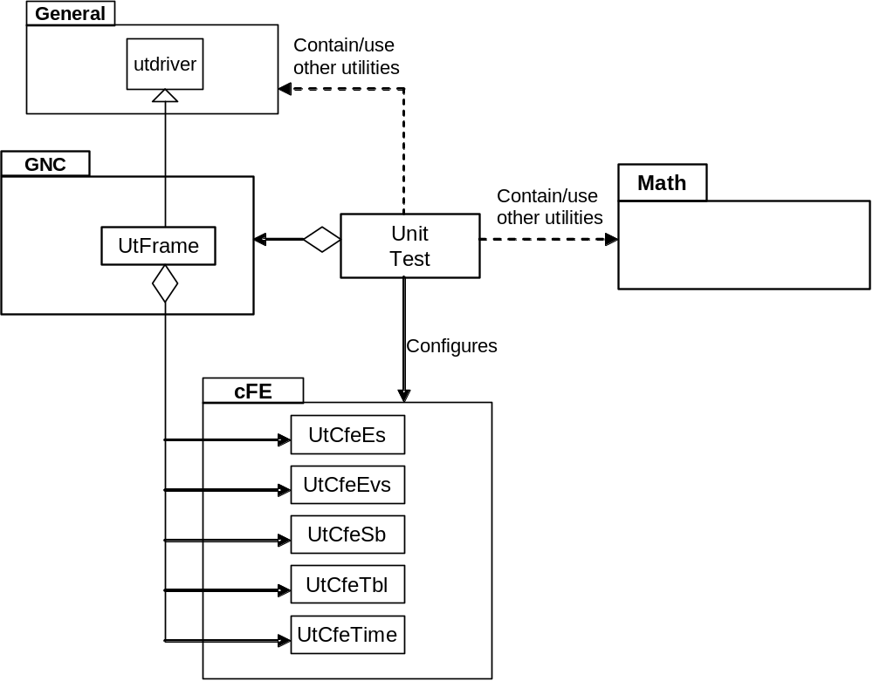

Figure 2-2, Framework-dependent Unit Test

The box below shows an example utframe main() unit test. Notice it is nearly identical to the framework independent unit test main() function. Because of the inheritance relationship utdriver types are still required by utframe.

static UtDriver_Test TestArray[] =
{
{ "Function1", TestXXXFunction1 },
{ "Function2", TestXXXFunction2 }
};

#define UT_TEST_CNT (sizeof(TestArray)/sizeof(UtDriver_Test))

int main (void)
{

int RetStatus = UTDRIVER_FAIL; /* Assume failure */

if ( UtFrame_ConstructorWithTests(UT_FILE_NAME, NULL, NULL, TestArray, UT_TEST_CNT) )
{

UtFrame_Execute();
RetStatus = UtFrame_Destructor();

} /* End if constructed */

return RetStatus;

} /* End main () */

Utility | Description
utframe  html\utframe_8h.html | Provides a unit test driver framework for framework-dependent units.
Utgncapp  html\utgncapp_8h.html | Provides functions to help verify that a GN&C application has been properly integrated.

3.0 Building Unit TEST
The FSW library, unit test tool libraries, and unit test executables are delivered pre-built. The instructions in this section describe how to rebuild the libraries if the need should arise. The following steps are required for building the unit tests executables

- Build FSW Libraries
- Build Unit Test Tool Libraries
- Build Unit Test Executable

Each step is described in a subsection below. The GN&C development environment can be built and executed on multiple platforms. The following platforms are supported:

- Cygwin
  - A PC-based Unix environment that uses make files for managing builds. The make files can be executed directly or executed from the Eclipse Integrated Development Environment (IDE).
  - The unit-test directory contains two files, config.mak and rule.mak, that are used by the make files used to build libraries and executables. Config.mak defines common variables such as directory paths and compiler settings. Rule.mak defines the common make rules.
  - All of the make files contain the following targets:
    - Default target is to build either an object library or an executable
    - Clean – Delete all non-source (not input to build process) files.
    - Depend – Create a dependency database

- Visual-C
  - A Windows environment that uses Visual C workspaces/projects for building libraries and executables.

3.1 Build FSW Libraries

Figure 3-1 shows the directory tree for the FSW libraries. The fsw-lib directory contains a directory for each supported development environment. Each development environment folder contains the same directory structure: framework, math, and objects.

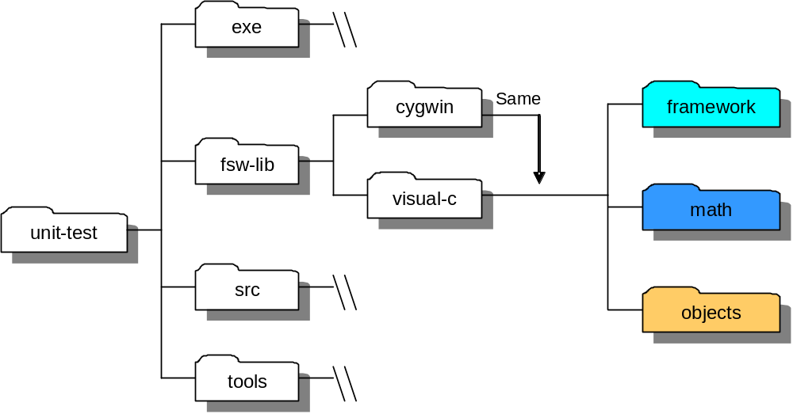

Figure 3-1 gnc-fsw Library Directory Structure

3.1.1 Cygwin
The cygwin directory contains a Makefile that can be used to manage all of the FSW libraries at once. The following make file options are available:

- “make” or “make all” builds framework.a, math.a, and objects.a. The library files are contained in their respective directory.
- “make clean” deletes all non-source framework, math, and objects files
- “make depend” creates a dependency database for framework, math, and objects library targets

Each unit-test/fsw-lib/cygwin’s subdirectory framework, math, and objects contains a make file that has the same name as the directory and a “.mak” file extension. For example the framework directory contains a make file named framework.mak. These files can be used to manage a single library and have the same options as the Makefile in the cygwin directory. For example framework.mak can be used as follows:

- “make –f framework.mak” builds framework.a
- “make –f framework.mak clean” deletes all non-source framework files
- “make –f framework.mak depend” creates a dependency database for the framework library target.

3.1.2 Visual-C
The visual-c directory contains a Microsoft Visual Studio Solution file that contains a Visual-C project for each of the libraries: framework, math, and objects. The actual project files are contained within their respective directories. There are multiple ways to accomplish a task in Visual-C. A simple way to manage the build process is to select either the entire solution or an individual project in the explorer panel and click the mouse’s right button. The options (build, rebuild, clean, etc.) will appear in a floating menu and can be selected by moving the cursor to a selection and clicking the mouse’s left button. The explorer panel is open by default. Note the library files (*.lib) are contained in the visual-c directory and a temp directory is used to store intermediate files.

3.2 Build Unit Test Tool Libraries

Figure 3-2 shows the directory tree for the unit test tool libraries. The gen, gnc, and inc directories contain the source code for the tools. The lib directory contains a directory for each supported development environment. Each development environment folder contains the same directory structure: cfe, gen, and gnc. These directories mirror the source directories because one library is built for each tool subsystem.

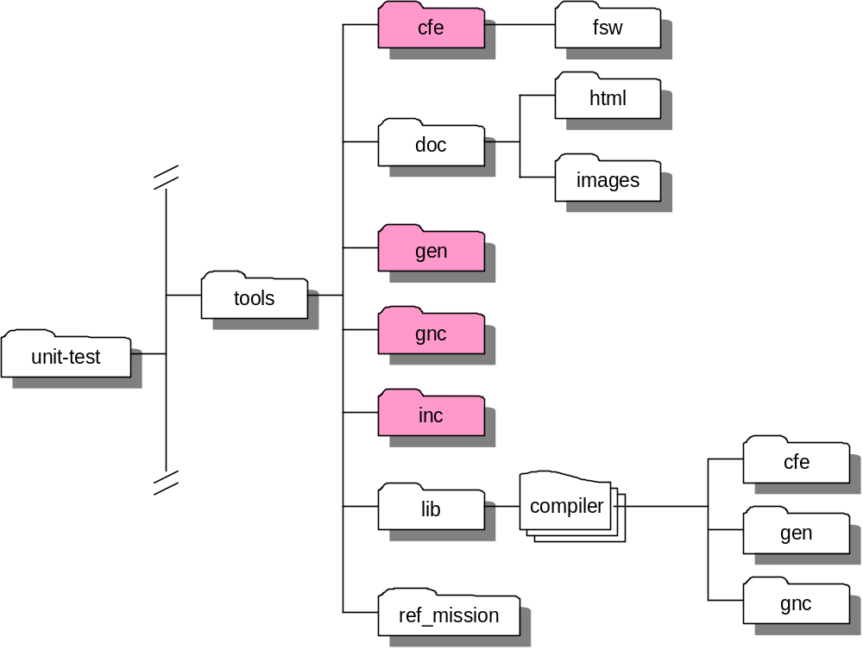

Figure 3-2 Unit Test Tool Library Directory Structure

3.2.1 Cygwin
The cygwin directory contains a Makefile that can be used to manage all of the unit test tool libraries at once. The following make file options are available:

- “make” or “make all” builds cfe.a, gen.a, and gnc.a. The library files are contained in their respective directory.
- “make clean” deletes all non-source cfe, gen, and gnc files
- “make depend” creates a dependency database for cfe, gen, and gnc library targets

Each unit-test/tools/lib/cygwin’s subdirectory cfe, gen, and gnc contains a make file that has the same name as the directory and a “.mak” file extension. For example the cfe directory contains a make file named cfe.mak. These files can be used to manage a single library and have the same options as the Makefile in the cygwin directory. For example cfe.mak can be used as follows:

- “make –f cfe.mak” builds cfe.a
- “make –f cfe.mak clean” deletes all non-source cfe files
- “make –f cfe.mak depend” creates a dependency database for the cfe library target.

3.2.2 Visual-C
The visual-c directory contains a Microsoft Visual Studio Solution file that contains a Visual-C project for each of the libraries: cfe, gen, and gnc. The actual project files are contained within their respective directories. There are multiple ways to accomplish a task in Visual-C. A simple way to manage the build process is to select either the entire solution or an individual project in the explorer panel and click the mouse’s right button. The options (build, rebuild, clean, etc.) will appear in a floating menu and can be selected by moving the cursor to a selection and clicking the mouse’s left button. The explorer panel is open by default. Note the library files (*.lib) are contained in the visual-c directory and a temp directory is used to store intermediate files.

3.3 Build Unit Tests

The unit tests and their executables have the same style of directory structures as the libraries. Figure 3-3 shows the directory structure for the source code.

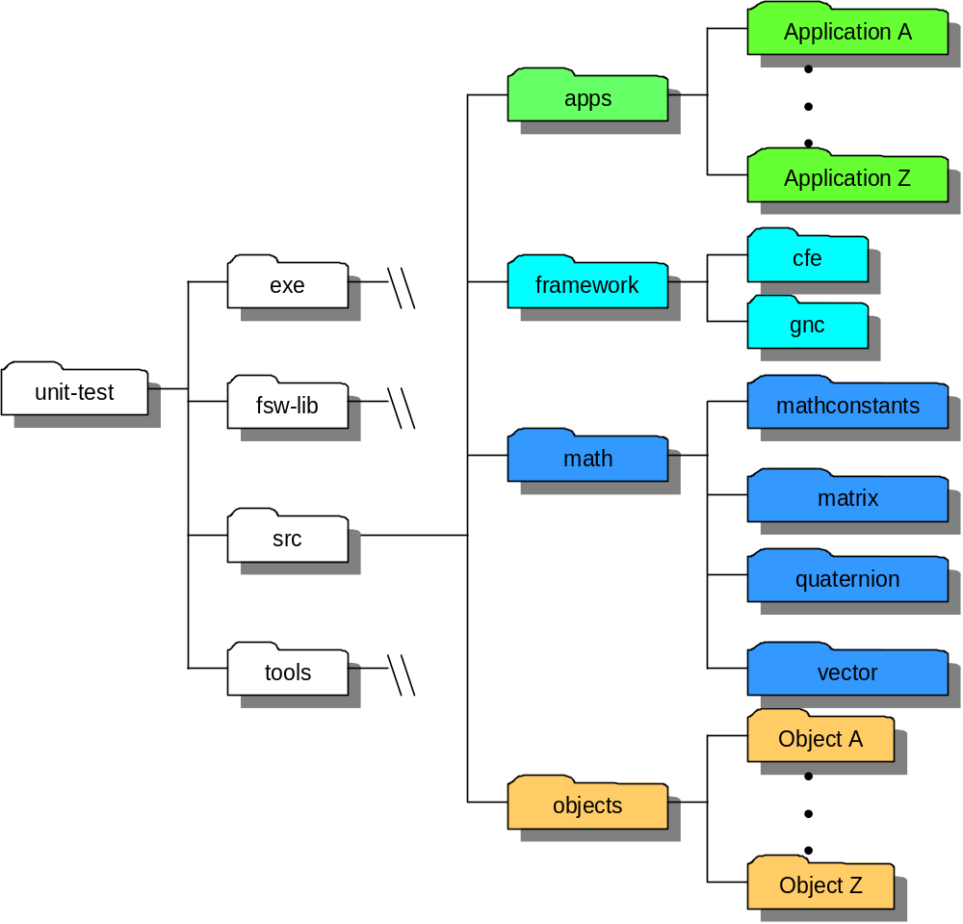

Figure 3-3 Unit Test Source Directory Structure

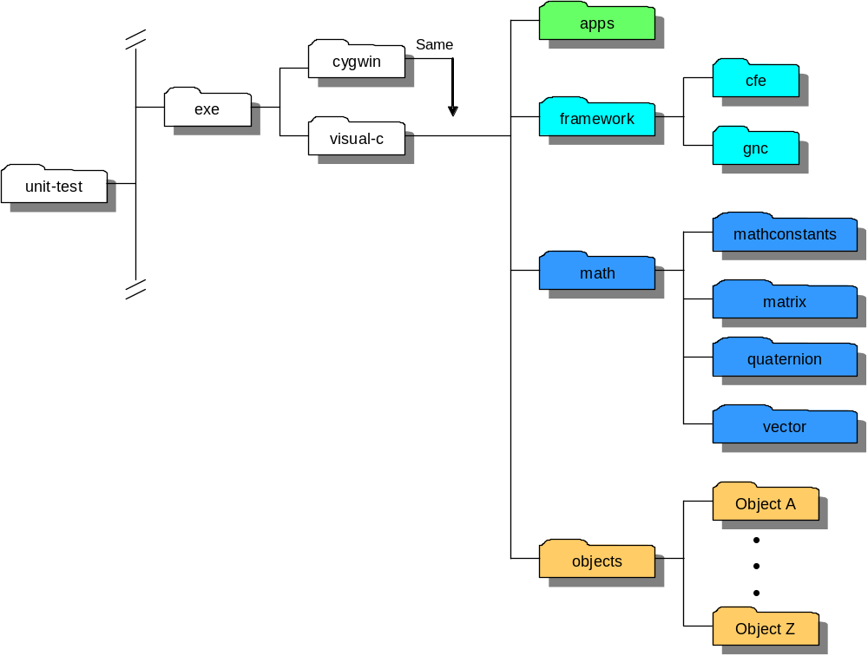

Figure 3-4 Unit Test Executable Directory Structure

3.1.1 Cygwin
TBD

3.1.2 Visual-C

TBD

