 | CORE FLIGHT SYSTEM  SCHEDULER  BUILD 2.2.0.0  FLIGHT SOFTWARE BUILD VERIFICATON  TEST REPORT  Flight Software Branch – Code 582  Version 1.0

Signatures
Submitted by:

_______________________________________ _______________
Walt Moleski/582 Date
CFS Flight Software Tester

Approved by:

_______________________________________ _______________
Charlie Wildermann/582 Date
Flight Software Branch/Head

_______________________________________ _______________
Susanne Strege /582 Date
CFS Flight Software Product Development Lead

Plan Update History
Version | Date | Description | Affected Pages
Draft | 8/8/12 | Draft for review | All
1.0 | 8/13/12 | Initial Release | All

Table of Contents
1 Introduction 1
1.1 Document Purpose 1
1.2 Applicable Documents 1
1.3 Document Organization 1
1.4 Definitions 2
2 OVERVIEW 3
2.1 Flight Data System Context 3
2.2 Test History 4
2.3 Testing Overview 4
2.4 Version Information 6
3 Build Verification Test Preparation 7
3.1 ScenArio Development 7
3.2 Procedure Development and Execution 7
3.3 Test Products 7
4 Build Verification Test Execution 8
4.1 Testbed Overview 8
4.2 Requirements Verification Matrix 9
4.3 Requirements Partially Tested 9
4.4 Requirements/Functionality Deferred 9
4.5 Requirements/Functionality Deferred for Mission Testing 9
5 Build Verficiaton Test Results 10
5.1 Overall Assessment 10
5.2 Procedure Description 10
5.3 Analysis Requirements Verification 11
5.4 DCRs 11
5.4.1 DCRs Verified 11
5.4.2 Outstanding DCRs 11
5.5 Notes 12
Appendix A - RTTM 13
Appendix B - Command, Telemetry, and Events Verification Matrix 14

Introduction

Document Purpose

This Test Report describes the test results from the Core Flight System (CFS) Scheduler (SCH) Flight Software (FSW) Test Team build 2.2.0.0 verification testing. It is used to verify that the SCH FSW has been tested in a manner that validates that it satisfies the functional and performance requirements defined within the CFS SCH Requirements Document. This Test Report summarizes the FSW test history, the build verification process, the build test configuration, and the test execution and results.

Applicable Documents
Unless otherwise stated, these documents refer to the latest version.

Parent Documents (Mission and FSW)

- 582-2008-036 CFS Scheduler Requirements Document, Version 1.1
- 582-2008-012 CFS Deployment Guide

Reference Documents

All of the references below can be found on the Code 582 internal website at http://fsw.gsfc.nasa.gov/

- 582-2003-001 FSB FSW Test Plan Template
- 582-2004-001 FSB FSW Test Description Template
- 582-2004-002 FSB FSW Test Scenario Template
- 582-2004-003 FSB FSW Test Procedure Template
- 582-2004-004 FSB FSW Test Execution Summary Template
- 582-2004-005 FSB Test Product Peer Review Form
- 582-2000-002 FSB FSW Unit Test Standard

Document Organization
Section 1 of this document presents some introductory material.
Section 2 provides a flight software overview and context along with the test history and testing overview.
Section 3 describes the build verification process including procedure development and execution and test products produced.
Section 4 describes the build test configuration which includes an overview of the testbed and the requirements verification matrix.
Section 5 describes the test execution and results by subsystem.
Appendix A - provides the Requirements Traceability Matrix
Appendix B - provides the Command, Telemetry, and Events Verification Matrix

Definitions
There were 3 verifications methods used during build verification testing. They were:
- Demonstration: Show compliance with system requirement by exhibiting the required capability (e.g. by demonstrating interactive capability, display capability, print capability, etc.
- Inspection: Show compliance with a system requirement by visual verification of the software (e.g. verifying preparation for delivery, proper interfacing)
- Analysis: Perform detailed analysis of code, generated data (both intermediate data and final output data), etc., to determine compliance with system requirements.

The fields in the Requirements Verification Matrix in Section 4.3 are defined as follows:
- Requirements Tested Passed: Requirement was fully tested in a build test procedure and passed all tests.
- Requirements Tested Failed: Requirement was fully tested in a build test procedure and failed one or more aspect of the testing.
- Requirements Tested Partially: Requirement was tested partially in a build test procedure. To be fully tested, the partially tested requirement is either tested additionally in one or more other test procedures within the same build and/or other aspects of the requirement must be tested in a later build, due to capabilities not present in the current build
- Total Tested: Total number of requirements fully tested in a build test procedure. Includes total passed and total failed, but does not include requirements tested partially, unless (included as a separate entry) testing in multiple procedures within the same build constitutes total testing of a particular requirement. Total Requirements Tested is computed this way in order to avoid multiple counting of individual requirements that are tested partially in more than one procedure.
- Deferred: Number of requirements that were planned to be tested in current build, but were not tested due to some FSW capability or necessary system component not being present.
- Total: Total Requirements Tested + Number of Requirements Deferred

In each software test section in Section 5 there is a table of DCRs. The state definitions are as follows:
- Opened: The DCR is currently being addressed
- Assigned: The DCR was accepted and the modification is being addressed
- InTest: The DCR was corrected and is currently in test
- Validated: The DCR was corrected and tested and have been validated, needs to have a CCB to close the DCR
- Closed: The DCR is closed and have been resolved and tested to satisfaction
- Closed with Defect: The DCR is closed and the defect is most likely assigned a differed DCR number associated with another subsystem.

OVERVIEW

Flight Data System Context
Figure 2-1 illustrates the CFS system context. The cFE interfaces to five external systems: an Operating System (OS), a Hardware Platform (HP), an Operational Interface (OI), Applications (APP), and other cFE-based systems.

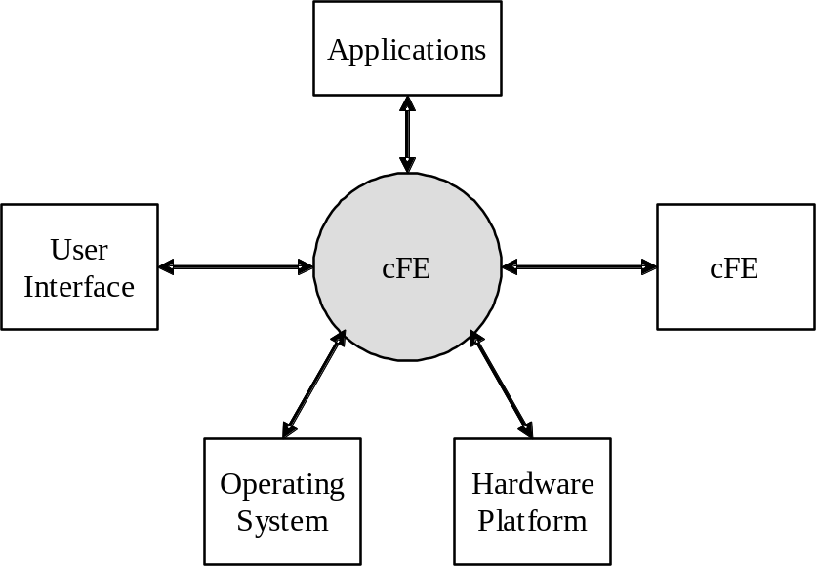

Figure 2-1 CFS System Context

The Scheduler (SCH) application is responsible for implementing a Time Division Multiplexer (TDM) scheduling mechanism for hosted system applications. SCH provides the ability to deterministically schedule application processing at specific times within a 1 second period, AND those scheduling opportunities are synchronized to the Spacecraft Clock.

The figure below shows major interfaces between the Scheduler task and other core Flight Executive (cFE) and Core Flight System (CFS) tasks. Note that although it isn’t shown explicitly, all task-to-task communications are accomplished via the cFE Software Bus task.
Inputs to the Scheduler Application include:
1) Major Frame signal to drive the Scheduler Application
2) Minor frame signal,
3) Commands originating from outside sources such as the ground or Stored Command Processor.

Outputs from the Scheduler application include:
1) Schedule Commands which can include Housekeeping requests, wake-up calls etc.
2) Event Messages and
3) Scheduler Housekeeping telemetry

Two tables are used by the Scheduler App:
1) The Schedule Definition Table (SDT) defines that major and minor frame activities that are to be performed.
2) The Message Definition Table (MDT) defines the messages that are sent as part of the activities.

An activity is defined in the SDT by: an Activity Type (currently only supports “Send Message Activity Type”), Activity State (“Unused”, “Enabled”, “Disabled”), Activity Frequency (e.g. – number of seconds between activity executions), Activity Offset (e.g. – phase shift, in seconds, of first execution) and Activity Group/Multi-Group identifiers.

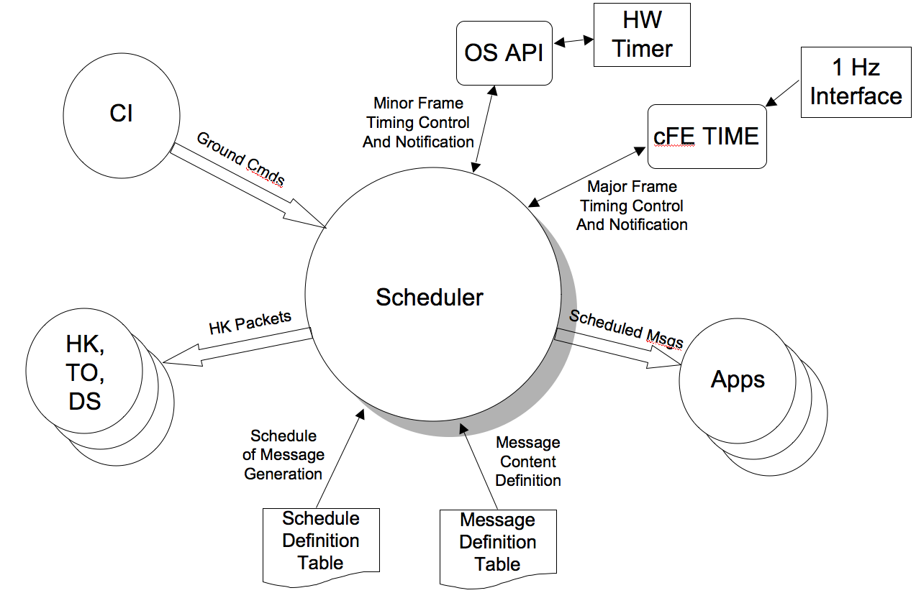
Figure 2-2 CFS SCH Context

Test History
SCH 1.0.1.0 – Build Verification Testing completed 4/2/2009 by Ezinne Uzo-Okoro
SCH 2.0.0.0 – Build Verification Testing completed 9/3/2009 by Walt Moleski
SCH 2.1.2.0 – Build Verification Testing completed 8/16/2011 by Walt Moleski
SCH 2.2.0.0 – Build Verification Testing completed 8/7/2012 by Walt Moleski

Testing Overview
The SCH application was tested during Build Verification testing using the following:
- 1 test application: tst_sch
- 4 test procedures: sch_gencmds, sch_timing_analysis, sch_functional_test, sch_lib_test
- Tests require use of the ASIST Ground Station.

The tst_sch test application is used to send schedule requests for the output of the cFE_TIME 1 Hz signal, and cFE and SCH’s housekeeping data. This was useful when performing build verification testing since it provided great control over the sequence of steps. When deployed for a mission, the Scheduler Application would provide this request. In addition, the test application also provides the ability to force Scheduler to miss slots during processing. TST_SCH contains the following ground commands that are used by the SCH test procedures and/or contained in the Scheduler Message Definition Table:
- TST_SCH_NOOP
This command increments the TST_SCH command counter.
- TST_SCH_ResetCtrs
This command sets the TST_SCH command and error counters to a zero value.
- TST_SCH_MissSlots
This command is used to force SCH to skip some slots while processing the minor frame. A slot skip is achieved by calling the CFE_Time_ExternalTone() function.
- TST_SCH_EnableSchProc
This command is used to call the SCH_EnableProcessing() function contained in the SCH_LIB shared library. The call is only performed if the SCH_LIB_PRESENCE configuration parameter is set to 1 (one).
- TST_SCH_DisableSchProc
This command is used to call the SCH_DisableProcessing() function contained in the SCH_LIB shared library. The call is only performed if the SCH_LIB_PRESENCE configuration parameter is set to 1 (one).
- TST_SCH_GetSchState
This command is used to call the SCH_GetProcessingState() function contained in the SCH_LIB shared library. The call is only performed if the SCH_LIB_PRESENCE configuration parameter is set to 1 (one).

The 4 SCH test procedures do the following:

Procedure | Description
SCH_GenCmds | The purpose of this test is to verify the Scheduler (SCH) Application general commands function properly. The NOOP and Reset Counters commands will be tested as well as invalid commands to see if the SCH application handles these appropriately.
SCH_Timing_Analysis | The purpose of this test is to verify the Scheduler (SCH) Application responds correctly to changes in the schedule and message definition tables. It also verifies the timing of the SCH schedule and message definition table processing. This test also verifies that the SCH application handles anomalies appropriately.
SCH_Functional_Test | The purpose of this test is to verify the Scheduler (SCH) Application responds correctly and timely to definition changes in the schedule and message table in order to the enabling/disabling of individual activities. This test also verifies that the SCH application handles anomalies appropriately.
SCH_Lib_Test | The purpose of this test is to verify that the SCH application supports the schedule library functions properly. These functions allow an external application to control the enabling/disabling of the SCH application’s activity processing.

The CFS Deployment Guide contains the instruction for how to set up both the CFS Flight and Ground test environment. The testers use a CFS Test Account for each build test. This account runs ASIST and is setup to contain all the files needed to test the application. These files are extracted from MKS, the source repository tool. Included in these files are test utilities. These utilities can be located in 2 places depending upon whether they are “local” or “global” utilities. The local utilities are extracted into the working prc directory ($WORK/prc). The global utilities are pointed to by ASIST in the global area defined on the test system. Additional tools utilized by the test procedures are located in the $TOOLS directory. It is assumed that test procedures and the ASIST telemetry database used for testing is built using procedure and database templates

The following utilities were used during testing:

Name | Description
cfe_startup | Directive combines the "start_data_center", "open_tlm", and "open cmd <cpu>" ASIST startup commands.
load_start_app | Procedure to load and start a user application from the /s/opr/accounts/cfebx/apps/cpux directory.
ut_pfindicate | Directive to print the pass fail status of a particular requirement number.
ut_runproc | Directive to formally run the procedure and capture the log file.
ut_sendcmd | Directive to send EVS commands Verifies command processed and command error counters.
ut_sendrawcmd | Send raw commands to the spacecraft. Verifies command processed and command error counters.
ut_setrequirements | A directive to set the status of the cFE requirements array.
ut_setupevents | Directive to look for multiple events and increment a value for each event to indicate receipt.
ut_tlmwait | Directive that waits for the specified telemetry condition to be met
ftp_file | To ftp a file to/from the FSW/GSW.
get_tbl_to_cvt | Directive that issues the CFE_TBL_Dump command and downloads the file to the ground and inserts it in the supplied table telemetry packet.
create_tbl_file_from_cvt | Directive that creates a CFE_TBL load file from the supplied table telemetry packet.
load_table | Directive that transfers the supplied file to the specified cpu and issues the CFE_TBL_Load command.

Version Information

Item | Version
SCH Requirements | 1.1
SCH Application | 2.2.0.0
TST_SCH Application | 2.2.0.0
CFE | 6.3.2.0
OSAL | 3.5.0.0
ASIST | 9.7k
VxWorks | 6.4

Build Verification Test Preparation

ScenArio Development
No new scenarios developed for build verification test 2.2.0.0. All scenarios are stored on the MKS server, in CFS-Repository SCH test-and-ground directory within the test-review-packages subdirectory in the Scenarios folder. It should be noted that as SCH requirement evolve these scenarios are not updated to reflect any changes made.

Procedure Development and Execution
This build test was completed by running 4 test procedures. All test procedures were written using the STOL scripting language. The naming convention for files created by the test procedures was: scx_cpu<#>_<procedure name.<ext>.

Test Products
Four log files were generated for every procedure that was run. They are defined as follows:
- Logs with the .loge extension list all events sent by the flight software
- Logs with the .logr extension list all requirements that passed validation by demonstration
- Logs with the .logp extension lists all prints that are generated by the test procedure
- Logs with the .logf extension lists everything from the other logs along with the steps in the test procedure
- Logs with the .logs extension lists the SFDU information (if applicable) contained in the full log.

A test summary report is developed in MKS for each procedure by the tester after build testing is completed. All test products are maintained on MKS in the CFS-Repository SCH test-and-ground directory.

Build Verification Test Execution

Testbed Overview
SCH FSW testing took place in the CFS FSW Development and Test Facility. A high level view of the CFS FSW Test Bed is shown in Figure 4-1. This facility is located in GSFC Building 23, Room N410. This facility consists of two ASIST workstations running ASIST version 9.7g and three MPC750 CPU boards running VxWorks 6.4. CPU1 is primarily used for development testing while CPU2 and CPU3 are used for build verification testing..
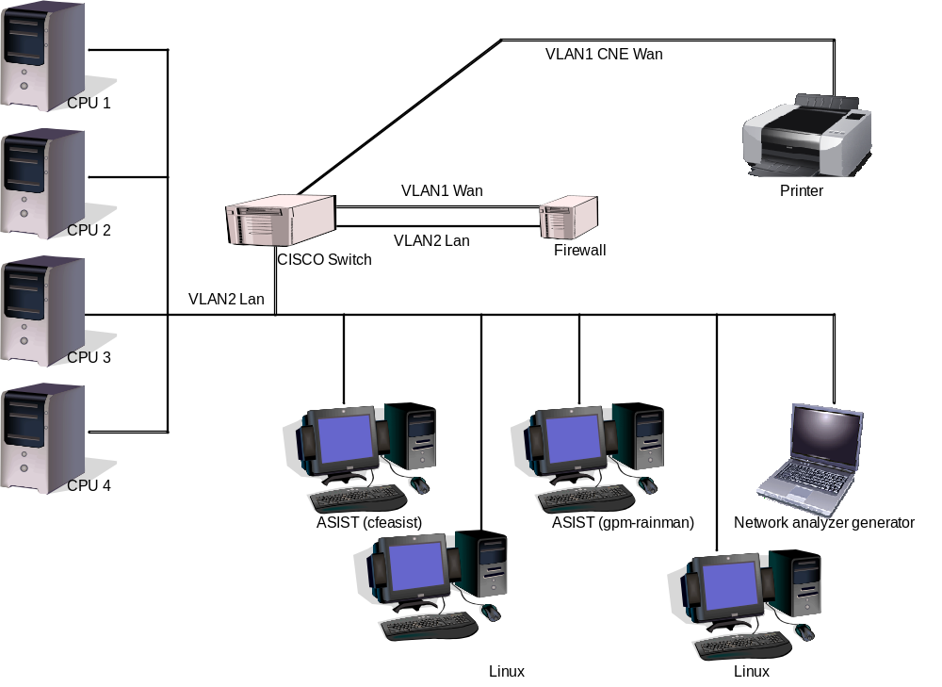
Figure 4-1 CFS FSW Development and Testing Facility

Equipment | Description | Purpose
CPU1 | MPC750 board | Development testing
CPU2 | MPC750 board | Build verification testing
CPU3 | MPC750 board | Build verification testing
Workstation | cfeasist (Dell Dimension 360 running RedHat Linux) | Running ASIST 9.7k for build testing
Workstation | gpm-rainman (Dell Dimension 360 running RedHat Linux) | Running ASIST 9.7k for build testing
Linux Workstation | cfelnx (Dell Precision 470 running RedHat Linux) | FSW Development
Linux Workstation | gpm-raindrop (Dell Precision 420 running RedHat Linux) | Serial port communications to flight CPUs from cfeasist & gpm-rainman
Network analyzer generator | PC running Wireshark | Communications diagnostics
Cisco Switch | 2900 series with 2 VLAN’s | Managed switch, allows port sniffing and VLANs
Firewall | Mini PC running Monowall | Lab firewall
Printer
4 port RS 232 Serial | Keyspan 49WLC 4-port USB Serial Adapter | Serial port communications to flight CPUs
VLAN2 Lan
VLAN1 CNE Wan

Requirements Verification Matrix

 | Scheduler (SCH)
Requirements Tested Passed | 48
Requirements Tested Failed | 0
Requirements Tested Partially | 0
Total Tested | 48
Deferred | 0
Total | 48

Requirements Partially Tested
No requirements were partially tested.

Requirements/Functionality Deferred
No requirements were deferred.

Requirements/Functionality Deferred for Mission Testing

No functionality was deferred to mission testing.

Build Verficiaton Test Results

Overall Assessment
During this build test of the SCH Application the software behaved as expected with the exception of the OS Timer Accuracy, which prompted the Scheduler Application to send slots at a minimum of 16.667 ms (10ms is expected). This however, is an artifact of the test environment and is not caused by the SCH Application. Below is a summary of the results:
- 47 requirements passed via demonstration
- 1 requirement was validated by analysis.
- 2 DCRs were verified.

Procedure Description

Procedure | Description | Requirements tested
SCH_GenCmds | The purpose of this test is to verify the Scheduler (SCH) general commands function properly. The NOOP and Reset Counters commands will be tested as well as invalid commands to see if the SCH application handles these appropriately. | SCH1000; SCH1001; SCH1002; SCH1004; SCH1005; SCH8000; SCH9000; SCH9001
SCH_Timing_Analysis | The purpose of this test is to verify the Scheduler (SCH) Application responds correctly to changes in the schedule and message definition tables. It also verifies the timing of the SCH schedule and message definition table processing. This test also verifies that the SCH application handles anomalies appropriately. | SCH1002; SCH1004; SCH1005; SCH2000; SCH2001; SCH2002; SCH3000; SCH3001; SCH3001.1; SCH3002; SCH3003; SCH3003.1; SCH4000; SCH4000.1; SCH4000.2; SCH4001; SCH4001.1; SCH4001.2; SCH4002; SCH4002.1; SCH4003; SCH4003.1; SCH4004; SCH4005; SCH8000; SCH9000; SCH9001
SCH_Functional_Test | The purpose of this test is to verify the Scheduler (SCH) Application responds correctly and timely to definition changes in the schedule and message table in order to the enabling/disabling of individual activities. This test also verifies that the SCH application handles anomalies appropriately. | SCH2000; SCH2002; SCH2003; SCH2003.1; SCH2003.2; SCH2003.3; SCH2003.4; SCH2004; SCH2005; SCH2006; SCH2006.1; SCH2006.2; SCH2006.3; SCH2006.4; SCH2006.5; SCH2007; SCH2007.1; SCH2007.2; SCH2007.3; SCH2007.4; SCH2007.5; SCH8000; SCH9000; SCH9001
SCH_Lib_Test | The purpose of this test is to verify that the SCH application supports the schedule library functions properly. These functions allow an external application to control the enabling/disabling of the SCH application’s activity processing. | SCH8000; SCH9000; SCH9001

Analysis Requirements Verification
The following requirements were verified using analysis:

Requirement | Description | Status | Justification
SCH2001 | The Schedule Definition Table shall schedule activities with a minimum minor frame resolution of <PLATFORM_DEFINED, 10> milliseconds and a major frame resolution of <PLATFORM_DEFINED, 1> | Pass | The Timing Analysis test procedure scheduled a large amount of NOOP commands in Step 2.1. The resolution can be determined by viewing the log file.

DCRs
No new DCRs were generated during SCH 2.2.0.0 testing

DCRs Verified
The following DCRs were verified during testing:

DCR | Description | Test Method | Test Approach
17271 | SCH – Remove Table Compiler Warning from Default Table(s) | Test Procedure | There were no compiler warnings generated during the table make process.
18259 | SCH – Commands that Modify Tables Do Not Prevent Checksum Errors | Test Procedure | The scx_cpu3_sch_dcr18259test.prc procedure was created to test this DCR. The SCH.SCHED_DEF table was put into the Tables Definition Table for the Checksum (CS) application to automatically checksum each cycle. The CS and TST_CS applications were then started. The SCH_EnableGroup, SCH_DisableGroup, SCH_EnableEntry and SCH_DisableEntry commands were sent with delays in between each command to allow for sufficient time for the CS application to determine if the table's checksum has changed.

Outstanding DCRs
The following outstanding DCRS are written against the Scheduler application:

DCR | Description
18919 | SCH – Timer Configuration Issues

Notes
- DCR #17271 was verified with a patch to the cFE 6.3.2.0 Table Services table file header macro CFE_TBL_FILEDEF. The Table Services table file header macro fix will be included in cFE 6.4.0.0.
- Integration testing is the ultimate verification of the SCH applications performance in a system-like scenario.

- RTTM
The SCH Build 2.2.0.0 RTTM can be found on the MKS server, in CFS-Repository SCH test-and-ground directory results folder.
- Command, Telemetry, and Events Verification Matrix

Command | Test Procedure(s) | Notes/Comments
SCH_NOOP | sch_gencmds
SCH_RESETCTRS | sch_funnctional_test; sch_gencmds
SCH_ENABLEENTRY | sch_funnctional_test; sch_timing_analysis
SCH_DISABLEENTRY | sch_funnctional_test; sch_timing_analysis
SCH_DISABLEGROUP | sch_funnctional_test; sch_lib_test; sch_timing_analysis
SCH_ENABLEGROUP | sch_funnctional_test; sch_lib_test; sch_timing_analysis
SCH_ENABLESYNC | sch_funnctional_test; sch_timing_analysis
SCH_SENDDIAG | sch_timing_analysis

Telemetry | Test Procedure(s) | Notes/Comments
SCH_CMDPC | sch_gencmds; sch_functional_test; sch_timing_analysis
SCH_CMDEC | sch_gencmds; sch_functional_test; sch_timing_analysis
SCH_SYNCTOMET | sch_gencmds; sch_functional_test; sch_timing_analysis
SCH_MAJORFRAMESOURCE | sch_gencmds; sch_lib_test; sch_functional_test; sch_timing_analysis
SCH_ACTSUCCESSCTR | sch_gencmds; sch_lib_test; sch_functional_test; sch_timing_analysis
SCH_ACTFAILURECTR | sch_gencmds; sch_lib_test; sch_functional_test; sch_timing_analysis
SCH_SLOTPROCCTR | sch_gencmds; sch_lib_test; sch_functional_test; sch_timing_analysis
SCH_SKIPSLOTCTR | sch_gencmds; sch_lib_test; sch_functional_test; sch_timing_analysis
SCH_MULTSLOTCTR | sch_gencmds; sch_lib_test; sch_functional_test; sch_timing_analysis
SCH_SAMESLOTCTR | sch_gencmds; sch_lib_test; sch_functional_test; sch_timing_analysis
SCH_BADTBLDATACTR | sch_gencmds; sch_lib_test; sch_functional_test; sch_timing_analysis
SCH_TBLPASSVERIFYCTR | sch_gencmds; sch_lib_test; sch_functional_test; sch_timing_analysis
SCH_TBLFAILVERIFYCTR | sch_gencmds; sch_lib_test; sch_functional_test; sch_timing_analysis
SCH_TBLPROCCTR | sch_gencmds; sch_lib_test; sch_functional_test; sch_timing_analysis
SCH_VALIDMFCTR | sch_gencmds; sch_lib_test; sch_functional_test; sch_timing_analysis
SCH_MISSMFCTR | sch_gencmds; sch_lib_test; sch_functional_test; sch_timing_analysis
SCH_UNEXPCTDMFCTR | sch_gencmds; sch_lib_test; sch_functional_test; sch_timing_analysis
SCH_MINORSINCETONE | sch_gencmds; sch_lib_test; sch_functional_test; sch_timing_analysis
SCH_NEXTSLOT | sch_gencmds; sch_lib_test; sch_functional_test; sch_timing_analysis
SCH_LASTSYNCMETSLOT | sch_gencmds; sch_lib_test; sch_functional_test; sch_timing_analysis
SCH_IGNOREMF | sch_gencmds; sch_lib_test; sch_functional_test; sch_timing_analysis
SCH_UNEXPCTDMAJORFRAME | sch_gencmds; sch_lib_test; sch_functional_test; sch_timing_analysis
SCH_ENTRYSTATES[]
SCH_MSGIDS[]

Table Telemetry | Test Procedure(s) | Notes/Comments
SCH_DefaultMessageTable[].MessageBuffer[] | sch_badmdttables; sch_mdtloadfile
SCH_DefaultScheduleTable[].EnableState | sch_badsdttbls; sch_sdt2; sch_sdt3; sch_sdtloadfile;
SCH_DefaultScheduleTable[].SE_Type | sch_badsdttbls; sch_functional_test; sch_sdt2; sch_sdt3; sch_sdtloadfile;
SCH_DefaultScheduleTable[].SE_Frequency | sch_badsdttbls; sch_functional_test; sch_sdt2; sch_sdt3; sch_sdtloadfile;
SCH_DefaultScheduleTable[].Remainder | sch_badsdttbls; sch_sdt2; sch_sdt3; sch_sdtloadfile;
SCH_DefaultScheduleTable[].MessageIndex | sch_badsdttbls; sch_sdt2; sch_sdt3; sch_sdtloadfile;
SCH_DefaultScheduleTable[].GroupData | sch_badsdttbls; sch_sdt2; sch_sdt3; sch_sdtloadfile;

 | Event Message Ids | Test Procedure(s) | Notes/Comments
1 | SCH_INITSTATS_INF_EID | sch_gencmds; sch_functional_test; sch_lib_test; sch_timing_analysis
2 | SCH_APP_EXIT_EID
3 | SCH_CR_PIPE_ERR_EID
4 | SCH_SUB_HK_REQ_ERR_EID
5 | SCH_SUB_GND_CMD_ERR_EID
7 | SCH_SDT_REG_ERR_EID
8 | SCH_MDT_REG_ERR_EID
9 | SCH_SDT_LOAD_ERR_EID
10 | SCH_MDT_LOAD_ERR_EID
11 | SCH_ACQ_PTR_ERR_EID
12 | SCH_MINOR_FRAME_TIMER_CREATE_ERR_EID
13 | SCH_MINOR_FRAME_TIMER_ACC_WARN_EID | sch_gencmds; sch_functional_test; sch_lib_test; sch_timing_analysis
14 | SCH_MAJOR_FRAME_SUB_ERR_EID
15 | SCH_SEM_CREATE_ERR_EID
16 | SCH_SAME_SLOT_EID | sch_functional_test; sch_gencmds; sch_lib_test;
17 | SCH_SKIPPED_SLOTS_EID | sch_functional_test;
18 | SCH_MULTI_SLOTS_EID | sch_functional_test;
19 | SCH_CORRUPTION_EID
20 | SCH_PACKET_SEND_EID
21 | SCH_NOISY_MAJOR_FRAME_ERR_EID | sch_functional_test; sch_lib_test;
30 | SCH_SCHEDULE_TBL_ERR_EID | sch_functional_test;
31 | SCH_SCHEDULE_TABLE_EID | sch_functional_test; sch_timing_analysis
32 | SCH_MESSAGE_TBL_ERR_EID | sch_functional_test;
33 | SCH_MESSAGE_TABLE_EID | sch_functional_test;
40 | SCH_NOOP_CMD_EID | sch_gencmds; sch_lib_test; sch_functional_test; sch_timing_analysis
41 | SCH_RESET_CMD_EID | sch_gencmds; sch_functional_test;
42 | SCH_ENABLE_CMD_EID | sch_functional_test; sch_timing_analysis
43 | SCH_DISABLE_CMD_EID | sch_functional_test; sch_timing_analysis
44 | SCH_ENA_GRP_CMD_EID | sch_functional_test; sch_lib_test; sch_timing_analysis
45 | SCH_DIS_GRP_CMD_EID | sch_functional_test; sch_lib_test; sch_timing_analysis
46 | SCH_ENA_SYNC_CMD_EID | sch_functional_test; sch_timing_analysis
47 | SCH_SEND_DIAG_CMD_EID | sch_timing_analysis
50 | SCH_ENABLE_CMD_ARG_ERR_EID | sch_timing_analysis
51 | SCH_ENABLE_CMD_ENTRY_ERR_EID | sch_timing_analysis
52 | SCH_DISABLE_CMD_ARG_ERR_EID | sch_timing_analysis
53 | SCH_DISABLE_CMD_ENTRY_ERR_EID | sch_timing_analysis
54 | SCH_ENA_GRP_CMD_ERR_EID | sch_timing_analysis
55 | SCH_ENA_GRP_NOT_FOUND_ERR_EID | sch_timing_analysis
56 | SCH_DIS_GRP_CMD_ERR_EID | sch_timing_analysis
57 | SCH_DIS_GRP_NOT_FOUND_ERR_EID | sch_timing_analysis
58 | SCH_CC_ERR_EID | sch_gencmds;
59 | SCH_MD_ERR_EID
60 | SCH_CMD_LEN_ERR_EID | sch_gencmds; sch_timing_analysis

