EUROPA 2.0 Install Guide
October 2005
europa-help@nx.mail.arc.nasa.gov
Nasa Ames Research Center,
Moffett Field, CA 94035

1 Introduction 1
2 Software requirements 2
2.1.1 Operating System 2
2.1.2 Compilers 2
2.1.3 Build tools 3
2.1.4 Documentation Generation Tool 3
2.1.5 MySQL Relational Database 3
3 Installing EUROPA 4
3.1 Unpacking the EUROPA software 4
3.2 Accessing the Documentation 4
3.3 Configuring your Software Environment 5
3.3.1 Setting your PATH 5
3.3.2 Setting your LD_LIBRARY_PATH 5
3.3.3 Setting your JAVA_HOME 5
3.3.4 Setting your OSTYPE 5
3.3.5 Setting your PLANWORKS_HOME 6
3.3.6 Example .cshrc file settings 6
3.3.7 Verify settings with “checkreqs” 6
3.4 Building the PLASMA Engine 7
3.5 Testing the PLASMA Engine 7
3.6 Building the PlanWorks interface 8
3.7 Testing the PlanWorks interface 8
4 Checklists 9
4.1 Environment Variables 9
4.2 Software Requirements 10
5 Frequently Asked Questions 11

Table of FIGURES
Figure 1: Trace of PLASMA Engine build ouptut 7
Figure 2: PlanWorks initial screen 8

Introduction
This guide will take you through the installation of EUROPA. It is structured as follows
- Section 2: lists the software that must be installed on your system before EUROPA can be installed. The time required by this stage depends upon how much of the perquisite software is already installed on your system. You may require the assistance of a systems administrator.
- Section 3: describes the EUROPA installation and testing process. This stage should take around one hour and requires some simple editing of environment configuration files.
- Section 4: provides stand alone check lists for the environment variable and software perquisites together with a list of frequently asked questions that our user community has raised while reading this guide.
- Section 5: lists the frequently asked questions raised by users during the installation of the system.
A comprehensive Users’ Guide supports this quick start guide. This guide will become available one you have installed and built EUROPA.

Software requirements
We require that you use one of the supported operating systems and have the following compilers, build tools, documentation generation tool, and relational database installed before using EUROPA.. Note that the MySQL database is only used by PlanWorks You may omit it if you plan to use only PLASMA.

Operating System
EUROPA is built and tested on the following platforms
- Red Hat Linux 2.4
- OS X 3.2 (Jaguar), 3.3 (Panther), and 3.4 (Tiger)
- Solaris 5.8

Compilers
Compiler software is required to translate the EUROPA source code shipped to you into an executable application. EUROPA is composed of C++ and Java source code.
- gcc 3.3.3 to gcc 4.0
  - gcc ships with our supported operating systems. Please see your system documentation for details on how to install it.
- Java 1.42 or higher.
  - Java can be downloaded from http://java.sun.com/

Build tools
Build tool software is required to orchestrate the compiler software in building the system. The PLASMA engine uses the Jam build tool rather than the more common make tool. Jam is open source and freely available.
- Jam 2.4 or higher
  - http://www.perforce.com/jam/jam.html

The PlanWorks interface uses the Ant build tool. Ant is a free tool provided by the apache project.

- Ant
  - http://ant.apache.org/

Documentation Generation Tool
EUROPA uses the doxygen tool to build its hyperlinked documentation

- doxygen 1.2.16 or higher
  - http://www.doxygen.org/

MySQL Relational Database
The PlanWorks interface requires that the MySQL database server be installed. This is an open source database available for all the operating system platforms that support EUROPA .
- MySQL version 4.013, 4.018, 4.1.1, and 4.1.7
  - http://www.mysql.com/

Installing EUROPA

Unpacking the EUROPA software
EUROPA ships as a single file that must be unpacked before it can be used. Using your operating systems command line shell change directory to the location where you want the system installed then enter the following two commands in sequence (substitute <version> for the actual version number shipped to you).

gzip –d EUROPA-<version>.gzip
tar –x EUROPA-<version>.tar

Note the location where you unpacked the system. We will refer to this as your install-directory throughout this guide. Your install-directory will contain two directories: PLASMA for the PLASMA engine and PlanWorks for the PlanWorks user interface.

Accessing the Documentation
Enter the Documentation directory and type “jam documentation” to build the documentation. Go into the html directory produced and select the index.html file as soon as the documentation is built.

Configuring your Software Environment
This section details the software environment variable settings required by EUROPA. It assumes that you are familiar with Unix shells. Please see your operating system’s documentation for details. All examples use cshell but are readily adapted to other shells.

Setting your PATH

Your PATH variable must include the locations of your Ant, gcc, Jam, Java, and Doxygen installations. If you don't know the locations, you can use the find commands listed below to help locate the executables. Then look for the directory the actual executable is in. Often, but not always, this is a "bin" directory.

find /usr -name ant*
find /usr -name gcc-*
find /usr -name 'j2sdk1.*' -o -name 'jdk1.*'
find /usr -name 'jam2.*'
find /usr -name doxygen

Setting your LD_LIBRARY_PATH
Your LD_LIBRARY_PATH (DYLD_LIBRARY on the Mac) must include the locations of your gcc and the EUROPA shared libraries. The shared libraries are relative to the location where you unpacked the system (section 3).

<install-directory>/PLASMA/lib

Setting your JAVA_HOME
Your JAVA_HOME must point to the location where you installed Java

Setting your OSTYPE
You must define a OSTYPE environment variable for the PlanWorks interface. Darwin is the name used for the Apple OS X operating system.
OSTYPE = linux | solaris | darwin

Setting your PLANWORKS_HOME
You need a PLANWORKS_HOME variable that points to the directory where you installed PlanWorks.
PLANWORKS_HOME <install-directory>/PlanWorks

Example .cshrc file settings
The following fragment is taken from a EUROPA user’s .csrhc file. It illustrates the necessary settings but is specific to the actual locations where the software was installed on this person’s computer. It is included only as a guide to assist you.

setenv JAVA_HOME /usr/java/j2sdk1.4.2_04
setenv JAM_HOME /usr/local/jam2.5
setenv GCC_HOME /user/local/gcc-3.3.3/bin
setenv ANT_HOME /usr/local/apache-ant/

set path = ( ${path} $JAVA_HOME )
set path = ( ${path} $GCC_HOME
set path = ( ${path} $JAM_HOME )
set path = ( ${path} $ANT_HOME )

setenv LD_LIBRARY_PATH /usr/local/gcc-3.3.3/lib
setenv LD_LIBRARY_PATH "$LD_LIBRARY_PATH":/home/uname/europa/PLASMA/lib

setenv OSTYPE Darwin
setenv PLANWORKS_HOME /user/uname/EUROPA/PlanWorks

Verify settings with “checkreqs”
We provide a script for automatically checking that the environment settings have been made correctly. Enter the following command into your operating system’s command line shell.

<install-directory>/PLASMA/checkreqs

The script will report if there are problems with the above settings. Please return to the relevant section and check for typographical errors and confirm that the paths you have entered do lead to the desired file

Building the PLASMA Engine

We are now ready to build the system. Enter the following command into your operating system’s command line shell.

<install-directory>/PLASMA/jam

This will initiate the building process that will take approximately one hour depending on the speed of your computer. The following is a small fragment of the trace information you should see as the system builds.

/users/uname/EUROPA/PLASMA > jam
...patience...
...found 1168 target(s)...
...updating 563 target(s)...
MkDir1 lib
MkDir1 Utils/objects
C++ Utils/objects/LockManager_g_pic.o
C++ Utils/objects/Debug_g_pic.o
C++ Utils/objects/LabelStr_g_pic.o
C++ Utils/objects/Entity_g_pic.o
C++ Utils/objects/Error_g_pic.o
…
…
…
Chmod1 System/test/gnats_2572_interval-tx_g_rt
C++ System/test/stackGenerator.o
Link System/test/stackGenerator
Chmod1 System/test/stackGenerator
...updated 563 target(s).
Figure 1: Trace of PLASMA Engine build ouptut
Problems are reported as “failed targets.” If this occurs please rerun the checkreqs script and verify your installation settings. If the system still will not build the please contact the EUROPA team using the e-mail address on the front of this guide for assistance

Testing the PLASMA Engine

We are now ready to test that the newly built system is operating correctly. Enter the following command into your operating system’s command line shell.

<install-directory>/PLASMA/jam run-install-tests

The tests should take around ten minuets to run depending on your computers performance. There should be no errors reported. Contact the EUROPA team using the e-mail address on the front of this guide for assistance

Building the PlanWorks interface
You must copy the following files from your MySQL installation into your PlanWorks installation.
- Copy the binary files from your mysql install to <install-directory>/PlanWorks/lib/mysql/bin.
- Overwrite the files in <install-directory>/PlanWorks/lib/mysql/share/mysql/English/ with the files in path-to-your-mysql/share/mysql/English.
You may need to edit the build.xml file in the PlanWorks directory to set the "mysql.custom.bindir” property to the location where you’ve installed PlanWorks.
Enter your PlanWorks directory from your operating systems command line shell and type the following command to initialize the systems database. This only has to be once for an installation.
ant planWorksDbInstall
Next enter the following command to create the JNI (Java Native Interface) for controlling the PLASMA engine. This only has to be done once for an installation.
ant createJNI
Now build and run the PlanWorks tool with the following command.
ant

Testing the PlanWorks interface
Typing ant within the PlanWorks directory will display the application screen shown in Figure 2 if PlanWorks is correctly installed. For the moment simply exit PlanWorks using the File menu at the top left menu bar.
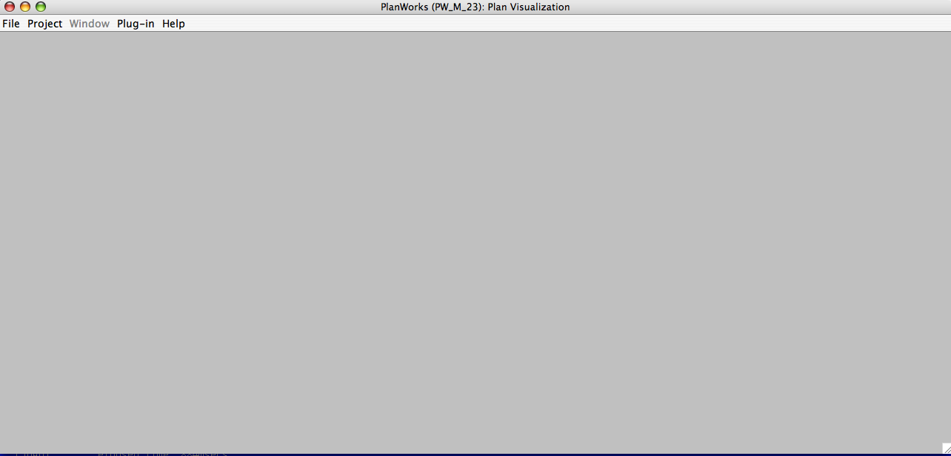
Figure 2: PlanWorks initial screen

Congratulations! You have installed and tested EUROPA!

Checklists

Environment Variables
This is a sample set of Euorpa₂ environment variable settings. The actual paths will depend upon where the software is installed on your system. We have included it as a guide for you to check your settings against.

setenv JAVA_HOME /usr/java/j2sdk1.4.2_04
setenv JAM_HOME /usr/local/jam2.5
setenv GCC_HOME /user/local/gcc-3.3.3/bin
setenv ANT_HOME /usr/local/apache-ant/

set path = ( ${path} $JAVA_HOME )
set path = ( ${path} $GCC_HOME
set path = ( ${path} $JAM_HOME )
set path = ( ${path} $ANT_HOME )

setenv LD_LIBRARY_PATH /usr/local/gcc-3.3.3/lib
setenv LD_LIBRARY_PATH "$LD_LIBRARY_PATH":/home/uname/europa/PLASMA/lib

setenv OSTYPE Darwin
setenv PLANWORKS_HOME /user/uname/EUROPA/PlanWorks

Software Requirements

Operating System | - Red Hat Linux 2.4 or  - OS X 3.2 (Jaguar), 3.3 (Panther), and 3.4 (Tiger) or  - Solaris 5.8
Compilers | - gcc 3.3.3 to gcc 4.0  - Java 1.42 or higher.
Build Tools | - Jam 2.4 or higher  - Ant
Documentation Generation Tools | - doxygen 1.2.16 or higher
MySQL Relational Database | - MySQL version 4.013, 4.018, 4.1.1, and 4.1.7

Frequently Asked Questions
This section will be populated as we gain experience with users and encounter problems.

