Europa₂ Project Plan

October to December 2005

Last Revised
10/20/05

Gantt Chart

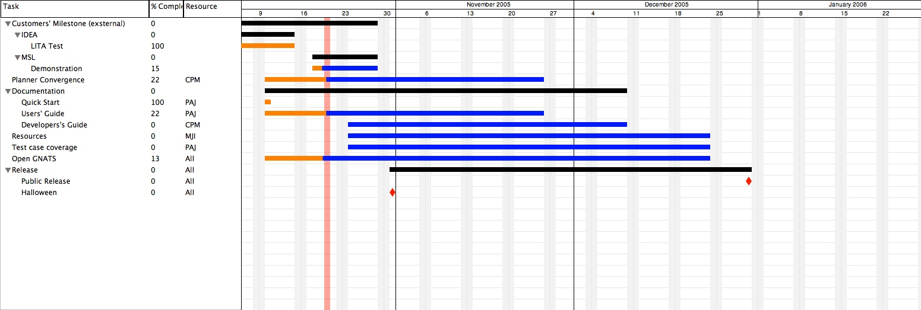

Detailed Work Break Down Structure

Planner Convergence

Task | Due Date | Status

Documentation

Task | Due Date | Status
Quick Start | 10/9 | Completed. Review comments from Jeremy integrated.
Users’ Guide
Planning  Background |  | Written. Ready for review.
Hello World Tutorial |  | Written. Ready for review.
Rover Tutorial | 10/21 | In progress.
Case Studies
Lorax |  | Not started
Reference
System architecture
CSP Primer |  | Needs reviewing and reorganizing
NDDL Ref |  | Needs reviewing and completing
Solver Ref |  | Not started
Plan Dbase Ref |  | Not started
System Ref
Build options |  | Completed
Debugging |  | Not started
Performance |  | Not started
Developers notes |  | Needs pasting from old manual

Resources
Task | Due Date | Status

Test Case Coverage
Task | Due Date | Status

Open Gnats

Release

Task | Due Date | Status
Halloween release | 10/30
End of year release | 12/30

