 | CORE FLIGHT SYSTEM  CCSDS File Delivery Protocol APPLICATION  BUILD 2.2.1.0  FLIGHT SOFTWARE BUILD VERIFICATON  TEST REPORT  Flight Software Branch – Code 582  Version 1.0

Signatures
Submitted by:

_______________________________________ _______________
Walt Moleski/582 Date
CFS Flight Software Tester

Approved by:

_______________________________________ _______________
Charlie WIldermann/582 Date
Flight Software Branch/Head

_______________________________________ _______________
Susanne Strege / 582 Date
CFS Flight Software Product Development Lead

Plan Update History
Version | Date | Description | Affected Pages
Draft | 2/27/12 | draft release | All
1.0 | 2/27/12 | Initial release | All

Table of Contents
1 Introduction 1
1.1 Document Purpose 1
1.2 Applicable Documents 1
1.3 Document Organization 1
1.4 Definitions 2
2 OVERVIEW 3
2.1 Flight Data System Context 3
2.2 Test History 7
2.3 Testing Overview 7
2.4 Version Information 11
3 Build Verification Test Preparation 12
3.1 Scenerio Development 12
3.2 Procedure Development and Execution 12
3.3 Test Products 12
4 Build Verification Test Execution 13
4.1 Testbed Overview 13
4.2 Requirements Verification Matrix 14
4.3 Requirements Partially Tested 14
4.4 Requirements/Functionality Deferred 14
4.5 Requirements/Functionality Deferred For Mission Testing 14
5 Build Verficiaton Test Results 15
5.1 Overall Assessment 15
5.2 Procedure Description 15
5.3 Analysis Requirements Verification 17
5.4 Failed Requirements 17
5.5 DCRs 18
5.5.1 DCRs Verified 18
5.5.2 Outstanding DCRs 18
5.6 Notes 19
5.7 Follow-on 19
Appendix A - RTTM 21
Appendix B - Command, Telemetry, and Events Verification Matrix 22

Introduction

Document Purpose

This Test Report describes the test results from the Core Flight System (CFS) CCSDS File Delivery Protocol (CF) Flight Software (FSW) Test Team build 2.2.1.0 verification testing. It is used to verify that the CF FSW has been tested in a manner that validates that it satisfies the functional and performance requirements defined within the CFS CF Requirements Document. This Test Report summarizes the FSW test history, the build verification process, the build test configuration, and the test execution and results.

Applicable Documents
Unless otherwise stated, these documents refer to the latest version.

Parent Documents (Mission and FSW)

- 582-2009- 006 CFS CF Requirements Document, Version 1.2
- 582-2008-012 CFS Deployment Guide

Reference Documents

All of the references below can be found on the Code 582 internal website at http://fsb.gsfc.nasa.gov/

- 582-2003-001 FSB FSW Test Plan Template
- 582-2004-001 FSB FSW Test Description Template
- 582-2004-002 FSB FSW Test Scenario Template
- 582-2004-003 FSB FSW Test Procedure Template
- 582-2004-004 FSB FSW Test Execution Summary Template
- 582-2004-005 FSB Test Product Peer Review Form
- 582-2000-002 FSB FSW Unit Test Standard

Document Organization
Section 1 of this document presents some introductory material.
Section 2 provides a flight software overview and context along with the test history and testing overview.
Section 3 describes the build verification process including procedure development and execution and test products produced.
Section 4 describes the build test configuration which includes an overview of the testbed and the requirements verification matrix.
Section 5 describes the test execution and results by subsystem.
Appendix A - provides the Requirements Traceability Matrix
Appendix B - provides the Command, Telemetry, and Events Verification Matrix

Definitions
There were 3 verifications methods used during build verification testing. They were:
- Demonstration: Show compliance with system requirement by exhibiting the required capability (e.g. by demonstrating interactive capability, display capability, print capability, etc.
- Inspection: Show compliance with a system requirement by visual verification of the software (e.g. verifying preparation for delivery, proper interfacing)
- Analysis: Perform detailed analysis of code, generated data (both intermediate data and final output data), etc., to determine compliance with system requirements.

The fields in the Requirements Verification Matrix in Section 4.3 are defined as follows:
- Requirements Tested Passed: Requirement was fully tested in a build test procedure and passed all tests.
- Requirements Tested Failed: Requirement was fully tested in a build test procedure and failed one or more aspect of the testing.
- Requirements Tested Partially: Requirement was tested partially in a build test procedure. To be fully tested, the partially tested requirement is either tested additionally in one or more other test procedures within the same build and/or other aspects of the requirement must be tested in a later build, due to capabilities not present in the current build
- Total Tested: Total number of requirements fully tested in a build test procedure. Includes total passed and total failed, but does not include requirements tested partially, unless (included as a separate entry) testing in multiple procedures within the same build constitutes total testing of a particular requirement. Total Requirements Tested is computed this way in order to avoid multiple counting of individual requirements that are tested partially in more than one procedure.
- Deferred: Number of requirements that were planned to be tested in current build, but were not tested due to some FSW capability or necessary system component not being present.
- Total: Total Requirements Tested + Number of Requirements Deferred

In each software test section in Section 5 there is a table of DCR’s. The state definitions are as follows:
- Opened: The DCR is currently being addressed
- Assigned: The DCR was accepted and the modification is being addressed
- InTest: The DCR was corrected and is currently in test
- Validated: The DCR was corrected and tested and have been validated, needs to have a CCB to close the DCR
- Closed: The DCR is closed and have been resolved and tested to satisfaction
- Closed with Defect: The DCR is closed and the defect is most likely assigned a differed DCR number associated with another subsystem.

OVERVIEW

Flight Data System Context
Figure 2-1 illustrates the CFS system context. The cFE interfaces to five external systems: an Operating System (OS), a Hardware Platform (HP), an Operational Interface (OI), Applications (APP), and other cFE-based systems.

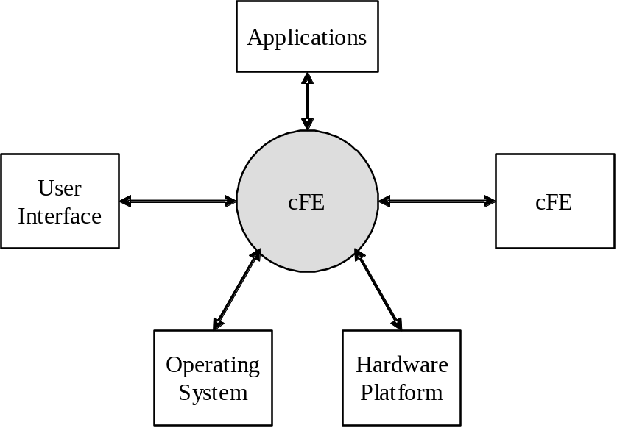

Figure 2-1 CFS System Context

The CFS CF Application provides the interface for transmitting and receiving files to/from the ground. CF utilizes CFDP as defined in the CCSDS 727.0-B-4 Blue Book.

To transfer files in the uplink or downlink direction, both a flight CFDP engine and a ground CFDP engine are required. The flight engine is contained in the CF application. The ground engine is typically integrated into the ground system.

The CFS CF context shows use of a complete CFS, presenting interfaces with other CFS applications. SCH is the CFS scheduler application that submits periodic housekeeping requests and Wake-up commands to CF. Ground commands come from a Command Ingest application (CI). Event messages and housekeeping packets are routed to the appropriate CFS output application, the Housekeeping (HK), Telemetry Output (TO), and/or Data Storage (DS) application. All accesses to the file system(s) are through the OS Abstraction Layer (OSAL) of the cFE.

The CF application has two major components, the CFDP flight engine and an outer layer interface to the engine. The CF application utilizes the CFDP Engine Developed by Code 583, SED Ground Systems Branch. The engine handles the CFDP protocol details and is capable of sending and receiving files simultaneously in Class 1 mode (unreliable) or Class 2 mode (Reliable). Each file transfer is broken down into a series of PDUs that are created by the engine. These PDUs contain file data or protocol messages. The outer layer passes the PDUs from the engine to the Software Bus (SB) for downlink transfers and from the SB to the engine for uplink transfers. The outer layer also provides a ground command interface and sends CF housekeeping data periodically.
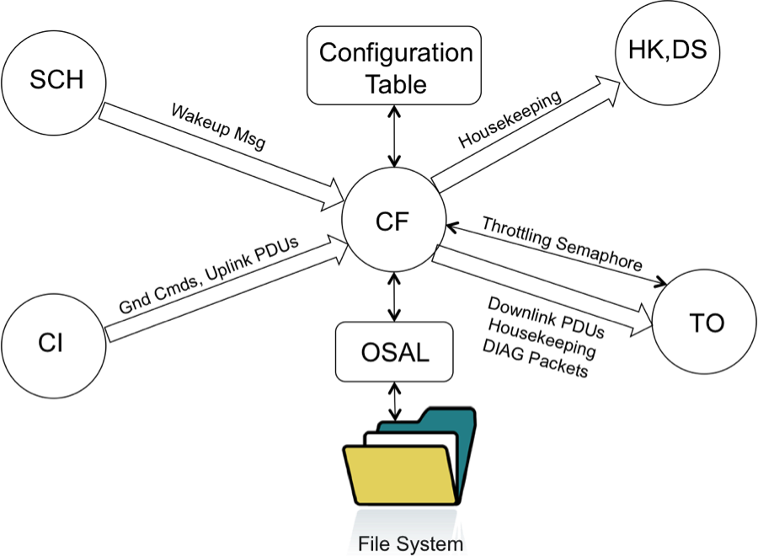

Figure 2.2 – CFS CF Context

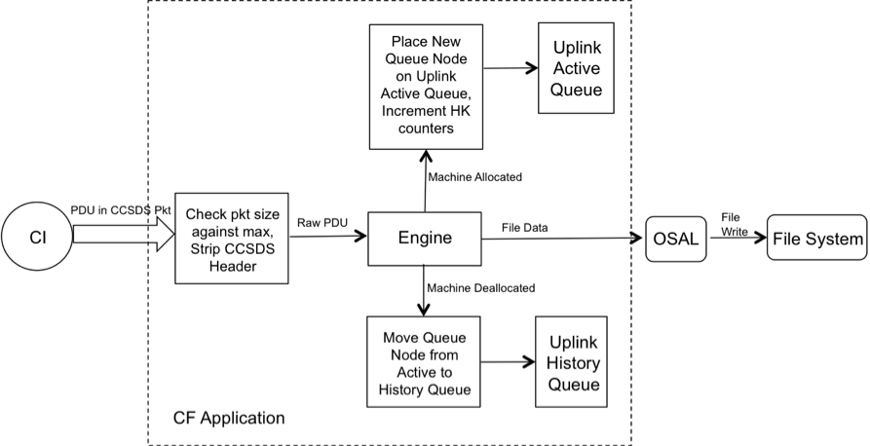
Figure 2.3 – CFS CF Uplink Processing

From the ground point of view, uplink transfers begin when the ground engine receives a put-request. A put-request is a request to the engine to begin outputting a file. In response to this put-request, the engine outputs a series of PDUs until the entire file has been transferred. From the CF application point of view, uplink transfers begin when the flight engine begins receiving the uplink PDUs. A command to the CF application to begin an uplink transfer is not needed and therefore does not exist.

For uplink file transfers, the CF outer layer receives PDUs that are enclosed in CCSDS packets from the Software Bus. The outer layer then strips off the CCSDS header and passes the raw PDU to the engine.
The outer layer does not need to look inside the PDUs. The outer layer maintains an uplink active queue and an uplink history queue. The queue nodes contain information about the transfer. Each node corresponds to one file transfer. When a transfer is active, the information regarding that transfer is held in the active queue. When the transfer is complete the queue node is read from the active queue and placed on the history queue. The CF application has a command to write the queue contents to a file so that it can be viewed on the ground.

The first PDU of a new transfer is a protocol message named meta-data and tells the engine the details of the transfer. In response to the meta-data PDU, the engine creates a temporary file with <PLATFORM_DEFINED, "/ram/cftmp" > directory/basename and leaves it open for writing. The engine will then receive a series of file-data PDUs. The engine writes the file data to the open file. At some point, the flight engine will receive an EOF PDU which tells the engine that all the file data should have been received. In the case of a Class 1 transfer, the engine would respond to the EOF PDU by closing and renaming the temporary file (to the destination path and filename) and performing a checksum test. In the case of a checksum failure, or if the temporary file cannot be renamed, an error event will be sent and the outer layer will count this as a failed transaction.

CF provides a maximum number <PLATFORM_DEFINED, 2> of playback channels. If the system has only one way for files to get to the ground, (such as via the Telemetry Output application) then only one channel is needed. If there is more than one path to the ground, then the CF application can be scaled to have more than one channel. Each channel contains a pending queue, active queue, history queue, throttling semaphore, polling directories, PDU buffer and separate message IDs for PDUs.

A simple playback example would start with the ground sending a CF command to playback a file. The outer layer receives this command from the software bus and stores the filename and other information in the pending queue (rather than giving the request to the engine immediately). The actual transfer does not begin until the flight engine receives a put-request from the outer layer. A put-request is a request to the engine to begin outputting a file.

The outer layer buffers the playback requests in the pending queue (one queue entry per file) so that the engine does not get inundated with transfer requests when a series of 'playback file' commands are received. The outer layer feeds the engine the transfer requests (or put-requests) one at a time. If dequeuing is enabled, the outer layer feeds to engine the transfer requests one at a time.
If there are no files in progress, the outer layer checks the pending queue periodically for playback requests. When a request is found on the pending queue, the outer layer immediately gives the engine a put request to start the transfer (if dequeing is enabled). Once the transfer is in progress, the pending queue is no longer checked periodically for transfer requests. When all the file data of the transaction has been sent, the outer layer gets an EOF-PDU-was-sent indication from the engine. At this time, the outer layer reads the pending queue and gives the engine a put request to start transferring the next file. Also when the outer layer receives a Machine-Allocated indication from the engine, the node representing the new transfer is moved from the pending queue to the active queue. A Machine-Allocated indication is the engines way of specifying that a new file-transfer state machine is created within the engine.

When a transfer is complete, the outer layer gets a Machine-Deallocated indication from the engine. This indication tells the outer layer that the engine has deallocated the internal, file-transfer state machine. In response to this indication, the outer layer moves the corresponding queue node from the active queue to the history queue.
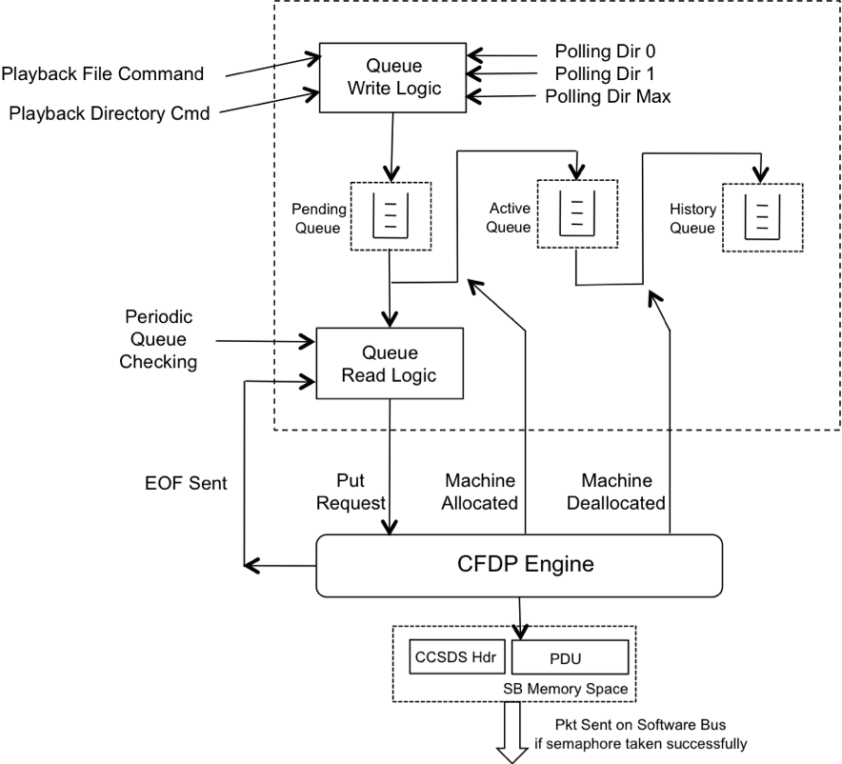

Figure 2.4 – CFS CF Playback Processing

Each playback channel defined in the configuration table has a maximum number <PLATFORM_DEFINED, 8> of polling directories. The user places files for downlink in these directories. CF will check the directories periodically, (at a table defined rate) and place all closed files found in the pending directories on the pending queue. The processing of the polling directories may be turned on or off by command.

The desired file order in the pending queue may vary each mission. It may be based on file age, file size, file name, priority or ‘don’t care’ for maximum performance. The pending queue sorting algorithm is done in a callback routine to provide the most flexibility to each project. As a default, the CFS delivers a single callback routine that sorts the playback pending queue by priority. This callback routine supports up to 256 priority levels. See Appendix B for more information on CF callback routines.

During an active file playback, PDUs are being sent from the engine to the Software Bus. At most one PDU per engine cycle is sent to the Software Bus. This rate may be too fast for the downlink application (ex. Telemetry Output or TO). To accommodate this, CF allows the downlink application to control the flow of downlink PDUs. This is done through a counting semaphore that is ‘given’ by the downlink application and ‘taken’ by the CF application. If the engine has a PDU ready to go out, it first checks with the outer layer to see if it can be released. Based on the response from a semaphore ‘take’, the outer layer will hold off the engine or allow the engine to send the PDU.

As stated above the CF application has one table, the configuration table. This table allows a configurable number of playback channels. It is loaded during initialization and is not checked during run time for updates. It can be updated at anytime, but CF will find the updates only after an application restart. Many table parameters can be changed through command. The Configuration Table parameters include:
- Table Name
- Table Version
- Number of Engine Cycles Per Wake-up
- Number of wake-ups per queue
- Number of wake-ups per polling directory
- Uplink History Queue Depth
- Ack Timeout Value
- Ack Limit Value
- Nak Timeout Value
- Nak Limit Value
- Inactivity Timeout Value
- Outgoing File Chunk Size
- Option to Save Incomplete Files or Not.
- Flight Entity Id
- Uplink Channel Parameters (repeated for each channel)
  - Incoming PDU MsgId
  - Class 2 Response Channel
- Playback Channel Parameters (repeated for each channel)
  - Dequeue Enable
  - Downlink PDU MsgId
  - Pending Queue Depth
  - History Queue Depth
  - Channel Name
  - Handshake Semaphore Name
  - Polling Directory Parameters (repeated for each polling directory)
    - Enable State
    - Class
    - Priority
    - Preserve file
    - Peer Entity Id
    - Source Path
    - Destination Path

Test History
CF 2.1.0.0 – Build Verification Testing completed by Walt Moleski on 11/15/2010
CF 2.2.0.0 – Build Verification Testing completed by Walt Moleski on 05/31/2011
CF 2.2.1.0 – Build Verification Testing completed by Walt Moleski on 02/27/2012

Testing Overview
The CF application was tested during Build Verification testing using the following:
- 2 test applications: tst_cf and tst_cf2
- A modified CI_Lab application to test uplink fault detection.
- 9 main test procedures (listed below)
- 5 test procedures that are called by the main procedures (listed below)
- Header files used in procedures: cf_events.h, cf_platform_cfg.h, cf_defs.h, cf_msgids.h, tst_cf_events.h, tst_cf2_events.h, ut_statusdefs.h, cfe_evs_events.h, cfe_es_events.h
- RDLs used: template_cmd_CF_CMD.rdl, template_file_CF_ACTVTRANS.rdl, template_file_CF_QUEUEINFO.rdl, template_table_CF_CONFIG_TBL.rdl, template_tlm_CF_CONFIG_TLM.rdl, template_tlm_CF_HK_TLM.rdl, template_tlm_CF_TRANS_TLM.rdl, template_cmd_TST_CF_CMD.rdl, template_tlm_TST_CF_HK_TLM.rdl, template_cmd_TST_CF2_CMD.rdl, template_tlm_TST_CF2_HK_TLM.rdl
- Header files used in RDLs: osconfig.h, cf_platform_cfg.h, cf_defs.h, cfe_mission_cfg.h, cfe_file_header.rdl, cfe_tbl_header.rdl, ccsds_header.rdl

The tst_cf test application is used to set CF housekeeping counters, create directories onboard the spacecraft, open and close files onboard the spacecraft, and start and stop the capture of PDU SB messages that are downlinked to the ground. TST_CF has 8 ground commands that are used by the CF test procedures:
- $sc_$cpu_TST_CF_NoOp
  - Input: none
  - Output: Command Accepted counter increased, info event message issued
- $sc_$cpu_TST_CF_ResetCtrs
  - Input: none
  - Output: Command Accepted and Rejected counters set to zero, debug event message issued
- $sc_$cpu_TST_CF_SetCounters
  - Input: none
  - Output: Command Accepted counter increased, debug event message issued
- $sc_$cpu_TST_CF_DirCreate
  - Input: Directory name that you wish to create
  - Output: Command Accepted counter increased, debug event message issued
- $sc_$cpu_TST_CF_Open
  - Input: File name of the file that you wish to open
  - Output: Command Accepted counter increased, debug event message issued
- $sc_$cpu_TST_CF_Close
  - Input: File name of the file that you wish to close
  - Output: Command Accepted counter increased, debug event message issued
- $sc_$cpu_TST_CF_CapturePDUs
  - Input: Message ID of the PDU SB Message to capture
  - Output: Command Accepted counter increased, debug event message issued
- $sc_$cpu_TST_CF_StopPDUCapture
  - Input: None
  - Output: Command Accepted counter increased, debug event message issued

The Handshake application (tst_cf2) is used to control the CF downlink data rate. TST_CF has 3 ground commands that are used by the CF Application Handshake test procedure:
- $sc_$cpu_TST_CF2_NoOp
  - Input: none
  - Output: Command Accepted counter increased, info event message issued
- $sc_$cpu_TST_CF2_ResetCtrs
  - Input: none
  - Output: Command Accepted and Rejected counters set to zero, debug event message issued
- $sc_$cpu_TST_CF2_ProcessPDUs
  - Input: The number of PDUs to process and the channel on which to process them
  - Output: Command Accepted counters is incremented, debug event message issued

These 8 main CF test procedures do the following:

Procedure | Description
template_cf_faultdet.prc | The purpose of this test is to verify that the CCSDS File Delivery Protocol (CF) application detects the faults listed in the requirements.
template_cf_filercv.prc | The purpose of this test is to verify the CCSDS File Delivery Protocol (CF) application adheres to its file receiving requirements.
template_cf_gencmds.prc | The purpose of this test is to verify the CCSDS File Delivery Protocol (CF) application general commands function properly. The NOOP and Reset Counters commands will be tested as well as invalid commands to see if the CF application handles these appropriately.
template_cf_handshake.prc | The purpose of this test is to verify the CCSDS File Delivery Protocol (CF) application can interface with another application for the purpose of controlling the data rate of the downlink.
template_cf_init.prc | The purpose of this test is to verify the CCSDS File Delivery Protocol (CF) initialization requirements are properly implemented.
template_cf_maxtrans.prc | The purpose of this test is to verify the CCSDS File Delivery Protocol (CF) application can handle the maximum simultaneous transactions as specified by the CF_MAX_SIMULTANEOUS_TRANSACTIONS configuration parameter.  NOTE: This test requires an alternate image of the CF application to be generated with the above configuration parameter set to a low number.
template_cf_misccmds.prc | The purpose of this test is to verify the CCSDS File Delivery Protocol (CF) application miscellaneous commands function properly. Both Valid and Invalid commands will be tested to see if the CF application handles these appropriately.
template_cf_playback.prc | The purpose of this test is to verify the CCSDS File Delivery Protocol (CF) application file playback commands function properly. Both valid and invalid commands will be tested to see if the CF application handles these appropriately.
template_cf_quemgmt.prc | The purpose of this test is to verify the CCSDS File Delivery Protocol (CF) initialization requirements are properly implemented.

The 5 test procedures described in the table below are called by the main test procedures.

Procedure | Description
template_cf_badcfgtbls.prc | This procedure creates seven (7) CFS CCSDS File Delivery Protocol (CF) Configuration Table load image files. These files contain:  - An invalid Class  - An invalid Outgoing File Chunk Size  - An invalid Flight Entity ID (value too large)  - An invalid Ground Entity ID (value too large)  - An invalid Ground Entity ID (invalid format)  - An invalid Incoming Message ID  - An invalid Downlink Message ID
template_cf_start_apps.prc | This procedure starts the CF and TST_CF applications if they are not already executing.
template_cf_tbl1.prc | This procedure creates the initial CF Configuration Table load image file. This table only has one enabled playback channel.
template_cf_tbl2.prc | This procedure creates a CF Configuration Table load image file that contains two enabled channels and a Class 1 and Class 2 enabled directory to allow playback under both modes.
template_cf_tbl3.prc | This procedure creates a CF Configuration Table load image file that contains two enabled channels and a Class 1 and Class 2 enabled directory to allow playback under both modes. Also, this table contains a unique message ID for each playback channel.

The CFS Deployment Guide contains the instruction for how to set up both the CFS Flight and Ground test environment. The testers use a CFS Test Account for each build test. This account runs ASIST and is setup to contain all the files needed to test the application. These files are extracted from MKS, the source repository tool. Included in these files are test utilities. These utilities can be located in 2 places depending upon whether they are “local” or “global” utilities. The local utilities are extracted into the working prc directory ($WORK/prc). The global utilities are pointed to by ASIST in the global area defined on the test system. Additional tools utilized by the test procedures are located in the $TOOLS directory. It is assumed that test procedures and the ASIST telemetry database used for testing is built using procedure and database templates

The following utilities were used during testing:
Name | Description
TST_CF (2.2.1.0) | Test CF application
TST_CF2 (2.2.1.0) | CF Handshake test application
CI_Lab (2.1.0.0) | A modified CI_Lab application that captures and drops CF PDUs and manipulates these PDUs to induce faults in the CFDP engine.
CFE_startup | Directive combines the "start_data_center", "open_tlm", and "open cmd <cpu>" ASIST startup commands.
CFE_shutdown | Directive combines the "close_data_center" and "exit" ASIST shutdown commands.
FILE_TO_CVT | Used to display file data in a display page
ftp_file | To ftp a file to/from the FSW/GSW.
load_start_app | Procedure to load and start a user application from the $WORK/apps/cpux directory.
ut_runproc | Directive to formally run the procedure and capture the log file.
ut_sendcmd | Directive to send EVS commands Verifies command processed and command error counters.
ut_sendrawcmd | Send raw commands to the spacecraft. Verifies command processed and command error counters.
ut_setrequirements | A directive to set the status of the cFE requirements array.
ut_setupevents | Directive to look for multiple events and increment a value for each event to indicate receipt.
ut_tlmupdate | Procedure to wait for a specified telemetry point to update.
ut_tlmwait | Directive that waits for the specified telemetry condition to be met

Version Information

Item | Version
CF Requirements | 1.2
CF Application | 2.2.1.0
TST_CF Application | 2.2.1.0
CFE | 6.3.1.0
ASIST | 9.7k
VxWorks | 6.4

Build Verification Test Preparation

Scenerio Development
No new scenarios were developed for build verification test 2.2.1.0. All scenarios are stored on the MKS server, in CFS-Repository CF test-and-ground directory within the test-review-packages subdirectory in the Scenarios folder. It should be noted that as CF requirements evolve these scenarios are not updated to reflect any changes made.

Procedure Development and Execution
This build test was completed by running the 9 test procedures. All test procedures were written using the STOL scripting language. The naming convention for files created by the test procedures was: scx_cpu<#>_<procedure name>_GMT.<ext>.

Test Products
Four log files were generated for every procedure that was run. They are defined as follows:
- Logs with the .loge extension list all events sent by the flight software
- Logs with the .logr extension list all requirements that passed validation by demonstration
- Logs with the .logp extension lists all prints that are generated by the test procedure
- Logs with the .logf extension lists everything from the other logs along with the steps in the test procedure
- Logs with the .logs extension lists the SFDU information (if applicable) contained in the full log.

A test summary report is developed in MKS for each procedure by the tester after build testing is completed. All test products are maintained on MKS in the CFS-Repository CF test-and-ground directory.

Build Verification Test Execution

Testbed Overview
CF FSW testing took place in the CFS FSW Development and Test Facility. A high level view of the CFS FSW Test Bed is shown in Figure 4-1. This facility is located in GSFC Building 23, Room N410. This facility consists of two ASIST workstations running ASIST version 9.7K and three MPC750 CPU boards running VxWorks 6.4. CPU1 is primarily used for development testing while CPU2 and CPU3 are used for build verification testing.
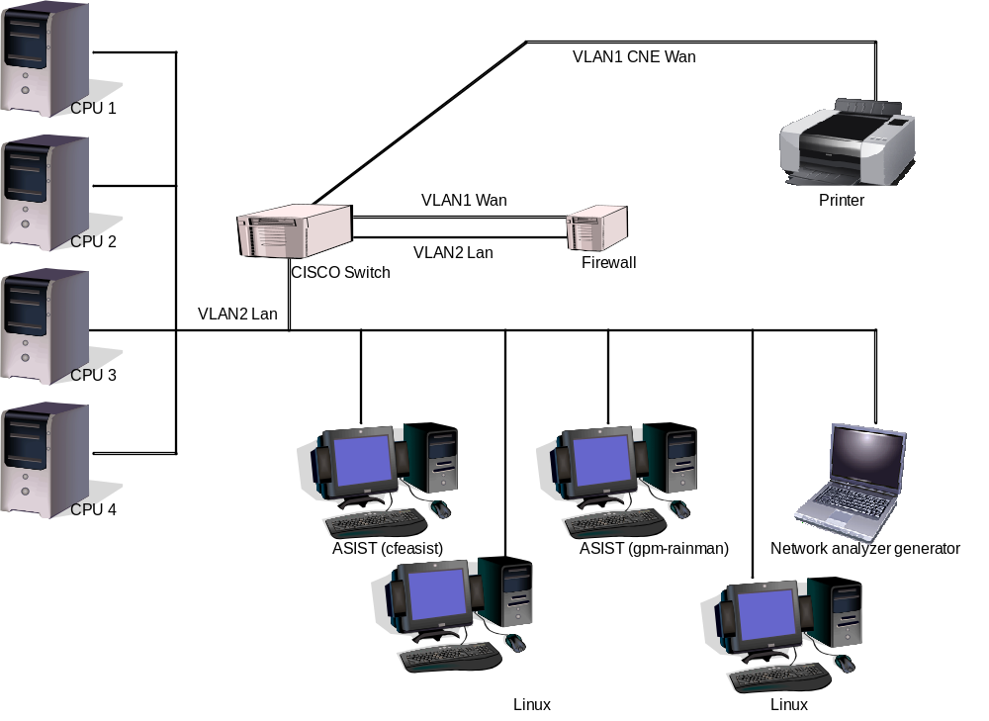
Figure 4-1 CFS FSW Development and Testing Facility

Equipment | Description | Purpose
CPU1 | MPC750 board | Development testing
CPU2 | MPC750 board | Build verification testing
CPU3 | MPC750 board | Build verification testing
Workstation | cfeasist (Dell Dimension 360 running RedHat Linux) | Running ASIST 9.7k for build testing
Workstation | gpm-rainman (Dell Dimension 360 running RedHat Linux) | Running ASIST 9.7k for build testing
Linux Workstation | cfelnx (Dell Precision 470 running RedHat Linux) | FSW Development
Network analyzer generator | PC running Wireshark | Communications diagnostics
Cisco Switch | 2900 series with 2 VLAN’s | Managed switch, allows port sniffing and VLANs
Firewall | Mini PC running Monowall | Lab firewall
Printer
4 port RS 232 Serial | Keyspan 49WLC 4-port USB Serial Adapter | Serial port communications to flight CPUs
VLAN2 Lan
VLAN1 CNE Wan

Requirements Verification Matrix

CCSDS File Delivery Protocol (CF)
Requirements Tested Passed | 68
Requirements Tested Failed | 9
Requirements Tested Partially | 0
Total Tested | 77
Deferred | 0
Total | 77

Requirements Partially Tested
No requirements were partially tested.

Requirements/Functionality Deferred
No requirements were deferred for later build testing

Requirements/Functionality Deferred For Mission Testing
No requirements were deferred for Mission Testing.

Build Verficiaton Test Results

Overall Assessment
During this build test of the CF Application the software behaved as expected with a few exceptions that are documented below. Below is a summary of the results:
- 66 requirements passed demonstration
- 9 requirements failed testing
- 2 requirements were validated by analysis.
- 1 existing DCR was validated

Procedure Description

Procedure | Description | Requirements Tested
template_cf_faultdet.prc | The purpose of this test is to verify that the CCSDS File Delivery Protocol (CF) application detects the faults listed in the requirements. | CF2000; CF2001; CF2002; CF2002.1; CF2002.1.2; CF6000; CF7000
template_cf_filercv.prc | The purpose of this test is to verify the CCSDS File Delivery Protocol (CF) application adheres to its file receiving requirements. | CF1003; CF2000; CF2001; CF2002; CF5012; CF5020; CF5021; CF6000; CF7000
template_cf_gencmds.prc | The purpose of this test is to verify the CCSDS File Delivery Protocol (CF) application general commands function properly. The NOOP and Reset Counters commands will be tested as well as invalid commands to see if the CF application handles these appropriately. | CF1000; CF1001; CF1002; CF1003; CF1004; CF6000; CF7000
template_cf_handshake.prc | The purpose of this test is to verify the CCSDS File Delivery Protocol (CF) application can interface with another application for the purpose of controlling the data rate of the downlink. | CF1003; CF3000; CF3006; CF5005; CF6000; CF7000
template_cf_init.prc | The purpose of this test is to verify the CCSDS File Delivery Protocol (CF) initialization requirements are properly implemented. | CF6000; CF7000; CF7001; CF7001.1; CF7001.1.1
template_cf_maxtrans.prc | The purpose of this test is to verify the CCSDS File Delivery Protocol (CF) application can handle the maximum simultaneous transactions as specified by the CF_MAX_SIMULTANEOUS_TRANSACTIONS configuration parameter.  NOTE: This test requires an alternate image of the CF application to be generated with the above configuration parameter set to a low number. | CF1003; CF3000; CF5013; CF5015; CF6000; CF7000
template_cf_misccmds.prc | The purpose of this test is to verify the CCSDS File Delivery Protocol (CF) application miscellaneous commands function properly. Both Valid and Invalid commands will be tested to see if the CF application handles these appropriately. | CF1002; CF1003; CF1004; CF3000; CF3001; CF5000; CF5001; CF5002; CF5002.1; CF5003; CF5003.1; CF5004; CF5006; CF5006.1; CF5007; CF5007.1; CF5008; CF5008.1; CF5009; CF6000; CF7000
template_cf_playback.prc | The purpose of this test is to verify the CCSDS File Delivery Protocol (CF) application file playback commands function properly. Both valid and invalid commands will be tested to see if the CF application handles these appropriately. | CF1002; CF1003; CF1004; CF3000; CF3000.1; CF3000.2; CF3000.3; CF3000.4; CF3000.5; CF3000.6; CF3001; CF3001.1; CF3001.3; CF3001.5; CF3001.6; CF3001.7; CF3005; CF3005.1; CF3007; CF3008; CF3009; CF5005; CF5005.1; CF5014; CF5015; CF5015.1; CF5016; CF5016.1; CF5017; CF5017.1; CF5018; CF5018.1; CF5019; CF5019.1; CF5020; CF5020.1; CF5021; CF5021.1; CF5022; CF5022.1; CF6000; CF7000
template_cf_quemgmt.prc | The purpose of this test is to verify the CCSDS File Delivery Protocol (CF) initialization requirements are properly implemented. | CF1002; CF1003; CF1004; CF4000; CF4000.1; CF4000.1.1; CF4000.2; CF4000.3; CF4001; CF4001.1; CF4001.2.1; CF6000; CF7000

Analysis Requirements Verification
Requirement | Requirement Text | Analysis
CF3007 | The CF application shall, if there is a series of files to be played back, wait until the engine indicates “EOF Sent” on the file currently being played back before starting playback for the next file in the playback pending queue on the corresponding playback channel. | Step 4.12 of the playback procedure issues a PlaybackDir command for a directory containing 4 files. The log file shows the start transaction followed by an EOF_Sent event message. The subsequent start transactions follow the previous EOF_Sent event message. The final transaction’s EOF_Sent event can be found in Step 4.28.1.
CF5012 | The CF application shall support a maximum uplink PDU size of <PLATFORM_DEFINED> bytes. | Step 2.2 and 2.3 of the filercv procedure issue the CFDP commands to set the PDU size to the maximum and uplink a file. The PDU size is set using a configuration parameter and subtracting the header size from the PDU length since the CFDP engine size refers to the Data size and not the entire PDU.
.

Failed Requirements
The following requirements failed during CF 2.2.1.0 testing:

Requirement | Description | Associated DCR(s)
CF1004 | If CF rejects any command, CF shall abort the command execution, increment the CF Command Rejected Counter and issue an event message. | 15074
CF2002.1.2 | The following faults shall be detected:  - Positive Ack Limit Received  - Deleted  - Deleted  - Filestore Rejection  - File Checksum Failure  - File Size Error  - NAK Limit Reached  - Inactivity Detected  - Deleted  - Suspend Request Received  - Cancel Request Received | 12577
CF5007.1 | The CF application shall issue an error event message and reject the command if there are currently no transactions in progress. (Abandon All) | 13295
CF5015.1 | The CF application shall issue an error event message if there are no transactions in progress. (Cancel All) | 13295
CF5016.1 | The CF application shall issue an error event message and reject the command if the command-specified transaction is not in progress. (Suspend) | 13295
CF5017.1 | The CF application shall issue an error event message and reject the command if there are no transactions in progress. (Suspend All) | 13295
CF5018.1 | The CF application shall issue an error event message and reject the command if the command-specified transaction is not currently suspended. (Resume) | 13295
CF5019.1 | The CF application shall issue an error event message and reject the command if there are no suspended transactions. (Resume All) | 13295
CF7001.1.1 | CF shall validate the following values in the Configuration table:  - Outgoing File Chunk Size  - Flight and Ground Entity Ids  - Message IDs  - CFDP Class 1 or 2 | 12578

DCRs
No new DCRs were generated during CF 2.2.1.0 testing.

DCRs Verified
The following DCRs were verified during CF 2.2.1.0 testing.

DCR | Description | Test Method | Test Approach
18668 | CF: Add function code and command struct to CF 2.2.0 for GPM | Inspection | The changes submitted with this DCR were found in the submitted file. These changes did not cause any new problems with the Build Verification Tests.

Outstanding DCRs
DCR | Description
12033
  CF doesn't build for VxWorks 6.6 (ARC found)
12577
  The Suspend Request Fault noted in requirement 2002.1.2 is not detected upon a suspend command
12578
  An invalid Ground Entity ID is not detected by the CF table Validation function
12998 | CF: Inactivity timer can time-out when cfdp engine is frozen
13053 | CF: Expand users guide to include table parameter details
13149 | CF: Update documentation for CF version 2.2.0
13294 | Event message ID 124 contains a hard-coded value for the actual parameter
13295 | There are several command requirements that CF does not satisfy
14251 | CF: Warnings when compiling (ARC)
14252 | CF_appPipe() doesn’t process OmputChannel Message ID’ (ARC)
14531 | CF: Implement LRO CFDP recommendations
14533 | CD: Issue with same filename on two separate CF entities, from LADEE team
15074 | CF: The Auto Suspend State command accepts an invalid state argument
15586 | CF: Scrub telemetry mnemonics and RDL Descriptions
15600 | CF: Add timer-expired and cancel PDY counters in housekeeping telemetry
15620 | Missing new-line character in CF call to syslog
15720 | CF Engine Change: Remove fault event from engine
15869 | CF: Possible null ptr reference in outgoing success processing
15870 | CF: GPM-IVV-1290 – Possible Buffer Overfolw in cf_utils.c
15948 | CF: No limit on history queue when MAX_TRANSACTIONS_IN_PROGRESS is met
15950 | CF: Consider adding a global enable command
16072 | CF: Function header details are incomplete
16073 | CF: Checksum failures due to missing function calls
17226 | CF: Unit Test gcov option should be updates to filter unwanted header file information
17236 | CF – CFS App Unit Test Makefiles path usage should be consistent
17258 | CF – Uninitialized variable CF_AppData.HkAutoSuspend.LowFreeMark
17261 | CF – Remove Table Compiler Warning from Default Table(s)
17278 | CF – Use FM Internal File Delete Function vs. File Delete Command
18502 | CF: Two problems with auto-suspend processing
18505 | CF – Discard NAKs when Open File Limit is reached

Notes
CF 2.2.1.0 was build specifically for the GPM mission. None of the Build Verification tests were modified to specifically test the changes in this version. Due to the serial nature of the build testing, integration testing is the ultimate verification of the CF applications performance in a system-like scenario.

Follow-on
No follow-on testing was identified for the CF Application.
- RTTM
The CF Build 2.2.1.0 RTTM can be found on the MKS server, in CFS-Repository CF test-and-ground directory results folder.

- Command, Telemetry, and Events Verification Matrix

Command | Test Procedure(s) | Notes/Comments
CF_Noop | GenCmds
CF_ResetCtrs | GenCmds
CF_PlaybackFile | Handshake, MaxTrans, MiscCmds, Playback
CF_PlaybackDir | MiscCmds, Playback
CF_Freeze | MiscCmds
CF_Thaw | MiscCmds
CF_Suspend | Playback
CF_Resume | Playback
CF_Cancel | Handshake, MaxTrans, Playback
CF_Abandon | MiscCmds
CF_SetAckLimit | MiscCmds
CF_SetAckTimeout | MiscCmds
CF_SetInactvTimeout | MiscCmds
CF_SetNakLimit | MiscCmds
CF_SetNakTimeout | MiscCmds
CF_SetSaveIncompFiles | MiscCmds
CF_SetOutgoingSize | Playback
CF_GetAckLimit | MiscCmds
CF_GetAckTimeout | MiscCmds
CF_GetGetInactivTimeout | MiscCmds
CF_GetNakLimit | MiscCmds
CF_GetNakTimeout | MiscCmds
CF_GetSaveIncompFiles | MiscCmds
CF_GetOutgoingSize | Playback
CF_SendTransDiag | MiscCmds
CF_SetPollParam | QueMgmt
CF_SendCfg | MiscCmds
CF_WritePB0PendInfo | Playback, QueMgmt
CF_WritePB0ActvInfo | Playback
CF_WritePB0HistInfo | Playback
CF_WritePB1PendInfo | Playback, QueMgmt
CF_WritePB1ActvInfo | Playback
CF_WritePB1HistInfo | Playback
CF_WriteUpActvInfo | Playback
CF_WriteUpHistInfo | Playback, FileRcv
CF_EnaDeque | Playback, QueMgmt
CF_DisDeque | Playback, QueMgmt
CF_EnaPoll | QueMgmt
CF_DisPoll | QueMgmt
CF_DequeNode | Playback
CF_PurgePendingQue | Playback
CF_PurgeInHistoryQue | FileRcv
CF_PurgeOutHistoryQue | Playback
CF_WriteActiveTrans | MiscCmds
CF_KickStart | MiscCmds
CF_QuickStatus | MiscCmds
CF_ChanSemAction | GenCmds
CF_AutoSuspend | GenCmds, Playback

Telemetry | Test Procedure(s) | Notes/Comments
CF_CMDPC | All
CF_CMDEC | All
CF_FileWakeupCnt
CF_EngnCycleCnt
CF_MemInUse
CF_PeekMemInUse
CF_LowMemMark
CF_MaxMemNeeded
CF_MemAllocated
CF_PoolHandle
CF_QNodesAlloc
CF_QNodesDealloc
CF_PDUsRcvd | All
CF_PDUsRejected | All
CF_TotalInProgTrans | All
CF_TotalFailedTrans | All
CF_TotalAbandTrans
CF_TotalGoodTrans
CF_TotalCompletedTrans | All
CF_LastFailedTrans[]
CF_AutoSuspendFlag | GenCmds
CF_AutoSuspendLFM
CF_PosAckNum | All
CF_FileStoreRejNum | All
CF_FileChecksumNum | All
CF_FileSizeNum | All
CF_NakLimitNum | All
CF_InactiveNum | All
CF_SuspendNum | FaultDet
CF_CancelNum | All
CF_FlightEntityId[]
CF_EngineFlags | All | Union
CF_FreezeFlag |  | Bit 1
CF_AllFlags |  | All bits
CF_MachinesAlloc
CF_MachinesDealloc
CF_PartnersFrozen | All
CF_NumSenders
CF_NumReceivers
CF_NumFrozen | All
CF_NumSuspended
CF_TotalFilesSent
CF_TotalFilesRcvd
CF_TotalBadSenders
CF_TotalBadReceivers
CF_MetaCount | GenCmds
CF_ActiveQFileCnt | All
CF_GoodUplinkCtr | All
CF_BadUplinkCtr | All
CF_LastFileUplinked[]
For each Channel defined:
CF_DownlinkChan[].PDUsSent | All
CF_DownlinkChan[].FilesSent | GenCmds
CF_DownlinkChan[].GoodDownlinkCnt | All
CF_DownlinkChan[].BadDownlinkCnt | All
CF_DownlinkChan[].PendingQFileCnt | All
CF_DownlinkChan[].ActiveQFileCnt | All
CF_DownlinkChan[].HistoryQFileCnt
CF_DownlinkChan[].DownlinkFlags | All | Union
CF_DownlinkChan[].DequeueFlag |  | Bit 1
CF_DownlinkChan[].DataBlastFlag |  | Bit 2
CF_DownlinkChan[].AllFlags |  | All bits
CF_DownlinkChan[].RedLightCtr | GenCmds
CF_DownlinkChan[].GreenLightCtr | GenCmds, Handshake
CF_DownlinkChan[].PollDirsChkCtr | GenCmds
CF_DownlinkChan[].PendingQChkCtr | GenCmds, MiscCmds, Playback
CF_CyclesPerWake
CF_AckLimit
CF_AckTimeOut
CF_NakLimit
CF_NakTimeOut
CF_InactivityTO
CF_OutGoingChunk
CF_PipeDepth
CF_MaxSimulTrans
CF_UplinkPduSize
CF_DnlinkPduSize
CF_NumInputChans
CF_MaxPbChans
CF_MaxPollDirsPerChan
CF_MemPoolBytes
CF_DebugCompiledIn
CF_SaveIncFiles[]
CF_Pipename[]
CF_TmpFilePrefix[]
CF_CfgTblName[]
CF_ CfgTblFilename[]
CF_DefQInfoFilename[]
CF_EngTransStat.TransLen
CF_EngTransStat.TransVal
CF_EngTransStat.Naks
CF_EngTransStat.PartLen
CF_EngTransStat.PartVal
CF_EngTransStat.Phase
CF_EngTransStat.Flags
CF_EngTransStat.TransNum
CF_EngTransStat.Attempts
CF_EngTransStat.CondCode
CF_EngTransStat.DeliCode
CF_EngTransStat.FdOffset
CF_EngTransStat.FdLength
CF_EngTransStat.Checksum
CF_EngTransStat.FinalStat
CF_EngTransStat.FileSize
CF_EngTransStat.RcvdFileSize
CF_EngTransStat.Role
CF_EngTransStat.State
CF_EngTransStat.StartTime
CF_EngTransStat.SrcFile[]
CF_EngTransStat.DstFile[]
CF_EngTransStat.TmpFile[]
CF_AppTransStats.Status
CF_AppTransStats.CondCode
CF_AppTransStats.Priority
CF_AppTransStats.Class
CF_AppTransStats.ChanNum
CF_AppTransStats.Source
CF_AppTransStats.NodeType
CF_AppTransStats.TransNum
CF_AppTransStats.SrcEntityID
CF_AppTransStats.SrcFile[]
CF_AppTransStats.DstFile[]

File and Table Telemetry | Test Procedure(s) | Notes/Comments
CF_TransInfo[].TransStatus
CF_TransInfo[].TransNum | MiscCmds
CF_TransInfo[].SrcEntityID | MiscCmds
CF_TransInfo[].FileName
CF_QInfo[].TransStatus | QueMgmt
CF_QInfo[].TransNum | Playback
CF_QInfo[].SrcEntityId | Playback
CF_QInfo[].FileName | Playback, QueMgmt
CF_TBLID[] | badCfgTbls, tbl1, tbl2, tbl3
CF_TBLVersion | badCfgTbls, tbl1, tbl2, tbl3
CF_TBLCyclesPerWakeup | MiscCmds, badCfgTbls, tbl1, tbl2, tbl3
CF_TBLWakeupsPerQ | badCfgTbls, tbl1, tbl2, tbl3
CF_TBLWakeupsPollDir | QueMgmt, badCfgTbls, tbl1, tbl2, tbl3
CF_TBLUpHistQDepth | badCfgTbls, tbl1, tbl2, tbl3
CF_TBLAckTimeout[] | MiscCmds, badCfgTbls, tbl1, tbl2, tbl3
CF_TBLAckLimit[] | MiscCmds, badCfgTbls, tbl1, tbl2, tbl3
CF_TBLNakTimeout[] | MiscCmds, badCfgTbls, tbl1, tbl2, tbl3
CF_TBLNakLimit[] | MiscCmds, badCfgTbls, tbl1, tbl2, tbl3
CF_TBLInactTimeout[] | MiscCmds, badCfgTbls, tbl1, tbl2, tbl3
CF_TBLOutChunkSize[] | Playback, badCfgTbls, tbl1, tbl2, tbl3
CF_TBLSaveIncomplete[] | MiscCmds, badCfgTbls, tbl1, tbl2, tbl3
CF_TBLFlightEntitiyID[] | badCfgTbls, tbl1, tbl2, tbl3
For each defined uplink channel:
CF_TBLUPCHAN[].IncomingPduMID | badCfgTbls, tbl1, tbl2, tbl3
CF_TBLUPCHAN[].Class2ResponseChan | badCfgTbls, tbl1, tbl2, tbl3
For each defined playback channel:
CF_TBLPBChan[].EntryInUse | Handshake, MaxTrans, MiscCmds, Playback, QueMgmt, badCfgTbls, tbl1, tbl2, tbl3
CF_TBLPBChan[].DeqEnable | QueMgmt, badCfgTbls, tbl1, tbl2, tbl3
CF_TBLPBChan[].DnlinkPDUMsgID | QueMgmt, badCfgTbls, tbl1, tbl2, tbl3
CF_TBLPBChan[].PendingQDepth | Playback, QueMgmt, badCfgTbls, tbl1, tbl2, tbl3
CF_TBLPBChan[].HistoryQDepth | QueMgmt, badCfgTbls, tbl1, tbl2, tbl3
CF_TBLPBChan[].ChanName[] | QueMgmt, badCfgTbls, tbl1, tbl2, tbl3
CF_TBLPBChan[].SemName[] | QueMgmt, badCfgTbls, tbl1, tbl2, tbl3
For each defined Polling Directory:
CF_TBLPBChan[].PollDir[].EntryInUse | Handshake, MaxTrans, MiscCmds, Playback, QueMgmt, badCfgTbls, tbl1, tbl2, tbl3
CF_TBLPBChan[].PollDir[].EnableState | QueMgmt, badCfgTbls, tbl1, tbl2, tbl3
CF_TBLPBChan[].PollDir[].CF_Class | Handshake, MaxTrans, MiscCmds, Playback, QueMgmt, badCfgTbls, tbl1, tbl2, tbl3
CF_TBLPBChan[].PollDir[].Priority | QueMgmt, badCfgTbls, tbl1, tbl2, tbl3
CF_TBLPBChan[].PollDir[].Preserve | QueMgmt, badCfgTbls, tbl1, tbl2, tbl3
CF_TBLPBChan[].PollDir[].PeerEntityID[] | badCfgTbls, tbl1, tbl2, tbl3
CF_TBLPBChan[].PollDir[].SrcPath[] | Handshake, MaxTrans, MiscCmds, Playback, QueMgmt, badCfgTbls, tbl1, tbl2, tbl3
CF_TBLPBChan[].PollDir[].DstPath[] | QueMgmt, badCfgTbls, tbl1, tbl2, tbl3

Id | Event Message | Test Procedure(s) | Notes/Comments
1 | CF_INIT_EID | All
2 | CF_CC_ERR_EID | GenCmds
3 | CF_MID_ERR_EID
4 | CF_CMD_LEN_ERR_EID | GenCmds, MiscCmds, Playback, QueMgmt
5 | CF_NOOP_CMD_EID | GenCmds
6 | CF_RESET_CMD_EID | GenCmds
7 | CF_FILE_IO_ERR1_EID
8 | CF_CR_PIPE_ERR_EID
9 | CF_SUB_REQ_ERR_EID
10 | CF_SUB_CMD_ERR_EID
11 | CF_RCV_MSG_ERR_EID
12 | CF_FILE_IO_ERR2_EID | FaultDet
13 | CF_REMOVE_ERR1_EID
14 | CF_LOGIC_NAME_ERR_EID | Playback
15 | CF_CFDP_ENGINE_DEB_EID | FaultDet, FileRcv, Handshake, MaxTrans, MiscCmds, Playback, QueMgmt
16 | CF_CFDP_ENGINE_INFO_EID | FaultDet, FileRcv, Handshake, MaxTrans, MiscCmds, Playback, QueMgmt
17 | CF_CFDP_ENGINE_WARN_EID | MiscCmds
18 | CF_CFDP_ENGINE_ERR_EID | FaultDet, MaxTrans, MiscCmds, Playback
19 | CF_FILE_IO_ERR3_EID
20 | CF_IN_TRANS_OK_EID | FaultDet, FileRcv, MiscCmds, QueMgmt
21 | CF_OUT_TRANS_OK_EID | MiscCmds, Playback, QueMgmt
22 | CF_IN_TRANS_FAILED_EID | FaultDet, MaxTrans, MiscCmds
23 | CF_OUT_TRANS_FAILED_EID | Handshake, MaxTrans, MiscCmds, Playback
24 | CF_MV_UP_NODE_EID
25 | CF_ENADIS_AUTO_SUS_CMD_EID | GenCmds, Playback
26 | CF_IND_XACT_SUS_EID | Playback
27 | CF_IND_XACT_RES_EID | Playback
28 | CF_IND_XACT_FAU_EID | FaultDet, Playback
29 | CF_IND_XACT_ABA_EID | MiscCmds
30 | CF_KICKSTART_CMD_EID | MiscCmds
31 | CF_REMOVE_ERR2_EID
32 | CF_IND_ACK_TIM_EXP_EID | FaultDet
33 | CF_IND_INA_TIM_EXP_EID
34 | CF_IND_NACK_TIM_EXP_EID | FaultDet
35 | CF_IND_UNEXP_TYPE_EID
36 | CF_FILE_CLOSE_ERR_EID
37 | CF_MACH_ALLOC_ERR_EID
38 | CF_PLAYBACK_FILE_EID | Handshake, MaxTrans, MiscCmds, Playback, QueMgmt
39 | CF_PUT_REQ_ERR1_EID
40 | CF_PUT_REQ_ERR2_EID
41 | CF_CFGTBL_REG_ERR_EID
42 | CF_CFGTBL_LD_ERR_EID | Init
43 | CF_CFGTBL_MNG_ERR_EID
44 | CF_CFGTBL_GADR_ERR_EID
45 | CF_TRANS_SUSPEND_OVRFLW_ERR_EID
46 | CF_FREEZE_CMD_EID | MiscCmds
47 | CF_THAW_CMD_EID | MiscCmds
48 | CF_CARS_CMD_EID | Handshake, MaxTrans, MiscCmds, Playback
49 | CF_CARS_ERR1_EID | MiscCmds, Playback
50 | CF_SET_MIB_CMD_EID | MiscCmds, Playback
51 | CF_GET_MIB_CMD_EID | MiscCmds, Playback
52 | CF_SUB_PDUS_ERR_EID
53 | CF_SND_Q_INFO_EID | FileRcv, Playback, QueMgmt
54 | CF_FILEWRITE_ERR_EID
55 | CF_SUB_WAKE_ERR_EID
56 | CF_KICKSTART_ERR1_EID
57 | CF_WR_CMD_ERR1_EID
58 | CF_WR_CMD_ERR2_EID | Playback
59 | CF_WR_CMD_ERR3_EID
60 | CF_SND_QUE_ERR1_EID
61 | CF_SND_TRANS_ERR_EID | MiscCmds
62 | CF_DEQ_NODE_ERR1_EID | Playback
63 | CF_DEQ_NODE_ERR2_EID
64 | CF_DEQ_NODE_ERR3_EID
65 | CF_DEQ_NODE_ERR4_EID
66 | CF_WR_CMD_ERR4_EID
68 | CF_DEQ_NODE1_EID
69 | CF_DEQ_NODE2_EID | Playback
70 | CF_PDU_RCV_ERR1_EID
71 | CF_PDU_RCV_ERR2_EID
72 | CF_PDU_RCV_ERR3_EID | MaxTrans
73 | CF_HANDSHAKE_ERR1_EID | FaultDet, FileRcv, GenCmds, Init, MaxTrans, MiscCmds, Playback, QueMgmt
74 | CF_SND_TRANS_CMD_EID | MiscCmds
75 | CF_IND_FAU_UNEX_EID
76 | CF_PB_FILE_ERR1_EID | Playback
77 | CF_PB_FILE_ERR2_EID
78 | CF_PB_FILE_ERR3_EID | Playback
79 | CF_PB_FILE_ERR4_EID | Playback
80 | CF_PB_FILE_ERR5_EID
81 | CF_PB_FILE_ERR6_EID
82 | CF_QDIR_INV_NAME1_EID
83 | CF_QDIR_INV_NAME2_EID
84 | CF_MEM_ALLOC_ERR_EID
85 | CF_MEM_DEALLOC_ERR_EID
86 | CF_ENA_DQ_CMD_EID | Playback, QueMgmt
87 | CF_DQ_CMD_ERR1_EID
88 | CF_DIS_DQ_CMD_EID | Playback, QueMgmt
89 | CF_DQ_CMD_ERR2_EID
90 | CF_ENA_POLL_CMD1_EID
91 | CF_ENA_POLL_CMD2_EID | QueMgmt
92 | CF_ENA_POLL_ERR1_EID | QueMgmt
93 | CF_ENA_POLL_ERR2_EID | QueMgmt
94 | CF_DIS_POLL_CMD1_EID
95 | CF_DIS_POLL_CMD2_EID | QueMgmt
96 | CF_DIS_POLL_ERR1_EID | QueMgmt
97 | CF_DIS_POLL_ERR2_EID | QueMgmt
98 | CF_OPEN_DIR_ERR_EID | Playback
99 | CF_QDIR_NOMEM1_EID
100 | CF_QDIR_NOMEM2_EID
101 | CF_QDIR_PQFUL_EID | Playback
102 | CF_IN_TRANS_START_EID | FaultDet, FileRcv, MaxTrans, MiscCmds, QueMgmt
103 | CF_OUT_TRANS_START_EID | Handshake. MaxTrans, MiscCmds, Playback, QueMgmt
104 | CF_SET_MIB_CMD_ERR1_EID
105 | CF_SET_MIB_CMD_ERR2_EID
106 | CF_TBL_VAL_ERR1_EID | Init
107 | CF_TBL_VAL_ERR2_EID | Init
108 | CF_TBL_VAL_ERR3_EID | Init
109 | CF_TBL_VAL_ERR4_EID
110 | CF_TBL_VAL_ERR5_EID
111 | CF_TBL_VAL_ERR6_EID | Init
112 | CF_TBL_VAL_ERR7_EID | Init
113 | CF_TBL_VAL_ERR8_EID
114 | CF_TBL_VAL_ERR9_EID
115 | CF_TBL_VAL_ERR10_EID | Init
116 | CF_TBL_VAL_ERR11_EID
117 | CF_TBL_VAL_ERR12_EID
118 | CF_TBL_VAL_ERR13_EID
119 | CF_TBL_VAL_ERR14_EID | Init
120 | CF_NO_TERM_ERR_EID
121 | CF_SET_POLL_PARAM_ERR1_EID | QueMgmt
122 | CF_SET_POLL_PARAM_ERR2_EID | QueMgmt
123 | CF_SET_POLL_PARAM_ERR3_EID | QueMgmt
124 | CF_SET_POLL_PARAM_ERR4_EID | QueMgmt
125 | CF_SET_POLL_PARAM_ERR5_EID
126 | CF_SET_POLL_PARAM_ERR6_EID
127 | CF_SET_POLL_PARAM_ERR7_EID
128 | CF_SET_POLL_PARAM1_EID | QueMgmt
129 | CF_SND_CFG_CMD_EID | MiscCmds
130 | CF_GIVETAKE_ERR1_EID | GenCmds
131 | CF_GIVETAKE_ERR2_EID | GenCmds
132 | CF_GIVETAKE_ERR3_EID | GenCmds
133 | CF_GIVETAKE_ERR4_EID
134 | CF_PLAYBACK_DIR_EID | MiscCmds, Playback
135 | CF_PB_DIR_ERR1_EID | Playback
136 | CF_PB_DIR_ERR2_EID
137 | CF_PB_DIR_ERR3_EID
138 | CF_PB_DIR_ERR4_EID
139 | CF_PB_DIR_ERR5_EID
140 | CF_PURGEQ_ERR1_EID
141 | CF_PURGEQ_ERR2_EID
142 | CF_PURGEQ_ERR3_EID
143 | CF_PURGEQ_ERR4_EID | Playback
144 | CF_PURGEQ_ERR5_EID
145 | CF_PURGEQ_ERR6_EID
146 | CF_PURGEQ1_EID | FileRcv
147 | CF_PURGEQ2_EID | Playback
148 | CF_WRACT_ERR1_EID | MiscCmds
149 | CF_WRACT_ERR2_EID
150 | CF_WRACT_TRANS_EID | MiscCmds
151 | CF_TBL_LD_ATTEMPT_EID | QueMgmt
152 | CF_OUT_SND_ERR1_EID
153 | CF_OUT_SND_ERR2_EID
154 | CF_OUT_SND_ERR3_EID
155 | CF_QDIR_ACTIVEFILE_EID | Playback, QueMgmt
156 | CF_QDIR_OPENFILE_EID | Playback
157 | CF_INV_FILENAME_EID
158 | CF_GIVETAKE_CMD_EID | GenCmds
159 | CF_QUICK_ERR1_EID
160 | CF_QUICK_CMD_EID | MiscCmds

