  ., | FLIGHT SOFTWARE BRANCH  Core Flight System (CFS) File Manager Application Heritage Analysis  Flight Software Branch – Code 582  Version 1.1 – 08/16/07  582-2007-026
document control and History
This document is a Flight Software Branch (FSB) controlled document. However it is not formally controlled by the FSB Configuration Control Board (CCB).
Version | Date | Description | Affected Pages
0.1 | 05/24/07 | Draft In Progress | All
1.0 | 05/24/07 | Draft In Progress | All
1.1 | 08/16/07 | Fixed spelling errors in section 6.4 and 6.11  Updated phone numbers in section 2.0  Fixed spelling errors in section 7.2.3  Added section 8.0 | 5, 14, 16, 18, 19, 20

Contents
1.0 Application Overview 1
2.0 Heritage Summary 1
3.0 Terminology 2
4.0 Context 3
5.0 Operational scenarios 8
5.1 LRO Ground OPS Context 8
5.2 JWST ISIM & BAT Ground OPS Context 9
6.0 Feature Analysis 9
6.1 Reset and Noop 9
6.2 File Copying, Moving, and Renaming 9
6.3 File Deletion 10
6.4 Retrieving File Information 10
6.5 File Closing 12
6.6 Setting and Clearing File Attributes 12
6.7 File Concatenation 12
6.8 File Decompression 12
6.9 File Reading and Writing 12
6.10 Directory Creation and Removal 13
6.11 Retrieving Directory Listings 13
6.12 File Transfer 13
6.13 Telemetry 13
7.0 Conclusions 13
7.1 Application Context 13
7.2 Application Features 14
7.2.1 Primary Features 14
7.2.2 To Be Considered 15
7.2.3 Rejected 15
7.3 Ground Interface Requirements 15
8.0 Heritage Analysis Review Decisions 16
8.1 Application Context 16
8.2 Application Features 17
8.2.1 Primary Features 17
8.2.2 To Be Considered 17
8.2.3 Rejected 18

1.0 Application Overview
The File Manager (FM) heritage analysis for the Core Flight System (CFS) evaluates heritage mission components responsible for onboard file system management services. These services have included copying files, moving or renaming files, deleting files, retrieving file information, creating directories, removing directories, and retrieving directory listings. Other file management services have included the uplink and downlink of files, decompressing files, concatenating files, and retrieving a listing of onboard devices. How these file management services have been allocated to system tasks has varied by project. Prior to Lunar Reconnaissance Orbiter (LRO) mission, all file services were part of the File Manager (FM) task. The LRO flight software architecture divided file management and uplink/downlink services into two separate tasks, the FM task and the CF task.

2.0 Heritage Summary
The GSFC missions used for this analysis were the Lunar Reconnaissance Orbiter (LRO), the James Webb Space Telescope (JWST) Integrated Science Instrument Module (ISIM), and the BAT instrument software for the SWIFT spacecraft (which was outsourced). These missions were chosen for the simple reason that they are the few GSFC missions that contained an onboard file system and hence needed file management services. Since there has not been a long heritage of file management within GSFC Flight Software (FSW) it was recommended to look outside of GSFC as well. The problem with looking outside of GSFC is obtaining the necessary information on a mission to perform the heritage analysis. The Applied Physics Laboratory’s (APL) MESSENGER mission uses an onboard file system. GSFC was able to retrieve various artifacts from the MESSENGER mission on its file system. The MESSENGER mission has been included in the heritage analysis summary section of this document; however the artifacts available did not supply adequate design details for analysis of MESSENGER’s file management context, operational scenarios, and features. What was derived from the MESSENGER artifacts was that MESSENGER contains two RAD6000 processors, the 25-MHz Main Processor (MP) and the 5-MHz Fault Protection Processor (FPP). MESSENGER’s MP provides both Command and Data Handling (C&DH), as well as, Guidance Navigation and Control (GN&C). MESSENGER’s MP utilizes a VxWorks DOS file system and utilizes the CCSDS CFDP protocol for all its file uplink and downlink.

LRO is a single CPU system based on the RAD750 processor produced by BAE systems. LRO utilizes a VxWorks DOS file system. The JWST ISIM is also a single CPU system based on the RAD750 processor produced by BAE systems. The ISIM utilizes a VxWorks DOS file system. The FM task for the BAT instrument runs on a single RAD6000 processor. BAT utilizes a VxWorks DOS file system.

The following table details the missions that were evaluated and artifacts used:

Mission | Artifact | Notes
LRO | Heritage | FM design based on heritage from Swift BAT. Implementation is 100% new code
LRO | Operational  Context | Single CPU system. Supports configuration of the Solid State Recorder (SSR). Utilizes OS API for all file information requests.
LRO | DCRs | One open DCR at the time of this writing for adding build 3 requirements
LRO | Req. Doc | The FM requirements as documented in the LRO MKS repository reviewed.
LRO | PDR | PDR reviewed
LRO | CDR | CDR reviewed
LRO | Code | Current build 2.5 reviewed
LRO | Unit Test | Test cases mature. Build 2.5 test coverage documented in the FM Unit Test Plan dated December 15, 2006
LRO | User’s Guide | Draft form dated November 1, 2006 reviewed
LRO | POC | Susanne Strege, Code 582, 301-286-3829
JWST | Heritage | Loosely based on Swift/BAT software. Implementation is 100% new code.
JWST | Operational Context | Single CPU system. UML design using the Rational Rose suite. Real-Time extension (ROSE RealTime) to the modeling and design tool generates C++ sources code that is compiled into object code for linking into an executable.
JWST | DCRs | All closed at the time of this writing
JWST | Req. Doc | JWST ISIM Flight Software Level 5 Requirements Specification IFSW-RQMT-000002 reviewed
JWST | PDR | PDR reviewed
JWST | CDR | Project CDR not yet held at the time of this writing
JWST | Code | Not examined
JWST | Unit Test | Not examined
JWST | User’s Guide | Not yet written at the time of this writing
JWST | POC | Gary Smith, Code 582, 301-286-6839
BAT | Heritage | FM based upon Triana with 100% reuse.
BAT | Operational Context | Single CPU system. Object-oriented design with implementation in the C++ programming language
BAT | DCRs | System in flight, no open DCRs assumed
BAT | Req. Doc | Version 1.5b, dated April 2, 2001 reviewed
BAT | PDR | Single BAT software design review held. Presentation for FM reviewed.
BAT | CDR | Single BAT software design review held. Presentation for FM reviewed.
BAT | Code | Not examined. Available in heritage mission directory structure
BAT | Unit Test | System in flight, expected to be mature
BAT | User’s Guide | Reviewed FM design description in HTML format.
BAT | POC | Mike Blau, Code 582, 301-286-7880
MESSENGER | Heritage | Unknown
MESSENGER | Operational Context | Unavailable
MESSENGER | DCRs | System in flight, no open DCRs assumed
MESSENGER | Req. Doc | Unavailable
MESSENGER | PDR | Review slides unavailable
MESSENGER | CDR | Review slides unavailable
MESSENGER | Code | System in flight, expected to be mature
MESSENGER | Unit Test | System in flight, expected to be mature
MESSENGER | User’s Guide | Unavailable
MESSENGER | Other | MESSENGER C&DH Flight Software Tutorial dated November 3, 2004 reviewed, File-based Data Processing on MESSENGER dated September 24, 2003 reviewed,
MESSENGER | POC | Bruce Savadkin, Code 582, 301-286-5286

3.0 Terminology
- cFE – Core Flight Executive. A layered software architecture providing a set of core flight software services and a standard Application Programmer Interface (API) to the services. Services include executive services, time services, software bus services, table services, and event services.

- CFS – A set of Plug and Play reusable cFE applications

- FM – File Manager. The term used for the CFS and mission FSW components used to manage an onboard file system.

- FILE SYSTEM - A method for storing and organizing files and the data they contain

- FILE STORE – A method for storing and organizing files and the data they contain

- HUB – An external electronics box

- EEPROM – Electrically Erasable Programmable Read Only Memory. Memory that retains its state over power cycles. Usually needs to be handled differently from standard RAM and will sometimes require separate MM/SM commands or command arguments for loading.

- RAM – Random Access Memory. Standard system memory that does not preserve data over power cycles. Data may be held over flight software restart cycles depending on the implementation.

- TABLE – A section of memory partitioned for a logical group of data. Usually fixed in size, at a fixed address, and created on system startup. Can be modified, but not normally deleted.

- FILE – A logical group of data, but more flexible than tables. May reside in memory or on physical media like a hard disk. Can grow or shrink in size, can be deleted or created at any time. Can be grouped in hierarchical directories if the file system supports it.

- OS API – Set of functions supplied as part of the cFE that isolate the calling application from operation system dependencies

4.0 Context
Understanding the context is critical. The context defines the boundaries of the application. It bounds the functionality contained within an application, identifies an application’s interfaces, and the interactions across the interfaces.

Figure 1 shows the context diagram for the LRO File Manager (taken from the flight software CDR package). LRO makes use of the cFE and therefore all its software applications are cFE applications. SH is a cFE scheduler application. SH submits periodic housekeeping requests to FM. Commands come from the cFE CI application. Event messages and housekeeping packets are routed to the appropriate cFE output application. All file information requests to and from the file systems (RAM, Local Data Storage, and Solid State Recorder) are performed through the OS API layer of the cFE. The Solid State Recorder (SSR) is a custom piece of hardware used for the storage of LRO science and housekeeping data. LRO’s FM is responsible for configuring the SSR and interfacing with the SSR to receive and report the SSR’s housekeeping and diagnostic data. FM accomplishes this through the SSR API, a custom set of software functions written for the purpose of creating a software interface to the SSR hardware. LRO’s FM also makes use of a cFE table, the SSR Configuration Table that provides FM with parameters for configuring the SSR. LRO’s FM also interfaces with two cFE critical data store flags, the SSR Alive Flag and the Local Data Storage (LDS) Alive Flag. LRO’s FM is responsible for updating and reporting the value of these two flags based on the state of each of the two storage devices. Note: LRO’s file uplink and downlink is accomplished through the use of another application, the CFDP application.

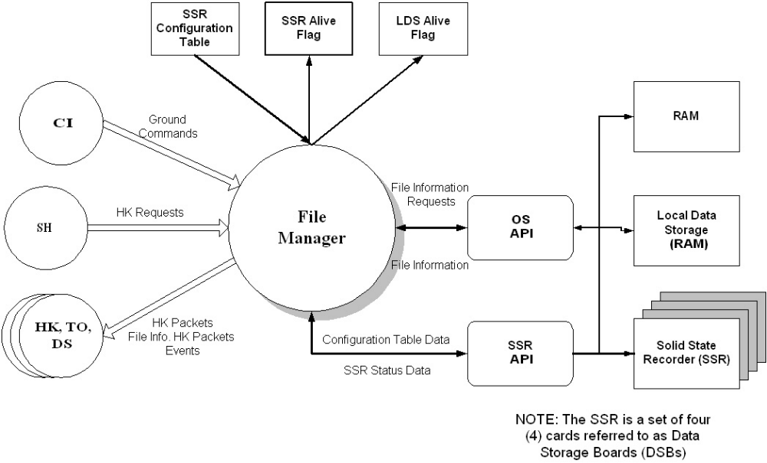

Figure 1, LRO File Manager Context Diagram

Figure 2 shows the context diagram for the LRO CCSDS File Delivery Protocol application (taken from the flight software CDR package). The CCSDS File Delivery Protocol (CFDP) is a CCSDS standard defining a protocol for the transmission of files to and from spacecraft data storage. In addition to the purely file delivery related functions (Note: copying a file is a delivery function) , the protocol also includes file management services to allow control over the storage medium. These services include: create file, delete file, rename file, append file, replace file, create directory, remove directory, and list directory. Since the cFE is a file based system, a CCSDS File Delivery Protocol application is targeted for the CFS. Because the CFDP protocol includes file management services it has been recommended that all file management could be performed through a CFS CFDP application rather than a separate CFS FM application. The LRO CFDP application context is shown in the CFS FM heritage analysis to point out that providing file management through CFDP would not only be a limiting design for the CFS, it could result in the creation of two separate API libraries required by the CFS that include the same services. The design would be limiting in the sense that the CFDP protocol only includes a fixed set of file management services. Services such as retrieving file information or modifying file attributes could not be performed through the protocol. The LRO CFDP application, CF, interfaces with a CFDP library providing the CF application with an API for transferring files using CFDP. The library currently only implements the file transfer part of CFDP and leaves the file management services unimplemented. This library would need to be modified to include the CFDP file management services if all file management were to be performed using CFDP. These file management services are already available to the cFE through the OS API. Looking at the CF context diagram it seems possible to include file management services within the CF application through its interface with the OS API as opposed to providing them through the CFDP library. Although this is possible it is not recommended for the CFS. Since the cFE is a file based system, file management is inevitable for missions utilizing the cFE. File management services such as copy, move, delete, etc. will not change. The method a mission chooses to transfer files could change. By imbedding file management within a CFDP application, one is limiting the file transfer mechanism to CFDP.

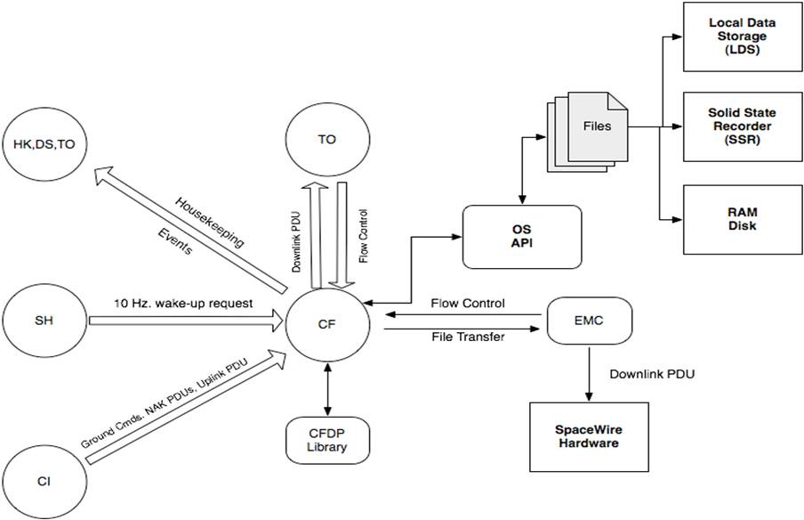

Figure 2, LRO CCSDS File Delivery Protocol Context Diagram

Figure 3 shows the context diagram for the JWST ISIM File Manager (taken from the flight software PDR package). The Scheduler Task provides FM with an interface to register itself with the scheduler and submits periodic housekeeping requests to FM. The Time Manager provides system time to FM. Memory Manager provides registration and table maintenance functions for all FM tables. FM periodically “checks-in” with the Health & Safety task to let the system know the FM task is running and responds to all Health & Safety requests. Commands come from the Command Manager. Event messages, housekeeping packets, and file dump packets are routed to the Telemetry Manager. All volatile file information requests to and from the three onboard RAM based file systems are performed through VxWorks file system calls. Non-volatile (NV) file information requests are performed though the NV Memory Manager. The File Load Manager provides FM with the functionality to load files from the ground to the spacecraft. The File Dump Manager provides FM with the functionality to dump files from the spacecraft to the ground. Note: JWST utilizes the CCSDS CFDP standard for file loading and dumping.

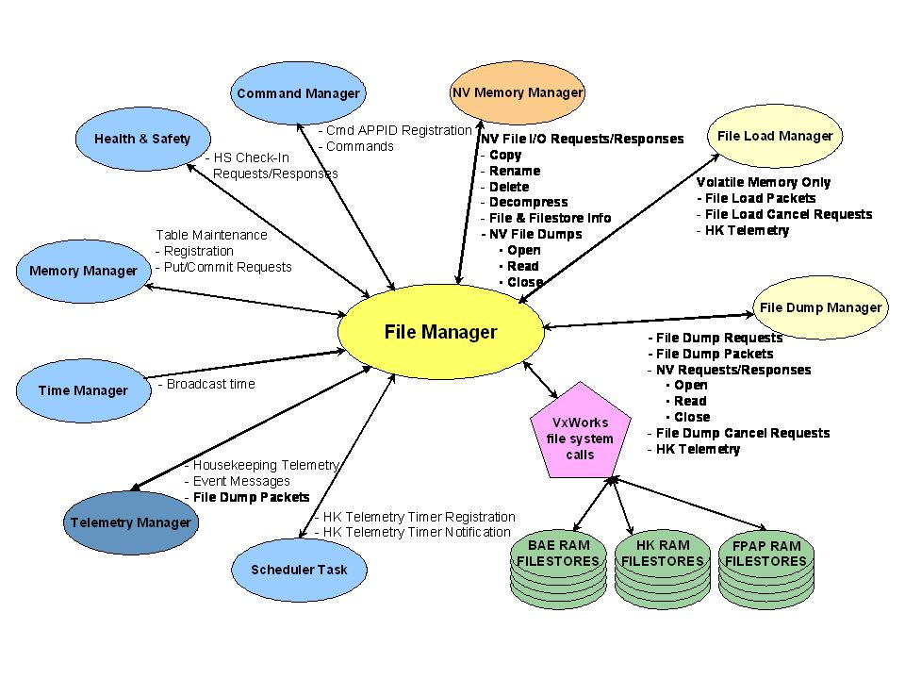
Figure 3, JWST ISIM File Manager Context Diagram

No context diagram was available for the BAT FM software. However some of the contextual features can be shown though its class diagram and file transfer data flow diagrams. Figure 4 shows the class diagram for the BAT FM application. Figure 5 shows the file transfer data flow diagrams for the BAT file uplink and downlink. Like a context diagram these two diagrams show the functionality contained within the BAT FM application. It is important to note the BAT FM functionality includes the ability to transfer files, manipulate files (copy, move, etc.), and provide information about files. See section 6.0 for more information on the features contained within the BAT FM software.

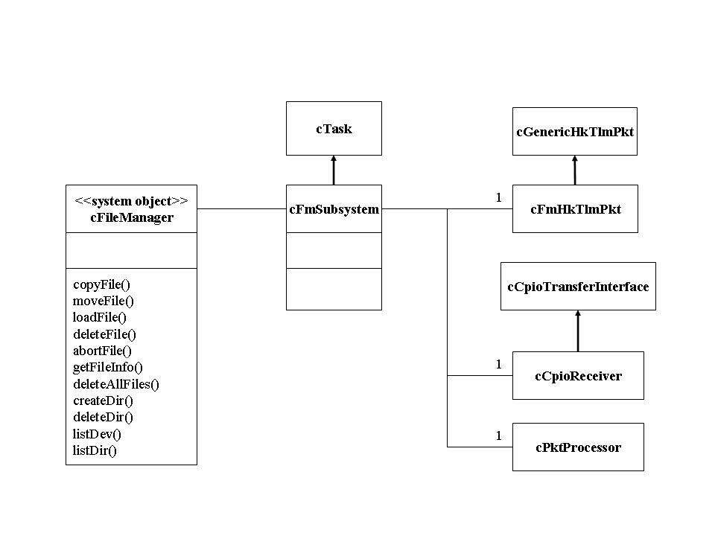
Figure 4, Swift BAT File Manager Class Diagram

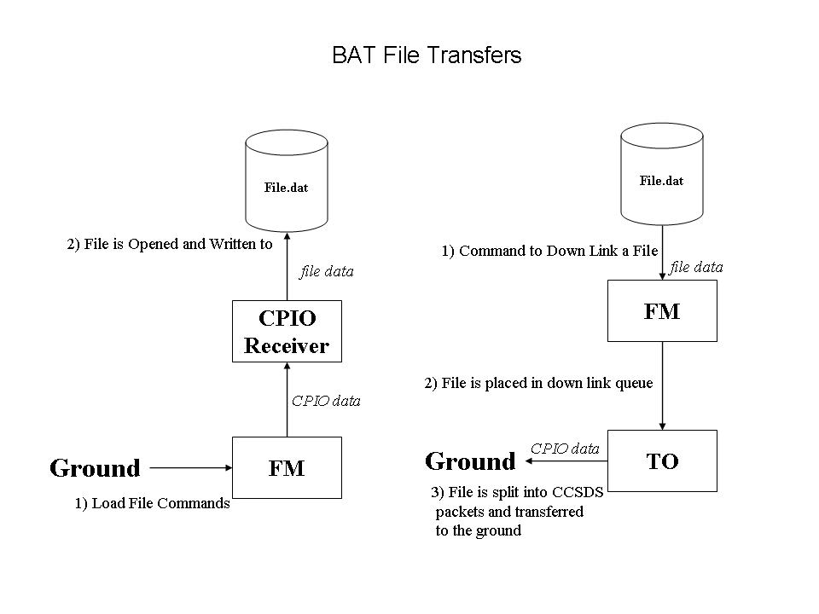
Figure 5, Swift BAT File Manager File Transfer Data Flow Diagram

5.0 Operational scenarios
For the LRO mission, ground operators must use a separate application from FM to upload and download files. All other file management commands are performed through FM. This differs from the other missions (JWST, BAT) this heritage analysis has looked at. The JWST and BAT missions make file upload and download a part of their file manager application.

All other file management commands (copy, move, delete, etc.) are handled similarly by all the studied GSFC heritage missions. The ground commands are issued and the FM task/application confirms the command through housekeeping telemetry and event messages. The details of these commands are discussed in Section 6.0.

  - LRO Ground OPS Context
Figure 6 shows the operations context for the LRO File Manager. Note that this is a view to assist in understanding the flight software applications an operator must interface with in order to execute file management operations. It is not meant to be a comprehensive context diagram. System tasks like Command Ingest (CI) and Telemetry Output (TO) are purposely not shown for the sake of simplicity. The flight system context is discussed in section 4.0.

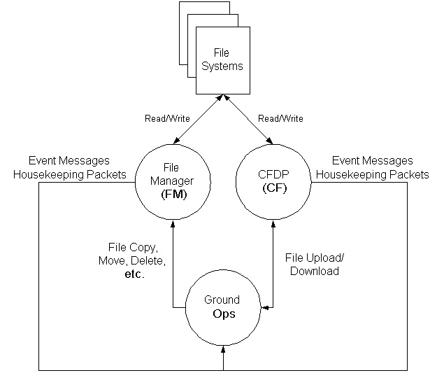

Figure 6, LRO Ops Context

  - JWST ISIM & BAT Ground OPS Context
Figure 7 shows the operations context for both the JWST ISIM File Manager and BAT File Manager. Note that this is a view to assist in understanding the flight software applications an operator must interface with in order to execute file management operations. It is not meant to be a comprehensive context diagram. System tasks like Command Ingest (CI) and Telemetry Out (TO) are purposely not shown for the sake of simplicity. The flight system context is discussed in section 4.0.

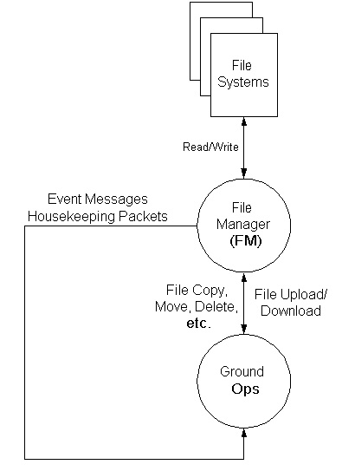

Figure 7, JWST ISIM & BAT Ops Context

6.0 Feature Analysis
6.1 Reset and Noop
All studied GSFC mission file management (LRO, JWST ISIM, and BAT) implementations support a NOOP command that simply increments the command received status counter and a reset command. The LRO and JWST ISIM reset command clears the command status counters only. The BAT reset command clears all its FM telemetry values setting the data to zero.

6.2 File Copying, Moving, and Renaming
LRO has COPY FILE and MOVE FILE commands for copying and moving a file from any of the onboard file systems to any of the onboard file systems. The MOVE FILE command may also be used to rename a file. These two commands accept a full pathname for both the source file to be copied or moved and the destination of where the file shall be copied or moved. The full path specification can be no longer than 40 characters in length. For each command, if the destination file already exists, it is overwritten without warning.

BAT has BFMCOPY for copying a source file to a destination file. Both file name parameters must be specified using a full path specification. If the destination file already exists, it is overwritten without warning. For file moving, BAT has the BFMMOVE command. The BFMMOVE command moves the source file to the destination file. Both file name parameters must be specified using a full path specification. If the destination file already exists, it is overwritten without warning. Although the BFMMOVE command could be used to rename a file, BAT has a separate command for renaming files. The BFRENAME command renames a file. Both command parameters for the BFRENAME command require full path information and, the path information in each must be identical. It is not possible to use this command to move a file.

JWST ISIM has the ICFM COPY command for copying a source file to a destination file. Both file name parameters must be specified using a full path specification. The full path specification can be no longer than 23 characters in length. The ICFM RENAME command is used to move or rename files. Both file name parameters must be specified using a full path specification. The full path specification can be no longer than 23 characters in length.

6.3 File Deletion
LRO has several commands for deleting files:

- The DELETE FILE command will delete the source file, if and only if, the source file does not have any of the following file attributes set: Read-only, Hidden, Archive, or System, from any of the onboard file systems. The source file to be deleted must be specified using a full path specification. The full path specification can be no longer than 40 characters in length.

- The OVERRIDE DELETE FILE command will delete a file regardless of the state of its attributes from any of the onboard file systems. The source file to be deleted must be specified using a full path specification. The full path specification can be no longer than 40 characters in length.

- The DELETE DIRECTORY CONTENTS command deletes all files in a given directory. The directory must be specified with a full path specification. The full path specification can be no longer than 40 characters in length. If any of the files in the directory has any of its attributes set, those files will not be deleted and the OVERRIDE DELETE FILE command will need to be commanded in order to clear the contents of the entire directory.

BAT has two commands for deleting files. The BFMDELETE command deletes the command specified file. The full path specification is required for the filename command parameter. The BFMDELETEALL command deletes all the files in the specified directory that have no file attributes set. Files marked as "hidden" or "read-only" will not be deleted. Files marked as “hidden” or “read-only” will need to be deleted using the BFMDELETE command.

JWST ISIM has only one command for deleting files, the ICFM DELETE command. The source file to be deleted must be specified using a full path specification. The full path specification can be no longer than 23 characters in length.

6.4 Retrieving File Information
LRO has many commands for retrieving different varieties of file information:
- The REQUEST FILE STATUS command creates a telemetry packet containing all attribute settings, the file status (Open, Closed, Non-existent), and the computed memory integrity value of the contents of the command specified file. The file to retrieve information on must be specified using a full path specification. The full path specification can be no longer than 40 characters.
- The REQUEST OPEN FILE LIST command creates a telemetry packet containing the number of open files, the name/path of each open file, and task identifier associated with each open file. The
- REQUEST DIRECTORY LISTING VIA FILE command creates and opens the command specified file and writes to that file the complete listing of a directory from any of the onboard file systems. The directory to be listed must be specified using a full path specification. The full path specification can be no longer than 40 characters. The directory listing includes for each file in the directory the file name, size of the file, and the file’s timestamp identifying the last time the file was modified. This command will only create the directory listing file. It will not downlink the file. See section 4.0 for the LRO context and section 5.1 for the LRO operational context for a description of how LRO accomplishes file transfer.
- DIRECTORY LISTING VIA TLM command creates a telemetry packet containing the contents of a directory (up to 20 filenames) from any of the onboard file systems. This is a quick means for retrieving directory listing information.
The BAT file management software also has several commands for retrieving different varieties of file information:

- The BFMFILEINFO command generates a file information telemetry packet for the specified file or directory. The file or directory to retrieve information on must be specified using a full path specification. The file information telemetry packet includes an error code that is returned from the software after generating the packet, the name of the file, the size of the file in 8-bit bytes, the file’s timestamp identifying the last time the file was modified, The raw 8-bit value of the file's attribute byte, a Boolean indicating whether or not the specified file exists, A Boolean indicating whether or not the file's read-only attribute bit is set, a Boolean indicating whether or not the file's hidden attribute bit is set, a Boolean indicating whether or not the file's system attribute bit is set, a Boolean indicating whether or not the file's volume attribute bit is set, a Boolean indicating whether or not the file's directory attribute bit is set, a Boolean indicating whether or not the file's archive attribute bit is set, and a 16-bit unsigned integer giving the check sum value for the file.

- The BFMLSDEV command generates a series of ASCII telemetry packets containing information about the specified device. The device to retrieve information on must be specified using a full path specification.

- The BFMLSHUB command generates a series of ASCII telemetry packets containing a listing of the devices currently available to the FM subsystem on the specified hub. The hub to retrieve information on must be specified using a full path specification.

- The BFMLSDIR command generates a series of ASCII telemetry packets containing a UNIX-style listing of the files and directories found in the specified directory. The directory to be listed must be specified using a full path specification.

- The BFMDWNLNKDIR creates a file containing a listing of the command specified directory and downlinks the file to the ground. The directory to be listed must be specified using a full path specification. The command accepts a QUEUE argument that specifies the downlink queue type. The downlink queue type may be either ENG for engineering queue or SCI for science queue. In the case of QUEUE=ENG: An exact copy of each file will be placed in the downlink directory on the ground system. The path is conserved under the ITOS /home/swift/downlink directory, if the path doesn't exist it will be created. In the case of QUEUE=SCI: A copy of each file will be placed in the /home/swift/ldps directory. The original file names will be lost. The downlinked files will be renamed using the convention "batldp.dat_" + APID + Sequence count. This command also accepts a priority argument, an integer in the range of 0 through 10, specifying the downlink queue priority.

JWST ISIM has only two commands for gathering file information, the ICFM INFO command and the ICFM DIR command. The ICFM INFO command creates an asynchronous telemetry packet containing the file name, file size, and creation time of a single file. The file to retrieve information on must be specified using a full path specification. The full path specification can be no longer than 23 characters in length. The ICFM DIR command generates an all file information telemetry packet containing a full directory listing of the command specified file store. The directory listing includes, for each onboard file in the file store, the full path specification of the file, the file size, and creation time.

6.5 File Closing
LRO provides a command for closing a file. The CLOSE FILE command closes a file from any of the onboard file systems. The source file to be closed must be specified using a full path specification. The full path specification can be no longer than 40 characters in length.

6.6 Setting and Clearing File Attributes
LRO provides commands for setting and clearing a file’s attributes, the SET FILE ATTRIBUTE command and the CLEAR FILE ATTRIBUTE command. LRO’s files attributes include HIDDEN, READ-ONLY, SYSTEM, and ARCHIVE. Both commands require a full path specification of the source file to be modified. The full path specification can be no longer than 40 characters in length. Each command also accepts a character parameter (‘H’, ‘R’, ‘S’, or ‘A’) specifying the attribute to be set or cleared.

6.7 File Concatenation
LRO provides a command for concatenating two files together. The CONCATENATE FILES command accepts two source file names and a destination file name. The two source files are concatenated together producing the command specified destination file (Contents of Source File 1 + Contents of Source File 2). Source and destination file names require a full path specification. The full path specification can be no longer than 40 characters in length. This command will only create the concatenation file. It will not downlink the file.

6.8 File Decompression
LRO has a DECOMPRESS FILE command that will decompress a file located on any of the onboard file systems. The command uses a decompression utility provided by the cFE to decompress the file and create the command specified destination file. This command will only create the decompression file. It will not downlink the file. Source and destination file names require a full path specification. The full path specification can be no longer than 40 characters in length.

JWST ISIM also has a command for decompressing compressed files, the ICFM UNZIP command. The JWST ISIM requirements specification explains “The uplink and storage of compressed files will facilitate MSA operations with reduced uplink time and onboard memory consumption.” The command accepts both source and destination file names. When the compressed source file is decompressed the command specified destination file is created. The command will only create the decompression file. It will not downlink the file. A full path specification is required for the command specified source and destination file names. The full path specification can be no longer than 23 characters in length.

6.9 File Reading and Writing
The JWST ISIM requirements specification contains file manipulation requirements stating “File Manager will provide requests to allow applications to read from, write to, and delete files in volatile file stores”. The cFE OS API layer provides these types of requests to cFE applications and will not be incorporated into the CFS File Manager application.

6.10 Directory Creation and Removal
LRO provides commands for creating and removing directories. The CREATE DIRECTORY command will create the command specified directory on any of the onboard file systems. The REMOVE DIRECTORY command will remove the command specified directory from any of the onboard file systems. The command will issue an event message and abort the removal if the command specified directory contains at least one file or subdirectory. The directory to be created or removed must be specified with a full path specification. The full path specification can be no longer than 40 characters in length.

The BAT FM software also provides commands for creating and removing directories. The BFMMKDIR command creates the command specified directory. The directory must be specified using a full path specification. The BFMRMDIR command deletes the command specified directory if it is empty. The directory must be specified using a full path specification.

6.11 Retrieving Directory Listings
See section 6.4 Retrieving File Information, for a description of the heritage mission directory listing commands.
6.12 File Transfer
Both the BAT and JWST ISIM FM software provide commands for transferring files to and from the ground. The commands are dependent on the file transfer mechanism used by the FSW system. BAT uses a CPIO receiver to transfer its files while the JWST ISIM uses the CCSDS CFDP protocol. The details of the transfer commands will not be provided in this document. What is important to keep in mind is that the transfer commands are contained within the FM software as opposed to being placed in a separate application as is the case for LRO. See section 4.0 for a more detailed look at how each heritage mission handles file transfers.
6.13 Telemetry
The details on the contents of the studied heritage mission periodic housekeeping telemetry packets will not be discussed in this document. It is important to note that all studied heritage missions included a command execution counter, command error counter, and free space available (for each on board file system) within the periodic housekeeping telemetry packet.

7.0 Conclusions
Based upon the analysis the following application context, application features, and ground interface requirements have been chosen for the CFS File Manager application.
7.1 Application Context
Figure 8 shows the proposed context of the CFS FM application. In the proposed context diagram a double legged unfilled arrow indicates the interface uses the software bus (message-based interaction) and a single legged arrow indicates direct access to hardware or to a library function. The proposed context of the CFS FM application is very similar to the context of the LRO mission since LRO makes use of the cFE and OS API. The proposed context shows use of a complete CFS, presenting interfaces with other CFS applications. SH is the CFS scheduler application that submits periodic housekeeping requests to FM. Commands come from the CFS Command Ingest application (CI). Event messages and housekeeping packets are routed to the appropriate CFS output application, the Housekeeping (HK), Telemetry Output (TO), and/or Data Storage (DS) application. All accesses to the file system(s) are through the OS API layer of the cFE. This removes any operating system or hardware interface dependencies from the FM application making it more portable across platforms. The File Uplink/Downlink manager is another CFS or mission customized application that provides FM the functionality for uploading files from ground to spacecraft and downloading files from spacecraft to ground. It is important to note that the goal of the proposed CFS FM context is to bind all file management functions within the CFS FM application.

The proposed context for the CFS FM application has been derived from the context of each of the heritage missions studied. Rational for the proposed context above is provided though the understanding of the context diagrams of the heritage missions studied in this analysis. A diagram (if available) along with a description of the context is provided for each of the heritage missions (LRO, BAT, JWST) in section 4.0.

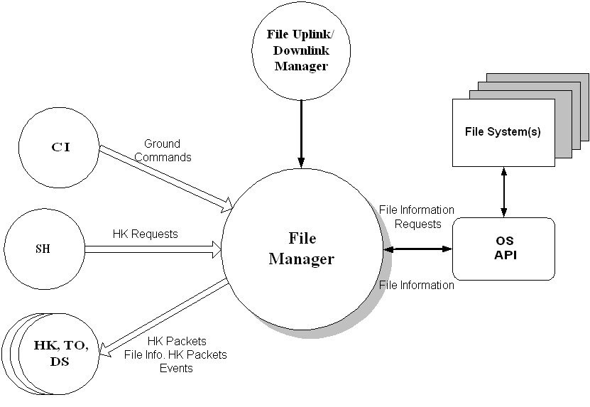

Figure 8, Proposed CFS File Manager Context Diagram

7.2 Application Features
7.2.1 Primary Features
Primary Features are features that are core requirements implemented in more than one of the heritage missions examined.

Requirement | Rationale | Heritage Reference
Noop | Basic debug command | LRO, JWST, BAT
Reset | Implemented by all | LRO, JWST, BAT
Copy File | Implemented by all | LRO, JWST, BAT
Move File | Implemented by all | LRO, JWST, BAT
Delete File | Implemented by all | LRO, JWST, BAT
Delete directory contents | Supports protection against deleting full directories. Allows for easy directory removal. | LRO, BAT
Close File | Supports file management | LRO
File Decompression | Supports reduced uplink time | LRO, JWST
File Concatenation | Supports file management | LRO
Generate File Information Telemetry packet | Implemented by all | LRO, JWST, BAT
Create Directory | Implemented by all | LRO, JWST, BAT
Remove Directory | Implemented by all | LRO, JWST, BAT
Generate Directory Listing Telemetry Packet(s) | Implemented by all, Allows quick method for retrieving a directory listing | LRO, JWST, BAT
Generate Directory Listing File | Supports large directory listings | LRO, BAT
File Directory Uplink/Downlink | Supports CFS proposed context, providing all file management services under one application. | JWST, BAT
File Free Space reporting in periodic housekeeping telemetry | Implemented by all | LRO, JWST, BAT

7.2.2 To Be Considered
The BAT and LRO missions implemented some special features that may be worth considering for CFS. These features will require some additional investigation to determine how useful they may be and if they can be implemented within the framework of the cFE and OS API. These are not critical capabilities and may be deferred to a later build of the CFS if the decision is made to incorporate any of them.

Requirement | Rationale | Heritage Reference
Generate Device Information telemetry packet | Provides useful file management information | BAT
Generate Device Listing | Provides useful file management information | BAT
Set/Clear File Attributes | Supports file protection | LRO
Override Delete File | Supports protection against deleting critical files. | LRO

7.2.3 Rejected
The following table lists features that have been rejected for the CFS File Manager. The Rationale column details the reasoning used.

Requirement | Rationale | Heritage Reference
Rename File | Duplicate of the File Move command | BAT, JWST

  - Ground Interface Requirements
Ground tools will be needed to create upload files and interpret the files and telemetry packets generated by the FM application. File information packets may include a checksum. The algorithms used in generating the file checksums in flight will need to be mimicked in a ground tool.

8.0 Heritage Analysis Review Decisions
On July 3, 2007 a review of the FM heritage analysis was held. Sections 1-7 of this document were presented to a review team. Several changes have been made to the FM heritage analysis conclusions as a result of the comments and suggestions made during the review. This section follows the format of the preceding section (7.0 Conclusions) and incorporates the comments and suggestions made during the review.
8.1 Application Context
Figure 9 shows the context of the CFS FM application. In this context diagram a double legged unfilled arrow indicates the interface uses the software bus (message-based interaction) and a single legged arrow indicates direct access to hardware or to a library function. This context of the CFS FM application is very similar to proposed context described in section 7.1. The only difference between the two context diagrams is the interface to the file uplink/downlink manager has been removed. The remaining interfaces between the two context diagrams are identical. The File Uplink/Downlink manager shown in section 7.1 is another CFS or mission customized application with its ground interface removed and placed within the FM application. It has been determined that having two separate application command interfaces adds no extra overhead to the ground operations as was presented in section 5.0 of this document. Including the File Uplink/downlink manager to FM would create command interface conflicts if the File Uplink/downlink manager were to change. This would not be the case if the File Uplink/downlink manager was developed as a separate CFS application with its own ground interface.

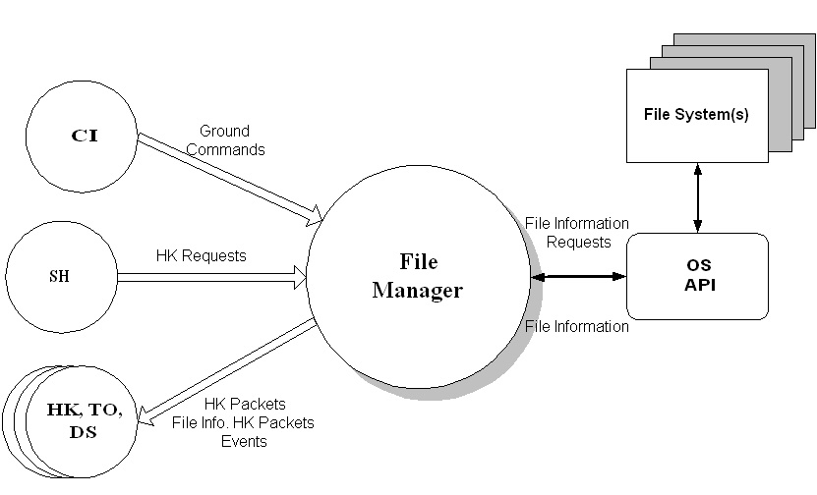

Figure 9, Proposed CFS File Manager Context Diagram

8.2 Application Features
8.2.1 Primary Features
Primary Features are features that are core requirements implemented in more than one of the heritage missions examined.

Requirement | Rationale | Heritage Reference
Noop | Basic debug command | LRO, JWST, BAT
Reset | Implemented by all | LRO, JWST, BAT
Copy File | Implemented by all | LRO, JWST, BAT
Move File | Implemented by all | LRO, JWST, BAT
Delete File | Implemented by all | LRO, JWST, BAT
Delete directory contents | Supports protection against deleting full directories. Allows for easy directory removal. | LRO, BAT
Close File | Supports file management. Open files cannot be deleted or downlinked. | LRO
File Decompression | Supports reduced uplink time | LRO, JWST
File Concatenation | Supports reassembly of large uplink files. With LEO orbits ground contacts are short and large uplink files need to be broken into smaller pieces. | LRO
Generate File Information Telemetry packet | Implemented by all | LRO, JWST, BAT
Create Directory | Implemented by all | LRO, JWST, BAT
Remove Directory | Implemented by all | LRO, JWST, BAT
Generate Directory Listing Telemetry Packet(s) | Implemented by all, Allows quick method for retrieving a directory listing | LRO, JWST, BAT
Generate Directory Listing File | Supports large directory listings | LRO, BAT
File Free Space reporting in periodic housekeeping telemetry | Implemented by all | LRO, JWST, BAT

8.2.2 To Be Considered
The BAT and LRO missions implemented some special features that may be worth considering for CFS. These features will require some additional investigation to determine how useful they may be and if they can be implemented within the framework of the cFE and OS API. These are not critical capabilities and may be deferred to a later build of the CFS if the decision is made to incorporate any of them.

Requirement | Rationale | Heritage Reference
Generate Device Information telemetry packet | Provides useful file management information | BAT
Generate Device Listing | Provides useful file management information | BAT
Set/Clear File Attributes | Supports file protection | LRO
Override Delete File | Supports protection against deleting critical files. | LRO

8.2.3 Rejected
The following table lists features that have been rejected for the CFS File Manager. The Rationale column details the reasoning used.

Requirement | Rationale | Heritage Reference
Rename File | Duplicate of the File Move command | BAT, JWST
File Directory Uplink/Downlink | Does not support interfaces changes to the uplink/downlink manager | JWST, BAT

