  ., | FLIGHT SOFTWARE BRANCH  Core Flight System (CFS) Limit Checker Application Heritage Analysis  Flight Software Branch – Code 582  Version 1.1 – 06/10/08  582-2008-007
document control and History
This document is a Flight Software Branch (FSB) controlled document. However it is not formally controlled by the FSB Configuration Control Board (CCB).
Version | Date | Description | Affected Pages
1.0 | 06/02/08 | Initial Release | All
1.1 | 06/10/08 | Added section 13.0 Heritage Analysis Review Addendums | 21-25

Contents
1.0 Application Overview 1
2.0 Heritage Summary 1
3.0 Terminology 2
3.1 LRO LC Terminology 2
3.2 SDO TS Terminology 3
4.0 Context 4
5.0 Table Formats 6
5.1 LRO LC Watchpoint Definition Table 6
5.2 LRO LC Actionpoint Definition Table 7
5.3 LRO LC Watchpoint Results Table 8
5.4 LRO LC Actionpoint Results Table 9
5.5 SDO TS Monitor Table 10
5.6 SDO TS Statistics Table 11
5.7 SDO TS Derived Function Pointer Table 11
6.0 Modes of Operation 12
6.1 LRO LC Operation Modes 12
6.2 SDO TS Operation Modes 12
7.0 Scheduling 13
8.0 Operational scenarios 14
8.1 LRO LC Example Scenario 14
8.2 SDO TS Example Scenario 15
9.0 Feature Analysis 16
9.1 Command Sets 16
9.2 Limits 17
9.3 Derived & Custom Functions 17
9.4 Triggering On Multiple Data Points 18
9.5 Memory Monitoring 18
10.0 Conclusions 18
10.1 Primary Features 18
10.2 To Be Considered 19
10.3 Rejected 19
11.0 Proposed Context 20
12.0 Ground Interface Requirements 21
13.0 Heritage Analysis Review Addendums 21
13.1 Derived Function Use In The SDO TS 21
13.2 Mulitple Thresholds In The LRO LC 21
13.3 Preventing Multiple RTS Requests 21
13.4 Memory Address Monitoring Using Memory Dwell (MD) 22
13.5 Revised Proposed Context 22
13.6 Additional LRO LC Examples 23

1.0 Application Overview
The Limit Checker (LC) heritage analysis for the Core Flight System (CFS) evaluates heritage mission components responsible for the onboard monitoring of telemetry. How this function has been allocated to system tasks has varied by project. On some missions this was called the Telemetry and Statistics Monitor (TS) and on others it was called the Limit Checker (LC). While Limit Checker (LC) is the terminology that will be used by the CFS project, heritage mission components will be referred to in this document using the naming conventions adopted by the mission under discussion.

In the most basic sense, the Limit Checker application monitors telemetry data points in the flight system and compares the values against predefined or computed threshold limits. When a threshold condition is encountered, an event message is issued and a Relative Time Sequence (RTS) command script may be initiated to respond to the threshold violation.

2.0 Heritage Summary
The applications that will be the focus of this analysis are the Lunar Reconnaissance Orbiter (LRO) Limit Checker (LC) and Solar Data Observatory (SDO) Telemetry and Statistics Monitor (TS). Each of these tasks have heritage from earlier missions.

LRO is a single CPU system based on the RAD750 processor produced by BAE systems. SDO has two flight processor types. The main processor is the same as LRO, a BAE-RAD750. In addition SDO uses multiple Subsystem Data Node (SDN) processor cards that are based on the less powerful Motorola Coldfire processor. For SDO, the telemetry monitoring function only runs on the main processor and not on any of the SDN boards.

The following table details the mission artifacts used:

Mission | Artifact | Notes
LRO | Heritage | 75% heritage from TRACE/WIRE, with modifications made primarily to support use of the cFE.
LRO | Operational  Context | Single CPU system, the LC application is controlled through a combination of configuration tables and ground commands.
LRO | DCRs | No open DCRs at the time of this writing
LRO | Req. Doc | Level 4 requirements as documented in the LRO CDR package
LRO | PDR | PDR material superseded by CDR materials
LRO | CDR | Project CDR held on April 17 – 19, 2007
LRO | Code | LC code baseline taken from LRO MKS on April 8, 2008
LRO | Unit Test | LC unit test results in LRO MKS dated March 19, 2007
LRO | User’s Guide | Version 1.0, dated December 27, 2007
LRO | POC | Scott Walling, Microtel LLC, 301-286-3799
SDO | Heritage | 95% heritage from WMAP
SDO | Operational Context | TS task only runs on main CPU. Application is controlled through a combination of configuration tables and ground commands.
SDO | DCRs | No open DCRs at the time of this writing
SDO | Req. Doc | TS Requirements Document Rev A, August 29, 2006
SDO | PDR | PDR reviewed, TS presented at CDR level
SDO | CDR | CDR reviewed, minor changes since PDR
SDO | Code | Code not reviewed, but expected to be mature
SDO | Unit Test | Unit test not performed, no test coverage report generated
SDO | User’s Guide | Version 4.0, dated October 26, 2007
SDO | POC | Dan Berry, Code 582, 301-286-0060

Other projects that were considered, but will not be discussed in detail:

The SWIFT/BAT mission implemented telemetry monitoring in a STOL-based script controller. Telemetry monitoring conditions and responses are in the form of scripts written using a subset of the STOL ground system programming language. These scripts are then compiled and loaded onto onboard memory similar to other pieces of flight software. This approach is fundamentally different from the functional partitioning envisioned for the CFS and not very applicable to a generic, baseline limit checking application design. It may be reexamined when stored command processing and onboard scripting is considered. The BAT mission did implement an Instrument Health & Safety (IH) task for monitoring temperature and voltage values that functions more like the SDO and LRO telemetry monitoring tasks. However, it wasn’t intended to be very robust or generic which are both desirable attributes for the eventual CFS design.

The ST-5 mission based its Telemetry and Statistics Monitor (TS) task on the same heritage mission as SDO (WMAP). As a result, both implementations are very similar with only minor differences in the layout of table parameters and the maximum number of monitor points they can support.

The GLAS mission had no comparable telemetry monitoring capability.

3.0 Terminology
- RTS - Relative Time Sequence, A predefined command sequence usually referenced by a numeric identifier that can be initiated by sending a software bus message to the Stored Commanding (SC) task.

- OSAL - Operating System Abstraction Layer. A set of program interfaces used to insulate flight application code from operating system dependencies.

- LC – Limit Checker. The term used by CFS and LRO for the system application used to monitor telemetry values.

- TS – Telemetry and Statistics Monitor. The term used by SDO for the system application used to monitor telemetry values.

While the LRO Limit Checker (LC) and SDO Telemetry and Statistics Monitor (TS) tasks both serve a similar purpose, they both use unique terminology in their documentation. The following sections detail these differences:

3.1 LRO LC Terminology
- WATCHPOINT – A piece of data, (either in telemetry or memory) whose value is to be compared against a predefined constant.

- TELEMETRY WATCHPOINT – A watchpoint that is read from a telemetry packet

- MEMORY WATCHPOINT – A watchpoint that is read from a memory address or memory mapped I/O port.

- IMMEDIATE WATCHPOINT – An alternate term used for MEMORY WATCHPOINT in the LRO LC documentation. MEMORY WATCHPOINT will be the term used in this document when referring to this type of LC watchpoint.

- WATCHPOINT DEFINITION TABLE – The input table that holds the information necessary to define all LC watchpoints.

- WATCHPOINT RESULTS TABLE – The output (dump-only) table that holds the results of watchpoint evaluations.

- ACTIONPOINT – A logical relationship between one or more watchpoint results, specified in Reverse Polish Notation

- REVERSE POLISH NOTATION (RPN) – A method of describing a mathematical equation that eliminates the need for parenthesis. Also known as postfix notation.

- ACTIONPOINT DEFINITION TABLE – The input table that holds the information necessary to define all LC actionpoints.

- ACTIONPOINT RESULTS TABLE – The output (dump-only) table that holds the results of actionpoint evaluations.

- CUSTOM FUNCTION – A mission specific function that can be used in place of a standard comparison operator in a watchpoint definition.

3.2 SDO TS Terminology
- MONITOR POINT – A piece of data in telemetry whose value is to be compared against one or more predefined threshold values.

- THRESHOLD – A predefined constant value that a monitor point is compared to.

- MONITOR LIMITS TABLE – The input table that holds the information necessary to define all TS monitor points, thresholds, and responses for violations.

- STATISTICS TABLE – The output (dump-only) table that stores statistics information on each monitor point.

- DERIVED FUNCTION – A mission specific function that can be invoked to transform the data in a monitor point prior to the threshold comparisons.

- DERIVED FUNCTION POINTER TABLE – Table that holds pointers to derived monitor functions.

4.0 Context
Figure 1 shows the context diagram for the LRO Limit Checker (taken from the LC User’s Guide). The LRO architecture uses a centralized scheduler application (SH). The SH task submits periodic housekeeping requests, watchpoint sample, and actionpoint evaluation commands to the LC task.

The LRO LC application makes use of four configuration/data tables which will be discussed later in this document. The LRO LC can monitor memory addresses (and by extension memory mapped I/O addresses) in addition to data points in telemetry packets.

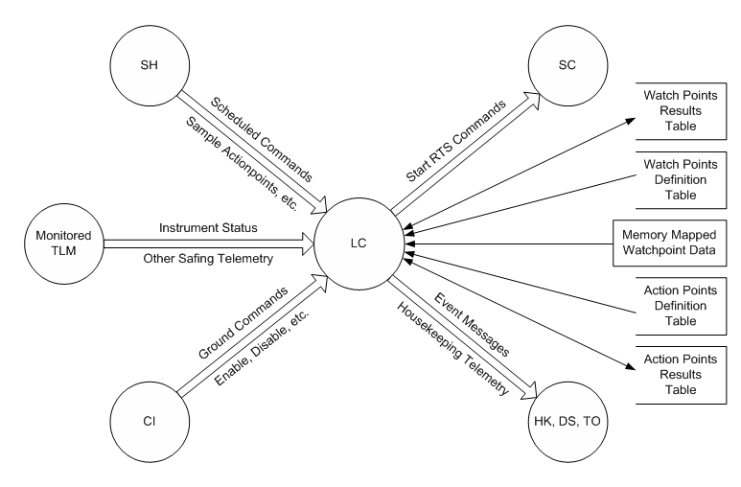

Figure 1. LRO Limit Checker (LC) Context Diagram

Figure 2 shows the context diagram for the SDO Telemetry and Statistics Monitor (taken from the TS User’s Guide).

The TS interfaces are fairly standard. SDO doesn’t use a scheduler application, so TS receives housekeeping request from HS and sends back its housekeeping data. It also receives commands from CI (or SC if in an RTS or ATS). In addition, the TS task can also send requests to start a RTS to SC. The SDO Software Manager task (SM) is used to load the Monitor Table, and can be used to dump the Statistics table. Sources of telemetry on the spacecraft pass their data to TS via the software bus (over the 1553 and through XB for tasks located on the SDN processor cards).

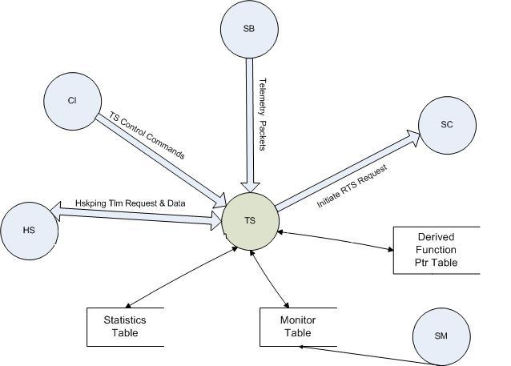

Figure 2. SDO Telemetry and Statistics Monitor (TS) Context Diagram

5.0 Table Formats
The LRO LC uses four tables. The Watchpoint Definition and Actionpoint Definition tables are input tables. Their values are only read by LC and not altered by the task. The Watchpoint Results and Actionpoint Results tables are output tables and the values are continually updated during LC processing.

5.1 LRO LC Watchpoint Definition Table
The lowest level of data monitoring that LC performs is at the level of a Watchpoint. It is at this level where flight data is captured, masked and compared. The Watchpoint Definition Table contains all of the information necessary to define a Watchpoint. It is an array of 256 elements. Below is a description of one array element.

Name | Type | Range
data_size | uint8 | 0-7
operator_id | uint8 | 0-7
stream_id | uint16
address_offset | uint32
bit_mask | uint32
comparison_value | uint32

- data_size - Contains a description of the type of flight data that will be captured and examined (byte, word, float etc.).

- operator_id - Contains the type of operation that is to be performed on the flight data (less than, greater than, equal etc.). May also be designated as “custom” for mission specific function hooks.

- stream_id - Contains an indicator as to the source of the flight data to be examined (telemetry packet or memory address). If non-zero, it’s a telemetry packet and this field holds the packet ID.

- address_offset - Contains the byte offset from the beginning of the packet or the 32-bit address of the memory location to monitor.

- bit_mask - Contains a 32-bit quantity that is to be masked with the captured flight data prior to comparison.

- comparison_value – Constant value to compare with watchpoint data value.

5.2 LRO LC Actionpoint Definition Table
The highest level of data evaluating that LC performs is at the level of an Actionpoint. It is at this level where previously recorded Watchpoint results are gathered and evaluated. If this evaluation indicates a failure, the LC task must then decide if the execution of an RTS is warranted. The Actionpoint Definition Table contains all of the information necessary to define an Actionpoint. It is an array of 256 elements. Below is a description of one array element.

Name | Type | Range
default_state | uint8 | 0-4
spare | uint8 | N/A
rts_id | uint16
event_text[32] | char | N/A
event_type | uint16
event_id | uint16
num_fails_before_rts_exec | uint16
max_event_msgs | uint16
polish_equation[20] | uint16

- default_state - Contains an indication of the active state of this Actionpoint (unused, active, passive, disabled)

- rts_id - Contains the identifier of the Relative Time Sequence command that could be requested by if this Actionpoint fails.

- event_text, event_type, and event_id - Defines the event message that will be generated should an RTS be requested by this Actionpoint.

- num_fails_before_rts_exec - Contains the number of consecutive failures of this Actionpoint that must occur before an RTS execution is requested.

- max_event_msgs - Contains the maximum number of informational event messages that LC will send out for this particular Actionpoint.

- polish_equation - Contains the description of the logical relationship between one or more Watchpoint results. Each word of this field must either be a Polish Operand or Polish Operator. Operands are the Watchpoint numbers.

5.3 LRO LC Watchpoint Results Table
As Watchpoints are evaluated, their results and activities are stored real-time in this dump-only table. It is an array of 256 elements. Below is a description of one array element.

Name | Type | Range | Description
watch_result | uint8 | 0-3
Spare | uint8 | N/A
Spare | uint8 | N/A
Spare | uint8 | N/A
watch_sample_count | uint32
false_to_true_cross_count | uint32
consec_true_count | uint32
cumm_true_count | uint32
last_false_to_true_crossing.value | uint32
last_false_to_true_crossing.timestamp | uint32  uint32 |  | Seconds and subseconds
last_true_to_false_crossing.value | uint32
last_true_to_false_crossing. timestamp | uint32  uint32 |  | Seconds and subseconds

- watch_result - Contains the current result of this Watchpoint evaluation (True, False, Error, Not Measured).

- watch_sample_count - Contains the count of the number of times that this Watchpoint has been evaluated.

- false_to_true_cross_count - Contains a count of the number of times that this Watchpoint has crossed the threshold from a False result to a True result.

- consec_true_count - Contains the count of the number of consecutive samples in which this Watchpoint has evaluated to True.

- cumm_true_count - Contains the count of the number of cumulative samples in which this Watchpoint has evaluated to True.

- last_false_to_true_crossing – A structure that contains two subfields. The first subfield holds the 32-bit piece of flight data that caused the threshold from false-to-true to be crossed. The second subfield within this structure is the 8-byte timestamp associated with this Watchpoint transition.

- last_true_to_false_crossing – A structure that contains two subfields. The first subfield holds the 32-bit piece of flight data that caused the threshold from true_to_false to be crossed. The second subfield within this structure is the 8-byte timestamp associated with this Watchpoint transition.

5.4 LRO LC Actionpoint Results Table
As Actionpoints are evaluated, their results and activities are stored real-time in this dump-only Table. It is an array of 256 elements. Below is a description of one array element.

Name | Type | Range
action_result | uint8 | 0-3
curr_state | uint8 | 0-4
Spare | uint8 | N/A
Spare | uint8 | N/A
fail_to_pass_cross_count | uint32 | N/A
pass_to_fail_cross_count | uint32 | N/A
consec_fail_count | uint32 | N/A
cumm_fail_count | uint32 | N/A
cumm_rts_exec_count | uint32 | N/A
cumm_event_msgs_sent | uint32 | N/A

- action_result - Contains the current result of this actionpoint (Pass, Fail, Error, Not Measured).

- curr_state - Contains the current state of this actionpoint (Active, Passive, Disabled, etc.)

- fail_to_pass_cross_count - Contains a count of the number of times that this Actionpoint has crossed the threshold from a Fail result to a Pass result.

- pass_to_fail_cross_count - Contains a count of the number of times that this Actionpoint has crossed the threshold from a Pass result to a Fail result.

- consec_fail_count - Contains the count of the number of consecutive samples in which this Actionpoint has evaluated to Fail.

- cumm_fail_count - Contains the count of the number of cumulative samples in which this Actionpoint has evaluated to Fail.

- cumm_rts_exec_count - Contains the count of the cumulative number of times that the RTS for this Actionpoint has been requested.

- cumm_event_msgs_sent - Contains the count of the cumulative number of informational messages have been sent for this Actionpoint.

5.5 SDO TS Monitor Table
The TS Monitor Table defines the monitors themselves: the location and format of the data point to sample, what the threshold limits are for that sample, how to process the sample, and whether any actions should be taken on the failure of a threshold. The Table consists of an array of 512 TS_Monitor_Record data types.

TS_Monitor_Record:

Name | Size in  Bytes | Data Type | Description
ID | 2 | uint16 | ID Number of this monitor (Nominally its index)
NAME | 30 | char | Character string naming the monitor (Max of 29 characters)
ACTIVE | 1 | uint8 | Whether this monitor is Enabled (1) or Disabled (0) by default.
DSIZE | 1 | uint8 | The data type of the monitored point: 0 = Signed Byte, 1 = Unsigned Byte, 2 = Signed Word, 3 = Unsigned Word, 4 = Signed Double Word, 5 = Unsigned Double Word, 6 = Float.
DERIVED | 1 | uint8 | Whether use of a derived function Enabled (1) or Disabled (0).
DFOFFST | 1 | uint8 | Number of the derived function to use if Enabled
SID | 2 | uint16 | Stream ID of the packet containing the point to sample
OFFST | 2 | uint16 | Byte offset in packet
BMASK | 4 | uint32 | Bitmask for data
DFPARM[1] | 2 | uint16 | 1st Parameter to pass into derived function
DFPARM[2] | 2 | uint16 | 2nd Parameter to pass into derived function
DFPARM[3] | 2 | uint16 | 3rd Parameter to pass into derived function
DFPARM[4] | 2 | uint16 | 4th Parameter to pass into derived function
DFPARM[5] | 2 | uint16 | 5th Parameter to pass into derived function
MAXEVT | 2 | uint16 | Maximum number of event messages to output
THRESH[1] | 12 | TS_Thresh | Information for threshold 0
THRESH[2] | 12 | TS_Thresh | Information for threshold 1
THRESH[3] | 12 | TS_Thresh | Information for threshold 2
THRESH[4] | 12 | TS_Thresh | Information for threshold 3

TS_Thresh: (up to four may be defined in each TS_Monitor_Record)

Name | Size in  Bytes | Data Type | Description
CTRL  (ACTIVE  CONT  OPER  SCACT  SPARE) | 1 | uint8 | Bit 7: Active Flag  Bit 6: Continue Flag  Bits 3-5: Operator (Bits: Equal, Less than, Greater than)  Bit 2: RTS Active Flag  Bits 0,1: Spare
SPARE | 1 | uint8 | Spare.
SCID | 2 | uint16 | RTS ID number to execute if RTS Active Flag is set.
LMT | 4 | variable | Limit for this threshold, in format specified by Data Type, used with Threshold Control Word to determine if a violation has occurred.
FAIL | 2 | uint16 | Number of times a sample must be within this threshold for limit to be considered to have failed.
SPARE2 | 2 | uint16 | Spare.

5.6 SDO TS Statistics Table
The Statistics table consists of a record for each monitor point, and stores statistics information, including the number of samples taken in each threshold, whether stored commands have been executed, and what the lowest, highest, current, and average values of the point have been. The table consists of an array of 512 TS_Statistics_Record data types.

TS_Statistics_Record:

Name | Size in  Bytes | Data Type | Description
MONID | 2 | uint16 | ID Number of this monitor (Nominally its index)
MSGCNT | 1 | uint8 | Number of event messages sent for this monitor point
SPARE | 1 | uint8 | Spare
RTIME | 8 | TM_Sys | UTC of last monitor reset
SC  (EXEC0  EXEC1  EXEC2  EXEC3  SPARE) | 2 | uint16 | Bit 15: Threshold 0 executed RTS  Bit 14: Threshold 1 executed RTS  Bit 13: Threshold 2 executed RTS  Bit 12: Threshold 3 executed RTS  Bit 0-11: Spare
CONSEC | 2 | uint16 | Samples that fall in the current threshold since entering the threshold
THRESHCNT[1] | 2 | uint16 | Number of samples received at Threshold 0
THRESHCNT[2] | 2 | uint16 | Number of samples received at Threshold 1
THRESHCNT[3] | 2 | uint16 | Number of samples received at Threshold 2
THRESHCNT[4] | 2 | uint16 | Number of samples received at Threshold 3
MONCNT | 4 | uint32 | Number of samples received for this monitor
AVGVAL | 4 | float | Average value of all samples
CURRENT.VL | 4 | variable | Value of Current sample in Data Type format
CURRENT.STIME | 4 | TM_Sys | Time of Current sample in System Time Format (TAI)
HIGH.VL | 4 | variable | Value of Highest sample in Data Type format
HIGH.STIME | 4 | TM_Sys | Time of Highest sample in System Time Format (TAI)
LOW.VL | 4 | variable | Value of Lowest sample in Data Type format
LOW.STIME | 4 | TM_Sys | Time of Lowest sample in System Time Format (TAI)

5.7 SDO TS Derived Function Pointer Table
The Derived Functions Pointer Table contains the location of each derived function, which is specified in the Monitor Points by index number. This table is not a Software Manager table, and must be changed via memory load as a software patch if new derived functions are being added.

The table contains 64 entries of which the first 50 (0-49) return the same format of data as the monitor point (unsigned, signed, or float), and the last 14 of which (50-63) will return a floating point value no matter what format the data of the Monitor Point has. Each entry is just a function pointer, and new functions could be added anywhere in available memory.

6.0 Modes of Operation
6.1 LRO LC Operation Modes
The LRO LC software has three operating modes:

- Active - Active mode is the normal operation mode. In Active mode, the LC task performs all limit tests defined in the watchpoint definition table and will invoke stored command sequences if the results of watchpoint evaluations trigger an actionpoint condition as defined in the actionpoint definition table.

- Passive - In Passive mode, the LC task behaves just like in Active mode except no stored command sequences will be invoked as a result of actionpoint triggers.

- Disabled - When disabled, the LC task will perform no watchpoint or actionpoint limit tests.

For both Power-On and Processor Resets the LRO LC operating mode is initialized to Active.

6.2 SDO TS Operation Modes
The SDO TS software has two mode toggles: Active Mode (which can be either enabled or disabled) and Watch Mode (which can also be either enabled or disabled).

- Active Mode - If Active Mode is disabled, the TS task will not process any telemetry. This is basically the on/off switch for the task. Disabling Active mode just stops the processing of the packets. Enabling Active mode evaluates which packets need to be looked at based on the monitors currently active, as well as beginning to monitor the points in those packets.

- Watch Mode - Watch Mode determines whether stored command sequence requests triggered by threshold failures will be sent to the Stored Command (SC) task. If Watch Mode is enabled, then the requests will not be sent. If Watch Mode is disabled, then the SC relative time sequence (RTS) request will be sent. In either case an event will be received by the ground.

For a Power-On Reset, the TS task sets Active Mode to disabled and Watch Mode to enabled. The ground will have to enable the TS task and disable watch mode. The TS task preserves all counters and state information when a Processor (Warm) Reset occurs.

7.0 Scheduling
The SDO TS software is composed of a single task that, from a high level, works in a very simplistic manner. TS receives packets, checks to see if the packet contains data relevant to a monitor point, and then checks for threshold violations. If there is a violation, then counters increment, event messages may be generated, and an RTS may be initiated. The SDO flight architecture has no separate scheduler task, so aside from commands and housekeeping requests, the TS application is driven solely by the arrival of telemetry packets from the software bus.

The LRO LC uses a different scheduling approach that is not just based on packet arrivals, but also command message control.

- Telemetry Watchpoints are evaluated whenever the packet containing them is received.

- Memory Watchpoints are evaluated when the LC SAMPLE command is received with one or more memory watchpoint IDs specified in the command arguments

- Actionpoints are evaluated when the LC SAMPLE command is received with one or more actionpoint IDs specified in the command arguments

The LC SAMPLE command may target none, one, or all watchpoints and/or actionpoints. The detailed specification for this command from the LRO project is as follows:

Command Name | LC Sample
Packet ID | 25 (0x1819)
Function Code | 08
Data Fields | Name | Type | Description
Data Fields | Watchpoint | uint16 | 0-255; 256=all watchpoints
Data Fields | Actionpoint | uint16 | 0-255; 256=all actionpoints
Operation | Examines actionpoints and watchpoints
Criticality | None
Telemetry Verification | Command execution counter increments  action_sample_count is updated
Error Conditions | Invalid watchpoint  Invalid actionpoint

The LC SAMPLE command may be sent to the LC task from the ground or the onboard Scheduler (SH) task at regular intervals. The LC task has two sets of command execution and command error counters to distinguish between ground commands and those received from the SH task.

It should be noted that in the LRO LC watchpoints can not be individually disabled. The only ways to keep watchpoints from being evaluated are to squelch the telemetry packet on which they trigger, change the SH task events that triggers evaluation of memory watchpoints, load a table that undefines a watchpoint or to disable the entire LC task. On the other hand, actionpoints may be individually or globally disabled by using the LC Action State and LC Action Off commands.

8.0 Operational scenarios
The LRO LC and SDO TS tasks are both table driven applications. As a result, their behavior is dictated by the contents of the configuration tables that the application uses for limit checking. To change this behavior is simply a matter of loading a new table with modified parameters.

In the case of SDO, this is done in the following way:
- Disable the task by setting Active Mode to DISABLED
- Load the new table through the Software Manager (SM) Task
- Reset and enable the new monitor points
- Enable the task by setting Active Mode to ENABLED

The LRO LC task uses table services provided by the Core Flight Executive (cFE) and will check for a table update each time it receives a message from the Software Bus. As a result, it is not necessary to disable the task (by setting its operation mode to DISABLED).

Ideally, the LC and TS tasks should require no intervention from the ground on a routine basis. Once monitoring is enabled, they just keep processing data and checking for threshold violations (assuming regular scheduler input in the case of the LRO LC)

  - LRO LC Example Scenario
Figure 3 (taken from the LRO LC CDR slide set) provides an example of the interaction between Watchpoint and Actionpoint table settings in the LRO LC task.
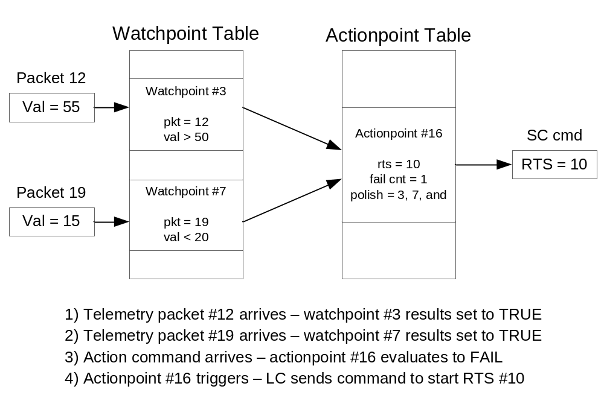

Figure 3. LRO Limit Checker (LC) Operational Example

It should be noted that both tables are processed from the first element to the last. There are NO short-circuit exits involved while parsing through the Watchpoint and Actionpoint Definition Tables. Table developers need to be careful to insert appropriate default values in unoccupied table elements.
8.2 SDO TS Example Scenario
The SDO TS uses a single configuration table. Each monitor point can consist of up to 4 user defined thresholds. Thresholds are checked sequentially from 0 to 3 with the first violation stopping the process. Associated with each threshold is a Failure Minimum, which is the number of times that threshold must be violated consecutively to be considered failed (and reported as such). Each threshold also has a few other settings: a Threshold Active flag which determines if that specific threshold is to be evaluated, a Continue flag which determines if the threshold will continue to be evaluated after it has failed (if not, monitoring will not occur for that threshold until the monitor point is reset), and a Stored Command flag which specifies whether failure of that threshold results in a stored command execution (stored commands will only be sent on the first failure of a threshold, the monitor point must be reset to allow the threshold to send the stored command sequence request again).

Example 1: To setup a threshold for a continuous evaluation of a telemetry point that will start a RTS and issue an event when a telemetry point goes out of limits.

The threshold would be configured as:
Active Flag : TRUE
Continue Flag : TRUE
Operator : Greater Than
RTS Active : TRUE
RTS ID : User specified
Limit : User specified
Failure Count : 1

Example 2: To setup multiple thresholds for continuous evaluation (worst case check LAST) of a telemetry point that will start a RTS and issue an event when a telemetry point goes out of limits for 5 consecutive samples.

Threshold 0 would be configured as:
Active Flag : TRUE
Continue Flag : FALSE
Operator : Greater Than
RTS Active : TRUE
RTS ID : User specified
Limit : User specified
Failure Count : 1
Threshold 1 would be configured as:
Active Flag : TRUE
Continue Flag : TRUE
Operator : Greater Than
RTS Active : TRUE
RTS ID : User specified
Limit : User specified (worst case last)
Failure Count : 5

More examples can be found in the SDO Telemetry and Statistics Monitor (TS) Users Guide (464-FSW-HDBK-0139).

9.0 Feature Analysis
9.1 Command Sets
The LRO LC has the following command set:

- No Operation - Increments the command counter

- Reset - Resets housekeeping counters.

- Set State - Change the state of the LC task (Active, Passive, Disabled)

- Action State - Changes the state of one or all Actionpoints (Active, Passive, Disabled)

- Action Off - Changes individual Actionpoint state to permanent disable

- Reset Action - Resets actionpoint statistics

- Reset Watch - Resets watchpoint statistics

- Sample - Examines actionpoints and memory watchpoints

The SDO TS has the following command set:

- No Operation - Increments the command counter

- Reset - Resets housekeeping counters.

- Enable Monitoring - Sets the monitoring state to Enabled.

- Disable Monitoring - Sets the monitoring state to Disabled.

- Enable Watch Mode - Enables watch mode, preventing RTSes from being executed if a limit fails.

- Disable Watch Mode - Disables watch mode, allowing RTSes to be executed if a limit fails.

- Enable Monitor Point - Enables a single monitor point.

- Disable Monitor Point - Disables a single monitor point.

- Reset Monitor Point Stats - Resets the statistics for a single monitor point or all monitor points.

9.2 Limits
The LRO LC task is sized for 256 watchpoints and 256 actionpoints. In the reverse polish expression specified in actionpoint definitions, the total combined number of operators and operands cannot exceed 20.

The SDO TS task has the following limits:

- 512 Monitor Points

- 4 Thresholds per Monitor Point

- 64 Derived Functions (50 return monitor point data type, 14 always return a floating point value)

- 5 16-bit Parameters per Derived Function

9.3 Derived & Custom Functions
In the SDO TS, derived functions are used for transforming the data contained in a monitor point. If enabled for a monitor point, the derived function is called once the packet is received and the value returned by the derived function is used when comparing against thresholds rather than the original data. In general, derived functions return the same data type as the monitor point: either an unsigned 32-bit value (for all unsigned types), a signed 32-bit value (for all signed types), or a floating point value. In addition to these standard type derived functions, there are a set of special derived functions called polynomial functions (with derived function index greater than or equal to 50) that always return a floating point value.

Associated with each monitor point is an index into a derived functions table (see section 5.7), and 5, 16-bit parameters which get passed to the called function. These parameters can be used for anything, but are usually used to specify the numbers of other monitor points. When these parameters are used to specify other monitor points, the parameters should have a number less than the current monitor point (i.e. so they are already evaluated). Each entry in the derived functions table is just a function pointer and may reference functions anywhere in available memory. This table is not a Software Manager table, and must be changed via memory load as a software patch if new derived functions are being added.

While derived functions are used to transform data prior to comparison in the SDO TS, custom functions in the LRO LC are used in place of the standard comparison operators. If the comparison operator in a watchpoint definition is designated as “custom” (as opposed to <, >, !=, =, etc.), the function LC_do_custom_function is called and passed the following three parameters:

- watch_id - The ID of the watchpoint for this call.

- sized_data - Raw data read from a packet, memory, or I/O.

- pkt_ptr - Pointer to the entire packet (NULL if memory or I/O watch point)

What happens at this point is up to the mission developers. The custom function(s) can do any special processing or data transformations it wants, but LC_do_custom_function must return either a TRUE or FALSE that is used as the result of the threshold comparison for the watchpoint that triggered the call. LC doesn’t make use of a function pointer table and can have as many custom functions as monitor points. Custom functions are added by modifying the source code for the LC_do_custom_function which is accomplished on LRO by rebuilding the LC application, uploading it to the flight system and restarting the task.
9.4 Triggering On Multiple Data Points
The way that the LRO LC uses reverse polish actionpoint expressions, it is fairly easy to setup responses to combinations of watchpoint states (see section 8.1). In the SDO TS, the only way to perform such an action is through the use of a derived function which can be passed the IDs of other monitor points to use in their processing.

9.5 Memory Monitoring
The LRO LC supports memory watchpoints that are evaluated when the LC SAMPLE command is sent to the LC task from the ground or the onboard Scheduler (SH). By extension, such watchpoints can be used to monitor memory mapped I/O addresses. The SDO TS task is limited to data points in telemetry packets only.

10.0 Conclusions
Based upon the analysis, the following tables list the required, optional, and rejected features recommended for the CFS Limit Checker (LC) application.

10.1 Primary Features
Primary Features are high level core requirements and were implemented in both of the heritage missions examined.

Requirement | Rationale | Heritage Reference
Noop Command Support | Common ground command | LRO, SDO
Reset Housekeeping Counters Command Support | Common ground command | LRO, SDO
Monitor telemetry data points against one or more threshold values | Core monitoring function | LRO, SDO
Compile statistics on threshold violations | Allows ground operators to monitor operation | LRO, SDO
Provide the capability to reset threshold violation statistics | Operators need to be able to clear statistics if an error condition is corrected or they want to discard prior monitoring data for some reason | LRO, SDO
Provide the capability to initiate RTS responses to threshold violations | Allows autonomous responses to spacecraft error conditions | LRO, SDO
Provide a mode that disables monitoring data points | Allows the application to be disabled if unexpected behavior occurs or configuration tables need to be updated | LRO, SDO
Provide a mode where monitoring data points is enabled, but RTS responses are disabled | Allows autonomous error responses to be turned off while still collecting data on threshold violations | LRO, SDO
Store monitoring and response configuration data in tables that can easily be updated by the ground operators | Provides in flight tuning of error conditions and responses | LRO, SDO
Support the use of Custom/Derived functions that can be updated by a software patch | Provides additional flexibility for complex data evaluations | LRO, SDO
10.2 To Be Considered
These features will require some additional investigation to determine how useful they may be. These are not critical capabilities and may be deferred to a later build of the CFS if the decision is made to incorporate any of them.

Requirement | Rationale | Heritage Reference
Support for Memory Address Monitoring | Allows monitoring of data that may not be accessible in telemetry packets. | LRO
Allow Symbol Name as Address Argument | May be useful in environments with dynamic loading. | None. Implemented in current CFS applications.
Allow Symbol Name With Optional Offset as Address Argument | Same rational as previous. | None. Implemented in current CFS applications.

10.3 Rejected
No features were identified that have been rejected.

11.0 Proposed Context
While both the SDO TS and LRO LC applications were developed to solve a similar problem (how to monitor and respond to spacecraft anomalies), they each take very different approaches. Based upon this heritage analysis it is recommended that the LRO LC design be used as the basis for the CFS Limit Checker for the following reasons:

- Using a design with heritage will speed development of the CFS LC application over a completely new implementation and many of the generic requirements can be taken as they currently exist from LRO

- The Trace/Wire heritage of the LRO LC design is more straight forward and flexible than the SDO TS approach (taken from WMAP) which puts all the configuration data for monitor points and responses into a single setup table (this is in agreement with an earlier telemetry monitor evaluation performed in 2004).

- The LRO LC has already been made compatible with the Core Flight System (cFE).

- The CFS flight architecture will be using a table based scheduler application that can drive the actionpoint sampling approach of the LRO design.

Figure 4 shows the proposed context diagram for the CFS Limit Checker (LC) application. It is very similar to the LRO context diagram. The main difference is that this one shows the explicit use of the cFE OS Abstraction Layer for access to hardware memory addresses.

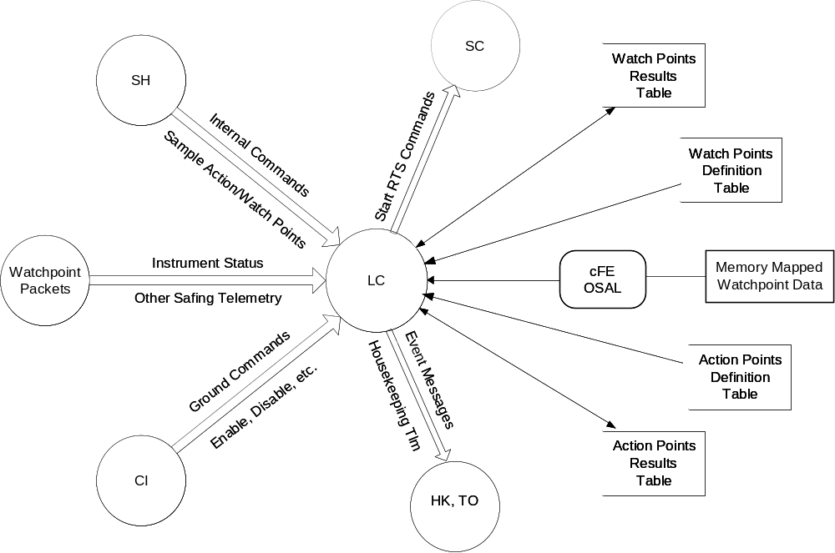

Figure 4. Proposed CFS LC Context Diagram

12.0 Ground Interface Requirements
The contents of the Limit Checker configuration tables by their very nature are going to be mission specific. However, it is anticipated that any ground support tools used for LRO can be adapted for use with the CFS LC application if the LRO design is adopted for the CFS version.

13.0 Heritage Analysis Review Addendums
On June 5, 2008 a review of the CFS LC heritage analysis was held. This section contains additional information or clarifications as a result of those discussions.

13.1 Derived Function Use In The SDO TS
Sections 9.3 and 9.4 discuss how derived functions in the SDO TS task can be used to setup responses to the states of multiple monitor points. Another common use of derived functions is to convert the raw data from a monitor point into a value with the same type of units as the threshold value specified in the monitor table. This is why the derived function is invoked before the comparison operation and why some slots in the derived function pointer table always return a floating point number (section 5.7).

Custom functions in the LRO LC can also be used for this purpose. However, for LRO the decision was made to have all telemetry data converted to standard units by the applications that construct the packets so custom functions were not needed for this kind of data transformation.

13.2 Mulitple Thresholds In The LRO LC
The SDO TS task supports up to 4 thresholds per monitor point (section 5.5). Multiple thresholds can also be configured in the LRO LC application by defining multiple watch points with the same telemetry point ID. Each watchpoint definition would have its own comparison value and actionpoint definitions could initiate different responses depending on which thresholds had been violated. With this approach, the number of thresholds per monitorpoint is only constrained by the allowable size of the Monitorpoint Definition Table.

13.3 Preventing Multiple RTS Requests
Both the SDO TS and LRO LC tasks have ways to keep RTS responses to threshold violations from getting initiated more than once.

In the TS task, when an RTS is triggered for a threshold violation, the SC field in the TS Statistics Table (which is bitmapped) is updated to reflect the event. As long as the “RTS executed” bit is set for a threshold, subsequent failures will not cause additional RTS requests to be sent to the Stored Commanding (SC) task. The monitor point must be reset (by the RESET MONITOR POINT STATS ground command) before a threshold failure will send the stored command sequence request again.

In the LC task, when an RTS is triggered the curr_state field in the Actionpoint Results Table is set to LC_ACTION_PASSIVE which allows the actionpoint to be fully evaluated but stops RTS requests. RTS requests can be re-enabled by resetting curr_state to LC_ACTION_ACTIVE with the LC ACTION STATE ground command.
13.4 Memory Address Monitoring Using Memory Dwell (MD)
While the LRO LC task supports direct monitoring of memory addresses (section 9.5) it was pointed out that the SDO TS task can accomplish the same result if memory contents are placed in telemetry packets by the Memory Dwell (MD) task. It was decided that this may be a desirable approach for the CFS implementation. Memory monitoring was a heritage capability of the LC task that was not used on LRO. Removing it would simplify the CFS LC task and eliminate the need to add symbolic name support to the LC table structures (thereby increasing their size).

13.5 Revised Proposed Context
Figure 5 shows the proposed context diagram for the CFS Limit Checker (LC) application updated after the Heritage Analysis Review. This diagram removes the memory watchpoint capability (see previous section).

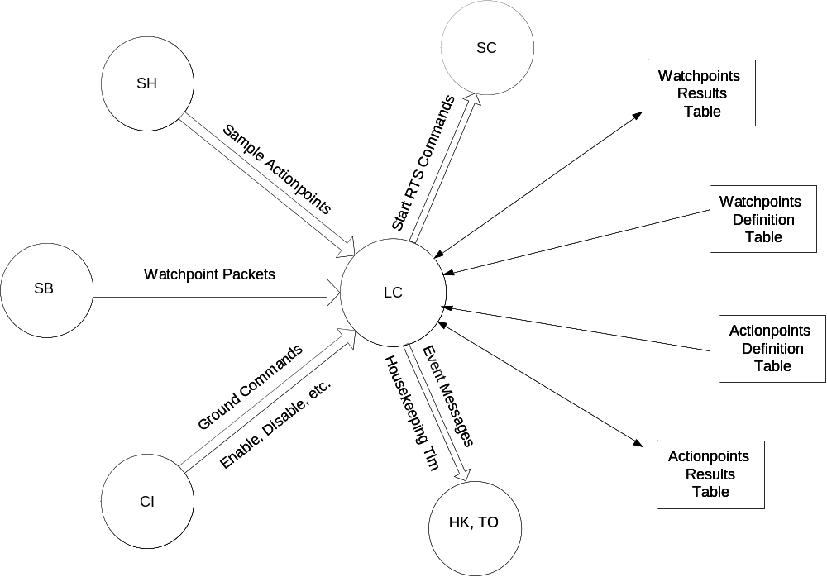

Figure 5. Proposed CFS LC Context Diagram (Revised)

13.6 Additional LRO LC Examples
Scott Walling of the LRO project provided additional examples of how the LRO LC watchpoint and actionpoint definition tables are used. His email is reproduced here in its entirety:

All,

I was asked to provide a sample of how LRO does incremental tests on the same data point. Here are a couple of excerpts from the LC tables used in LRO.

Also, I put a couple of more complex actionpoint definitions at the end. They have nothing to do with the incremental test examples.

Scott

Note: The fact that the watchpoint numbers (index into watchpoint table) and actionpoint numbers (index into actionpoint table) are the same has no particular meaning.

Watchpoints

/* #112 (Diviner - low s/c bus voltage, level 1) */
{ .data_size = LC_DATA_U_WORD,
.operator_id = LC_OPER_LT,
.stream_id = PSE_FAST_HK_TLM_MID,
.address_offset = 184,
.bit_mask = 0xFFFF,
.comparison_value.Pad32_U16.u16 = 3417
},
/* #113 (Diviner - low s/c bus voltage, level 2) */
{ .data_size = LC_DATA_U_WORD,
.operator_id = LC_OPER_LT,
.stream_id = PSE_FAST_HK_TLM_MID,
.address_offset = 184,
.bit_mask = 0xFFFF,
.comparison_value.Pad32_U16.u16 = 3319
},

Actionpoints:

/* #112 */
{ .default_state = LC_ACTION_DISABLED,
.rts_id = RTS_ID_DIVINER_SAFE_MODE,
.event_text = { "Diviner: low input volt (1)" },
.event_type = CFE_EVS_INFORMATION,
.event_id = 1112,
.num_fails_before_rts_exec = 60,
.polish_equation = { /* (WP_112) */
112,
LC_POLISH_EQUAL
}
},

/* #113 */
{ .default_state = LC_ACTION_DISABLED,
.rts_id = RTS_ID_DIVINER_SAFE_MODE,
.event_text = { "Diviner: low input volt (2)" },
.event_type = CFE_EVS_INFORMATION,
.event_id = 1113,
.num_fails_before_rts_exec = 3,
.polish_equation = { /* (WP_113) */
113,
LC_POLISH_EQUAL
}
},

The next couple of actionpoints are examples of more complex Reverse Polish equations:

/* #43 */
{ .default_state = LC_ACTION_ENABLED,
.rts_id = RTS_ID_ACS_EXIT_THRUSTER_MODE,
.event_text = { "GNC: delta-V sys attitude" },
.event_type = CFE_EVS_INFORMATION,
.event_id = 1043,
.num_fails_before_rts_exec = 10,
.polish_equation = { /* (WP_26 && !WP_61 && !WP_64 &&
!WP_45 && WP_46 && WP_47) */
26, 61,
LC_POLISH_NOT,
LC_POLISH_AND,
64,
LC_POLISH_NOT,
LC_POLISH_AND,
45,
LC_POLISH_NOT,
LC_POLISH_AND,
46,
LC_POLISH_AND,
47,
LC_POLISH_AND,
LC_POLISH_EQUAL
}
},

/* #47 */
{ .default_state = LC_ACTION_ENABLED,
.rts_id = RTS_ID_ACS_POWER_OFF_ALL_RW,
.event_text = { "GNC: wheel on, attached" },
.event_type = CFE_EVS_INFORMATION,
.event_id = 1047,
.num_fails_before_rts_exec = 2,
.polish_equation = { /* (!WP_80 && (WP_48 || WP_49 ||
WP_50 || WP_51))) */
80,
LC_POLISH_NOT,
48, 49, 50, 51,
LC_POLISH_OR,
LC_POLISH_OR,
LC_POLISH_OR,
LC_POLISH_AND,
LC_POLISH_EQUAL
}
},

/* #142 */
{ .default_state = LC_ACTION_DISABLED,
.rts_id = RTS_ID_LEND_POWER_OFF,
.event_text = { "LEND: comp over temp #1" },
.event_type = CFE_EVS_INFORMATION,
.event_id = 1142,
.num_fails_before_rts_exec = 60,
.polish_equation = { /* (WP_142 && WP_143) || (WP_144
&& WP_145) || (WP_146 && WP_147) */
142, 143,
LC_POLISH_AND,
144, 145,
LC_POLISH_AND,
146, 147,
LC_POLISH_AND,
LC_POLISH_OR,
LC_POLISH_OR,
LC_POLISH_EQUAL
}
},

