 | CORE FLIGHT SYSTEM  Limit Checker eXtended  BUILD 2.0.0.0  FLIGHT SOFTWARE BUILD VERIFICATON  TEST REPORT  Flight Software Branch – Code 582  Version 1.0

Signatures
Submitted by:

_______________________________________ _______________
Walt Moleski/582 Date
CFS Flight Software Tester

Approved by:

_______________________________________ _______________
Charlie Wildermann/582 Date
Flight Software Branch/Head

_______________________________________ _______________
Susanne Strege/582 Date
CFS Flight Software Product Development Lead

Plan Update History
Version | Date | Description | Affected Pages
Draft | 9/27/2012 | Draft for review | All
1.0 |  | Initial Release | All

Table of Contents
1 Introduction 1
1.1 Document Purpose 1
1.2 Applicable Documents 1
1.3 Document Organization 1
1.4 Definitions 2
2 OVERVIEW 3
2.1 Flight Data System Context 3
2.2 Test History 4
2.3 Testing Overview 4
2.4 Version Information 9
3 Build Verification Test Preparation 10
3.1 Scenerio Development 10
3.2 Procedure Development and Execution 10
3.3 Test Products 10
4 Build Verification Test Execution 11
4.1 Testbed Overview 11
4.2 Requirements Verification Matrix 12
4.3 Requirements Partially Tested 12
4.4 Requirements/Functionality Deferred 12
4.5 Requirements/Functionality Deferred for Mission Testing 12
5 Build Verficiaton Test Results 13
5.1 Overall Assessment 13
5.2 Procedure Description 13
5.3 Analysis Requirements Verification 15
5.4 Failed Requirements 15
5.5 DCRs 15
5.5.1 DCRs Verified 15
5.5.2 Outstanding DCRs 15
5.6 Notes 15
Appendix A - RTTM 17
Appendix B - Command, Telemetry, and Events Verification Matrix 18

Introduction

Document Purpose

This Test Report describes the test results from the Core Flight System (CFS) Limit Checker eXtended (LCX) Flight Software (FSW) Test Team build 2.0.0.0 verification testing. It is used to verify that the LCX FSW has been tested in a manner that validates that it satisfies the functional and performance requirements defined within the CFS LCX Requirements Document. This Test Report summarizes the FSW test history, the build verification process, the build test configuration, and the test execution and results.

Applicable Documents
Unless otherwise stated, these documents refer to the latest version.

Parent Documents (Mission and FSW)

- 582-2012-006 CFS Limit Checker eXtended Requirements Document, Version 1.0
- 582-2008-012 CFS Deployment Guide

Reference Documents

All of the references below can be found on the Code 582 internal website at http://fsw.gsfc.nasa.gov/

- 582-2003-001 FSB FSW Test Plan Template
- 582-2004-001 FSB FSW Test Description Template
- 582-2004-002 FSB FSW Test Scenario Template
- 582-2004-003 FSB FSW Test Procedure Template
- 582-2004-004 FSB FSW Test Execution Summary Template
- 582-2004-005 FSB Test Product Peer Review Form
- 582-2000-002 FSB FSW Unit Test Standard

Document Organization
Section 1 of this document presents some introductory material.
Section 2 provides a flight software overview and context along with the test history and testing overview.
Section 3 describes the build verification process including procedure development and execution and test products produced.
Section 4 describes the build test configuration which includes an overview of the testbed and the requirements verification matrix.
Section 5 describes the test execution and results by subsystem.
Appendix A - provides the Requirements Traceability Matrix
Appendix B - provides the Command, Telemetry, and Events Verification Matrix

Definitions
There were 3 verification methods used during build verification testing. They were:
- Demonstration: Show compliance with system requirement by exhibiting the required capability (e.g. by demonstrating interactive capability, display capability, print capability, etc.
- Inspection: Show compliance with a system requirement by visual verification of the software (e.g. verifying preparation for delivery, proper interfacing)
- Analysis: Perform detailed analysis of code, generated data (both intermediate data and final output data), etc., to determine compliance with system requirements.

The fields in the Requirements Verification Matrix in Section 4.3 are defined as follows:
- Requirements Tested Passed: Requirement was fully tested in a build test procedure and passed all tests.
- Requirements Tested Failed: Requirement was fully tested in a build test procedure and failed one or more aspect of the testing.
- Requirements Tested Partially: Requirement was tested partially in a build test procedure. To be fully tested, the partially tested requirement is either tested additionally in one or more other test procedures within the same build and/or other aspects of the requirement must be tested in a later build, due to capabilities not present in the current build
- Total Tested: Total number of requirements fully tested in a build test procedure. Includes total passed and total failed, but does not include requirements tested partially, unless (included as a separate entry) testing in multiple procedures within the same build constitutes total testing of a particular requirement. Total Requirements Tested is computed this way in order to avoid multiple counting of individual requirements that are tested partially in more than one procedure.
- Deferred: Number of requirements that were planned to be tested in current build, but were not tested due to some FSW capability or necessary system component not being present.
- Total: Total Requirements Tested + Number of Requirements Deferred

In each software test section in Section 5 there is a table of DCR’s. The state definitions are as follows:
- Opened: The DCR is currently being addressed
- Assigned: The DCR was accepted and the modification is being addressed
- InTest: The DCR was corrected and is currently in test
- Validated: The DCR was corrected and tested and has been validated, needs to have a CCB to close the DCR
- Closed: The DCR is closed and have been resolved and tested to satisfaction
- Closed with Defect: The DCR is closed and the defect is most likely assigned a differed DCR number associated with another subsystem.

OVERVIEW

Flight Data System Context
Figure 2-1 illustrates the CFS system context. The cFE interfaces to five external systems: an Operating System (OS), a Hardware Platform (HP), an Operational Interface (OI), Applications (APP), and other cFE-based systems.

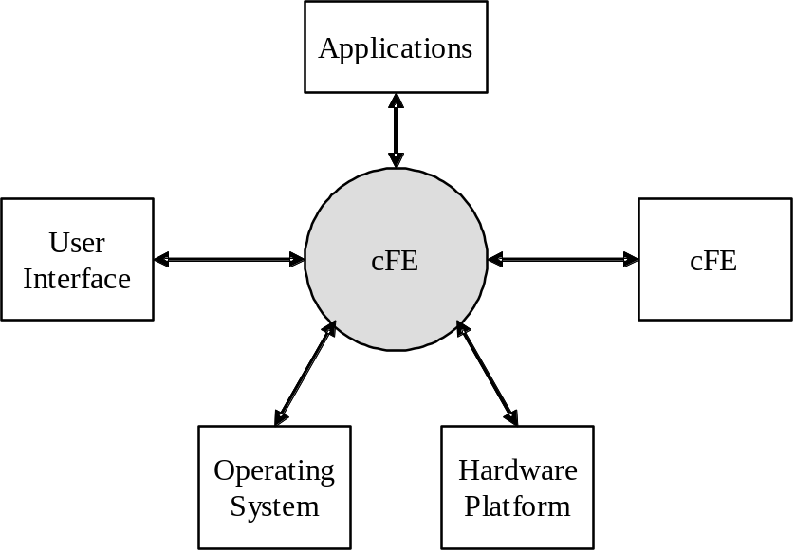

Figure 2-1 CFS System Context
The figure below shows major interfaces between the Limit Checker eXtended application and other core Flight Executive (cFE) and Core Flight System (CFS) applications. Although it isn’t shown explicitly, all task-to-task communications are accomplished via the cFE Software Bus application.
Inputs to the Limit Checker eXtended task include: 1) Wake-up calls from the Scheduler (SCH) application which trigger processing, 2) Housekeeping requests from the Scheduler (SCH) application which trigger housekeeping data collection, 3) configuration commands from the Command Ingest (CI) application, and 4) updates to Limit Checker Tables managed by the Table Services (TBL) application 5) Watchpoint Packets from the Software Bus (SB) application.
Outputs from the Limit Checker application include: 1) Limit Checker housekeeping messages sent to the Housekeeping (HK) application, 2) RTS Commands sent to the Stored Command application for processing, and 3) Event messages.

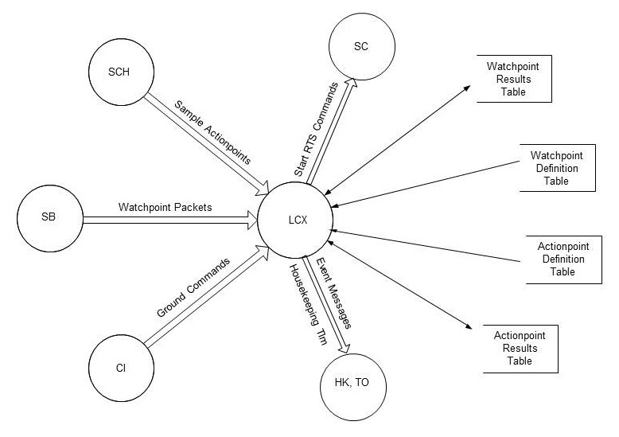

Figure 2-1 CFS LCX Context

Test History
LCX 2.0.0.0 – Build Verification Testing completed 10/2/2012 by Walt Moleski

Testing Overview
The CFS Test procedures assume that the CFS application and its corresponding test application are not executing before the start of the test. If this is not the case, the test procedures will need to be modified to handle this situation.

The LCX application was tested during Build Verification testing using the following:
- 1 test application: tst_lc
- 10 main test procedures: lcx_evtfilter.prc, lcx_gencmds.prc, lcx_monitoring.prc, lcx_noaction.prc, lcx_stale.prc, lcx_resetcds.prc, lcx_resetnocds.prc, lcx_stress.prc, lcx_tabletesting.prc, lcx_withaction.prc
- 17 test procedures that setup the Actionpoint and Watchpoint Definition Tables: lcx_adt1.prc, lcx_adt1a.prc, lcx_adt1b.prc, lcx_adt2.prc, lcx_adt2a.prc, lcx_adt3.prc, lcx_adt4.prc. lcx_adt4a.prc, lcx_adt5.prc, lcx_adt6.prc lcx_wdt1.prc, lcx_wdt2.prc, lcx_wdt2a.prc, lcx_wdt3.prc, lcx_wdt4.prc, lcx_wdt4a.prc, and lcx_wdt5.prc
- 2 test procedures that are called by some of the main procedures: lcx_sendmonpackets.prc and lcx_sendpackets.prc
- 1 test procedure that tests another aspect of the lcx_resetcds.prc: lcx_resetcdsstate.prc
- 1 RTS load file to be used by the lcx_stress.prc to actually execute an RTS: lcx_rts10_load.scs. Refer to the LC Special Build Instructions document in the lcx/docs repository in MKS.
- All tests require the Advanced Spacecraft Integration and System Test (ASIST) Ground Station

The TST_LC test application is used to send schedule requests for the output of LCX’s housekeeping data to the LCX application. This was useful when performing build verification testing since it provided great control over the sequence of steps. When deployed for a mission, the Scheduler Application would provide this request. In addition, the test application has 7 ground commands defined to help with the LCX testing. These commands are described below:
- TST_LC_NOOP
  - This command that issues an event and increments the command processed counter.
- TST_LC_ResetCtrs
  - This command resets the command processed and command error counters to zero (0).
- TST_LC_SetCounters
  - This command sets several Limit Checker (LCX) counters so that the LC_ResetCtrs command can be tested and verified.
- TST_LC_SetWRT
  - This command sets the Watchpoint statistics with non-zero data in order to detect whether the results table was restored properly from the Critical Data Store or if the last dump on the table actually changed the values.
- TST_LC_SetART
  - This command sets the Actionpoint statistics with non-zero data in order to detect whether the results table was restored properly from the Critical Data Store or if the last dump on the table actually changed the values.
- TST_LC_SendPacket
  - This command sends a packet of data to the LCX application so that it can be processed by the LCX application.
- TST_LC_SendSample
  - This command requests the LCX application to sample the specified Actionpoint.

The LCX 2.0.0.0 testing was performed using 4 different configurations. Each configuration required a separate compilation with changes to the PLATFORM_DEFINED configuration parameters. These configurations are described below:
- Normal: LCX compiled out of the box with no Critical Data saved.
- Normal CDS: LCX compiled with the following parameters set:
  - LC_SAVE_TO_CDS defined
  - LC_STATE_WHEN_CDS_RESTORED set to LC_STATE_FROM_CDS
- CDS ACTIVE State: LCX compiled with the configuration above and the LC_STATE_WHEN_CDS_RESTORED set to LC_STATE_ACTIVE.
- CDS PASSIVE State: LCX compiled with the configuration above and the LC_STATE_WHEN_CDS_RESTORED set to LC_STATE_PASSIVE.

The main LCX test procedures do the following:

Procedure | Description
lcx_evtfilter | The purpose of this test is to verify that Limit Checker eXtended (LCX) properly filters the PASS to FAIL and FAIL to PASS transition events when the table-defined maximum number of times has been reached for an ActionPoint (AP).
lcx_gencmds | The purpose of this test is to verify that the LCX general commands execute and function properly.
lcx_monitoring | The purpose of this test is to verify that the LCX application functions properly when monitoring WatchPoints (WP). All WPs evaluate to FALSE so no thresholds will be reached to cause ActionPoints (AP) to take action.
lcx_noaction | The purpose of this test is to verify that the LCX application functions properly when monitoring Watchpoints (WP). WPs evaluate to a mix of TRUE, FALSE, and STALE. All ActionPoints (AP) PASS which results in no thresholds being reached and thus, no actions taken.
lcx_stale | The purpose of this test is to verify that the LCX application properly handles “stale” data. Stale data is data that has not been received for x Sample commands as specified in the WatchPoint Definition table.
lcx_resetcds | The purpose of this test is to verify that the LCX application initializes the appropriate data items based upon the type of reset that occurs (Application, Processor, or Power-On). This test should NOT be executed if the configuration parameter indicating Save Critical Data is not set by the Mission.
lcx_resetcdsstate | The purpose of this test is to verify that the LCX application restores the proper Application State when an Application or cFE Processor Reset occurs. This test should NOT be executed if the configuration parameter indicating Save Critical Data is not set by the Mission.
lcx_resetnocds | The purpose of this test is to verify that the LCX application does not save any data across a reset (Application, Processor, or Power-On). This test should NOT be executed if the configuration parameter indicating Save Critical Data is set by the Mission.
lcx_stress | The purpose of this test is to verify that the LCX application functions properly when monitoring the maximum number of WatchPoints (WP). All evaluate to FALSE. The maximum number of ActionPoints (SP) evaluate to FAIL which in turn trigger the execution of an RTS. Also, Anomaly tests are performed to ensure the appropriate action is taken by the LC application.
lcx_tabletesting | The purpose of this test is to verify that the LCX application functions properly when loading new WatchPoint Definition Tables (WDT) and ActionPoint Definition Tables (ADT). The tables are updated while the LCX application is in the ACTIVE, PASSIVE, and DISABLED state. Other tests attempt to load invalid tables to ensure that the validation functions correctly reject the table loads.
lcx_withaction | The purpose of this test is to verify that the LCX application functions properly when monitoring WatchPoints (WP). WPs evaluate to a mix of TRUE, FALSE, and STALE. ActionPoints (APs) evaluate to a mix of PASS, FAIL, and STALE.

The test procedures described in the table below are called by at least one of the test procedures above.

Procedure | Description
lcx_sendmonpackets | This procedure sends packet data that is used by the lcx_monitoring test procedure.
lcx_sendpackets | This procedure sends packet data that is used by several test procedures described above.
lcx_adt1 | This procedure sets up a version of the ActionPoint Definition Table (ADT) that is used by the main test procedures. NOTE: This ADT is to be used in conjunction with the lcx_wdt1 procedure described below.
lcx_adt1a | This procedure sets up a version of the ActionPoint Definition Table (ADT) that is used by the main test procedures. NOTE: This ADT is to be used in conjunction with the lcx_wdt1 procedure described below.
lcx_adt1b | This procedure sets up a version of the ActionPoint Definition Table (ADT) that is used by the main test procedures. NOTE: This ADT is to be used in conjunction with the lcx_wdt1 procedure described below.
lcx_adt2 | This procedure sets up a version of the ActionPoint Definition Table (ADT) that is used by the main test procedures. NOTE: This ADT is to be used in conjunction with the lcx_wdt2 procedure described below.
lcx_adt2a | This procedure sets up a version of the ActionPoint Definition Table (ADT) that is used by the main test procedures. NOTE: This ADT is to be used in conjunction with the lcx_wdt2a procedure described below.
lcx_adt3 | This procedure sets up a version of the ActionPoint Definition Table (ADT) that is used by the main test procedures. NOTE: This ADT is to be used in conjunction with the lcx_wdt3 procedure described below.
lcx_adt4 | This procedure sets up a version of the ActionPoint Definition Table (ADT) that is used by the main test procedures. NOTE: This ADT is to be used in conjunction with the lcx_wdt4 procedure described below.
lcx_adt4a | This procedure sets up a version of the ActionPoint Definition Table (ADT) that is used by the main test procedures. NOTE: This ADT is to be used in conjunction with the lcx_wdt4a procedure described below.
lcx_adt5 | This procedure sets up a version of the ActionPoint Definition Table (ADT) that is used by the evtfilter test procedure. NOTE: This ADT is to be used in conjunction with the lcx_wdt1 procedure described below.
lcx_adt6 | The purpose of this procedure is to generate an ActionPoint Definition Table (ADT) to be used by the LCX application to determine if the correct transitions are achieved when a WatchPoint goes “stale”.
lcx_wdt1 | This procedure sets up a version of the WatchPoint Definition Table (WDT) that is used by the main test procedures. NOTE: This WDT is to be used in conjunction with the lcx_adt1, lcx_adt1a, and lcx_adt1b procedures described above.
lcx_wdt2 | This procedure sets up a version of the WatchPoint Definition Table (WDT) that is used by the main test procedures. NOTE: This WDT is to be used in conjunction with the lcx_adt2 procedure described above.
lcx_wdt2a | This procedure sets up a version of the WatchPoint Definition Table (WDT) that is used by the main test procedures. NOTE: This WDT is to be used in conjunction with the lcx_adt2a procedure described above.
lcx_wdt3 | This procedure sets up a version of the WatchPoint Definition Table (WDT) that is used by the main test procedures. NOTE: This WDT is to be used in conjunction with the lcx_adt3 procedure described above.
lcx_wdt4 | This procedure sets up a version of the WatchPoint Definition Table (WDT) that is used by the main test procedures. NOTE: This WDT is to be used in conjunction with the lcx_adt4 procedure described above.
lcx_wdt4a | This procedure sets up a version of the WatchPoint Definition Table (WDT) that is used by the main test procedures. NOTE: This WDT is to be used in conjunction with the lcx_adt4a procedure described above.
lcx_wdt5 | The purpose of this test is to generate the WatchPoint Definition Table (WDT) 5 in order to test the new StaleAge option for the LCX application.

The CFS Deployment Guide contains the instruction for how to set up both the CFS Flight and Ground test environment. The testers use a CFS Test Account for each build test. This account runs ASIST and is setup to contain all the files needed to test the application. These files are extracted from MKS, the source repository tool. Included in these files are test utilities. These utilities can be located in 2 places depending upon whether they are “local” or “global” utilities. The local utilities are extracted into the working prc directory ($WORK/prc). The global utilities are pointed to by ASIST in the global area defined on the test system. Additional tools utilized by the test procedures are located in the $TOOLS directory. It is assumed that test procedures and the ASIST telemetry database used for testing is built using procedure and database templates.

The following utilities were used during testing:

Name | Description
CFE_startup | Directive combines the "start_data_center", "open_tlm", and "open cmd <cpu>" ASIST startup commands.
close_data_center | Directive that closes the command and telemetry connection to the CPU being used.
create_tbl_file_from_cvt | Procedure that creates a load file from the specified arguments and cvt
load_start_app | Procedure to load and start a user application from the /s/opr/accounts/cfstest/apps/cpux directory.
load_table | Procedure that takes the specified file and transfers the file to the specified processor and then issues a TBL_LOAD command using the file.
tst_lc (version 2.0.0.0) | Test application required to test the LCX application.
ut_pfindicate | Directive to print the pass fail status of a particular requirement number.
ut_runproc | Directive to formally run the procedure and capture the log file.
ut_sendcmd | Directive to send EVS commands Verifies command processed and command error counters.
ut_sendrawcmd | Send raw commands to the spacecraft. Verifies command processed and command error counters.
ut_setrequirements | A directive to set the status of the cFE requirements array.
ut_setupevents | Directive to look for multiple events and increment a value for each event to indicate receipt.
ut_tlmupdate | Procedure to wait for a specified telemetry point to update.
ut_tlmwait | Directive that waits for the specified telemetry condition to be met

Version Information

Item | Version
LCX Requirements | 1.0
LCX Application | 2.0.0.0
TST_LC Application | 2.0.0.0
CFE | 6.3.2.0
OSAL | 3.5.0.0
ASIST | 9.7k
VxWorks | 6.4

Build Verification Test Preparation

Scenerio Development
No scenarios were developed for LCX 2.0.0.0 Build Verification Test. Since LCX was an enhancement to the LC application, all the LC scenarios are applicable to LCX. All scenarios are stored on the MKS server, in CFS-Repository LCX test-and-ground directory within the Scenarios subdirectory. It should be noted that as LCX requirements evolve these scenarios are not updated to reflect any changes made.

Procedure Development and Execution
This build test was completed by running 10 test procedures. All test procedures were written using the STOL scripting language. The naming convention for files created by the test procedures was: scx_cpu<#>_<procedure name>_GMT.<ext>.

Test Products
Five log files were generated for every procedure that was run. They are defined as follows:
- Logs with the .loge extension list all events sent by the flight software
- Logs with the .logr extension list all requirements that passed validation by demonstration
- Logs with the .logp extension lists all prints that are generated by the test procedure
- Logs with the .logf extension lists everything from the other logs along with the steps in the test procedure
- Logs with the .logs extension lists the SFDU information (if applicable) contained in the full log.

A test summary report is developed in MKS for each procedure by the tester after build testing is completed. All test products are maintained on MKS in the CFS-Repository LCX test-and-ground directory.

Build Verification Test Execution

Testbed Overview
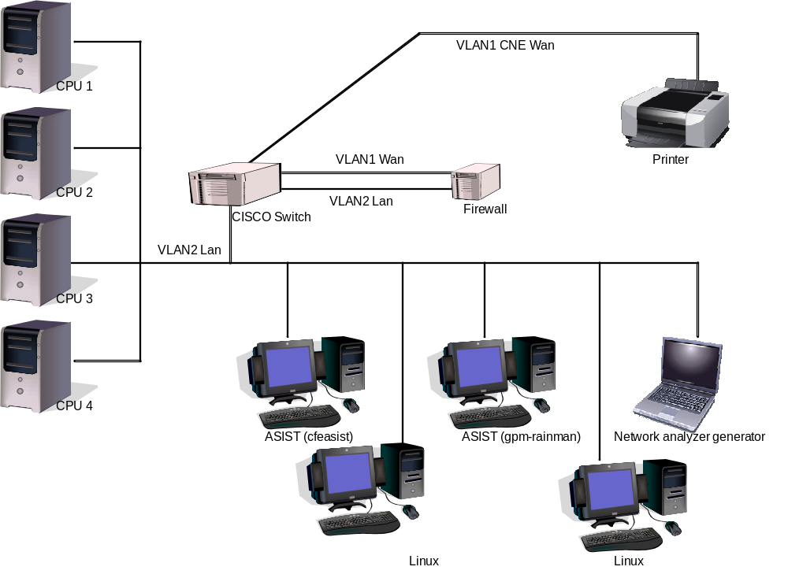
LCX FSW testing took place in the CFS FSW Development and Test Facility. A high level view of the CFS FSW Test Bed is shown in Figure 4-1. This facility is located in GSFC Building 23, Room N410. This facility consists of two ASIST workstations running ASIST version 9.7k and three MPC750 CPU boards running VxWorks 6.4. CPU1 is primarily used for development testing while CPU2 and CPU3 are used for build verification testing.

Figure 4-1 CFS FSW Development and Testing Facility

Equipment | Description | Purpose
CPU1 | MPC750 board | Development testing
CPU2 | LEON3 board | Development and Build verification testing
CPU3 | MPC750 board | Build verification testing
Workstation | cfeasist (Dell Dimension 360 running RedHat Linux) | Running ASIST 9.7k for build testing
Workstation | gpm-rainman (Dell Dimension 360 running RedHat Linux) | Running ASIST 9.7k for build testing
Linux Workstation | cfelnx (Dell Precision 470 running RedHat Linux) | FSW Development
Linux Workstation | gpm-raindrop (Dell Precision 420 running RedHat Linux) | Serial port communications to flight CPUs from cfeasist & gpm-rainman
Network analyzer generator | PC running Wireshark | Communications diagnostics
Cisco Switch | 2900 series with 2 VLAN’s | Managed switch, allows port sniffing and VLANs
Firewall | Mini PC running Monowall | Lab firewall
Printer
4 port RS 232 Serial | Keyspan 49WLC 4-port USB Serial Adapter | Serial port communications to flight CPUs
VLAN2 Lan
VLAN1 CNE Wan

Requirements Verification Matrix

Limit Checker
(LCX)
Requirements Tested Passed | 62
Requirements Tested Failed | 0
Requirements Tested Partially | 0
Total Tested | 62
Deferred | 0
Total | 62

Requirements Partially Tested
No requirements were partially tested.

Requirements/Functionality Deferred
No requirements were deferred to later build testing:

Requirements/Functionality Deferred for Mission Testing
No requirements/functionality was deferred to mission testing:

Build Verficiaton Test Results

Overall Assessment
During this build test of the LCX Application the software behaved as expected. Below is a summary of the results:
- 62 requirements passed via demonstration
- 0 requirements failed testing.
- 1 DCR were verified

Procedure Description

Procedure | Description | Requirements tested
lcx_evtfilter | The purpose of this test is to verify that Limit Checker eXtended (LCX) properly filters the PASS to FAIL and FAIL to PASS transition events when the table-defined maximum number of times has been reached for an ActionPoint (AP). | LCX1003, LCX3001, LCX3001.2, LCX3002, LCX3002.1, LCX3002.1.1, LCX3002.2, LCX3002.2.1, LCX3002.3, LCX3002.3.1, LCX3002.4, LCX3006, LCX4000, LCX8000, LCX9000, LCX9001, LCX9002
lcx_gencmds | The purpose of this test is to verify that the LCX general commands execute and function properly. | LCX1000, LCX1001, LCX1002, LCX1003, LCX1004, LCX2004, LCX3006, LCX4000, LCX4001, LCX4002, LCX4003, LCX4004, LCX4005, LCX4006, LCX4007, LCX4008, LCX4009, LCX4009.1, LCX4010, LCX4011, LCX4012, LCX4013, LCX8000, LCX9000, LCX9001, LCX9002
lcx_monitoring | The purpose of this test is to verify that the LCX application functions properly when monitoring WatchPoints (WP). All WPs evaluate to FALSE so no thresholds will be reached to cause ActionPoints (AP) to take action. | LCX1003, LCX2003, LCX2003.2, LCX2003.3, LCX2004, LCX3001, LCX3001.1, LCX3002, LCX3003, LCX3004, LCX3005, LCX3006, LCX4000, LCX4001, LCX4002, LCX4003, LCX4004, LCX4005, LCX4006, LCX4007, LCX4008, LCX4009, LCX8000, LCX9000, LCX9001, LCX9002, LCX9005, LCX9006
lcx_noaction | The purpose of this tese is to verify that the LCX application functions properly when monitoring Watchpoints (WP). All WP evaluate to a mix of TRUE, FALSE, and STALE. All ActionPoints (AP) PASS which results in no thresholds being reached and thus, no actions taken. | LCX1003, LCX2003, LCX2003.2, LCX2003.3, LCX2004, LCX3001, LCX3001.1, LCX3002, LCX3003, LCX3004, LCX3005, LCX3006, LCX4000, LCX4003, LCX4004, LCX4005, LCX4006, LCX4007, LCX4009, LCX8000, LCX9000, LCX9001, LCX9002
lcx_resetcds | The purpose of this test is to verify that the LCX application initializes the appropriate data items based upon the type of reset that occurs (Application, Processor, or Power-On). This test should NOT be executed if the configuration parameter indicating Save Critical Data is not set by the Mission. | LCX1003, LCX2004, LCX3006, LCX4000, LCX4004, LCX8000, LCX9000, LCX9001, LCX9002, LCX9004, LCX9004.1, LCX9004.1.1, LCX9004.3, LCX9005, LCX9006, LCX9007, LCX9007.1, LCX9007.2
lcx_resetcdsstate | The purpose of this test is to verify that the LCX application restores the proper Application State when an Application or cFE Processor Reset occurs. This test should NOT be executed if the configuration parameter indicating Save Critical Data is not set by the Mission. | LCX1003, LCX4000, LCX8000, LCX9000, LCX9001, LCX9002, LCX9004.1, LCX9005, LCX9006, LCX9007, LCX9007.2
lcx_resetnocds | The purpose of this test is to verify that the LCX application does not save any data across a reset (Application, Processor, or Power-On). This test should NOT be executed if the configuration parameter indicating Save Critical Data is set by the Mission. | LCX2004, LCX3006, LCX8000, LCX9000, LCX9001, LCX9002, LCX9003, LCX9005, LCX9006, LCX9007
lcx_stale | The purpose of this test is to verify that the LCX application properly handles “stale” data. Stale data is data that has not been received for x Sample commands as specified in the WatchPoint Definition table. | LCX1003, LCX2001, LCX2002, LCX2004, LCX3001, LCX3002, LCX3006, LCX4000, LCX8000, LCX9000, LCX9001, LCX9002
lcx_stress | The purpose of this test is to verify that the LCX application functions properly when monitoring the maximum number of WatchPoints (WP). All evaluate to FALSE. The maximum number of ActionPoints (SP) evaluate to FAIL which in turn trigger the execution of an RTS. Also, Anomaly tests are performed to ensure the appropriate action is taken by the LCX application. | LCX1003, LCX2000, LCX2003, LCX2003.2, LCX2003.5, LCX2004, LCX3000, LCX3001, LCX3001.1, LCX3001.3, LCX3002, LCX3002.3, LCX3002.3.1, LCX3002.4, LCX3006, LCX4000, LCX4003, LCX4004, LCX4006, LCX8000, LCX9000, LCX9001, LCX9002
lcx_tabletesting | The purpose of this test is to verify that the LCX application functions properly when loading new WatchPoint Definition Tables (WDT) and ActionPoint Definition Tables (ADT). The tables are updated while the LCX application is in the ACTIVE, PASSIVE, and DISABLED state. Other tests attempt to load invalid tables to ensure that the validation functions correctly reject the table loads. | LCX1003, LCX2004, LCX2005, LCX3006, LCX3007, LCX4000, LCX4001, LCX4002, LCX4004, LCX8000, LCX9000, LCX9001, LCX9002, LCX9005, LCX9006, LCX9007
lcx_withaction | The purpose of this test is to verify that the LCX application functions properly when monitoring WathPoints (WP). All WP evaluate to a mix of TRUE, FALSE, and STALE. All ActionPoints (AP) evaluate to a mix of PASS, FAIL, and STALE. | LCX1003, LCX2003, LCX2003.2, LCX2003.3, LCX2003.4, LCX2004, LCX2005, LCX3001, LCX3001.1, LCX3001.2, LCX3002, LCX3002.1, LCX3002.2, LCX3002.3, LCX3002.3.1, LCX3002.4, LCX3003, LCX3004, LCX3005, LCX3006, LCX3007, LCX4000, LCX4001, LCX4002, LCX4003, LCX4004, LCX4005, LCX4006, LCX4007, LCX4009, LCX8000, LCX9000, LCX9001, LCX9002

Analysis Requirements Verification
No requirements were verified using analysis.

Failed Requirements
No requirements failed during LCX 2.0.0.0 testing:

DCRs
No DCRs were generated during LCX 2.0.0.0 testing.

DCRs Verified
The following DCR was verified during testing.

DCR | Description | Test Method | Test Approach
19474 | LCX – Initial Development | Test Procedure | All the LCX test procedures were executed successfully. The lcx_stale procedure tests the enhanced features of LCX.

Outstanding DCRs
The following DCRs exist against LCX:

DCR | Description
21039 | LCX – Unit Testing Does Not Cover CDS LOC

Notes
It should be noted that integration testing is the ultimate verification of the LCX application’s performance in a system-like scenario.

- RTTM
The LCX Build 2.0.0.0 RTTM can be found on the MKS server, in CFS-Repository LCX test-and-ground directory results folder.
- Command, Telemetry, and Events Verification Matrix

Command | Test Procedure(s) | Notes/Comments
LC_NOOP | lcx_gencmds
LC_ResetCtrs | lcx_gencmds, lcx_stress, lcx_withaction
LC_SetLCState | lcx_evtfilter, lcx_gencmds, lcx_monitoring, lcx_noaction, lcx_resetcds, lcx_resetcdsstate, lcx_stale, lcx_stress, lcx_tabletesting, lcx_withaction
LC_SetAPState | lcx_evtfilter, lcx_gencmds, lcx_monitoring, lcx_noaction, lcx_resetcds, lcx_stale, lcx_stress, lxc_tabletesting, lcx_withaction
LC_SetAPPermOff | lcx_gencmds, lcx_monitoring, lcx_noaction
LC_ResetAPStats | lcx_gencmds, lcx_stress, lcx_withaction
LC_ResetWPStats | lcx_gencmds, lcx_stress, lcx_withaction

Telemetry | Test Procedure(s) | Notes/Comments
LC_CMDPC | All
LC_CMDEC | All
LC_APSAMPLECNT | All
LC_MONMSGCNT | All
LC_RTSCNT | All
LC_PASSRTSCNT | All
LC_WPSINUSE | lcx_noaction, lcx_resetcds, lcx_stress, lcx_tabletesting, lcx_withaction
LC_ACTIVEAPS | lcx_noaction, lcx_resetcds, lcx_stress, lcx_tabletesting, lcx_withaction
LC_CURLCSTATE | All
WRRESULTS[] | All
ARRESULTS[] | All
Table Telemetry
LC_ADT[].DefaultState | lcx_adt1, lcx_adt1a, lcx_adt1b, lcx_adt2, lcx_adt2a, lcx_adt3, lcx_adt4, lcx_adt4a, lcx_adt5, lcx_adt6
LC_ADT[].MaxPassiveEvents | lcx_adt1, lcx_adt1a, lcx_adt1b, lcx_adt2, lcx_adt2a, lcx_adt3, lcx_adt4, lcx_adt4a, lcx_adt5, lcx_adt6
LC_ADT[].MaxPassFailEvents | lcx_adt1, lcx_adt1a, lcx_adt1b, lcx_adt2, lcx_adt2a, lcx_adt3, lcx_adt4, lcx_adt4a, lcx_adt5, lcx_adt6
LC_ADT[].MaxFailPassEvents | lcx_adt1, lcx_adt1a, lcx_adt1b, lcx_adt2, lcx_adt2a, lcx_adt3, lcx_adt4, lcx_adt4a, lcx_adt5, lcx_adt6
LC_ADT[].RTSId | lcx_adt1, lcx_adt1a, lcx_adt1b, lcx_adt2, lcx_adt2a, lcx_adt3, lcx_adt4, lcx_adt4a, lcx_adt5, lcx_adt6
LC_ADT[].MaxFailsBefRTS | lcx_adt1, lcx_adt1a, lcx_adt1b, lcx_adt2, lcx_adt2a, lcx_adt3, lcx_adt4, lcx_adt4a, lcx_adt5, lcx_adt6
LC_ADT[].RPNEquation[] | lcx_adt1, lcx_adt1a, lcx_adt1b, lcx_adt2, lcx_adt2a, lcx_adt3, lcx_adt4, lcx_adt4a, lcx_adt5, lcx_adt6
LC_ADT[].EventType | lcx_adt1, lcx_adt1a, lcx_adt1b, lcx_adt2, lcx_adt2a, lcx_adt3, lcx_adt4, lcx_adt4a, lcx_adt5, lcx_adt6
LC_ADT[].EventId | lcx_adt1, lcx_adt1a, lcx_adt1b, lcx_adt2, lcx_adt2a, lcx_adt3, lcx_adt4, lcx_adt4a, lcx_adt5, lcx_adt6
LC_ADT[].EventText[] | lcx_adt1, lcx_adt1a, lcx_adt1b, lcx_adt2, lcx_adt2a, lcx_adt3, lcx_adt4, lcx_adt4a, lcx_adt5, lcx_adt6
LC_ART[].ActionResult | All
LC_ART[].CurrentState | All
LC_ART[].PassiveAPCount | lcx_evtfilter, lcx_stale
LC_ART[].FailToPassCount | All
LC_ART[].PassToFailCount | All
LC_ART[].ConsecutiveFailCount | All
LC_ART[].CumulativeFailCount | All
LC_ART[].CumulativeRTSExecCount | All
LC_WDT[].DataType | lcx_wdt1, lcx_wdt2, lcx_wdt2a, lcx_wdt3, lcx_wdt4, lcx_wdt4a, lcx_wdt5
LC_WDT[].OperatorID | lcx_wdt1, lcx_wdt2, lcx_wdt2a, lcx_wdt3, lcx_wdt4, lcx_wdt4a, lcx_wdt5
LC_WDT[].MessageID | lcx_wdt1, lcx_wdt2, lcx_wdt2a, lcx_wdt3, lcx_wdt4, lcx_wdt4a, lcx_wdt5
LC_WDT[].WPOffset | lcx_wdt1, lcx_wdt2, lcx_wdt2a, lcx_wdt3, lcx_wdt4, lcx_wdt4a, lcx_wdt5
LC_WDT[].BitMask | lcx_wdt1, lcx_wdt2, lcx_wdt2a, lcx_wdt3, lcx_wdt4, lcx_wdt4a, lcx_wdt5
LC_WDT[].ComparisonValue.Signed32 | lcx_wdt1, lcx_wdt2, lcx_wdt2a, lcx_wdt3, lcx_wdt4, lcx_wdt4a, lcx_wdt5
LC_WDT[].ComparisonValue.UnSigned32 | lcx_wdt1, lcx_wdt2, lcx_wdt2a, lcx_wdt3, lcx_wdt4, lcx_wdt4a, lcx_wdt5
LC_WDT[].ComparisonValue.Float32 | lcx_wdt1, lcx_wdt2, lcx_wdt2a, lcx_wdt3, lcx_wdt4, lcx_wdt4a, lcx_wdt5
LC_WDT[].StaleAge | lcx_wdt1, lcx_wdt2, lcx_wdt2a, lcx_wdt3, lcx_wdt4, lcx_wdt4a, lcx_wdt5
LC_WDT[].CustFctArgument | lcx_wdt1, lcx_wdt2, lcx_wdt2a, lcx_wdt3, lcx_wdt4, lcx_wdt4a, lcx_wdt5
LC_WRT[].WatchResults | All
LC_WRT[].CountdownToStale | lcx_stale
LC_WRT[].EvaluationCount | All
LC_WRT[].FalseToTrueCount | All
LC_WRT[].ConsecutiveTrueCount | All
LC_WRT[].CumulativeTrueCount | All
LC_WRT[].FtoTValue | All
LC_WRT[].SecFtoTTimeStamp | lcx_gencmds
LC_WRT[].SubSecFtoTTimeStamp | lcx_gencmds
LC_WRT[].TtoFValue | All
LC_WRT[].SecTtoFTimeStamp | lcx_gencmds
LC_WRT[].SubSecTtoFTimeStamp | lcx_gencmds

Id | Event Message | Test Procedure(s) | Notes/Comments
1 | LC_TASK_EXIT_EID
2 | LC_INIT_INF_EID | lcx_evtfilter, lcx_gencmds, lcx_monitoring, lcx_noaction, lcx_resetcds, lcx_resetcdsstate, lcx_resetnocds, lcx_stale, lcx_stress, lcx_tabletesting, lcx_withaction
3 | LC_CR_PIPE_ERR_EID
4 | LC_SUB_HK_REQ_ERR_EID
5 | LC_SUB_GND_CMD_ERR_EID
6 | LC_SUB_SAMPLE_CMD_ERR_EID
7 | LC_WDT_REGISTER_ERR_EID
8 | LC_WDT_REREGISTER_ERR_EID
9 | LC_ADT_REGISTER_ERR_EID
10 | LC_WRT_REGISTER_ERR_EID
11 | LC_ART_REGISTER_ERR_EID
12 | LC_WRT_CDS_REGISTER_ERR_EID
13 | LC_ART_CDS_REGISTER_ERR_EID
14 | LC_APP_CDS_REGISTER_ERR_EID
15 | LC_WDT_LOAD_ERR_EID
16 | LC_ADT_LOAD_ERR_EID
17 | LC_WRT_GETADDR_ERR_EID
18 | LC_ART_GETADDR_ERR_EID
19 | LC_WDT_GETADDR_ERR_EID
20 | LC_ADT_GETADDR_ERR_EID
21 | LC_CDS_RESTORED_INF_EID
22 | LC_CDS_UPDATED_INF_EID | lcx_resetcds, lcx_resetcdsstate
23 | LC_CDS_DISABLED_INF_EID
24 | LC_CC_ERR_EID | lcx_gencmds
25 | LC_APSAMPLE_APNUM_ERR_EID | lcx_gencmds, lcx_stress
26 | LC_NOOP_INF_EID | lcx_gencmds, lcx_stress
27 | LC_RESET_DBG_EID | lcx_gencmds, lcx_stress, lcx_withaction
28 | LC_LCSTATE_INF_EID | lcx_evtfilter, lcx_gencmds, lcx_monitoring, lcx_noaction, lcx_resetcds, lcx_resetcdsstate, lcx_stale, lcx_stress, lcx_tabletesting, lcx_withaction
29 | LC_LCSTATE_ERR_EID | lcx_gencmds
30 | LC_APSTATE_NEW_ERR_EID | lcx_gencmds
31 | LC_APSTATE_CURR_ERR_EID | lcx_gencmds
32 | LC_APSTATE_APNUM_ERR_EID | lcx_gencmds
33 | LC_APSTATE_INF_EID | lcx_evtfilter, lcx_gencmds, lcx_monitoring, lcx_noaction, lcx_resetcds, lcx_stale, lcx_stress, lcx_tabletesting, lcx_withaction
34 | LC_APOFF_APNUM_ERR_EID | lcx_gencmds
35 | LC_APOFF_CURR_ERR_EID | lcx_gencmds
36 | LC_APOFF_INF_EID | lcx_gencmds, lcx_monitoring, lcx_noaction
37 | LC_APSTATS_APNUM_ERR_EID | lcx_gencmds
38 | LC_APSTATS_INF_EID | lcx_gencmds, lcx_stress, lcx_withaction
39 | LC_WPSTATS_WPNUM_ERR_EID | lcx_gencmds
40 | LC_WPSTATS_INF_EID | lcx_gencmds, lcx_stress, lcx_withaction
41 | LC_HKREQ_LEN_ERR_EID | lcx_gencmds
42 | LC_APSAMPLE_LEN_ERR_EID | lcx_gencmds
43 | LC_LEN_ERR_EID | lcx_gencmds
44 | LC_UNSUB_WP_ERR_EID
45 | LC_SUB_WP_ERR_EID
46 | LC_WRT_NO_SAVE_ERR_EID
47 | LC_ART_NO_SAVE_ERR_EID
48 | LC_APP_NO_SAVE_START_ERR_EID
49 | LC_MID_INF_EID
50 | LC_WP_DATATYPE_ERR_EID
51 | LC_WP_OPERID_ERR_EID
52 | LC_WP_NAN_ERR_EID
53 | LC_WP_OFFSET_ERR_EID | lcx_stale, lcx_stress
54 | LC_WDTVAL_FPERR_EID
55 | LC_WDTVAL_ERR_EID | lcx_tabletesting
56 | LC_WDTVAL_INF_EID | lcx_evtfilter, lcx_gencmds, lcx_monitoring, lcx_noaction, lcx_resetcds, lcx_resetnocds, lcx_resetcdsstate, lcx_stale, lcx_stress, lcx_tabletesting, lcx_withaction
57 | LC_APSAMPLE_CURR_ERR_EID | lcx_gencmds, lcx_monitoring, lcx_noaction
58 | LC_AP_PASSTOFAIL_INF_EID | lcx_evtfilter, lcx_resetcds, lcx_withaction
59 | LC_PASSIVE_FAIL_DBG_EID | lcx_stress, lcx_withaction
60 | LC_AP_PASSIVE_FAIL_DBG_EID | lcx_evtfilter, lcx_resetcds, lcx_stale, lcx_stress, lcx_withaction
61 | LC_AP_FAILTOPASS_INF_EID | lcx_evtfilter, lcx_resetcds, lcx_withaction
62 | LC_ACTION_ERROR_ERR_EID | lcx_stale, lcx_stress
63 | LC_INVALID_RPN_ERR_EID
64 | LC_ADTVAL_RPNERR_EID
65 | LC_ADTVAL_ERR_EID | lcx_tabletesting
66 | LC_ADTVAL_INF_EID | lcx_evtfilter, lcx_gencmds, lcx_monitoring, lcx_noaction, lcx_resetcds, lcx_resetnocds, lcx_resetcdsstate, lcx_stale, lcx_stress, lcx_tabletesting, lcx_withaction
67 | LC_CFCALL_ERR_EID | lcx_evtfilter, lcx_monitoring, lcx_noaction, lcx_resetcds, lcx_stale, lcx_withaction
1000 | LC_BASE_AP_EID

