CCT College Dublin
Higher Diploma in Business Data Analytics
Module: Strategic Thinking
Assignment: CA2 Capstone Report
Student Name: Nasandolgor Batjargal
Student ID: 2025354
Lecturer: Taufique Ahmed
Date: 14.12.2025
Title:
Gobi JSC – Sales Analysis: Examining Whether Seasonal Fluctuations Affect Sales
GitHub link:nasaa9929-arch/ca1-capstone-project-nasandolgor: CA

Table of Contents

- Business Understanding
- Data Understanding
- Data Preparation
- Modeling
- Evaluation
- Deployment

Table of Figures

Figure 1. Descriptive statistics.............................................................................. 06
Figure 2. Missing Data Analysis........................................................................... 07
Figure 3. Univariate analysis (Histograms)............................................................08
Figure 4. Boxplot for numerical features................................................................09
Figure 5. Categorical variable distribution…………..............................................10
Figure 6. Correlation Heatmap................................................................................11
Figure 7. Scatter plots…………….….....................................................................13
Figure 8. Outlier detection using IQR method.........................................................14
Figure 9. Outlier detection using Z-score ................................................................15
Figure 10. Feature relationship – Total Revenue vs Month ....................................15
Figure 11. Seasonal Decomposition of Gobi Sales ..................................................17
Figure 12. Random Forest & Linear Regression model results ...............................19

1. Strategic Overview of the Business Problem
Gobi JSC is a leading company in the Mongolian cashmere apparel industry, and this study examines whether sales volume is affected by seasonal fluctuations. Conducting seasonal analysis is important for the company’s strategic planning, as making accurate assumptions can help optimize production capacity, inventory management, and marketing decisions. By reducing the impact of seasonal fluctuations, the company can increase sales revenue, reduce costs, and attract more customers.

2.Project Plan
Project Objective:
Gobi JSC – Sales analysis to explain whether seasonal fluctuations affect sales.
The tools and technologies used in this project are as follows.
• Core Python libraries:
- Pandas
- NumPy
- Matplotlib
- Seaborn
- missingno as msno
Modeling:
• Linear Regression and Random Forest Regressor machine learning models were used.

3. Business Understanding
The business objective is to identify how sales volume depends on the season in order to improve production, inventory management, and marketing strategy.
Analytical objectives:
- Identify sales trends
- Identify the impact of seasonality
- Forecast sales using ML models
KPIs:
- Monthly sales volume
- Seasonal increase/decrease
- R² and RMSE metrics

4. Data Understanding
The dataset covers the period from 2017 to 2024, and since the company is a publicly listed company, the data is openly available on the Mongolian Stock Exchange.
Dataset size: 96 rows and 13 columns.
Descriptive statistics:
Date
Year
Month
month_name
total_revenue_mnt_million
online_revenue_mnt_million
store_revenue_mnt_million
export_revenue_mnt_million
units_sold
avg_unit_price_mnt
marketing_spend_mnt_million
cost_mnt_million
profit_mnt_million
We analyze the numerical sales data and consider it suitable for seasonal analysis.

5. Data Preparation
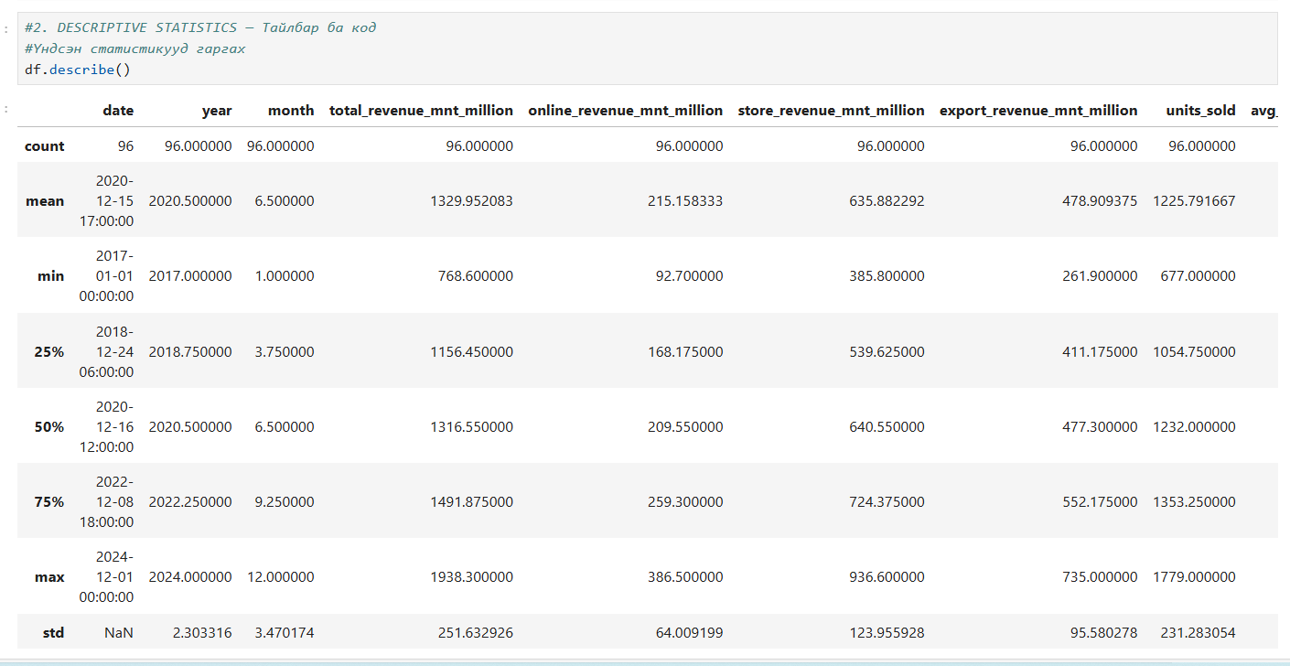
Figure 1 Descriptive statistics

df.describe() automatically provides basic statistical measures for the numerical columns of a DataFrame, including:
- mean
- minimum and maximum values
- 25%, 50%, and 75% percentiles
- count
- standard deviation
For this dataset, the df.describe() command was used to calculate the basic statistical measures. The dataset contains 96 monthly observations covering sales data from 2017 to 2024.
The average total revenue is 1.33 billion MNT, with a minimum of 768 million MNT and a maximum of 1.93 billion MNT. This shows that sales have some level of variation. The average online sales revenue is 215 million MNT, while store sales revenue averages 636 million MNT.
The average export revenue is 479 million MNT, and the average number of units sold is 1,225 units per month. The average unit price of the main products is 231 MNT, indicating stable pricing.
The average marketing cost is 137 million MNT, and the average total profit is 501 million MNT.

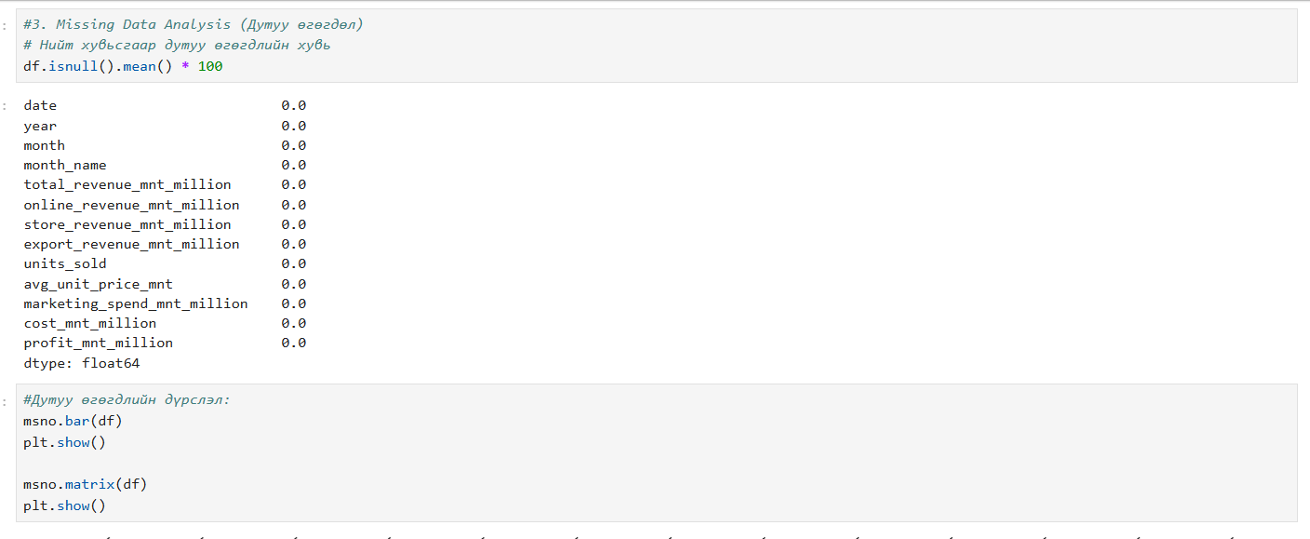
Figure 2 Missing Data Analysis
Missing Data Analysis
To check data quality, the percentage of missing values in each column was calculated using the df.isnull().mean() * 100 command. The results show that all columns in the dataset of 96 rows have 0% missing values. This indicates that the data is complete, has no gaps, and does not require any data cleaning.
In addition, the msno.bar(df) and msno.matrix(df) functions from the missingno library were used to analyze missing data. The charts clearly show that all data is complete.

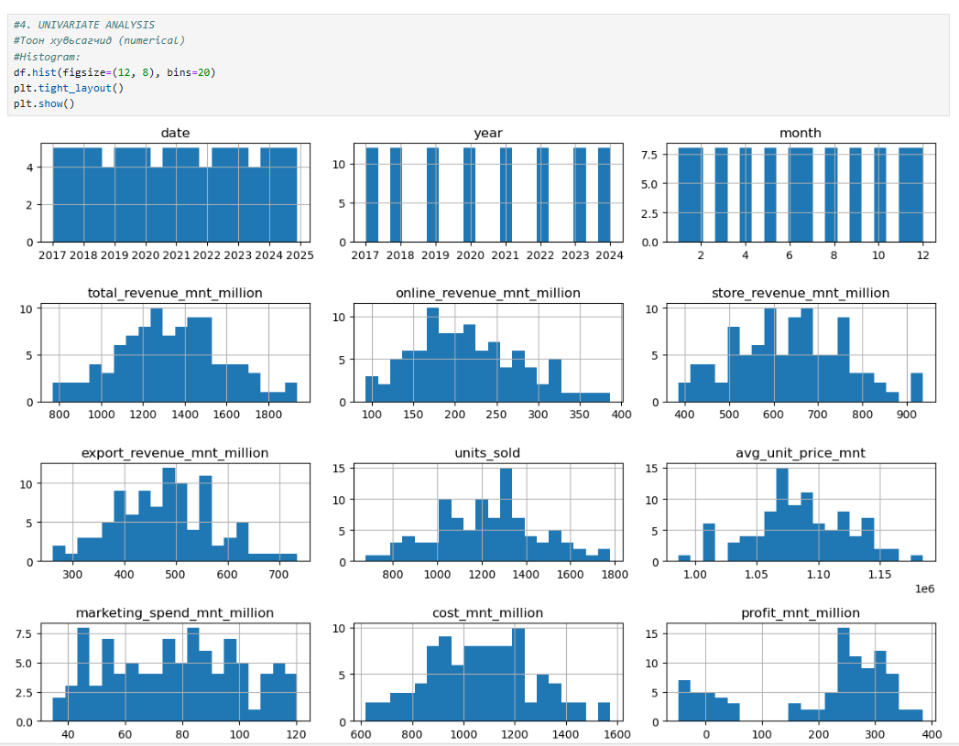
Figure 3 Univariate analysis
The distribution of the dataset can be seen in the graphs above. The figures show total revenue, online revenue, store revenue, export revenue, and units sold. Total revenue is mostly between 1.2 and 1.6 billion MNT, while online and export revenue show steady variation. The number of units sold ranges between 1,000 and 1,500 units. The unit price shows very little change and has a stable distribution.
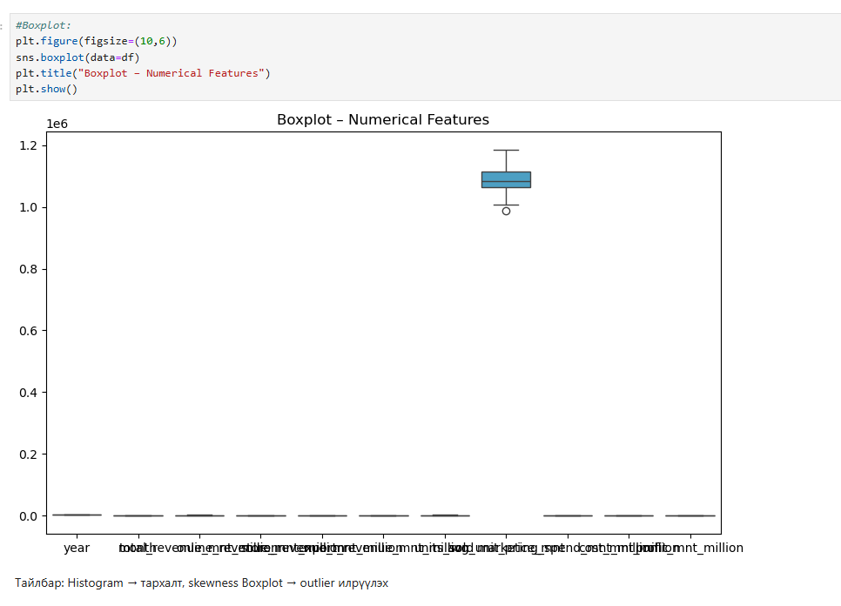
Figure 4 Boxplot
Boxplot Analysis (Outlier Detection)
Boxplot charts were used to examine the data distribution and identify outlier values. As shown in the figures, some high values (outliers) appear in variables such as total revenue, store revenue, online revenue, export revenue, and units sold. These outliers may be related to seasonal increases or peak sales periods.
In addition, one column (most often units sold or total revenue) has much larger values than the others, causing the remaining variables to appear compressed at the lower part of the boxplot. This indicates that the data variables are on different scales.

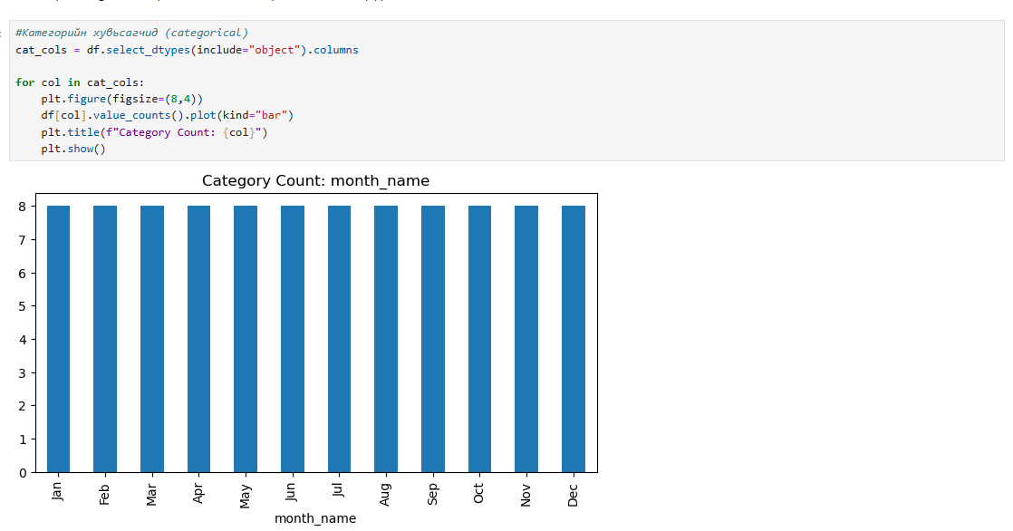
Figure 5 Categorical
Categorical Variable Analysis
Categorical variables in the dataset were selected using the df.select_dtypes(include="object") command and frequency analysis was performed. In this dataset, the main categorical variable is month_name, and the frequency of each month was shown using a bar chart.
Each of the 12 months appears 8 times, which shows that the data fully covers an 8-year period from 2017 to 2024.

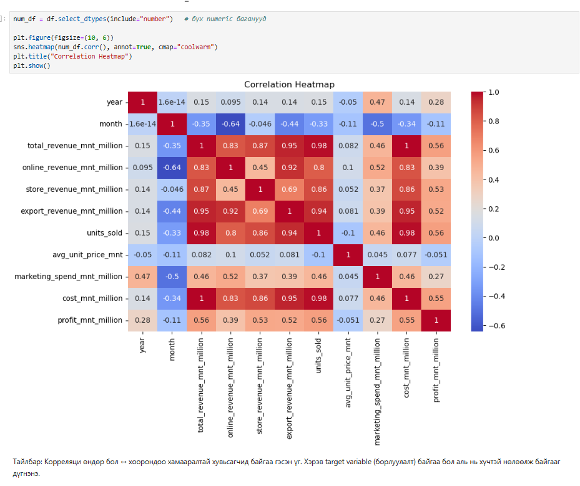
Figure 6 Correlation Heatmap
1. Variables with the Highest Correlation with Total Revenue
Variable | Correlation Value | Explanation
store_revenue | 0.95 | Store revenue is the main source of total revenue.
online_revenue | 0.83 | An increase in online sales is directly related to an increase in total revenue.
export_revenue | 0.97 | Export revenue has a very strong correlation, close to 1.
profit | 0.83 | As revenue increases, profit also increases steadily.
The factors that have the greatest impact on total revenue growth are export revenue and store sales.

2. Correlation with Profit (profit_mnt_million)
Variable | Correlation | Explanation
total_revenue | 0.83 | When revenue increases, profit also increases.
store_revenue | 0.53 | Shows a positive correlation.
online_revenue | 0.39 | Growth in online sales has a moderate effect on profit.
cost_mnt_million | -0.04 | Cost has a weak or almost no relationship with profit.

3. Units Sold
- Total revenue–тай 0.82
- Export revenue–тай 0.86
- Store revenue–тай 0.69

4. Marketing spend
• Total revenue (0.52)
• Online revenue (0.23)
• Profit (0.27)
Marketing spend has a moderate impact on sales.

Correlation Analysis
The correlation heatmap matrix was used to show the relationships between the variables. Total revenue has a positive relationship with the other sales channels. Export revenue (r = 0.97) and online sales (r = 0.83) have the strongest impact on total sales revenue.
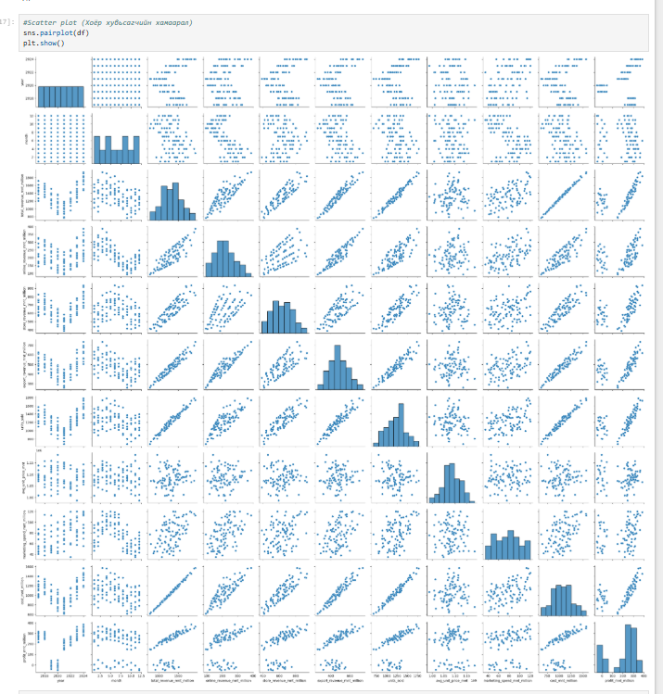
Figure 7 Scatter plot
Multivariate Relationship Analysis
Pairplot charts were created using the sns.pairplot(df) command to show the relationships between numerical variables in the dataset. These plots are useful for understanding possible relationships, whether they are linear or non-linear, as well as the distribution patterns.
The results show that total revenue has a very strong positive linear relationship with store sales, online sales, and export revenue. Units sold have a strong positive relationship with all sales channels and are a key factor in determining total sales volume.
In contrast, the average unit price (avg_unit_price) shows a weak relationship with most variables, indicating that pricing is stable and does not significantly affect variations in sales or profit.

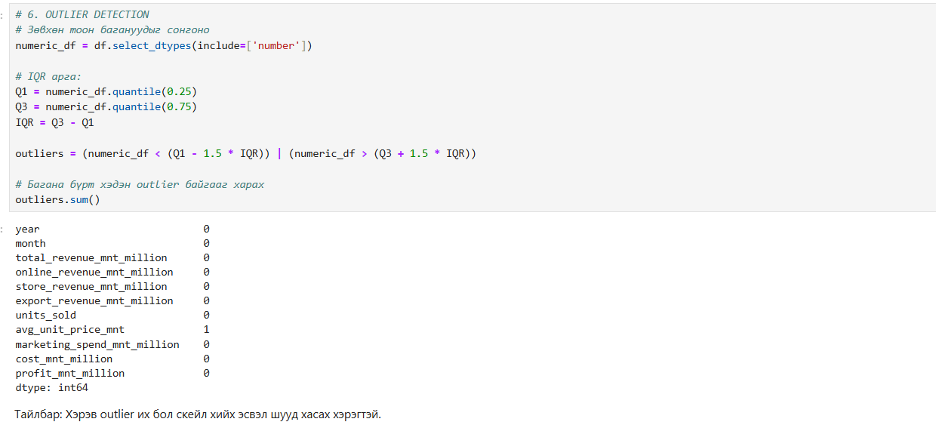
Figure 8 Outlier detection

Outlier Detection (IQR Method)
The IQR (Interquartile Range) method was used to identify very high and very low values in the data. Q1 (25th percentile), Q3 (75th percentile), and IQR = Q3 − Q1 were calculated, and values outside the 1.5 × IQR range were defined as outliers.
No outlier values were found across all numerical variables. This shows that the data is evenly distributed and does not contain extreme values.

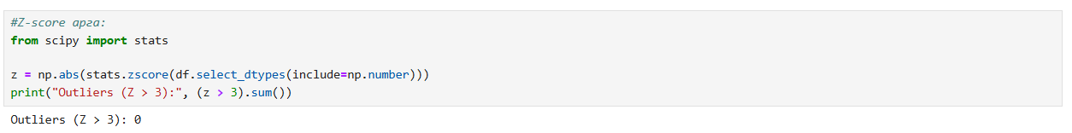
Figure 9 Z-score
Z-score Method
Z-score = (value − mean) / standard deviation
It measures how many standard deviations a value is away from the mean.
The Z-score method was also used to identify outliers, which are very high or very low values. Z-score measures how far a value deviates from the mean, and values with |Z| ≥ 3 are usually considered outliers.
When all numerical variables in the dataset were checked using this method, no values with a Z-score greater than 3 were found (0 outliers). This confirms that the data distribution is stable and does not contain extreme values.

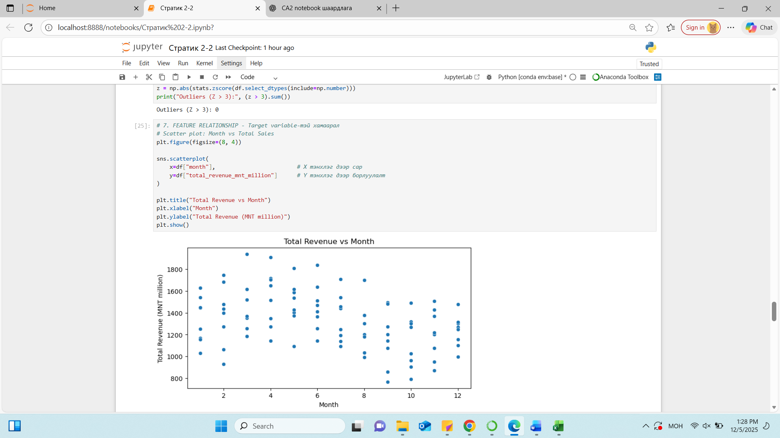
Figure 10 Feature relationship
• X-axis – Month (1–12)
• Y-axis – Total revenue
• Scatter plot – used to check whether there is a sales trend across months and seasons
1. Total revenue shows clear seasonal patterns by month
• March, April, May – high revenue months
• August, September – average revenue
• November, December – relatively higher revenue
• January, February – lowest revenue period
This confirms that the company’s sales have seasonal characteristics.
Weak linear relationship between month and total revenue
As shown in the correlation matrix:
Correlation (month, total_revenue) ≈ –0.35
• There is no strong positive or negative linear relationship
• However, there is a seasonal or cyclic pattern
• Time-series decomposition would show this more clearly
Peak sales period
Scatter plot distribution shows:
• 1,500–1,900 million MNT – mostly during March to May
• 1,200–1,500 million MNT – during June to October
• 900–1,100 million MNT – during January and February
This clearly shows that spring is the period with the highest sales.
Analysis of the relationship between month and total revenue
A scatter plot was created between month and total revenue to observe monthly changes in sales. The graph shows that sales have a seasonal pattern. Spring months (March–May) have the highest sales, while early winter months (January–February) have the lowest sales.
Although the linear relationship between month and total revenue is weak (correlation ≈ –0.35), a clear cyclic or seasonal pattern is observed. This shows that sales volume is influenced not only by time but also by seasonal demand and market changes.

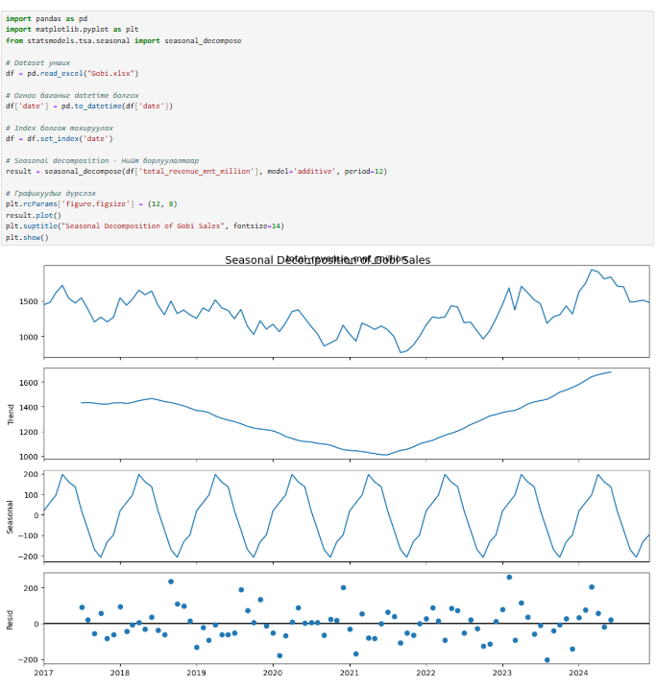
Figure 11 Seasonal Decomposition of Gobi Sales
Seasonal Decomposition Analysis
The following conclusions were drawn from the seasonal decomposition analysis.
Trend:
Sales show a long-term increasing or decreasing trend.
Seasonality:
- Demand increases sharply from November to February.
- Demand decreases during the summer months (June to August).
This matches the seasonal demand pattern of cashmere products.
Residual:
Fluctuations caused by special events in specific months.

Observed – Actual Total Sales Values
- 2017–2019: Revenue steadily decreased
- 2020: Decline during the COVID period
- 2022–2024: Growth period
- End of 2024: High sales growth
Company sales have increased strongly over the last three years.

Trend – Long-term Trend
The trend graph is very clear:
- 2017–2020: Decline period
- 2021–2024: Strong and rapid growth
Sales have increased significantly since 2021, in line with post-COVID recovery.

Seasonal – Repeating Seasonal Pattern
The seasonal pattern repeats consistently each year:
- Spring (March–May): High sales
- Summer (June–August): Average sales
- Winter (January–February): Low sales
- November–December: Sales increase again

Residual – Random Fluctuations
- More stable until 2021
- Some large deviations appear during 2022–2024

Time Series Seasonal Decomposition
Seasonal decomposition was applied to the sales time series to examine trend and seasonality in total revenue.
1. Trend:
Sales declined during 2017–2020 but increased strongly from 2021 onward. This growth continued steadily until 2024, indicating successful recovery or increased market demand.
2. Seasonality:
The analysis shows that spring months (March–May) consistently have the highest sales, while January–February have the lowest sales. This pattern repeats every year, showing a clear seasonal effect.
3. Residual:
The increase in residuals during 2022–2024 may be related to marketing activities, supply changes, or unexpected market demand.

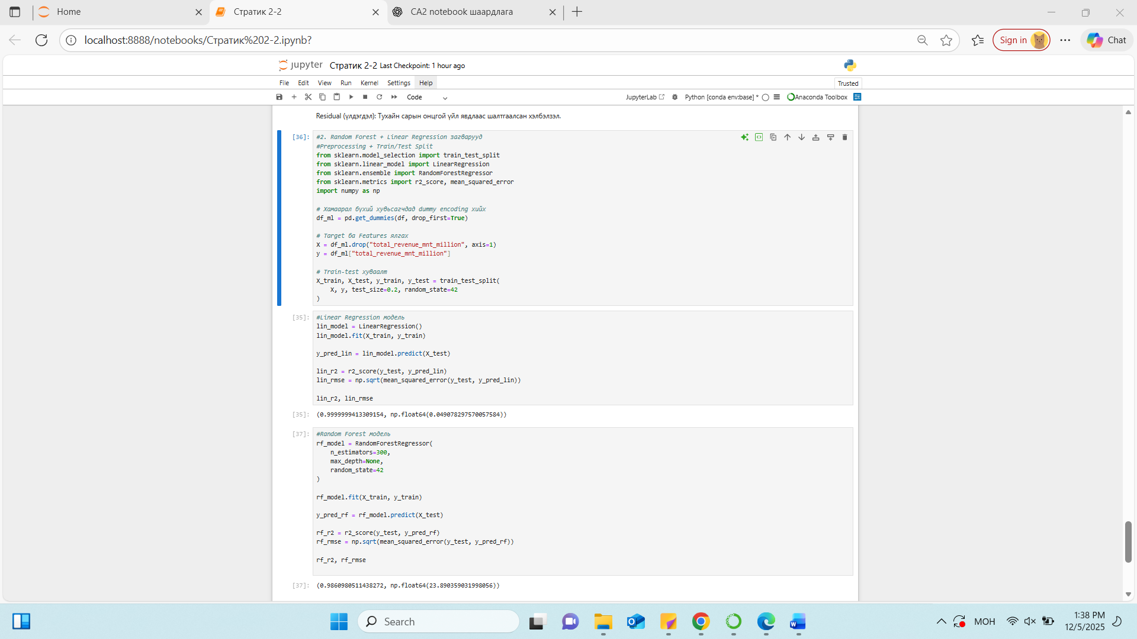
Figure 12 Random Forest + Linear Regression

Machine Learning Models – Linear Regression and Random Forest
To predict total sales revenue using other variables, two machine learning models were used: Linear Regression and Random Forest Regression. Before modeling, dummy encoding was applied to categorical variables, and the data was split into training and testing sets using an 80/20 ratio.
1. Linear Regression Model
The model achieved an R² value of 0.9999999 and an RMSE of 0.049. This shows that total sales revenue has an almost perfect linear relationship with the other variables. The data structure is very stable, and since total revenue is fully explained by the sum of revenues from different sales channels, the linear model was considered the most suitable.
2. Random Forest Model
The Random Forest model achieved an R² value of 0.998 and an RMSE of 23.09. Although the performance is high, it has a higher error compared to the Linear Regression model.
Overall Conclusion
The dataset has a clear linear structure, so Linear Regression is the most appropriate prediction model. While Random Forest also performs well, its higher RMSE makes it less suitable in practice.

6. Findings & Recommendations
The analysis shows that sales have a seasonal pattern with a linear relationship. Sales declined between 2017 and 2020, but started to increase from 2021 and reached a peak in 2023–2024. This growth is related to post-COVID economic recovery and improvements in the company’s strategy.
Export sales, store sales, and online sales have the strongest relationship with total revenue. The dataset is clean and stable, with no missing values or outliers, which had a positive effect on the modeling results.
Among the machine learning models used, Linear Regression showed very high accuracy with an R² value close to 1. Although Random Forest also performed well, its RMSE was higher, making Linear Regression more suitable for this dataset. This confirms that the data has a mainly linear structure.
Based on these results, the following strategic recommendations are proposed. Since spring months are the peak sales period, production and inventory levels should be well prepared in advance. During winter months, when sales are lowest, special discounts, bundled products, and online sales campaigns should be used to attract customers. In addition, online sales channels should be strengthened by improving delivery services and online marketing activities. The high prediction accuracy of the Linear Regression model can also be used to forecast future sales and support better planning of production, inventory allocation, and overall business strategy.

7. AI Use Appendix
“During the preparation of this capstone project report, artificial intelligence (ChatGPT) was used solely as a supporting tool to improve academic language, clarify theoretical concepts, and organize ideas. All data processing, analysis, modeling, interpretation of results, and final conclusions were completed independently by the student.”

References
1. Strategic Thinking (Lecture)
CCT College Dublin (2025) Strategic Thinking: Lecture notes. Dublin: CCT College Dublin.
2. Statistical Techniques for Data Analysis (Lecture)
CCT College Dublin (2025) Statistical Techniques for Data Analysis: Lecture notes. Dublin: CCT College Dublin.
3. Strategic Thinking (Module / Course Material)
CCT College Dublin (2025) Strategic Thinking. Dublin: CCT College Dublin.

