S-57 APPENDIX B.1

Annex A - Use of the Object Catalogue for ENC

This document must only be used with Edition 2.0 of the
ENC Product Specification - S-57 Appendix B.1

S-57 Appendix B.1 - Annex A April 2002 Edition 2.1

Page intentionally left blank

CONTENTS

1. Introduction 1
1.1 General 1
1.2 Presentation of the document 1
1.3 Use of language 1
2. General rules 2
2.1 Cartographic framework 2
2.1.1 Horizontal datum 2
2.1.2 Vertical datum 2
2.1.3 Sounding datum 3
2.1.4 Units 3
2.1.5 Dates 3
2.1.5.1 Seasonal Objects 4
2.1.6 Times 4
2.2 Data quality description 4
2.2.1 Production information 4
2.2.2 Up-to-dateness information 4
2.2.3 Quality, reliability and accuracy of bathymetric data 4
2.2.3.1 Quality of bathymetric data 5
2.2.3.2 Survey reliability 6
2.2.3.3 Quality of sounding 6
2.2.3.4 Sounding accuracy 6
2.2.3.5 Technique of sounding measurement 6
2.2.4 Accuracy of non-bathymetric data 7
2.2.4.1 Quality of positions 7
2.2.4.2 Horizontal accuracy 7
2.2.4.3 Vertical accuracy 7
2.2.5 Source of data 7
2.2.5.1 Source of bathymetric data 7
2.2.5.2 Source of other data 8
2.2.6 Compilation scale 8
2.2.7 Use of the attribute SCAMIN 8
2.3 Textual information 9
2.4 Colours and colour patterns 9
2.5 Reference to other publications 10
2.6 Updating 10
2.6.1 Issuing updates in advance 10
2.7 Multiple objects 11
3. Time Varying Objects 12
3.1 Magnetic data (see M4 - §270) 12
3.1.1 Magnetic variation 12
3.1.2 Abnormal magnetic variation (see M4 - §274) 12
3.2 Tidal data (see M4 - §406) 12
3.2.1 Time series data 12
3.2.2 Prediction by harmonic methods 13
3.2.3 Prediction by non-harmonic methods 13
3.3.1 Tidal stream (flood/ebb) 14
3.3.2 Tidal stream time series 14
3.3.3 Prediction by harmonic methods 14
3.3.4 Prediction by non-harmonic methods 14
3.3.5 Tidal stream panels 15
3.4 Current data 15
4. Topography 15
4.1 Land area 15
4.2 Vertical measurements (see M4 - §302 and §303) 15
4.2.1 Vertical datum 15
4.2.2 Heights and elevations 15
4.3 Control points (see M4 - §304 to §306) 16
4.4 Distance marks (see M4 - §307) 16
4.5 Coastline 16
4.5.1 Natural coastline (see M4 - §312) 17
4.5.2 Artificial coastline (see M4 - §313 and §320) 17
4.6 Harbour installations 19
4.6.1 Harbour facilities 19
4.6.2 Berths (see M4 - §323) 19
4.6.3 Harbour offices (see M4 - §325) 19
4.6.4 Checkpoints 20
4.6.5 Small craft facilities 20
4.6.6 Docks 20
4.6.6.1 Dry docks (see M4 - §326.1) 20
4.6.6.2 Floating docks (see M4 - §326.2) 21
4.6.6.3 Tidal and non-tidal basins (see M4 - §326.3 and §326.4) 21
4.6.6.6 Gridirons (see M4 - §326.8) 22
4.6.7 Mooring / warping facilities and pontoons 23
4.6.7.1 Mooring / warping facilities (see M4 - §327) 23
4.6.7.2 Piles 23
4.6.7.3 Pontoons (see M4 - §326.9) 23
4.6.8 Hulks 24
4.6.9 Dockside buildings and structures 24
4.6.9.1 Transit sheds and warehouses (see M4 - §328.1) 24
4.6.9.2 Timber yards (see M4 - §328.2) 24
4.6.9.3 Cranes (see M4 - §328.3) 24
4.6.10 Works in progress and projected (see M4 - §329) 25
4.7 Natural features (see M4 - §350) 25
4.7.1 Natural sceneries 25
4.7.2 Height contours, spot heights (see M4 - §351) 25
4.7.3 Marsh (see M4 - §312.2) 26
4.7.4 Dunes, sand hills (see M4 - §312.3) 26
4.7.5 Cliffs (see M4 - §312.1) 26
4.7.6 Rivers (see M4 - §353) 26
4.7.7 Rapids, waterfalls (see M4 - §353.5) 27
4.7.7.1 Rapids 27
4.7.7.2 Waterfalls 27
4.7.8 Lakes (see M4 - §353.6) 27
4.7.9 Saltpans (see M4 - §353.7) 27
4.7.10 Glaciers (see M4 - §353.8) 28
4.7.11 Vegetation (see M4 - §312.4, §352.4 and §354) 28
4.7.12 Lava flow (see M4 - §355) 28
4.8 Artificial features 29
4.8.1 Canals (see M4 - §361) 29
4.8.2 Railways (see M4 - §362) 29
4.8.3 Tunnels (see M4 - §363.1) 29
4.8.4 Cuttings and embankments (see M4 - §363.2 and §364.1) 30
4.8.5 Dams (see M4 - §364.2) 30
4.8.6 Flood barrages (see M4 - §326.7) 30
4.8.7 Dykes (see M4 - §313.1) 30
4.8.8 Roads and tracks (see M4 - §365) 31
4.8.9 Causeways 31
4.8.10 Bridges (see M4 - §381) 31
4.8.11 Conveyors (see M4 - §382.3) 31
4.8.12 Airfields (see M4 - §366) 32
4.8.13 Production and storage areas (see M4 - §367) 32
4.8.14 Built-up areas (see M4 - §370) 33
4.8.15 Buildings, landmarks, tanks, silos (see M4 - §370 to §378) 33
4.8.16 Fences and walls 37
4.8.17 Fortified structures (see M4 - §379) 37
4.8.18 Pylons and bridge supports (see M4 - §381 and §382) 37
4.8.19 Oil barriers 38
4.8.20 Views and sketches, viewpoints 38
4.8.21 Signs and Notice boards 38
5. Depth 39
5.1 Sounding datum 39
5.2 Depth contours (see M4 - §411) 39
5.3 Soundings (see M4 - §412) 39
5.4 Depth areas 40
5.4.1 Geo object depth areas 40
5.4.2 Geometry of depth areas 41
5.4.3 Use of attributes DRVAL1 and DRVAL2 for depth areas in general 42
5.4.4 Use of attributes DRVAL1 and DRVAL2 for depth areas adjoining non-navigable waterways 45
5.4.5 Use of attributes DRVAL1 and DRVAL2 for depth areas adjoining constructions which are always dry 46
5.4.6 Use of attributes DRVAL1 and DRVAL2 for depth areas adjoining a dredged area 47
5.4.7 Use of attributes DRVAL1 and DRVAL2 for dredged areas adjoining dredged areas 47
5.4.8 Rivers, canals, lakes, basins 49
5.5 Dredged areas (see M4 - §414) 49
5.6 Swept areas (see M4 - §415) 49
5.7 Areas of continual change (see M4 - §416) 50
5.8 Areas with inadequate depth information (see M4 - §417) 50
5.8.1 Unsurveyed areas 50
5.8.2 Incompletely surveyed areas 50
5.8.3 Bathymetry in areas of minimal depiction of detail on paper charts 51
5.8.3.1 Areas of omitted bathymetry 51
5.8.3.2 Areas of very simplified bathymetry 51
6. Dangers 52
6.1 Rocks and coral reefs (see M4 - §421) 52
6.1.1 Rocks which do not cover (islets) 52
6.1.2 Rocks which may cover 52
6.2 Wrecks, foul areas and obstructions (see M4 - §422) 53
6.2.1 Wrecks 53
6.2.2 Obstructions and foul areas 54
6.3 Danger lines 55
6.3.1 Danger line around a point danger or an isolated sounding 55
6.3.2 Danger line limiting an area of wrecks or obstructions 56
6.3.3 Danger line bordering an area through which navigation is not safe (see M4 -§420.1) 56
6.4 Overfalls, races, breakers, eddies (see M4 - §423) 56
6.5 Doubtful dangers (see M4 - §424) 56
6.6 Caution areas 57
7. Nature of the seabed 58
7.1 Description of the bottom (see M4 - §425) 58
7.2 Special bottom types 59
7.2.1 Sand waves (see M4 - §428.1) 59
7.2.2 Weed - Kelp (see M4 - §428.2) 59
7.2.3 Springs in the seabed (see M4 - §428.3) 59
7.2.4 Tideways 59
9. Harbour regulations 60
9.1 Regulations within harbour limits 60
9.1.1 Administrative harbour areas (see M4 - §430.1) 60
9.1.2 Speed limits (see M4 - §430.2) 60
9.2 Anchorages and prohibited/restricted anchorages; moorings 60
9.2.1 Anchorages (see M4 - §431.1 and 431.3) 60
9.2.2 Anchor berths (see M4 - §431.2) 61
9.2.3 Anchoring restricted (see M4 - §431.4) 61
9.2.4 Mooring buoys (see M4 - §431.5) 61
9.2.5 Mooring trots (see M4 - §431.6) 62
9.2.6 Anchorage - relationships 62
10. Recommended tracks and routes 63
10.1 Leading, clearing and transit lines and recommended tracks (see M4 - §433) 63
10.1.1 Navigation lines and recommended tracks 63
10.1.2 Range systems - relationship 65
10.1.3 Measured distances (see M4 - §458) 65
10.2 Routeing measures 65
10.2.1 Traffic separation schemes 65
10.2.1.1 Traffic separation scheme lanes (see M4 - §435.1) 66
10.2.1.2 Traffic separation scheme boundaries (see M4 - §435.1) 66
10.2.1.3 Traffic separation lines (see M4 - §435.1) 66
10.2.1.4 Traffic separation zones (see M4 - §435.1) 67
10.2.1.5 Traffic separation scheme crossings (see M4 - §435.1) 67
10.2.1.6 Traffic separation scheme roundabouts (see M4 - §435.1) 67
10.2.1.7 Inshore traffic zones (see M4 - §435.1) 67
10.2.1.8 Precautionary areas (see M4 - §435.2) 67
10.2.2 Deep water routes (see M4 - §435.3) 68
10.2.2.1 Deep water route parts 68
10.2.2.2 Deep water route centrelines 68
10.2.3 Traffic separation scheme systems 69
10.2.4 Recommended routes (see M4 - §435.4) 69
10.2.5 Recommended direction of traffic flow (see M4 - §435.5) 69
10.2.6 Two-way routes (see M4 - §435.6) 70
10.2.7 Areas to be avoided (see M4 - §435.7) 70
10.3 Ferries (see M4 - §438) 70
10.4 Fairways 71
11. Regulated areas 71
11.1 Restricted areas in general (see M4 - §439.2 to § 439.4) 71
11.2 Maritime jurisdiction areas (see M4 - §440) 72
11.2.1 National territories 72
11.2.2 Custom zones 72
11.2.3 Free port areas 72
11.2.4 Territorial seas 72
11.2.5 Contiguous zones 73
11.2.6 Fishery zones 73
11.2.7 Continental shelves 73
11.2.8 Exclusive economic zones 73
11.3 Military practice areas; submarine transit lanes; minefields 74
11.3.1 Military practice areas (see M4 - §441) 74
11.3.2 Submarine transit lanes (see M4 - §441.5) 74
11.3.3 Minefields (see M4 - §441.8) 74
11.4 Dumping grounds (see M4 - §442) 74
11.5 Cables and cable areas 74
11.5.1 Submarine cables (see M4 - §443) 74
11.5.2 Overhead cables (see M4 - §382) 75
11.5.3 Submarine cable areas (see M4 - §443.2) 75
11.6 Pipelines and pipeline areas 76
11.6.1 Pipelines, submarine or on land (see M4 - §377 and §444) 76
11.6.2 Diffusers, cribs 76
11.6.3 Overhead pipelines (see M4 - §383) 76
11.6.4 Pipeline areas (see M4 - §444.2) 77
11.7 Oil and Gas fields 77
11.7.1 Wellheads (see M4 - §445.1, §445.5 and §445.7) 77
11.7.2 Offshore platforms (see M4 - §445.2) 77
11.7.3 Offshore safety zones (see M4 - §445.2) 77
11.7.4 Offshore production areas (see M4 - §445.3) 78
11.7.5 Offshore tanker loading systems (see M4 - §445.4) 78
11.7.6 Flare stacks (see M4 - §445.6) 78
11.8 Spoil grounds, dredging areas (see M4 - §446) 78
11.9 Fishing equipment and aquaculture areas 78
11.9.1 Fishing facilities (see M4 - §447.1 to §447.3) 78
11.9.2 Marine farms (see M4 - § 447.4 and §447.6) 79
11.9.3 Fish havens (see M4 - §447.5) 79
11.9.4 Fishing grounds 79
11.10 Degaussing ranges (see M4 - §448) 79
11.11 Historic wrecks (see M4 §449.5) 79
11.12 Seaplane landing areas (see M4 §449.6) 80
11.13 Various maritime areas 80
11.13.1 Ice areas (see M4 - §449.1) 80
11.13.2 Log ponds (see M4 - §449.2) 80
11.13.3 Incineration areas (see M4 - §449.3) 80
11.13.4 Cargo transhipment areas (see M4 - §449.4) 80
11.14 Nature reserves 80
12. Aids to navigation 81
12.1 Lighthouses, navigational marks - relationships 81
12.1.1 Geo objects forming parts of navigational aids 81
12.1.2 Relationships 82
12.2 Buoyage systems and direction of buoyage (see M4 - §461) 82
12.3 Fixed structures (see M4 - §455) 85
12.3.1 Beacons 85
12.3.2 Lighthouses (see M4 - § 457.3) 86
12.3.3 Daymarks 86
12.4 Floating structures (see M4 - §460) 87
12.4.1 Buoys 87
12.4.2 Light floats and light vessels (see M4 - § 462.8 and §474.1) 88
12.5 Fog signals (see M4 - §451) 88
12.6 Topmarks (see M4 - §463) 88
12.7 Retro-reflectors 89
12.8 Lights (see M4 - §470) 89
12.8.2 Types and functions of lights (see M4 - §471.1) 90
12.8.3 Rhythms of lights (see M4 - §471.2) 90
12.8.4 Elevations of lights (see M4 - §471.6) 90
12.8.5 Times of exhibition and exhibition conditions 90
12.8.5.1 Night lights 90
12.8.5.2 Unwatched lights (see M4 - §473.1) 91
12.8.5.3 Occasional lights (see M4 - §473.2) 91
12.8.5.4 Daytime lights (see M4 - §473.4) 91
12.8.5.5 Fog lights (see M4 - §473.5) 91
12.8.6 Sector lights and lights not visible all round (see M4 - §475) 91
12.8.6.1 Sector lights (see M4 - §475.1) 91
12.8.6.2 Lights obscured by obstructions (see M4 - §475.3) 92
12.8.6.3 White fairway sectors (see M4 - §475.5) 92
12.8.6.4 Leading lights (see M4 - §475.6) 92
12.8.6.5 Directional lights (see M4 - §475.7) 93
12.8.6.6 Moiré effect lights (see M4 - §475.8) 93
12.8.7 Various special types of lights 93
12.8.8 Light structures 94
12.9 Radio stations (see M4 - §480 to §485) 94
12.9.1 Marine and aero-marine radiobeacons (see M4 - §481) 94
12.9.2 Aeronautical radiobeacons (see M4 - §482) 94
12.9.3 Radio direction-finding stations (see M4 - §483) 94
12.9.4 Coast radio stations providing QTG service (see M4 - §484) 95
12.10 Radar beacons (see M4 - §486) 95
12.11 Radar surveillance systems (see M4 - §487) 95
12.11.1 Radar ranges (see M4 - §487.1) 96
12.11.2 Radar reference lines (see M4 - §487.2) 96
12.11.3 Radar station (see M4 - §487.3) 96
12.12 Radar conspicuous objects (see M4 - §485.2) 96
12.13 Radio reporting (calling-in) points (see M4 - §488) 97
13. Marine services and signal stations 97
13.1 Pilot stations (see M4 - §491) 97
13.1.1 Pilot stations ashore (see M4 - §491.3 and 491.4) 97
13.1.2 Pilot boarding places (see M4 - §491.2) 97
13.2 Coastguard stations (see M4 - §492) 97
13.3 Rescue stations (see M4 - §493) 98
13.4 Signal stations (see M4 - §494 to §497) 98
14. Geographic names 99
15. Collection objects 100

Figures

Figure 1 – Heights and elevations 16
Figure 2 – Shoreline constructions 18
Figure 3 - Landmarks 37
Figure 4 – Depth contours 39
Figure 5 – Geometry of depth areas 41
Figure 6 – Depth areas 43
Figure 7 – Depth areas at seaward end of a non-navigable waterway and approaches 45
Figure 8 – Depth areas adjoining a shoreline construction 46
Figure 9 – Depth areas adjoining a dredged area 47
Figure 10 – Dredged areas adjoining dredged areas 47
Figure 11 – Linear depth areas along dredged area boundaries 48
Figure 12 – Area of wrecks 56
Figure 13 - Seabed areas 58
Figure 14 – Mooring trot 62
Figure 15 – Navigation lines and recommended tracks 64
Figure 16 – Range systems 65
Figure 17 - Junction 66
Figure 18 – One-way traffic flow in a two-way route 70
Figure 19 – Maritime jurisdiction areas 72
Figure 20 – Navigational aids 82
Figure 21 – Buoyage system and direction 84
Figure 22 – Obscured light sectors 92

Page intentionally left blank

1. Introduction

1.1 General

The following clauses specify the conventions that must be used to encode the geometry and semantic description of each object in an ENC. This document is laid out, as far as possible, along the lines of the IHO publication “Chart Specifications of the IHO - M4".

This document describes how to encode information that the cartographer considers relevant to an ENC. The content of an ENC is at the discretion of the producing authority provided that the conventions described within this document are followed. A “producing authority” is a Hydrographic Office (HO) or an organisation authorised by a government, HO or other relevant government institution to produce ENCs.

This document is intended for use with Edition 2.0 of the ENC Product Specification (S-57 Appendix B1, Annex A) contained within S-57 Edition 3.1 which was issued in November 2000.

For details of the use of this document by producing authorities still producing ENCs conforming to S-57 Edition 3.0, see the Introduction to the Explanatory Booklet which was issued with S-57 Edition 3.1.

1.2 Presentation of the document

The following conventions are used:

- Presentation conventions: Object class: WRECKS
Attribute: EXPSOU
Mandatory attribute: WATLEV
Prohibited attribute: VERDAT
Attribute value: -2.4
- Attributes_A: For each object class, the whole list of subset A is given, with the specific applicable attribute values, where required, for the feature object. Reference should be made to S-57 Annex B, Appendix B1; ENC Product Specification, section 3.5.2, for conditional mandatory attributes.
- Attributes_B, attributes_C: Except for attributes INFORM, NINFOM, and more rarely SORDAT, the attributes from subsets B and C are not mentioned in the following lists; however, this does not mean that their use is prohibited.

For definitions of attribute subsets A, B and C, see Appendix A, Chapter 1, section 1.1.

1.3 Use of language

Within this document:
“Must” indicates a mandatory requirement.
“Should” indicates an optional requirement, that is the recommended process to be followed, but is not mandatory.
“May” means “allowed to” or “could possibly”, and is not mandatory.

2. General rules

2.1 Cartographic framework

2.1.1 Horizontal datum

The horizontal datum must be unique in a data set and must be WGS 84. It must be encoded in the “Horizontal Geodetic Datum” [HDAT] subfield of the “Data Set Parameter” [DSPM] field.

The use of the meta object M_HDAT is prohibited.

The use of the attribute HORDAT on any spatial object is prohibited.

The meta object M_HOPA may be used to provide the shift from another horizontal datum to WGS 84 (see ENC Product Specification clause 4.1).

Meta object: Horizontal Datum (M_HOPA)
Attributes: HORDAT to contain the original horizontal datum of the data.
SHIPAM INFORM NINFOM

Where data has been transformed to WGS 84 from another datum, the producing authority may wish to indicate the accuracy of the transformation. If so, it must be done using the attribute INFORM on the meta object M_QUAL.

2.1.2 Vertical datum

Vertical datum information is encoded using the subfield VDAT, the meta object M_VDAT, or the attribute VERDAT on individual objects. The values encoded in the attributes ELEVAT, HEIGHT, VERCCL, VERCLR, VERCOP and VERCSA are referenced to the specified datum(s). VERDAT must not be encoded on an object unless at least one of the above attributes is also encoded on that object.

The default value for the entire data set must be given in the “Vertical Datum” [VDAT] subfield of the “Data Set Parameter” [DSPM] field.

If the vertical datum for an area is different to the value given in the VDAT subfield for the data set, it must be encoded using M_VDAT. The areas covered by these meta objects must not overlap.

Meta object: Vertical datum (M_VDAT)
Attributes: VERDAT INFORM NINFOM

Height contours, going across areas having different values of vertical datum, must be split at the border of these areas.

Various datums are used on paper charts and these datums are used in the same way for ENC. For example, different datums may be used for the following:

- altitude of spot heights, height contours, landmarks,
- elevation of lights,
- vertical clearance.

Where different vertical datums are used for the various vertical measurements, the default value given by the VDAT subfield or M_VDAT applies to the first group of the above list. The attribute VERDAT on an individual object applies to the elevation of lights and vertical clearances and must only be populated if different to the value given by VDAT or M_VDAT.

2.1.3 Sounding datum

Sounding datum information is encoded using the subfield SDAT or the meta object M_SDAT, and must be constant over large areas. The values encoded in the attributes VALSOU, DRVAL1, DRVAL2 and VALDCO, and the sounding values encoded in SOUNDG objects, are referenced to this datum.

The default value for the entire data set must be given in the “Sounding Datum” [SDAT] subfield of the “Data Set Parameter” [DSPM] field.

If the sounding datum for an area is different to the value given in the SDAT subfield for the data set, it must be encoded using M_SDAT. The areas covered by these meta objects must not overlap.

Meta object: Sounding datum (M_SDAT)
Attributes: VERDAT INFORM NINFOM

The use of the attribute VERDAT on individual objects related to depth (e.g. DEPARE, DEPCNT, DRGARE, OBSTRN, SOUNDG, UWTROC, WRECKS) is prohibited.

Depth contours and depth areas going across areas having different values of sounding datum must be split at the border of those areas.

2.1.4 Units

The depth, height and positional accuracy units in a data set must be metres. They must be given in the “Units of Depth Measurement” [DUNI], “Units of Height Measurement” [HUNI] and “Units of Positional Accuracy” [PUNI] subfields of the “Data Set Parameter” [DSPM] field.

The use of the meta object M_UNIT is prohibited.

2.1.5 Dates

When encoding dates using the attributes CPDATE, DATEND, DATSTA, PEREND, PERSTA, SORDAT, SUREND and SURSTA, and no specific year, month or day is required, the following values must apply in conformance to ISO 8601:1988.

- No specific year required, same day each year: --MMDD
- No specific year required, same month each year: --MM
- No specific day required: CCYYMM
- No specific month required: CCYY

Notes: CCYY = calendar year; MM = month; DD = day.

In the first two values, the dashes (--) must be included.

2.1.5.1 Seasonal Objects

If it is required to show seasonality of objects, it must be done using the attribute STATUS = 5 (periodic/intermittent). If it is required to encode the start and/or end dates of the season, this must be done using the attributes PERSTA and PEREND.

2.1.6 Times

If it is required to show the beginning and end of the active period of tidal objects, it must be encoded using the attributes TIMSTA and TIMEND. When using these attributes, all times must be encoded as Coordinated Universal Time (UTC). The attribute definition for TIMSTA and TIMEND (see Chapter 2 of S-57 Appendix A) states that the mandatory format is CCYYMMDDThhmmss, where T is the separator, and this format must be used.

2.2 Data quality description

2.2.1 Production information

The producing authority of the ENC must be given in the cell file name and in the “Producing Agency” [AGEN] subfield of the “Data Set Identification” [DSID] field. The use of the meta object M_PROD is prohibited.

2.2.2 Up-to-dateness information

Up-to-dateness information must be given in the cell file name extension and in the “Edition Number” [EDTN], “Update Number” [UPDN], “Update Application Date” [UADT] and “Issue Date” [ISDT] subfields of the “Data Set Identification” [DSID] field.

2.2.3 Quality, reliability and accuracy of bathymetric data

Information about quality, reliability and accuracy of bathymetric data is given using:
- the meta object M_QUAL for an assessment of the quality of bathymetric data,
- the meta object M_SREL for additional information about the survey,
- the attributes QUASOU, SOUACC and TECSOU on groups of soundings or individual objects,
- the attributes POSACC and QUAPOS on the spatial objects (see clause 2.2.4.1).

For the mariner, M_QUAL provides the most useful information. Therefore, the use of M_QUAL is mandatory for areas containing depth data or bathymetry.

More detailed information about a survey may be given using M_SREL. For example, in incompletely surveyed areas, lines of passage soundings may be indicated as such using a linear M_SREL object. This information is more difficult for the mariner to interpret. Therefore, the use of M_SREL is optional.

For individual objects (wrecks, obstructions etc), or small groups of soundings, QUASOU, SOUACC and TECSOU may be used to provide additional information about quality and accuracy.

2.2.3.1 Quality of bathymetric data

The meta object M_QUAL defines areas within which uniform assessment exists for the quality of bathymetric data, and must be used to provide an assessment of the overall quality of bathymetric data to the mariner. Areas of a cell containing depth data or bathymetry must be covered by one or more M_QUAL, which must not overlap.

Meta object: Quality of data (M_QUAL)
Attributes: CATQUA CATZOC DRVAL1
DRVAL2 - the maximum depth to which the quality information applies
POSACC SOUACC SURSTA SUREND TECSOU VERDAT
INFORM NINFOM

Remarks:
- A CATZOC category indicates that the depths encoded within a M_QUAL area meet the minimum criteria described in the CATZOC definition table. A CATZOC category may be further sub-divided by specifying depth and positional accuracy, and sounding technique, using the attributes POSACC, SOUACC and TECSOU, within separate M_QUAL areas.
- DRVAL1 must not be used on a M_QUAL object, unless a swept area occupies the entire M_QUAL area.
- DRVAL2 must not be used on a M_QUAL object, except to specify the maximum depth to which the CATZOC category applies. When DRVAL2 is specified, the CATZOC category applies only to depths equal to or shoaler than DRVAL2. No quality information is provided for depths deeper than DRVAL2.
- POSACC must not be used on a M_QUAL object, except to specify a higher positional accuracy of the depths than the CATZOC category indicates. When DRVAL1 is specified, POSACC must not be used - there is no positional accuracy information provided for any underlying depths in this circumstance.
- SOUACC must not be used on a M_QUAL object, except to specify a higher accuracy of the depths than the CATZOC category indicates. When DRVAL1 is specified, SOUACC refers only to the accuracy of the swept depth defined by DRVAL1 - there is no depth accuracy information provided for any underlying depths in this circumstance.
- When the M_QUAL area contains soundings of two or more different techniques, the attribute TECSOU must not be used.
- When the M_QUAL area contains data from only one survey, the date of survey, if required, must be specified using the attribute SUREND. When the M_QUAL area contains data from two or more surveys, the date of the oldest survey, if required, must be specified using the attribute SURSTA, and the date of the most recent survey, if required, must be specified using SUREND.
- Additional quality information may be given using the meta object M_SREL.
- Where M_QUAL areas are encoded over land, CATZOC should be set to 6 (unassessed).
- M_QUAL may either be encoded over wet areas only, or alternatively a single M_QUAL object may be created for the whole cell over wet and dry areas.
- When M_QUAL and the meta object M_ACCY are encoded in a cell, they should not overlap.
- When both M_QUAL and M_ACCY objects are used in a cell, the area covered by these objects should equal the area of data coverage for the cell.
- POSACC on the M_QUAL applies to bathymetric data situated within the area, while QUAPOS or POSACC on the associated spatial objects, qualifies the location of the M_QUAL object itself.

2.2.3.2 Survey reliability

The survey reliability may be encoded using the meta object M_SREL.

Meta object: Survey reliability (M_SREL)
Attributes: QUAPOS QUASOU SCVAL1 SCVAL2 SDISMN SDISMX SURATH SUREND SURSTA SURTYP TECSOU INFORM NINFOM

Remarks:
- If the attributes SOUACC and TECSOU are required, they must be encoded on either the meta object M_QUAL or on individual geo objects (e.g. SOUNDG).
- If it is required to encode information to indicate the source of a survey, it must be done using the attribute SURATH on M_SREL (see clause 2.2.5.1).
- QUAPOS on the M_SREL applies to bathymetric data situated within the area, while QUAPOS or POSACC on the associated spatial objects, qualifies the location of the M_SREL object itself.

Quality of sounding

If it is required to encode the quality of sounding, it must be done using the attribute QUASOU on either the meta object M_SREL or on individual geo objects (e.g. SOUNDG).

The quality of sounding must not be encoded using QUASOU on the depth geo object, unless it is different to the value of QUASOU encoded on M_SREL (see tables 5.1 and 6.4).

Sounding accuracy

Sounding accuracy is encoded using the attribute CATZOC on the meta object M_QUAL. If it is required to encode additional sounding accuracy information (see clauses 2.2.3.1 and 5.6), it must be done using the attribute SOUACC on either the meta object M_QUAL or on individual geo objects (e.g. SOUNDG).

The accuracy of sounding must not be encoded using SOUACC on the depth geo object, unless it is different to the value of SOUACC encoded on M_QUAL.

Technique of sounding measurement

If it is required to encode the technique of sounding measurement, it must be done using the attribute TECSOU on either the meta object M_QUAL or on individual geo objects (e.g. SOUNDG).

The technique of sounding measurement must not be encoded using TECSOU on the depth geo object, unless it is different to the value of TECSOU encoded on M_QUAL.

2.2.4 Accuracy of non-bathymetric data

2.2.4.1 Quality of positions

The meta object M_ACCY may be used to provide an overall accuracy of position for all non-bathymetric features. It must not be used to provide the accuracy of bathymetric information.

Meta object: Accuracy of data (M_ACCY)
Attributes: HORACC POSACC SOUACC VERACC INFORM NINFOM

The attributes QUAPOS and POSACC may be applied to any spatial object, in order to qualify the location of an object.

QUAPOS and POSACC must not be applied to the spatial object of any geo object if they are identical to the QUAPOS and POSACC values of the underlying meta object.

QUAPOS gives qualitative information, whereas POSACC gives quantitative information.

POSACC on the M_ACCY applies to non bathymetric data situated within the area, while QUAPOS or POSACC on the associated spatial objects, qualifies the location of the M_ACCY object itself.

Meta objects M_ACCY and M_QUAL should not overlap.

2.2.4.2 Horizontal accuracy

If it is required to encode the accuracy of a horizontal clearance (attribute HORCLR), it must be done using the attribute HORACC.

HORACC applies only to HORCLR. There is no attribute to express the accuracy of the attributes HORLEN and HORWID.

2.2.4.3 Vertical accuracy

If it is required to encode the accuracy of a vertical clearance (attributes VERCLR, VERCOP, VERCSA, VERCCL), it must be done using the attribute VERACC.

If several vertical clearances are given for one object, the accuracy given must be that of the least accurate.

2.2.5 Source of data

2.2.5.1 Source of bathymetric data

Details of the source surveys used in compilation may be encoded using the meta object M_SREL, as described in clause 2.2.3.2.

Remarks:
- If it is required to encode details of the survey authority, it must be done using the attribute SURATH, and must not be encoded using the attribute SORIND.
- If an object has a source different to that given by the underlying M_SREL, this other source should be encoded using both the attributes SORIND and SORDAT on the object, but only if this information is considered to be useful to the mariner.

2.2.5.2 Source of other data

The source of non-bathymetric information should be encoded using both the attributes SORIND and SORDAT on the individual objects, but only if this information is considered to be useful to the mariner.

2.2.6 Compilation scale

The default value for the entire data set must be given in the “Compilation Scale of Data” [CSCL] subfield of the “Data Set Parameter” [DSPM] field. The default value should be the compilation scale appropriate to the greater part of the data in the cell.

If the compilation scale for an area is different to the value given in the CSCL subfield for the data set, it must be encoded using the meta object M_CSCL. The areas covered by these meta objects must not overlap.

Meta object: Compilation scale of data (M_CSCL)
Attributes: CSCALE INFORM NINFOM

Remarks:
- The compilation scale provides the reference value for the overscale indication on an ECDIS.

2.2.7 Use of the attribute SCAMIN

The SCAMIN value of an object determines the display scale below which the object is no longer displayed. Its purpose is to reduce clutter, to prioritise the display of objects and to improve display speed. In encoding its value, the producing authority should consider these factors, as well as the scale at which the object is no longer likely to be required for navigation.

In order to optimise the performance and clarity of the ENC, it is strongly recommended that SCAMIN is used.

Remarks:
- SCAMIN only affects the display of an object on an ECDIS, not its presence in the SENC.
- If SCAMIN is not encoded, the object is displayed at all scales.
- Where SCAMIN is used, it must always be set to a scale less (i.e. to a smaller scale) than or equal to the compilation scale of the data as described in clause 2.2.6 above. Failure to follow this rule will mean that objects will not be displayed on screen until the overscale warning is activated.
- Group 1 and Meta objects must always be displayed. Therefore, SCAMIN must not be encoded on Group 1 and Meta objects.
- If the same object exists in cells of different navigational purposes, the same SCAMIN value should be assigned to each occurrence of the object.

2.3 Textual information

The attributes INFORM, NINFOM, TXTDSC and NTXTDS should not be used when it is possible to encode the information by means of any other attribute. However, for reasons of backward compatibility with the S-57 Object Catalogue Edition 3.0, attribute values which appear for the first time in the S-57 Object Catalogue Edition 3.1, must have their meaning described in INFORM (e.g. wellhead mark).

INFORM and NINFOM contain information as text, whereas TXTDSC and NTXTDS encode the name of an external file.

The text contained in INFORM and NINFOM is ASCII text. Formatting characters (C0 as defined in S-57 Part 3, Annex B) are prohibited. INFORM and NINFOM should generally be used for short notes (e.g. caution notes from paper charts), or to transfer information which cannot be encoded by other attributes, or to give more detailed information about an object.

The text files referenced by TXTDSC and NTXTDS must be ASCII files, and may contain formatted text. These files should generally be used for longer texts (e.g. longer chart notes, tables or paragraphs from sailing directions). It is up to the producing authority to determine the most suitable means of encoding a particular piece of text.

2.4 Colours and colour patterns

If it is required to encode multiple colours on an object, they must be interpreted and encoded using the attributes COLPAT and COLOUR as follows:

- For horizontal stripes (COLPAT = 1), the first colour in the list must be the top-most, and subsequent colours follow sequentially from top to bottom. For example, COLOUR = 3,1 to encode a red stripe above a white stripe.
- For vertical stripes (COLPAT = 2), the first colour in the list must be the left-most, and subsequent colours follow sequentially from left to right. For example, COLOUR = 3,1,3 to encode red, white, red vertical stripes.
- For diagonal stripes (COLPAT = 3), the first colour in the list must be the top-left-most and subsequent colours follow sequentially from top left to bottom right. For example, COLOUR = 1,3,1,3,1 to encode white, red, white, red, white diagonal stripes.
- For squares (COLPAT = 4), the first colour in the list must be the top-left-most square. Subsequent colours follow sequentially from left to right along the top row then repeated for subsequent rows until the bottom right-most square is reached. For example, COLOUR = 1,3,3,1 to encode white, red squares on the top row, and red, white squares on the bottom row.
- For border stripes (COLPAT = 6), the first colour in the list must be the border stripe, the second colour must be that of the background. For example, COLOUR = 3,1 to encode a red border stripe on a white background. Where a border stripe is combined with other patterns, the border stripe must be the first colour in the list, and subsequent colours must be interpreted in accordance with the rules defined for the additional patterns. Therefore, if a pattern contains a border stripe as well as other patterns, the border stripe must be the first value in the list of COLPAT.

2.5 Reference to other publications

If it is required to encode a reference to other nautical information or publications, it must be done using the meta object M_NPUB.

Meta object: Nautical publication information (M_NPUB)
Attributes: INFORM NINFOM

Remarks:
- References to nautical publications in M_NPUB, must be encoded using the attribute PUBREF, and references to external picture files must be encoded using the attribute PICREP.

2.6 Updating

2.6.1 Issuing updates in advance

Under certain conditions, it may be necessary for a data producer to issue update information in advance. For example, a change in a traffic routeing system must be made public before the new situation is implemented. Within an ER data set there is no means of indicating the date at which an update must be applied. Therefore, when an ER data set is received by an end user, it must be applied immediately. To avoid situations where update information would cause target data to reflect a situation that does not yet exist, the following coding rules must be followed:

a) If the advance update information contained in the update message involves the addition of objects to the existing data (e.g. a new lighthouse), the attribute DATSTA on the new objects must contain the date at which the update becomes active.

b) If the advance update information contained in the update message involves the modification of existing objects (e.g. a change in a traffic routeing system), it must be treated as a deletion of the existing objects and replacement with new objects. See a) above and c) below.

c) If the advance update information contained in the update message involves the deletion of existing objects (e.g. the removal of a buoy), the update message must set the DATEND attribute of all objects to be deleted to the date at which the update becomes active. NB. This update message does not actually delete the objects from the data set, it simply indicates that on the date held in DATEND they become obsolete. A further update to actually delete the obsolete objects from the data set should be sent at the time that the change in the real world occurs.

d) To highlight to the mariner that the advance update information contained in an update message will take place in the future, it is recommended that a caution area object (CTNARE) be created covering the location at which the future changes will take place. A warning note specifying, in plain language, the nature of the future change should be encoded, either in the attribute INFORM or in a file referenced by the TXTDSC attribute of the CTNARE. The attribute DATEND on the CTNARE must be set to the date at which the change described in the update becomes active.

Changes to DATSTA and DATEND cannot be applied to spatial objects. Therefore, a change to the geometry of a real world object (e.g. the relocation of a buoy) to be applied in the future can only be achieved by updating all of the feature and spatial objects involved.

As a consequence of issuing advance information updates, more than one instance of a particular real world object could exist in the data set.

2.7 Multiple objects

On some sources, multiple objects in close proximity are generalised to a single object with a text string indicating the presence of the other objects. In such cases, one object of the appropriate class should be encoded and the true number of objects should be encoded using the attribute INFORM (e.g. 3 chimneys). If the true number of objects is not known, the text ”more than one” should be encoded using INFORM.

For the encoding of multiple, identical lights using the attribute MLTYLT, see table 12.3 in clause 12.8.7.

For the encoding of leading lights that are merged on the source document, see clause 12.8.6.4.

  - Minimal depiction areas (see M4 - §404)

Where minimal depiction areas exist within a specified ENC navigational purpose, they should be encoded using one of the following options:

2.8.1 Wide blank areas

Areas of a data set which contain no data must be covered using the meta object M_COVR, with attribute CATCOV = 2 (no coverage available).

    - Simplified or minimal depiction areas

- Bathymetry in such areas should be encoded as described in clause 5.8.3.
- Information that does not relate to bathymetry but is relevant to Group 1 objects (islands, shoreline constructions, floating docks, hulks etc) may be encoded.
- One CTNARE object covering the whole area should be created. The attributes INFORM or TXTDSC should be encoded using one of the following options (the textual content of the attributes is within quotation marks and italicised):

Where larger scale coverage is available:

“Most features, including bathymetry, are omitted in this area. The minimal depiction of detail in this area does not support safe navigation, mariners should use a more appropriate navigational purpose.”
Any other information contained in chart notes pertaining to the area should be incorporated within, or replace completely, the above statement.

Where no larger scale coverage is available:

“Most features, including bathymetry, are omitted in this area. The minimal depiction of detail in this area does not support safe navigation.”
This statement should be supplemented by additional cautionary information from chart notes relating to any authority to be consulted before navigating in the area.

3. Time Varying Objects

3.1 Magnetic data (see M4 - §270)

3.1.1 Magnetic variation

Until a world magnetic model is universally available for inclusion in ECDIS, if it is required to encode magnetic variation, it must be done using the object class MAGVAR. As a minimum, updates should be supplied to coincide with changes of epoch (i.e. every five years).

Geo object: Magnetic variation (MAGVAR)
Attributes: DATEND DATSTA RYRMGV VALACM VALMAG INFORM NINFOM

3.1.2 Abnormal magnetic variation (see M4 - §274)

If it is required to encode an abnormal magnetic variation in a localised area, it must be done using the object class LOCMAG.

Geo object: Local magnetic anomaly (LOCMAG)
Attributes: NOBJNM OBJNAM VALLMA INFORM NINFOM

If the area cannot be defined, the feature should be represented as a point object.

When the deviation for an area makes reference to a range rather than a specific value, the range of values should be indicated using the attribute INFORM (e.g. From -27 degrees to 3 degrees)

3.2 Tidal data (see M4 - §406)

The inclusion of tidal information in ENC data sets is optional.

For Standard Ports the appropriate national HO or an organisation authorised by it should provide the predictions.

For Secondary Ports, the appropriate HO or an organisation authorised by it should, where possible, provide the predictions. Should such predictions not be available, the ECDIS manufacturer should approach the appropriate national HO for advice regarding the best methods of prediction for the Secondary Ports in its area of responsibility.

It is recommended that each appropriate HO, or an organisation authorised by it, should determine the spatial limits for applying tidal information where applicable, and the number of tidal stations to be used in modelling. The HOs should be responsible for determining the best methodologies to be used in their areas of responsibility.

Where tidal information is encoded, it must be assessed to a minimum confidence level of 95%, irrespective of the method of application or its source.

3.2.1 Time series data

If it is required to encode times and heights of high and low waters, it must be done using the object class T_TIMS. In addition, where the data is available, a regular time series of tidal heights should also be encoded using this object class.

Geo object: Tide-time series (T_TIMS)
Attributes: NOBJNM OBJNAM
TIMEND TIMSTA - specify the period for which the time series is valid
T_ACWL T_TSVL T_TINT T_HWLW STATUS INFORM NINFOM

3.2.2 Prediction by harmonic methods

If it is required to encode the parameters for the prediction of tidal heights using harmonic methods, it must be done using the object-class T_HMON. The supplier of parameters should be consulted on how to use this data, and which calculation algorithms to use with the data.

Geo object: Tide-harmonic prediction (T_HMON)
Attributes: NOBJNM OBJNAM T_ACWL
T_MTOD - 1 - simplified harmonic method of tidal prediction
2 - full harmonic method of tidal prediction
T_VAHC STATUS INFORM NINFOM

3.2.3 Prediction by non-harmonic methods

If it is required to encode the parameters for the prediction of tidal heights using time and height differences, it must be done using the object class T_NHMN.

The reference port to be used for these predictions must be identified using a collection object (C_ASSO) between the tidal parameter object T_TIMS or T_HMON of the reference port, and the tidal parameter object T_NHMN of the secondary port. If the reference port is not located within the data set or exchange set, then its tidal parameters should be supplied as a geo object with no geometry.

Other non-harmonic methods for predicting tidal heights are not currently supported.

Geo object: Tide-non-harmonic prediction (T_NHMN)
Attributes: NOBJNM OBJNAM T_ACWL
T_MTOD - 3 – time and height differences non-harmonic method
T_THDF STATUS INFORM NINFOM

3.3 Tidal stream data (see M4 - §407)

3.3.1 Tidal stream (flood/ebb)

If it is required to encode tidal stream information that is limited to flood and ebb directions and/or values, it must be done using the object class TS_FEB.

Geo object: Tidal stream-flood/ebb (TS_FEB)
Attributes: CAT_TS
CURVEL - maximum rate (during springs)
DATEND DATSTA NOBJNM OBJNAM ORIENT PEREND PERSTA
INFORM NINFOM

3.3.2 Tidal stream time series

If it is required to encode time series data for tidal streams, it must be done using the object class TS_TIS.

Geo object: Tidal stream - time series (TS_TIS)
Attributes: NOBJNM OBJNAM
TIMEND TIMSTA - specify the period for which the time series is valid
TS_TSV T_TINT STATUS INFORM NINFOM

3.3.3 Prediction by harmonic methods

If it is required to encode parameters for the prediction of tidal streams using harmonic methods, it must be done using the object class TS_PRH. The supplier of parameters should be consulted on how to use this data, and which calculation algorithms to use with the data.

Geo object: Tidal steam - harmonic prediction (TS_PRH)
Attributes: NOBJNM OBJNAM
T_MTOD - 1 - simplified harmonic method of tidal prediction
2 - full harmonic method of tidal prediction
T_VAHC STATUS INFORM NINFOM

3.3.4 Prediction by non-harmonic methods

If it is required to encode parameters for the prediction of tidal streams using time and rate, it must be done using the object class TS_PNH.

The reference station to be used for these predictions must be identified using a collection object (C_ASSO) between the stream parameter object TS_TIS or TS_PRH of the reference station, and the stream parameter object TS_PNH of the secondary station. If the reference station is not located within the data set or exchange set, then its tidal stream parameters should be supplied as a geo object with no geometry.

Other non-harmonic methods for predicting tidal stream are not currently supported.

Geo object: Tidal steam - non-harmonic prediction (TS_PNH)
Attributes: NOBJNM OBJNAM T_THDF
T_MTOD - 3 – time and height differences non-harmonic method
STATUS INFORM NINFOM

3.3.5 Tidal stream panels

If it is required to encode the information generally shown on paper charts as a tidal stream panel and stations, it must be done using the object class TS_PAD.

Tidal stream values encoded in this way should be mean spring rates, i.e. the tidal stream rates associated with a tidal range which is defined as the difference in height between MHWS and MLWS.

Geo object: Tidal steam panel data (TS_PAD)
Attributes: NOBJNM OBJNAM TS_TSP INFORM NINFOM

3.4 Current data

If it is required to encode a non-gravitational current, it must be done using the object class CURENT.

Geo object: Current (CURENT)
Attributes: CURVEL DATEND DATSTA NOBJNM OBJNAM ORIENT PEREND
PERSTA INFORM NINFOM

4. Topography

4.1 Land area

Mangrove areas or land areas that are never covered by the sea must be encoded using the object class LNDARE.

Rivers, canals, lakes, basins and docks, which are not navigable at compilation scale, must be encoded on top of LNDARE or UNSARE objects (see clause 5.4.8).

LNDARE objects of type area are part of Group 1.

Geo object: Land area (LNDARE)
Attributes: CONDTN OBJNAM NOBJNM INFORM NINFOM STATUS

Remarks:
- If it is required to describe the natural scenery of the land, it must be done using the object class LNDRGN (see clause 4.7.1).
- LNDARE is usually of type area; it may, however, be of type point (e.g. islet, rock that does not cover), or of type line (e.g. islet, offshore bar, isthmus).

4.2 Vertical measurements (see M4 - §302 and §303)

4.2.1 Vertical datum

See clause 2.1.2.

4.2.2 Heights and elevations

If it is required to encode the altitude of natural features (e.g. hills, coastlines, slopes), with the exception of trees, it must be done using the attribute ELEVAT (figure 1 - a).

For artificial features (e.g. landmarks, buildings) or trees:
- If it is required to encode the altitude of the ground level at the base of the object, it must be done using ELEVAT (figure 1 - b).
- If it is required to encode the altitude of the highest point of the object, it must be done using the attribute HEIGHT (figure 1 - c).
- If it is required to encode the height of the object above ground level, it must be done using the attribute VERLEN (figure 1 - d).

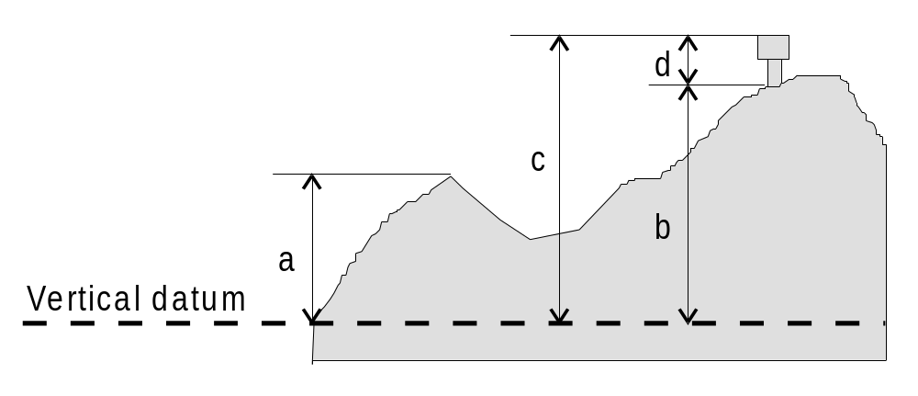

Figure 1 – Heights and elevations

4.3 Control points (see M4 - §304 to §306)

If it is required to encode a control point, it must be done using the object class CTRPNT.

Geo object: Control point (CTRPNT)
Attributes: CATCTR DATEND DATSTA ELEVAT NOBJNM OBJNAM VERACC
VERDAT INFORM NINFOM

4.4 Distance marks (see M4 - §307)

If it is required to encode a distance mark, it must be done using the object class DISMAR.

Geo object: Distance mark (DISMAR)
Attributes: CATDIS DATEND DATSTA NOBJNM OBJNAM
INFORM - the value of distance with its unit of measurement
NINFOM

4.5 Coastline

In all cases the coastline must be encoded using either COALNE or SLCONS (line or area) objects. These features form the border of the land area (LNDARE) object.

Natural sections of coastlines, lakeshores and river banks should be encoded as COALNE, whereas artificial sections of coastlines, lake shores, river banks, canal banks and basin borders should be encoded as SLCONS. The exception to this general rule is when a lake, river, canal, or basin is not navigable at the compilation scale, in which case the boundaries must not be encoded as COALNE or SLCONS (see clauses 4.6.6.3, 4.6.6.5, 4.7.6, 4.7.8, 4.8.1).

4.5.1 Natural coastline (see M4 - §312)

Geo object: Coastline (COALNE)
Attributes: CATCOA COLOUR CONRAD CONVIS ELEVAT NOBJNM OBJNAM VERACC VERDAT INFORM NINFOM

Spatial objects associated with unsurveyed coastlines (see M4 - §311) should be encoded using spatial attribute QUAPOS = 2 (unsurveyed).

If it is required to encode a description of the nature of the coastline, it must be done using the attribute CATCOA. Other area objects may be used to describe the land region adjacent to the coastline (see clause 4.7).

4.5.2 Artificial coastline (see M4 - §313 and §320)

Geo object: Shoreline construction (SLCONS)
Attributes: CATSLC COLOUR COLPAT CONDTN CONRAD CONVIS DATEND DATSTA HEIGHT
HORACC - applies to HORCLR
HORCLR HORLEN HORWID NATCON NOBJNM OBJNAM STATUS
VERACC VERDAT VERLEN WATLEV INFORM NINFOM
Figure 2 represents a shoreline construction such as a mole, including a berthing facility (INT1 - IF12), with a relatively flat top (abcdlmna), and sloping sides partly above high water (nmldefgn) and partly intertidal (dopqrhgfed).

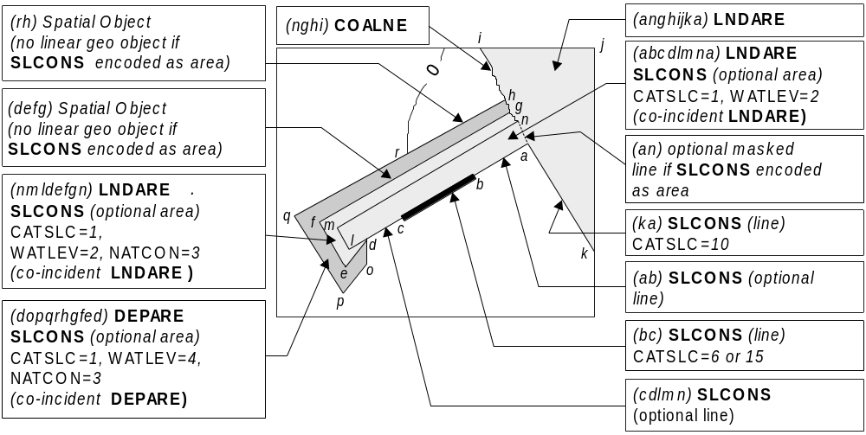

Figure 2 – Shoreline constructions
Remarks:
- Each of the three parts of the shoreline construction may be encoded as separate SLCONS objects of type area, and the masked line (an) is optional. Alternatively, the boundaries of the shoreline construction may be encoded as SLCONS objects of type line, and, if part of the SLCONS boundary has a different characteristic (e.g. (bc) attribute CATSLC = 6 or 15), it should be encoded as a separate SLCONS object of type line.
- In this example, the shoreline construction area above the high water line must also be covered by a LNDARE object of type area, and the intertidal shoreline construction area must also be covered by a DEPARE object of type area.
- SLCONS objects should be broken into their constituent parts, and categorised using attributes such as CATSLC and WATLEV as indicated on the source.
- If the presence of an object is only indicated on the source by a textual reference, without a clear symbol (e.g. ‘pier’, ‘groyne’, ‘post’), it should be encoded using a CTNARE object with the textual reference encoded using the attribute INFORM.
- Intertidal or submerged artificial rock walls, such as training walls that are not attached to the shoreline, should be encoded using the appropriate value for CATSLC, and WATLEV = 3 (always under water/submerged) or WATLEV = 4 (covers and uncovers).

4.6 Harbour installations

Harbour facilities

If it is required to encode a harbour facility, it must be done using the object class HRBFAC.

Geo object: Harbour facility (HRBFAC)
Attributes: CATHAF CONDTN DATEND DATSTA NATCON NOBJNM OBJNAM PEREND PERSTA STATUS INFORM NINFOM

Remarks:
- Depending on the navigational purpose, harbour facilities are defined by: an area including docks, basins, and dockside equipment, or a point.

Berths (see M4 - §323)

If it is required to encode a berth, it must be done using the object class BERTHS.

Geo object: Berth (BERTHS)
Attributes: DATEND DATSTA
DRVAL1 - minimum depth at the berth
NOBJNM OBJNAM - name or number of the berth
PEREND PERSTA QUASOU SOUACC STATUS VERDAT
INFORM - maximum draft permitted at the berth (e.g. Maximum draft permitted = 14 metres)
NINFOM

Remarks:
- The berth encodes the named place where a vessel can be moored adjacent to a shoreline construction. The shoreline construction itself should be encoded using the object class SLCONS (see clause 4.5.2).
- Landing places for boats should be encoded as small craft facilities (see clause 4.6.5).

4.6.3 Harbour offices (see M4 - §325)

If it is required to encode a harbour office, it must be done using the object class BUISGL (see clause 4.8.15), with the attribute FUNCTN taking at least one of the values:

2 - harbour-master’s office

3 - custom office

4 - health office
11 - pilot office

4.6.4 Checkpoints

If it is required to encode a checkpoint, it must be done using the object class CHKPNT.

Geo object: Checkpoint (CHKPNT)
Attributes: CATCHP NOBJNM OBJNAM STATUS INFORM NINFOM
Remarks:
- The CHKPNT must only be used to encode the function. In addition, if it is required to encode a physical object (e.g. building), it must be done using an appropriate object class (e.g. BUISGL, LNDMRK).

Small craft facilities

If it is required to encode a small craft facility, it must be done using the object class SMCFAC.

Geo object: Small craft facility (SMCFAC)
Attributes: CATSCF NOBJNM OBJNAM PEREND PERSTA STATUS INFORM
NINFOM

Remarks:
- The SMCFAC must only be used to encode the function. In addition, if it is required to encode a physical object (e.g. building, mooring buoy), it must be done using an appropriate object class (e.g. BUISGL, MORFAC).

4.6.6 Docks

Dry docks (see M4 - §326.1)

If it is required to encode a dry dock, it must be done using the object class DRYDOC.

Geo object: Dry dock (DRYDOC)
Attributes: CONDTN
DRVAL1 - minimum depth in the dock when the gate is open.
HORACC - applies to HORCLR
HORCLR HORLEN HORWID NOBJNM OBJNAM QUASOU SOUACC
STATUS VERDAT
INFORM - maximum draft permitted in the dock (e.g. Maximum draft permitted = 6 metres)
NINFOM

Remarks:
- A dry dock must also be covered by a LNDARE object. The boundary of a dry dock must not be encoded as a separate object (COALNE or SLCONS), except for the gate object (GATCON), which may be encoded.

4.6.6.2 Floating docks (see M4 - §326.2)

If it is required to encode a floating dock, it must be done using the object class FLODOC.

Geo object: Floating dock (FLODOC)
Attributes: COLOUR COLPAT CONDTN CONRAD CONVIS DATEND DATSTA
DRVAL1
HORACC - applies only to HORCLR
HORCLR HORLEN HORWID LIFCAP NOBJNM OBJNAM STATUS
VERACC VERDAT VERLEN
INFORM - maximum draft permitted in the dock (e.g. Maximum draft permitted = 6 metres)
NINFOM

Remarks:
- FLODOC of type area are part of Group 1.

4.6.6.3 Tidal and non-tidal basins (see M4 - §326.3 and §326.4)

Geo object: Dock area (DOCARE)
Attributes: CATDOC CONDTN DATEND DATSTA
HORACC - applies only to HORCLR
HORCLR - size of the entrance
NOBJNM OBJNAM STATUS INFORM NINFOM

Remarks:
- If the dock is navigable at compilation scale, it must be encoded using the object classes DEPARE or DRGARE (see clause 5.4.8), and the geo objects making up the dock limits must be encoded using appropriate object classes such as COALNE, SLCONS or GATCON. The dock must not be encoded as DOCARE. If it is required to encode the name of the dock, it must be done using the object class SEAARE.
- If it is required to encode a dock which is not navigable at compilation scale, it must be done using the object class DOCARE, covered by a LNDARE or UNSARE object. The name of the dock should be encoded using the attribute OBJNAM on the DOCARE. The boundary of a dock must not be encoded as a separate object (e.g. COALNE, SLCONS), except for the gate object (GATCON), which may be encoded.
- In a non-tidal basin, depths may refer to a sounding datum different to that in open waters. If this area is navigable at the compilation scale, the value of this datum must be encoded using the meta object M_SDAT, with attribute VERDAT = 24 (local datum).
- In reality, smaller dock areas may be included in major dock areas, with different names or characteristics. To encode this fact, dock areas (DOCARE) and/or sea areas (SEAARE) may overlap.

4.6.6.4 Gates (see M4 - §326.5 to §326.7)

If it is required to encode a gate that controls the flow of water, it must be done using the object class GATCON.

Geo object: Gate (GATCON)
Attributes: CATGAT CONDTN
DRVAL1 - minimum depth over the sill
HORACC - applies only to HORCLR
HORCLR NATCON NOBJNM OBJNAM QUASOU SOUACC STATUS
VERACC - applies only to VERCLR
VERCLR
VERDAT - applies only to VERCLR (not DRVAL1)
INFORM NINFOM

GATCON of type area must also be covered by a DEPARE or LNDARE object.

4.6.6.5 Locks

If it is required to encode a lock basin, it must be done using the object class LOKBSN.

Geo object: Lock basin (LOKBSN)
Attributes: DATEND DATSTA
HORACC - applies only to HORCLR
HORCLR HORLEN HORWID NOBJNM OBJNAM STATUS INFORM
NINFOM

Remarks:
- If the lock is navigable at compilation scale, it must be encoded using the object classes DEPARE or DRGARE (see clause 5.4.8), and the geo objects making up the limits of the lock must be encoded using appropriate object classes such as COALNE, SLCONS or GATCON. The lock must not be encoded as LOKBSN. If it is required to encode the name of the lock, it must be done using the object class SEAARE.
- If it is required to encode a lock that is not navigable at compilation scale, it must be done using LOKBSN covered by a LNDARE or UNSARE object. The name of the lock should be encoded using the attribute OBJNAM on the LOKBSN object.
- The gates should be encoded as a GATCON object with attribute CATGAT = 4 (lock gate) or 3 (caisson). At small scale, a lock may be encoded using GATCON only, without using LOKBSN.

4.6.6.6 Gridirons (see M4 - §326.8)

If it is required to encode a gridiron, it must be done using the object class GRIDRN.

Geo object: Gridiron (GRIDRN)
Attributes: HORACC HORLEN HORWID NATCON NOBJNM OBJNAM STATUS VERACC VERLEN WATLEV INFORM NINFOM

4.6.7 Mooring / warping facilities and pontoons

4.6.7.1 Mooring / warping facilities (see M4 - §327)

If it is required to encode a mooring/warping facility, it must be done using the object class MORFAC.

Geo object: Mooring / warping facility (MORFAC)
Attributes: BOYSHP - used only if CATMOR = 7
CATMOR COLOUR COLPAT CONDTN CONRAD CONVIS
DATEND DATSTA HEIGHT NATCON NOBJNM OBJNAM
PEREND PERSTA STATUS VERACC VERDAT VERLEN
WATLEV INFORM NINFOM

Remarks:
- If it is required to encode a pile or post that is used as a mooring post, it must be done using MORFAC, with attribute CATMOR = 5 (pile or post). If the pile or post is not used as a mooring post, see clause 4.6.7.2.
• Stumps of mooring posts dangerous to navigation must be encoded using the object class OBSTRN, with attribute CATOBS = 1 (snag/stump). If such stumps are not dangerous to navigation, they must be encoded using MORFAC, with attributes CATMOR = 5 (pile or post) and CONDTN = 2 (ruined).
- A MORFAC object of type area, with attribute WATLEV = 1, 2 or 6 must also be covered by a LNDARE object.

4.6.7.2 Piles

If it is required to encode a pile or post that is not used as a mooring/warping facility, it must be done using the object class PILPNT.

Geo object: Pile (PILPNT)
Attributes: CATPLE COLOUR COLPAT CONDTN CONVIS DATEND DATSTA
HEIGHT NOBJNM OBJNAM VERACC VERDAT VERLEN INFORM NINFOM

Remarks:
- Stumps of piles or posts that are dangerous to navigation must be encoded using OBSTRN objects, with attribute CATOBS = 1 (snag/stump), and must not be encoded using PILPNT.
- See clause 4.6.7.1 for details of how to encode a pile or post that is used as a mooring/warping facility.

4.6.7.3 Pontoons (see M4 - §326.9)

If it is required to encode a pontoon, it must be done using the object class PONTON.

Geo object: Pontoon (PONTON)
Attributes: CONDTN CONRAD CONVIS DATEND DATSTA NATCON
NOBJNM OBJNAM PEREND PERSTA STATUS VERACC
VERLEN INFORM NINFOM

Remarks:
- PONTON objects of type area are part of Group 1.

4.6.8 Hulks

If it is required to encode a hulk, it must be done using the object class HULKES.

Geo object: Hulk (HULKES)
Attributes: CATHLK COLOUR COLPAT CONDTN CONRAD CONVIS
HORACC HORLEN HORWID NOBJNM OBJNAM VERACC
VERLEN INFORM NINFOM

Remarks:
- HULKES objects of type area are part of Group 1.

4.6.9 Dockside buildings and structures

4.6.9.1 Transit sheds and warehouses (see M4 - §328.1)

If it is required to encode a transit shed or warehouse, it must be done using a BUISGL object (see clause 4.8.15), with attributes FUNCTN = 15 (transit shed/warehouse), and if it is required, OBJNAM = name or number of the shed.

4.6.9.2 Timber yards (see M4 - §328.2)

If it is required to encode a timber yard, it must be done using a PRDARE object (see clause 4.8.13), with attribute CATPRA = 6 (timber yard).

4.6.9.3 Cranes (see M4 - §328.3)

If it is required to encode a crane, it must be done using the object class CRANES.

Geo object: Crane (CRANES)
Attributes: CATCRN COLOUR COLPAT CONDTN CONRAD CONVIS HEIGHT
LIFCAP NOBJNM OBJNAM
ORIENT - angular distance from true north to the axis of the crane’s jib (generally perpendicular to the wharf)
RADIUS STATUS
VERACC - applies only to VERCLR (not HEIGHT)

VERCLR
VERDAT - applies only to VERCLR (not HEIGHT)
VERLEN INFORM NINFOM

Remarks:
- The position of a sheerleg or a travelling crane is defined as its resting position. If it is required to encode the track, it must be done using the object class RAILWY (see clause 4.8.2).

4.6.10 Works in progress and projected (see M4 - §329)

Features that are under construction or projected should be encoded in the same way as existing features (e.g. using LNDARE, SLCONS, DRYDOC, PIPSOL objects), with the attributes:

CONDTN - 1 - under construction
3 - under reclamation
5 - planned construction
SORDAT - year or date of the information

The coastline existing before the beginning of the works should remain encoded as a COALNE or SLCONS object until the completion of the works.

4.7 Natural features (see M4 - §350)

4.7.1 Natural sceneries

If it is required to describe the natural scenery of the land, or to give the geographic name of an area on land, it should be encoded using the object class LNDRGN.

Geo object: Land region (LNDRGN)
Attributes: CATLND NATQUA NATSUR NOBJNM OBJNAM WATLEV INFORM
NINFOM

Remarks:
- This object class has a use similar to that of the object class SEAARE (see clause 8), but for the land.
- A LNDRGN area should be bounded, if possible, by existing lines used by other objects (e.g. COALNE). If necessary, however, this area may be bounded by other lines created to close the area, or to describe a new area.
- For capes, points, peninsulas and other types of LNDRGN where there is no specific value for the attribute CATLND, the generic term "Cape", "Point", "Peninsula", etc may be included on the attributes OBJNAM and NOBJNM.
- LNDRGN objects of type area may overlap.
- A LNDRGN object of type area must be covered by objects from Group 1 (LNDARE, DEPARE, UNSARE etc).

4.7.2 Height contours, spot heights (see M4 - §351)

If it is required to encode a height contour or spot height, it must be done using the object class LNDELV.

Geo object: Land elevation (LNDELV)
Attributes: CONVIS ELEVAT NOBJNM OBJNAM VERACC VERDAT INFORM NINFOM

Height contours are associated with line spatial objects, whereas spot heights are associated with point spatial objects.

Spatial objects associated with approximate contours or spot heights should be encoded using the attribute QUAPOS = 4 (approximate).

4.7.3 Marsh (see M4 - §312.2)

If it is required to encode a marshy area behind the coastline, it must be done using a LNDRGN object, with attribute CATLND = 2 (marsh).

If the seaward edge of a marsh area is coincident with the coastline, the coastline should be encoded as a COALNE object, with attribute CATCOA = 8 (marshy shore), and the coastline’s spatial object should have the attribute QUAPOS = 4 (approximate) for the visible coastline.

4.7.4 Dunes, sand hills (see M4 - §312.3)

If it is required to encode a dune or sand hill, it must be done using the object class SLOGRD.

Geo object: Sloping ground (SLOGRD)
Attributes: CATSLO - 3 - dune
4 - hill
COLOUR CONRAD CONVIS NATCON NATQUA NATSUR
NOBJNM OBJNAM INFORM NINFOM

If these features are positioned along the coastline, a COALNE object must also be created.

If it is required to encode the height of one of these features, a LNDELV object must also be created.

4.7.5 Cliffs (see M4 - §312.1)

If it is required to encode a cliff, it must be done using a SLOGRD object (see clause 4.7.4), with attribute CATSLO = 6 (cliff) and / or using the object class SLOTOP.

Geo object: Slope topline (SLOTOP)
Attributes: CATSLO - 6 - cliff
COLOUR CONRAD CONVIS ELEVAT NATCON NATQUA
NATSUR NOBJNM OBJNAM VERACC VERDAT INFORM NINFOM

For example:
SLOGRD may be used at large scale to indicate the horizontal extent of the cliff.
SLOTOP should be used on its own to encode cliffs at small scale, or in conjunction with SLOGRD to indicate the crest line of the cliff:
- when it is useful to know its elevation,
- to encode a cliff on land distant from the coastline.

Remarks:
- When the cliff is coincident with the coastline, a COALNE object, with attribute CATCOA = 1 (steep coast) should be encoded, and there should be no SLOTOP or SLOGRD encoded.

4.7.6 Rivers (see M4 - §353)

If it is required to encode a river, it must be done using the object class RIVERS.

Geo object: River (RIVERS)
Attributes: NOBJNM OBJNAM
STATUS - 5 - intermittent
INFORM NINFOM
Remarks:
- If the river is navigable at compilation scale, it must be encoded using the object classes DEPARE or DRGARE (see clause 5.4.8), and the river banks must be encoded using the object classes COALNE or SLCONS. The river must not be encoded as a RIVERS object. If it is required to encode the name of the river, it must be done using a SEAARE object with attribute CATSEA = 53 (river).
- If it is required to encode a river that is not navigable at compilation scale, it must be done using RIVERS, covered by a LNDARE or UNSARE object. The name of the river should be encoded using the attribute OBJNAM on the RIVERS object.
- Use of the object class RIVBNK is prohibited.

4.7.7 Rapids, waterfalls (see M4 - §353.5)

4.7.7.1 Rapids

If it is required to encode rapids within a river, it must be done using the object class RAPIDS.

Geo object: Rapids (RAPIDS)
Attributes: NOBJNM OBJNAM VERACC VERLEN INFORM NINFOM

The area covered by rapids must also be covered by a RIVERS object, and a LNDARE or UNSARE object.

4.7.7.2 Waterfalls

If it is required to encode a waterfall within a river, it must be done using the object class WATFAL.

Geo object: Waterfall (WATFAL)
Attributes: CONVIS NOBJNM OBJNAM VERACC VERLEN INFORM NINFOM

The area covered by a waterfall must also be covered by a RIVERS object, and a LNDARE or UNSARE object.

4.7.8 Lakes (see M4 - §353.6)

If it is required to encode a lake, it must be done using the object class LAKARE.

Geo object: Lake (LAKARE)
Attributes: ELEVAT NOBJNM OBJNAM VERACC VERDAT INFORM NINFOM

Remarks:
- If the lake is navigable at compilation scale, it must be encoded using the object classes DEPARE or DRGARE (see clause 5.4.8), and the lake shore must be encoded using the object classes COALNE or SLCONS. The lake must not be encoded as a LAKARE object. If it is required to encode the name of the lake, it must be done using a SEAARE object, with attribute CATSEA = 52 (lake).
- If it is required to encode a lake that is not navigable at compilation scale, it must be done using LAKARE, covered by a LNDARE or UNSARE object. The name of the lake should be encoded using the attribute OBJNAM on the LAKARE object.
- Use of the object class LAKSHR is prohibited.

4.7.9 Saltpans (see M4 - §353.7)

If it is required to encode a saltpan area, it must be done using a LNDRGN object, with attribute CATLND = 15 (salt pan) covered by a LNDARE object (i.e. the saltpan does not form a hole in the land area).

If the seaward edge of an encoded saltpan area is coincident with the coastline, it should be encoded using a COALNE object, with attribute CATCOA = 2 (flat coast).

4.7.10 Glaciers (see M4 - §353.8)

If it is required to encode the portion of a glacier that is on land, it must be done using an ICEARE object, with attribute CATICE = 5 (glacier) covered by a LNDARE object (i.e. the glacier does not form a hole in the land area).

If the seaward edge of an encoded glacier is coincident with the coastline, this edge should be encoded using a COALNE object, with attribute CATCOA = 6 (glacier (seaward end)).

ICEARE objects that are located in the sea must be covered by a LNDARE or UNSARE object, if the depth of water beneath them is unknown, or covered by a DEPARE object, if the depth is known.

4.7.11 Vegetation (see M4 - §312.4, §352.4 and §354)

If it is required to encode vegetation, it must be done using the object class VEGATN.

Geo object: Vegetation (VEGATN)
Attributes: CATVEG CONVIS ELEVAT
HEIGHT - approximate altitude of the highest point of the top of the vegetation
NOBJNM OBJNAM VERACC VERDAT VERLEN INFORM NINFOM

If it is required to encode an isolated tree used as a landmark, it must be done using a VEGATN object, with attribute CATVEG = 13 to 21.

If it is required to encode a mangrove area, it must be done using a VEGATN object, with CATVEG = 7 (mangroves).

The seaward edge of an encoded mangrove area should be encoded using a COALNE object, with attribute CATCOA = 7 (mangrove), and the mangrove area’s spatial object should have the attribute QUAPOS = 4 (approximate).

4.7.12 Lava flow (see M4 - §355)

If it is required to encode a lava flow, it must be done using a LNDRGN object, with attribute CATLND = 14 (lava flow).

4.8 Artificial features

4.8.1 Canals (see M4 - §361)

If it is required to encode a canal, it must be done using the object class CANALS.

Geo object: Canal (CANALS)
Attributes: CATCAN CONDTN DATEND DATSTA
HORACC - applies only to HORCLR
HORCLR HORWID NOBJNM OBJNAM STATUS INFORM NINFOM

Remarks:
- If the canal is navigable at compilation scale, it must be encoded using the object classes DEPARE or DRGARE (see clause 5.4.8), and the canal banks must be encoded using the object classes COALNE or SLCONS. The canal must not be encoded as a CANALS object. If it is required to encode the name of the canal, it must be done using a SEAARE object, with attribute CATSEA = 51 (canal).
- If it is required to encode a canal that is not navigable at compilation scale, it must be done using CANALS, covered by a LNDARE or UNSARE object. The name of the canal should be encoded using the attribute OBJNAM on the CANALS object.
- Use of the object class CANBNK is prohibited.

4.8.2 Railways (see M4 - §362)

If it is required to encode a railway, it must be done using the object class RAILWY.

Geo object: Railway (RAILWY)
Attributes: CONDTN HEIGHT NOBJNM OBJNAM STATUS VERACC INFORM NINFOM

Remarks:
- If it is required to encode a railway station, it must be done using a BUISGL object, with attribute FUNCTN = 8 (railway station).

4.8.3 Tunnels (see M4 - §363.1)

If it is required to encode a tunnel, it must be done using the object class TUNNEL.

Geo object: Tunnel (TUNNEL)
Attributes: BURDEP CONDTN
HORACC - applies only to HORCLR
HORCLR NOBJNM OBJNAM
VERACC - applies only to VERCLR
VERCLR STATUS
INFORM NINFOM

Remarks:
- If there is a waterway inside the tunnel, and the waterway is navigable at compilation scale, it must be encoded as if it were a navigable canal (see clause 4.8.1), using the object classes DEPARE or DRGARE in conjunction with the TUNNEL object. There must be no LNDARE object in the area covering the waterway.
- If it is required to encode a waterway inside a tunnel that is not navigable at compilation scale, it must be done using the object class CANALS in conjunction with the TUNNEL object. A LNDARE object must cover the tunnel. The attributes HORACC, HORCLR, VERACC and VERCLR must not be encoded on the TUNNEL object in this case.
- If it is required to encode a tunnel that has no waterway inside it (but a railway, road etc), only the TUNNEL object must be encoded (not the railway or the road), covered by LNDARE, DEPARE, DRGARE or UNSARE objects as appropriate.

4.8.4 Cuttings and embankments (see M4 - §363.2 and §364.1)

If it is required to encode cuttings and embankments, this must be done in the same way as cliffs; using SLOGRD and / or SLOTOP objects (see clause 4.7.5), with attribute CATSLO = 1 (cutting) or 2 (embankment).

4.8.5 Dams (see M4 - §364.2)

If it is required to encode a dam, it must be done using the object class DAMCON.

Geo object: Dam (DAMCON)
Attributes: CATDAM COLOUR COLPAT CONDTN CONRAD CONVIS DATEND DATSTA HEIGHT NATCON NOBJNM OBJNAM VERACC VERDAT VERLEN INFORM NINFOM

Remarks:
- When a DAMCON object is of type area, it must be covered by a LNDARE object.
- The geometry of the dam includes any gates. Gates should be encoded as separate GATCON objects.

4.8.6 Flood barrages (see M4 - §326.7)

If it is required to encode the fixed part of a flood barrage, and the flood barrage is inside an area which is navigable at compilation scale, it must be done using a DAMCON object, with attribute CATDAM = 3 (flood barrage), and must be covered by a LNDARE object. If it is required to encode the opening part of the flood barrage, it must be done using a GATCON object, with attribute CATGAT = 2 (flood barrage gate), and must be covered by a DEPARE object.

When an encoded flood barrage is inside an area that is not navigable at compilation scale, the gates need not be encoded. In this case, the DAMCON object must go all the way across the river or lake.

4.8.7 Dykes (see M4 - §313.1)

If it is required to encode a dyke, it must be done using the object class DYKCON.

Geo object: Dyke (DYKCON)
Attributes: CONDTN CONRAD DATEND DATSTA HEIGHT NATCON VERACC VERDAT VERLEN INFORM NINFOM

Remarks:
- If it is required to encode a dyke whose seaward edge is coincident with the coastline, it must be done using DYKCON, and with a SLCONS object of type line along its seaward edge, with no value populated for attribute CATSLC.
- When a DYKCON object is of type area, it must be covered by a LNDARE object.
- At large compilation scales, the dyke crown (the topline of the dyke) may be encoded as a SLOTOP object, with attribute CATSLO = 2 (embankment).

4.8.8 Roads and tracks (see M4 - §365)

If it is required to encode a road or track, it must be done using the object class ROADWY.

Geo object: Road (ROADWY)
Attributes: CATROD CONDTN NATCON NOBJNM OBJNAM STATUS INFORM
NINFOM

Remarks:
- Road crossings (attribute CATROD = 7) should not be encoded.

4.8.9 Causeways

If it is required to encode a causeway, it must be done using the object class CAUSWY.

Geo object: Causeway (CAUSWY)
Attributes: CONDTN NATCON NOBJNM OBJNAM STATUS WATLEV INFORM
NINFOM

4.8.10 Bridges (see M4 - §381)

If it is required to encode a bridge, it must be done using the object class BRIDGE.

Geo object: Bridge (BRIDGE)
Attributes: CATBRG - mandatory over navigable waters
COLOUR COLPAT CONDTN CONRAD CONVIS DATEND
DATSTA
HORACC - applies only to HORCLR
HORCLR NATCON NOBJNM OBJNAM
VERACC - applies only to VERCCL, VERCLR, VERCOP
VERCCL - mandatory for opening bridges
VERCLR - mandatory for non-opening bridges
VERCOP - mandatory for opening bridges with limited clearance
VERDAT - applies only to VERCCL, VERCLR, VERCOP
INFORM NINFOM

Remarks:
- Water under a bridge must be encoded using the object class DEPCNT and the object classes DEPARE, DRGARE or UNSARE if the waterway is navigable at compilation scale, or using the object classes LNDARE or UNSARE if the waterway is not navigable at compilation scale.
- In navigable water, bridge supports must be encoded, where possible, using a PYLONS object (see clause 4.8.18), with attribute CATPYL = 4 or 5.
- It is not mandatory to encode roads or railways on bridges.

4.8.11 Conveyors (see M4 - §382.3)

If it is required to encode a conveyor, it must be done using the object class CONVYR.

Geo object: Conveyor (CONVYR)
Attributes: CATCON COLOUR COLPAT CONDTN CONRAD CONVIS DATEND
DATSTA HEIGHT LIFCAP NOBJNM OBJNAM PRODCT STATUS
VERACC - applies only to VERCLR (not HEIGHT)
VERCLR - mandatory over navigable waters
VERDAT - applies only to VERCLR (not HEIGHT)
VERLEN INFORM NINFOM

4.8.12 Airfields (see M4 - §366)

At large scale, an airport should be encoded using a combination of the following objects: AIRARE (area), RUNWAY (area or line), BUISGL (area or point) and LNDMRK (area or point). At least one AIRARE or RUNWAY must be in this set of objects. Where it is necessary to establish a relationship between these objects, they should be associated using the collection object C_ASSO (see clause 15).

At small scale, an airport should be encoded as an AIRARE of type point.

Geo object: Airport / airfield (AIRARE)
Attributes: CATAIR CONDTN CONVIS NOBJNM OBJNAM STATUS INFORM NINFOM

Geo object: Runway (RUNWAY)
Attributes: CATRUN CONDTN CONVIS NATCON NOBJNM OBJNAM PEREND PERSTA STATUS INFORM NINFOM

Remarks:
- If individual buildings are visually conspicuous, they must be encoded as separate objects.
- Two or more crossing runways may be encoded as one area.
- If it is required to encode the control tower, it must be done using a LNDMRK object, with attributes FUNCTN = 39 (control) and CATLMK = 17 (tower). If it is required to encode other buildings, this must be done using the object class BUISGL.
- If it is required to encode a seaplane landing area, it must be done using the object class SPLARE (see clause 11.12).

4.8.13 Production and storage areas (see M4 - §367)

If it is required to encode production or storage area, it must be done using the object class PRDARE.

Geo object: Production / storage area (PRDARE)
Attributes: CATPRA CONDTN CONRAD CONVIS DATEND DATSTA
ELEVAT HEIGHT NOBJNM OBJNAM PRODCT STATUS VERACC VERDAT VERLEN INFORM NINFOM

Remarks:
- It there are individual buildings or equipment objects contained within this area, they should be encoded as separate objects such as BUISGL, CRANES, LNDMRK or SILTNK within the PRDARE area object.
- If visible from seaward, a quarry face should be encoded in a similar way to a cliff (see clause 4.7.5), with attribute CATSLO = 6 (cliff).

4.8.14 Built-up areas (see M4 - §370)

If it is required to encode a built-up area, it must be done using the object class BUAARE.

Geo object: Built-up area (BUAARE)
Attributes: CATBUA CONDTN CONRAD CONVIS HEIGHT NOBJNM OBJNAM
VERACC VERDAT INFORM NINFOM

Remarks:
- A built-up area crossed by line objects (e.g. roads, streets, railways) should not be divided into multiple objects, unless separate sections of the built-up area have at least one different attribute value.
- However, for presentation purposes, a built up area of type area crossed by a river or canal of type area must be divided into several objects, with the built-up area objects not overlapping the river or canal object. A built up area of type area should not overlap a lake, dock or lock basin object of type area.
- Use of the object class SQUARE is prohibited.
- Several buildings or built-up areas may be referred to by the same settlement, village or town name on the source. In such cases, the individual buildings or built-up areas should be encoded as separate unnamed objects, using the object classes BUISGL or BUAARE, and additionally, an ADMARE object (see clause 14) covering the whole named area should be created with the name encoded using the attribute OBJNAM. The encoded ADMARE object should also have the attribute JRSDTN = 3 (national sub-division).

4.8.15 Buildings, landmarks, tanks, silos (see M4 - §370 to §378)

If it is required to encode buildings, landmarks, tanks or silos, they must be done using the object classes BUISGL, LNDMRK or SILTNK, depending on their shape and use. The following table describes the way to encode these objects.

Geo object: Building, single (BUISGL)
Attributes: BUISHP COLOUR COLPAT CONDTN CONRAD CONVIS ELEVAT
FUNCTN HEIGHT NATCON NOBJNM OBJNAM STATUS VERACC
VERDAT VERLEN INFORM NINFOM

Geo object: Landmark (LNDMRK)
Attributes: CATLMK COLOUR COLPAT CONDTN CONRAD CONVIS ELEVAT
HEIGHT NATCON NOBJNM OBJNAM STATUS FUNCTN VERACC
VERDAT VERLEN INFORM NINFOM

Geo object: Silo / tank (SILTNK)
Attributes: BUISHP CATSIL COLOUR COLPAT CONDTN CONRAD CONVIS
ELEVAT HEIGHT NATCON NOBJNM OBJNAM PRODCT STATUS
VERACC VERDAT VERLEN INFORM NINFOM

In the following table, the symbol ‘/’ indicates that this attribute does not exist for that particular object class. A blank indicates that the encoder may choose a relevant value for the attribute. The table contains the most common examples of coding; other coding combinations are possible.

Feature | INT1 | Object-class | FUNCTN | CATLMK | BUISHP | PRODCT | CATSIL
Administrative | IG72 | BUISGL | 18 | / |  | / | /
Bank office |  | BUISGL | 13 | / |  | / | /
Buddhist temple | IE16 | BUISGL | 25 | / |  | / | /
Bus station |  | BUISGL | 42 | / |  | / | /
Cairn | IQ100 | LNDMRK | / | 1 | / | / | /
Cemetery | IE19 | LNDMRK |  | 2 | / | / | /
Chapel | IE11 | BUISGL | 21 | / |  | / | /
Chimney | IE22 | LNDMRK |  | 3 |  | /
Church | IE10.1 | BUISGL | 20 | / |  | / | /
Church dome, Cupola | IE10.4 | LNDMRK | 20 | 15 | / | / | /
Church spire | IE10.3 | LNDMRK | 20 | 20 | / | / | /
Church tower | IE10.2 | LNDMRK | 20 | 17 | / | / | /
Clock tower |  | LNDMRK | 38 | 17 | / | / | /
Column | IG66 | LNDMRK | / | 10 | / | / | /
Communication mast |  | LNDMRK | 29 | 7 | / | / | /
Communication tower |  | LNDMRK | 29 | 17 | / | / | /
Control tower |  | LNDMRK | 39 | 17 | / | / | /
Cooling tower |  | LNDMRK | 35 | 17 | / | / | /
Cross, Calvary | IE12 | LNDMRK |  | 14 | / | / | /
Custom office | IF61 | BUISGL | 3 | / |  | / | /
Dish aerial | IE31 | LNDMRK |  | 4 | / | / | /
Dome or cupola, part of a building |  | LNDMRK |  | 15 | / | / | /
Educational facility |  | BUISGL | 19 | / |  | / | /
Factory | IG80 | BUISGL | 16 | / |  | / | /
Flagstaff, Flagpole | IE27 | LNDMRK |  | 5 | / | / | /
Flare stack | IE23 | LNDMRK |  | 6 | / | / | /
Grain elevator |  | SILTNK | / | / |  | 22 | 3
Harbour-master’s office | IF60 | BUISGL | 2 | / |  | / | /
Headquarters for district control |  | BUISGL | 14 | / |  | / | /
Health office | IF62.1 | BUISGL | 4 | / |  | / | /
Hospital | IF62.2 | BUISGL | 5 | / |  | / | /
Hotel | ID6 | BUISGL | 7 | / |  | / | /
House, Building | IG63 | BUISGL |  | / |  | / | /
Large rock or boulder on land |  | LNDMRK | / | 21 | / | / | /
Light house (tower) | IP1 | LNDMRK | 33 | 17 | / | / | /
Light house (other shapes) | IP1 | BUISGL | 33 | / |  | / | /
Lookout station in general | IG77 | BUISGL | 28 | / |  | / | /
Lookout tower |  | LNDMRK | 28 | 17 | / | / | /
Marabout | IE18 | BUISGL | 27 | / |  | / | /
Mast in general | IG67 | LNDMRK |  | 7 | / | / | /
Memorial plaque |  | LNDMRK |  | 11 | / | / | /
Microwave tower |  | LNDMRK | 34 | 17 | / | / | /
Minaret | IE17 | LNDMRK | 26 | 20 | / | / | /
Monument | IE24 | LNDMRK |  | 9 | / | / | /
Mooring mast | IG69 | LNDMRK | 40 | 7 | / | / | /
Mosque | IE17 | BUISGL | 26 | / |  | / | /
Obelisk |  | LNDMRK | / | 12 | / | / | /
Observation tower |  | LNDMRK | 36 | 17 | / | / | /
Pagoda | IE14 | BUISGL | 23 | / |  | / | /
Pilot lookout | IT2 | BUISGL | 12 | / |  | / | /
Pilot office | IT3 | BUISGL | 11 | / |  | / | /
Police station |  | BUISGL | 9 | / |  | / | /
Post office | IF63 | BUISGL | 6 | / |  | / | /
Power station | IG88 | BUISGL | 17 | / |  | / | /
Radar dome | IE30.4 | LNDMRK | 32 | 15 | / | / | /
Radar mast | IE30.1 | LNDMRK | 32 | 7 | / | / | /
Radar scanner | IE30.3 | LNDMRK |  | 16 | / | / | /
Radar tower | IE30.2 | LNDMRK | 32 | 17 | / | / | /
Radio mast | IE28 | LNDMRK | 31 | 7 | / | / | /
Radio tower | IE29 | LNDMRK | 31 | 17 | / | / | /
Railway station | ID13 | BUISGL | 8 | / |  | / | /
Shinto shrine | IE15 | BUISGL | 24 | / |  | / | /
Silo | IE33 | SILTNK | / | / |  |  | 1
Spire, part of a building |  | LNDMRK |  | 20 | / | / | /
Stadium |  | BUISGL | 41 | / |  | / | /
Statue |  | LNDMRK |  | 13 | / | / | /
Tank | IE32 | SILTNK | / | / |  |  | 2
Television mast | IE28 | LNDMRK | 30 | 7 | / | / | /
Television tower | IE29 | LNDMRK | 30 | 17 | / | / | /
Temple | IE13 | BUISGL | 22 | / |  | / | /
Timeball tower |  | LNDMRK | 37 | 17 | / | / | /
Tower | IE20 | LNDMRK |  | 17 | / | / | /
Tower, part of a building |  | LNDMRK |  | 17 | / | / | /
Transit shed, Warehouse | IF51 | BUISGL | 15 | / |  | / | /
Water tower | IE21 | SILTNK | / | / | / | 3 or 8 | 4
Water-police station |  | BUISGL | 10 | / |  | / | /
Windmill | IE25 | LNDMRK |  | 18 | / | / | /
Windmotor | IE26 | LNDMRK |  | 19 | / | / | /
 |  |  |  |  |  | table 4.1

Remarks:
- A ruined building or landmark should be encoded in the same way as the feature in good condition, but with attribute CONDTN = 2 (ruined).
- When a building is shown as an area, indicating its true shape, and it is required to encode a prominent feature such as a tower or spire that is part of the structure, two objects must be created (see Figure 3 b):
- a BUISGL object of type area for the main building,
- a LNDMRK object of type point for the prominent feature.
- Not all landmarks are visually conspicuous. If a feature is visually conspicuous (i.e. it is distinctly and noticeably visible from seaward), the attribute CONVIS = 1 (visually conspicuous) must be encoded (see M-4 §340).
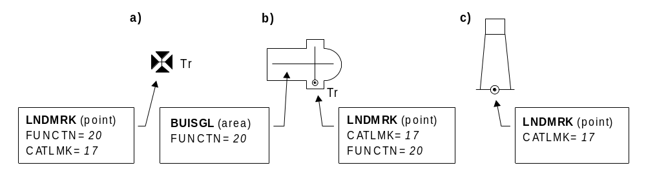

Figure 3 - Landmarks

4.8.16 Fences and walls

If it is required to encode a fence or wall, it must be done using the object class FNCLNE.

Geo object: Fence/wall (FNCLNE)
Attributes: CATFNC COLOUR COLPAT CONDTN CONRAD CONVIS
ELEVAT HEIGHT NATCON NOBJNM OBJNAM STATUS
VERACC VERDAT VERLEN INFORM NINFOM

4.8.17 Fortified structures (see M4 - §379)

If it is required to encode a fortified structure, it must be done using the object class FORSTC.

Geo object: Fortified structure (FORSTC)
Attributes: CATFOR CONDTN CONRAD CONVIS HEIGHT NATCON NOBJNM OBJNAM VERACC VERDAT VERLEN INFORM NINFOM

4.8.18 Pylons and bridge supports (see M4 - §381 and §382)

If it is required to encode a pylon or bridge support, it must be done using the object class PYLONS.

Geo object: Pylon / bridge support (PYLONS)
Attributes: CATPYL COLOUR COLPAT CONDTN CONRAD CONVIS DATEND DATSTA HEIGHT NATCON NOBJNM OBJNAM VERACC VERDAT VERLEN WATLEV INFORM NINFOM

Remarks:
- A PYLONS object of type area with attribute WATLEV = 1,2 or 6 must be covered by a LNDARE object of type area (see clause 4.8.10).

4.8.19 Oil barriers

If it is required to encode an oil barrier, it must be done using the object class OILBAR.

Geo object: Oil barrier (OILBAR)
Attributes: CATOLB CONDTN DATEND DATSTA NOBJNM OBJNAM STATUS INFORM NINFOM

4.8.20 Views and sketches, viewpoints

If it is required to indicate a drawing or a photograph, the attribute PICREP must be used to indicate the file name (without the path) of the external graphical file. Picture files that form part of the ENC must be in TIFF format. Picture files in other formats may be used if a private agreement exists between the producing authority and receiver. An ECDIS may not be able to display files in formats other than TIFF.

4.8.21 Signs and Notice boards

If it is required to encode a fixed or floating sign or notice board, it must be done using a BCNSPP object (see clause 12.3.1) or BOYSPP object (see clause 12.4.1), with attribute CATSPM = 18 (notice mark), or using the object class DAYMAR (see clause 12.3.3).

Remarks:
- If it is required to encode a sign or notice board that has more than one colour, the attributes COLOUR and COLPAT must be used, according to the rules laid out in clause 2.4.
- If it is required to encode any text shown on a notice board or sign, it must be done using the attribute INFORM.
- If it is required to encode the shape and colour of a notice board, it must be done by encoding the board as a DAYMAR object.

5. Depth
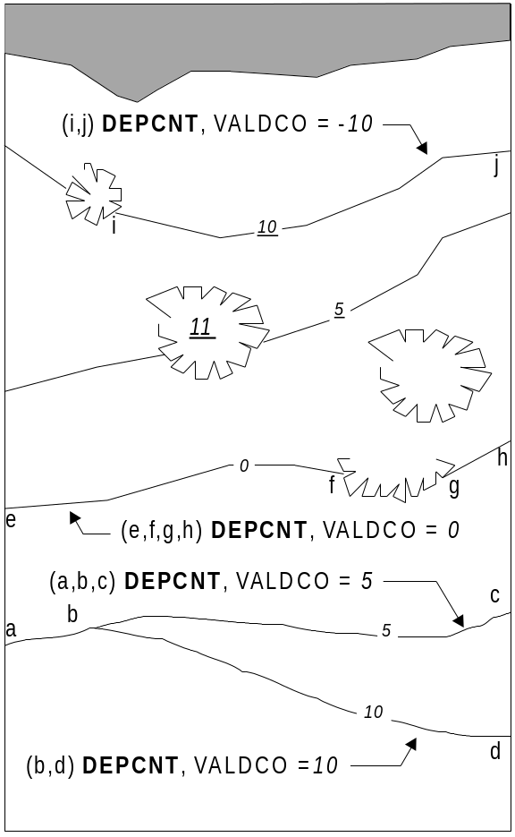

Figure 4 – Depth contours

5.1 Sounding datum

See clause 2.1.3.

5.2 Depth contours (see M4 - §411)

Geo object: Depth contour (DEPCNT)
Attributes: VALDCO - value of depth contour (negative value for drying contours)
VERDAT INFORM NINFOM

The boundary of a drying rocky area (see INT1 - IJ20) or coral reef (see INT1 - IJ22) may be coincident with the zero metre contour (see ‘fg’ in Figure 4). If it is required to encode this boundary, it must be done using the object class DEPCNT with the attribute VALDCO = 0.

On paper charts, the presentation of contours in areas of steep slope is sometimes generalised so that closely spaced contours are removed to leave a single contour (see ‘ab’ in Figure 4). In such cases, this contour must be encoded using the shallowest depth of the slope. A linear depth area must also be created at the same position (see clause 5.4.3).

Wherever possible, contours must be closed, or connected to the border of the cell, a coastline feature or another contour, in order to define closed areas.

Spatial objects associated with approximate contours should be encoded using the attribute QUAPOS = 4 (approximate).

5.3 Soundings (see M4 - §412)

Geo object: Sounding (SOUNDG)
Attributes: EXPSOU - indicates objects with a “value of sounding” within or not within the range of depth of the surrounding area
NOBJNM OBJNAM
QUASOU - see Table 5.1 below
SOUACC - see use of the meta object M_QUAL (clauses 2.2.3.1 and 2.2.3.4)
STATUS - 18 - existence doubtful
TECSOU - only for lower reliability soundings
VERDAT INFORM NINFOM
SORDAT - see Table 5.1 below

Sounding | M4 | INT 1 | QUAPOS | QUASOU | Remarks
In true position | 412.1 | II10 |  | 1 | Should be encoded using QUAPOS = 10
Out of position  on paper chart | 412.2 | II11  II12 |  | 1 | Spatial object must be encoded at the true position. There is no “sounding, out of position” in an ENC.
No bottom found | 412.3 | II13 |  | 5
Lower reliability | 412.4 | II14 | 4 | 4
Drying | 413 | II15 |  | 1 | Negative value
Doubtful | 424.4 | II2 |  | 3 | Existence doubtful should be encoded using STATUS = 18
Reported but not confirmed |  | II4 | 8 | 9 | If available, the year of report must be encoded using the attribute SORDAT
 |  |  |  |  | table 5.1

A sounding associated with a rock or coral pinnacle which is an obstruction to navigation must be encoded using the object class UWTROC (INT1 IK14) with attribute VALSOU populated with the value of the sounding.

The geometry of soundings is held in a 3 dimensional array (latitude, longitude, depth). In the interests of efficiency, multiple soundings should be encoded in one spatial object, provided that all the spatial and geo object attributes are common to the group.

As the sounding multiplication factor (SOMF) for ENC is always 10, soundings must only be encoded to one decimal place of a metre. Drying soundings must be indicated by a negative value.

For soundings surrounded by a danger line, see clause 6.3.

5.4 Depth areas

5.4.1 Geo object depth areas

The sea area, the intertidal area and the navigable parts of rivers, lakes and canals must be divided into depth areas, each of them having a range of depth.

As many depth areas as possible must be created using encoded depth contours.

In the maritime area, there may be a discontinuity in the succession of minimum and maximum depths of adjoining Group 1 area objects (e.g. attributes DRVAL1 and DRVAL2 for DEPARE and DRGARE objects, or height of the coastline (-H) for other Group 1 objects). If this occurs, a DEPARE object of type line must be created to fill this gap.

DEPARE objects of type line are used to ensure the continuity of the line making up the safety contour on an ECDIS, taking into account the requirement of S-52 that a safety contour should be displayed to enable the mariner to clearly see the dividing line between safe and unsafe water.

A DEPARE object of type line must be encoded where two or more of the contours in a data set merge to form a single “cliff contour”. This may happen naturally, or at a dredged area boundary, at a coastline or shoreline construction, etc. However, a DEPARE object of type line may also be created at the borders of area objects DEPARE and DRGARE when there is no discontinuity in the succession of their minimum and maximum depths, and the limit between the two objects does not contain any COALNE, DAMCON, DEPCNT, GATCON, LNDARE or SLCONS objects of type line.

A DEPARE object of type line may also be created at the borders of FLODOC, HULKES, PONTON, UNSARE and LNDARE objects of type area. In all such cases, the DRVAL1 of the DEPARE line objects should be set to -H (see definition of H in Figure 6 below).

DEPARE objects of type area are part of Group 1.

Geo object: Depth area (DEPARE)
Attributes: DRVAL1 - (see clause 5.4.3)
DRVAL2 - (see clause 5.4.3)
QUASOU SOUACC VERDAT INFORM NINFOM

Geometry of depth areas

Where areas are not closed on the source, it may be necessary to close these areas using edges without associated line objects. This is mandatory at the boundary of a cell (see Figure 5).

Remarks:
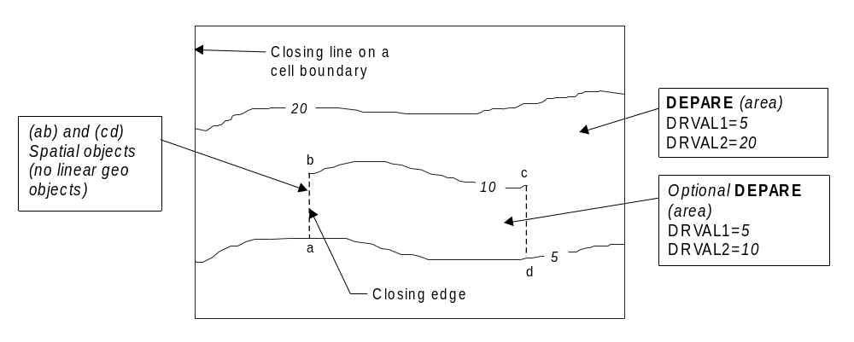

Figure 5 – Geometry of depth areas
- For short isolated sections of DEPCNT objects such as (bc), it is up to the producing authority whether to encode the small area (abcda) as a separate DEPARE object of type area, or to encode only the line (bc) as a floating DEPCNT object.

5.4.3 Use of attributes DRVAL1 and DRVAL2 for depth areas in general

For each depth area of type area, DRVAL1 and DRVAL2 should be encoded with the values corresponding to the shallowest and deepest depths in that area. These values, except for the shallowest and deepest areas, should be chosen from the values of the depth contours encoded in the data set.

The overall succession of DRVAL1 and DRVAL2 in the whole maritime area should be continuous (no gaps, no overlaps). Therefore, for each DEPARE object of type line, DRVAL1 usually takes the maximum value (DRVAL2) of the shallowest adjoining Group 1 DEPARE or DRGARE area object, and DRVAL2 takes the minimum value (DRVAL1) of the deepest adjoining DEPARE or DRGARE area object. However, in some cases DRVAL1 and DRVAL2 may be set to the same value, dependent upon the information shown on the source data. Also, if the shallowest adjoining Group 1 area is a FLODOC, HULKES, LNDARE, PONTON or UNSARE object of type area, the DRVAL1 value of the DEPARE line object, if required, should be set to -H (see definition of H in Figure 6 below).

A drying area, within which a drying height is indicated without a true position, should be encoded using a DEPARE object, with DRVAL1 usually set to -H and DRVAL2 set to a data set contour value (usually zero). The drying height should be encoded using the attribute INFORM on the DEPARE object (e.g. Dries 1.4).

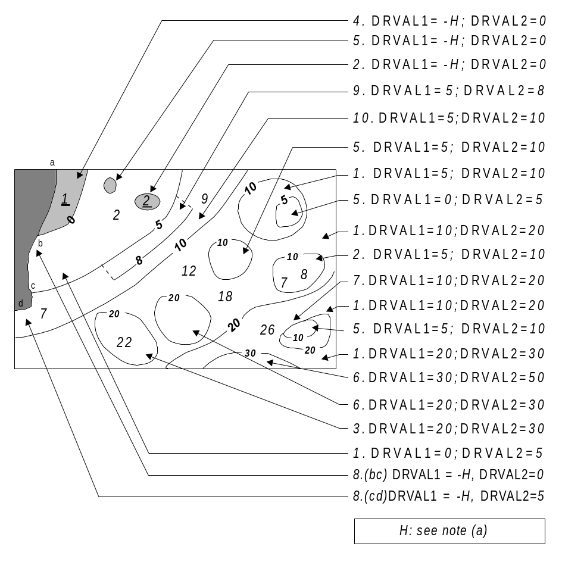
Figure 6 – Depth areas

(a): H = Height of the coastline datum above sounding datum, or a rounded value (e.g. (1) the value of the highest drying contour indicated on the source document; (2) zero, if the coastline datum is the same as the sounding datum).

In the following clauses, the paragraph numbers refer to the item numbers in Figure 6. These clauses do not cover all encoding scenarios and must be used in conjunction with the clauses associated with Figure 7 in clause 5.4.4 below.

1. If the depth area is bounded by two or more depth contours:
DRVAL1 should take the value of the data set depth contour immediately shallower than the value of DRVAL2.
DRVAL2 should take the value of the deepest depth contour bounding the area.

- If the deepest depth is shown by a depth contour, and the shallowest depth is shown by a sounding (a shoal):
DRVAL1 should take the value of the data set depth contour immediately shallower than the value of the sounding or -H.
DRVAL2 should take the value of the depth contour.
3. If the deepest depth is shown by a sounding and the shallowest depth is shown by a depth contour (a deep):
DRVAL1 should take the value of the depth contour.
DRVAL2 should take the value of the data set depth contour immediately deeper than or equal to the value of the sounding.

4. If the shallowest depth is defined by the coastline:
DRVAL1 should take the value of -H.
DRVAL2 should take the value of the shallowest data set depth contour bounding the area.

5. If the depth area is bounded by only one depth contour, contains no soundings, and is a shoal:
DRVAL1 should take the value of the data set depth contour immediately shallower than the value of the depth contour, or -H.
DRVAL2 should take the value of the depth contour.

6. If the depth area is bounded by only one depth contour, contains no soundings, and is a deep:
DRVAL1 should take the value of the depth contour.
DRVAL2 should take the value of the data set depth contour immediately deeper than the value of the depth contour.

7. If two or more depth contours are merged (a cliff), a DEPARE object of type line must be created at the same position:
DRVAL1 should take the value of the DRVAL2 of the shallowest DEPARE area object sharing the cliff as its boundary.
DRVAL2 should take the value of the deepest of the merged depth contours.

8. If one or more depth contours are merged with the coastline, a DEPARE object of type line must be created at the same position:
DRVAL1 should take the value of -H.
DRVAL2 should take the value of the DRVAL1 of the DEPARE area object for which the section of coastline forms the boundary.

9. If the depth area is bounded by an incomplete depth contour on one side (such as in incompletely surveyed area), and a complete depth contour on the other:
If encoded, DRVAL1 should take the value of the shallowest depth contour.
If encoded, DRVAL2 should take the value of the deepest depth contour.
Note: The encoding of this DEPARE object as a separate area is optional - see also Figure 5.

10. If the depth area is bounded by complete depth contours, but contains an incomplete (floating) depth contour:
DRVAL1 should take the value of the shallowest depth contour.
DRVAL2 should take the value of the deepest depth contour.

5.4.4 Use of attributes DRVAL1 and DRVAL2 for depth areas adjoining non-navigable waterways

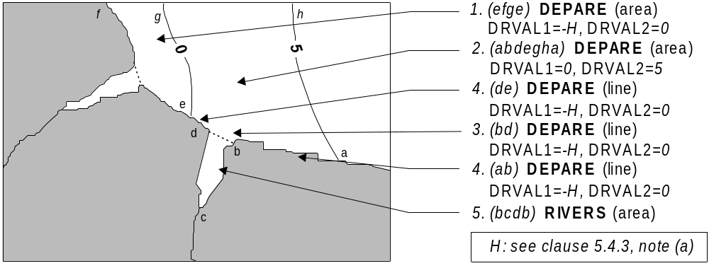
Figure 7 – Depth areas at seaward end of a non-navigable waterway and approaches
Remarks:
- The DEPARE line objects (ab), (bd) and (de) should be encoded as a single linear feature object (abde).

In the following clauses, the paragraph numbers refer to the item numbers in Figure 7. These clauses do not cover all encoding scenarios and must be used in conjunction with the clauses associated with Figure 6 in clause 5.4.3 above.

1. If a depth area is intertidal and adjacent to a non-navigable waterway (RIVERS, CANALS or DOCARE object):
DRVAL1 should take the value of -H.
DRVAL2 should take the value of the deepest depth contour bounding the area (normally zero).

2. If a depth area is always under water and adjacent to a non-navigable waterway (RIVERS, CANALS or DOCARE object):

DRVAL1 should take the value of the shallowest depth contour bounding the area, or the DRVAL2 of a DEPARE line object sharing the contour, if it exists.

DRVAL2 should take the value of the deepest depth contour bounding the area.

3. If a depth area is always under water and adjacent to a non-navigable waterway, a DEPARE object of type line should be created to close the non-navigable waterway. This border of the waterway may also be encoded as a masked line:
DRVAL1 should take the value of -H.
DRVAL2 should take the value of the DRVAL1 of the adjoining depth area.

4. If one or more depth contours merge with the coastline to form a cliff, a DEPARE object of type line should be created at the same position as the cliff:
DRVAL1 should take the value of -H.
DRVAL2 should take the value of DRVAL1 of the area DEPARE object for which the section of coastline forms part of the boundary.

5. If it is required to encode non-navigable waterways, they must be done using the object classes CANALS, DOCARE or RIVERS, and must be covered by LNDARE or UNSARE objects of type area.

5.4.5 Use of attributes DRVAL1 and DRVAL2 for depth areas adjoining constructions which are always dry
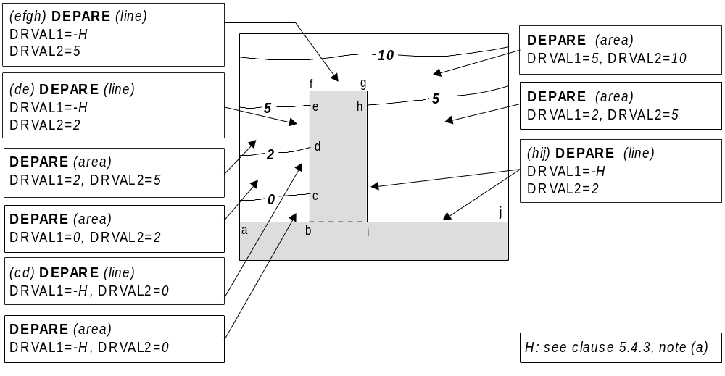
Figure 8 – Depth areas adjoining a shoreline construction

5.4.6 Use of attributes DRVAL1 and DRVAL2 for depth areas adjoining a dredged area
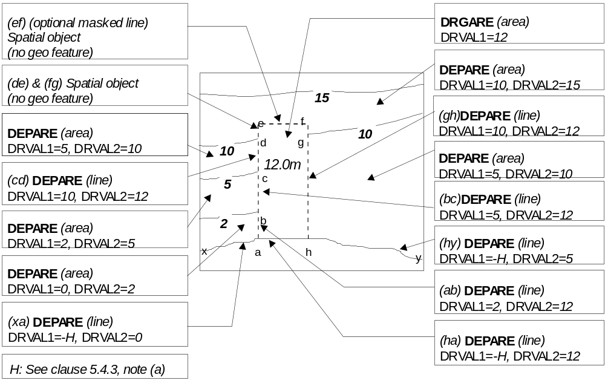
Figure 9 – Depth areas adjoining a dredged area

When a dredged area has a depth of dredging which is deeper than the DRVAL2 of adjoining Group 1 area objects (DEPARE), the boundary of the dredged area must be encoded as a series of DEPARE objects of type line between each intersection with a depth contour:
DRVAL1 should take the value of the maximum depth (DRVAL2) of the adjoining Group 1 area object, or -H.
DRVAL2 should take the value of the depth of dredging.

5.4.7 Use of attributes DRVAL1 and DRVAL2 for dredged areas adjoining dredged areas

In Figure 10, the following DEPARE objects of type line must be encoded, with the following attribute values (see clause 5.4.6):
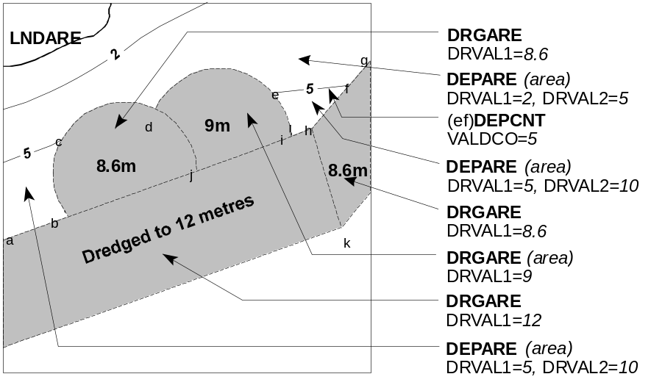
Figure 10 – Dredged areas adjoining dredged areas

(ab) DRVAL1 = 10 DRVAL2 = 12
(cd) DRVAL1 = 5 DRVAL2 = 8.6
(de) DRVAL1 = 5 DRVAL2 = 9
(fg) DRVAL1 = 5 DRVAL2 = 8.6
(hi) DRVAL1 = 10 DRVAL2 = 12

When the depth of dredging is within the range of depths of the adjoining depth area, there should be no geo feature object of type line encoded on the boundary (i.e (bc), (ei), (fh) in Figure 10).

When two dredged areas adjoin:
If the depths of dredging of the two adjoining dredged areas are either side of one or more data set depth contour intervals, the boundary must be encoded as a DEPARE object of type line:
DRVAL1 should take the value of the depth of dredging of the shallower dredged area.
DRVAL2 should take the value of the depth of dredging of the deeper dredged area.

In Figure 10, this corresponds to the following boundaries:

(bj) DRVAL1 = 8.6 DRVAL2 = 12
(ij) DRVAL1 = 9 DRVAL2 = 12
(hk) DRVAL1 = 8.6 DRVAL2 = 12

If the depths of two adjoining dredged areas fall within a data set depth contour interval, there should be no geo feature object of type line encoded on the boundary (i.e. (dj) in Figure 10).

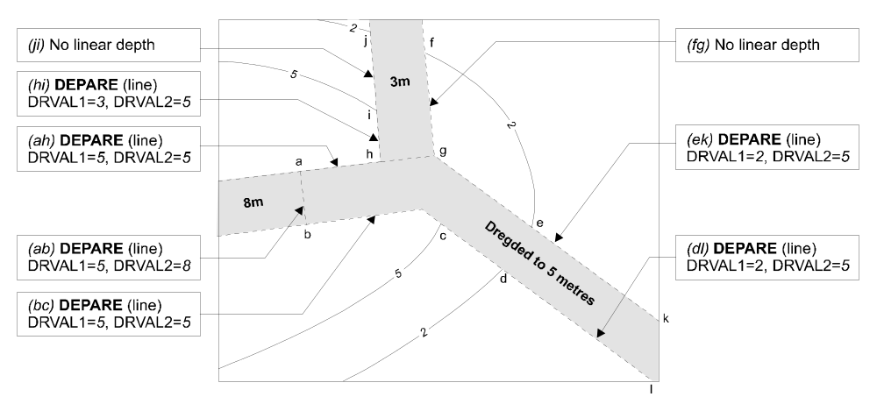
Figure 11 – Linear depth areas along dredged area boundaries

In Figure 11, the 5 metre dredged area extends into the 5-10 metre depth area. In order to ensure that the safety contour can be drawn correctly, linear depth areas ((bc) and (ah)) must be created with both DRVAL1 and DRVAL2 set to 5 metres along these sections of the boundary of the dredged area. There should be no linear depth areas between (ge) and (cd).

5.4.8 Rivers, canals, lakes, basins

Where these areas are navigable at compilation scale, they must be encoded using the Group 1 object classes DEPARE, DRGARE or UNSARE, and coastline-type object classes COALNE or SLCONS. If it is required to encode the nature and name of the area, it must be done using the object class SEAARE.

Where these areas are required and are not navigable at compilation scale, they must be encoded using the object classes RIVERS, CANALS, LAKARE, DOCARE or LOKBSN. These objects must be covered by LNDARE or UNSARE objects. Use of the object classes CANBNK, LAKSHR and RIVBNK is prohibited.

5.5 Dredged areas (see M4 - §414)

If it is required to encode dredged areas, this must be done using the object class DRGARE.

Geo object: Dredged area (DRGARE)
Attributes: DRVAL1 - depth of dredging
DRVAL2 - depth of dredging (if different to DRVAL1)
NOBJNM OBJNAM
QUASOU - 10 - maintained depth
11 - not regularly maintained
If encoded, the value of QUASOU must be one of the above

RESTRN
SOUACC - see use of M_QUAL (clause 2.2.3.1)
TECSOU VERDAT
INFORM - date of dredging (e.g. Dredged in 1995)
NINFOM - date of dredging in national language (e.g. Dragué en 1995)

Remarks:
- DRGARE objects of type area are part of Group 1.
- For the encoding of the boundaries of a dredged area, see clauses 5.4.6 and 5.4.7.

5.6 Swept areas (see M4 - §415)

If it is required to encode a swept area, it must be done using the object class SWPARE.

Geo object: Swept area (SWPARE)
Attributes: DRVAL1 - swept depth
QUASOU SOUACC
TECSOU - 6 - swept by wire-drag
8 - swept by vertical acoustic system
- - swept by side scan sonar
If encoded, the value of TECSOU must be one of the above

VERDAT
INFORM - latest date of sweeping (e.g. Swept in 1998)
NINFOM

Spot soundings and depth contours shown in these areas must be encoded using SOUNDG and DEPCNT objects. Attributes QUASOU, SOUACC and TECSOU encoded on SWPARE apply to the swept area only. When it is required to encode the quality of spot soundings and depth contours, it must be done using the meta object M_QUAL (see clause 2.2.3.1).

Even if the area contains no spot soundings or depth contours, a SWPARE object must overlap DEPARE or DRGARE objects. If there is insufficient depth information to allow the attributes DRVAL1 and DRVAL2 to be encoded on a DEPARE or DRGARE object, DRVAL1 should be set to the swept depth and DRVAL2 should be set to ‘unknown’.

Remarks:
- When a swept area occupies an entire M_QUAL area object and a SWPARE object is not defined separately, DRVAL1 for the M_QUAL object must be used to encode the swept depth. The attribute SOUACC may be used on the M_QUAL object to specify the accuracy of the swept depth defined by DRVAL1 - the attribute POSACC must not be used. There must be no depth or positional accuracy information provided for any underlying soundings within the swept area.
- When a swept area occupies an entire M_QUAL area object and a SWPARE object is defined separately, the DRVAL1 value encoded on the M_QUAL object must be the same as the DRVAL1 value encoded on the SWPARE object. SOUACC may be used on the M_QUAL object to specify the accuracy of the swept depth - POSACC must not be used. There must be no depth or positional accuracy information provided for any underlying soundings within the swept area.
- When a SWPARE object exists within a M_QUAL object, SOUACC must only be used on the M_QUAL object if the same depth accuracy applies to the swept depth and to the soundings outside the swept area. POSACC must only be used to encode the accuracy of depths falling outside the boundaries of the swept area. There must be no depth or positional accuracy information provided for any underlying soundings within the swept area.

5.7 Areas of continual change (see M4 - §416)

If it is required to encode an area of continually changing depth, it must be done using the object class CTNARE (see clause 6.6).

Caution notes in such areas must be encoded using the attributes INFORM or TXTDSC (see clause 6.6).

Such areas must always overlap DEPARE objects.

An area with the indication "Less water" should be encoded using this method.

If it is required to encode sand waves, they must be done using the object class SNDWAV (see clause 7.2.1).

5.8 Areas with inadequate depth information (see M4 - §417)

5.8.1 Unsurveyed areas

Areas with no bathymetric survey information, and falling within a meta object M_COVR area with attribute CATCOV = 1 (coverage available), must be encoded using the object class UNSARE.

Geo object: Unsurveyed area (UNSARE)
Attributes: INFORM NINFOM

Remarks:
- UNSARE objects of type area are part of Group 1.

5.8.2 Incompletely surveyed areas

An incompletely surveyed area should be encoded using either an UNSARE object, within which soundings and contours may be encoded (but not depth areas), or using DEPARE objects. The attributes DRVAL1 and DRVAL2 for such depth areas should have explicit values.

The area must also be covered by M_QUAL objects (see clause 2.2.3.1), with suitably defined attribute CATZOC values. Further information may be given using the meta object M_SREL, where appropriate.

A cautionary note should also be encoded using a CTNARE object of type area (see clause 6.6).

5.8.3 Bathymetry in areas of minimal depiction of detail on paper charts

Where areas of little or no depth information exist within a specified ENC usage, they should be encoded using one of the following options:

5.8.3.1 Areas of omitted bathymetry

Where larger scale coverage is available, the larger scale charts should be examined to determine the shallowest DEPARE object within the whole of the area. One DEPARE object should then be created, with attributes DRVAL1 and DRVAL2 encoded from the values obtained from the larger scale. DEPARE objects of type line may be created to join the area of omitted bathymetry with adjoining known DEPARE objects of type area.

Where larger scale coverage does not exist, a single DEPARE object should be created to cover the area of omitted bathymetry. The DRVAL1 value of the DEPARE object should be set to the shallowest value appropriate to the colour tint that is applied to it (e.g. if blue tint is used for 5-20m areas, the DRVAL1 value for the area of omitted bathymetry should be set to 5). The DRVAL2 value should be set to the shallowest value of the surrounding Group 1 polygons. DEPARE objects of type line may be created to join the area with adjoining known DEPARE objects of type area.

In either case, the areas should be covered by a CTNARE object, the boundary of which follows exactly the surrounding Group 1 objects (see clause 2.8.2).

Areas of very simplified bathymetry

In these areas, information relating to bathymetry (e.g. depth contours, dangers, rocky areas, isolated rocks, nature of the seabed, dredged areas, unsurveyed areas) should be individually encoded as normal.

A CTNARE object should be created covering the DEPARE objects of type area, within the area of simplified bathymetry, in order to encode a cautionary note (see clause 2.8.2).

6. Dangers

6.1 Rocks and coral reefs (see M4 - §421)

6.1.1 Rocks which do not cover (islets)

An area feature must be encoded using:
- A LNDARE object of type area (mandatory)
- COALNE or SLCONS objects of type line (mandatory)
- LNDELV objects of type point (optional)

A line feature must be encoded using:
- A LNDARE object of type line (mandatory)
- LNDELV objects of type point (optional)

A point feature must be encoded using:
- A LNDARE object of type point (mandatory)
- A LNDELV object of type point (optional)

6.1.2 Rocks which may cover

These rocks may cover and uncover, may be awash, or may be always underwater.

Geo object: Underwater / awash rock (UWTROC)
Attributes: EXPSOU - indicates objects with a “value of sounding” within or not within the range of depth of the surrounding area

NATQUA
NATSUR - 9 - rock
- - coral
- - boulder
NOBJNM OBJNAM
QUASOU - see Table 6.1 below.
SOUACC - see use of the meta object M_QUAL (clause 2.2.3.1)
STATUS - 18 - existence doubtful
TECSOU
VALSOU - see Table 6.1 below.

VERDAT
WATLEV - see Table 6.1 below.
INFORM NINFOM
SORDAT - year of report, for reported but not confirmed danger

Rock or coral reef | INT 1 | WATLEV | QUASOU | Comment
Covers and uncovers, depth unknown | IK11 | 4 | 2
Covers and uncovers, depth known | IK11 | 4 | any value except 2 | Negative value for VALSOU
Awash | IK12 | 5
Underwater rock, depth unknown | IK13 | 3 | 2
Underwater rock, depth known | IK14 | 3 | any value except 2
Reported, not confirmed | II3.1,3.2 | 3,4 or 5 | 9 | If available, the year reported should be encoded in SORDAT.  The attribute QUAPOS should be set to 8 (reported, not confirmed).
 |  |  |  | table 6.1

Remarks:
- All UWTROC objects should be encoded using one of the above combinations of attributes.
- A rock represented by a spot sounding and an associated nature of seabed (underwater rock not dangerous to surface navigation) may be encoded using a single UWTROC object.
- For area rock features, see clause 7.1.
- When a group of rocks is surrounded by a danger line, each rock should be encoded as a separate UWTROC object covered by an obstruction area object (OBSTRN).

6.2 Wrecks, foul areas and obstructions (see M4 - §422)

6.2.1 Wrecks

If it is required to encode a wreck, it must be done using the object class WRECKS.

Geo object: Wreck (WRECKS)
Attributes: CATWRK - see Table 6.2 below
CONRAD CONVIS
EXPSOU - indicates objects with a “value of sounding” within or not within the range of depth of the surrounding area
HEIGHT - only if WATLEV = 1 or 2
NOBJNM OBJNAM
QUASOU - see Table 6.2 below
SOUACC - see use of the meta object M_QUAL (clause 2.2.3.1)
STATUS - 13 - for historic wrecks
18 - for existence doubtful
If encoded the value of STATUS must be one of the above
TECSOU - see Table 6.2 below
VALSOU VERACC VERDAT VERLEN
WATLEV - see Table 6.2 below
INFORM NINFOM

In the following table, the symbol ‘/’ indicates that this attribute must not be encoded. A blank indicates that the encoder may choose a relevant value for the attribute.

Wrecks… | M4 | INT 1 | CATWRK | WATLEV | QUASOU | TECSOU
Showing any part of hull or superstructure | 422.2 | IK24  IK20 | 5 | 1,2 or 4 | / | /
Covers and uncovers | 422.2 | IK24  IK21 | 4 or 5 | 4
Awash |  |  |  | 5
The mast only is visible at high water | 422.5 | IK25 | 4 or 5 | 2 | / | /
The mast only is visible at low water | 422.5 | IK25 | 4 | 4
Measured depth | 422.4 | IK26 | 1 or 2 | 3 | 6
Depth measured and swept by wire drag | 422.3 | IK27 | 1 or 2 | 3 | 6 | 6
Depth unknown, considered dangerous by the responsible producing authority | 422.5 | IK28 | 2 | 3 | 2 | /
Depth unknown, not considered dangerous by the responsible producing authority | 422.6 | IK29 | 1 | 3 | 2 | /
Depth unknown, with a safe clearance | 422.7 | IK30 | 1 or 2 | 3 | 7 | /
Distributed remains of wreck | 422.8 | IK31 | 3
Reported, not confirmed | 424.5 | II 3.1,3.2 |  |  | 9
 |  |  |  |  |  | table 6.2

All wrecks should be encoded using one of the above combinations of attributes.

Where a wreck is shown with its true shape (large scale chart):
Soundings and heights are often given inside a wreck to show the highest points of the hull or superstructure (e.g. mast, funnel). If it is required to encode such features, they must be done using:
- A WRECKS object of type area with all populated attributes applying to the highest point of the wreck.
- LNDELV objects of type point to encode the features of the wreck that are always dry; the type of each feature (e.g. mast, funnel) may be encoded using the attributes INFORM and NINFOM.
- SOUNDG objects to encode the features of wrecks which are always submerged, or cover and uncover; the type of each feature (e.g. mast, funnel) may be encoded using INFORM and NINFOM, which means that these soundings must be encoded individually.

Remarks:
- A WRECKS object of type area must be covered by an area object from Group 1 as appropriate.
- If it is required to encode a wreck whose true depth is unknown, but for which there is a safe clearance depth, it must be done using the attribute VALSOU and the attribute QUASOU = 7 (least depth unknown, safe clearance at value shown).

6.2.2 Obstructions and foul areas

If it is required to encode snags, stumps, wellheads, diffusers, cribs, fish havens, foul areas, foul grounds, booms, ice booms or ground tackle, it must be done using the object class OBSTRN.

Geo object: Obstruction (OBSTRN)
Attributes: CATOBS CONDTN
EXPSOU - indicates objects with a “value of sounding” within or not within the range of depth of the surrounding area
HEIGHT - only if WATLEV = 1 or 2
NATCON NATQUA NATSUR NOBJNM OBJNAM
PRODCT - only used for wellheads
QUASOU - see Table 6.3 below
SOUACC - see use of the meta object M_QUAL (clause 2.2.3.1)
STATUS - 18 - existence doubtful
TECSOU - see Table 6.3 below
VALSOU VERACC VERDAT
VERLEN - distance above the sea bed
WATLEV - see Table 6.3 below
INFORM NINFOM

In the following table, the symbol ‘/’ indicates that this attribute must not be encoded. A blank indicates that the encoder may choose a relevant value for the attribute.

Obstruction... | INT 1 | WATLEV | QUASOU | TECSOU
Depth unknown | IK40 | 3 or 4 | 2 | /
Least depth known | IK41 | 3 or 4 | 6
Swept by wire to the depth shown | IK42 | 3 | 6 | 6
 |  |  |  | table 6.3

All obstructions should be encoded using one of the above combinations of attributes.

Remarks:
- If the nature of a dangerous underwater object, dangerous underwater area, or floating object is not explicitly known, it must be encoded using OBSTRN.
- An OBSTRN object of type area must be covered by an area object from Group 1 as appropriate.
- In certain circumstances where an obstruction is always dry (e.g. cribs), it may be covered by a LNDARE object.

6.3 Danger lines

6.3.1 Danger line around a point danger or an isolated sounding

In general terms, a danger line that surrounds a single symbol or sounding (e.g. INT1 - IK28, IK40a or IK 41 to IK43.1) should not be encoded as a separate area. However, when the danger line indicates the true shape of the feature, it should be encoded using WRECKS or OBSTRN objects of type area. A single sounding enclosed by a danger line should be encoded using an OBSTRN object of type point. The sounding value, in this case, must be encoded using the attribute VALSOU.

Danger line limiting an area of wrecks or obstructions

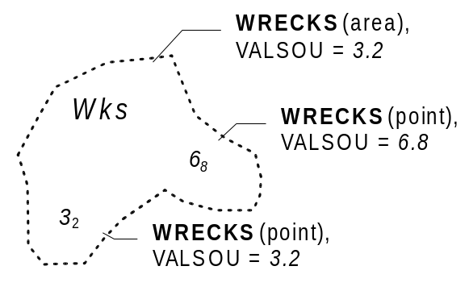
Figure 12 – Area of wrecks

The area enclosed by the danger line must be encoded using WRECKS or OBSTRN objects of type area, with the attribute values, when encoded, reflecting the characteristics of the shallowest point object encoded in the area. The area must also be covered by DEPARE or UNSARE objects as appropriate.

If it is required to encode one or more least depths in such an area, it must be done using a point object for each of the depths, in addition to the area object.

6.3.3 Danger line bordering an area through which navigation is not safe (see M4 -§420.1)

A danger line, bordering an area through which navigation is not safe, should be encoded using an OBSTRN object of type area, with attribute CATOBS = 6 (foul area).

6.4 Overfalls, races, breakers, eddies (see M4 - §423)

If it is required to encode a disturbance of water, it must be done using the object class WATTUR.

Geo object: Water turbulence (WATTUR)
Attributes: CATWAT OBJNAM NOBJNM INFORM NINFOM

Remarks:
- If it is required to encode a breaker over an off-lying shoal, it must be done using a WATTUR object at the same position as the feature causing the breaker.
- A WATTUR object of type area must be covered by DEPARE or UNSARE objects as appropriate.

6.5 Doubtful dangers (see M4 - §424)

The fact that a danger is doubtful should be encoded using the feature attributes QUASOU and STATUS and the spatial attribute QUAPOS on the object:

 | M4 | INT 1 | QUAPOS | QUASOU | STATUS
Position approximate | 424.1 | IB7 | 4
Position doubtful | 424.2 | IB8 | 5
Existence doubtful | 424.3 | II1 |  |  | 18
Doubtful sounding | 424.4 | II2 |  | 3
Reported danger | 424.5 | II3 | 7 or 8 | 8 or 9
 |  |  |  |  | table 6.4

Remarks:
- The same notions of approximate or doubtful positions and doubtful existence also apply to features other than dangers (e.g. landmarks, buoys).
- The text "Discoloured water" on the source indicates the probable existence of shallow water. This should be encoded using a CTNARE object with attribute INFORM or TXTDSC containing a cautionary note (see clause 6.6).

6.6 Caution areas

If it is required to identify an area in which the mariner must be aware of circumstances influencing the safety of navigation (e.g. an area of continually changing depths), it must be done using the object class CTNARE. This object class may be required to identify a danger, a risk, a rule or advice that is not directly related to a particular object.

Geo Object: Caution area (CTNARE)
Attributes: DATEND DATSTA PEREND PERSTA INFORM NINFOM TXTDSC
NTXTDS

7. Nature of the seabed

7.1 Description of the bottom (see M4 - §425)

If it is required to encode an area of the sea where the nature of the bottom is homogeneous, it must be done using the object class SBDARE.

Geo object: Seabed area (SBDARE)
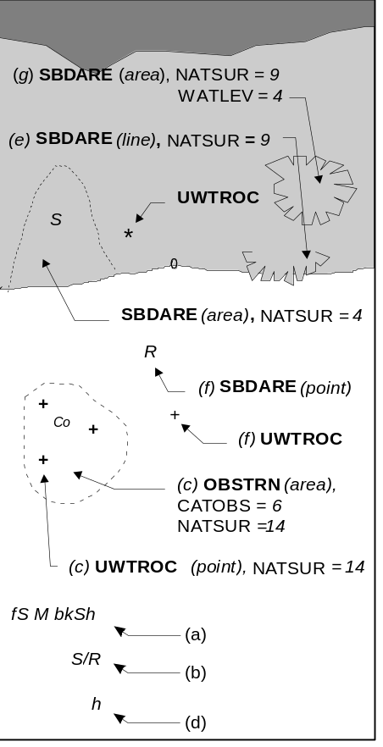
Figure 13 - Seabed areas
Attributes: COLOUR NATQUA NATSUR
WATLEV NOBJNM OBJNAM
INFORM NINFOM

Remarks:
In the following clauses, the paragraph prefixes refer to the examples shown in Figure 13.

(a) Mixed natures: The dominant nature of the seabed should be given first. When there are qualifying terms associated with the various natures of surface, the qualifying terms must be listed in the same order as the nature of surface list. Where a particular nature of surface has no qualifying term, the place in the list must be left empty and a delimiting comma must be encoded. For example, to encode a bottom quality such as "fine sand, mud and broken shells", the attributes NATSUR = 4,1,17 and NATQUA = 1,,4 must be encoded as shown. Where the last nature of surface in a list has no qualifying term, a trailing comma must be encoded. For example, “fine sand and mud” must be encoded with NATSUR = 4,1 and NATQUA = 1,.

(b) Underlying material: Should be encoded in the same way as mixed natures, replacing the comma by a slash (/). The surface layer must be given first, followed by the underlying layers.

(c) Coral reef, which is always covered, represented as an area (IK16): An OBSTRN object of type area must be encoded with attributes CATOBS = 6 (foul area) and NATSUR = 14 (coral). This object must be covered by a DEPARE or UNSARE object as appropriate. In this area, some point dangers may be shown. An UWTROC object should be encoded for each individual point danger.

(d) Hard bottom: The attribute NATQUA = 10 (hard) should be encoded, without being associated with NATSUR.

(e) On the source, in the intertidal area or along the drying line, the nature of surface is sometimes shown by an open line rather than a closed area. In such cases, a SBDARE object of type line should be encoded, with attribute WATLEV = 4 (covers and uncovers).

(f) If it is required to encode a rock pinnacle which is dangerous to navigation, it must be done using the object class UWTROC, while a rocky nature of seabed should be encoded using a SBDARE object of type point.

(g) Where a SBDARE object of type area is located in an intertidal area, it should be encoded with WATLEV = 4 (covers and uncovers).

7.2 Special bottom types

7.2.1 Sand waves (see M4 - §428.1)

If it is required to encode sand waves, this must be done using the object class SNDWAV.

Geo object: Sand waves (SNDWAV)
Attributes: VERACC
VERLEN - amplitude of the sand wave above the bottom
INFORM NINFOM

7.2.2 Weed - Kelp (see M4 - §428.2)

If it is required to encode marine weed or kelp, it must be done using the object class WEDKLP.

Geo object: Weed / kelp (WEDKLP)
Attributes: CATWED NOBJNM OBJNAM INFORM NINFOM

7.2.3 Springs in the seabed (see M4 - §428.3)

If it is required to encode a spring from the seabed, it must be done using the object class SPRING.

Geo object: Spring (SPRING)
Attributes: NOBJNM OBJNAM INFORM NINFOM

7.2.4 Tideways

If it is required to encode a tideway, it must be done using the object class TIDEWY.

Geo object: Tideway (TIDEWY)
Attributes: NOBJNM OBJNAM INFORM NINFOM

Remarks:
- TIDEWY objects must be covered by DEPARE, DRGARE or UNSARE objects.

8. Sea areas (see M4 - §550)

Undersea features and sea areas in general, including intertidal areas, may be identified by their names and may be delimited by the spatial objects used by other geo objects (e.g. depth contours, coastlines). If it is required to encode these areas, this must be done using the object class SEAARE.

Geo object: Sea area (SEAARE)
Attributes: CATSEA NOBJNM OBJNAM INFORM NINFOM

Remarks:
- This object class has a use similar to that of the object class LNDRGN (see clause 4.7.1), but for the sea.
- A SEAARE object of type area should be bounded, if possible, by existing lines used by other objects (e.g. DEPCNT, COALNE). If necessary, however, this area may be bounded by other lines created to close the area, or to describe a new area.
- For seas, oceans, gulfs and other types of sea area, where there is no specific value for the attribute CATSEA, the generic term 'Sea', 'Ocean', 'Gulf', etc may be included in the attributes OBJNAM and NOBJNM.
- SEAARE objects of type area may overlap.
- A SEAARE object of type area must be covered by objects from Group 1 (DEPARE, DRGARE, UNSARE etc).

9. Harbour regulations

9.1 Regulations within harbour limits

9.1.1 Administrative harbour areas (see M4 - §430.1)

If it is required to encode an administrative harbour area, it must be done using the object class HRBARE.

Geo object: Harbour area (HRBARE)
Attributes: NOBJNM OBJNAM STATUS INFORM NINFOM

Remarks:
- A masked line may be used to suppress the symbolisation of the boundary, where such symbolisation is considered inappropriate.

9.1.2 Speed limits (see M4 - §430.2)

Speed is often limited inside harbours in order to prevent wakes. If it is required to encode this restriction, it must be done using a RESARE object (see clause 11.1) with the attribute CATREA = 24 (no wake area) or RESTRN = 13 (no wake). If it is required to encode cases where the speed limit is known, it must be done using RESTRN = 27 (speed restricted), with the speed limit and its unit of measurement encoded using the attribute INFORM (e.g. Speed limit is 5 knots).

If it is required to encode the buoys/beacons marking the RESARE object with speed limits, it must be done using BCNSPP or BOYSPP objects (see clauses 12.3.1, 12.4.1), with the attribute CATSPM = 24 (“reduced wake” mark) or 25 (speed limit mark). The speed limit and its unit of measurement should be encoded using the attribute INFORM (e.g. Speed limit is 6 knots).

9.2 Anchorages and prohibited/restricted anchorages; moorings

9.2.1 Anchorages (see M4 - §431.1 and 431.3)

If it is required to encode an anchorage area, it must be done using the object class ACHARE.

Geo object: Anchorage area (ACHARE)
Attributes: CATACH DATEND DATSTA NOBJNM
OBJNAM - name or number of the anchorage
PEREND PERSTA RESTRN STATUS
INFORM - additional information about the category of anchorage
NINFOM

Remarks:
- Individual recommended anchorages without defined limits should be encoded as ACHARE objects of type point, with attributes CATACH = 1 (unrestricted anchorage) and STATUS = 3 (recommended).
- Areas with numerous small craft moorings (see M4 - §431.7) may be encoded as ACHARE objects of type area, with CATACH = 8 (small craft mooring area). For the encoding of mooring buoys, see clause 9.2.4.
- If it is required to encode an anchorage which may be used for a period of not more than 24 hours, it must be done using CATACH = 9 (anchorage for periods up to 24 hours).
- If it is required to encode an anchorage with a specific, limited time period, it must be done using CATACH = 10 (anchorage for limited period of time). The specific limit of time should be encoded using the attribute INFORM (e.g. Anchorage limited to 12 hours).

9.2.2 Anchor berths (see M4 - §431.2)

If it is required to encode an anchor berth, it must be done using the object class ACHBRT.

Geo object: Anchor berth (ACHBRT)
Attributes: CATACH DATEND DATSTA NOBJNM
OBJNAM - name or number of the berth
PEREND PERSTA
RADIUS - radius of the swinging circle in metres
STATUS
INFORM - additional information about the category of anchorage
NINFOM

Remarks:
- If an anchor berth is defined by a centre point and a swinging circle, it should be of type point, with the radius of the swinging circle encoded using the attribute RADIUS.

9.2.3 Anchoring restricted (see M4 - §431.4)

If it is required to encode a restricted anchoring area, it must be done using a RESARE object, or using other objects with the attribute RESTRN (see clause 11.1), where RESTRN = 1 (anchoring prohibited), 2 (anchoring restricted) or 7 (entry prohibited). Additional information about the restriction should be encoded using the attribute INFORM or TXTDSC.

9.2.4 Mooring buoys (see M4 - §431.5)

If it is required to encode a mooring buoy, it must be done using a MORFAC object (see clause 4.6.7.1), with attribute CATMOR = 7 (mooring buoy).

9.2.5 Mooring trots (see M4 - §431.6)

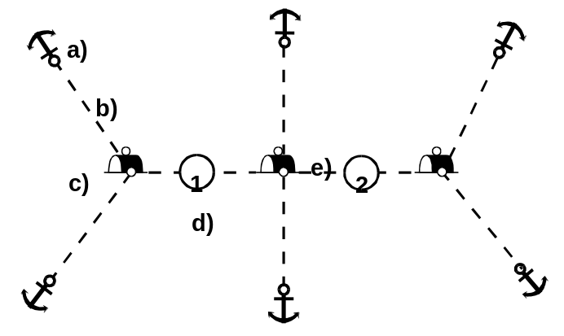
Figure 14 – Mooring trot
A complete mooring trot is composed of ground tackle, mooring cables, buoys and mooring berths on junction cables. The following remarks refer to the annotations in Figure 14 above:

(a) Ground tackle should be encoded using OBSTRN objects (see clause 6.2.2), with attribute CATOBS = 9 (ground tackle).
(b) Mooring cables should be encoded using CBLSUB objects (see clause 11.5.1), with attribute CATCBL = 6 (mooring cable/chain).
(c) Buoys should be encoded using MORFAC objects (see clause 4.6.7.1), with attribute CATMOR = 7 (mooring buoy).
(d) Mooring berths should be encoded using BERTHS objects (see clause 4.6.2).
(e) Junction cables should be encoded using MORFAC objects (see clause 4.6.7.1), with attribute CATMOR = 6 (chain/wire/cable).

All of these objects should be aggregated using the collection object C_AGGR (see clause 15).

9.2.6 Anchorage - relationships

To encode an anchorage, objects such as ACHARE, ACHBRT, MORFAC, RESARE, C_AGGR (mooring trots) and the anchorage’s navigational aids objects may be associated using a collection object C_ASSO (see clause 15).

10. Recommended tracks and routes

10.1 Leading, clearing and transit lines and recommended tracks (see M4 - §433)

If it is required to encode leading, clearing and transit lines and recommended tracks, it must be done using the object classes NAVLNE and RECTRC, and related point navigational aids object classes. This applies for visual and radio navigational aids.

Relationships should be defined between these objects (see clauses 10.1.2 and 15)

NB. In North America the word ‘range’ is used instead of ‘transit’ and ‘leading line’.

10.1.1 Navigation lines and recommended tracks

If it is required to encode a navigation line, it must be done using the object class NAVLNE.

Geo object: Navigation line (NAVLNE)
Attributes: CATNAV DATEND DATSTA
ORIENT - value of the bearing from seaward
PEREND PERSTA STATUS
INFORM - legend as shown on the source
NINFOM

If it is required to encode a recommended track, it must be done using the object class RECTRC.

Geo object: Recommended track (RECTRC)
Attributes: CATTRK DATEND DATSTA
DRVAL1 - minimum depth along the track
DRVAL2 NOBJNM OBJNAM ORIENT PEREND PERSTA QUASOU SOUACC STATUS TECSOU TRAFIC VERDAT
INFORM - maximum authorised draft (e.g. Maximum authorised draft = 14 metres)
NINFOM

Remarks:
- The value 3 (recommended) should not be used on the attribute STATUS in this case because, by definition, RECTRC is recommended.
- In the case of a two-way recommended track, the value of orientation encoded on the attribute ORIENT should be the value of the bearing from seaward. If it is not possible to define a seaward direction, the value that is less than 180° should be used.
- When the traffic flow is one way, the direction of digitising of an object of type line should be the same as the direction of the traffic flow.

The use of NAVLNE and RECTRC is defined in more detail in the following table, and in Figure 15 below:

Figure 15 |  | NAVLNE | RECTRC | Navigational aids
1 | Recommended track on a leading line | CATNAV = 3 | CATTRK = 1 | at least 2
2 | Clearing line on marks in line | CATNAV = 1 | none | at least 2
3 | Transit line on marks in line | CATNAV = 2 | none | at least 2
4 | Recommended track on a bearing | CATNAV = 3 | CATTRK = 1 | 1
5 | Clearing line on a bearing | CATNAV = 1 | none | 1
6 | Transit line on a bearing | CATNAV = 2 | none | 1
7 | Recommended track not based on fixed marks | none | CATTRK = 2 | none
 |  |  |  | table 10.1

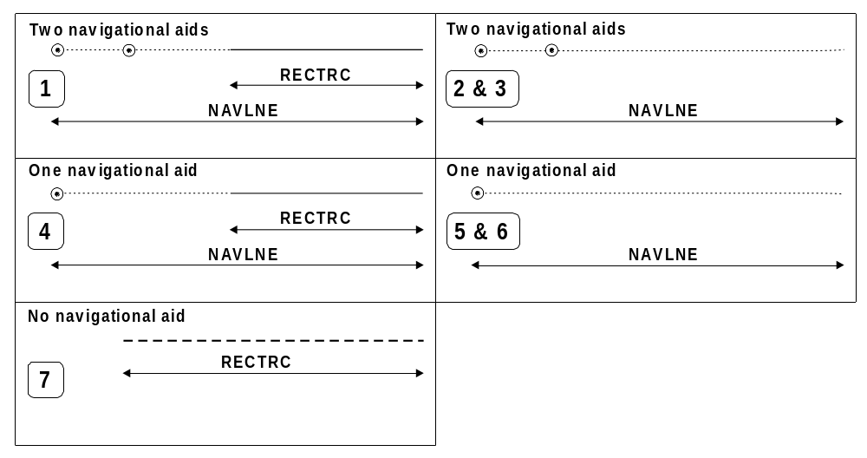
Figure 15 – Navigation lines and recommended tracks

Remarks:
- Even if, on the source, navigational aids are merged into only one symbol, one geo object must be created for each navigational aid.

10.1.2 Range systems - relationship

To encode a range system, the objects NAVLNE, RECTRC and the navigational aids objects should be aggregated using a collection object C_AGGR (see clause 15).

This aggregation object may also be associated, using a collection object C_ASSO (see clause 15), with the dangers (e.g. OBSTRN, WRECKS, UWTROC objects) marked by the clearing or transit line.

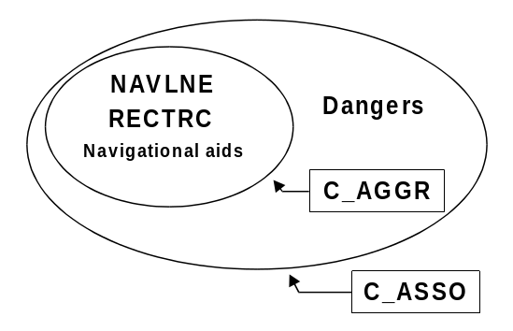
Figure 16 – Range systems

10.1.3 Measured distances (see M4 - §458)

If the track to be followed is on a leading line or a bearing, it must be encoded in the way described in Table 10.1 and Figure 15 above (cases 1 or 4). If the track is not on a leading line or bearing, it must be encoded only as a NAVLNE object with the attribute CATNAV being set to “unknown”. In either case, if it is required to encode the measured distance, it must be done using the attribute INFORM (e.g. Measured distance = 1450 metres).

If it is required to encode the transit lines, they must be done using NAVLNE objects, with CATNAV = 2 (transit line).

If it is required to encode the beacons, they must be done using BCNSPP objects, with attribute CATSPM = 17 (measured distance mark).

Where the entire measured distance system exists within a single cell, each transit line with its beacons must be aggregated into a collection object C_AGGR (see clause 15). These two aggregation objects and the track to be followed must be aggregated into another C_AGGR object.

10.2 Routeing measures

10.2.1 Traffic separation schemes

If it is required to encode a traffic separation scheme, it must be done using DWRTCL, DWRTPT, ISTZNE, PRCARE, TSELNE, TSEZNE, TSSBND, TSSCRS, TSSLPT, TSSRON objects, and navigational aids objects.

The encoding of relationships between these objects is defined in clause 10.2.3.

10.2.1.1 Traffic separation scheme lanes (see M4 - §435.1)

A complete traffic separation scheme lane consists of one or more areas within which the flow of traffic follows one defined direction. If it is required to encode these areas, this must be done using the object class TSSLPT.

Geo object: Traffic separation scheme lane part (TSSLPT)
Attributes: CATTSS DATEND DATSTA
ORIENT - direction of the traffic flow
RESTRN STATUS INFORM NINFOM

Remarks:
- At junctions, other than crossings and roundabouts, a separate TSSLPT object must be encoded. For this object, the attribute ORIENT must be omitted, in order to avoid implying that one lane has priority over another (see INT1 IM22). Warning text may be encoded using the attribute INFORM or TXTDSC.

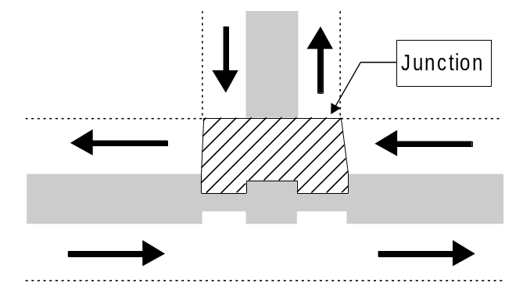
Figure 17 - Junction

10.2.1.2 Traffic separation scheme boundaries (see M4 - §435.1)

The object class TSSBND must only be used to encode the outer limits of traffic lanes or traffic separation scheme roundabouts.

Geo object: Traffic separation scheme boundary (TSSBND)
Attributes: CATTSS DATEND DATSTA STATUS INFORM NINFOM

10.2.1.3 Traffic separation lines (see M4 - §435.1)

The object class TSELNE must only be used to encode the common boundary of two traffic lanes, or of one traffic lane and one inshore traffic zone.

Geo object: Traffic separation line (TSELNE)
Attributes: CATTSS DATEND DATSTA STATUS INFORM NINFOM

10.2.1.4 Traffic separation zones (see M4 - §435.1)

The object class TSEZNE must only be used to encode the separation areas between two traffic lanes, or of one traffic lane and one inshore traffic zone, or to encode the centre part of a roundabout.

Geo object: Traffic separation zone (TSEZNE)
Attributes: CATTSS DATEND DATSTA STATUS INFORM NINFOM

10.2.1.5 Traffic separation scheme crossings (see M4 - §435.1)

The object class TSSCRS must only be used to encode the area where at least four traffic lanes cross.

Geo object: Traffic separation scheme crossing (TSSCRS)
Attributes: CATTSS DATEND DATSTA RESTRN STATUS INFORM NINFOM

Remarks:
- Junctions other than crossings and roundabouts should be encoded using the object class TSSLPT (see clauses 10.2.1.1 and 10.2.1.6).
- A TSSCRS object must not overlap a TSEZNE object at its centre.

10.2.1.6 Traffic separation scheme roundabouts (see M4 - §435.1)

The object class TSSRON must only be used to encode the area in which traffic moves in a counter-clockwise direction around a specified point or zone.

Geo object: Traffic separation scheme roundabout (TSSRON)
Attributes: CATTSS DATEND DATSTA RESTRN STATUS INFORM NINFOM

Remarks:
- A TSSRON object must not overlap a TSEZNE object at its centre.

10.2.1.7 Inshore traffic zones (see M4 - §435.1)

The object class ISTZNE must only be used to encode the designated area between the landward boundary of a traffic separation scheme and the adjacent coast.

Geo object: Inshore traffic zone (ISTZNE)
Attributes: CATTSS DATEND DATSTA RESTRN STATUS INFORM NINFOM

10.2.1.8 Precautionary areas (see M4 - §435.2)

The object class PRCARE must only be used to encode an area, within defined limits, where ships must navigate with particular caution, and within which the direction of traffic flow may be recommended.

Geo object: Precautionary areas (PRCARE)
Attributes: DATEND DATSTA RESTRN STATUS INFORM NINFOM TXTDSC
NTXTDS
Remarks:
- A PRCARE object may overlap other objects encoded for the traffic separation scheme (e.g. TSSRON, TSSLPT, TSSCRS).

10.2.2 Deep water routes (see M4 - §435.3)

10.2.2.1 Deep water route parts

A complete deep water route (DW) consists of one or more areas within which the flow of traffic either follows one defined direction for one-way traffic, or follows one defined direction and its reciprocal for two-way traffic. If it is required to encode these areas, this must be done using the object class DWRTPT.

Geo object: Deep water route part (DWRTPT)
Attributes: DATEND DATSTA
DRVAL1 - minimum depth
DRVAL2 NOBJNM
OBJNAM - should only be used if the individual object is not aggregated in a collection object
ORIENT - direction of the traffic flow
QUASOU RESTRN SOUACC STATUS TECSOU TRAFIC VERDAT INFORM NINFOM

Remarks:
- The route must be covered by DEPARE objects.
- A deep water route part may overlap a TSSLPT object.
- To encode a complete deep water route, the DWRTCL, DWRTPT objects, and the navigational aids objects (if they are stated in the regulation defining the DW), may be aggregated using the collection object C_AGGR (see clause 15). The attribute OBJNAM on the C_AGGR object is used to encode the name of the DW, and the attribute INFORM or TXTDSC should be used to encode textual information about the whole DW.

10.2.2.2 Deep water route centrelines

If it is required to encode the centreline of a deep water route, the width of which is not explicitly defined, it must be done using the object class DWRTCL.

Geo object: Deep water route centreline (DWRTCL)
Attributes: CATTRK DATEND DATSTA
DRVAL1 - minimum depth
DRVAL2 NOBJNM
OBJNAM - should only be used if the individual object is not aggregated in a collection object
ORIENT QUASOU SOUACC STATUS TECSOU TRAFIC VERDAT INFORM NINFOM

Remarks:
- When the traffic flow is one way (attribute TRAFIC = 3), the direction of digitising should be the same as the direction of traffic flow.

10.2.3 Traffic separation scheme systems

To encode a traffic separation scheme (TSS) system, the DWRTCL, DWRTPT, ISTZNE, PRCARE, TSELNE, TSEZNE, TSSBND, TSSCRS, TSSLPT, TSSRON objects, and the navigational aids objects (if they are stated in the regulation defining the TSS or DW), must be aggregated using the collection object C_AGGR (see clause 15). The attribute OBJNAM for the C_AGGR object is used to encode the name of the TSS, and the attribute INFORM or TXTDSC should be used to encode textual information about the whole TSS.

10.2.4 Recommended routes (see M4 - §435.4)

If it is required to encode the centreline of a recommended route, it must be done using the object class RCRTCL.

Geo object: Recommended route centreline (RCRTCL)
Attributes: CATTRK DATEND DATSTA
DRVAL1 - minimum depth
DRVAL2 NOBJNM OBJNAM ORIENT PEREND PERSTA QUASOU SOUACC STATUS TECSOU TRAFIC VERDAT
INFORM NINFOM

Remarks:
- When the traffic flow is one way (attribute TRAFIC = 3), the direction of digitising should be the same as the direction of traffic flow.

10.2.5 Recommended direction of traffic flow (see M4 - §435.5)

The object class RCTLPT should be used to encode areas with a recommended direction of traffic flow:
- between two TSS (INT1 - IM26.1)
- in the entrance area of a TSS
- along the outside of a deep water route (INT1 - IM26.2)

Geo object: Recommended traffic lane part (RCTLPT)
Attributes: DATEND DATSTA ORIENT STATUS INFORM NINFOM

Remarks:
- When the area is not defined, a point object should be encoded.

10.2.6 Two-way routes (see M4 - §435.6)

A two-way route consists of one or more areas within which traffic flows in two directions along one bearing and its reciprocal. If it is required to encode these areas, this must be done using the object class TWRTPT. These route parts will generally be two-way, but some may be restricted to one-way traffic flow (INT1 - IM28.2).

Geo object: Two-way route part (TWRTPT)
Attributes: CATTRK DATEND DATSTA
DRVAL1 - minimum depth
DRVAL2 ORIENT QUASOU SOUACC STATUS TECSOU TRAFIC VERDAT INFORM NINFOM
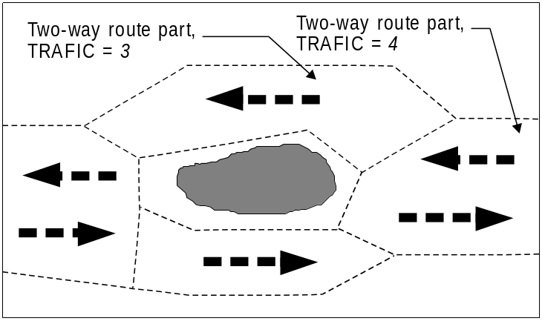
Figure 18 – One-way traffic flow in a two-way route
If it is required to encode a two-way route with one-way sections, separate TWRTPT objects must be encoded for the different parts, with attribute TRAFIC = 3 (one-way) or 4 (two-way). In one-way sections, the attribute ORIENT must indicate the true direction of traffic flow, not its reciprocal. In two-way sections, ORIENT may indicate either direction of traffic flow.

10.2.7 Areas to be avoided (see M4 - §435.7)

If it is required to encode an area to be avoided, it must be done using a RESARE object (see clause 11.1), with attribute RESTRN = 14 (area to be avoided). An area to be avoided around a navigational aid must also be encoded with attribute CATREA = 12 (navigational aid safety zone).

10.3 Ferries (see M4 - §438)

If it is required to encode a ferry route, it must be done using the object class FERYRT.

Geo object: Ferry route (FERYRT)
Attributes: CATFRY DATEND DATSTA NOBJNM OBJNAM PEREND PERSTA
STATUS INFORM NINFOM

10.4 Fairways

If it is required to encode a fairway, it must be done using the object class FAIRWY.

Geo object: Fairway (FAIRWY)
Attributes: DATEND DATSTA
DRVAL1 - minimum depth in the fairway
NOBJNM OBJNAM ORIENT QUASOU RESTRN SOUACC STATUS
TRAFIC VERDAT INFORM NINFOM

Remarks:
- A collection object C_AGGR or C_ASSO (see clause 15) should be created to relate a fairway with associated navigational aids, recommended tracks, dredged areas, and other regulated areas.
- Where beacons or buoys marking a fairway are offset from the actual fairway limits, this should be indicated using the attribute INFORM on the FAIRWY object.

11. Regulated areas

11.1 Restricted areas in general (see M4 - §439.2 to § 439.4)

If it is required to encode a restricted area, it must be done using the object class RESARE, or using other object classes having the attribute RESTRN (ACHARE, CBLARE, DMPGRD, DRGARE, DWRTPT, FAIRWY, ICNARE, ISTZNE, MARCUL, MIPARE, OSPARE, PIPARE, PRCARE, SPLARE, SUBTLN, TESARE, TSSCRS, TSSLPT, TSSRON).

Geo object: Restricted area (RESARE)
Attributes: CATREA - describes the reason for the regulation
DATEND DATSTA NOBJNM OBJNAM PEREND PERSTA
RESTRN - describes the restrictions
STATUS
INFORM - a short explanation about the regulation (e.g. caution note from paper chart). The attribute TXTDSC may be used instead of INFORM, or for longer explanations or notes

NINFOM

Remarks:
- If it is required to encode an area for which the mariner must be made aware of circumstances influencing the safety of navigation, it must be done using the object class CTNARE (see clause 6.6). This object class may be used to identify a danger, a risk, a rule or advice (e.g. an area of continually changing depths) which is not directly related to a particular object.

Maritime jurisdiction areas (see M4 - §440)

11.2.1 National territories
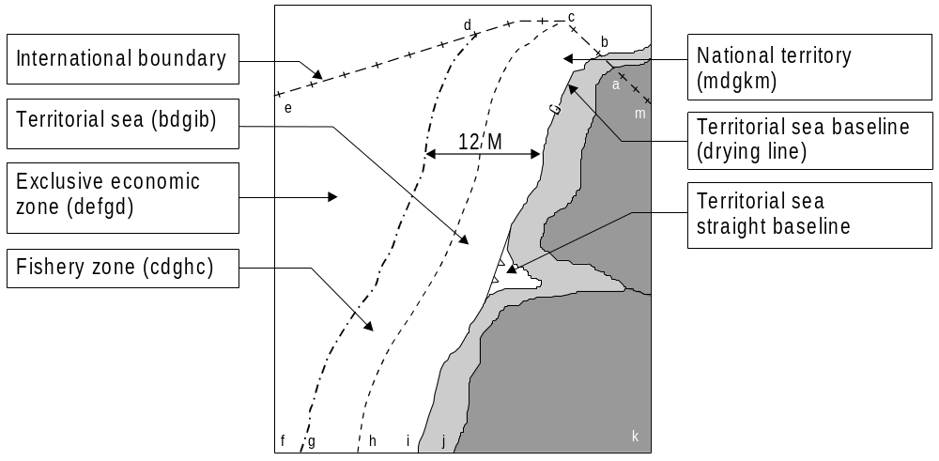
Figure 19 – Maritime jurisdiction areas

If it is required to encode a national territory, it must be done using the object class ADMARE.

Geo object: Administration area (ADMARE)
Attributes: JRSDTN - 2 - national
NATION NOBJNM OBJNAM INFORM NINFOM

11.2.2 Custom zones

If it is required to encode a custom zone, it must be done using the object class CUSZNE.

Geo object: Custom zone (CUSZNE)
Attributes: NATION INFORM NINFOM

11.2.3 Free port areas

If it is required to encode a free port area, it must be done using the object class FRPARE.

Geo object: Free port area (FRPARE)
Attributes: NOBJNM OBJNAM STATUS INFORM NINFOM

11.2.4 Territorial seas

A territorial sea is delimited by:
- territorial sea baselines (drying lines),
- straight territorial sea baselines,
- international maritime boundaries,
- seaward limits of territorial seas.
If it is required to encode the straight territorial sea baseline, it must be done using the object class STSLNE.

Geo object: Straight territorial sea baseline (STSLNE)
Attributes: NATION INFORM NINFOM

If it is required to encode the territorial sea area, it must be done using the object class TESARE.

Geo object: Territorial sea area (TESARE)
Attributes: NATION RESTRN INFORM NINFOM

11.2.5 Contiguous zones

If it is required to encode a contiguous zone, it must be done using the object class CONZNE.

Geo object: Contiguous zone (CONZNE)
Attributes: DATEND DATSTA NATION STATUS INFORM NINFOM

11.2.6 Fishery zones

If it is required to encode a fishery zone, it must be done using the object class FSHZNE.

Geo object: Fishery zone (FSHZNE)
Attributes: NATION NOBJNM OBJNAM STATUS
INFORM - value and unit of measure of the associated limit (e.g. 6 M or 12 M).

NINFOM

11.2.7 Continental shelves

If it is required to encode a continental shelf, it must be done using the object class COSARE.

Geo object: Continental shelf area (COSARE)
Attributes: NATION NOBJNM OBJNAM INFORM NINFOM

11.2.8 Exclusive economic zones

If it is required to encode an exclusive economic zone, it must be done using the object class EXEZNE.

Geo object: Exclusive economic zone (EXEZNE)
Attributes: NATION INFORM NINFOM

11.3 Military practice areas; submarine transit lanes; minefields

11.3.1 Military practice areas (see M4 - §441)

If it is required to encode a military practice area, it must be done using the object class MIPARE.

Geo object: Military practice area (MIPARE)
Attributes: CATMPA DATEND DATSTA NOBJNM OBJNAM PEREND PERSTA RESTRN STATUS INFORM NINFOM

11.3.2 Submarine transit lanes (see M4 - §441.5)

If it is required to encode a submarine transit lane, it must be done using the object class SUBTLN.

Geo object: Submarine transit lane (SUBTLN)
Attributes: NOBJNM OBJNAM INFORM NINFOM RESTRN

11.3.3 Minefields (see M4 - §441.8)

If it is required to encode a minefield, it must be done using a RESARE object (see clause 11.1), with attribute CATREA = 14 (minefield). Former mined areas should also be encoded with attribute STATUS = 4 (not in use).

11.4 Dumping grounds (see M4 - §442)

If it is required to encode a dumping ground, it must be done using the object class DMPGRD.

Geo object: Dumping ground (DMPGRD)
Attributes: CATDPG NOBJNM OBJNAM RESTRN STATUS INFORM NINFOM

11.5 Cables and cable areas

11.5.1 Submarine cables (see M4 - §443)

If it is required to encode a submarine cable, it must be done using the object class CBLSUB.

Geo object: Cable, submarine (CBLSUB)
Attributes: BURDEP - if the buried depth varies along the cable, the cable must be encoded as several objects.
CATCBL - 1 - power line
4 - telephone
5 - telegraph
6 - mooring cable/chain
if encoded, the value of CATCBL must be one of the above
CONDTN- 1 - under construction (during laying)
5 - planned construction (planned laying)
if encoded, the value of CONDTN must be one of the above
DATEND DATSTA DRVAL1 DRVAL2 NOBJNM OBJNAM
STATUS - 4 - not in use (disused)
VERDAT INFORM NINFOM

Remarks:
- Where a cable is disused, it should be encoded with the attribute STATUS = 4 (not in use (disused)), and the attribute CATCBL should not be encoded.

11.5.2 Overhead cables (see M4 - §382)

If it is required to encode an overhead cable, it must be done using the object class CBLOHD.

Geo object: Cable, overhead (CBLOHD)
Attributes: CATCBL
CONDTN- 1 - under construction
5 - planned construction
if encoded, the value of CONDTN must be one of the above
CONRAD CONVIS DATEND DATSTA ICEFAC NOBJNM OBJNAM
STATUS
VERACC - applies only to VERCLR and VERCSA
VERCLR VERCSA
VERDAT - applies only to VERCLR and VERCSA
INFORM NINFOM

Remarks:
- If it is required to encode telepheric cables, this must be done using CONVYR objects (see clause 4.8.11), with attribute CATCON = 1 (aerial cableway (telepheric)).
- Where a cable has radar reflectors, they must be encoded as separate RADRFL objects (see clause 12.12). If the whole cable is radar conspicuous, or the compilation scale is too small to show individual reflectors, the CBLOHD should be encoded with attribute CONRAD = 1 (radar conspicuous).

11.5.3 Submarine cable areas (see M4 - §443.2)

If it is required to encode a submarine cable area, it must be done using the object class CBLARE.

Geo object: Cable area (CBLARE)
Attributes: CATCBL - 1 - power line
4 - telephone
5 - telegraph
If encoded, the value of CATCBL must be one of the above
DATEND DATSTA NOBJNM OBJNAM RESTRN
STATUS - used only to encode the status of the area and not the status of the cables in the area.
INFORM NINFOM

11.6 Pipelines and pipeline areas

11.6.1 Pipelines, submarine or on land (see M4 - §377 and §444)

If it is required to encode a submarine or land pipeline, it must be done using the object class PIPSOL.

Geo object: Pipeline, submarine / on land (PIPSOL)
Attributes: BURDEP - if the buried depth varies along the pipeline, the pipeline must be encoded as several objects
CATPIP
CONDTN - 1 - under construction (during laying)
5 - planned construction (planned laying)
if encoded, the value of CONDTN must be one of the above
DATEND DATSTA
DRVAL1 - shallowest depth over the pipeline
DRVAL2 - deepest depth over the pipeline
NOBJNM OBJNAM PRODCT
STATUS - 4 - not in use (disused)
INFORM NINFOM VERACC VERDAT VERLEN

Remarks:
- Where a pipeline is disused, it should be encoded with the attribute STATUS = 4 (not in use (disused)), and the attributes CATPIP and PRODCT should not be encoded.

11.6.2 Diffusers, cribs

If it is required to encode diffusers and cribs, this must be done using OBSTRN objects (see clause 6.2.2), with attribute CATOBS = 3 (diffuser) or 4 (crib).

11.6.3 Overhead pipelines (see M4 - §383)

If it is required to encode an overhead pipeline passing over or nearby navigable waters, it must be done using the object class PIPOHD.

Geo object: Pipeline overhead (PIPOHD)
Attributes: CATPIP
CONDTN - 1 - under construction
5 - planned construction
if encoded, the value of CONDTN must be one of the above
CONRAD CONVIS DATEND DATSTA NOBJNM OBJNAM PRODCT STATUS
VERACC - applies only to VERCLR
VERCLR
VERDAT - applies only to VERCLR
INFORM NINFOM

Where an overhead pipeline is disused, it should be encoded with the attribute STATUS = 4 (not in use (disused)), and the attributes CATPIP and PRODCT should not be encoded.

11.6.4 Pipeline areas (see M4 - §444.2)

If it is required to encode a pipeline area, it must be done using the object class PIPARE.

Geo object: Pipeline area (PIPARE)
Attributes: CATPIP CONDTN DATEND DATSTA NOBJNM OBJNAM PRODCT RESTRN
STATUS - used only to encode the status of the area and not the status of the pipelines in the area.
INFORM NINFOM

11.7 Oil and Gas fields

11.7.1 Wellheads (see M4 - §445.1, §445.5 and §445.7)

If it is required to encode wellheads, this must be done using OBSTRN objects of type point (see clause 6.2.2), with attributes:

CATOBS - 2 - wellhead
HEIGHT
STATUS - 4 - not in use (disused)
VALSOU
VERLEN - vertical length of the wellhead above the seabed
WATLEV- 2 - always dry (for wellheads that protrude at high water)
3 - always under water/submerged

11.7.2 Offshore platforms (see M4 - §445.2)

If it is required to encode a permanent offshore platform, it must be done using the object class OFSPLF.

Geo object: Offshore platform (OFSPLF)
Attributes: CATOFP COLOUR COLPAT CONDTN CONRAD CONVIS DATEND DATSTA
HEIGHT - for fixed platforms, referred to the vertical datum (see clause 2.1.2)
NATCON NOBJNM OBJNAM PRODCT STATUS VERACC VERDAT
VERLEN - for floating platforms, referred to the sea level
INFORM NINFOM

Remarks:
- If it is required to encode sites of dismantled platforms, this must be done using OBSTRN objects (see clause 6.2.2), with attribute CATOBS = 7 (foul ground).
- Platforms may carry lights (see clause 12.8), fog signals (see clause 12.5) and helicopter platforms (see clause 4.8.12).

11.7.3 Offshore safety zones (see M4 - §445.2)

If it is required to encode an offshore safety zone, it must be done using a RESARE object (see clause 11.1), with attribute CATREA = 1 (offshore safety zone).

11.7.4 Offshore production areas (see M4 - §445.3)

If it is required to encode an offshore production area, it must be done using the object class OSPARE.

Geo object: Offshore production area (OSPARE)
Attributes: CATPRA CONDTN CONRAD CONVIS DATEND DATSTA HEIGHT
INFORM NINFOM NOBJNM OBJNAM PRODCT RESTRN STATUS
VERACC VERLEN

11.7.5 Offshore tanker loading systems (see M4 - §445.4)

If it is required to encode an offshore tanker loading system, it must be done using the object class BOYINB (see clause 12.4.1).

If it is required to encode an articulated tower, it must be done using an OFSPLF object (see clause 11.7.2), with attribute:

CATOFP - 4 - articulated loading platform (ALP)
5 - single anchor leg mooring (SALM)
8 - floating production, storage and off-loading vessel (FPSO)
10 - navigation, communication and control buoy (NCCB) (which may include storage facilities)

11.7.6 Flare stacks (see M4 - §445.6)

If it is required to encode a flare stack, it must be done using a LNDMRK object (see clause 4.8.15), with attribute CATLMK = 6 (flare stack).

An offshore flare stack may share the same geometry as the platform on which it is installed.

11.8 Spoil grounds, dredging areas (see M4 - §446)

If it is required to encode a spoil ground, it must be done using a DMPGRD object (see clause 11.4), with attribute CATDPG = 5 (spoil ground).

If it is required to encode a dredging area, it must be done using a RESARE object (see clause 11.1), with attribute CATREA = 21 (dredging area).

11.9 Fishing equipment and aquaculture areas

11.9.1 Fishing facilities (see M4 - §447.1 to §447.3)

If it is required to encode a fishing facilityit must be done using the object class FSHFAC.

Geo object: Fishing facility (FSHFAC)
Attributes: CATFIF NOBJNM OBJNAM PEREND PERSTA STATUS VERACC
VERLEN - height of the object above the seabed
INFORM NINFOM

11.9.2 Marine farms (see M4 - § 447.4 and §447.6)

If it is required to encode a marine farm, it must be done using the object class MARCUL.

Geo object: Marine farm / culture (MARCUL)
Attributes: CATMFA DATEND DATSTA EXPSOU INFORM NINFOM NOBJNM OBJNAM PEREND PERSTA QUASOU RESTRN SOUACC STATUS VALSOU VERDAT
VERLEN - height of the object above the seabed
WATLEV

When it is required to encode the minimum depth of the object, the attributes EXPSOU and QUASOU and the mandatory attribute VALSOU must be used. When a MARCUL object covers an area of the seafloor at the compilation scale of the ENC, the value of the attribute VALSOU represents the minimum depth, if known, over any structure used to form or support the marine farm, or within the area of the marine farm itself. The mandatory attribute WATLEV must be used to encode the water level of the shallowest section of the area, if partly or completely under water.

11.9.3 Fish havens (see M4 - §447.5)

If it is required to encode a fish haven, it must be done using an OBSTRN object (see clause 6.2.2), with attribute CATOBS = 5 (fish haven).

11.9.4 Fishing grounds

If it is required to encode a fishing ground, it must be done using the object class FSHGRD.

Geo object: Fishing ground (FSHGRD)
Attributes: NOBJNM OBJNAM PEREND PERSTA STATUS INFORM NINFOM

11.10 Degaussing ranges (see M4 - §448)

If it is required to encode a degaussing range, it must be done using a RESARE object (see clause 11.1), with attribute CATREA = 8 (degaussing range).

11.11 Historic wrecks (see M4 §449.5)

If it is required to encode a restricted area around a historic wreck, it must be done using a RESARE object (see clause 11.1), with attribute CATREA = 10 (historic wreck area).

In addition, the wreck itself should be encoded as a WRECKS object (see clause 6.2.1).

11.12 Seaplane landing areas (see M4 §449.6)

If it is required to encode a seaplane landing area, it must be done using the object class SPLARE.

Geo object: Seaplane landing area (SPLARE)
Attributes: NOBJNM OBJNAM PEREND PERSTA RESTRN STATUS INFORM
NINFOM

Remarks:
- If it is required to encode an anchorage for seaplanes, it must be done using an ACHARE object (see clause 9.2.1), with attribute CATACH = 6 (seaplane anchorage).

11.13 Various maritime areas

11.13.1 Ice areas (see M4 - §449.1)

If it is required to encode an ice area, it must be done using the object class ICEARE.

Geo object: Ice area (ICEARE)
Attributes: CATICE CONVIS ELEVAT HEIGHT NOBJNM OBJNAM PEREND PERSTA STATUS VERACC VERDAT VERLEN
INFORM NINFOM

11.13.2 Log ponds (see M4 - §449.2)

If it is required to encode a log pond, it must be done using the object class LOGPON.

Geo object: Log pond (LOGPON)
Attributes: NOBJNM OBJNAM STATUS INFORM NINFOM

11.13.3 Incineration areas (see M4 - §449.3)

If it is required to encode an incineration area, it must be done using the object class ICNARE.

Geo object: Incineration area (ICNARE)
Attributes: NOBJNM OBJNAM PEREND PERSTA RESTRN STATUS INFORM
NINFOM

11.13.4 Cargo transhipment areas (see M4 - §449.4)

If it is required to encode a cargo transhipment area, it must be done using the object class CTSARE.

Geo object: Cargo transhipment area (CTSARE)
Attributes: DATEND DATSTA NOBJNM OBJNAM PEREND PERSTA STATUS
INFORM NINFOM

11.14 Nature reserves

If it is required to encode a marine nature reserve area, it must be done using a RESARE object (see clause 11.1), with attribute CATREA = 4 (nature reserve). A nature reserve that is shown on the source as a point symbol should be encoded using a CTNARE object of type point, with the attribute INFORM = Marine nature reserve.

12. Aids to navigation

12.1 Lighthouses, navigational marks - relationships

12.1.1 Geo objects forming parts of navigational aids

Aids to navigation are composed of fixed or floating structures carrying equipment objects.

The most common structure objects are: BCNCAR, BCNISD, BCNLAT, BCNSAW, BCNSPP, BOYCAR, BOYINB, BOYISD, BOYLAT, BOYSAW, BOYSPP, BRIDGE, BUISGL, DAYMAR, LITFLT, LITVES, LNDMRK, MORFAC, OFSPLF, PILPNT, SLCONS.

Equipment objects consist of: DAYMAR, FOGSIG, LIGHTS, RADSTA, RDOSTA, RETRFL, RTPBCN, SISTAT, SISTAW, TOPMAR.

Radar reflectors must not be encoded as separate objects when attached to navigational aids. If it is required to encode their existence, it must be done using the attribute CONRAD = 3 (radar conspicuous (has radar reflector)) on the structure object.

Rescue stations and coastguard stations are not related directly to navigation, and they must not, therefore, be part of the equipment objects of navigational aids. If it is required to encode a rescue or coastguard station at the same location as a navigational mark, it must be encoded as a separate object, and share the same spatial object as the navigational aid.

12.1.2 Relationships

A master to slave relationship must be created in order to relate the different objects comprising a navigational aid.

When the navigational aid contains a structure object (from the above list), this object must be the master object, and the equipment objects must be the slaves.

When the nature of the base structure is unknown or there is no structure object, one of the equipment objects must be chosen as the master object, giving priority to a LIGHTS object, if one exists.
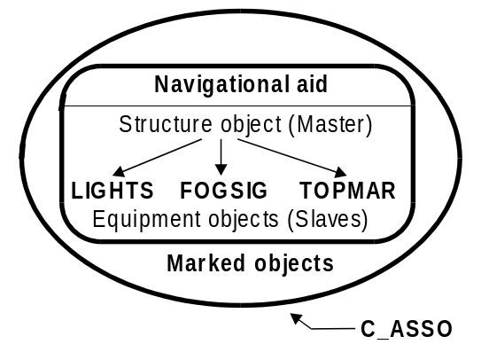
Figure 20 – Navigational aids
If it is required to encode the name of the navigational aid, it must be done using the attribute OBJNAM (and possibly the attribute NOBJNM) on the master object. The name should not be repeated for the slave objects. If the name is painted on the structure, it must be encoded with the same spelling in OBJNAM if it is based on the Latin alphabet. If the name is not based on the Latin alphabet, it must be encoded on NOBJNM, and transliterated for encoding on OBJNAM.

All point objects comprising a navigational aid must point to the same point spatial object.

The navigational aid may be associated with the objects which it marks (e.g. RESARE or OBSTRN objects) using the collection object C_ASSO (see clause 15). Several navigational aids and several marked objects may be associated in the same relationship.

12.2 Buoyage systems and direction of buoyage (see M4 - §461)

The buoyage system of the data set and, where necessary, the direction of buoyage, must be encoded using the meta object M_NSYS:

Meta object: Navigational system of marks (M_NSYS)
Attributes: MARSYS ORIENT INFORM NINFOM

All parts of the data set containing data must be covered by M_NSYS objects, with the attribute MARSYS indicating the buoyage system in operation. M_NSYS with a value encoded for MARSYS must not overlap.
In the following table the symbol ‘/’ indicates that this attribute is not relevant for that particular object class. The table contains the most common examples of coding; other coding combinations are possible. For encoding of buoys, substitute BOY for BCN in Object class.

Feature | INT 1 | Object class |  |  | CATCAM | COLOUR |  | COLPAT |  | MARSYS
North cardinal beacon | IQ 130.3 | BCNCAR |  |  | 1 | 2,6 |  | 1 |  | 1 and 2  (IALA A and B)
East cardinal beacon | IQ 130.3 | BCNCAR |  |  | 2 | 2,6,2 |  | 1 |  | 1 and 2  (IALA A and B)
South cardinal beacon | IQ 130.3 | BCNCAR |  |  | 3 | 6,2 |  | 1 |  | 1 and 2  (IALA A and B)
West cardinal beacon | IQ 130.3 | BCNCAR |  |  | 4 | 6,2,6 |  | 1 |  | 1 and 2  (IALA A and B)
Isolated danger beacon | IQ 130.4 | BCNISD |  |  | / | 2,3,2 |  | 1 |  | 1 and 2  (IALA A and B)
Port lateral beacon | IQ 130.1 | BCNLAT |  |  | 1 | 3 |  | / |  | 1 (IALA A)
Starboard lateral beacon | IQ 130.1 | BCNLAT |  |  | 2 | 4 |  | / |  | 1 (IALA A)
Preferred channel to starboard lateral beacon | IQ 130.1 | BCNLAT |  |  | 3 | 3,4,3 |  | 1 |  | 1 (IALA A)
Preferred channel to port lateral beacon | IQ130.1 | BCNLAT |  |  | 4 | 4,3,4 |  | 1 |  | 1 (IALA A)
Port lateral beacon | IQ130.1 | BCNLAT |  |  | 1 | 4 |  | / |  | 2 (IALA B)
Starboard lateral beacon | IQ130.1 | BCNLAT |  |  | 2 | 3 |  | / |  | 2 (IALA B)
Preferred channel to starboard lateral beacon | IQ130.1 | BCNLAT |  |  | 3 | 4,3,4 |  | 1 |  | 2 (IALA B)
Preferred channel to port lateral beacon | IQ130.1 | BCNLAT |  |  | 4 | 3,4,3 |  | 1 |  | 2 (IALA B)
Safe water beacon | IQ130.5 | BCNSAW |  |  | / | 3,1 or 1,3 |  | 2 |  | 1 and 2  (IALA A and B)
Special purpose beacon | IQ130.6 | BCNSPP |  |  | / | 6 |  | / |  | 1 and 2  (IALA A and B)
Feature | INT 1 | Object class |  |  | TOPSHP | COLOUR |  | COLPAT |  | MARSYS
North cardinal topmark | IQ 130.3 | TOPMAR |  |  | 13 | 2 |  | / |  | 1 and 2  (IALA A and B)
East cardinal topmark | IQ 130.3 | TOPMAR |  |  | 11 | 2 |  | / |  | 1 and 2  (IALA A and B)
South cardinal topmark | IQ 130.3 | TOPMAR |  |  | 14 | 2 |  | / |  | 1 and 2  (IALA A and B)
West cardinal topmark | IQ 130.3 | TOPMAR |  |  | 10 | 2 |  | / |  | 1 and 2  (IALA A and B)
Isolated danger topmark | IQ130.4 | TOPMAR |  |  | 4 | 2 |  | / |  | 1 and 2  (IALA A and B)
Port lateral topmark | IQ130.1 | TOPMAR |  |  | 5 | 3 |  | / |  | 1 (IALA A)
Starboard lateral topmark | IQ130.1 | TOPMAR |  |  | 1 | 4 |  | / |  | 1 (IALA A)
Feature | INT 1 | Object class |  |  | TOPSHP | COLOUR |  | COLPAT |  | MARSYS
Port lateral topmark | IQ130.1 | TOPMAR |  |  | 5 | 4 |  | / |  | 2 (IALA B)
Starboard lateral topmark | IQ130.1 | TOPMAR |  |  | 1 | 3 |  | / |  | 2 (IALA B)
Safe water topmark | IQ130.1 | TOPMAR |  |  | 3 | 3 |  | 2 |  | 1 and 2  (IALA A and B)
Special purpose topmark | IQ130.1 | TOPMAR |  |  | 7 | 6 |  | / |  | 1 and 2  (IALA A and B)
 |  |  |  |  |  |  |  |  |  |  | table 12.1

Within a data set, there may be some areas where the direction of buoyage is defined by local rules and must, therefore, be specified. These areas should be encoded as separate M_NSYS area objects, with the attribute ORIENT indicating the direction of buoyage (MARSYS must not be encoded). M_NSYS objects with a value encoded for ORIENT must not overlap, but in areas where local buoyage directions apply, M_NSYS with a value encoded for ORIENT may overlap M_NSYS with a value encoded for MARSYS (see Figure 21 below).

Individual buoys and beacons may not be part of the general buoyage system. This should be encoded using MARSYS on these buoy and beacon objects.

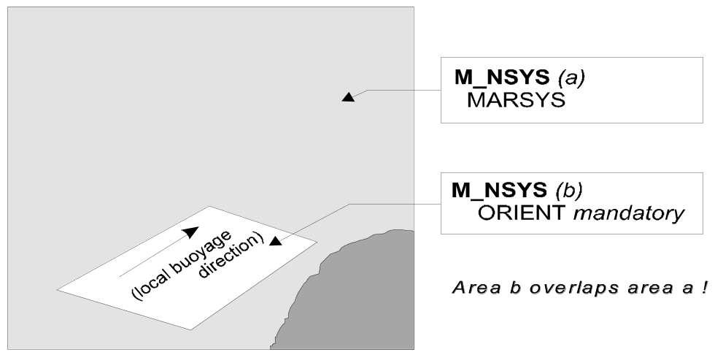
Figure 21 – Buoyage system and direction

12.3 Fixed structures (see M4 - §455)

12.3.1 Beacons

If it is required to encode a beacon, it must be done using the object classes BCNCAR, BCNISD, BCNLAT, BCNSAW or BCNSPP.

Geo objects: Beacon, cardinal (BCNCAR)
Beacon, isolated danger (BCNISD)
Beacon, lateral (BCNLAT)
Beacon, safe water (BCNSAW)
Beacon, special purpose (BCNSPP)
Attributes: BCNSHP
CATCAM - only for BCNCAR
CATLAM - only for BCNLAT
CATSPM - only for BCNSPP
COLOUR COLPAT CONDTN CONRAD CONVIS DATEND DATSTA
ELEVAT HEIGHT
MARSYS - only if different to the value encoded on meta object M_NSYS
NATCON NOBJNM OBJNAM PEREND PERSTA STATUS VERACC VERDAT VERLEN INFORM NINFOM

Remarks:
- If it is required to encode the altitude of the ground level above the vertical datum at the position of a beacon, it must be done using the attribute ELEVAT, but only for beacons built on land.
- If it is required to encode the total altitude of a beacon, including any equipment objects (e.g. topmark, light), above the vertical datum, it must be done using the attribute HEIGHT.
- If it is required to encode the total vertical length of a beacon, including any equipment objects (e.g. topmark, light), above the seabed or ground, it must be done using the attribute VERLEN.
- If it is required to encode a cairn that bears the colour(s) specified by a navigational system of marks, it must be done using a beacon object.
- If it is required to encode a beacon that has more than one colour, the attributes COLOUR and COLPAT must be encoded, according to the rules laid out in clause 2.4.

In the following table, the symbol ‘/’ indicates that this attribute does not exist for that particular object class. A blank indicates that the encoder may choose a relevant value for the attribute. The table contains the most common examples of coding; other coding combinations are possible.

Feature | INT1 | Object-class | BCNSHP | CATSPM | Other attributes
Minor not permanent mark | IQ90 | BCN*** | 1
Minor not permanent mark | IQ91 | BCNLAT | 1 | /
Minor not permanent mark | IQ92 | BCNLAT | 2 | /
Cairn | IQ100 | BCN*** | 6
Coloured or white mark | IQ101 | DAYMAR | / |  | NATCON = 9
Coloured topmark with function of beacon | IQ102.1 | DAYMAR | / |  | NATCON = 9
Painted board with function of leading beacon | IQ102.2 | DAYMAR | / | 16 | NATCON = 9, TOPSHP = 6
Beacon tower | IQ110 | BCN*** | 3
Lattice beacon | IQ111 | BCN*** | 4
Leading beacon | IQ120 | BCNSPP |  | 16
Beacon marking a clearing line | IQ121 | BCNSPP |  | 41
Beacon marking measured distance | IQ122 | BCNSPP |  | 17
Cable landing beacon | IQ123 | BCNSPP |  | 6
Outfall landing beacon | IQ123 | BCNSPP |  | 8
Pipeline landing beacon | IQ123 | BCNSPP |  | 39
Refuge beacon | IQ124 | BCNSPP |  | 44
Firing practice area beacon | IQ125 | BCNSPP |  | 1
Notice board | IQ126 | BCNSPP |  | 18
Buoyant beacon | IP5 | BCN*** | 7
 |  |  |  |  | table 12.2

12.3.2 Lighthouses (see M4 - § 457.3)

If it is required to encode a lighthouse, it must be done using a LNDMRK object (see clause 4.8.15), with attributes CATLMK = 17 (tower) and FUNCTN = 33 (light support) for towers, or using a BUISGL object (see clause 4.8.15), with the attribute FUNCTN = 33, for any other shapes.

If it is required to encode the attributes ELEVAT, HEIGHT and VERLEN for a lighthouse, this must be done as described in clause 12.3.1.

12.3.3 Daymarks

If it is required to encode a daymark, it must be done using the object class DAYMAR.

Geo object: Daymark (DAYMAR)
Attributes: CATSPM COLOUR COLPAT DATEND DATSTA ELEVAT HEIGHT NATCON NOBJNM OBJNAM PEREND PERSTA STATUS
TOPSHP VERACC VERDAT VERLEN INFORM NINFOM

Remarks:
- If it is required to encode the attributes ELEVAT, HEIGHT and VERLEN for a daymark, this must be done as described in clause 12.3.1.

12.4 Floating structures (see M4 - §460)

12.4.1 Buoys

If it is required to encode a buoy, it must be done using the object classes BOYCAR, BOYINB, BOYISD, BOYLAT, BOYSAW or BOYSPP.

Geo objects: Buoy, cardinal (BOYCAR)
Buoy, installation (BOYINB)
Buoy, isolated danger (BOYISD)
Buoy, lateral (BOYLAT)
Buoy, safe water (BOYSAW)
Buoy, special purpose (BOYSPP)
Attributes: BOYSHP
CATCAM - only for BOYCAR
CATINB - only for BOYINB
CATLAM - only for BOYLAT
CATSPM - only for BOYSPP
COLOUR COLPAT CONRAD DATEND DATSTA
MARSYS - only if different to the value encoded on meta object M_NSYS
NATCON NOBJNM OBJNAM PEREND PERSTA
PRODCT - only for BOYINB
STATUS - VERACC VERLEN INFORM NINFOM

Remarks:
- If it is required to encode the total vertical length, including any equipment objects (e.g. topmark, light), of the buoy above the water level, it must be done using the attribute VERLEN.
- If it is required to encode a buoy that has more than one colour, the attributes COLOUR and COLPAT must be encoded, according to the rules laid out in clause 2.4.

In the following table, the symbol ‘/’ indicates that this attribute does not exist for that particular object class. A blank indicates that the encoder may choose a relevant value for the attribute. The table contains the most common examples of coding; other coding combinations are possible.

Feature | INT1 | Object-class | BOYSHP | CATSPM | Other attributes
Mooring buoy | IQ40 | MORFAC |  | / | CATMOR = 7
Oil or gas installation buoy | IL16 | BOYINB | 7 | / | PRODCT = 1 or 2, CATINB = 1 or 2
Firing danger area buoy | IQ50 | BOYSPP |  | 1
Target | IQ51 | BOYSPP |  | 2
Marker ship | IQ52 | BOYSPP |  | 3
Barge | IQ53 | BOYSPP |  | 5
Degaussing range buoy | IQ54 | BOYSPP |  | 4
Buoy marking cable | IQ55 | BOYSPP |  | 6
Spoil ground buoy | IQ56 | BOYSPP |  | 7
Buoy marking outfall | IQ57 | BOYSPP |  | 8
Buoy marking pipeline |  | BOYSPP |  | 39
Superbuoy | IQ26 | BOY*** | 7
Large automatic navigational buoy | IP6 | BOYSPP | 7 | 15
Data-collecting buoy of superbuoy size | IQ58 | BOYSPP | 7 | 9
Buoy marking wave recorder (or current meter) | IQ59 | BOYSPP |  | 10 | INFORM = wave recorder (e.g.)
Seaplane anchorage buoy | IQ60 | BOYSPP |  | 11
Buoy marking traffic separation scheme | IQ61 | BOYSPP |  | 19
Buoy marking recreation zone | IQ62 | BOYSPP |  | 12
 |  |  |  |  | table 12.3

12.4.2 Light floats and light vessels (see M4 - § 462.8 and §474.1)

If it is required to encode a light float or a light vessel, it must be done using the object class LITFLT or LITVES.

Geo objects: Light float (LITFLT)
Light vessel (LITVES)
Attributes: COLOUR COLPAT CONRAD CONVIS DATEND DATSTA HORACC HORLEN HORWID NATCON NOBJNM OBJNAM PEREND PERSTA STATUS VERACC VERLEN INFORM NINFOM

12.5 Fog signals (see M4 - §451)

If it is required to encode a fog signal, it must be done using the object class FOGSIG.

Geo object: Fog signal (FOGSIG)
Attributes: CATFOG DATEND DATSTA NOBJNM OBJNAM SIGFRQ SIGGEN
SIGGRP SIGPER SIGSEQ STATUS VALMXR INFORM NINFOM

12.6 Topmarks (see M4 - §463)

If it is required to encode a topmark, it must be done using the object class TOPMAR.

Geo object: Topmark (TOPMAR)
Attributes: COLOUR COLPAT
HEIGHT
MARSYS - the value is given on meta object M_NSYS or MARSYS for the structure object
STATUS TOPSHP VERACC VERDAT VERLEN INFORM NINFOM

12.7 Retro-reflectors

If it is required to encode a retro-reflector, it must be done using the object class RETRFL.

Geo object: Retro-reflector (RETRFL)
Attributes: COLOUR COLPAT HEIGHT
MARSYS - the value is given on meta object M_NSYS or MARSYS for the structure object
STATUS VERACC VERDAT
INFORM - describes letters, patterns or numerals shown on the retro-reflector

NINFOM

12.8 Lights (see M4 - §470)

If the actual structure that supports a light in a water area is unknown, a PILPNT object with no attributes should also be encoded at the same position as the light.

12.8.1 Description of lights

If it is required to encode a light and its sectors, each sector of the light must be encoded using one separate LIGHTS object. These objects must be slave objects of the same master object, which is either the structure object or one of the LIGHTS, so that the relationship between them is indicated using the master/slave relationship mechanism described in clause 12.1.2.

Geo object: Light (LIGHTS)
Attributes: CATLIT - mandatory for air obstruction and fog detector lights
COLOUR - mandatory except for air obstruction and fog detector lights
DATEND DATSTA EXCLIT
HEIGHT - prohibited for floating lights
LITCHR - mandatory except for air obstruction and fog detector lights
LITVIS MARSYS MLTYLT NOBJNM OBJNAM
ORIENT - prohibited, except for directional or moiré effect lights
PEREND PERSTA
SECTR1 - only for sector lights
SECTR2 - only for sector lights
SIGGRP - prohibited for fixed lights
SIGPER - prohibited for fixed lights
SIGSEQ - prohibited for fixed lights
STATUS VALNMR VERACC
VERDAT - applies only to HEIGHT; this value must only be encoded if it is different to the value encoded in the VDAT subfield of the Data Set Parameter (DSPM) field, or different to the value of VERDAT encoded on meta object M_VDAT
INFORM NINFOM

Remarks:
- If it is required to encode details of the lighting technology (e.g. neon), it must be done using the attribute INFORM.
- If it is required to encode the purpose of a marine spotlight, it must be done using INFORM.

12.8.2 Types and functions of lights (see M4 - §471.1)

If it is required to encode types and functions of lights, this must be done using the attribute CATLIT.

12.8.3 Rhythms of lights (see M4 - §471.2)

If it is required to encode the rhythms of lights, this must be done using the attributes LITCHR and SIGGRP.

The use of these attributes is defined in the following table; it contains the most common examples of coding; other coding combinations are possible:

Rhythms of lights | F | Oc | Oc(2) | Oc(2+3) | Iso | Fl | Fl(3) | LFl
LITCHR | 1 | 8 | 8 | 8 | 7 | 2 | 2 | 3
SIGGRP | prohibited | (1) | (2) | (2+3) | (1) | (1) | (3) | (1)

Rhythms of lights | Q | Q(3) | IQ | VQ | VQ(3) | IVQ | UQ | IUQ
LITCHR | 4 | 4 | 9 | 5 | 5 | 10 | 6 | 11
SIGGRP | (1) | (3) | ( ) | (1) | (3) | ( ) | (1) | ( )

Rhythms of lights | Mo(K) | FFl | Q(6)+LFl | VQ(6)+LFl | Al.WR | Al.Fl.WR | Al.Fl(2W+1R) | Al.Oc(4)WR
LITCHR | 12 | 13 | 25 | 26 | 28 | 19 | 19 | 17
SIGGRP | (K) | ()(1) | (6)(1) | (6)(1) | ( ) | (1) | (2+1) | (4)
table 12.4

Some lights recently constructed may appear to the mariner as "fixed and flashing - FFL" by night, while the real world object actually comprises two separate lights vertically disposed, one fixed and the other flashing (F&Fl). When it is known that two separate features actually exist, they must be encoded as separate objects, in this case two LIGHTS objects, one with attribute LITCHR = 1 (fixed) and the other with LITCHR = 2 (flashing), and not as one LIGHTS with LITCHR = 13 (fixed and flashing).

12.8.4 Elevations of lights (see M4 - §471.6)

If it is required to encode the elevation of a light on a fixed structure, it must be done using the attribute HEIGHT.

If it is required to encode the height above the water surface of a light on a floating structure, it must be done using the attribute INFORM on the LIGHTS object.

12.8.5 Times of exhibition and exhibition conditions

12.8.5.1 Night lights

If it is required to encode a night light, it must be done using a LIGHTS object, with attribute EXCLIT = 4 (night light).

12.8.5.2 Unwatched lights (see M4 - §473.1)

This information should not be encoded, but unwatched (unmanned) lights, with no standby or emergency arrangements, may be encoded using attribute STATUS = 17 (unwatched).

12.8.5.3 Occasional lights (see M4 - §473.2)

If it is required to encode an occasional light, it must be done using attribute STATUS = 2 (occasional). If it is required to encode a private light that is not regularly exhibited, it must be done using STATUS = 2,8 (occasional, private).

12.8.5.4 Daytime lights (see M4 - §473.4)

If it is required to encode a daytime light, it must be done using attribute EXCLIT = 1 (light shown without change of character).

If it is required to encode a light having characteristics shown by day different to those shown at night, it must be done by encoding two LIGHTS objects sharing the same point spatial object:
- one LIGHTS object with EXCLIT = 2 (daytime light),
- one LIGHTS object with EXCLIT = 4 (night light).

12.8.5.5 Fog lights (see M4 - §473.5)

If it is required to encode a fog light , it must be done using a LIGHTS object, with attributes EXCLIT = 3 (fog light) and STATUS = 2 (occasional).

If it is required to encode a light having characteristics shown in fog that are different to those shown in conditions of normal visibility, it must be done by encoding two LIGHTS objects sharing the same point spatial object:
- one LIGHTS object with EXCLIT = 3 (fog light) and STATUS = 2 (occasional)
- one LIGHTS object with EXCLIT = 2 (daytime light) or 4 (night light) and attribute INFORM = Character of the light changes in fog.

12.8.6 Sector lights and lights not visible all round (see M4 - §475)

12.8.6.1 Sector lights (see M4 - §475.1)

Each sector in which the light is visible from seaward must be encoded as one LIGHTS object.

There must be no object created to encode a sector where no light is exhibited.

Limits of sectors must be encoded using attributes SECTR1 and SECTR2.

12.8.6.2 Lights obscured by obstructions (see M4 - §475.3)

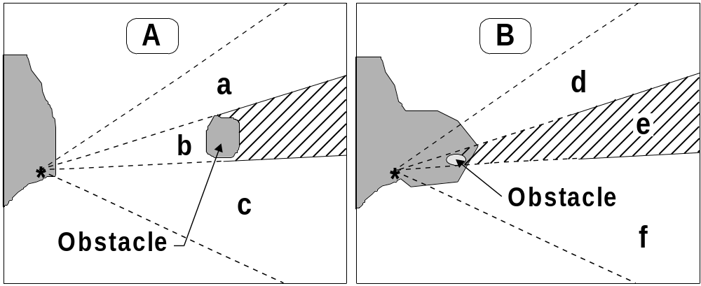
Figure 22 – Obscured light sectors

If an encoded light is obscured in a part of the navigable area of a sector (see Figure 22 - A) beyond an offshore obstruction, it must be encoded as several LIGHTS objects. The partially obscured sector of (b), seaward of the island, must be encoded as a LIGHTS object, with attributes LITVIS = 8 (partially obscured) and INFORM = Sector obscured only beyond .…. The sectors in which the light is visible from seaward ((a) and (c)) must be encoded as separate LIGHTS objects.

If there is no navigable water between the light and the obstacle (see Figure 22 - B), the masked sector must be encoded as a LIGHTS object, with LITVIS = 3 (faint) or 7 (obscured).

12.8.6.3 White fairway sectors (see M4 - §475.5)

The light sectors must be encoded as separate LIGHTS objects. The fairway defined by the succession of navigable areas in the white sectors may be encoded using the object class FAIRWY (see clause 10.4).

12.8.6.4 Leading lights (see M4 - §475.6)

If it is required to encode a leading light, it must be done using a LIGHTS object, with attribute:

CATLIT = 4,12 - front leading light
4,13 - rear leading light
4,14 - lower leading light
4,15 - upper leading light

Remarks:
- The attribute ORIENT must not be used for leading lights, except for directional lights.
- Even if, on the source, the leading lights are merged into a single symbol, at least one LIGHTS object must be created for each light.
- The leading line must be encoded using the method described in clause 10.1.

12.8.6.5 Directional lights (see M4 - §475.7)

If it is required to encode a directional light, it must be done using a LIGHTS object, with attribute CATLIT = 1 (directional function) and, if the light is intensified in this sector, with attribute LITVIS = 4 (intensified).

The attribute ORIENT must be encoded to indicate the orientation, measured from seaward, of the leading line of the directional light.

If it is required to encode the recommended track, it must be done using the method described in clause 10.1.

12.8.6.6 Moiré effect lights (see M4 - §475.8)

If it is required to encode a moiré effect light, it must be done using a LIGHTS object, with attribute CATLIT = 16 (moire effect).

The attribute ORIENT must be encoded to indicate the orientation, measured from seaward, of the leading line of the moiré effect light.

If it is required to encode the recommended track, it must be done using the method described in clause 10.1.

12.8.7 Various special types of lights

Type | M-4 | CATLIT | Remarks
Subsidiary light | 471.8 | 10
Aero light | 476.1 | 5
Air obstruction light | 476.2 | 6
Fog detector light | 477 | 7
Bearing light | 478.1 | 18
Flood light | 478.2 | 8 | Only to encode flood lights that are visible from seaward. The illuminated structure should be encoded using appropriate object classes, with attribute STATUS = 12 (illuminated)
Synchronised lights | 478.3 |  | STATUS =15. Synchronised lights may be associated using the collection object C_ASSO
Strip light | 478.5 | 9
Spot light |  | 11 | Only to encode spot lights that are visible from seaward. The illuminated feature should be encoded using appropriate object classes, with attribute STATUS = 12 (illuminated)
Emergency light |  | 17 | Must be encoded as a separate object to the main LIGHTS object
Horizontally disposed lights | 471.8 | 19 | The number of lights must be encoded using attribute MLTYLT
Vertically disposed lights | 471.8 | 20 | The number of lights must be encoded using attribute MLTYLT
 |  |  | table 12.5

12.8.8 Light structures

If a light that is on a fixed structure is located in a water area and the structure that supports it is unknown, a PILPNT object with no attributes should also be encoded at the same position as the light. This will ensure that a symbol will be shown on ECDIS systems when the LIGHTS objects are not displayed during daytime navigation.

12.9 Radio stations (see M4 - §480 to §485)

If it is required to encode a radio station, it must be done using the object class RDOSTA.

Geo object: Radio station (RDOSTA)
Attributes: CALSGN CATROS COMCHA DATEND DATSTA ESTRNG NOBJNM
OBJNAM ORIENT PEREND PERSTA SIGFRQ STATUS INFORM
NINFOM

Remarks:
- The RDOSTA must only be used to encode the technical equipment itself, independent of the building or structure in which it is installed. If it is required to encode the building or structure (e.g. mast, tower, radar dome), it must be done using an appropriate object class (e.g. BUISGL, LNDMRK).
- Further information (e.g. transmission characteristic) may be encoded using attribute INFORM or TXTDSC.

12.9.1 Marine and aero-marine radiobeacons (see M4 - §481)

If it is required to encode a marine and aero-marine radiobeacon, it must be done using a RDOSTA object, with attributes:

CATROS - 1 - circular (omni-directional) marine or aero-marine radiobeacon
2 - directional radiobeacon
3 - rotating-pattern radiobeacon
4 - Consol beacon
ORIENT - value of the bearing from seaward. Applies only for CATROS = 2.

Remarks:
- If it is required to encode the bearing line and the recommended track for a directional radiobeacon, it must be done as described in clause 10.1. Where the bearing line coincides with a leading line defined by lights or other visual features making up a range system, navigation lines and recommended tracks must not be duplicated. The objects making up the range system must be aggregated using the collection object C_AGGR (see clause 10.1.2).

12.9.2 Aeronautical radiobeacons (see M4 - §482)

If it is required to encode an aeronautical radio beacon, it must be done using a RDOSTA object, with attribute CATROS = 7 (aeronautical radiobeacon). The identification signal may be encoded using the attribute CALSGN.

12.9.3 Radio direction-finding stations (see M4 - §483)

If it is required to encode a radio direction-finding station, it must be done using a RDOSTA object, with attribute CATROS = 5 (radio direction-finding station). The identification signal may be encoded using the attribute CALSGN.

12.9.4 Coast radio stations providing QTG service (see M4 - §484)

If it is required to encode a coast radio station which provides a QTG service, it must be done using a RDOSTA object, with attribute CATROS = 6 (coast radio station providing QTG service).

12.10 Radar beacons (see M4 - §486)

If it is required to encode a radar beacon, it must be done using the object class RTPBCN.

Geo object: Radar transponder beacon (RTPBCN)
Attributes: CATRTB DATEND DATSTA NOBJNM OBJNAM RADWAL SECTR1 SECTR2
SIGGRP - morse identification letter(s)
SIGSEQ STATUS VALMXR INFORM NINFOM

Remarks:
- The RTPBCN must only be used to encode the technical equipment itself, independent of the building or structure in which it is installed. If it is required to encode the building or structure (e.g. mast, tower, radar dome), it must be done using an appropriate object class (e.g. BUISGL, LNDMRK).
- If it is required to encode the bearing line and the recommended track for leading racons, it must be done as described in clause 10.1. Where the bearing line coincides with a leading line defined by lights or other visual features making up a range system, navigation lines and recommended tracks must not be duplicated. The objects making up the range system must be aggregated using the collection object C_AGGR (see clause 10.1.2).
- The sweep period may be encoded using the attribute INFORM.

12.11 Radar surveillance systems (see M4 - §487)

If it is required to encode a radar surveillance system, it must be done using the object classes RADRNG, RADLNE and RADSTA.

12.11.1 Radar ranges (see M4 - §487.1)

If it is required to encode a radar range, it must be done using the object class RADRNG.

Geo object: Radar range (RADRNG)
Attributes: COMCHA DATEND DATSTA NOBJNM OBJNAM STATUS INFORM
NINFOM

Remarks:
- RADRNG objects must be of type area.

12.11.2 Radar reference lines (see M4 - §487.2)

If it is required to encode a radar reference line, it must be done using the object class RADLNE.

Geo object: Radar line (RADLNE)
Attributes: NOBJNM OBJNAM
ORIENT - value of the bearing from seaward
STATUS INFORM NINFOM

12.11.3 Radar station (see M4 - §487.3)

If it is required to encode a radar station, it must be done using the object class RADSTA.

Geo object: Radar station (RADSTA)
Attributes: CATRAS COMCHA DATEND DATSTA
HEIGHT - height of the emitting part of the radar
NOBJNM OBJNAM STATUS VERACC VALMXR VERDAT INFORM NINFOM

Remarks:
- The RADSTA must only be used to encode the technical equipment itself, independent of the building or structure in which it is installed. If it is required to encode the building or structure (e.g. mast, tower, radar dome) it must be done using an appropriate object class (e.g. BUISGL, LNDMRK).

12.12 Radar conspicuous objects (see M4 - §485.2)

The attribute CONRAD (conspicuous, radar) is used to encode whether or not an object is radar conspicuous.

Remarks:
- If it is required to encode an object which has no radar reflector, but is radar conspicuous, it must be indicated using attribute CONRAD = 1 (radar conspicuous) on the object.
- If it is required to encode an area or point object which is radar conspicuous because it is fitted with a radar reflector, it must be indicated using CONRAD = 3 (radar conspicuous (has radar reflector)) on the object.
- If it is required to encode radar reflectors on line objects (e.g. overhead cables), this must be done using the object class RADRFL.

Geo object: Radar reflector (RADRFL)
Attributes: HEIGHT STATUS VERACC VERDAT INFORM NINFOM

12.13 Radio reporting (calling-in) points (see M4 - §488)

If it is required to encode a radio reporting point or line, it must be done using the object class RDOCAL.

Geo object: Radio calling-in point (RDOCAL)
Attributes: COMCHA DATEND DATSTA NOBJNM
OBJNAM - e.g. alphanumeric designator
ORIENT - orientation of the traffic flow at that point
PEREND PERSTA STATUS TRAFIC
INFORM - notes; for example, if the requirement to report by radio relates to certain classes of vessels only. The attribute TXTDSC may be used instead of INFORM, or for longer explanations or notes

NINFOM

Remarks:
- Each RDOCAL object must only carry one orientation. If it is required to encode the reciprocal orientation, to indicate that a bearing and its opposite apply to a RDOCAL object, it must be done using attribute TRAFIC = 4 (two-way). If the same position is used for another orientation (not opposite) of traffic flow, an additional RDOCAL object must be created.
- RDOCAL objects of type line should be digitised such that the traffic direction that is required to report is to the right.

13. Marine services and signal stations

13.1 Pilot stations (see M4 - §491)

13.1.1 Pilot stations ashore (see M4 - §491.3 and 491.4)

If it is required to encode a pilot station, it must be done using a BUISGL or LNDMRK object, with attribute FUNCTN = 11 (pilot office) or 12 (pilot lookout).

13.1.2 Pilot boarding places (see M4 - §491.2)

If it is required to encode a pilot boarding place, it must be done using the object class PILBOP.

Geo object: Pilot boarding place (PILBOP)
Attributes: CATPIL COMCHA DATEND DATSTA NOBJNM NPLDST OBJNAM PEREND PERSTA PILDST STATUS INFORM NINFOM

13.2 Coastguard stations (see M4 - §492)

If it is required to encode a coastguard station, it must be done using the object class CGUSTA.

Geo object: Coastguard station (CGUSTA)
Attributes: DATEND DATSTA NOBJNM OBJNAM PEREND PERSTA STATUS
INFORM NINFOM

Remarks:
- The CGUSTA must only be used to describe the function of the coastguard station, independent of the building or structure itself. If it is required to encode the building or structure in which the coastguard station operates, it must be done using an appropriate object class (e.g. BUISGL, LNDMRK).

13.3 Rescue stations (see M4 - §493)

If it is required to encode a rescue station, it must be done using the object class RSCSTA.

Geo object: Rescue station (RSCSTA)
Attributes: CATRSC DATEND DATSTA NOBJNM OBJNAM PEREND PERSTA STATUS INFORM NINFOM

Remarks

- The RSCSTA must only be used to describe the function of the rescue station, independent of the building or structure itself. If it is required to encode the building or structure housing the service, it must be done using an appropriate object class (e.g. BUISGL, LNDMRK).
- If it is required to encode a refuge beacon, it must be done using a BCNSPP object, with attribute CATSPM = 44 (refuge beacon), not by using RSCSTA.

13.4 Signal stations (see M4 - §494 to §497)

If it is required to encode a signal station, it must be done using traffic signal stations or warning signal stations.

Geo object: Signal station, traffic (SISTAT)
Attributes: CATSIT COMCHA DATEND DATSTA NOBJNM OBJNAM PEREND PERSTA STATUS INFORM NINFOM

Remarks:
- If it is required to encode a bridge light marking the centre of a navigable span, it must be done using the object class LIGHTS.
- The SISTAT must only be used to describe the function of the signal station, independent of the building or structure itself. If it is required to encode the building or structure housing the service, it must be done using an appropriate object class (e.g. BUISGL, LNDMRK).

Geo object: Signal station, warning (SISTAW)
Attributes: CATSIW COMCHA DATEND DATSTA NOBJNM OBJNAM
PEREND PERSTA STATUS INFORM NINFOM

Remarks:
- The SISTAW must only be used to describe the function of the signal station, independent of the building or structure itself. If it is required to encode the building or structure housing the service, it must be done using an appropriate object class (e.g. BUISGL, LNDMRK).

14. Geographic names

If it is required to encode an international or national geographic name, it must be done using attributes OBJNAM and NOBJNM as described in the ENC Product Specification (S-57 Appendix B.1), clause 3.11. The use of the cartographic object $TEXTS is prohibited.

When possible, existing objects (e.g. BUAARE, RIVERS, navigational marks) should be used to carry this information.

If it is required to encode a geographic name for which there is no existing object, a specific ADMARE, SEAARE or LNDRGN object must be created (see clauses 4.7.1 and 8). In order to minimise the data volume, these objects should, where possible, use the geometry of existing objects, e.g. a SEAARE object may use the geometry of a DEPARE object.

Geographic names should be encoded using OBJNAM based on the following criteria and at the producing authority’s discretion:

- Named points or capes that do not contain navigational aids should be encoded as LNDRGN objects (of type area or point), with the geographic name encoded using OBJNAM.

- Named points or capes that contain one navigational aid should be encoded using OBJNAM on the master object associated with the navigational aid. If more than one navigational aid exists on the point or cape, a LNDRGN object (of type area or point) should be encoded, with the geographic name encoded using OBJNAM .

- A group of hydrographic objects (e.g. SBDARE, UWTROC, OBSTRN), associated with a particular geographic name, should have the name encoded using OBJNAM on a SEAARE object (of type area or point). The name should not be encoded on the individual hydrographic objects.

- A major island name close to primary shipping corridors should be encoded using OBJNAM on the LNDARE object delimiting the island. A group of islands associated with a geographic name should have the name encoded using OBJNAM on a LNDRGN object (of type area or point), or a collection object C_ASSO.

- Named features listed in HOs’ Sailing Directions that may assist in navigation should be encoded using OBJNAM on the relevant object (e.g. LNDRGN, UWTROC, SBDARE, SEAARE, OBSTRN).

- If it is required to encode an administrative area of international, national, provincial or municipal jurisdiction that may have legal inference, it must be done using an ADMARE object, with the name encoded using OBJNAM.

- If it is required to encode a major city along the coast, it must be done using BUAARE or ADMARE objects (see clause 4.8.14), with the name encoded using OBJNAM.

- If it is required to encode the name of a navigable river, lake or canal, it must be done using a SEAARE object, with the name encoded using OBJNAM.

In all instances, if the exact extent of the feature to be named is known, an area object must be created. If the exact extent is not known, an existing or specifically encoded point object should be used to encode the geographic name.

15. Collection objects

If it is required to identify an aggregation or association between two or more objects, it must be done using the object classes C_AGGR or C_ASSO.

Collection object: Aggregation (C_AGGR)
Attributes: NOBJNM OBJNAM INFORM NINFOM

C_AGGR objects should be used to encode the link between objects that are functionally related and which together form a higher level entity. For example, a navigation line, a recommended track and the defining navigational aids should be linked using a C_AGGR object to form a range system.

Collection object: Association (C_ASSO)
Attributes: NOBJNM OBJNAM INFORM NINFOM

C_ASSO objects should be used to encode the association between two or more objects. The association does not create any higher level entity. For example, a wreck should be associated with the buoy that marks it.

The following table shows the most common examples of the application of collection objects. Other applications for collection objects are possible.

Relationships | FFPT field | collection object | comment
Mooring trots | peer * | C_AGGR | see 9.2.5
Measured distances | peer * | C_AGGR | see 10.1.3
Traffic Separation Schemes systems | peer * | C_AGGR | see 10.2.3
Navigation lines and tracks | peer * | C_AGGR | see 10.1.2
Navigation lines, tracks and dangers | peer * | C_ASSO | see 10.1.2 **
Synchronised lights | peer * | C_ASSO | see 12.8.7
Airfield, airport, (runway, control etc.) | peer * | C_ASSO | see 4.8.12
Tide, tidal stream (non-harmonic prediction – time series or harmonic prediction) | peer * | C_ASSO | see 3.2.3, 3.3.3 and 3.3.4
Anchorage | peer * | C_ASSO | see 9.2.6
Fairway | peer * | C_ASSO/C_AGGR | see 10.4
Radar beacon | peer * | C_AGGR | see 12.10
 |  |  | table 15.1

* Relationships defined using collection objects are assumed to be peer to peer. The RIND subfield of the collection feature record must be “peer” (see ENC Product Specification, clause 3.9)

** Such a C_ASSO object must not be used to link the individual elements of the navigation lines and tracks, but should be used to show the relationship between the navigation lines and tracks and the associated dangers.

Relationships may be hierarchical.

If a collection object extends beyond a cell boundary (i.e. the objects that makes up the collection are spread over multiple cells), the collection object should be repeated in each cell that contains one or more component objects. However, only the objects that exist in the cell that contains the instance of the collection object can be referenced by that collection object. If this technique is used, each instance of the original collection object must have the same feature identifier (LNAM). It is up to the application (e.g. the ECDIS) that uses the cells to rebuild the complete collection object based on the unique feature identifier.

It is highly recommended that no use be made of pointers that reference objects outside the cell in which the pointer is encoded. Use of such pointers cannot be prohibited, as no such rule exists in the ENC Product Specification.

__________

Page intentionally left blank
ALPHABETICAL INDEX

A
Accuracy 3, 5
Horizontal 5
Vertical 6
ACHARE 50, 51, 59, 66
ACHBRT 50, 51
ADMARE 26, 60, 82
Aids to navigation 67
AIRARE 1, 25
Airfields 25
Airport 25
Altitude of beacons 31, 69
Anchor berths 50
Anchorage
Relationship 51
Anchorages 50
Prohibited 50
Anchoring restricted 51
Aquaculture areas 65
Areas
Administrative harbour 50
Aquaculture 65
Built-up 26
Cable 62
Cargo transhipment 67
Continual change 41
Depth 33, 35, 37, 38
Dredged 39, 40
Exercise 61
Foul 44, 45
Free port 60
Ice 67
Inadequate depth information 41
Incineration 67
Incompletely surveyed 42
Intertidal 49
Land 12
Maritime jurisdiction 60
Military practice 61
Offshore production 65
Pipeline 63, 64
Precautionary 56
Regulated 59
Restricted 59
Sea 49
Seaplane landing 25, 66
Swept 41
To be avoided 58
Unsafe navigation 46
Unsurveyed 41
Wrecks, foul areas and obstructions 44
Areas to be avoided 58
Articulated loading platform (ALP) 65
Articulated towers 65
B
Bank Office 27
Baselines 60, 61
Basins 12, 40
Tidal & non-tidal 17
BCNCAR 67, 69
BCNISD 67, 69
BCNLAT 67, 69, 70
BCNSAW 67, 69
BCNSPP 31, 54, 67, 69, 70, 81
Beacons 69
buoyant 70
clearing line 70
consol 77
lattice 70
leading 70
measured distance 70
radar transponder 78
refuge 81
Berths 15
BERTHS 15, 51
Bollard 18
bottom quality See Seabed
Boulder on land 29
BOYCAR 67, 71
BOYINB 65, 67, 71
BOYISD 67, 71
BOYLAT 67, 71
BOYSAW 67, 71
BOYSPP 31, 67, 71, 72
Breakers 46
Breakwater (floating) 19
Bridge
lights 81
supports 25
water under 25
BRIDGE 25, 67
Bridges 25
BUAARE 26, 82
Buddhist Temple 27
Buildings
Bank Office 27
Buddhist Temple 27
Bus Station 27
Church 27
Custom Office 15, 27
Dockside 19
Factory 26
Health Office 15, 28
House 28
Landmarks 26
Marabout 28
Mosque 28
Pagoda 28
Pilot Lookout 28, 79
Pilot Office 15, 28, 79
Police Station 28
Post Office 28
Power Station 26, 28
Railway Station 29
Silos 26
Tanks 26
Transit Shed 29
Transit sheds/warehouses 19
Warehouse 29
Built-up areas 26
BUISGL 15, 19, 23, 25, 26, 27, 28, 29,
67, 70, 79, 80, 81
Buoyage system See Buoys 51, 71
Direction of buoyage 68
Mooring 51
navigation, communication and control buoy (NCCB) 65
Spoil ground 71
Bus Station 27
C
C_AGGR 51, 53, 54, 57, 59, 77, 78, 82
C_ASSO 11, 12, 25, 51, 53, 59, 68, 76, 82, 83
Cable areas 62
Cables
Areas 62
Disused 62
Overhead 62
Submarine 62
Telepheric 63
Cairn 69, 70
Canal banks 14, 23
Canals 12, 23, 40
Navigable 23
CANALS 23, 37, 40
CANBNK 23, 40
Cargo transhipment areas 67
Cartographic framework 1
Causeways 24
CAUSWY 24
Caution Area 47
Caution note 41, 59
CBLARE 59, 63
CBLOHD 62
CBLSUB 51, 62
CGUSTA 80
Checkpoints 16
CHKPNT 16
Church 27
Dome 27
Spire 27
Tower 27
Clearing line 52
Cliff contour 33
Cliffs 21, 23
Clock Tower 27
COALNE 14, 17, 20, 21, 22, 23, 40, 43, 49
Coast radio stations (QTG service) 77
Coastguard stations 67, 80
Coastline 14
Artificial 14
Cliff 21
Natural 14
Unsurveyed 14
Collection objects 82
Colours 7
Compilation scale 6
CONRAD 67, 79
Contiguous zone 61
Continental shelf 61
Continual change areas 41
Control 13
Control Tower 25, 27, 82
Conveyors 25
CONVYR 25, 63
CONZNE 61
Cooling Tower 27
COSARE 61
Crane
jib 19
Travelling 19
Cranes 19
CRANES 26
Cribs 45, 63
Cross, Calvary 27
CTNARE 8, 15, 41, 42, 47, 59, 67
CTRPNT 13
CTSARE 67
Cupola 27
CURENT 12
Currents 12
Custom Office 15, 27
Custom zones 60
CUSZNE 60
Cuttings and embankments 23
D
DAMCON 24
Dams 24
Danger line 46
Around point 46
Around rock 44
Limiting wreck area or obstructions 46
Unsafe area 46
Dangers 43
Doubtful 47
Data
Bathymetric 3, 4
Bathymetric source 6
Other source 6
Source 6
Data quality 3
Dates 3
Datum
Horizontal 1
Sounding 2, 32
Vertical 2, 13
DAYMAR 31, 67, 70
Daymarks 70
Deep water route 56
Centerline 56
Part 56
Degaussing ranges 66
DEPARE 2, 15, 17, 21, 22, 23, 24, 33,
34, 35, 36, 37, 38, 39, 40, 41, 42, 44,
45, 46, 49, 56, 82
DEPCNT 2, 25, 32, 34, 41, 49
Depth 2, 3, 32, 33, 34, 35, 37, 38
Contours 2, 32
swept 41
Swept 4
Units 41
Unknown 43
Depth areas 33, 35, 37, 38
Adjoining constructions 38
Adjoining dredged areas 38
Adjoining non-navigable water 37
Always dry 38
DRVAL1 & DRVAL2 34
Geo object 33
Geometry 34
linear depth areas 32
Diffusers 63
Dish Aerial 27
DISMAR 13
Distance marks 13
DMPGRD 59, 62, 65
DOCARE 17, 37, 40
Docks 16
Dry 16
Floating 16
Dolphin 18
Dome 27
Dredged areas 39, 40
Adjoining dredged areas 39
Date of dredging 40
depth maintained 40
Spoil grounds 65
DRGARE 2, 17, 21, 22, 23, 33, 34, 40,
41, 42, 59
DRYDOC 16, 19
Drying
Areas 34
Contours 32
Height 34
Rocky areas 32
Dumping grounds 62
Dunes, sand hills 20
DWRTCL 54, 56, 57
DWRTPT 54, 56, 57, 59
DYKCON 24
Dykes 24
E
Eddies 46
ELEVAT 13
Embankment See Cuttings and embankments
Exclusive economic zone 61
EXEZNE 61
F
Factory 26
Fairway 58
FAIRWY 58, 59, 75
Features
Artificial 23
Natural 20
Fences and walls 30
Ferries 58
FERYRT 58
Firing range 61
Fish havens 45, 66
Fishery zone 61
Fishing equipment 65
Fishing facilities 65
Fishing ground 66
Fixed structures 69
Flagpole 27
Flagstaff 27
Flare Stack 27, 65
Flare stacks 65
Floating production, storage and off-loading vessel (FPSO) 65
Floating structures 71
FLODOC 16, 33, 34, 42
Flood barrages 24
FNCLNE 26, 30
Fog signals 72
FOGSIG 67, 72
FORSTC 30
Fortified structures 30
Foul areas 44, 45
Foul ground 45
Free port area 60
FRPARE 60
FSHFAC 65
FSHGRD 66
FSHZNE 61
G
GATCON 17, 18, 24
Gates 17
Geographic names 82
Glaciers 22
Grain Elevator 28
Gridiron 18
GRIDRN 18
Ground tackle 45, 51
Groynes 15
H
Harbour
Administrative areas 50
Facilities 15
Installations 15
Offices 15
Regulations 50
Regulations within limits 50
Health Office 15, 28
Height
Contours, spot heights 20
Units 3
Heights and elevations 13
House 28
HRBARE 50
HRBFAC 15
HULKES 19, 33, 34, 42
Hulks 19
I
Ice areas 67
ICEARE 22, 67
ICNARE 59, 67
Inadequate depth information areas 41
Incineration areas 67
Incompletely surveyed areas 42
International maritime boundaries 60
Intertidal Areas 49
ISTZNE 54, 56, 57, 59
J
Junction cables 51
L
LAKARE 22, 40
Lakes 12, 22, 40
LAKSHR 22, 40
Land area 12
Landing place 15
Landmarks
Cairn 69, 70
Church Dome 27
Church Spire 27
Church Tower 27
Clock Tower 27
Control Tower 25, 27, 82
Cooling Tower 27
Cross, Calvary 27
Cupola 27
Dish Aerial 27
Dome 27
Flagstaff 27
Lookout Station 28
Lookout Tower 28
Mast 27, 28, 44, 45, 79
Memorial Plaque 28
Microwave Tower 28
Minaret 28
Monument 28
Mooring Mast 28
Obelisk 28
Observation Tower 28
Radar Dome 28, 79
Radar Tower 28
Radio
Tower 29
Radio Mast 28
Shinto Shrine 29
Spire 29
Television Mast 29
Television Tower 29
Timeball Tower 29
Tower 27, 28, 29, 70, 78, 79, 80
Tree 22
Windmill 29
Landmarks: 27, 28, 65
Lava 22
Light float 72
Light vessel 72
Lighthouses 67, 70
Lights 73, 74, 75
Aero 76
Air obstruction 76
Bearing 76
Daytime 74
Description 73
Directional 76
Elevation 73
Emergency 76
Flood 76
Fog 74
Fog detector 76
Horizontally disposed 76
Leading 75
Moiré effect 76
Night 73
Obscured by obstructions 75
Obscured sectors 74
Occasional 74
Rhythm 73
Sector 74
Special 76
Spot 76
Strip 76
Structures 76
Time of exhibition 73
Types and functions 73
Unwatched 74
White fairway sectors 75
LIGHTS 67, 68, 73, 74, 75, 76, 81
Lines
Leading 52
Navigation 52, 53, 77, 78, 83
Recommended track 52
Transit 52
LITFLT 67, 72
LITVES 67, 72
LNDARE 12, 14, 15, 16, 18, 19, 21, 22,
23, 24, 30, 33, 34, 37, 40, 42, 43
LNDELV 20, 21, 43, 45
LNDMRK 25, 26, 27, 28, 29, 65, 67,
70, 79, 80, 81
LNDRGN 12, 20, 22, 49, 82
Locks 17
LOCMAG 10
Log ponds 67
LOGPON 67
LOKBSN 17, 18, 19, 40
Lookout Station 28
Lookout Tower 28
M
M_ACCY 5
M_CSCL 6
M_HDAT 1
M_HOPA 2
M_NPUB 8
M_NSYS 31, 68, 69, 71, 72
M_PROD 3
M_QUAL 2, 4, 5, 40, 41, 42, 43, 44, 45
M_SDAT 2, 17
M_SREL 4, 5, 6, 42
M_UNIT 3
M_VDAT 2, 73
Magnetic data 9
Magnetic variation 9
MAGVAR 9
Mangrove 12
Marabout 28
MARCUL 59, 66
Marine farms 66
Marine nature reserves 67
Marine services 79
Maritime areas
Various 67
Maritime jurisdiction areas 60
Marsh 20
Masked line 15, 37, 50
Mast 27, 28, 44, 45, 79
Measured distance 54
Memorial Plaque 28
Microwave Tower 28
Military practice areas 61
Minaret 28
Minefields 61, 62
MIPARE 59, 61
Mole 14
Monument 28
Mooring 50
Buoys 51
Small craft 50
Trots 51
Mooring / warping facilities 18
Mooring Mast 28
MORFAC 18, 51, 67, 71
Mosque 28
N
National territory 60
Natural sceneries 20
navigable 12, 14
Navigation Lines 77, 78, 83
Navigational marks 67
NAVLNE 52, 53, 54
O
Obelisk 28
Observation Tower 28
OBSTRN 2, 18, 44, 45, 46, 48, 51,
53, 63, 64, 66
Obstructions 44, 45, 46, 75
Offshore platforms 64
Offshore production areas 65
Offshore tanker loading systems 65
OFSPLF 64, 65, 67
Oil and gas fields 64
Oil barriers 30
OILBAR 30
OSPARE 59, 65
Overfalls 46
P
Pagoda 28
Picture files 30
PILBOP 80
Piles 18
Pilot boarding places 80
Pilot Lookout 28, 79
Pilot Office 15, 28, 79
Pilot stations 79
Ashore 79
PILPNT 18, 67, 73, 76
PIPARE 59, 64
Pipeline areas 64
Pipelines
Areas 63, 64
Disused 63
Land 63
Overhead 64
Submarine 63
PIPOHD 64
PIPSOL 19, 63
Planned construction 20, 62, 63, 64
Police Station 28
PONTON 18, 19, 33, 34, 42
Pontoons 18
Position
Quality 5
Post Office 28
Power Station 26, 28
PRCARE 54, 56, 57, 59
PRDARE 19, 26
Precautionary area 56
Production areas 26
Production information 3
PYLONS 25, 30
Pylons and bridge supports 30
Q
QTG service 77
R
Races 46
Radar 28, 78, 79, 82
Beacons 78
Conspicuous object 79
Range 78
Reference lines 78
Reflector 63
Station 78
Surveillance systems 78
transponder beacons See Beacons: radar transponder
Radar Dome 28, 79
Radar Tower 28
Radio
Calling-in points 79
direction-finding stations 77
Mast 28
Reporting points 79
stations 77
Tower 29
Radiobeacons
Aeronautical 77
circular 77
Directional 77
Marine and aero-marine 77
RADLNE 78
RADRFL 63, 79
RADRNG 78
RADSTA 67, 78, 79
Railway Station 23, 29
Railways 23
RAILWY 19, 23
Range systems
Relationship 53
Rapids 21
RAPIDS 21
RCRTCL 57
RCTLPT 57
RDOCAL 79
RDOSTA 67, 77
Recommended direction of traffic flow 57
Recommended routes 57
Recommended tracks and routes 52
RECTRC 52, 53
Refinery 26
Regulated areas 59
Relationship 52, 54, 68, 83
Anchorage 51
Lighthouses 67
RESARE 50, 51, 58, 59, 62, 65, 66, 67
Rescue stations 67, 80
Restricted areas 59, 66
RETRFL 67, 72
Retro-reflectors 72
RIVBNK 21, 40
River bank 14, 21
Rivers 12, 21, 40
RIVERS 21, 37, 40, 82
Roads and tracks 24
ROADWY 24
Rocks
Do not cover 43
May cover 43
Rocks and reefs 43
Routeing measures 54
Routes
Deep water 56
Recommended 57
Routing measures 54
Two-way 58
RSCSTA 80, 81
RTPBCN 67, 78
Ruin 29
RUNWAY 25
S
Safety zones 65
Saltpans 22
Sand waves 41, 48
SBDARE 48
SCAMIN 6
Sea areas 49
SEAARE 17, 20, 21, 22, 23, 40, 49, 82
Seabed
Description of bottom 48
Nature 48
Special bottom types 48
Seaplane landing areas 25, 66
Seasonal Objects 3
Sector Lights 73
Settlement 26
Shoreline Construction 35
Sign 31
Signal stations 79
SILTNK 26, 27, 28, 29
SISTAT 67, 81
SISTAW 67, 81
slag heap 26
SLCONS 14, 15, 17, 19, 20, 21, 22, 23,
24, 40, 43, 67
SLOGRD 20, 21, 23
SLOTOP 21, 23, 24
Small craft facilities 16
SMCFAC 16
SNDWAV 41, 48
SOUNDG 2, 32, 41, 45
Soundings 32, 45
Accuracy 5
Drying 33
Enclosed by danger line 46
Existence doubtful 32
Geometry 33
out of position 33
Quality 5
Technique 5
Speed limits 50
Spire 29
SPLARE 25, 59, 66
Spoil ground 62
Spoil grounds 65
Spot Heights 2, 20
SPRING 49
Springs in seabed 49
SQUARE 26
Stockpile 26
STSLNE 61
Submarine
Cable Areas 63
Cables See Submarine Cables
Pipeline 63
Transit lanes 62
SUBTLN 59, 62
Survey reliability 5
Swept areas 41
Swinging circle 51
SWPARE 41
T
T_HMON 10, 11
T_NHMN 11
T_TIMS 10, 11
Tank 27
Farm 26
Tanker loading buoys 65
Television Mast 29
Television Tower 29
Territorial sea 60, 61
TESARE 59, 61
Text 7
Tides
Data 10
Harmonic 10, 11
Non-harmonic 11, 12
Stream (flood/ebb) 11
Stream data 11
Stream panels 12
Stream time series 11
Time series data 10, 11
Tideway 49
TIDEWY 49
Timber yards 19, 26
Time varying objects 9
Timeball Tower 29
TOPMAR 67, 72
Topmarks 72
Topography 12
Tower 27, 28, 29, 70, 78, 79, 80
Towers
Church 27
Clock 27
Control 25, 27, 82
Cooling 27
Lookout 28
Microwave 28
Observation 28
Radar 28
Radio 29
Television 29
Timeball 29
Water 29
Town 26
Traffic Separation Scheme 54, 55, 57
Boundaries 55
Crossings 55
Lanes 54
Roundabouts 55
Separation line 55
Separation zone 55
Systems 57
Traffic signal station See
Traffic zone
Inshore 56
Transit Lines See Lines - Transit
Transit Shed 29
TS_FEB 11
TS_PAD 12
TS_PNH 12
TS_PRH 11, 12
TS_TIS 11, 12
TSELNE 54, 55, 57
TSEZNE 54, 55, 57
TSSBND 54, 55, 57
TSSCRS 54, 55, 56, 57, 59
TSSLPT 54, 55, 56, 57, 59
TSSRON 54, 55, 56, 57, 59
TUNNEL 23
Tunnels 23
Two-way routes 58
TWRTPT 58
U
Under construction 19, 62, 63, 64
Undersea features 49
Units 3
UNSARE 22, 33, 34, 35, 37, 40, 41,
42, 45, 46
Unsurveyed areas 41
UWTROC 2, 33, 43, 44, 48, 53
V
VEGATN 22
Vegetation 22
Vertical measurements 13
Views and sketches 30
W
Walls See Fences and walls
Wake, no wake 53
Warehouse 29
Warning signal station 81
Water Tower 29
Waterfalls 21, 22
WATFAL 22
WATTUR 46
WEDKLP 49
Weed - kelp 49
Wellheads 45, 64
Wharf 15
Wind farm 26
Windmill 29
Wrecks 44, 46
Foul areas and obstructions 44
Historic 66
WRECKS 2, 44, 45, 46, 53
Z
Zones
Contiguous 61
Exclusive economic 61
Fishery 61
Safety 65

