ENDSEM PROJECT
HOSPITAL MANAGEMENT SYSTEM
JATIN NASARWAL
BT23CSE200

CREATE DATABASE hospital_db;
USE hospital_db;

-- 1) DEPARTMENT
CREATE TABLE Department (
dept_id INT PRIMARY KEY AUTO_INCREMENT,
dept_name VARCHAR(100),
floor_no INT
);

-- 2) DOCTOR
CREATE TABLE Doctor (
doctor_id INT PRIMARY KEY AUTO_INCREMENT,
name VARCHAR(100),
specialization VARCHAR(100),
contact VARCHAR(20),
dept_id INT,
FOREIGN KEY (dept_id) REFERENCES Department(dept_id)
);

-- 3) PATIENT
CREATE TABLE Patient (
patient_id INT PRIMARY KEY AUTO_INCREMENT,
name VARCHAR(100),
age INT,
gender VARCHAR(10),
contact VARCHAR(20),
address VARCHAR(200)
);

-- 4) APPOINTMENT
CREATE TABLE Appointment (
appointment_id INT PRIMARY KEY AUTO_INCREMENT,
patient_id INT,
doctor_id INT,
appointment_date DATE,
time_slot VARCHAR(20),
FOREIGN KEY (patient_id) REFERENCES Patient(patient_id),
FOREIGN KEY (doctor_id) REFERENCES Doctor(doctor_id)
);

-- 5) TREATMENT
CREATE TABLE Treatment (
treatment_id INT PRIMARY KEY AUTO_INCREMENT,
patient_id INT,
doctor_id INT,
diagnosis VARCHAR(200),
treatment_date DATE,
FOREIGN KEY (patient_id) REFERENCES Patient(patient_id),
FOREIGN KEY (doctor_id) REFERENCES Doctor(doctor_id)
);

-- 6) MEDICINE
CREATE TABLE Medicine (
medicine_id INT PRIMARY KEY AUTO_INCREMENT,
medicine_name VARCHAR(100),
price DECIMAL(10,2)
);

-- 7) PRESCRIPTION
CREATE TABLE Prescription (
prescription_id INT PRIMARY KEY AUTO_INCREMENT,
treatment_id INT,
medicine_id INT,
quantity INT,
FOREIGN KEY (treatment_id) REFERENCES Treatment(treatment_id),
FOREIGN KEY (medicine_id) REFERENCES Medicine(medicine_id)
);

-- 8) BILL
CREATE TABLE Bill (
bill_id INT PRIMARY KEY AUTO_INCREMENT,
patient_id INT,
treatment_id INT,
consultation_fee DECIMAL(10,2),
medicine_cost DECIMAL(10,2),
total_amount DECIMAL(10,2),
payment_date DATE,
payment_mode VARCHAR(20),
FOREIGN KEY (patient_id) REFERENCES Patient(patient_id),
FOREIGN KEY (treatment_id) REFERENCES Treatment(treatment_id)
);

-- 9) WARD
CREATE TABLE Ward (
ward_id INT PRIMARY KEY AUTO_INCREMENT,
ward_name VARCHAR(50),
capacity INT
);

-- 10) ADMISSION
CREATE TABLE Admission (
admission_id INT PRIMARY KEY AUTO_INCREMENT,
patient_id INT,
ward_id INT,
admit_date DATE,
discharge_date DATE,
FOREIGN KEY (patient_id) REFERENCES Patient(patient_id),
FOREIGN KEY (ward_id) REFERENCES Ward(ward_id)
);

-- 11) NURSE
CREATE TABLE Nurse (
nurse_id INT PRIMARY KEY AUTO_INCREMENT,
name VARCHAR(100),
contact VARCHAR(20),
ward_id INT,
FOREIGN KEY (ward_id) REFERENCES Ward(ward_id)
);
INSERT INTO Department (dept_name, floor_no) VALUES
('Cardiology', 2),
('Orthopedics', 3),
('Neurology', 4),
('Pediatrics', 1),
('General Medicine', 1);
INSERT INTO Doctor (name, specialization, contact, dept_id) VALUES
('Dr. Arjun Mehta', 'Cardiologist', '9876543210', 1),
('Dr. Neha Sinha', 'Orthopedic Surgeon', '9988776655', 2),
('Dr. Rakesh Rao', 'Neurologist', '9123456789', 3),
('Dr. Priya Sharma', 'Pediatrician', '9090909090', 4),
('Dr. Karan Kapoor', 'General Physician', '9000000001', 5);
INSERT INTO Patient (name, age, gender, contact, address) VALUES
('Rohan Shah', 45, 'Male', '9001112222', 'Mumbai'),
('Anita Verma', 32, 'Female', '9003334444', 'Delhi'),
('Kunal Patil', 60, 'Male', '9005556666', 'Pune'),
('Pooja Sen', 12, 'Female', '9007778888', 'Kolkata'),
('Vikram Singh', 28, 'Male', '9009991111', 'Bangalore'),
('Sara Khan', 50, 'Female', '9012345678', 'Hyderabad');
INSERT INTO Appointment (patient_id, doctor_id, appointment_date, time_slot) VALUES
(1, 1, '2025-01-10', '10:00 AM'),
(2, 2, '2025-01-11', '11:00 AM'),
(3, 3, '2025-01-12', '02:00 PM'),
(4, 4, '2025-01-13', '12:00 PM'),
(5, 5, '2025-01-14', '03:00 PM'),
(6, 1, '2025-01-15', '01:00 PM'),
(2, 3, '2025-01-16', '04:00 PM'),
(5, 2, '2025-01-17', '09:00 AM');
INSERT INTO Treatment (patient_id, doctor_id, diagnosis, treatment_date) VALUES
(1, 1, 'High Blood Pressure', '2025-01-10'),
(2, 2, 'Knee Pain', '2025-01-11'),
(3, 3, 'Migraine', '2025-01-12'),
(4, 4, 'Flu & Cold', '2025-01-13'),
(5, 5, 'General Checkup', '2025-01-14'),
(6, 1, 'Chest Pain', '2025-01-15'),
(2, 3, 'Nerve Compression', '2025-01-16'),
(5, 2, 'Fracture', '2025-01-17');
INSERT INTO Medicine (medicine_name, price) VALUES
('Paracetamol', 20),
('Aspirin', 30),
('Antibiotics', 100),
('Pain Relief Gel', 80),
('Cough Syrup', 60),
('Blood Pressure Tablet', 90),
('Vitamin Supplements', 150);
INSERT INTO Prescription (treatment_id, medicine_id, quantity) VALUES
(1, 6, 2),
(1, 7, 1),
(2, 4, 1),
(3, 1, 2),
(4, 5, 1),
(5, 7, 1),
(6, 6, 2),
(7, 3, 1),
(8, 4, 2);
INSERT INTO Bill (patient_id, treatment_id, consultation_fee, medicine_cost, total_amount, payment_date, payment_mode)
VALUES
(1, 1, 500, 260, 760, '2025-01-10', 'UPI'),
(2, 2, 600, 80, 680, '2025-01-11', 'Card'),
(3, 3, 700, 40, 740, '2025-01-12', 'Cash'),
(4, 4, 400, 60, 460, '2025-01-13', 'UPI'),
(5, 5, 300, 150, 450, '2025-01-14', 'Cash'),
(6, 6, 550, 260, 810, '2025-01-15', 'UPI'),
(2, 7, 650, 100, 750, '2025-01-16', 'Card'),
(5, 8, 600, 160, 760, '2025-01-17', 'UPI');
INSERT INTO Ward (ward_name, capacity) VALUES
('General Ward', 20),
('ICU', 10),
('Emergency', 15),
('Private Room', 5);
INSERT INTO Admission (patient_id, ward_id, admit_date, discharge_date) VALUES
(1, 2, '2025-02-01', '2025-02-05'),
(3, 1, '2025-02-03', '2025-02-10'),
(4, 4, '2025-02-05', '2025-02-07'),
(6, 3, '2025-02-06', NULL);
INSERT INTO Nurse (name, contact, ward_id) VALUES
('Nurse Lata', '9001234567', 1),
('Nurse Riya', '9002345678', 2),
('Nurse John', '9003456789', 3),
('Nurse Amit', '9004567890', 4);

-- 1. Show all patients
SELECT * FROM Patient;
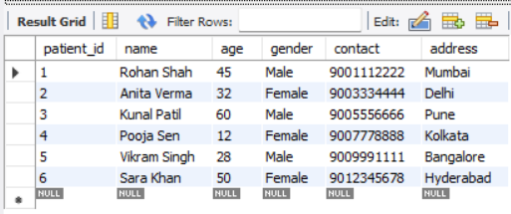

-- 2. List all doctors with their departments
SELECT d.name AS doctor_name, d.specialization, dep.dept_name
FROM Doctor d
JOIN Department dep ON d.dept_id = dep.dept_id;
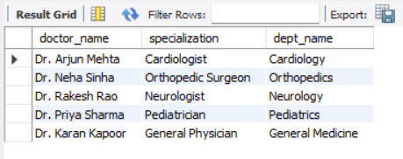
-- 3. Appointments scheduled for a specific date
SELECT a.appointment_id, p.name AS patient, d.name AS doctor, a.time_slot
FROM Appointment a
JOIN Patient p ON a.patient_id = p.patient_id
JOIN Doctor d ON a.doctor_id = d.doctor_id
WHERE a.appointment_date = '2025-01-11';
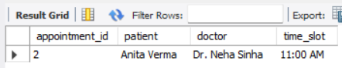
-- 4. List treatments of a particular patient
SELECT t.treatment_id, t.diagnosis, t.treatment_date
FROM Treatment t
JOIN Patient p ON t.patient_id = p.patient_id
WHERE p.name = 'Anita Verma';
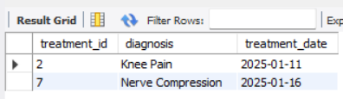
-- 5. Show all medicines with price greater than 50
SELECT * FROM Medicine
WHERE price > 50;
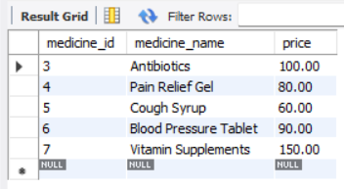

-- 6. Show all patients admitted in ICU
SELECT p.name, a.admit_date, a.discharge_date
FROM Admission a
JOIN Patient p ON a.patient_id = p.patient_id
JOIN Ward w ON a.ward_id = w.ward_id
WHERE w.ward_name = 'ICU';
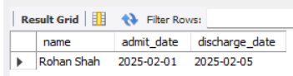
-- 7. List nurses assigned to each ward
SELECT n.name AS nurse_name, w.ward_name
FROM Nurse n
JOIN Ward w ON n.ward_id = w.ward_id;
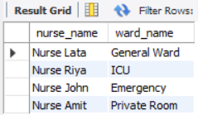

-- 8. Count number of patients treated by each doctor
SELECT d.name AS doctor_name, COUNT(t.treatment_id) AS total_patients
FROM Doctor d
LEFT JOIN Treatment t ON d.doctor_id = t.doctor_id
GROUP BY d.name;
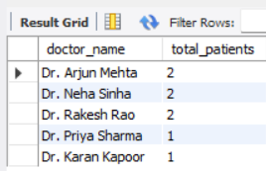
-- 9. Find total revenue generated (sum of all bills)
SELECT SUM(total_amount) AS total_revenue
FROM Bill;
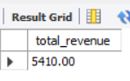

-- 10. Find the patient with the highest bill amount
SELECT p.name, b.total_amount
FROM Bill b
JOIN Patient p ON b.patient_id = p.patient_id
ORDER BY b.total_amount DESC
LIMIT 1;
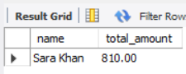

-- 11. Show patients who have NOT been admitted
SELECT p.name
FROM Patient p
LEFT JOIN Admission a ON p.patient_id = a.patient_id
WHERE a.patient_id IS NULL;
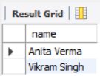

-- 12. List appointments for doctors in the Cardiology department
SELECT p.name AS patient, d.name AS doctor, a.appointment_date
FROM Appointment a
JOIN Doctor d ON a.doctor_id = d.doctor_id
JOIN Patient p ON a.patient_id = p.patient_id
JOIN Department dep ON d.dept_id = dep.dept_id
WHERE dep.dept_name = 'Cardiology';
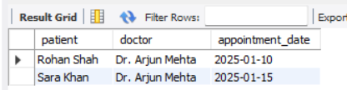

-- 13. Count number of patients in each ward
SELECT w.ward_name, COUNT(a.patient_id) AS total_patients
FROM Ward w
LEFT JOIN Admission a ON w.ward_id = a.ward_id
GROUP BY w.ward_name;
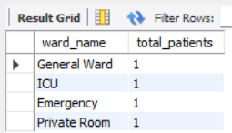
-- 14. Show all prescriptions with medicine names
SELECT pr.prescription_id, m.medicine_name, pr.quantity
FROM Prescription pr
JOIN Medicine m ON pr.medicine_id = m.medicine_id;
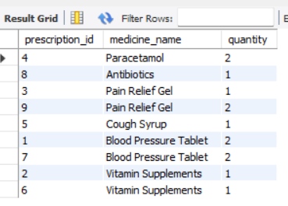

-- 15. List diagnosis given by Dr. Arjun Mehta
SELECT t.diagnosis, t.treatment_date
FROM Treatment t
JOIN Doctor d ON t.doctor_id = d.doctor_id
WHERE d.name = 'Dr. Arjun Mehta';
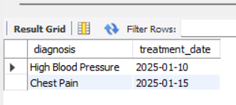

-- 16. Show patient, diagnosis, prescribed medicine, and quantity
SELECT p.name AS patient, t.diagnosis, m.medicine_name, pr.quantity
FROM Prescription pr
JOIN Treatment t ON pr.treatment_id = t.treatment_id
JOIN Patient p ON t.patient_id = p.patient_id
JOIN Medicine m ON pr.medicine_id = m.medicine_id;
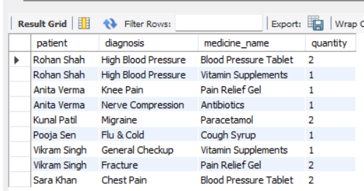

-- 17. Find average consultation fee of all bills
SELECT AVG(consultation_fee) AS avg_consultation_fee
FROM Bill;
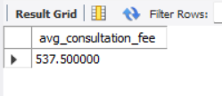
-- 18. Show all doctors who treated more than 1 patient
SELECT d.name, COUNT(t.treatment_id) AS total_treated
FROM Doctor d
JOIN Treatment t ON d.doctor_id = t.doctor_id
GROUP BY d.name
HAVING COUNT(t.treatment_id) > 1;
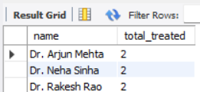

-- 19. Find patients who have taken more than one appointment
SELECT p.name, COUNT(a.appointment_id) AS total_appointments
FROM Patient p
JOIN Appointment a ON p.patient_id = a.patient_id
GROUP BY p.name
HAVING COUNT(a.appointment_id) > 1;
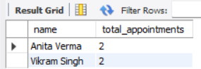

-- 20. Get total medicine cost per treatment
SELECT t.treatment_id, p.name AS patient,
SUM(pr.quantity * m.price) AS total_medicine_cost
FROM Prescription pr
JOIN Treatment t ON pr.treatment_id = t.treatment_id
JOIN Patient p ON t.patient_id = p.patient_id
JOIN Medicine m ON pr.medicine_id = m.medicine_id
GROUP BY t.treatment_id, p.name;

