1: question link :   
<https://leetcode.com/problems/two-sum/description/>

Solution link:  
<https://leetcode.com/problems/two-sum/submissions/1626997898/>

Time Complexity: O(n²) – two nested loops

Space Complexity: O(1) – no extra data structures used

Screenshot:

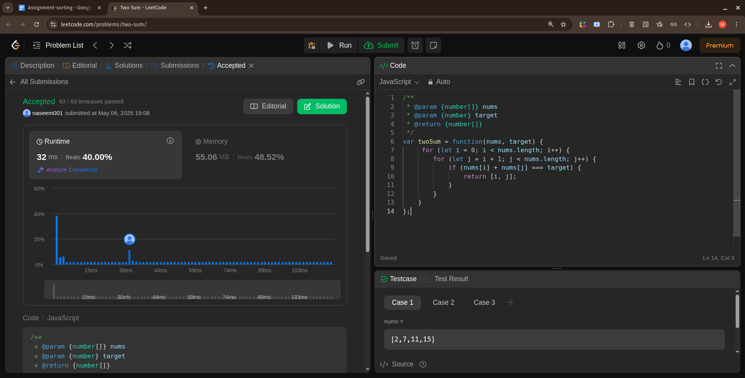

2: question link :

<https://leetcode.com/problems/3sum/description/>

Solution link:

<https://leetcode.com/problems/3sum/submissions/1627027062/>

Time Complexity: O(n²) – two nested loops

Space Complexity: O(1) – (excluding output)

Screenshot:   
  
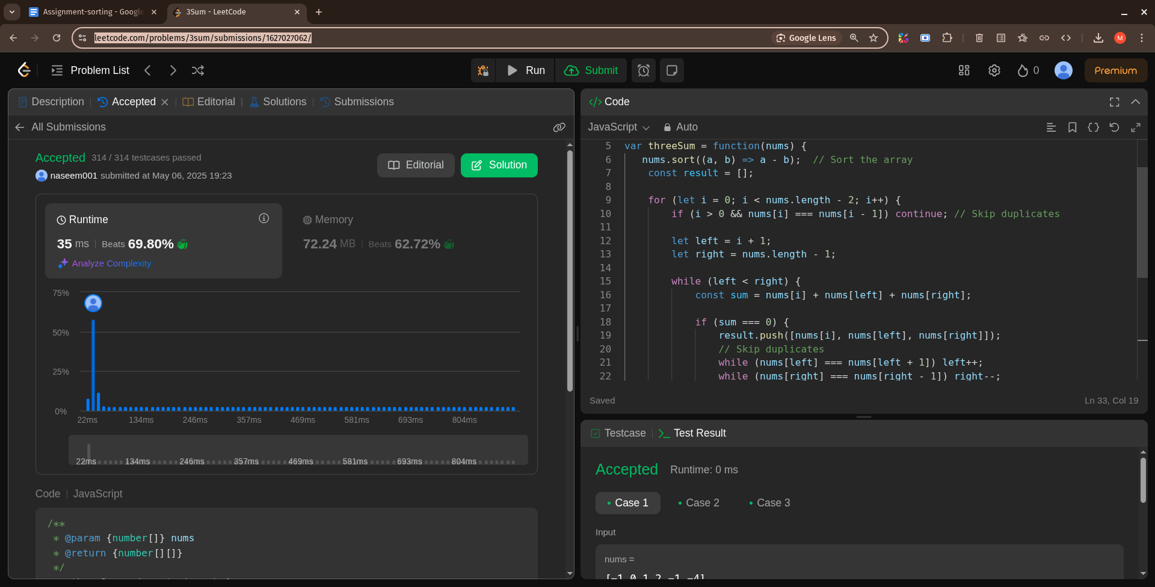  
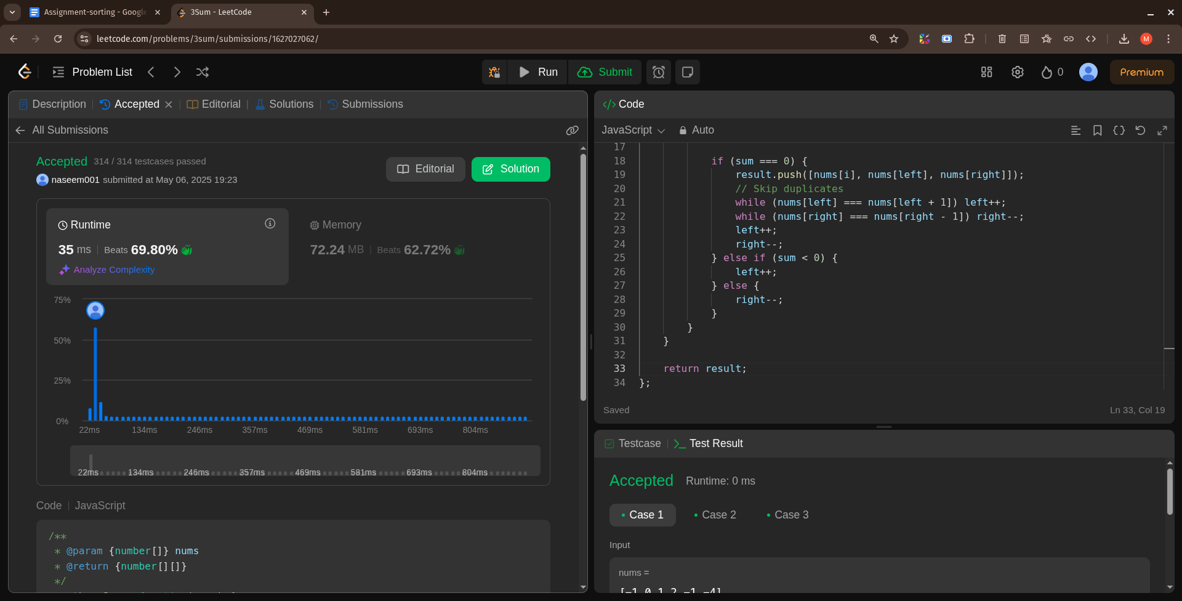

3: question link :

<https://leetcode.com/problems/long-pressed-name/description/>

Solution link:  
<https://leetcode.com/problems/long-pressed-name/submissions/1627030698/>

Time Complexity: O(n + m) - One pass through both strings

Space Complexity: O(n + m)

Screenshot:

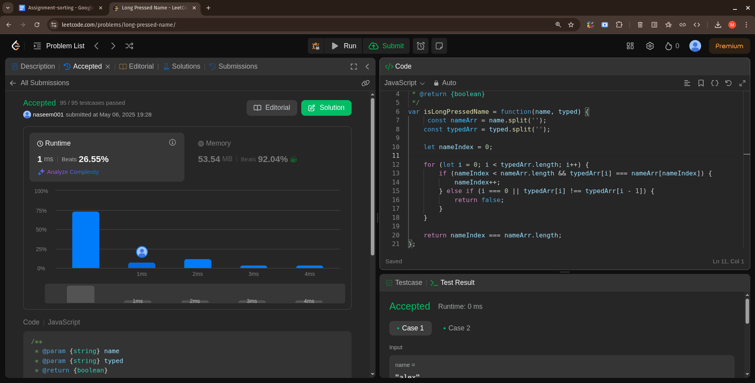

4: question link :

<https://leetcode.com/problems/max-chunks-to-make-sorted/description/>

Solution link:

<https://leetcode.com/problems/max-chunks-to-make-sorted/submissions/1627034481/>

Time Complexity: O(n) Single pass through the array

Space Complexity: O(1) Only variables used, no extra storage

Screenshot:   
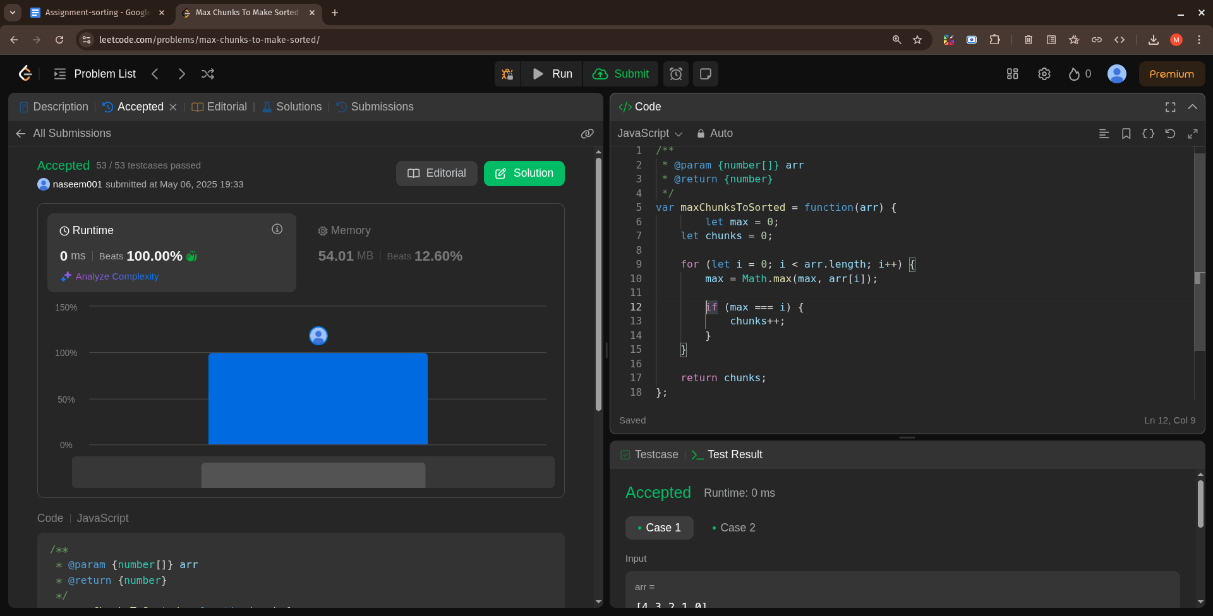

5: question link :

<https://leetcode.com/problems/sort-colors/description/>

Solution link:

<https://leetcode.com/problems/sort-colors/submissions/1627036001/>

Time Complexity: O(n) Single traversal through the array

Space Complexity: O(1) In-place sort; no extra data structures

Screenshot:

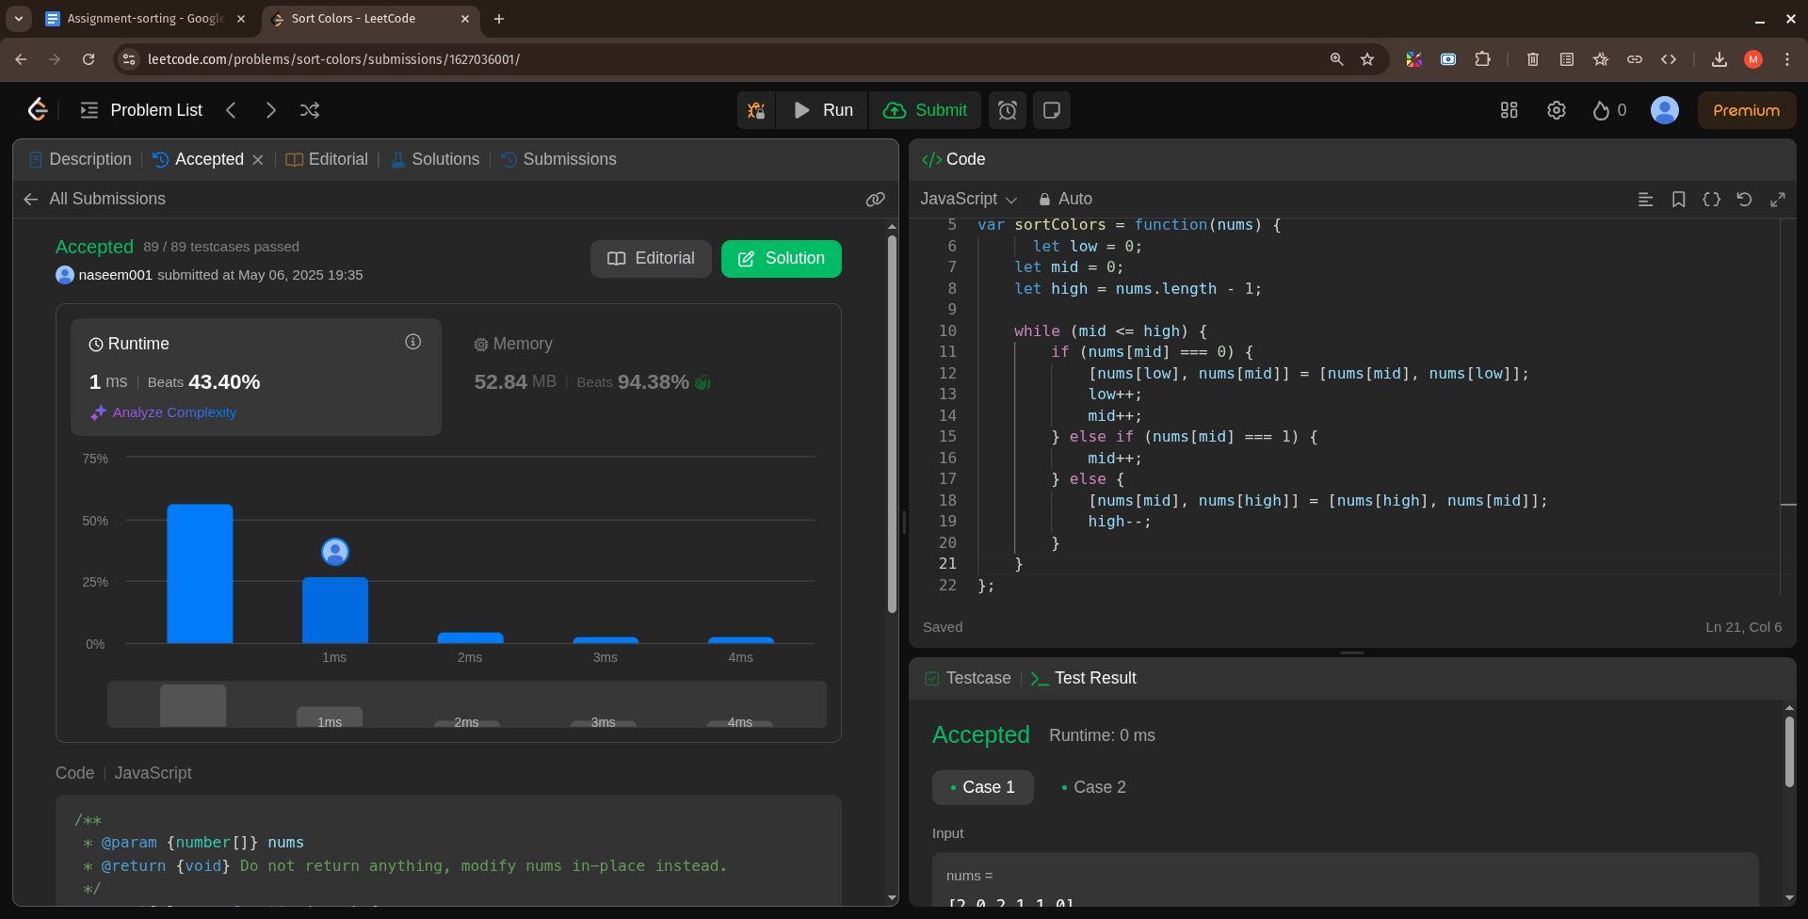

6: question link :

<https://leetcode.com/problems/maximum-subarray/description/>

Solution link:

<https://leetcode.com/problems/maximum-subarray/submissions/1627037573/>

Time Complexity: O(n)

Space Complexity: O(1)

Screenshot:

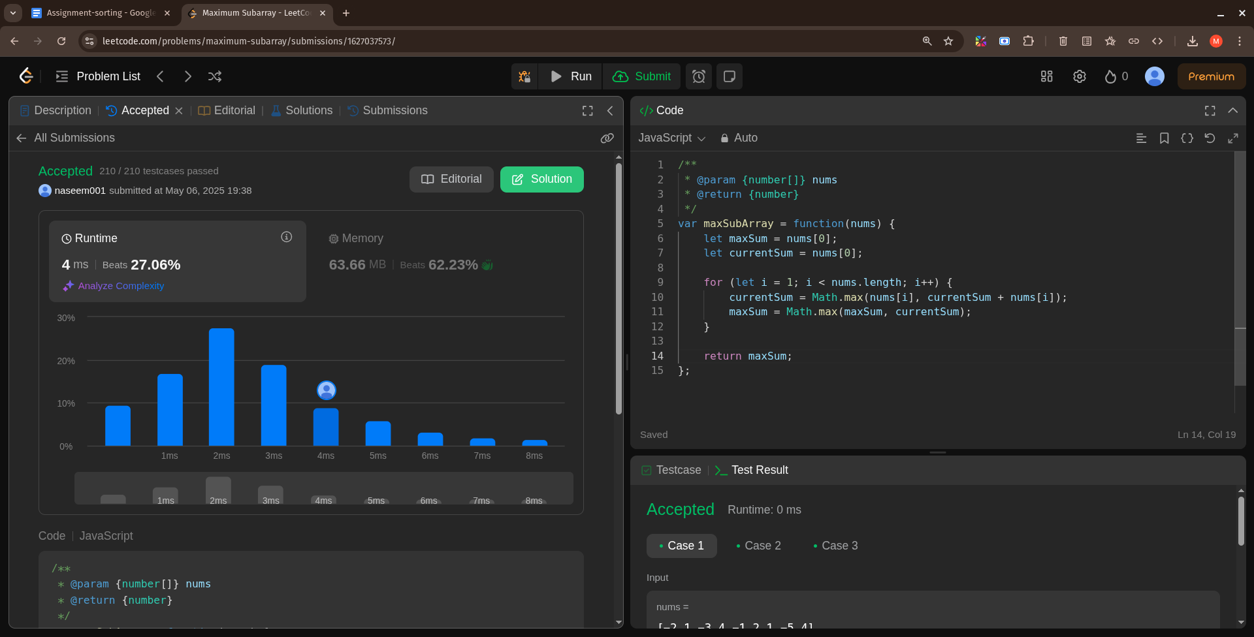

7: question link :

<https://leetcode.com/problems/product-of-array-except-self/description/>

Solution link:

<https://leetcode.com/problems/product-of-array-except-self/submissions/1627039157/>

Time Complexity: O(n) Two passes through the array (n is the length)

Space Complexity: O(1)(excluding output)Constant extra space (ignoring the result array)

Screenshot:

