Project Name:
Retail and Customer Intelligence System
Objective:
Analyze retail sales, customer behavior,
product performance, and regional trends
using Oracle SQL.
Dataset:
Sample Superstore Dataset
Tools:
Oracle SQL Developer
SQL PHASE
Insights:
1. West region generated the highest sales and profit.
2. Canon imageCLASS 2200 Advanced Copier is the highest revenue product.
Day 3 Business Insights
Task 1: Customer Segment Analysis
1. Customer Segment Analysis
Segment | Customers | Sales | Profit
Consumer | 409 | 1,161,401.34 | 134,119.33
Corporate | 236 | 706,146.44 | 91,979.45
Home Office | 148 | 429,653.29 | 60,299.01

Insights
- Consumer segment is the largest customer segment with 409 customers.
- Consumer segment generates the highest sales revenue.
- Consumer segment also contributes the highest profit.
- Home Office segment contributes the lowest sales and profit.
Task 2: Most Profitable Customers
Customer | Profit
Tamara Chand | 8,981.32
Raymond Buch | 6,976.09
Sanjit Chand | 5,757.42
Insights
- Tamara Chand is the most profitable customer.
- The top 10 customers contribute a significant share of company profit.
- These customers can be targeted for loyalty and retention programs.
Task 3: Top 10 States by sales
STATE TOTAL_SALES
-------------------------------------------------- -----------
California 457687.68
New York 310876.2
Texas 170187.98
Washington 138641.29
Pennsylvania 116512.02
Florida 89473.73
Illinois 80166.16
Ohio 78258.21
Michigan 76269.61
Virginia 70636.72

10 rows selected.
Insights
- California is the highest revenue-generating state, contributing nearly ₹457K in sales.
- New York is the second-largest market.
- California and New York together contribute a significant share of total company revenue.
- The top 10 states account for a major portion of overall sales.
- Future marketing and inventory planning should prioritize high-performing states.

Task 4: Top Revenue-Generating Cities
City | Sales
New York City | 256,368.12
Los Angeles | 175,851.33
Seattle | 119,540.74
San Francisco | 112,669.09
Philadelphia | 109,077.09
Insights
- New York City is the largest market by sales.
- New York City and Los Angeles together contribute a major portion of revenue.
- Large metropolitan cities drive most retail sales.
Day 4: Time-Based Analysis & Window Functions

Task 1&2: Year-wise Sales & Profit Analysis — Insights
Task1: The analysis generated 48 monthly records, representing 12 months across each year from 2014 to 2017. Monthly analysis allows the business to identify periods of higher and lower order activity and understand seasonal sales patterns.
Based on your results:
- 2017 was the best-performing year, with total sales of 733,215.19 and total profit of 93,439.77.
- Sales increased significantly from 2015 to 2016, rising from 470,532.46 to 609,205.86.
- Sales continued to increase in 2017, reaching the highest level in the dataset.
- 2015 had lower sales than 2014, but its profit was higher (61,618.69 vs. 49,544.06), indicating improved profitability despite lower revenue.
- Overall, the business shows a strong upward sales and profit trend from 2015 to 2017.
Business conclusion:
The company experienced strong growth toward 2017, making 2017 the strongest year in terms of both revenue and profitability.

Task 3: Customer Ranking Using RANK() — Insights
Your query ranked all 793 customers according to their total sales.
You can write:
- The analysis ranked 793 customers based on their total sales contribution.
- Sean Miller was the highest-ranked customer with total sales of 25,043.07.
- Tamara Chand ranked second with sales of 19,052.22.
- Raymond Buch ranked third with sales of 15,117.35.
- The ranking helps identify high-value customers who contribute significantly to company revenue.
- This information can support customer-retention strategies and targeted marketing campaigns.
Business conclusion:
Customer ranking helps the business identify its most valuable customers and prioritize retention and relationship-building efforts.

Task 4: RANK() vs DENSE_RANK() — Insights
For this task, the main purpose is understanding how SQL handles ties rather than discovering a new sales result.
Write:
- Both RANK() and DENSE_RANK() can be used to rank customers according to total sales.
- When two customers have the same sales value, both functions assign them the same rank.
- RANK() skips the next rank after a tie.
- DENSE_RANK() does not skip the next rank.
- This difference becomes important when creating customer or product rankings where multiple records can have the same value.
- The query returned 793 customers, confirming that each customer received a ranking result.
Business conclusion:
RANK() is useful when the business wants competition-style ranking with gaps after ties, while DENSE_RANK() is useful when continuous ranking numbers are preferred.

Task 6: Top 3 Customers by Region
- Central: Tamara Chand is the highest-selling customer with 18,437.14 in sales.
- East: Tom Ashbrook is the highest-selling customer with 13,723.50.
- South: Sean Miller is the highest-selling customer with 23,669.21.
- West: Raymond Buch is the highest-selling customer with 14,345.28.
- Sean Miller has the highest regional customer sales among these four regional leaders.

Business Conclusion
The analysis identifies the highest-value customers within each region, allowing the company to develop region-specific customer retention and marketing strategies.
Task 7: Top 3 Products by Category:
- The analysis identified the top 3 products within each product category based on total sales.
- Technology contains the highest-selling product overall: Canon imageCLASS 2200 Advanced Copier, generating $61,599.83.
- The Office Supplies category's top product is the Fellowes PB500 Electric Punch, with $27,453.38 in sales.
- The Furniture category's top product is the HON 5400 Series Task Chair, with $21,870.57.
- Technology products show particularly strong sales among the top-performing products.
- Identifying top products within each category can help the business with inventory planning, product promotion, and category-level sales strategies.

Business Conclusion
The analysis shows that different products drive revenue within each category. Technology has the strongest individual top-selling product, suggesting that high-value technology products should receive particular attention in inventory and promotional planning.
Task 8: Top 10 Customers:
CTE Analysis: A Common Table Expression was used to organize the customer sales calculation into a separate logical step. The analysis identified Sean Miller as the highest revenue-generating customer with total sales of 25,043.07, followed by Tamara Chand with 19,052.22 and Raymond Buch with 15,117.35.
Task 9 — CTE + RANK()

Insights
- Tamara Chand is the highest-selling customer in the Central region.
- Tom Ashbrook is the highest-selling customer in the East region.
- Sean Miller is the highest-selling customer in the South region and has the highest sales among all four regional leaders.
- Raymond Buch is the highest-selling customer in the West region.
- The analysis identifies the top 3 customers within every region, rather than only finding the top customers across the entire company.
- This can help the company develop region-specific customer retention and marketing strategies.

Business Conclusion
CTEs combined with window functions can be used to perform multi-step customer analysis efficiently. Identifying top customers within each region helps management understand regional customer value and develop targeted strategies.
Day 6 — Task 10: SQL Views

Customer Sales & Profit View
A customer-level analytical view was created using Oracle SQL to calculate total sales and profit by customer, segment, and region. The view contains 2,501 analytical records.
The analysis revealed that high sales do not always result in high profitability. For example, Sean Miller generated 23,669.21 in sales in the South region but recorded a loss of 1,787.05. This demonstrates the importance of analyzing both revenue and profit when evaluating customer value.
Task 11 — One-Row-Per-Customer View
View CUSTOMER_PROFITABILITY_VIEW created.
793 rows selected.
That confirms our new view has exactly one row per customer.
Task 12 — Find Profitable vs Loss-Making Customers
Out of your 793 customers:
- 155 customers are loss-making.
- The remaining 638 customers are not loss-making.
Calculation:
793 − 155 = 638
So approximately 19.5% of customers are loss-making.

Business Insight
Add this to your documentation:
Customer Profitability Analysis: The analysis identified 155 out of 793 customers with negative total profit. This means approximately 19.5% of customers are loss-making. These customers require further investigation to understand whether losses are caused by excessive discounts, high shipping costs, product-level losses, or other factors.
⚠️ One important point: don't conclude yet that these customers should be removed. We need to investigate why they are loss-making first.
Step 2: Count Loss-Making Customers
Task 12 – Loss-Making Customer Analysis
Result:
- Total customers: 793
- Loss-making customers: 155
- Non-loss-making customers: 638
- Loss-making customer percentage: 19.5%
Business Insight:
The analysis identified 155 loss-making customers out of 793 total customers, representing approximately 19.5% of the customer base. These customers require further investigation to identify the reasons for negative profitability, such as discounts, shipping costs, or loss-making products.
Task 13 – High-Sales but Loss-Making Customers
Business Insight:
The analysis identified customers who generate significant sales but have negative total profit. Sean Miller generated the highest sales among the loss-making customers at 25,043.07, while recording a loss of 1,980.75. Grant Thornton generated 9,351.20 in sales but recorded a loss of 4,108.66. This demonstrates that revenue alone is not sufficient to determine customer value; profitability must also be considered.
Business Conclusion:
The company should investigate the reasons behind losses from high-sales customers, such as discounting, shipping costs, or loss-making products, before deciding on customer retention strategies.
• SQL: data extraction, transformation, customer/product profitability and business queries.
• Python: deeper EDA, distributions, trends, correlations, and analytical validation.
• Excel: practical business analysis and validation/pivot-based analysis.
• Power BI: final interactive dashboard and business storytelling.

Our final project can have sections like:
1. Executive Overview
- Total Sales
- Total Profit
- Total Orders
- Total Customers
2. Sales Performance
- Year-wise sales
- Monthly trends
- Region performance
- Category performance
3. Customer Intelligence
- Top customers
- Customer profitability
- Loss-making customers
- Regional customer rankings
4. Product Intelligence
- Top products
- Category performance
- Loss-making products
5. Power BI Dashboard
- KPI cards
- Sales/profit trends
- Region map
- Category/product analysis
- Customer analysis
- Interactive filters
6. Business Recommendations
- What is driving revenue?
- Where are profits weak?
- Which customers/products need attention?
- What actions should management take?
Task 14 — Find the Products Causing Customer Losses
Loss-Making Product Analysis
The analysis identified 301 products with negative total profit. Several products generated substantial sales while still producing losses. For example, Bretford Rectangular Conference Table Tops generated 12,995.28 in sales but resulted in a loss of 327.25. This indicates that revenue alone cannot be used to evaluate product performance. The company should investigate pricing, discounting, shipping costs, and product-level margins for loss-making products.

Task 15 – Category Sales & Profit Analysis
Business Insights:
- Technology generated the highest sales (836,154.10) and highest profit (145,455.66).
- Office Supplies generated 719,046.99 in sales and 122,490.88 in profit, showing strong profitability.
- Furniture generated 741,999.98 in sales but only 18,451.25 in profit.
- Furniture therefore requires further investigation because its sales are relatively high while its profit is significantly lower than the other categories.
Business Recommendation:
Management should investigate the Furniture category for factors such as excessive discounting, high shipping costs, or low-margin products. Improving Furniture's profitability could significantly improve overall business performance.
Task 16 — Sub-Category Sales & Profit Analysis

Biggest problem: Tables
Sub-Category | Sales | Profit
Tables | 206,965.68 | -17,725.59
Bookcases | 114,880.05 | -3,472.56
Supplies | 46,673.52 | -1,188.99
These are the only sub-categories in your output with negative total profit.

Strongest sub-categories
Sub-Category | Sales | Profit
Copiers | 149,528.01 | 55,617.90
Phones | 330,007.10 | 44,516.25
Accessories | 167,380.31 | 41,936.78
Paper | 78,479.24 | 34,053.34
Binders | 203,412.77 | 30,221.64

⭐ Most important finding
Tables is the biggest profitability problem.
It generated:
206,965.68 sales
but resulted in:
17,725.59 LOSS
That's a very important finding because Tables isn't a tiny category with only a few sales—it has more than 200K in sales and still loses money.
And remember our previous analysis:
Furniture had 741,999.98 sales but only 18,451.25 profit.
Now we've discovered that Tables alone is responsible for a major portion of Furniture's profitability problem.

Sub-Category Profitability Analysis
Business Insights:
- Tables is the worst-performing sub-category, generating 206,965.68 in sales but a loss of 17,725.59.
- Bookcases generated 114,880.05 in sales but recorded a loss of 3,472.56.
- Supplies also recorded a small loss of 1,188.99.
- Copiers is the most profitable sub-category, generating 55,617.90 in profit.
- Phones and Accessories are also strong contributors to profitability.
Business Recommendation:
The company should investigate the Tables sub-category as a priority. Pricing, discounts, shipping expenses, and individual product margins should be reviewed to determine the causes of the negative profitability. Loss-making products within Tables should be identified and evaluated for corrective action.
Task 17 — Find the Products Inside "Tables" Causing the Loss
Chromcraft Bull-Nose Wood Oval Conference Tables & Bases is the biggest loss-making Tables product:
- Sales = 9,917.64
- Profit = -2,876.11
The second-largest loss is the Bush Advantage Collection Racetrack Conference Table, with a -1,934.40 profit.

Tables Product Profitability Analysis
Business Insights:
The Tables sub-category was investigated because it generated the largest loss within the Furniture category. The analysis identified 56 Tables products. The Chromcraft Bull-Nose Wood Oval Conference Tables & Bases generated 9,917.64 in sales but recorded the largest loss of 2,876.11. The Bush Advantage Collection Racetrack Conference Table also generated a significant loss of 1,934.40.
Business Recommendation:
Management should investigate the pricing, discount levels, shipping costs, and margins of the worst-performing Tables products. Products with consistently negative margins should be reviewed for repricing, supplier cost reduction, discount optimization, or discontinuation.
Task 18 — Discount vs Profitability

Very important finding
Look at the change:
20% discount → +90,338.16 profit
But:
30% discount → -10,369.34 loss
And at 70% discount → -40,075.46 loss.
So in this dataset, higher discount levels are strongly associated with negative profitability.
The 80% discount level also produces a loss of 30,539.13.

One interesting point
The 0% discount group has:
1,087,908.47 sales → 320,987.88 profit
That's a very large profit contribution.
This doesn't automatically prove that discount causes the losses—there can be other factors such as product cost, shipping, and product mix—but it gives us a strong reason to investigate discounting further.
Business Insights:
The analysis examined the relationship between discount levels, sales, and profitability. Transactions with discounts up to 20% remained profitable, while discounts of 30% and above resulted in negative total profit in this dataset.
At a 20% discount, total profit was 90,338.16, whereas at a 30% discount, the result became a 10,369.34 loss. The 70% discount level produced the largest loss of 40,075.46.
Business Recommendation:
The company should review its high-discount transactions and establish appropriate discount limits. Discounting should be evaluated together with product margins and costs to prevent sales growth from reducing overall profitability.
Task 19 — Discount Analysis for Tables
Look at 40% discount:
Sales = 45,614.40
Profit = -16,187.40
That's a huge loss.
And notice the pattern:
0% discount → +13,276.27 profit
20% discount → -303.58
30% discount → -3,402.32
40% discount → -16,187.40
45% discount → -2,493.12
50% discount → -8,615.44
So for Tables, profitability deteriorates dramatically as discount levels increase.

🔗 We can now connect our findings
We started with:
Furniture
→ only 18,451.25 profit
Then:
Tables
→ -17,725.59 loss
Then:
Tables products
→ identified specific loss-making products
Then:
Tables discounts
→ discovered that high discounts are associated with substantial losses.
Business Insights:
Discount analysis of the Tables sub-category shows a strong relationship between higher discount levels and negative profitability. At 0% discount, Tables generated 13,276.27 in profit. At a 20% discount, profitability became slightly negative at -303.58. At a 40% discount, Tables generated 45,614.40 in sales but resulted in a significant loss of 16,187.40.
Business Recommendation:
The company should review discount policies for Tables products, particularly discounts of 30% and above. Management should evaluate whether high discounts are justified by customer value and should consider setting category-specific discount limits.
Task 20 — Regional Profitability
1. West is the strongest region
- Highest profit: 108,418.79
- Highest profit margin: 14.94%
- It is performing strongly in both revenue and profitability.
2. East is also performing well
- Profit: 91,522.84
- Margin: 13.48%
- It has the second-highest profit margin.
3. Central needs attention 🚨
- Sales: 501,239.88
- Profit: only 39,706.45
- Margin: 7.92%
Central has substantially lower profitability than the other regions.

⭐ Important business insight
Don't look only at sales.
For example:
Central: 501K sales → 7.92% margin
while:
West: 725K sales → 14.94% margin
So the West isn't just selling more—it is also converting its sales into profit much more efficiently.

Regional Profitability Analysis
Business Insights:
The West region generated the highest total profit of 108,418.79 and the highest profit margin of 14.94%. The East region followed with a profit margin of 13.48%. The Central region recorded the lowest profit margin at 7.92%, despite generating 501,239.88 in sales.
Business Recommendation:
Management should investigate the Central region's lower profitability by analyzing its product mix, discount levels, shipping costs, and customer profitability. Best practices from the higher-performing West region could potentially be used to improve Central's profitability.
Task 21 — Year-over-Year Growth

What does this tell us?
2015 — slight decline
- Sales decreased by 2.83% compared with 2014.
2016 — major recovery 📈
- Sales increased by 29.47% compared with 2015.
- This is the strongest year-over-year growth in the dataset.
2017 — continued growth
- Sales increased another 20.36% compared with 2016.
- 2017 also has the highest total sales: 733,215.19.

⭐ Overall business story
Your project now tells a much more complete story:
2014
484K sales
↓
2015
-2.83% decline
↓
2016
+29.47% growth 🚀
↓
2017
+20.36% growth 🚀
The business experienced a small decline in 2015 but then achieved strong growth in 2016 and 2017.

Year-over-Year Sales Growth
Business Insights:
Sales declined by 2.83% in 2015 compared with 2014. However, the business recovered strongly in 2016, achieving 29.47% year-over-year growth. Sales continued to grow by 20.36% in 2017, reaching the highest annual sales of 733,215.19.
Business Recommendation:
Management should investigate the factors behind the strong growth in 2016 and 2017 and identify whether the growth was driven by specific products, regions, customers, or categories. These successful factors can be used to support future growth strategies.
Task 22 — Monthly Sales & Growth
Calculate monthly sales:

Initial observations
A few interesting points:
- Highest monthly sales: November 2017 — 118,447.81
- Second highest: December 2016 — 96,999.07
- Lowest monthly sales: February 2014 — 4,519.92
- Sales tend to be noticeably stronger toward September–December in several years.
- This suggests there may be seasonality, especially toward the end of the year.
But we won't make a strong conclusion from just looking at the numbers. We'll validate the pattern in Python later.
Monthly Sales Analysis
Monthly sales were calculated for the 48-month period from 2014 to 2017. Sales showed considerable variation across months, with several of the strongest sales values occurring toward the end of the year. November 2017 recorded the highest monthly sales at 118,447.81, while February 2014 recorded the lowest at 4,519.92. The monthly trend will be further analyzed using Python and Power BI to identify seasonal patterns.
Monthly Sales Growth:
A few important observations:
- March 2014: +1,132.12% — a very large increase from February's unusually low sales.
- September 2014: +193.01%.
- November 2015: +141.91%.
- March 2016: +125.06%.
- September 2016: +135.93%.
- March 2017: +190.00%.
- November 2017: +52.29%.
There are also significant monthly declines, such as:
- January 2015: -73.87%
- January 2016: -75.25%
- January 2017: -54.67%

One important SQL concept you learned
This query used:
LAG(TOTAL_SALES) OVER (ORDER BY MONTH)
LAG() looks at the previous row's value.
That's an important window-function concept for interviews.

Month-over-Month Sales Growth
Business Insights:
Month-over-month sales growth was calculated using the LAG() window function. The analysis showed significant fluctuations in monthly sales. Some months experienced substantial increases, including March 2014 (+1,132.12%), November 2015 (+141.91%), September 2016 (+135.93%), and March 2017 (+190.00%). Significant declines were also observed, particularly at the beginning of several years.
Business Recommendation:
Monthly sales patterns should be investigated further to identify seasonal trends and factors influencing demand. The findings can be validated through Python analysis and visualized in Power BI to support sales forecasting and planning.
** Task 24 — Project KPI Summary **
TOTAL_SALES TOTAL_PROFIT TOTAL_ORDERS TOTAL_CUSTOMERS PROFIT_MARGIN
----------- ------------ ------------ --------------- -------------
2297201.07 286397.79 5009 793 12.47
Executive KPI Summary
A consolidated KPI query was created to provide an executive-level overview of the business. The dataset generated total sales of 2,297,201.07, total profit of 286,397.79, 5,009 orders, and 793 customers, with an overall profit margin of 12.47%.

What I used learned nd used in SQL:
You learned and applied:
- SELECT, WHERE, GROUP BY, HAVING
- Aggregations: SUM(), COUNT()
- RANK(), DENSE_RANK(), ROW_NUMBER()
- PARTITION BY
- LAG()
- CTEs
- SQL Views
- Customer profitability
- Product/category analysis
- Discount analysis
- Regional analysis
- YoY and MoM growth
- KPI calculations

PYTHON PHASE
Here We'll use Python for:
- Data loading & inspection
2. Data cleaning/validation
3. Exploratory Data Analysis (EDA)
4. Statistical analysis
5. Sales/profit visualizations
6. Customer/product analysis
7. Discount-profit relationship
8. Seasonal analysis
9. Business insights
I Choosed Python 3.10.6. ✅
For your Retail & Customer Intelligence System, I recommend 3.10.6 because:
- It is a mature, widely supported version.
- Pandas, NumPy, Matplotlib, and other data-analysis packages work reliably with it.
- It avoids potential compatibility issues with Python 3.14.4, which is much newer.
- Since this is a learning/project environment, stability is more important than having the newest Python version.

What libraries are used for
Library | Purpose
pandas | Load, clean, and analyze the Superstore data
numpy | Numerical calculations
matplotlib | Create charts and visualizations
Python Task 1 — Load the dataset

df.shape: Checks the dataset size (output: (9994, 21))
df.columns: Shows us all the columns (Output: Index(['Row ID', 'Order ID', 'Order Date', 'Ship Date', 'Ship Mode', 'Customer ID', 'Customer Name', 'Segment', 'Country', 'City', 'State', 'Postal Code', 'Region', 'Product ID', 'Category', 'Sub-Category', 'Product Name', 'Sales', 'Quantity', 'Discount', 'Profit'], dtype='object'))
Python Task 2 — Data Inspection
Step 1 — Check data types and non-null values

df.info() tells us
It will show:
- Number of rows
- Column names
- Number of non-null values
- Data type of every column
- Memory usage
Convert the dates because Currently Python sees:
Order Date → object
Ship Date → object We want: Order Date → datetime Ship Date → datetime
So that top convert we have: to_datetime
Eg: df["Order Date"] = pd.to_datetime(df["Order Date"])
To check conversion worked: df[["Order Date", "Ship Date"]].dtypes
Task 3 — Overall Business KPIs
Total Sales: 2297200.86Total Profit: 286397.02Total Orders: 5009Total Customers: 793Profit Margin: 12.47 %
Python Task 4 — Descriptive Statistics
df[["Sales", "Quantity", "Discount", "Profit"]].describe()
---> This will give us:
- Count
- Mean
- Standard deviation
- Minimum
- 25th percentile
- Median
- 75th percentile
- Maximum

Why are we doing this?
This is a standard Exploratory Data Analysis (EDA) step.
 | Sales | Quantity | Discount | Profit
count | 9994.000000 | 9994.000000 | 9994.000000 | 9994.000000
mean | 229.858001 | 3.789574 | 0.156203 | 28.656896
std | 623.245101 | 2.225110 | 0.206452 | 234.260108
min | 0.444000 | 1.000000 | 0.000000 | -6599.978000
25% | 17.280000 | 2.000000 | 0.000000 | 1.728750
50% | 54.490000 | 3.000000 | 0.200000 | 8.666500
75% | 209.940000 | 5.000000 | 0.200000 | 29.364000
max | 22638.480000 | 14.000000 | 0.800000 | 8399.976000

Task 5 — Category Analysis
Category | Total_Sales | Total_Profit
Furniture | 741999.80 | 18451.27
Office Supplies | 719047.03 | 122490.80
Technology | 836154.03 | 145454.95

Business insight
Technology is the strongest category:
- Highest sales: 836,154.03
- Highest profit: 145,454.95
Furniture needs attention:
- Sales: 741,999.80
- Profit: only 18,451.27
So Furniture generates substantial sales but much less profit than Technology and Office Supplies.

Task 6 — First Visualization
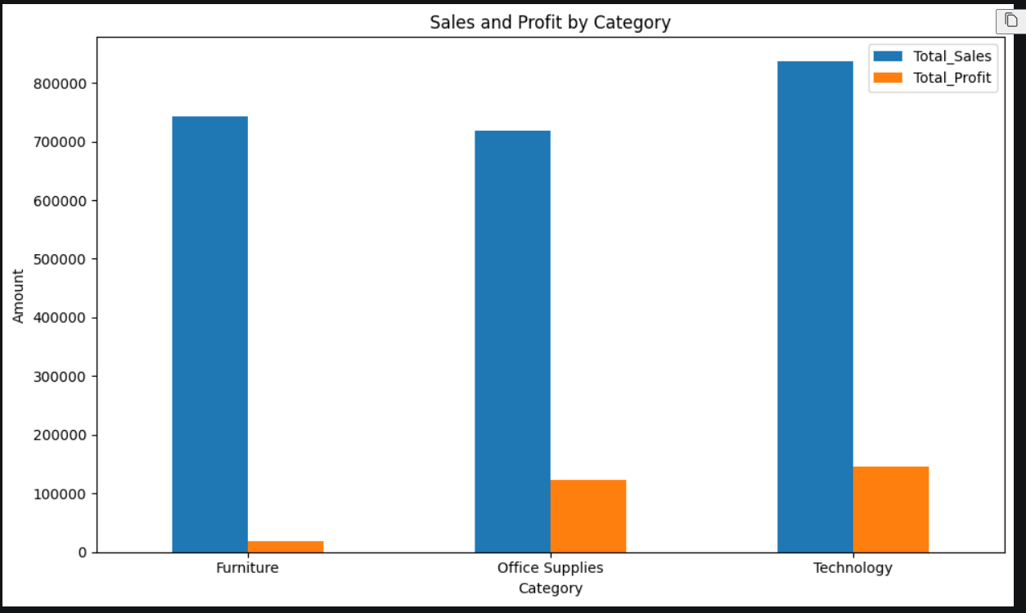

A bar chart was created using Matplotlib to compare sales and profit across product categories. Technology generated the highest sales and profit, while Furniture showed comparatively low profitability despite substantial sales.
Task 7 — Sub-Category Profitability

Why ascending=True?
We're sorting from:
Lowest profit → Highest profit
So the loss-making sub-categories will appear at the top.
Sub-Category | Total_Sales | Total_Profit
Tables | 206965.53 | -17725.48
Bookcases | 114880.00 | -3472.56
Supplies | 46673.54 | -1189.10
Fasteners | 3024.28 | 949.52
Machines | 189238.63 | 3384.76
Labels | 12486.31 | 5546.25
Art | 27118.79 | 6527.79
Envelopes | 16476.40 | 6964.18
Furnishings | 91705.16 | 13059.14
Appliances | 107532.16 | 18138.01
Storage | 223843.61 | 21278.83
Chairs | 328449.10 | 26590.17
Binders | 203412.73 | 30221.76
Paper | 78479.21 | 34053.57
Accessories | 167380.32 | 41936.64
Phones | 330007.05 | 44515.73
Copiers | 149528.03 | 55617.82
Loss-making sub-categories:
Sub-Category | Sales | Profit
🔴 Tables | 206,965.53 | -17,725.48
🔴 Bookcases | 114,880.00 | -3,472.56
🔴 Supplies | 46,673.54 | -1,189.10
These three sub-categories are generating sales but losing money.
🟢 Most profitable sub-categories
Sub-Category | Sales | Profit
Copiers | 149,528.03 | 55,617.82
Phones | 330,007.05 | 44,515.73
Accessories | 167,380.32 | 41,936.64
Copiers have the highest total profit.
Task 8 — Visualize Sub-Category Profitability
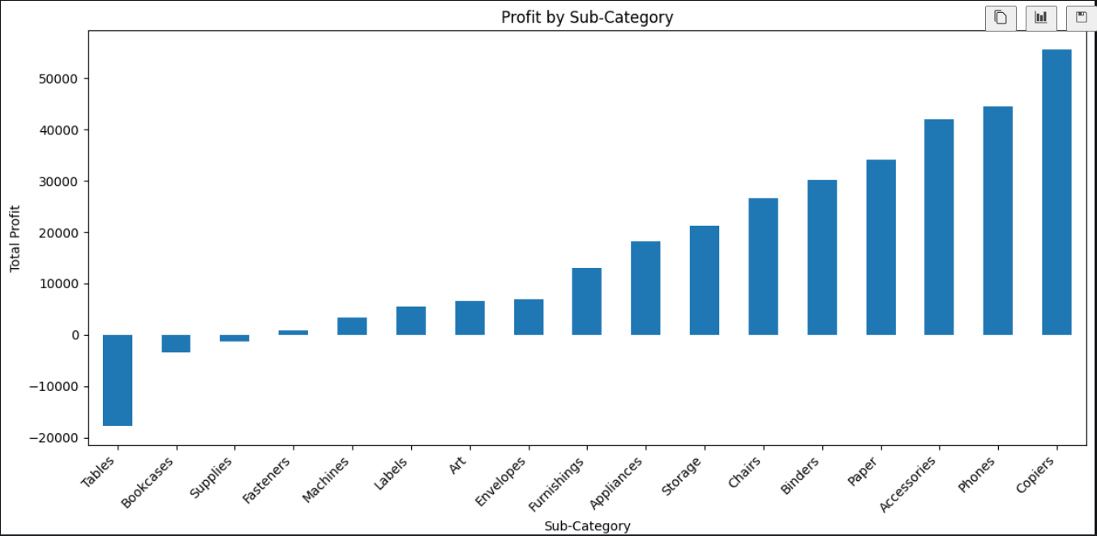
Task 9 — Regional Performance
Region | Total_Sales | Total_Profit
Central | 501239.89 | 39706.36
East | 678781.24 | 91522.78
South | 391721.90 | 46749.43
West | 725457.82 | 108418.45
Task 10 — Regional Sales & Profit Visualization
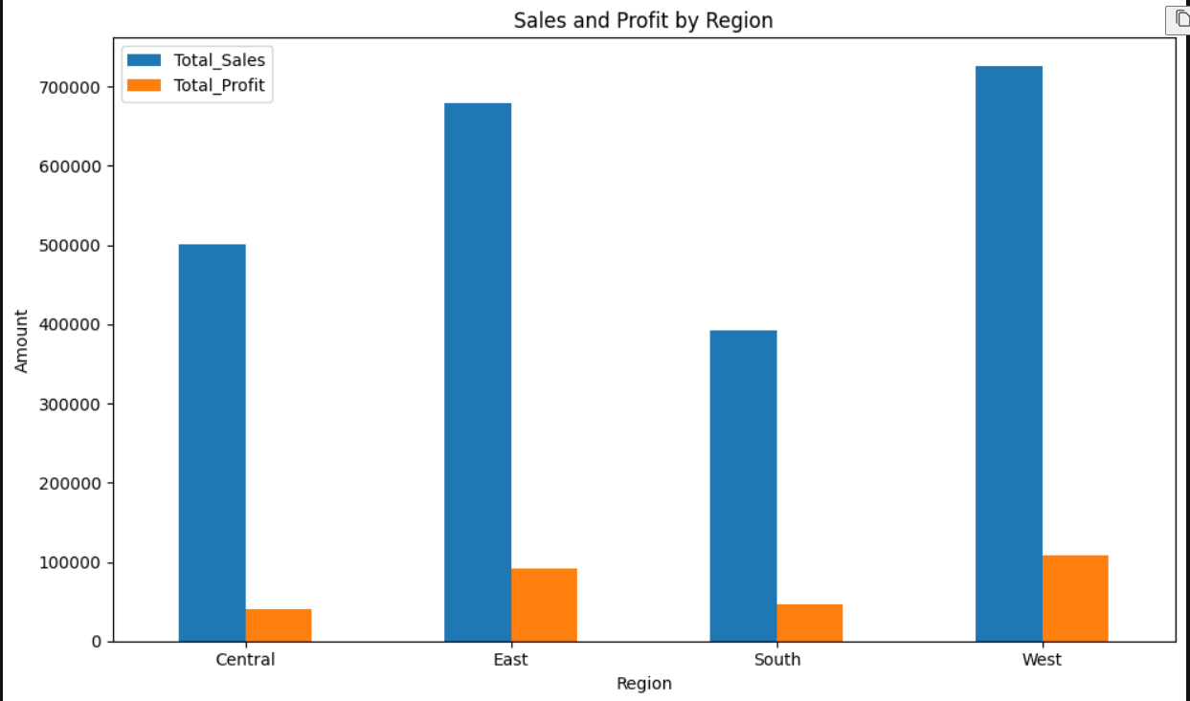
Task 11 — Customer Segment Analysis
we'll analyze the three customer segments:
- Consumer
- Corporate
- Home Office
 | Total_Sales | Total_Profit | Total_Customers
Segment
Consumer | 1161401.34 | 134119.21 | 409
Corporate | 706146.37 | 91979.13 | 236
Home Office | 429653.15 | 60298.68 | 148

Business insights
- 🥇 Consumer is the strongest segment by both sales and profit.
- Consumer customers generated 1.16M sales and 134.12K profit.
- Corporate is the second strongest segment.
- Home Office has the lowest sales and profit among the three segments.
- Consumer also has the largest customer base (409 customers).
Task 12 — Segment Visualization
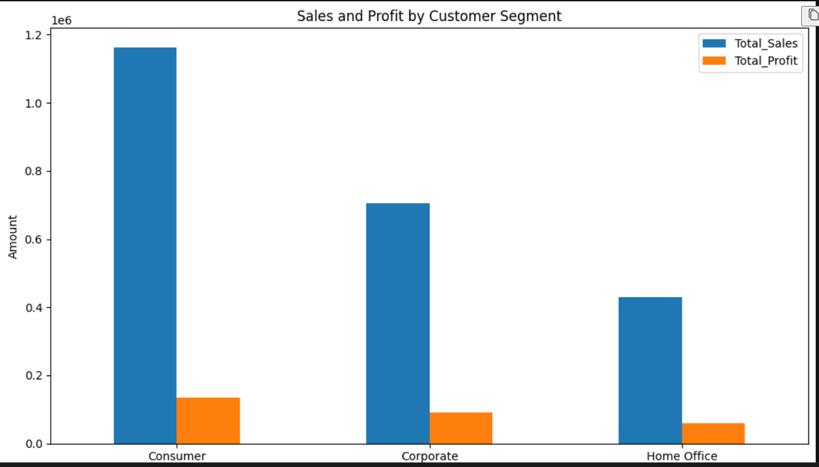
Task 13 — Top 10 Customers by Sales

What we're doing
The steps are:
groupby → calculate total sales → sort highest to lowest → take top 10
Customer Name
Sean Miller 25043.05
Tamara Chand 19052.22
Raymond Buch 15117.34
Tom Ashbrook 14595.62
Adrian Barton 14473.57
Ken Lonsdale 14175.23
Sanjit Chand 14142.33
Hunter Lopez 12873.30
Sanjit Engle 12209.44
Christopher Conant 12129.07
Name: Sales, dtype: float64
The top 10 customers are therefore useful targets for customer retention and relationship management, because losing a high-value customer could have a noticeable impact on sales.
Task 14 — Visualize Top 10 Customers
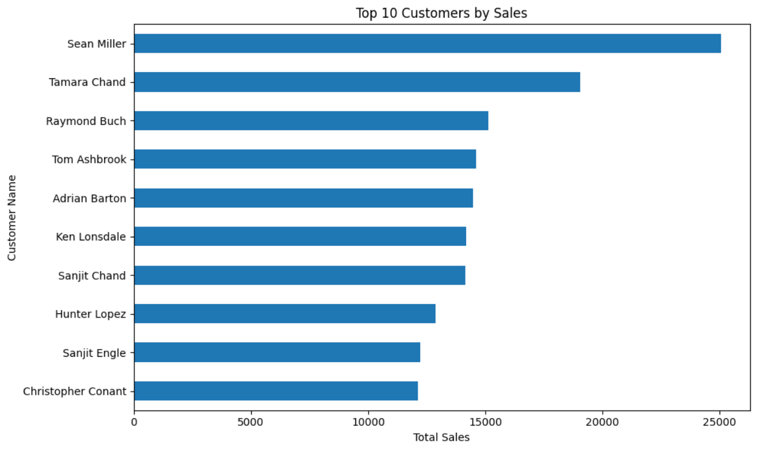

Task 15 — Top 10 Customers by Profit
Customer Name
Tamara Chand 8981.32
Raymond Buch 6976.10
Sanjit Chand 5757.41
Hunter Lopez 5622.43
Adrian Barton 5444.81
Tom Ashbrook 4703.79
Christopher Martinez 3899.89
Keith Dawkins 3038.63
Andy Reiter 2884.62
Daniel Raglin 2869.08
Name: Profit, dtype: float64

Task 16 — Visualize Top 10 Customers by Profit
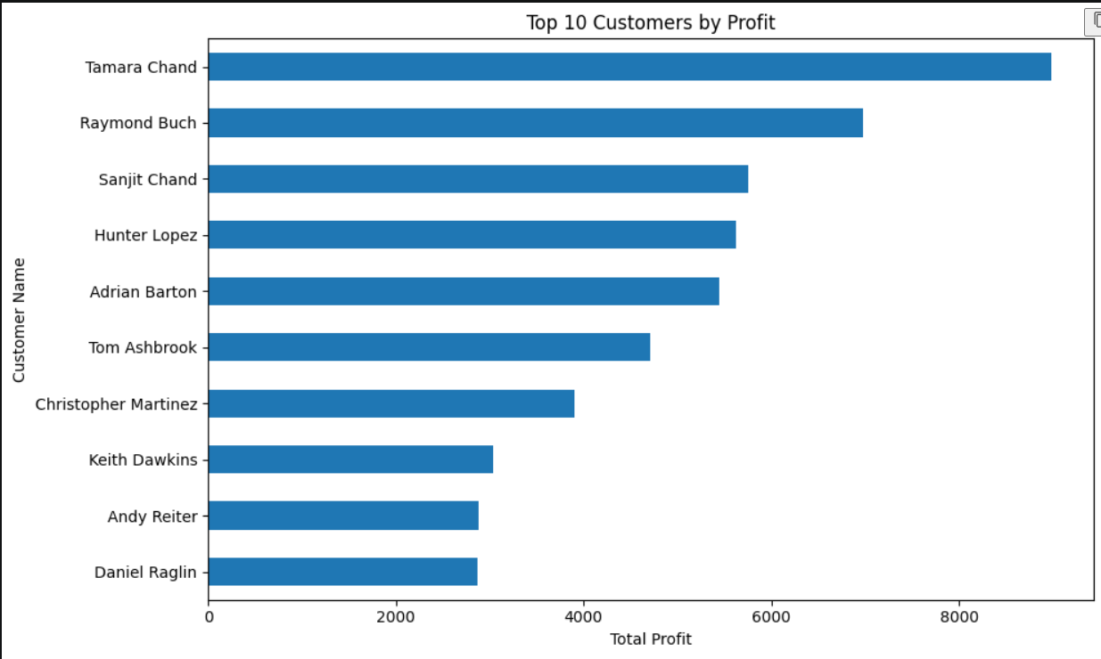
Task 17 — Discount & Profitability Analysis
Discount | Total_Sales | Total_Profit
0.00 | 1087908.47 | 320987.60
0.10 | 54369.35 | 9029.18
0.15 | 27558.52 | 1418.99
0.20 | 764594.37 | 90337.31
0.30 | 103226.66 | -10369.28
0.32 | 14493.46 | -2391.14
0.40 | 116417.78 | -23057.05
0.45 | 5484.97 | -2493.11
0.50 | 58918.54 | -20506.43
0.60 | 6644.70 | -5944.66
0.70 | 40620.28 | -40075.36
0.80 | 16963.76 | -30539.04
Task 18 — Discount vs Profit Visualization
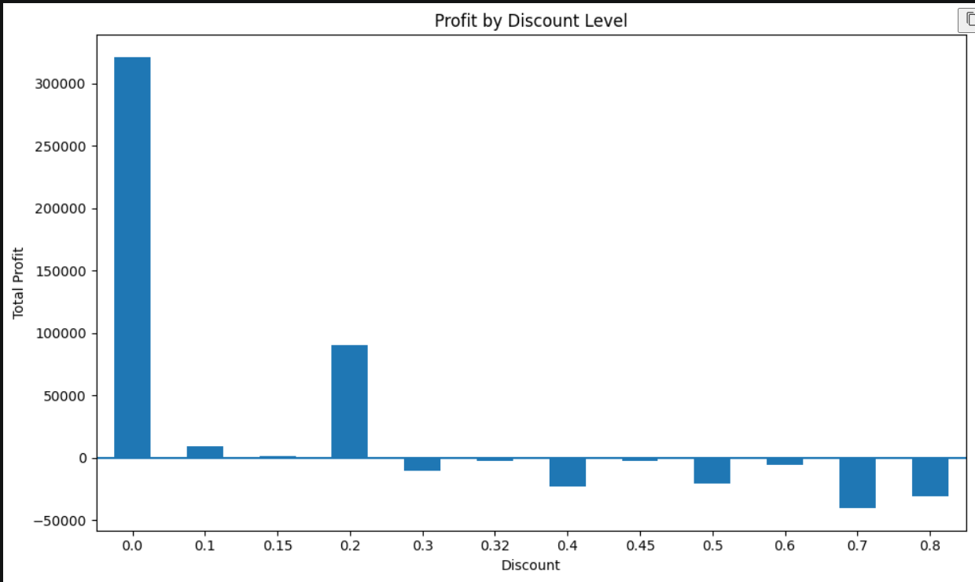

chart shows
- 0% discount → by far the highest profit.
- 10% and 15% → still profitable.
- 20% → profitable, but much lower than 0%.
- 30% and above → the bars go below the zero line, meaning overall losses.
- 70% discount → the largest loss among the discount levels shown.
Task 19 — Ship Mode Analysis
Ship Mode | Total_Sales | Total_Profit
First Class | 351428.42 | 48969.84
Same Day | 128363.12 | 15891.76
Second Class | 459193.57 | 57446.64
Standard Class | 1358215.74 | 164088.79

Business insights
- Standard Class generates by far the highest sales and profit.
- Same Day has the lowest sales and profit.
- Standard Class accounts for the largest share of the business's shipping activity.
- However, this analysis shows total performance, not profitability per shipment, so we shouldn't conclude that Standard Class is inherently more profitable per order.
Task 21 — Monthly Sales Trend
Order Date2014-01 14236.89502014-02 4519.89202014-03 55691.00902014-04 28295.34502014-05 23648.28702014-06 34595.12762014-07 33946.39302014-08 27909.46852014-09 81777.35082014-10 31453.39302014-11 78628.71672014-12 69545.62052015-01 18174.07562015-02 11951.41102015-03 38726.25202015-04 34195.20852015-05 30131.68652015-06 24797.29202015-07 28765.32502015-08 36898.33222015-09 64595.91802015-10 31404.92352015-11 75972.56352015-12 74919.5212
...
2017-09 87866.65202017-10 77776.92322017-11 118447.82502017-12 83829.3188Freq: M, Name: Sales, dtype: float64
• Sales fluctuate considerably from month to month.
• 2017-11 is particularly strong at about 118,447.83.
• 2014-02 is one of the lowest months at about 4,519.89.
• The later years generally show higher monthly sales than the earlier years.
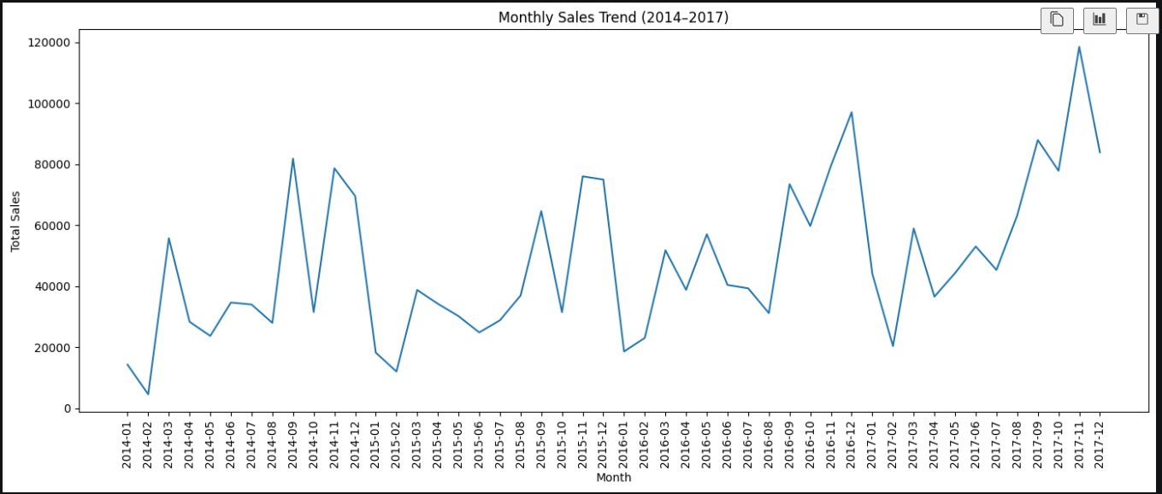
Task 23 — Yearly Sales & Year-over-Year Growth
Order Date | Total_Sales | YoY_Growth
2014 | 484247.50 | NaN
2015 | 470532.51 | -2.83
2016 | 609205.60 | 29.47
2017 | 733215.26 | 20.36

Business insights
- 2015: Sales decreased slightly by 2.83% compared with 2014.
- 2016: Sales recovered strongly, growing 29.47%.
- 2017: Sales continued to grow by 20.36%, reaching the highest annual sales of the four-year period.
- Overall, the business shows strong growth after 2015.
Task 25 — Customer Sales & Profit Analysis
Customer Name | Total_Sales | Total_Profit | Total_Orders
Sean Miller | 25043.05 | -1980.74 | 5
Tamara Chand | 19052.22 | 8981.32 | 5
Raymond Buch | 15117.34 | 6976.10 | 6
Tom Ashbrook | 14595.62 | 4703.79 | 4
Adrian Barton | 14473.57 | 5444.81 | 10
Ken Lonsdale | 14175.23 | 806.86 | 12
Sanjit Chand | 14142.33 | 5757.41 | 9
Hunter Lopez | 12873.30 | 5622.43 | 6
Sanjit Engle | 12209.44 | 2650.68 | 11
Christopher Conant | 12129.07 | 2177.05 | 5
Task 26 — Identify Loss-Making Customers
(155, 3)
Customer Name | Total_Sales | Total_Profit | Total_Orders
Sean Miller | 25043.05 | -1980.74 | 5
Becky Martin | 11789.63 | -1659.96 | 4
Grant Thornton | 9351.21 | -4108.66 | 3
Peter Fuller | 9062.86 | -614.29 | 4
Natalie Fritzler | 8322.83 | -1695.97 | 7
Sean Braxton | 8057.89 | -2082.75 | 7
Zuschuss Carroll | 8025.71 | -1032.15 | 13
Joseph Holt | 7955.00 | -644.70 | 6
Joseph Airdo | 6491.03 | -819.42 | 8
Victoria Wilson | 6134.04 | -874.66 | 10
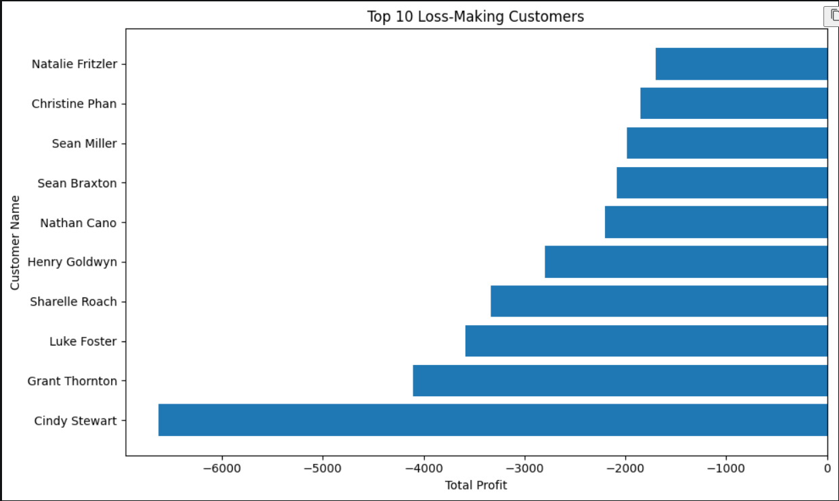
Task 28 — Product Performance Analysis
Product Name | Total_Sales | Total_Profit
Canon imageCLASS 2200 Advanced Copier | 61599.82 | 25199.93
Fellowes PB500 Electric Punch Plastic Comb Binding Machine with Manual Bind | 27453.38 | 7753.04
Cisco TelePresence System EX90 Videoconferencing Unit | 22638.48 | -1811.08
HON 5400 Series Task Chairs for Big and Tall | 21870.58 | 0.00
GBC DocuBind TL300 Electric Binding System | 19823.48 | 2233.51
GBC Ibimaster 500 Manual ProClick Binding System | 19024.50 | 760.98
Hewlett Packard LaserJet 3310 Copier | 18839.69 | 6983.88
HP Designjet T520 Inkjet Large Format Printer - 24" Color | 18374.90 | 4094.98
GBC DocuBind P400 Electric Binding System | 17965.07 | -1878.17
High Speed Automatic Electric Letter Opener | 17030.31 | -262.00
Task 30 — Top 10 Products by Profit
Product Name | Total_Sales | Total_Profit
Zebra ZM400 Thermal Label Printer | 6965.70 | 3343.54
Ibico EPK-21 Electric Binding System | 15875.92 | 3345.28
Plantronics Savi W720 Multi-Device Wireless Headset System | 9367.29 | 3696.28
3D Systems Cube Printer, 2nd Generation, Magenta | 14299.89 | 3717.97
Ativa V4110MDD Micro-Cut Shredder | 7699.89 | 3772.95
HP Designjet T520 Inkjet Large Format Printer - 24" Color | 18374.90 | 4094.98
Canon PC1060 Personal Laser Copier | 11619.83 | 4570.93
Hewlett Packard LaserJet 3310 Copier | 18839.69 | 6983.88
Fellowes PB500 Electric Punch Plastic Comb Binding Machine with Manual Bind | 27453.38 | 7753.04
Canon imageCLASS 2200 Advanced Copier | 61599.82 | 25199.93
Task 32 — Regional Customer Analysis
 | Region | Customer Name | Total_Sales | Sales_Rank
579 | Central | Tamara Chand | 18437.138 | 1.0
5 | Central | Adrian Barton | 12181.594 | 2.0
57 | Central | Becky Martin | 10539.896 | 3.0
1276 | East | Tom Ashbrook | 13723.498 | 1.0
916 | East | Hunter Lopez | 10522.550 | 2.0
705 | East | Bill Shonely | 10022.293 | 3.0
1745 | South | Sean Miller | 23669.196 | 1.0
1736 | South | Sanjit Engle | 8805.040 | 2.0
1499 | South | Grant Thornton | 8167.420 | 3.0
2354 | West | Raymond Buch | 14345.276 | 1.0
2199 | West | Ken Lonsdale | 8472.394 | 2.0
2029 | West | Edward Hooks | 7447.770 | 3.0
Task 34 — Profit Margin by Region
Region | Total_Sales | Total_Profit | Profit_Margin
Central | 501239.89 | 39706.36 | 7.92
East | 678781.24 | 91522.78 | 13.48
South | 391721.90 | 46749.43 | 11.93
West | 725457.82 | 108418.45 | 14.94
Task 36 — Category Profitability Analysis
Category | Total_Sales | Total_Profit | Profit_Margin
Furniture | 741999.80 | 18451.27 | 2.49
Office Supplies | 719047.03 | 122490.80 | 17.04
Technology | 836154.03 | 145454.95 | 17.40
Task 38 — Sub-Category Profitability Analysis
Total_Sales | Total_Sales | Total_Profit | Profit_Margin
Tables | 206965.53 | -17725.48 | -8.56
Bookcases | 114880.00 | -3472.56 | -3.02
Supplies | 46673.54 | -1189.10 | -2.55
Fasteners | 3024.28 | 949.52 | 31.40
Machines | 189238.63 | 3384.76 | 1.79
Labels | 12486.31 | 5546.25 | 44.42
Art | 27118.79 | 6527.79 | 24.07
Envelopes | 16476.40 | 6964.18 | 42.27
Furnishings | 91705.16 | 13059.14 | 14.24
Appliances | 107532.16 | 18138.01 | 16.87
Storage | 223843.61 | 21278.83 | 9.51
Chairs | 328449.10 | 26590.17 | 8.10
Binders | 203412.73 | 30221.76 | 14.86
Paper | 78479.21 | 34053.57 | 43.39
Accessories | 167380.32 | 41936.64 | 25.05
Phones | 330007.05 | 44515.73 | 13.49
Copiers | 149528.03 | 55617.82 | 37.20
Most important insight
Tables are the biggest profitability problem.
They generated:
- $206,965.53 in sales
- -$17,725.48 in profit
- -8.56% profit margin
So the company is generating substantial revenue from Tables but actually losing money.
On the other hand, Labels have a 44.42% margin, and Paper has a 43.39% margin.
Sub-category profitability analysis identified significant differences in performance. Tables had the lowest profitability, generating a loss of 17,725.48 and a negative profit margin of 8.56%. Bookcases and Supplies also generated negative profits. In contrast, Labels, Paper, Envelopes, and Copiers showed strong profit margins. This analysis helps identify sub-categories requiring corrective action and those contributing strongly to overall profitability.
Python — Final Analysis 1: Correlation Analysis
Step 1 — Calculate correlations
 | Sales | Quantity | Discount | Profit
Sales | 1.00 | 0.20 | -0.03 | 0.48
Quantity | 0.20 | 1.00 | 0.01 | 0.07
Discount | -0.03 | 0.01 | 1.00 | -0.22
Profit | 0.48 | 0.07 | -0.22 | 1.00
Step 2 — Visualize it
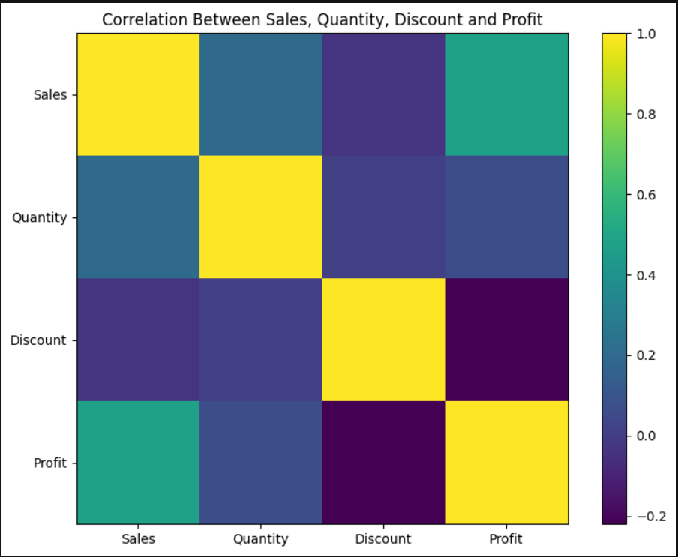
Final Python analysis:loss-making customers
Customer Name | Total_Sales | Total_Profit | Total_Orders
Cindy Stewart | 5690.05 | -6626.39 | 6
Grant Thornton | 9351.21 | -4108.66 | 3
Luke Foster | 3930.51 | -3583.98 | 7
Sharelle Roach | 3233.48 | -3333.91 | 5
Henry Goldwyn | 3247.64 | -2797.96 | 12
... | ... | ... | ...
Thais Sissman | 4.83 | -3.32 | 2
Adrian Hane | 1735.51 | -2.31 | 7
Mitch Gastineau | 16.74 | -1.25 | 1
Paul Lucas | 239.48 | -0.75 | 5
Jasper Cacioppo | 71.26 | -0.36 | 4

