* What is a Snowflake warehouse?
* A snowflake warehouse is made up of database architectures and utilizes database tables to store all data. It also utilizes MPP (massively parallel processing) compute clusters to process queries for the stored data.

### Snowflake warehouse vs. database

* A snowflake warehouse is made up of database architectures and utilizes database tables to store all data. It also utilizes MPP (massively parallel processing) compute clusters to process queries for the stored data.
* A database by itself is an electronically stored and structured collection of data.

## Types of Warehouses

* There are two types of warehouses supported by Snowflake, as explained below:
* Standard — It is the commonly used type and can be a good fit for most of the scenarios.
* Snow park Optimized — This type is generally recommended for workloads that have large memory requirements, e.g. ML training use cases.

## Create Snowflake Warehouse

* One can use either Snowflake UI or SQL statement to create a warehouse. Both of the options are explained below.

**Using Snowflake UI**

* Login to your Snowflake account and navigate to Admin > Warehouses section and click on Warehouse button on the top right of the screen.
* Provide the warehouse name and I strongly recommend putting a description/comment for the warehouse. It is extremely helpful in a large environment with many warehouses. Afterward, select the appropriate warehouse size and other advanced options. More on the advanced options in the Using SQL section.

**CREATE WAREHOUSE**

Creates a new [virtual warehouse](https://docs.snowflake.com/en/user-guide/warehouses-overview) in the system.

Initial creation of a virtual warehouse might take some time to provision the compute resources, unless the warehouse is created initially in a SUSPENDED state.

This command supports the following variants:

* [CREATE OR ALTER WAREHOUSE](https://docs.snowflake.com/en/sql-reference/sql/create-warehouse#label-create-or-alter-warehouse-syntax): Creates a new warehouse if it doesn’t exist or alters an existing warehouse.

**See also:**

[ALTER WAREHOUSE](https://docs.snowflake.com/en/sql-reference/sql/alter-warehouse) , [DESCRIBE WAREHOUSE](https://docs.snowflake.com/en/sql-reference/sql/desc-warehouse) , [DROP WAREHOUSE](https://docs.snowflake.com/en/sql-reference/sql/drop-warehouse) , [SHOW WAREHOUSES](https://docs.snowflake.com/en/sql-reference/sql/show-warehouses)

[CREATE OR ALTER <object>](https://docs.snowflake.com/en/sql-reference/sql/create-or-alter)

## Import worksheets from the Classic Console

You can import your SQL worksheets from the Classic Console to Snowsight from within Snowsight.

Import your SQL worksheets to make it easier to refer to queries and SQL statements that you’ve written in the past, without needing to switch to a different web interface and session.

**Note**

You can import your worksheets to Snowsight even if you can no longer access the Classic Console.

To import your SQL worksheets to Snowsight, do the following:

1. Sign in to Snowsight.
2. Select **Projects** » **Worksheets**.
3. Select the **…** more menu » **Import Worksheets**.

[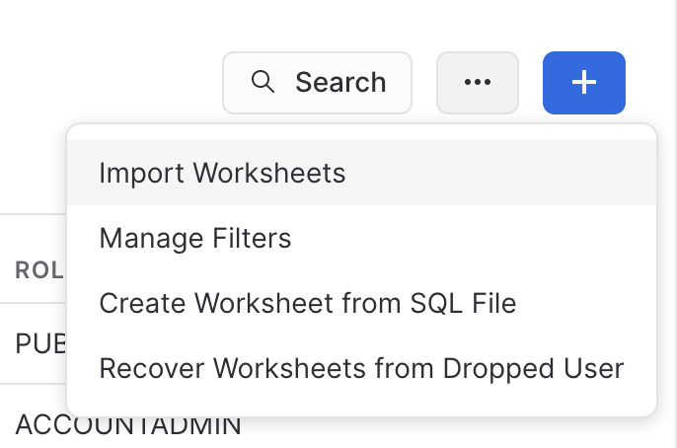](https://docs.snowflake.com/en/_images/snowsight-worksheets-import.png)

1. In the confirmation dialog, select **Import**.

Snowflake creates a folder named **Import YYYY-MM-DD** and places all worksheets from the Classic Console in that folder.

**Important**

Snowsight has a maximum worksheet size of 1MB. Worksheets larger than 1MB fail to import. See [Troubleshoot issues with upgrading to Snowsight](https://docs.snowflake.com/en/user-guide/ui-snowsight-upgrade-migrate.html#label-troubleshoot-snowsight-upgrade).

### After importing worksheets

Worksheets are not synced between Snowsight and the Classic Console. If you make updates to a SQL worksheet in Snowsight, the changes are not reflected in the Classic Console, and vice versa.

## Create worksheets in Snowsight

To create a worksheet in Snowsight, do the following:

1. Sign in to Snowsight.
2. Select **Projects** » **Worksheets** to open the list of worksheets.
3. Select **+** and select **SQL Worksheet** or **Python Worksheet** to create a worksheet.

The worksheet opens in the same window with the date and time of creation as the default title.

You can then start writing in your worksheet. For a SQL worksheet, [start writing queries](https://docs.snowflake.com/en/user-guide/ui-snowsight-query.html#label-worksheets-write-sql). For a Python worksheet, [start writing code](https://docs.snowflake.com/en/developer-guide/snowpark/python/python-worksheets).

### Create worksheets from a SQL file

To create a SQL worksheet from an existing SQL file, do the following:

1. Sign in to Snowsight.
2. Select **Projects** » **Worksheets** to open the list of worksheets.
3. Select the **…** more menu » **Create Worksheet from SQL File**.
4. Browse to the SQL file to upload.
5. A new worksheet opens with a title that matches the file name.

You can also add a SQL file to an existing SQL worksheet. Refer to [Append a SQL script to an existing worksheet](https://docs.snowflake.com/en/user-guide/ui-snowsight-query.html#label-worksheets-append-sql).

## Opening worksheets in tabs

You can use tabs to refer to multiple active worksheets and explore the databases and schemas in Snowflake while writing SQL statements or Python code in Snowsight. Your scroll position is preserved in each tab, making comparisons across worksheets easier to perform. Worksheet tabs are preserved across sessions, so you can pick up your work where you left off.

To open your Snowsight worksheets in tabs, do the following:

1. Sign in to Snowsight.
2. Select **Projects** » **Worksheets**.
3. Select an existing worksheet, or select **+ Worksheet** to open a new worksheet.
4. Select a role to run the worksheet as, and select a warehouse to allocate the compute resources for your query.
5. In the **Worksheets** menu, select an existing worksheet or select **+** to open a new worksheet tab. By default, the new worksheet uses your default role and warehouse.
6. (Optional) Make changes to the role or warehouse used to run the new worksheet.

After you open a worksheet, you can [update the contents](https://docs.snowflake.com/en/user-guide/ui-snowsight-worksheets), [run SQL statements](https://docs.snowflake.com/en/user-guide/ui-snowsight-query) or [write Python code](https://docs.snowflake.com/en/developer-guide/snowpark/python/python-worksheets), and manage the worksheet.

https://youtu.be/51TbZbFiLME?si=Qy-YWLesfUvROZwY

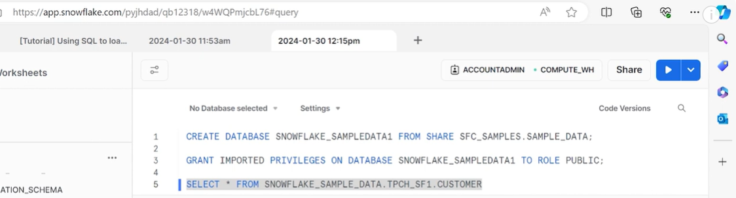

Create database syntax:

CREATE DATABASE database name

# CREATE DATABASE

Creates a new database in the system.

This command supports the following variants:

* [CREATE OR ALTER DATABASE](https://docs.snowflake.com/en/sql-reference/sql/create-database#label-create-or-alter-database-syntax): Creates a database if it doesn’t exist or alters an existing database.
* [CREATE DATABASE … CLONE](https://docs.snowflake.com/en/sql-reference/sql/create-database#label-create-database-clone-syntax): Creates a clone of an existing database, either at its current state or at a specific time/point in the past (using Time Travel). For more information about cloning a database, see [Cloning considerations](https://docs.snowflake.com/en/user-guide/object-clone).

In addition, this command can be used to:

* Create a database from a specified listing. See [About sharing with listings](https://other-docs.snowflake.com/en/collaboration/collaboration-listings-about).
* Create a database from a share provided by another Snowflake account. For more information about shares, see [About Secure Data Sharing](https://docs.snowflake.com/en/user-guide/data-sharing-intro).
* Create a replica of an existing primary database (for example, a secondary database). For more information about database replication, see [Introduction to database replication across multiple accounts](https://docs.snowflake.com/en/user-guide/db-replication-intro).
* **Standard Database (from a listing)**
* **CREATE** **DATABASE** <name> **FROM** **LISTING** '<listing_global_name>'
* **Shared Database (from a Share)**
* **CREATE** **DATABASE** <name> **FROM** **SHARE** <provider_account>.<share_name>
* **Secondary Database (Database Replication)**
* **CREATE** **DATABASE** <name>
* **AS** **REPLICA** **OF** <account_identifier>.<primary_db_name>
* [ **DATA_RETENTION_TIME_IN_DAYS** = <integer> ]