Molecular Docking Report
Gandaria Seed Extract Compounds Against Alpha-Amylase
Prepared from using AutoDock Vina screening results prepared in PyMOL/PyRx workflow

1. Executive Summary
Seven gandaria seed extract ligands were docked against the cleaned alpha-amylase receptor using AutoDock Vina. The workflow was used to estimate binding affinity, predicted binding pose, and pose consistency for each compound. This report summarizes the docking setup, explains why some ligands return more poses than others, and provides a clean format for presenting the screening results.
Seven Flavonoids from Gandaria Extract (1), kampferol (2), afzelin (3), quercetin (4), quercitrin (5), myricitin (6), and naringenin (7) (Note: The mearnsitrin file couldn’t be found) were prepared and docked against a cleaned alpha-amylase receptor (4GQR). The workflow was used to estimate binding affinity, predicted binding pose and pose consistency for each flavonoid compound. This report is a summary of the docking setup, explains why some ligands return more poses than others, and provides a clean format for presenting the screening results.

2. Project Overview
The objective of this dry-lab stage was to evaluate whether compounds associated with gandaria seed extract can plausibly interact with alpha-amylase, a carbohydrate-digesting enzyme relevant to postprandial glucose control. The receptor was prepared beforehand and saved as alpha_amylase_clean.pdb. The ligands were checked in PyMOL, converted for docking, and screened individually with AutoDock Vina.

3. Method Summary
- Protein Receptor preparation: alpha-amylase (4GQR) structure cleaned in PyMOL, solvent removed, hydrogens added, and saved as alpha_amylase_clean.pdb.
- Ligand preparation: seven available ligands imported from .sdf format and checked visually in Pymol before docking.
- Docking engine: AutoDock Vina through a GUI workflow (PrRx).
- Binding-site definition: grid box set around the selected alpha-amylase active site.
- Output recorded: best binding affinity (kcal/mol), pose number, RMSD lower bound, and RMSD upper bound for each ligand.

4. Docking Results Table
Below here is the table with values from the docking process (CSV). The best pose is usually the ones with low binding affinity (Note: Here lower affinity means better).
Ligand | Best Affinity (kcal/mol) | Best Mode | RMSD LB | RMSD UB
Naringenin | -4.4 | 1 | 0.069 | 1.083
Quercetin | -4.1 | 0 | 0.0 | 0.0
Quercitrin | -0.1 | 0 | 0.0 | 0.0
Kaempferol | -4.5 | 0 | 0.0 | 0.0
Mycitrin | -0.4 | 0 | 0.0 | 0.0
Afzelin | 0.7 | 0 | 0.7 | 0.0
Mearnsitrin | -0.5 | 0 | 0.0 | 0.0

5. Limitations in Data (Modes): Why Some Ligands Return > 6 Modes and Others Only 1-2
In Vina MD it is normal. The number of poses printed in the output is a maximum, not a guarantee. Vina may return fewer binding modes if it doesn’t find enough distinct ‘interesting’ poses internally. The output is also bound by energy range, so closely related poses may be filtered out. In addition, the searching process is stochastic, so docking can vary wildly unless the random seed and settings are used the same.
In practical terms, ligands that are more flexible, larger, or able to fit the pocket in multiple distinct ways often produce more reported modes. More rigid ligands, or ligands whose best conformations cluster strongly into one dominant pose, often produce only one or two modes.

6. How to Interpret the Output
- Lower binding affinity (more negative kcal/mol) suggests stronger predicted binding in this screening context.
- A ligand that repeatedly appears in similar poses across modes is usually more reliable than a ligand with one isolated outlier pose.
- RMSD lower bound and RMSD upper bound are measures of similarity between docked poses; smaller values generally indicate pose clustering near the best mode.
- The best ligand for follow-up MD is usually the one with both strong affinity and a stable, well-clustered binding mode.

7. Results Summary Text
The docking screen identified a ranked set of gandaria seed extract ligands with differing predicted affinities toward alpha-amylase. The observed spread in output poses reflects ligand flexibility, pocket complementarity, and Vina's internal filtering of distinct poses. The top-ranked ligands should be selected for molecular dynamics analysis to evaluate stability of the protein-ligand complex over time.

8. Figures and Docked Molecules
Format:
- Ligand Name
- Image before docking
- Image after docking
Naringenin:
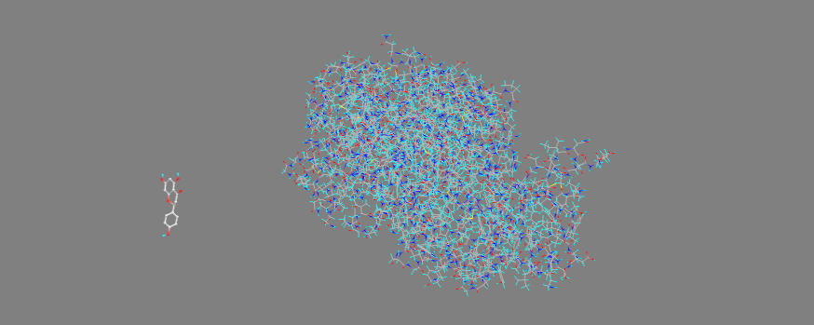

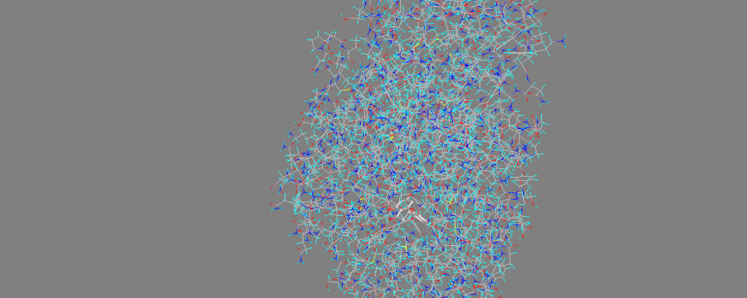
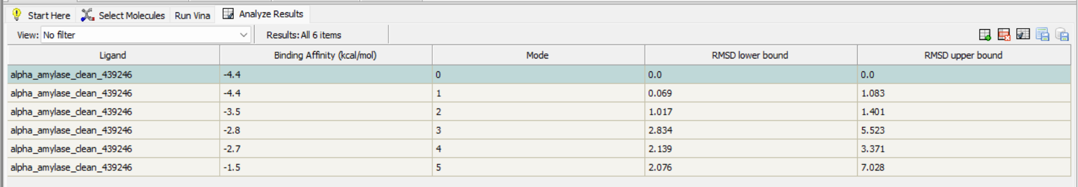
Quercetin:
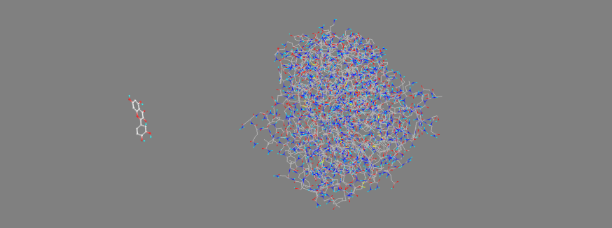
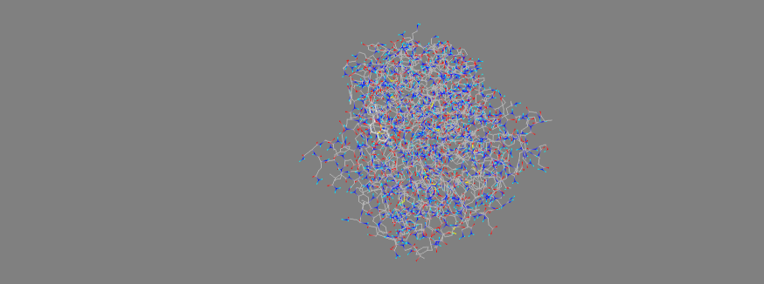
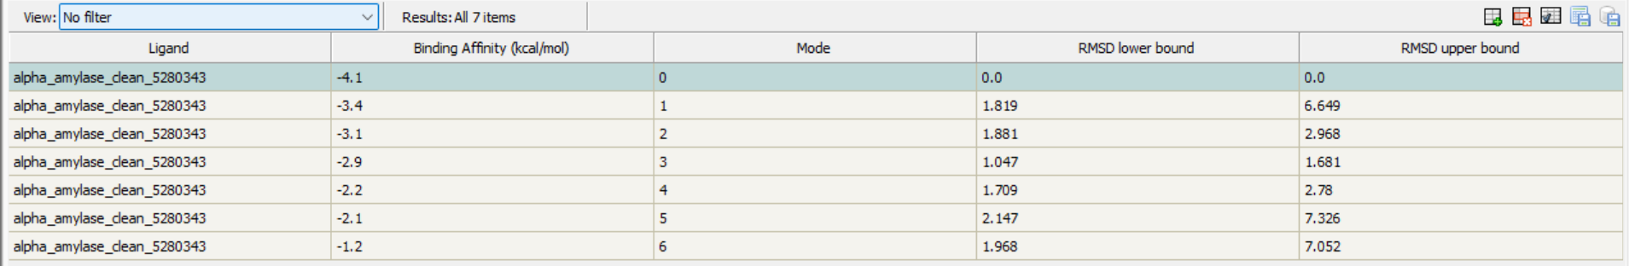
Quercitrin:
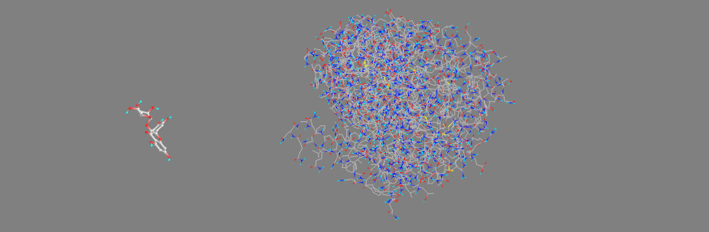
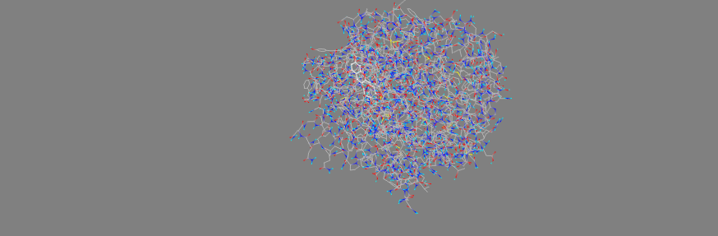
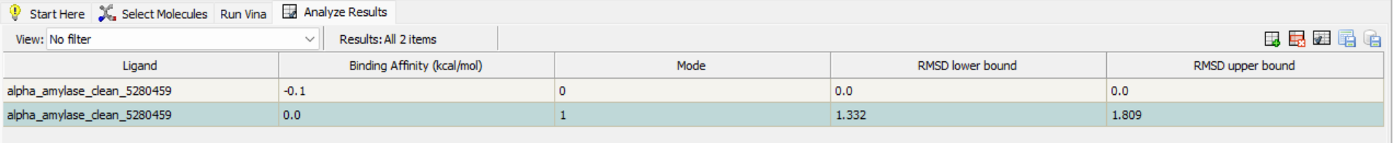
Kaempferol:
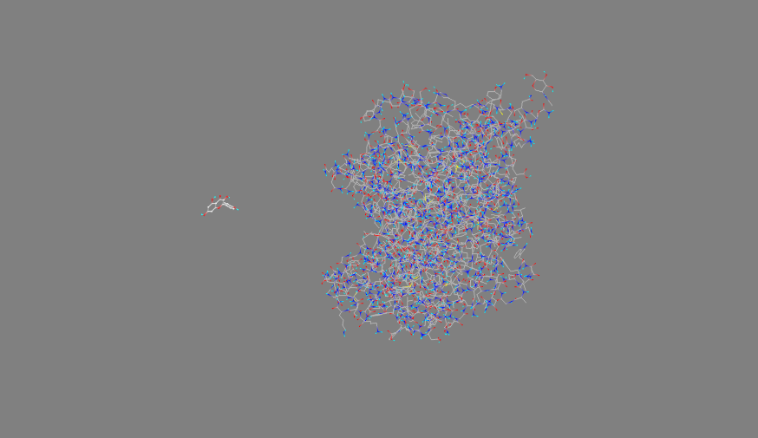
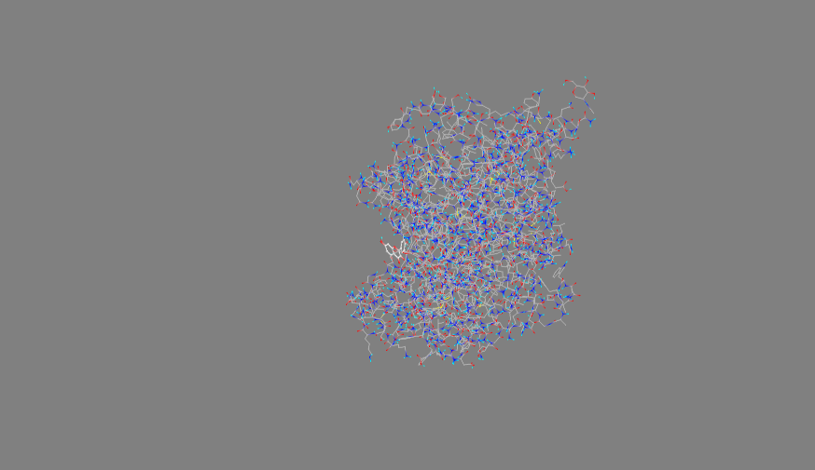
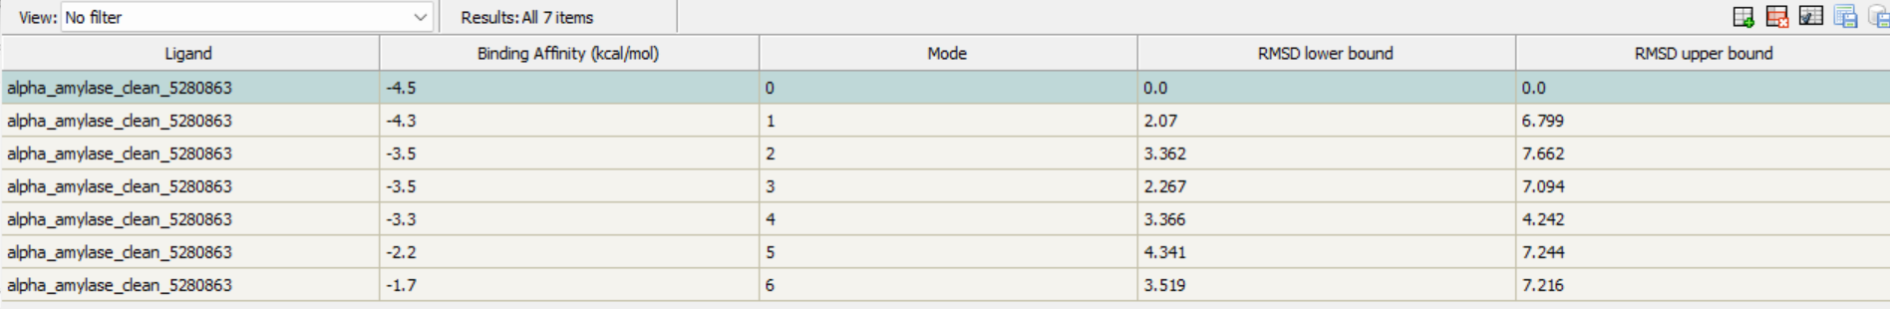

Mycitrin:
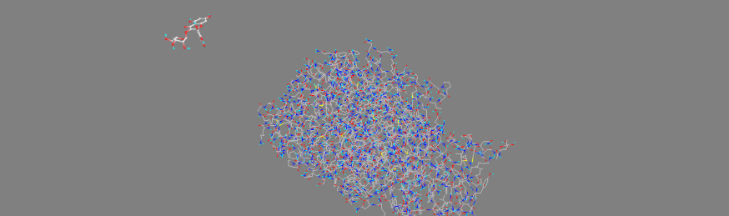

Afzelin:
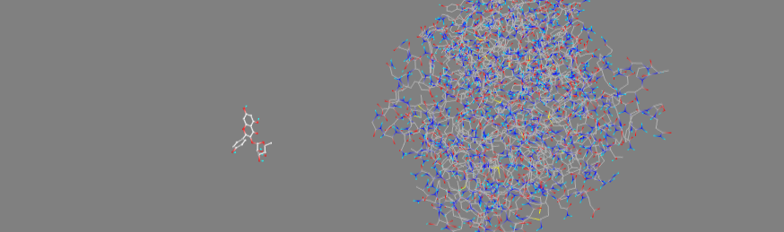
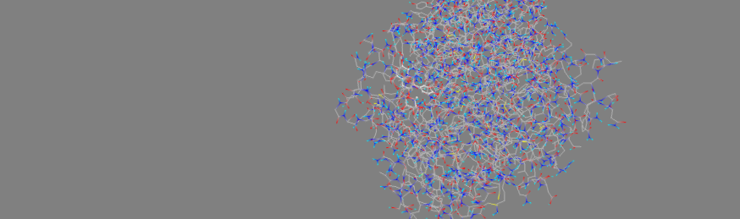
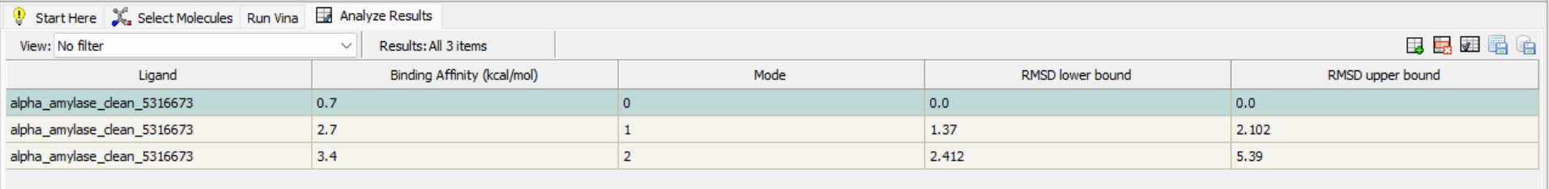
Mearnsitrin:
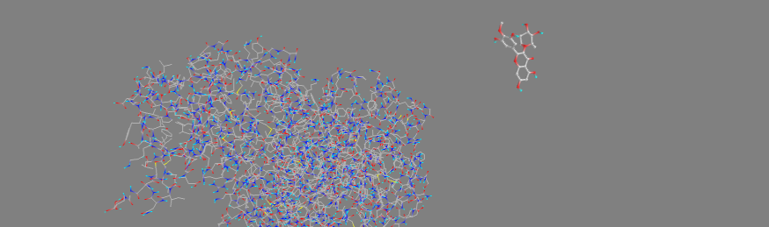
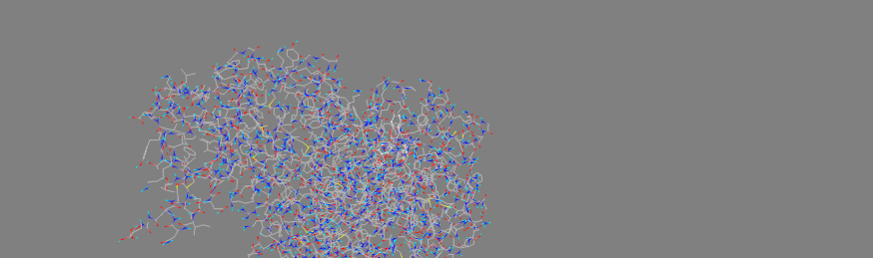

9. Conclusion
AutoDock Vina screening of the seven available gandaria seed extract compounds against alpha-amylase produced distinct binding poses and affinity values. The docking stage is suitable for narrowing the candidate list before molecular dynamics, and the best-performing ligands can be carried forward for a more detailed stability analysis.

