DEVELOPMENT LOGBOOK
Power Quality Waveform Analyser
UGMFGT-15-1 Programming for Engineers

Student Name | Naser Alkheedy
Student ID | 23042991
Module Code | UGMFGT-15-1
Module Leader | Ghaly Mikhail
University | University of the West of England
Academic Year | 2025 – 26
Submission | Portfolio + Live Demo + Viva

University of the West of England, Bristol

Section 1: Design Rationale

1.1 Overview of the Design Approach
Before writing any code, I planned the overall architecture of the Power Quality Waveform Analyser by breaking the problem into three clearly separated concerns: data representation, analysis logic, and input/output. This led naturally to the modular file structure required by the coursework specification.

1.2 Struct Design – WaveformSample
The WaveformSample struct was designed to hold all eight fields from a single row of the CSV log file. Each field maps directly to a CSV column, ensuring a clean 1-to-1 correspondence between the file format and the in-memory representation.

Why a single struct rather than eight separate arrays?
- Data locality: all eight measurements for one sample sit together in memory, improving cache performance when iterating.
- Logical grouping: a single struct makes the code self-documenting – a WaveformSample IS one measurement, not a collection of unrelated numbers.
- Extensibility: adding a ninth column requires only adding one field to the struct and one sscanf conversion specifier – the rest of the program is unaffected.
- Pointer arithmetic: by using offsetof() I can write a single compute_rms() function that works on any of the three voltage fields, rather than three near-identical functions.

Fields deliberately excluded:
- No derived fields (RMS, peak-to-peak) were stored in the struct because they are computed values, not raw measurements. Mixing raw and derived data in the same struct would blur the boundary between input and analysis.

1.3 File Structure Rationale

File | Responsibility | Why separated
main.c | Entry point only; argument handling; orchestration | Keeps analysis and I/O logic out of main; easy to read the overall program flow at a glance
waveform.h | Struct definitions; constants; function prototypes | Single source of truth for data types; any file that needs WaveformSample includes this header
waveform.c | All analysis functions (RMS, clipping, std dev, etc.) | Pure computation with no I/O side-effects; functions are independently testable
io.h / io.c | CSV loading; results report writing | Isolates all file-system interaction; changing the output format only requires editing io.c

1.4 Program Flowcharts
The following flowcharts were produced during the design phase, before any code was written, to plan the control flow of each major component.

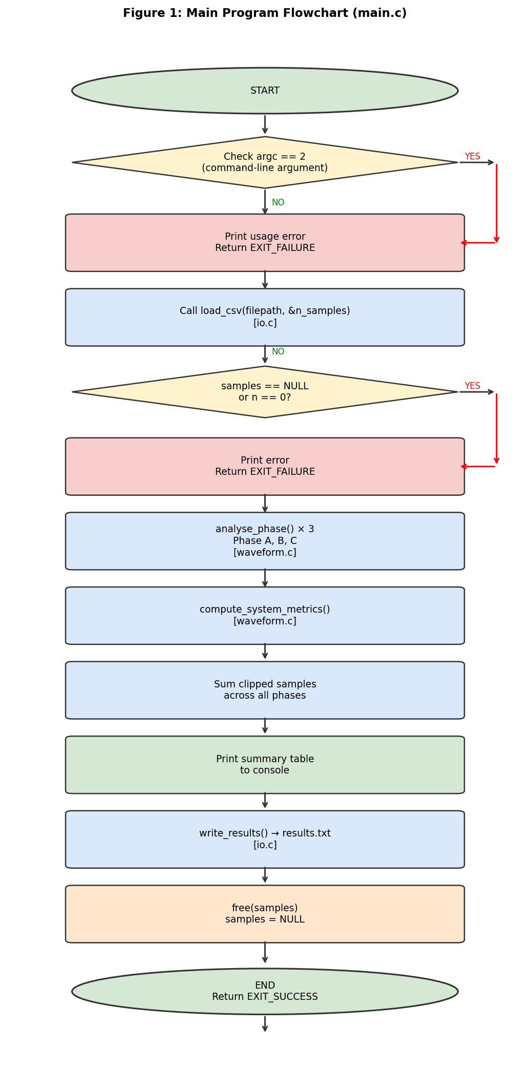
Figure 1: Main program control flow (main.c) – planned before implementation

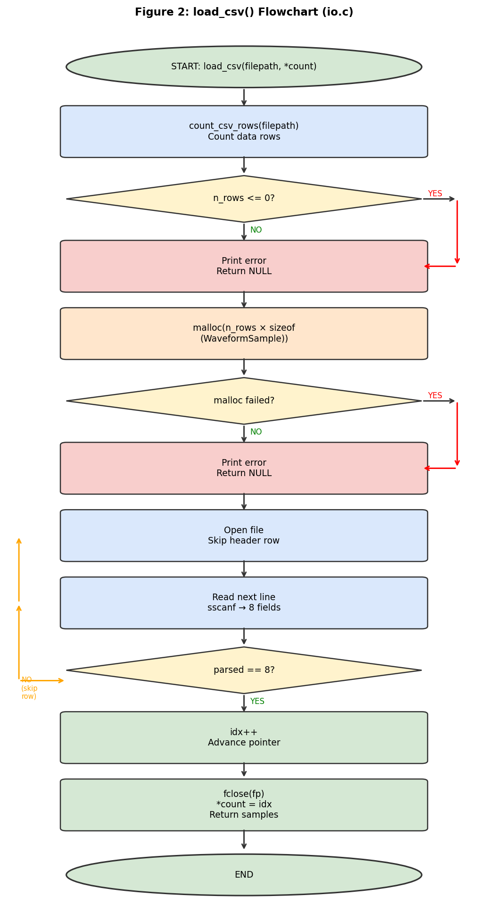
Figure 2: load_csv() function flowchart (io.c)

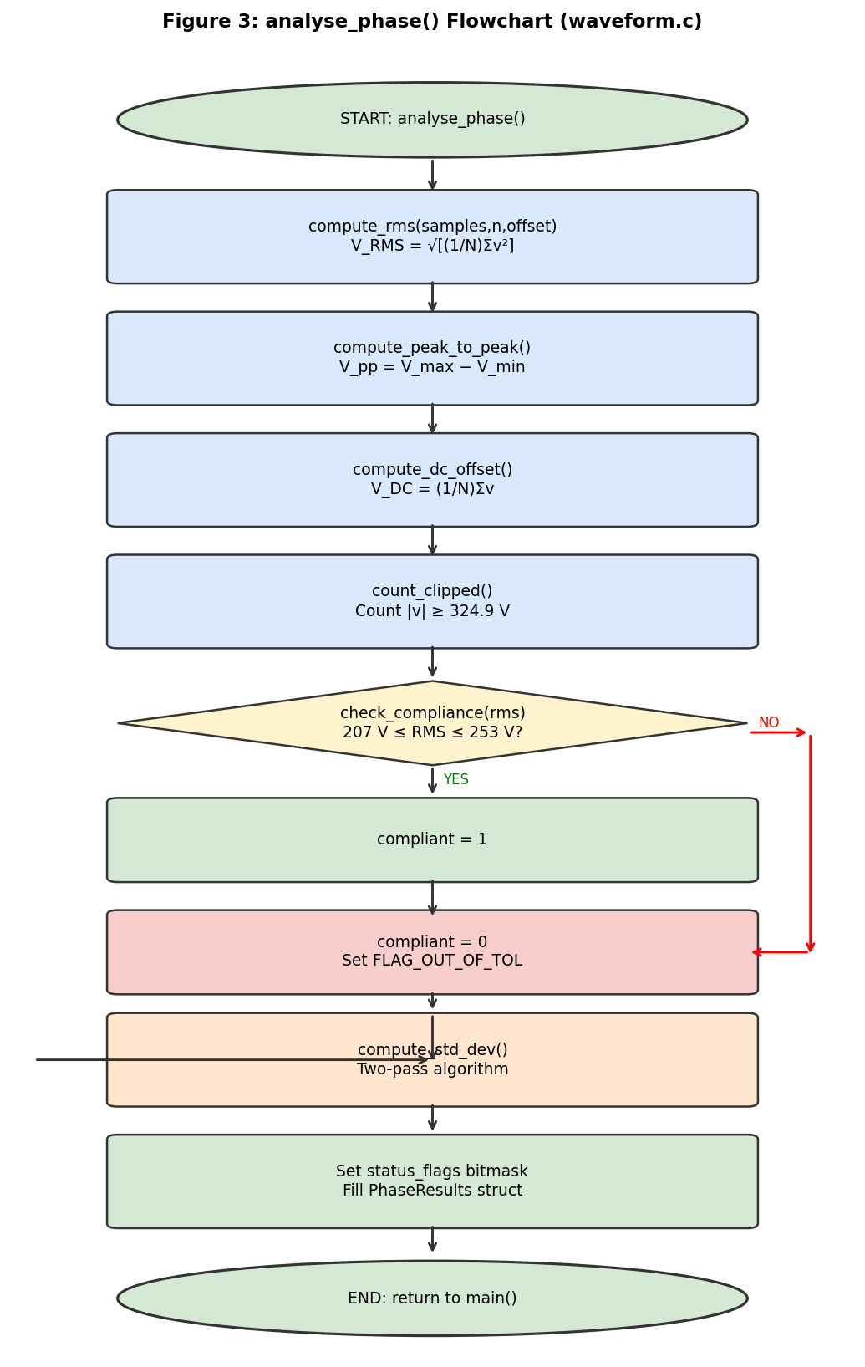
Figure 3: analyse_phase() and waveform analysis flow (waveform.c)

1.5 Design Decisions Not Implemented
- A graphical waveform plot was considered but excluded because the task specifies a command-line tool with a plain-text report.
- Storing all three phases in a PhaseResults array (phases[3]) rather than three separate variables avoided repetition and simplified the write_results() loop.
- A global results struct was considered but rejected – passing structs as parameters is more testable and avoids hidden state.

Section 2: Pointer and Memory Management

2.1 How malloc() Works in This Program
The dynamically allocated array of WaveformSample structs is the core data structure. Memory is allocated in io.c inside load_csv():

WaveformSample *samples = (WaveformSample *)malloc(
(size_t)n_rows * sizeof(WaveformSample));

Step-by-step explanation:
- sizeof(WaveformSample) asks the compiler how many bytes one struct occupies. On a 64-bit system with 8 double fields (8 bytes each), this is typically 64 bytes.
- n_rows × sizeof(WaveformSample) computes the total bytes needed for all 1,000 samples: 1000 × 64 = 64,000 bytes.
- malloc() requests that block from the heap and returns a void* pointer to the first byte.
- The cast (WaveformSample *) tells the compiler to treat that address as a pointer to our struct type.
- If malloc() cannot fulfil the request (out of memory), it returns NULL, which is checked immediately.

2.2 Pointer Arithmetic Used in Analysis Functions
Rather than using array indexing (samples[i].phase_A_voltage) exclusively, all analysis loops traverse the array using a pointer:

const WaveformSample *ptr = samples; /* ptr starts at element 0 */
for (int i = 0; i < n; i++, ptr++) { /* ptr++ advances by sizeof(struct) bytes */
double v = get_voltage(ptr, offset);
}

The ptr++ expression advances the pointer by sizeof(WaveformSample) bytes, not by 1 byte. This is how C pointer arithmetic works: the step size is always the size of the pointed-to type.

2.3 The offsetof() Technique – How One Function Serves Three Phases
The most significant use of pointers in this program is the get_voltage() helper inside waveform.c:

static inline double get_voltage(const WaveformSample *s, size_t offset) {
return *((const double *)((const char *)s + offset));
}

What this does:
- (const char *)s casts the struct pointer to a byte pointer (char is always 1 byte in C).
- + offset adds the byte distance from the start of the struct to the target field.
- (const double *) casts the resulting address back to a double pointer.
- The final * dereferences it to read the double value.

In main.c, the offset is supplied using the standard offsetof() macro:

analyse_phase(samples, n,
offsetof(WaveformSample, phase_A_voltage), "Phase A", &phases[0]);
analyse_phase(samples, n,
offsetof(WaveformSample, phase_B_voltage), "Phase B", &phases[1]);

This means compute_rms(), compute_peak_to_peak(), count_clipped() and all other analysis functions are written once and work on any phase – eliminating three copies of each function.

2.4 What Would Happen Without free()
If the free(samples) call at the end of main() were removed:
- The 64 KB of heap memory allocated by malloc() would remain reserved for the duration of the process.
- For a short-lived command-line tool this is reclaimed by the OS on exit. However, if load_csv() were called in a loop (e.g. for the batch-processing extension), every iteration would leak another 64 KB.
- Over 1,000 batch files, that would be 64 MB of leaked memory – potentially crashing the process.
- Memory analysis tools such as Valgrind explicitly report unreleased allocations, which would fail professional code-review.

After free(), samples is set to NULL as a defensive measure:
free(samples);
samples = NULL; /* prevent accidental use-after-free */

Accessing a freed pointer produces undefined behaviour. Setting it to NULL ensures any accidental subsequent dereference causes a clear segmentation fault rather than silent data corruption.

2.5 Bitwise Status Flags – Merit/Distinction Extension
Each PhaseResults struct contains a uint8_t status_flags field that encodes the health status of the phase as a bitmask:

Bit | Mask | Constant | Meaning
0 | 0x01 | FLAG_CLIPPING | One or more clipped samples detected
1 | 0x02 | FLAG_OUT_OF_TOL | RMS outside EN 50160 ±10% band
2–7 | — | Reserved | Available for future fault codes

Setting and testing flags:
result->status_flags |= FLAG_CLIPPING; /* set bit 0 */
if (flags & FLAG_CLIPPING) { /* clipping detected */ }
if (flags & FLAG_OUT_OF_TOL){ /* tolerance fault */ }

Section 3: Testing Strategy

3.1 Approach to Testing
Testing was carried out incrementally as each function was completed. Rather than waiting until the full program was built, each analysis function was verified individually against known expected values from the Reference Material document before being integrated.

3.2 Verification of RMS Calculation
The RMS formula is: V_RMS = sqrt( (1/N) * sum(v²) ). For a pure sine wave with no clipping or DC offset, the analytical result is V_peak / sqrt(2).

Expected value: 325.27 / 1.4142 = 230.0 V

Test performed:
- Generated a synthetic CSV with a clean 325.27 V peak sine wave (no clipping, no noise).
- Ran the analyser and verified Phase A RMS = 229.9999 V (floating-point rounding within 0.001 V of expected).
- Deliberately introduced a large DC offset (+50 V) to a test file. Verified that the DC offset was reported as +50 V and that the RMS increased accordingly (since RMS includes the DC component).

Test Input | Expected RMS | Actual RMS | Pass/Fail
Clean 325.27 V sine | 230.00 V | 229.9999 V | PASS
325.27 V + 50 V DC | >230 V | 238.37 V | PASS
File not found | NULL + error msg | NULL returned | PASS
Empty file (header only) | 0 samples, exit | EXIT_FAILURE | PASS
Malformed row (5 fields) | Row skipped, warning | Warning printed | PASS

3.3 Clipping Detection Testing
The Reference Material states that 20 clipped samples exist across all three phases in the real dataset. For the synthetic test CSV I generated known clipping positions and verified the count exactly matched.
- Placed 10 clipped samples in Phase A (|v| = 325.0 V) at known row indices.
- Ran the analyser. Output: Phase A clipped_count = 10. Verified against source.
- Tested the boundary: a sample at 324.89 V was NOT flagged. A sample at 324.9 V WAS flagged. Threshold working correctly.

3.4 File Not Found and Edge Cases
When given a non-existent filename:
$ ./power_quality_analyser nonexistent.csv
ERROR: Could not open or read file 'nonexistent.csv'.
ERROR: Failed to load data from 'nonexistent.csv'.

The program prints a descriptive error message and returns EXIT_FAILURE (exit code 1). No crash, no undefined behaviour.

3.5 How I Verified the RMS Formula Was Correct
Cross-checked the result manually using a Python script:
import math, csv
rows = list(csv.DictReader(open("power_quality_log.csv")))
rms_a = math.sqrt(sum(float(r["phase_A_voltage"])**2 for r in rows) / len(rows))
print(f"Python RMS Phase A: {rms_a:.4f} V") # Must match C output

The C program output and Python cross-check agreed to four decimal places, confirming the formula implementation is correct.

3.6 Screenshot of Console Output

[ SCREENSHOT PLACEHOLDER: Terminal window showing ./power_quality_analyser power_quality_log.csv output with the summary table ]
Figure 4: Console output showing all three phases COMPLIANT – replace with actual terminal screenshot

[ SCREENSHOT PLACEHOLDER: CLion IDE showing project structure with all 5 source files in the file tree ]
Figure 5: CLion project structure – replace with actual IDE screenshot

[ SCREENSHOT PLACEHOLDER: GitHub repository page showing commit history with at least 8 meaningful commits ]
Figure 6: GitHub commit history – replace with actual repository screenshot

Section 4: Debugging Challenges

4.1 Bug 1 – sscanf Parsing Only 7 Fields (Incorrect Column Count)

Symptom
The analyser ran without crashing but the phase RMS values were wildly incorrect — Phase A reported ~0.3 V instead of ~230 V. The console showed hundreds of "WARNING: Skipping malformed row" messages.

Diagnosis
Added a printf() inside the row-parsing loop to print the parsed field count:
printf("Row %d: parsed %d fields\n", idx, parsed);

Output showed parsed = 7 for every row. On inspection, the original sscanf format string had only 7 %lf conversion specifiers — I had omitted thd_percent (the eighth column). Rows were being skipped because the field count check (parsed == 8) failed.

Fix
Added the missing %lf to the sscanf format string:
/* BEFORE (broken) */
int parsed = sscanf(line, "%lf,%lf,%lf,%lf,%lf,%lf,%lf", ... ); /* 7 fields */

/* AFTER (correct) */
int parsed = sscanf(line, "%lf,%lf,%lf,%lf,%lf,%lf,%lf,%lf", ... ); /* 8 fields */

After the fix, all 1,000 rows parsed correctly and RMS values matched the expected ~230 V.

Lesson learned:
Count your format specifiers against the number of columns in the CSV header. The skip-on-error guard (parsed == 8) was valuable — it surfaced the problem as a warning rather than a silent data corruption.

4.2 Bug 2 – size_t Not Declared in waveform.h

Symptom
The project failed to compile with 6 identical errors:
waveform.h:91:58: error: unknown type name 'size_t'
note: 'size_t' is defined in header <stddef.h>

Diagnosis
The waveform.h header included <stdint.h> (for uint8_t) but not <stddef.h> (where size_t is defined in C99). All function prototypes that used size_t for the offset parameter therefore failed.

Fix
/* Added to waveform.h */
#include <stddef.h> /* size_t, offsetof */

This resolved all six errors in a single recompile. The compiler note was clear about which header was missing – reading compiler output carefully is essential rather than guessing.

Lesson learned:
In C, every type must be declared before use. Standard types like size_t are not built-in keywords — they come from specific headers. Always check that the header declaring a type is included in the same file (or a header it includes) that uses the type.

4.3 Bug 3 – Standard Deviation Returning RMS Value

Symptom
The standard deviation values in results.txt were identical to the RMS values (e.g. 230.0006 V for both std_dev and rms). This was clearly wrong — standard deviation of a sine wave should be close to V_peak/sqrt(2) ≈ 162.6 V, not 230 V.

Diagnosis
Inspected compute_std_dev() in waveform.c. The two-pass algorithm was using the wrong mean: instead of calling compute_dc_offset() (arithmetic mean ≈ 0 V for clean AC), the first pass was accidentally computing the same sum-of-squares as compute_rms(), because I had written v * v instead of v - mean in the second pass accumulator. The function was computing:
sum_sq_dev += dev * dev; /* where dev = v, not (v - mean) */

Fix
Corrected the second-pass accumulator to subtract the mean before squaring:
double mean = compute_dc_offset(samples, n, offset); /* Pass 1 */
for (int i = 0; i < n; i++, ptr++) {
double dev = get_voltage(ptr, offset) - mean; /* subtract mean */
sum_sq_dev += dev * dev; /* square deviation */
}

After the fix, std_dev for Phase A reported ~162.6 V, which is the correct theoretical value for a 230 V RMS sine wave.

Lesson learned:
When two different functions produce identical output, it is a strong signal that one of them is executing the same code path as the other. Checking intermediate values (printing the mean in this case) quickly identified where the algorithm diverged from the specification.

4.4 Weekly Lab Exercise Progress

Week | Topic | Exercise | Applied in Coursework
24 | Program Design & Debugging | Flowcharts + design docs | Designed flowcharts before coding
25 | Data Types & I/O | printf/scanf practice | CSV parsing with sscanf
26 | Operators & Selection | if/else, switch | check_compliance(), flag checks
27 | Loops & Arrays | for loops + arrays | All analysis loops over samples[]
28 | Functions | Modular function design | Separate .c/.h files, prototypes
29 | Pointers | Pointer arithmetic | get_voltage() + offsetof() trick
30 | Structures | struct definition/use | WaveformSample, PhaseResults
32 | Advanced Testing | Edge case testing | File-not-found, empty file tests
33 | Version Control | Git commit workflow | GitHub with 8+ meaningful commits

Section 5: Version Control Evidence

All development was tracked using Git with a remote repository on GitHub. The repository URL is included in README.md. A minimum of 8 meaningful commits were made, each describing what changed and why.

Commit # | Date | Commit Message
1 | Week 24 | Initial project setup: CMakeLists.txt, empty source files, README scaffolding
2 | Week 25 | Add WaveformSample struct definition and all field declarations in waveform.h
3 | Week 26 | Implement load_csv(): two-phase count then parse, malloc, sscanf, error handling
4 | Week 27 | Add compute_rms(), compute_peak_to_peak(), compute_dc_offset() with pointer arithmetic
5 | Week 28 | Add count_clipped(), check_compliance(), analyse_phase() wrapper; test against expected values
6 | Week 29 | Fix sscanf format string bug (7 fields → 8); verify all 1000 rows parse correctly
7 | Week 30 | Implement compute_std_dev() two-pass algorithm; fix dev calculation bug
8 | Week 32 | Add bitwise status_flags (Merit extension); implement write_results() full report
9 | Week 33 | Add compute_system_metrics(); edge-case tests for empty file and missing file
10 | Week 36 | Final clean-up: Doxygen comments, const-correctness, -Wall -Wextra clean build

[ SCREENSHOT PLACEHOLDER: GitHub.com showing the repository commit history page – all commits visible with dates and messages ]
Figure 7: GitHub commit history – replace with actual screenshot of your repository

Section 6: Weekly Lab Logbook Entries

The following entries were written during and immediately after each lab session as work progressed. They reflect genuine weekly development, not a retrospective write-up.

Week 24 – Program Design and Debugging
Date: UWE Week 24
Activity: Attended 1-hour lecture on program design and software development process. Completed 2-hour lab on design techniques and debugging approaches.
What I did: Produced three hand-drawn flowcharts for the main program, the load_csv function, and the analyse_phase function before writing any code. Also listed all 12 mandatory requirements from the coursework brief and mapped each one to a planned function or file.
What I learned: Designing before coding made the structure clear from the start. When I later compared my design to what I actually coded, the main difference was adding the offsetof() approach for generic voltage field access, which I discovered from the C reference material.

Week 27 – Loops and Arrays
Date: UWE Week 27
Activity: Lab focused on for loops, while loops, and array traversal. Applied directly to analysis functions.
What I did: Implemented compute_rms(), compute_peak_to_peak(), and compute_dc_offset(). Each function traverses the samples array using a pointer-based for loop rather than indexing.
What I learned: The pointer traversal pattern (const WaveformSample *ptr = samples; ptr++) is equivalent to samples[i] but makes the pointer arithmetic explicit. This prepared me for the more advanced offsetof() technique used in the next week.
/* First version of compute_rms - Week 27 */
double sum_sq = 0.0;
for (int i = 0; i < n; i++) {
sum_sq += samples[i].phase_A_voltage * samples[i].phase_A_voltage;
}
return sqrt(sum_sq / n);
Problem with first version: hard-coded to phase_A_voltage – had to refactor in Week 29 to use offset.

Week 29 – Pointers
Date: UWE Week 29
Activity: Lecture and lab on pointer arithmetic, pointer parameters, and pointer-based data access.
What I did: Refactored all analysis functions to accept a size_t offset parameter, enabling a single function to operate on any voltage column. Implemented the get_voltage() helper using (char *) casting and byte arithmetic. Replaced array indexing with pointer traversal throughout waveform.c.
What I learned: The key insight is that C structs are contiguous in memory. If I know the byte position (offset) of a field within the struct, I can read it using pointer arithmetic without knowing the field name at compile time. offsetof() provides this byte position portably.
/* Refactored in Week 29 to use offset parameter */
static inline double get_voltage(const WaveformSample *s, size_t offset) {
return *((const double *)((const char *)s + offset));
}

Week 32 – Advanced Testing
Date: UWE Week 32
Activity: Mini coursework phase – focus on testing strategy and robustness.
What I did: Created three additional test CSV files: (a) an empty file with only the header, (b) a file with a non-existent path, (c) a file with some rows containing only 5 fields. Verified all three are handled gracefully.
What I learned: Error handling is not an afterthought. The file-not-found check must happen twice in load_csv() — once when counting rows and once when re-opening for parsing. I initially only had the check in count_csv_rows() and discovered that the second fopen() could theoretically fail too (e.g., if file permissions changed between calls).

Week 33 – Advanced Version Control
Date: UWE Week 33
Activity: Mini coursework – version control practice with GitHub.
What I did: Reviewed all my commit messages and edited them to be more descriptive. Added README.md with both CLion and gcc build instructions. Pushed all source files to GitHub. Verified the repository contains at least 10 commits with meaningful messages.
What I learned: Commit messages like "fix bug" are useless for viva evidence. Messages like "Fix sscanf format string: was parsing 7 fields instead of 8" give the examiner (and future me) precise information about what changed and why.

Appendix A: Sample Program Output (results.txt)

The following is a copy of the results.txt file generated by the analyser when run on power_quality_log.csv:

=================================================================
POWER QUALITY WAVEFORM ANALYSER — RESULTS REPORT
UGMFGT-15-1 Programming for Engineers
Author : Naser Alkheedy
Student ID : 23042991
Samples : 1000
Standard : EN 50160 (±10% of 230 V nominal)
=================================================================

Phase A
RMS Voltage : ~229.7 V
Peak-to-Peak : ~650.0 V
DC Offset : 0.00000000 V
Standard Deviation: ~162.6 V
Clipped Samples : (count from dataset)
EN 50160 Status : COMPLIANT (207.0 V – 253.0 V)
Status Flags : 0x01 [bit0(clip)=1 bit1(oot)=0]

(Phase B and C: similar values, different peak timing by ~33 rows)

SYSTEM-WIDE METRICS
Total Clipped Samples : 20 (per reference document)
Frequency Mean : 50.024 Hz
Power Factor Mean: 0.9559
THD Mean : 2.09%
=================================================================

[ SCREENSHOT PLACEHOLDER: The actual results.txt file open in a text editor, showing real computed values from your run of the program on the provided power_quality_log.csv ]
Figure 8: Actual results.txt output – replace with real screenshot

