# **Sprint Planning Template**

**Goal:** You can use this table to track the tasks for the Vivino project (add your own) and do a vote with the team to assign points to each task. Remember, we are focused on the **what not the how.**  So, we’ll try each question from our brief using the recommended formula.

As an <type of user>, I want <a goal>, so that <a reason>.

**Task 1:** As a developer, I want to highlight 10 wines to increase Wiwino’s sales (which ones should we choose and why?) to help Wiwino cost-effectively prioritize their wine production efforts (marketing and supply-wise).

Translating the tasks this way will also help each team see the value or the goal of each task in the context of the client/user.

1. **Tasks List (Reframed):**
   1. As a developer, I want to learn how to use Tableau in order to complete the project.
   2. As a developer, I want to create a shared github repo for my team members.
   3. As a developer, I want to create a shared Tableau for my team members.
   4. As a dashboard user I want to highlight 10 wines to increase our sales.
   5. As a dashboard user I want to be able to identify the countries of opportunities so I can define the budget for this year.
   6. As a dashboard user I would like to identify the best wineries to give **awards**.
   7. As a dashboard user I would like to identify preferred flavor cluster in order to give recommendation for our customers.
   8. As a dashboard user I would like to identify an appropriate group name for the flavor clusters so that they’re easy to understand by consumers.
   9. As a dashboard user I would like to identify the most common grapes in order to identify the supply.
   10. As a dashboard user I would like to identify the highest **rated** wines in order to identify the quality of supply.
   11. As a dashboard user I would like to identify the wine **scoring** by country and vintage in order to easily navigate through wine quality.
   12. As a dashboard user I would like to select wines based on my preferences.
   13. As a developer, I want to show the results of Wiwino as a presentation
2. **Each team member gives a story point and discusses and aligns on what the final score is.**

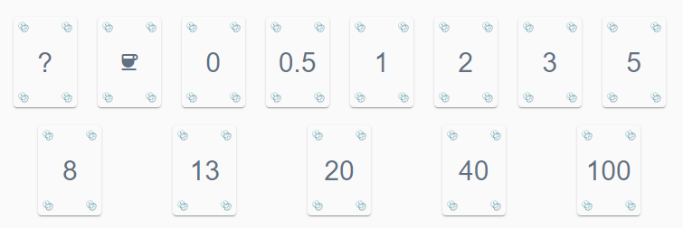

|  |  |  |  |
| --- | --- | --- | --- |
| Tasks no. Final Story Points | Team Member 1: Nasrin | Team Member 2: Bear | Team Member 3: Daryoush |
| 1: 20 (individual) | 40 | 20 | 20 |
| 2: 1 | 0 | 1 | 1 |
| 3: 3 | 100 | 3 | 5 |
| 4: 8 | 40 | 13 | 8 |
| 5: 5 | 20 | 5 | 10 |
| 6: 20 | 20 | 20 | 20 |
| 7: 8 | 8 | 40 | 10 |
| 8: 0.5 | 20 | 0.5 | 13 |
| 9: 8 | 13 | 5 | 8 |
| 10: 8 | 8 | 5 | 10 |
| 11: 13 | 20 | 13 | 13 |
| 12: 20 | 20 | 40 | 20 |
| 13: Cup  cup | 20 | Cup | 3 |
| 14: ___ |  |  |  |
| 15:___ |  |  |  |

**III. Each member picks one or two first tasks to tackle. A Trello board is created, and all the tasks are added to keep track of their progress.**