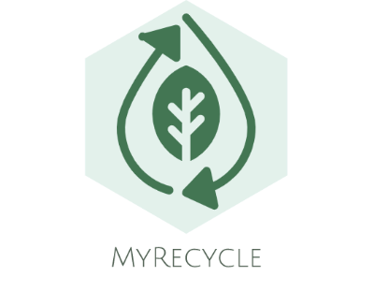

# About this app

MyRecycle is an application that involve both parties from users and company or organisation. It is about people who sell or buy unused things but still can be reused or recycled such as paper, drink can, box, plastic (bottle/egg carton), book, wire, metal, and cloth. Some of user keep the number of recycling company in their phonebook which sometime they can put it everywhere and lose it. Plus, they cannot choose the time to ask recycling person to pickup their recycle thing at any time. However, this application can help user to choose company, date, and time whenever they want to sell their recycle thing. Company or organisation also can manage order from customer online without need to answering call for whole day.

# Features

## Company/Organisation

1. Register company – company able to provide their profile including company name, contact number, address (select from map), and email.
2. Manage category – not all company will buy all type of recycle things as mentioned. Some company might only accept cloth while there are company might not buy cloth as recycle thing. Company should able to provide price for each recycle category per kilogram (kg). However, company able to update price, add or delete the recycle category.
3. Manage slot – company provide date and time as a slot so that user can select available slot to ask for pickup recycle things at their home.
4. Manage order – company can view customer order details such as customer name, address, slot, recycle category, and pickup status.