**Team 4 ChocAn User Manual**

**Main Menu**

When you first launch the ChocAn program, you will be presented with 4 options:

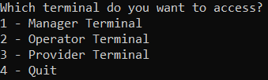

* Entering 1 will bring you to the Manager Terminal
* Entering 2 will bring you to the Operator Terminal
* Entering 3 will bring you to the Provider Terminal
* Entering 4 will close the program

**Manager Terminal**

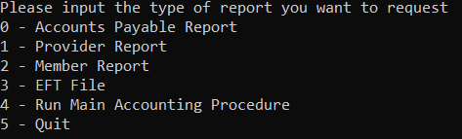

When you enter the Manager Terminal, you are presented with the following 6 options.

* Entering 1, 2, or 3 will generate their respective reports in the form a .txt file
* Entering 4 will act as the “Timer” and generate all the files that result from the Main Accounting Procedure
* Entering 5 will return to the main menu

**Operator Terminal**

When you enter the Operator Terminal, entering 0 will allow you to operate on Member Data, and entering 1 will allow you to operate on Provider Data.

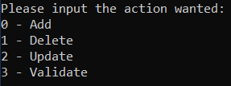

Regardless of whether you choose provider or member, you will be given 4 options:

* Add

To add a member/provider, you must enter the data in the following format:

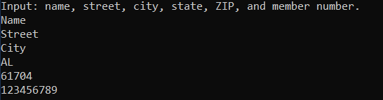

The input must adhere to the following guidelines:

* + Name: >= 25 characters, only letters and spaces
  + Street: >= 25 characters
  + City: >= 14 characters, only letters
  + State: 2 characters, only letters
  + Zip code: 5 characters, only numbers
  + Member/Provider number: 9 characters, only numbers
* Delete

To delete a member/provider, you simply enter the member/provider number of the person you want to delete. If the number exists, they will be deleted, if it doesn’t exist, a message will pop up saying “No such member/provider exists to remove.”

* Update

To update a person you must first enter their member or provider number. You can also enter -1 to exit the update menu. If the member/provider number doesn’t exist, you will be re-prompted to enter it.

You will then be given a list of options, entering 0, 1, 2, 3, or 4, 5will allow you to update name, street, city, state, ZIP, and status respectively.

* Validate

Selecting validate, will prompt you to enter a member/provider number. This will then output a message telling you if the person exists.

**Provider Terminal**

When you enter the provider terminal, you must first enter a valid provider number to continue. Entering a number that doesn’t exist will return you to the main menu. You will then be able to add a service.

First enter a valid member number of the member you wish to add the service to.

The program will then prompt you to enter each value one by one, and will show you the correct format to put each value in.

Service name, service code, and service fee can all be found in “ProviderDirectory.txt”

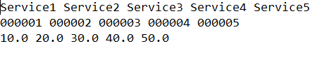

The first line contains the names of the service, the second line contains the service codes, and the third line contains the service fees. The lines are all in order (ex. The first service name on the first line corresponds with the first service code on the second line).

When entering this data in the program, you will first enter one of the above service codes, then the program will ask if the corresponding service name is correct for the code you entered.

You can then add another service or return to the main menu.

**Task Distribution:**

Do Thien An Duong: 20%

* Classes: ManagerTerminal, ProviderTerminal, MainAccountingController, MainApplication
* Unit tests for ServiceController class

Erik Jones: 20%

* Classes: PersonData, MemberData, ProviderData, ServiceData
* User manual
* Unit tests for MemberController class

Jonathan Pence: 20%

* Classes: ReportController, ServiceController, ProviderController, MemberController, IOController
* Integration
* Unit tests for ProviderData class

Lyle Stokes: 20%

* Classes: OperatorTerminal, EFTFileData, MemberReport
* ANT file building
* Unit tests for ServiceData class

Sanghyun Jeon: 20%

* Classes: AccountsPayableReport, ProviderReport, ProviderDirectoryData
* Updated class diagram to reflect changes made in project 4
* Unit tests for ProviderController class