**3rd October**

**End-Game**

**1. White to Play**

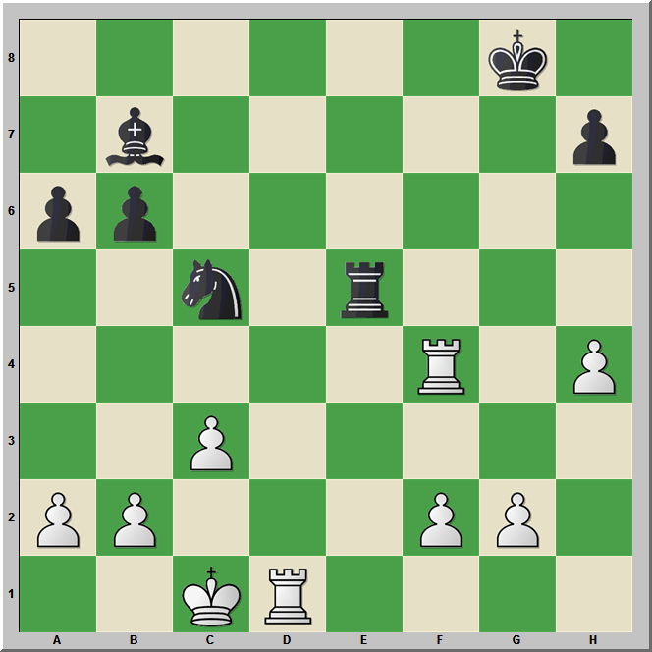

**Middle Game**

**1. Black to Play**

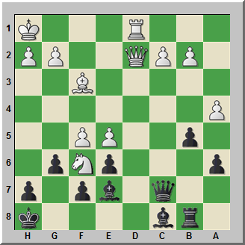

**Find the Continuation**

**Game-1**

**1.e4 e5 2.Nf3 Nc6**

**3.Bb5 a6 4.Ba4 Nf6**

**5.0–0 Be7 6.Re1 b5**

**7.Bb3 0–0 8.c3 d5**

**9.d4 exd4 10.e5 Ne4**

**11.h3**

**Write Best Continuation for Black**

**Opening**

**Sicilian 3. Bc4 [B50]**

**Cicak,Slavko - Jirovsky,Pavel**

**1.e4 c5 2.Nf3 d6 3.Bc4 Nf6 4.c3 e6 5.Qe2 Nc6**

**6.Bb3 d5?!**

[Black should only play this move whenever White has already played d4, since as long as the pawn remains on d2, Black cannot after e5 place his knight on e4 on account of d3. ]

**7.e5 Nd7**

[7...c4 8.exf6 cxb3 9.fxg7 Bxg7 10.axb3²]

**8.d4 Qb6 9.dxc5?**

[This is equivalent to a strategic resignation! After 9.e3 White is of course better.]

[9.Be3! Be7 10.0–0 0–0 11.Nbd2 c4 Or else Black has absolutely nothing. 12.Bc2 Qxb2 13.Nxc4! Qxc3 *(13...dxc4 14.Bxh7+ Kxh7 15.Qxb2+–;*

*13...Qb5 14.Qd3 g6 15.Nd6 Qxd3 16.Bxd3±)*

14.Nd6 Bxd6 15.exd6 Qb4 16.Qd3 g6 17.Bf4°

White has excellent compensation for the pawn.]

**9...Nxc5 10.Bc2 a5 11.0–0 Qa6 12.Qe3 a4 13.Na3 b5 14.Nd4 Nxd4 15.Qxd4 Bd7 16.Be3 Qb7 17.Nb1 Bc6 18.a3 Be7 19.Nd2 Rd8 20.Qg4 g6 21.Nf3 h5 22.Qf4 Ne4 23.h4 Rg8 24.Qh2 Rd7 25.Nd4 Nc5 26.Qg3 Rc7 27.Bg5 Bf8 28.Rfe1 Ne4 29.Bxe4 dxe4 30.Nxc6 Qxc6 31.Rad1 Be7 32.Rd4 Kf8 33.Bf6 Rd7 34.Red1 Rd5 35.Qf4 Bc5 36.R4d2 Be7 37.Bxe7+ Kxe7 38.Qf6+ Ke8 39.Rxd5 1–0**

**Kovanova,Baira Goryachkina,Aleksandra**

**From above game after 6.Bb3 Be7**

[6...d5? 7.e5 Nd7 8.d4 Qb6 9.Be3²]

**7.0–0 0–0 8.d4 cxd4 9.cxd4**

[Now Black must find some way of attacking the white centre.]

**9...d5**

[9...e5 10.dxe5

*(10.Rd1!? Bg4 11.dxe5 Nxe5 12.Bf4! Nxf3+ 13.gxf3 Bh3 14.Nc3²)*

10...dxe5 11.Rd1 Qc7 12.Nc3 Bg4 13.Be3²]

**10.e5 Ne4 11.Bc2!**

[Provoking ...f5 looks very logical.]

[11.Nc3 Nxc3 12.bxc3 Bd7 13.Qd3 Na5 14.Bc2 g6 15.Bh6 Re8÷]

**11...f5**

[In this position the pawn sacrifice does not achieve so much.]

[11...b6 12.Bxe4 dxe4 13.Qxe4 Bb7 14.Nc3²]

**12.exf6 Bxf6 13.Nc3 Nd6**

[13...Nxd4 14.Nxd4 Bxd4 15.Nxe4 dxe4 16.Qxe4 g6 17.Bh6+–;

13...Nxc3 14.bxc3 Bd7 15.Rb1 b6 16.Re1²]

**14.Bf4 Nf5 15.Bxf5 exf5 16.Be5²**

[White has a clear strategic advantage.]

**16...Be6 17.Rfe1 Bf7 18.Qb5 Bh5 19.Qxb7 Bxf3 20.Qxc6 Bxe5 21.Qe6+ Kh8 22.Qxe5 Qg5 23.Qg3 Qxg3 24.hxg3 Bh5 25.Nxd5 Rfd8 26.Nf4 Bf7 27.Re7 Bg8 28.Nh5 g6 29.Nf6 Rxd4 30.Rc1 Rd6 31.Nxg8 Kxg8 32.Rcc7 h5 33.Rxa7 Rc8 34.Re1 Kf8 35.Rae7 Rd2 36.R7e2 Rd4 37.b3 Rd3 38.Rb1 Kf7 39.b4 Ra3 40.b5 Rb8 41.b6 Rb7 42.Rc2 Kf6 43.Rc6+ Kf7 44.Rb2 Ra6 45.f3 g5 46.Rb5 f4 47.Rf5+ Ke7 48.Rxg5 Raxb6 49.Rxb6 Rxb6 50.gxf4 1–0**

Answers

**1, Mate in Two Moves**

**White to Play**

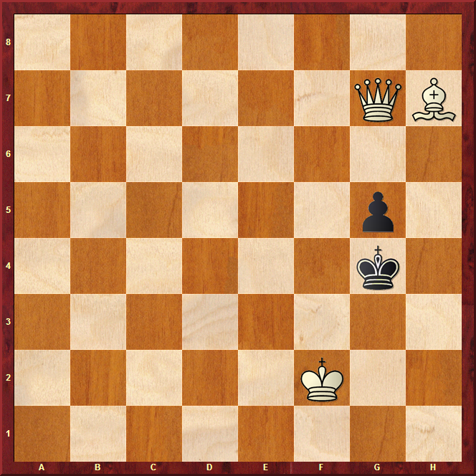

1 Qh8 !!

**2, White to Play**

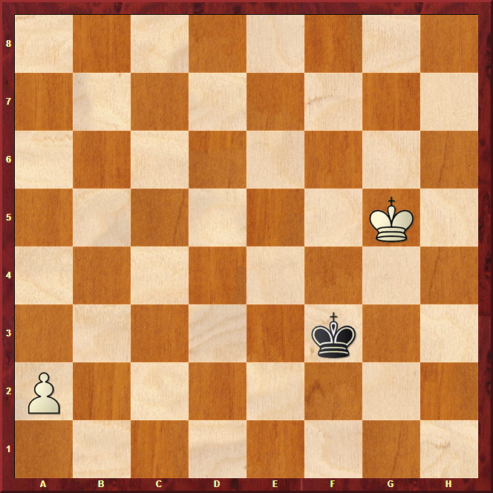

1 Kf5 Ke3 2 Ke5 Kd3 3 Kd5 Kc3 4 Kb2 a4!!+-

**3, White to Play**

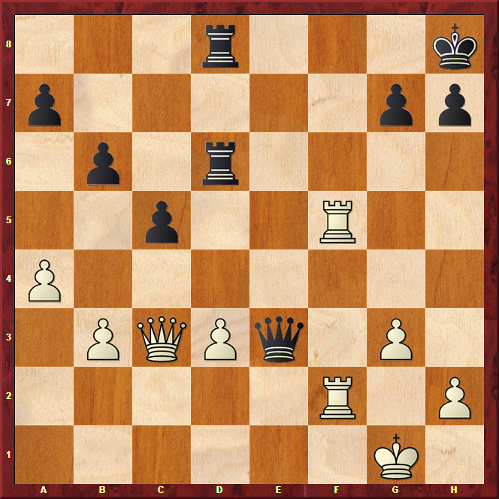

**1 Qe5 !!**