

**Create Pokémon with machine learning**

**Documentation**

**2020**

**Installing anaconda on Windows**

1. Go to anaconda website <https://www.anaconda.com/> and click download
2. Click windows and press downloads under python version 3.7.
3. Double click the installer to launch.
4. Click Next.
5. Read the licensing terms and click “I Agree”.
6. Select an install for “Just Me” unless you’re installing for all users (which requires Windows Administrator privileges) and click Next.
7. Select a destination folder to install Anaconda and click the Next button.
8. Choose to add Anaconda to your PATH environment variable, choose to add anaconda as your default Python 3.7 and press install.

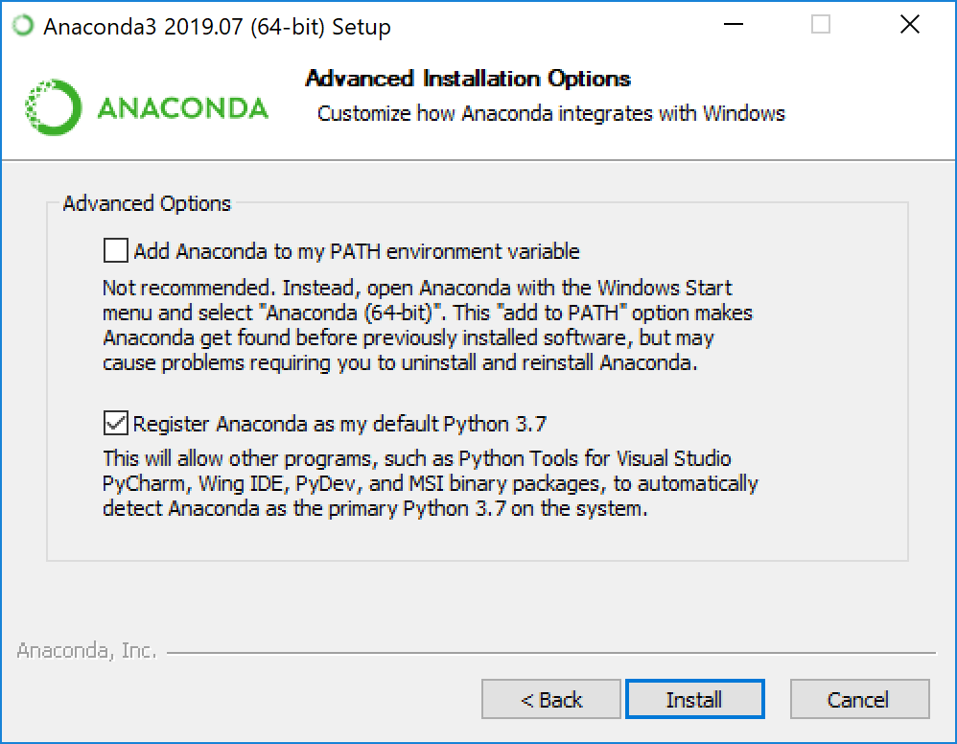

1. Click next to install anaconda without PyCharm.
2. After successful installation press finish.

**Installing Dependencies**

* Click Start, search or select Anaconda Prompt from the menu.
* First, create a virtual environment in which the dependencies will be installed,
  + Conda create - -name [NameOfEnvironment] python=3.x
* In anaconda prompt install the given dependencies,
  + conda install -c pytorch pytorch
  + conda install torchvision -c pytorch
* You can also to verify the installation of the packages you can use the command given below.
  + conda list