East West University
Department of Computer Science and Engineering

Software Requirements Specification (SRS) & Analysis Report
CSE-347 | Section: 04

Integrated Emergency Alert and Response Information System

Submitted By
Team E

Aninda Saha Akash (ID: 2023-3-60-474)
Abdullah al Numan (ID: 2023-3-60-468)
Sadia khan Farhin (ID: 2023-3-60-539)
Nasheba afrin Ruba (ID: 2023-3-60-462)

Submitted To
Yasin Sazid
Department of Computer Science and Engineering
East West University

Submission Date: 20 April 2026

List of Figures and Tables

List of Figures

Figure 2.1: Use Case Diagram – Level 0 (Overall System)
Figure 2.2: Use Case Diagram – Level 1 (Main Modules)
Figure 2.3: Use Case Diagram – Level 1.1 (User & Account Management)
Figure 2.4: Use Case Diagram – Level 1.2 (Dashboard)
Figure 2.5: Use Case Diagram – Level 1.3 (Disaster Monitoring & Alert Management)
Figure 2.6: Use Case Diagram – Level 1.4 (Emergency Response Coordination)
Figure 2.7: Use Case Diagram – Level 1.5 (Volunteers Management)
Figure 2.8: Use Case Diagram – Level 1.6 (Relief Distribution Management)
Figure 2.9: Use Case Diagram – Level 1.7 (Shelter & Camp Management)
Figure 2.10: Use Case Diagram – Level 1.8 (Admin Panel)
Figure 2.11: Activity Diagram – User Registration & Login
Figure 2.12: Activity Diagram – Disaster Alert Monitoring
Figure 2.13: Activity Diagram – Emergency Request Submission
Figure 2.14: Activity Diagram – Relief Distribution
Figure 2.15: Activity Diagram – Volunteer Task Assignment
Figure 3.1: Class Diagram of the Integrated Emergency Alert and Response Information System
Figure 4.1: State Diagram – User Authentication and Account Management Class
Figure 4.2: State Diagram – Profile Management Class
Figure 4.3: State Diagram – Change Password Class
Figure 4.4: State Diagram – Account Status Class
Figure 4.5: State Diagram – Earthquake Early Warning and Alert Management Class
Figure 4.6: State Diagram – Integrated Emergency Service Communication Class
Figure 4.7: State Diagram – Account Based Device Tracking and Recovery Class
Figure 4.8: State Diagram – Natural Disaster Monitoring and Emergency Response Class
Figure 4.9: UML Sequence Diagram – Integrated Emergency Alert and Response Information System

List of Tables

Table 3.1: Noun Analysis Table
Table 3.2: Verb Analysis Table
Table 3.3: Noun Classification Table
Table 3.4: Noun Selection Criteria Table
Table 3.5: Class Cards
Table 3.6: CRC Cards

Chapter 1. Introduction

1.1 Project Overview
The Integrated Emergency Alert and Response Information System is a comprehensive digital platform designed to enhance national disaster preparedness, response coordination, and public safety communication in Bangladesh and similar developing nations. The system serves as a centralized hub that bridges the gap between government emergency management agencies, first responders, volunteers, and the general public during natural and man-made disasters.

The primary objective of this system is to reduce response time, improve situational awareness, and facilitate effective resource allocation during emergencies such as earthquakes, floods, cyclones, and other crisis events. By leveraging real-time seismic monitoring, automated alert generation, multi-channel notification delivery, and integrated emergency service communication, the platform empowers both authorities and civilians to act swiftly and decisively when disaster strikes.

The system incorporates several key functional modules: user authentication and account management, earthquake early warning and alert distribution, flood and cyclone monitoring, integrated emergency service communication (covering fire, medical, search and rescue, and law enforcement), volunteer management, relief distribution tracking, shelter and camp management, account-based device tracking and recovery, and a robust administrative control panel. Together, these modules form a unified ecosystem that supports the entire lifecycle of emergency response — from pre-disaster monitoring and alert dissemination to post-disaster recovery coordination.

Beyond technical capability, the system prioritizes accessibility and ease of use, ensuring that individuals with varying levels of digital literacy can register, receive timely alerts, submit emergency requests, and access life-saving guidance. The platform is designed to operate reliably even under high-load conditions that typically accompany major disaster events, making resilience and availability core architectural principles.

1.2 Stakeholders
The system involves the following primary stakeholders, each with distinct roles, responsibilities, and interaction patterns:

General Users (Public): Citizens who register on the platform to receive disaster alerts, submit emergency requests, view shelter information, track relief distribution updates, and access safety guidelines. They are the primary beneficiaries of the system and the most numerous user group.

Volunteers: Registered and verified individuals who assist in disaster response efforts. They receive task assignments from administrators, participate in relief delivery, support shelter operations, and update task completion statuses through the platform.

Rescue Teams: Specialized emergency response units responsible for conducting search and rescue operations, dispatching personnel to affected areas, updating operation statuses, and coordinating with the administrative authority during crisis events.

Administrators: System operators and emergency management officials who monitor disaster data, create and distribute alerts, manage user roles, approve volunteer registrations, oversee relief distribution, assign rescue teams, manage shelter capacities, and generate system reports. They hold the highest level of system authority and are responsible for overall platform governance.

1.3 Requirements

Normal Requirements
Normal requirements represent the basic, expected functionalities that the system must provide as a minimum viable product. These are features users assume will be present in any emergency management platform:

- Users must be able to register an account using their phone number, NID, Gmail, and password, with OTP-based verification.
- The system must allow users to log in securely and access a personalized dashboard.
- Administrators must be able to monitor seismic and natural disaster data in real time.
- The system must generate and distribute earthquake, flood, and cyclone alerts to registered users via push notifications.
- Users must be able to submit emergency requests specifying the type of emergency (fire, medical, search and rescue, or law enforcement).
- Volunteers must be able to register, view assigned tasks, and update task statuses.
- The system must allow administrators to manage rescue team deployment and track operational status.
- Users must be able to view available shelters and camp information, including capacity and location.
- The system must support relief distribution tracking, allowing administrators to assign and monitor distribution tasks.
- Administrators must be able to generate and export system reports for operational review.

Expected Requirements
Expected requirements represent capabilities that users anticipate beyond the basics, which significantly enhance the utility and trustworthiness of the platform:

- Security: All user data, communications, and system transactions must be protected through encryption and secure authentication protocols.
- Real-Time Notifications: Alerts must be delivered to users within seconds of detection and administrative approval.
- Role-Based Access Control: Different user roles (User, Volunteer, Rescue Team, Admin) must have access only to features relevant to their responsibilities.
- Profile Management: Users must be able to update their profile picture and personal information.
- Device Tracking and Recovery: The system should support account-based device location tracking and allow users to mark devices as secured.
- Multi-Disaster Support: The platform must simultaneously monitor and respond to multiple distinct disaster types (earthquake, flood, cyclone) without performance degradation.
- Volunteer Approval Workflow: Volunteer registrations must go through an administrative approval process before task assignment becomes available.
- Shelter Availability Checking: The system must dynamically update and display shelter occupancy and availability.

Extraordinary Requirements
Extraordinary requirements represent advanced capabilities that go beyond standard expectations and significantly differentiate this system:

- Earthquake Early Warning Integration: The system integrates with seismic monitoring infrastructure to automatically detect seismic events and trigger alert generation workflows without manual intervention.
- Multi-Agency Emergency Service Coordination: A single interface consolidates communication with fire services, medical/ambulance services, search and rescue operations, and law enforcement, enabling seamless multi-agency coordination.
- Automated Safety Instruction Generation: Upon disaster event creation, the system automatically dispatches categorized safety instructions relevant to the disaster type to all affected users.
- Real-Time Rescue Operation Tracking: Rescue teams update operation progress in real time, and administrators can monitor all active operations from a centralized dashboard.
- Location-Based Shelter Mapping: Shelters and camps are displayed on an interactive map, with GPS coordinates enabling users to identify the nearest available refuge.
- System-Wide Reporting and Analytics: The platform generates comprehensive operational summaries covering rescue data, distribution records, volunteer performance, and emergency logs for post-disaster analysis.

1.4 User Story
The Integrated Emergency Alert and Response Information System is envisioned as a national-scale emergency management platform designed to protect lives, coordinate resources, and reduce human suffering during disaster events. The following narrative describes how each type of user interacts with the system in a realistic emergency scenario.

The General User Experience:
Consider Rahim, a resident of a coastal district in Bangladesh prone to cyclones and flooding. After hearing about the new government emergency platform, Rahim downloads the app and registers by entering his phone number. The system sends an OTP for verification. Upon confirming, Rahim provides his NID number and Gmail address, sets a password, and completes registration. He is now part of the emergency alert network.

When the meteorological department detects an approaching cyclone, the administrator creates a Cyclone Alert through the system. Cyclone Emergency Management protocols are activated. Rahim receives an instant push notification on his phone titled "CYCLONE ALERT" with safety instructions and the location of the nearest shelter camp. He navigates to the shelter section of the app, sees that Camp B has available capacity, and heads there safely. During the storm, Rahim uses the emergency request feature to request medical assistance for an injured neighbor. The system routes the request to the medical ambulance service, which dispatches help.

After the storm, Rahim tracks the relief distribution status through the app. He can see that relief packages have been assigned to his area and when delivery is expected. He also views his device tracking section when his phone goes missing after the disaster, marks it as sought, and later confirms recovery.

The Volunteer Experience:
Fatema is a university student who wants to contribute during disaster relief. She registers on the platform as a volunteer, providing her personal details and area of availability. The administrator reviews her application and approves her volunteer status. When a flood affects a nearby district, the administrator assigns Fatema a relief delivery task through the Volunteer Task module. She receives the assignment notification on her dashboard, accepts the task, confirms delivery upon completion, and updates the task status. This real-time update allows the administrator to track progress and reassign resources as needed.

The Rescue Team Experience:
Team Alpha is a search and rescue unit connected to the system. When an earthquake is detected and the administrator creates an Earthquake Alert, the system notifies the admin, who then assigns Team Alpha to a rescue operation in the affected area. The team lead receives the assignment, confirms the team assignment, and begins the operation. Throughout the rescue, the team updates operational status through the system. Upon completion, the team marks the operation as resolved, triggering the release of team members and a final status update to the administrator.

The Administrator Experience:
The administrator serves as the nerve center of the entire operation. From the Admin Panel, they monitor incoming seismic data and meteorological feeds. When an alert threshold is triggered, they define the alert level and target area, issue the alert, and push notifications to all registered users in the affected region. They simultaneously coordinate rescue team dispatch, approve volunteer deployments, manage shelter registrations, oversee relief distribution assignments, and respond to emergency service requests. At the conclusion of a disaster event, the administrator generates a comprehensive System Report covering all rescue operations, distribution records, volunteer summaries, and emergency logs, which serves as official documentation for post-disaster review and future planning.

This integrated approach ensures that no stakeholder operates in isolation. The system creates a unified, data-driven emergency management ecosystem that dramatically improves the speed, transparency, and effectiveness of disaster response in Bangladesh.

Chapter 2. Scenario Based Modeling

2.1 Use Case Modeling
Use case modeling captures the functional requirements of the Integrated Emergency Alert and Response Information System by describing the interactions between actors and the system. The system involves four primary actors: User (general public), Volunteer, Rescue Team, and Administrator. The use case diagrams are presented at multiple levels of abstraction, from a high-level overview down to detailed module-specific interactions.

The Level 0 diagram provides the broadest view, showing all four actors interacting with the overarching system boundary. At Level 1, eight primary functional modules are identified: User and Account Management, Dashboard, Disaster Monitoring and Alert Management, Emergency Response Coordination, Volunteer Management, Relief Distribution Management, Shelter and Camp Management, and the Admin Panel. Each of these modules is further elaborated at deeper levels.

Actors and Their Roles:

User: Registers an account, logs in, views earthquake and disaster alerts, submits emergency requests, tracks request status, views shelter information, checks relief distribution updates, manages profile, changes password, tracks devices, and logs out.

Volunteer: Registers as a volunteer, views assigned tasks, updates task status, delivers relief items, and coordinates with shelter management activities.

Rescue Team: Receives emergency request assignments, dispatches personnel, updates rescue status, views emergency requests, and requests volunteer backup when needed.

Administrator: Manages all users and roles, monitors disaster data, creates and distributes alerts, assigns rescue teams, manages volunteers, oversees relief distribution and shelter camps, and generates system reports.

The following descriptions elaborate the key use cases within each major module:

Level 1.1 – User and Account Management:
This module covers the complete lifecycle of user accounts. Users can register accounts with OTP verification, validate their identity with NID and email, log in to their dashboard, change passwords through multiple secure methods (current password verification, phone OTP, or Gmail OTP), forget and reset passwords, and deactivate or reactivate their accounts. Administrators can manage all user roles from this module, and rescue teams and volunteers are also recognized as actors for certain account operations.

Level 1.2 – Dashboard:
The dashboard serves as the central hub for authenticated users. From here, users can view and edit their profile, monitor earthquake alerts, view all active alerts and notifications, submit emergency requests (which include providing location details), track the status of submitted requests, view shelter information and locations on the map, check relief distribution updates, view assigned tasks (for volunteers), and log out. The dashboard also includes the ability to view shelter locations on a map, which extends to map-based location services.

Level 1.3 – Disaster Monitoring and Alert Management:
This module is primarily administrator-driven. The administrator monitors incoming disaster data from connected monitoring sources, creates and issues alerts for specific disaster types, sets the alert level, selects the geographic target area, sends alert notifications to all affected users, and updates alert levels as the situation evolves. Users can view issued alerts and access safety instructions, which is an extended function of the alert viewing capability.

Level 1.4 – Emergency Response Coordination:
This module governs the coordination of emergency response activities. Volunteers can report emergency incidents and view emergency requests. The administrator assigns rescue teams and dispatches them to affected areas. Rescue teams update their rescue operation status, view incoming emergency requests, request volunteer support when required, and dispatch assistance. The Dispatch Rescue Team use case involves an include relationship with the Assign Rescue Team use case, and the Request Volunteer Support includes a dispatch sub-function.

Level 1.5 – Volunteer Management:
Users can register as volunteers through this module. Administrators approve volunteer registrations after review, view the complete volunteer list, and assign volunteer tasks. Volunteers themselves can view their assigned tasks, update task statuses, and view the volunteer list. The Assign Volunteer Task use case includes a View Volunteer List sub-function.

Level 1.6 – Relief Distribution Management:
Users can request relief aid through this module. Administrators approve relief requests, assign distribution tasks, and monitor distribution status. Volunteers deliver relief items (extending their task assignment) and update distribution status. The Deliver Relief Items use case has an include relationship with Assign Distribution Task.

Level 1.7 – Shelter and Camp Management:
Users can view available shelters and register their camp, which includes checking shelter availability as a sub-function. Volunteers assist in managing shelter activities and can assign themselves to shelters (extending the general Assign Volunteers to Shelter function managed by administrators). Administrators update shelter capacity and manage overall shelter assignments. The system ensures real-time visibility of shelter occupancy to help users locate available refuge during disasters.

Level 1.8 – Admin Panel:
The Admin Panel provides the administrator with full system governance capabilities. The administrator can suspend or activate users (both functions extending the central Manage Users capability), update system configuration (which includes managing system settings), manage alert settings, view system reports, and monitor all system activity. The system configuration update and system settings management are linked through an include relationship.

The complete use case diagrams for all levels are presented in Figures 2.1 through 2.10 below.
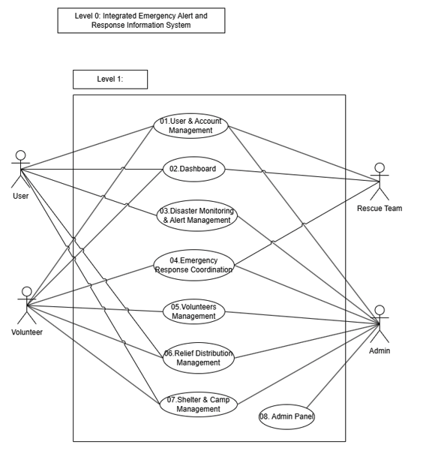
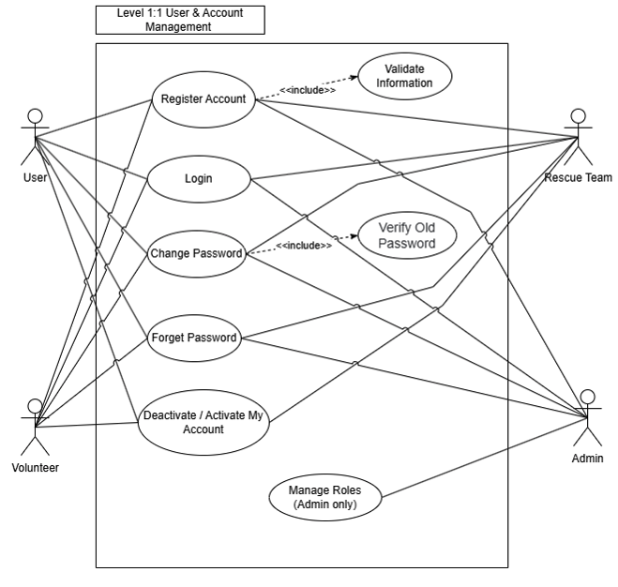
Figure 2.1: Use Case Diagram – Level 0 (Overall System) and Level 1 (Main Modules)

Figure 2.2: Use Case Diagram – Level 1.1 (User & Account Management)
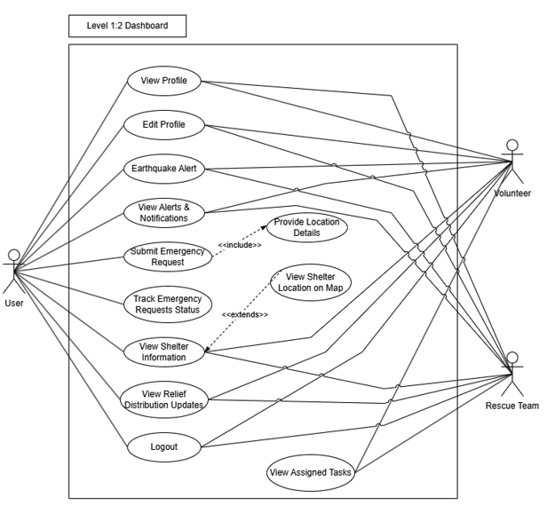
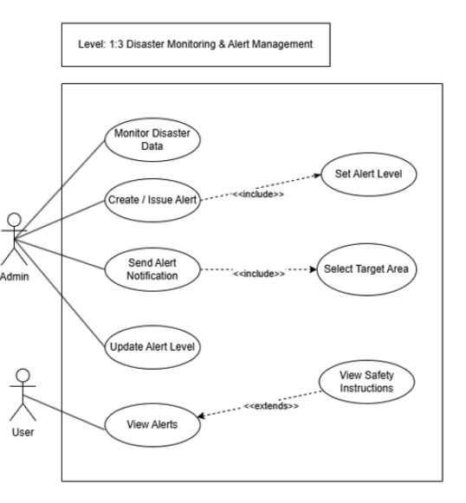
Figure 2.3: Use Case Diagram – Level 1.2 (Dashboard)

Figure 2.4: Use Case Diagram – Level 1.3 (Disaster Monitoring & Alert Management)

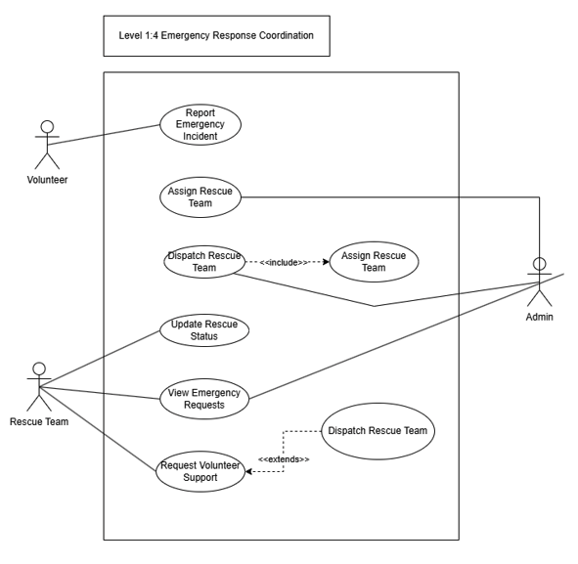
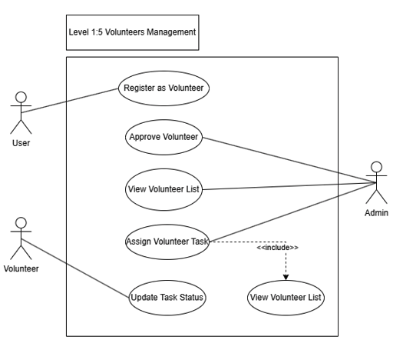
Figure 2.5: Use Case Diagram – Level 1.4 (Emergency Response Coordination)

Figure 2.6: Use Case Diagram – Level 1.5 (Volunteers Management)
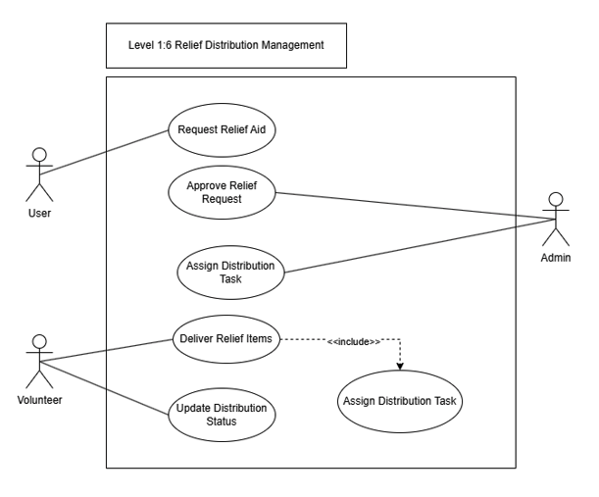
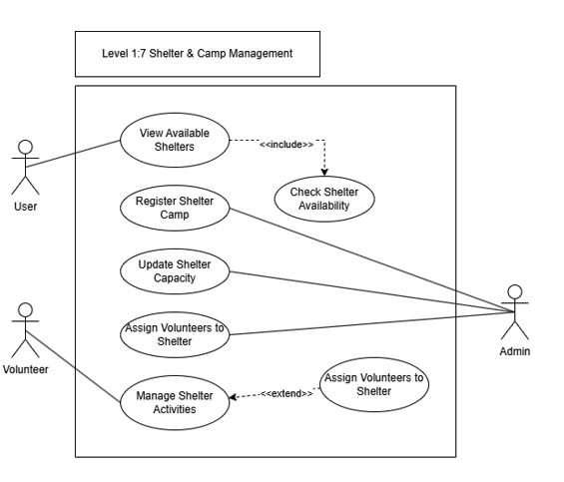
Figure 2.7: Use Case Diagram – Level 1.6 (Relief Distribution Management)

Figure 2.8: Use Case Diagram – Level 1.7 (Shelter & Camp Management)
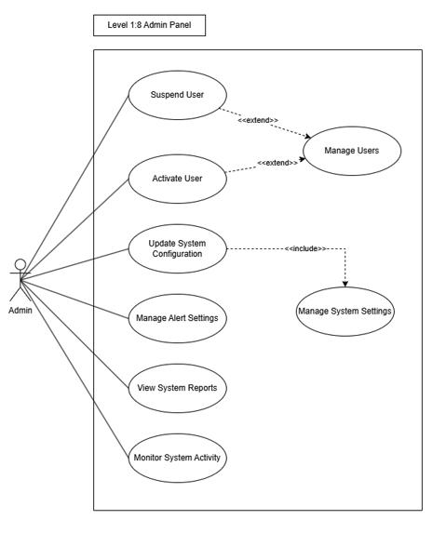
Figure 2.9: Use Case Diagram – Level 1.8 (Admin Panel)

2.2 Activity Modeling
Activity diagrams model the dynamic workflow of key system processes, illustrating the sequence of actions, decision points, and parallel flows involved in critical system operations. Since activity diagrams were not provided for this system, the following descriptions are derived from the use case and sequence diagrams and represent the logical workflow of each major process.

Activity 1 – User Registration and Login:
The registration process begins when a user opens the application. The user initiates the Sign Up flow by entering their phone number. The system sends an OTP, which the user submits for verification. Upon successful OTP verification, the system automatically detects it and advances to the NID submission step. The user provides their National ID number, clicks Next, then provides their Gmail address, and proceeds to the Set Password stage. After the user confirms their password, registration is complete and the system redirects them to the Login page. The user enters their credentials; if valid, they are granted access to the Dashboard. If login fails, the user is returned to the Logging In state. A user can cancel at any point and return to the Offline state.

Activity 2 – Disaster Alert Generation and Distribution:
Disaster alert generation begins when the monitoring subsystem detects a seismic event or natural disaster risk indicator. For earthquakes, the system transitions from the Monitoring Seismic Data state to the Earthquake Detected state. The administrator then defines the alert level and target geographic area, which triggers Create Earthquake Alert. The system records the generated alert, notifies the administrator, and transitions to the Alert Distributed state. A push notification is sent to all registered users in the target area, and users transition to the User Views Earthquake Alert state. A similar parallel flow exists for floods and cyclones through the Natural Disaster Monitoring module, where detected risks branch into Flood Emergency Management or Cyclone Emergency Management, each sending alerts and providing categorized safety guidelines.

Activity 3 – Emergency Request Submission and Response:
A user who requires emergency assistance navigates to the Emergency Request section of the Dashboard. The user selects the type of emergency: Fire Service, Medical/Ambulance, Search and Rescue, or Law Enforcement. Upon selection, the system captures the user's location and submits the emergency request. The request is flagged if it contains any false alert indicators; otherwise, it is forwarded to the administrative dashboard. The administrator reviews the request, assigns the appropriate rescue team, and dispatches them. The rescue team begins the operation, updates progress, and marks it complete upon resolution. The user is notified of the status updates throughout this process.

Activity 4 – Volunteer Task Assignment and Completion:
A volunteer accesses the system after receiving administrator approval of their registration. The administrator creates a volunteer task, specifying the task description, assigned area, and deadline. The system notifies the volunteer, who accepts the task from their dashboard. If the volunteer is unavailable, the administrator is notified and may reassign the task to another available volunteer. Upon accepting, the volunteer performs the task (such as relief delivery or shelter support) and updates the task status to completed. The administrator receives the completion update and records it in the system.

Activity 5 – Relief Distribution:
The relief distribution process begins when a user submits a Relief Request through the Dashboard. The request is logged in the system with the user's details, requested item type, and quantity. The administrator reviews the request, approves it, and creates a distribution task. The task is assigned to an available volunteer. If shelter support is required, the system coordinates shelter resources simultaneously. The volunteer receives the distribution task, performs delivery, and marks the task complete. The system updates the distribution status, and the user can view the updated distribution record through their dashboard. The administrator monitors all distribution activities and can reassign tasks if delivery is delayed.

The described activities collectively represent the core operational workflows of the system and reflect the integration between all major modules. Detailed activity diagrams capturing these flows are referenced as Figures 2.11 through 2.15.

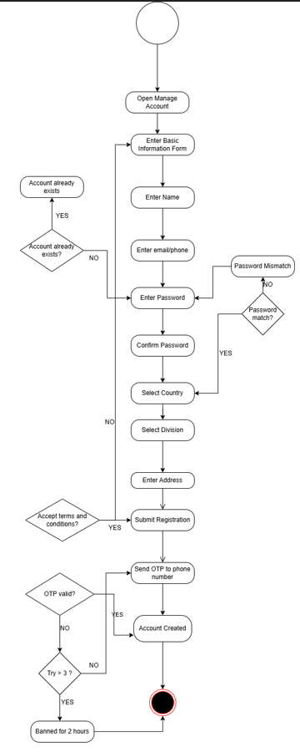

Figure 2.11: Activity Diagram – User Registration and Login

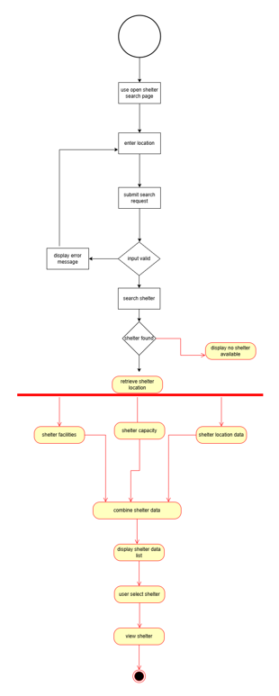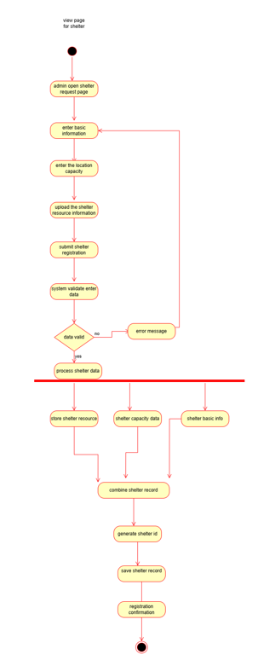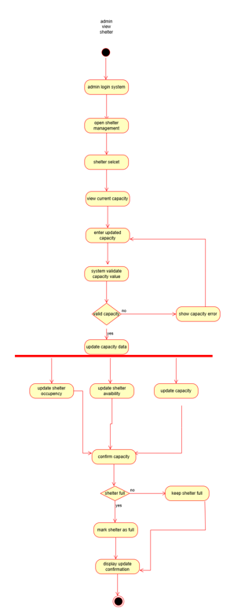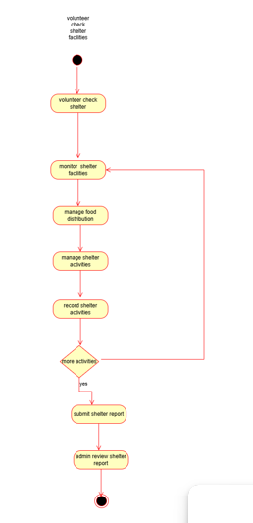

Figure 2.12: Activity Diagram – Manage Shelter camp

Figure 2.13: Activity Diagram – Emergency Request Submission and Response

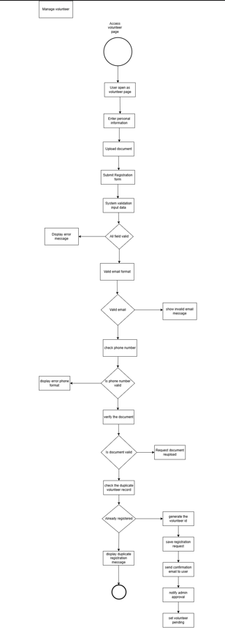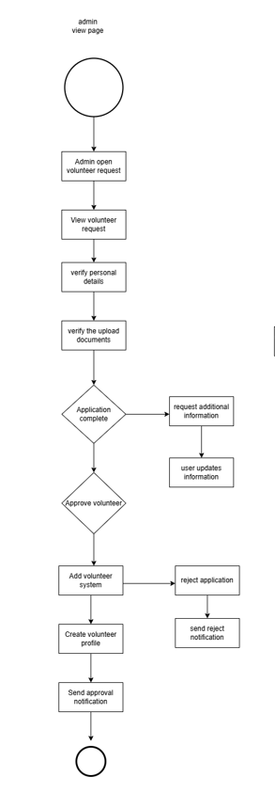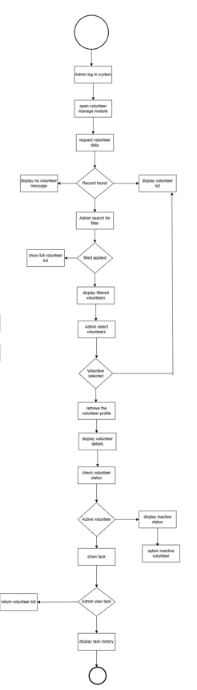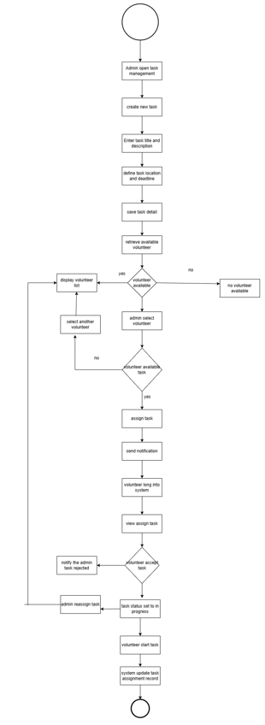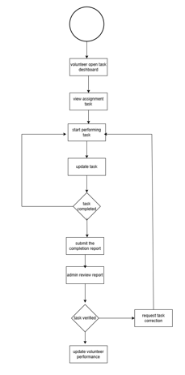
Figure 2.14: Activity Diagram – Volunteer Task Assignment and Completion
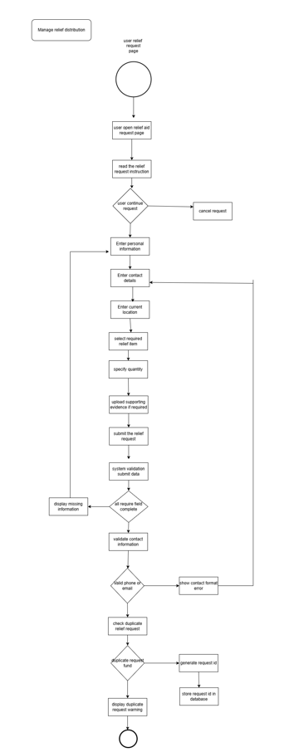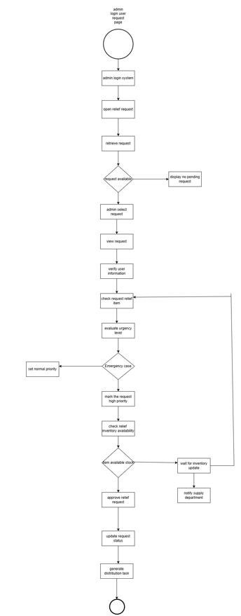

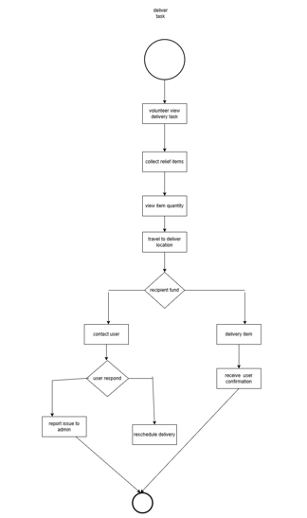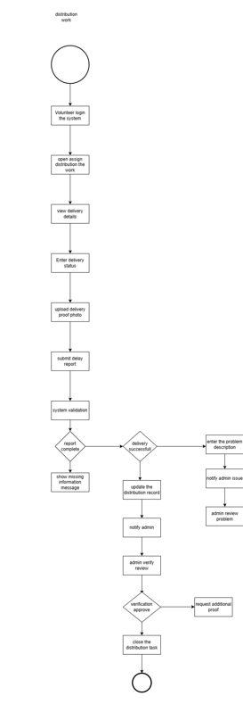
Figure 2.15: Activity Diagram – Relief Distribution

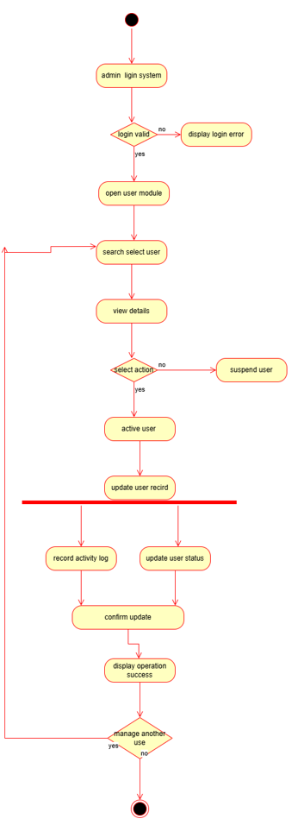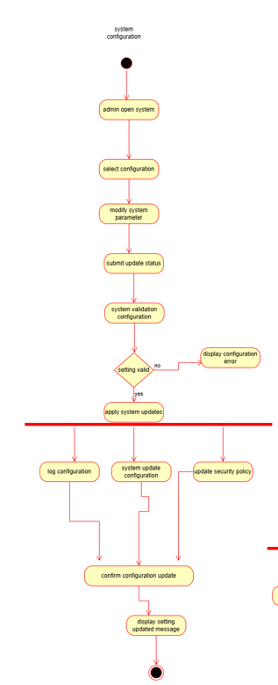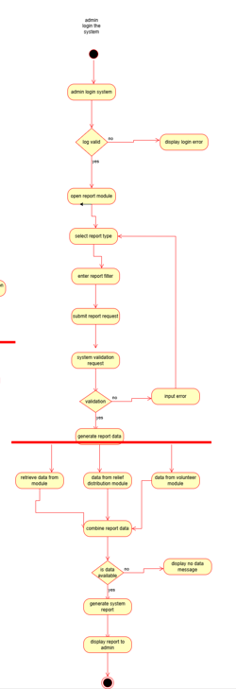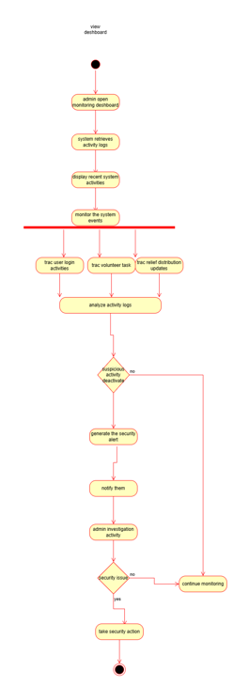
Figure 2.13: Activity Diagram – Admin Panel Control

Chapter 3. Class Based Modeling

3.1 Analysis Classes
Class-based modeling begins with the identification of candidate classes through the analysis of nouns and verbs extracted from the system requirements and user stories. Two analysis tables are constructed: a Noun Analysis Table, which identifies potential object classes from the system domain, and a Verb Analysis Table, which identifies operations and behaviors that these classes must support.

The noun analysis identifies key domain objects that may become classes in the system. These nouns are drawn from stakeholder descriptions, use case narratives, and system interaction scenarios. Each noun is evaluated based on its relevance, persistence, and role within the system domain.

Table 3.1: Noun Analysis Table
No. | Noun | No. | Noun
1 | User | 21 | Alert
2 | Admin | 22 | DisasterEvent
3 | Volunteer | 23 | SafetyInstruction
4 | Rescue Team | 24 | Notification
5 | OTPVerification | 25 | EmergencyRequest
6 | Account | 26 | RescueOperation
7 | Profile | 27 | ReliefRequest
8 | Password | 28 | ReliefDistribution
9 | Dashboard | 29 | VolunteerTask
10 | Location | 30 | Shelter
11 | Phone Number | 31 | ShelterCamp
12 | Gmail | 32 | SystemReport
13 | NID | 33 | Device
14 | Session | 34 | Map
15 | Role | 35 | Push Notification
16 | Permission | 36 | Seismic Data
17 | Earthquake | 37 | Flood
18 | Cyclone | 38 | Safety Guideline
19 | Fire Service | 39 | Medical Ambulance
20 | Search & Rescue | 40 | Law Enforcement

The verb analysis identifies actions and operations that the system and its actors must perform. These verbs form the basis for the methods that will be defined on each class. Each verb is associated with at least one identified actor or system function.

Table 3.2: Verb Analysis Table
No. | Verb | No. | Verb
1 | register() | 21 | monitor_disaster_data()
2 | login() | 22 | create_alert()
3 | logout() | 23 | set_alert_level()
4 | verify_otp() | 24 | send_notification()
5 | change_password() | 25 | submit_emergency_request()
6 | reset_password() | 26 | assign_rescue_team()
7 | update_profile() | 27 | start_rescue_operation()
8 | upload_picture() | 28 | complete_rescue_operation()
9 | deactivate_account() | 29 | register_volunteer()
10 | reactivate_account() | 30 | approve_volunteer()
11 | track_device() | 31 | assign_volunteer_task()
12 | mark_device_secured() | 32 | update_task_status()
13 | view_dashboard() | 33 | request_relief()
14 | view_alert() | 34 | approve_relief_request()
15 | view_shelter() | 35 | assign_distribution_task()
16 | submit_relief_request() | 36 | deliver_relief()
17 | view_relief_update() | 37 | update_distribution_status()
18 | view_shelter_location() | 38 | register_shelter_camp()
19 | generate_report() | 39 | check_shelter_availability()
20 | detect_seismic_event() | 40 | view_system_report()

3.2 CRC Cards
Following noun and verb analysis, candidate classes are classified using Rumbaugh's seven general classification categories: (1) External Entities, (2) Things, (3) Events, (4) Roles, (5) Organizational Units, (6) Places, and (7) Structures. This classification helps to determine the nature and purpose of each candidate class and guides the selection process.

Table 3.3: Noun Classification Table
Noun | General Classification
User | 4, 5, 7 – Role, Organizational Unit, Structure
Admin | 4, 5, 7 – Role, Organizational Unit, Structure
Volunteer | 4, 5, 7 – Role, Organizational Unit, Structure
Rescue Team | 4, 5, 7 – Role, Organizational Unit, Structure
OTPVerification | 2, 3 – Thing, Event
Account | 2, 7 – Thing, Structure
Alert | 2, 3 – Thing, Event
DisasterEvent | 2, 3 – Thing, Event
EmergencyRequest | 2, 3 – Thing, Event
RescueOperation | 2, 3 – Thing, Event
ReliefRequest | 2, 3 – Thing, Event
ReliefDistribution | 2, 3 – Thing, Event
VolunteerTask | 2, 3 – Thing, Event
SafetyInstruction | 2 – Thing
Notification | 1, 3 – External Entity, Event
Location | 2, 7 – Thing, Structure
Shelter | 2 – Thing
ShelterCamp | 2 – Thing
SystemReport | 2 – Thing

Classes are then selected based on six criteria developed by Coad and Yourdon. A class must satisfy approximately three or more of the following criteria to qualify for inclusion: (1) retain information, (2) provide needed services, (3) have multiple attributes, (4) have common attributes across instances, (5) have common operations, and (6) represent an essential system requirement.

Table 3.4: Noun Selection Criteria Table
Noun | Selection Criteria | Status
User | 1, 2, 3, 4, 5, 6 | SELECTED
Admin | 1, 2, 3, 4, 5, 6 | SELECTED
Volunteer | 1, 2, 3, 4, 5, 6 | SELECTED
Rescue Team | 1, 2, 3, 4, 5, 6 | SELECTED
OTPVerification | 1, 2, 3, 6 | SELECTED
Account | 1, 2, 3, 4, 6 | SELECTED
Alert | 1, 2, 3, 6 | SELECTED
DisasterEvent | 1, 2, 3, 6 | SELECTED
EmergencyRequest | 1, 2, 3, 6 | SELECTED
RescueOperation | 1, 2, 3, 6 | SELECTED
ReliefRequest | 1, 2, 3, 6 | SELECTED
ReliefDistribution | 1, 2, 3, 6 | SELECTED
VolunteerTask | 1, 2, 3, 6 | SELECTED
SafetyInstruction | 1, 2, 6 | SELECTED
Notification | 2, 5, 6 | SELECTED
Location | 1, 3 | NOT SELECTED
Shelter | 1, 2, 3, 6 | SELECTED
ShelterCamp | 1, 2, 3, 6 | SELECTED
SystemReport | 1, 2, 6 | SELECTED
Map | 1, 6 | NOT SELECTED

CRC (Class-Responsibility-Collaborator) Cards define the responsibilities of each selected class and identify the classes it must collaborate with to fulfill those responsibilities. The following CRC cards describe the key classes in the system:

Class: User
Responsibilities | Collaborators
Account registration and login | OTPVerification
Profile management | Account
Password management | EmergencyRequest
Viewing alerts and dashboard | Alert
Submitting emergency requests | Notification
Tracking device recovery | Shelter
Viewing shelter and relief info | ReliefDistribution

Class: Admin
Responsibilities | Collaborators
User role management | User
Volunteer approval | Volunteer
Alert creation and management | RescueTeam
Rescue team assignment | Alert
Relief distribution oversight | DisasterEvent
Shelter management | ReliefDistribution
System report generation | SystemReport

Class: Volunteer
Responsibilities | Collaborators
Volunteer registration | VolunteerTask
Task acceptance and completion | ReliefDistribution
Relief delivery | Shelter
Shelter support coordination | Admin
Task status updates | Notification

Class: OTPVerification
Responsibilities | Collaborators
OTP generation and sending | User
OTP verification | Notification
OTP expiration management
OTP resend handling

Class: Alert
Responsibilities | Collaborators
Alert creation and issuance | Admin
Alert level configuration | DisasterEvent
Target area specification | Notification
Alert distribution to users | SafetyInstruction
Alert status updates | User

Class: DisasterEvent
Responsibilities | Collaborators
Disaster data recording | Alert
Event severity assessment | Admin
Event details validation | SafetyInstruction
Event resolution marking | Notification

Class: EmergencyRequest
Responsibilities | Collaborators
Request submission | User
Request type selection | RescueOperation
Request status tracking | Admin
Request cancellation | Notification

Class: RescueOperation
Responsibilities | Collaborators
Operation initiation | EmergencyRequest
Rescue team assignment | RescueTeam
Operational status updates | Admin
Operation completion | VolunteerTask

Class: ReliefDistribution
Responsibilities | Collaborators
Relief task assignment | Volunteer
Delivery tracking | Admin
Distribution status updates | ReliefRequest
Completion reporting | SystemReport

Class: VolunteerTask
Responsibilities | Collaborators
Task creation | Volunteer
Task assignment to volunteer | Admin
Task status management | Notification
Volunteer reassignment | ReliefDistribution

Class: Shelter
Responsibilities | Collaborators
Shelter information management | ShelterCamp
Capacity management | Admin
Availability checking | Volunteer
 | User

Class: SystemReport
Responsibilities | Collaborators
Report generation | Admin
Report viewing and export | RescueOperation
Data aggregation from operations | ReliefDistribution
 | VolunteerTask

Class: Notification
Responsibilities | Collaborators
Sending system notifications | User
Delivering alerts to users | Admin
Marking notifications as read | Alert
 | OTPVerification

Class: SafetyInstruction
Responsibilities | Collaborators
Creating safety instructions | DisasterEvent
Linking to disaster type | Alert
Archiving outdated instructions | Admin

3.3 Class Cards
Class cards provide a structured summary of each selected class, listing its attributes (data it stores) and its methods (operations it performs). The following class cards represent all 15 primary classes selected for the system:

Table 3.5: Class Cards
Class Name | Attributes | Methods
User | - userID: int | + register(): void
User | - firstName: string | + login(): void
User | - lastName: string | + logout(): void
User | - gmail: string | + updateProfile(): void
User | - accountStatus: string | + changePassword(): void
User | - phoneNumber: int | + recoverPassword(): void
User | - NID: int
User | - password: string
Admin | - admin_id: int | + manageUsers(): void
Admin | - admin_name: string | + assignRescueTeam(): void
Admin | - admin_email: string | + approveVolunteer(): void
Admin | - admin_phn_num: int | + approveReliefRequest(): void
Admin |  | + assignVolunteerTask(): void
Admin |  | + viewSystemReport(): void
Volunteer | - volunteer_id: int | + registerVolunteer(): void
Volunteer | - volunteer_name: string | + viewAssignedTask(): void
Volunteer | - volunteer_phn_num: int | + updateTaskStatus(): void
Volunteer | - volunteer_email: string | + deliverRelief(): void
Volunteer | - volunteer_nid: int
Volunteer | - volunteer_status: string
Volunteer | - assignedArea: string
OTPVerification | - otpID: int | + sendOTP(): string
OTPVerification | - code: string | + verifyOTP(): void
OTPVerification | - sentTo: int | + expireOTP(): void
OTPVerification | - sentType: string | + resendOTP(): void
OTPVerification | - expiryTime: date
OTPVerification | - verificationStatus: string
Alert | - alertID: int | + issueAlert(): void
Alert | - alertType: string | + updateAlertStatus(): void
Alert | - alertMessage: string | + setTargetArea(): void
Alert | - alertLevel: string | + deactivateAlert(): void
Alert | - targetArea: string
Alert | - issueTime: date
Alert | - status: string
DisasterEvent | - eventID: int | + recordEvent(): void
DisasterEvent | - disasterType: string | + validateEventDetails(): void
DisasterEvent | - magnitude: string | + assessSeverity(): void
DisasterEvent | - origin: string | + markEventResolved(): void
DisasterEvent | - affectedArea: string
DisasterEvent | - eventTime: date
DisasterEvent | - details: string
EmergencyRequest | - request_id: int | + createRequest(): void
EmergencyRequest | - request_type: string | + updateRequestStatus(): void
EmergencyRequest | - request_date: date | + cancelRequest(): void
EmergencyRequest | - request_status: string | + trackRequest(): void
EmergencyRequest | - description: string
EmergencyRequest | - user_location: string
RescueOperation | - operation_id: int | + startOperation(): void
RescueOperation | - operation_type: string | + assignTeam(): void
RescueOperation | - assigned_team: string | + updateStatus(): void
RescueOperation | - start_date_time: date | + completeOperation(): void
RescueOperation | - end_date_time: date
RescueOperation | - status: string
ReliefDistribution | - distribution_id: int | + assignDistributionTask(): void
ReliefDistribution | - distribution_date: date | + deliverRelief(): void
ReliefDistribution | - distribution_status: string | + updateDistributionStatus(): void
ReliefDistribution | - assigned_volunteer: string
ReliefDistribution | - target_location: string
VolunteerTask | - task_id: int | + assignTask(): void
VolunteerTask | - taskTitle: string | + updateTaskStatus(): void
VolunteerTask | - taskDescription: string | + reassignVolunteer(): void
VolunteerTask | - assignedDate: date
VolunteerTask | - completionStatus: string
VolunteerTask | - assignedVolunteer: string
SafetyInstruction | - instructionID: int | + createInstruction(): void
SafetyInstruction | - disasterType: string | + updateInstruction(): void
SafetyInstruction | - instructionText: string | + assignToDisasterType(): void
SafetyInstruction |  | + archiveInstruction(): void
Notification | - notificationID: int | + sendNotification(): int
Notification | - message: string | + markAsRead(): bool
Notification | - dateTime: date
Notification | - status: string
Shelter | - shelter_id: int | + updateCapacity(): void
Shelter | - shelter_name: string | + checkAvailability(): void
Shelter | - address: string
Shelter | - capacity: int
Shelter | - location: string
Shelter | - contact_number: int
ShelterCamp | - camp_id: int | + registerCamp(): void
ShelterCamp | - camp_name: string | + updateCampInfo(): void
ShelterCamp | - area: string | + updateCapacity(): void
ShelterCamp | - capacity: int | + assignVolunteer(): void
ShelterCamp | - current_occupancy: int
ShelterCamp | - status: string
SystemReport | - report_id: int | + generateReport(): void
SystemReport | - reportType: string | + viewReport(): void
SystemReport | - generatedDate: date | + exportReport(): void
SystemReport | - reportDetails: string

3.4 Class Diagram
The class diagram presented in Figure 3.1 illustrates the complete structure of the system, showing all identified classes, their attributes and methods, and the relationships between them. The User class serves as the parent class, with Admin and Volunteer both extending it through inheritance. The following key relationships are captured in the diagram:

- User CREATES EmergencyRequest (1 to 0..* relationship)
- Admin GENERATES SystemReport and CREATES Alert
- Alert is associated with DisasterEvent (0..* to 1 relationship)
- DisasterEvent CREATES 0..* SafetyInstructions and 0..* Notifications
- EmergencyRequest is ASSIGNED TO RescueOperation
- RescueOperation involves RescueTeam
- Alert is ASSIGNED to VolunteerTask
- VolunteerTask PERFORMS ReliefDistribution
- Location CONTAINS Shelter, and Shelter HAS ShelterCamp
- User RECEIVES OTPVerification (0..* relationship)

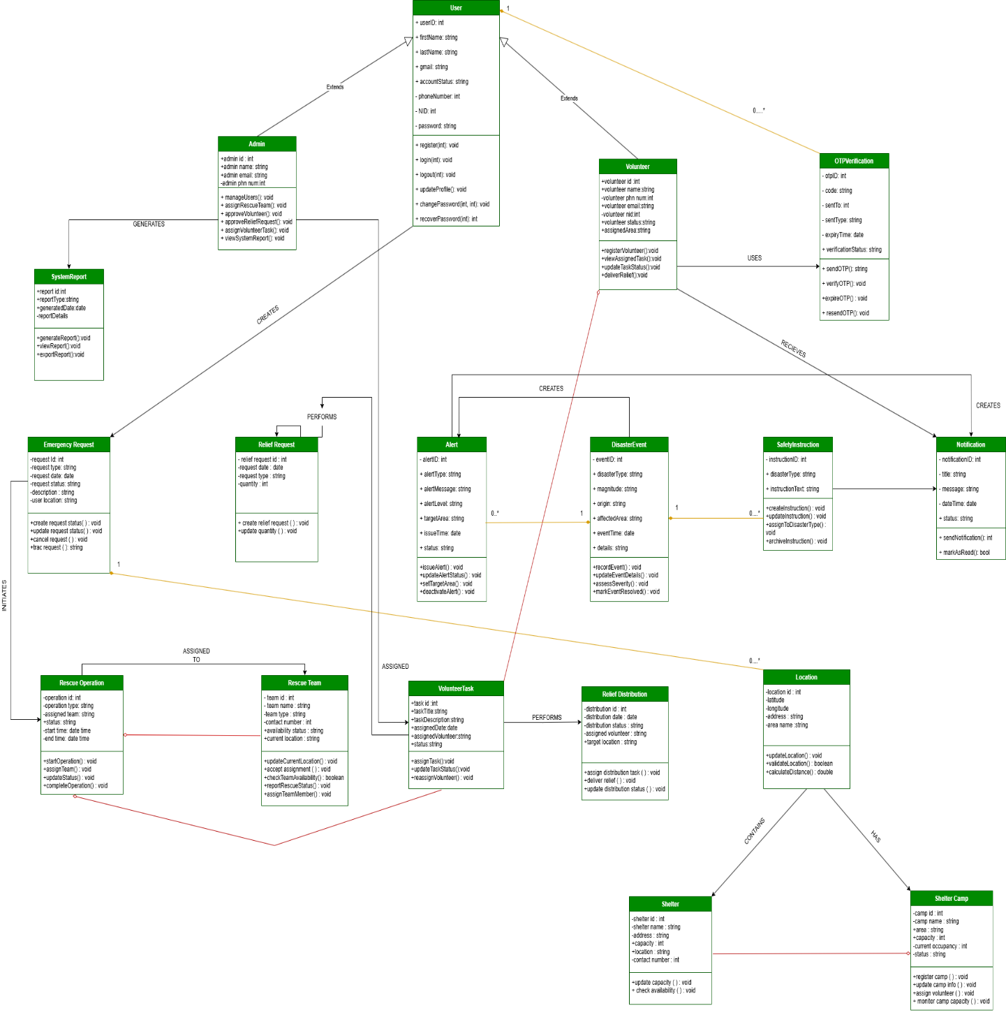
Figure 3.1: Class Diagram of the Integrated Emergency Alert and Response Information System

Chapter 4. Behavioral Modeling
Behavioral modeling describes how the system responds over time to events, inputs, and changing conditions. This chapter presents two forms of behavioral models: state diagrams, which capture the lifecycle of key system objects, and sequence diagrams, which illustrate message flows between system components during key operational scenarios.

4.1 State Diagrams
State diagrams model the dynamic lifecycle of the most important objects in the system, showing how they transition between states in response to events and triggers. The following state diagrams have been derived from the provided State Diagram document and cover eight major classes of the system.

State Diagram 1 – User Authentication and Account Management Class:
The user account lifecycle begins in the Offline state. When a user opens the app and initiates the Sign Up process, the system transitions to the Signing_Up state. After the user enters their phone number, the system sends an OTP and moves to the OTP_Verification state. Upon successful OTP detection, the system advances to Provide_NID. After NID submission, the user advances to Provide_Gmail, and after Gmail submission, to Set_Password. Once the password is confirmed and signup is complete, the system transitions to the Registered state. A registration_successful event redirects the system back to the Logging_In state, from which a login_successful event leads to the Dashboard state. If login fails, the system remains in Logging_In. Users can log out, which returns the system to the Offline state. At any point, a cancel_or_error event returns the system to Offline.

State Diagram 2 – Profile Management Class:
From the Dashboard_Idle state, the user can open their profile, which transitions the system to Viewing_Profile. From there, the user may choose to upload or change their profile picture, moving to the Updating_Profile_Picture state. Once the picture is confirmed as updated, the picture_updated event returns the system to Viewing_Profile. The user can navigate back to the dashboard at any time using the back_to_dashboard event.

State Diagram 3 – Change Password Class:
From Dashboard_Idle, a change_password event triggers a transition to Select_Change_Password_Method. The user may proceed via one of three paths: using their current password (transitions to Verify_Current_Password, which upon current_password_valid moves directly to Reset_Password), using phone OTP (transitions to Verify_Phone_via_OTP; after phone verification, the system sends a Gmail OTP and transitions to Verify_Gmail_OTP; after Gmail OTP is entered, the system transitions to Reset_Password), or using the forgot password option (using_forgot_password transitions to Verify_Phone_via_OTP following the same OTP path). Once the password is updated (password_updated event), the system returns to Dashboard_Idle.

State Diagram 4 – Account Status Class:
An account begins in the Active state. A deactivate_account event transitions it to Deactivated. A reactivate_account event returns it to Active. This simple two-state model governs the suspension and restoration of user access across all account types.

State Diagram 5 – Earthquake Early Warning and Alert Management Class:
The system begins in the Monitoring_Seismic_Data state. When a seismic event is detected, it transitions to Earthquake_Detected. The administrator defines the alert level and area, triggering Create_Earthquake_Alert. Upon alert generation, the system enters Admin_Notified. A send_push_notification event moves the system to Alert_Distributed. When users open the alert, the system enters the User_Views_Earthquake_Alert state, completing the alert delivery cycle.

State Diagram 6 – Integrated Emergency Service Communication Class:
From the initial state, a request_help event triggers a transition to Select_Emergency_Type. The user may then choose fire (transitioning to Fire_Service), medical (transitioning to Medical_Ambulance_Service), search and rescue (transitioning to Search_and_Rescue_Operation), or police (transitioning to Law_Enforcement_Service). Once the appropriate service state is reached and an emergency_request_submitted event occurs, the system returns to Select_Emergency_Type, allowing additional requests if necessary.

State Diagram 7 – Account Based Device Tracking and Recovery Class:
The device tracking lifecycle begins with a track_device event, transitioning to Tracking_Requested. When the device is found, the system enters Device_Located. Upon displaying the location, the system transitions to Show_Device_Location. After the user confirms the device has been secured, a recovery_confirmed event transitions the system to Mark_Device_as_Secured, completing the recovery cycle.

State Diagram 8 – Natural Disaster Monitoring and Emergency Response Class:
From Monitor_Natural_Disaster_Data, the system can branch based on detected risk type. A flood_risk_detected event triggers a transition to Flood_Emergency_Management, which then progresses to Send_Flood_Alert and finally Provide_Flood_Guidelines. Simultaneously (or alternatively), a cyclone_risk_detected event triggers Cyclone_Emergency_Management, progressing to Send_Cyclone_Alert and Provide_Cyclone_Guidelines. Both branches operate in parallel, enabling the system to simultaneously manage multiple disaster types.

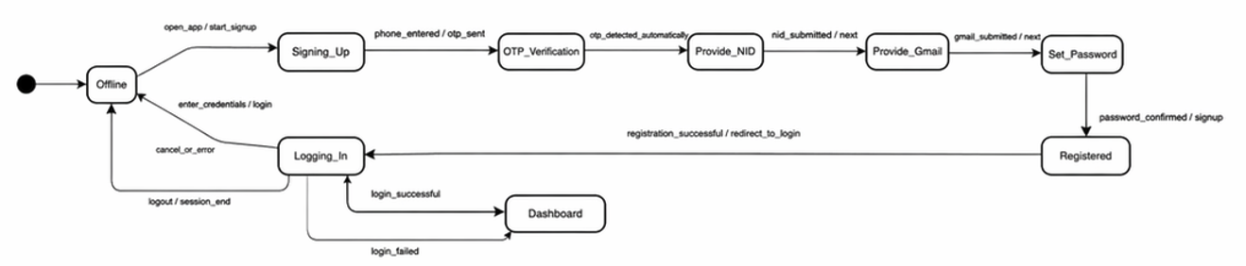
Figure 4.1: State Diagram – User Authentication and Account Management Class

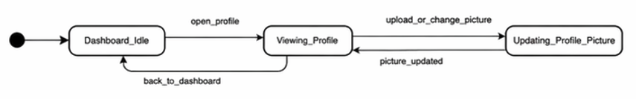
Figure 4.2: State Diagram – Profile Management Class

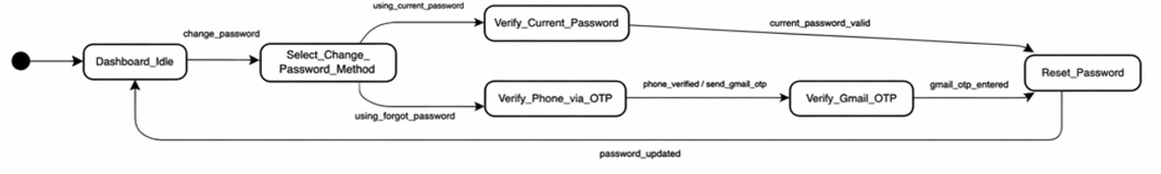
Figure 4.3: State Diagram – Change Password Class
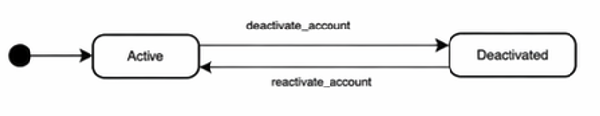
Figure 4.4: State Diagram – Account Status Class

Figure 4.5: State Diagram – Earthquake Early Warning and Alert Management Class

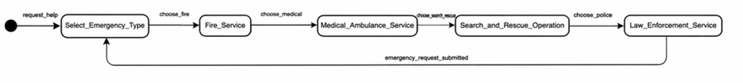
Figure 4.6: State Diagram – Integrated Emergency Service Communication Class

Figure 4.7: State Diagram – Account Based Device Tracking and Recovery Class

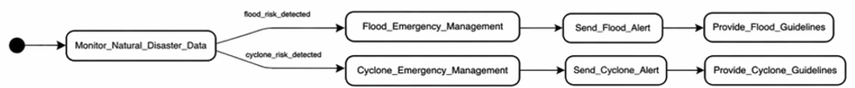
Figure 4.8: State Diagram – Natural Disaster Monitoring and Emergency Response Class

4.2 Sequence Diagrams
The UML sequence diagram for the Integrated Emergency Alert and Response Information System illustrates the chronological flow of messages and interactions between 17 lifeline objects across the system's most critical operational scenarios. The diagram is organized into three major alt (alternative) combined fragments, each representing a distinct operational phase.

Phase 1 – User Verification:
The sequence begins with User Verification. The system calls verify(user) on the OTPVerification object. The user submits their OTP through submitOTP(). If verification succeeds, the OTPVerification object returns a verified confirmation. If it fails, verificationFail() is triggered and the user may call retryAttempt() to restart the OTP submission. Once verified, the system proceeds to the next phase.

Phase 2 – Emergency Request Submission:
Within the Emergency Valid alt fragment, the user calls submitEmergencyRequest() directed at the EmergencyRequest object, which responds with requestReceived(). If the request is later identified as a false report, the Alert object is called with flagFalseAlert(). If the request is genuine, captureLocation() is called on the Location object, which returns linkLocation(). The location is then confirmed via locationConfirmed(). A triggerAlert() call is made to the Alert object, which creates a DisasterEvent through createDisasterEvent(). The SafetyInstruction object then calls fetchSafetyInstructions() and returns instructionsReady(). The system calls sendAlertData() to the Notification object. The Admin is notified through notifyAdmin(). The sequence concludes with sendNotification() being delivered to the User.

Phase 3 – Relief and Response Coordination:
Within the Relief Needed alt fragment, the user calls submitReliefRequest() on the ReliefRequest object, which calls reliefLogged() and verifies with validateRelief(). If relief is not needed, the system calls markAsNoReliefNeeded(). When a request is confirmed, reviewRequest() is called by the Admin on the EmergencyRequest object. requestData() and releaseData() are exchanged, followed by startStatus() on RescueOperation. The Admin calls assignRescueTeam() on RescueOperation, which sends teamAssigned() to RescueTeam. The rescue team receives joinOperation() confirmation.

Within the Volunteer Available alt fragment, Admin calls createVolunteerTask() on the VolunteerTask object. The Volunteer receives acceptTask() and sends notifyAdmin() back. If the volunteer is unavailable, the Admin calls requestVolunteerBackup() and may call reassignVolunteer() to an alternative resource. Within the Shelter Required alt fragment, the system calls arrangeShelterSupport() on the Shelter object and receives shelterConfirmed(). If shelter is not required, continueWithoutShelter() is called. Admin then calls approveReliefDistribution() on ReliefDistribution, which assigns coordinateWithShelter() and assigns distribution tasks.

Within the Distribution Completed alt fragment, the Volunteer confirms distributionCompleted() on ReliefDistribution. If delayed, distributionDelayed() is triggered and Admin may call rescheduleDistribution(). The RescueOperation is updated via updateRescueStatus(), and VolunteerTask is updated via updateTaskProgress() from lastProgressReport(). The Admin sends sendStatusNotification() to the User, and the User sends back an ack().

Following operation completion, rescueCompleted() is called on RescueOperation, endOperation() confirms completion, releaseTeam() releases the rescue team, and releaseVolunteers() releases volunteer resources. The system then calls generateSystemReport() on the SystemReport object. Data is collected via collectRescueData(), collectDistributionData(), and collectVolunteerSummary(). The SystemReport compiles all data and returns distributionData(). Finally, collectEmergencyLog() is called, the emergency log is received as emergencyLog(), and sendFinalSummary() delivers the comprehensive report to the Admin. The Admin receives sendResolutionNotice() as the final confirmation, concluding the complete emergency response lifecycle.
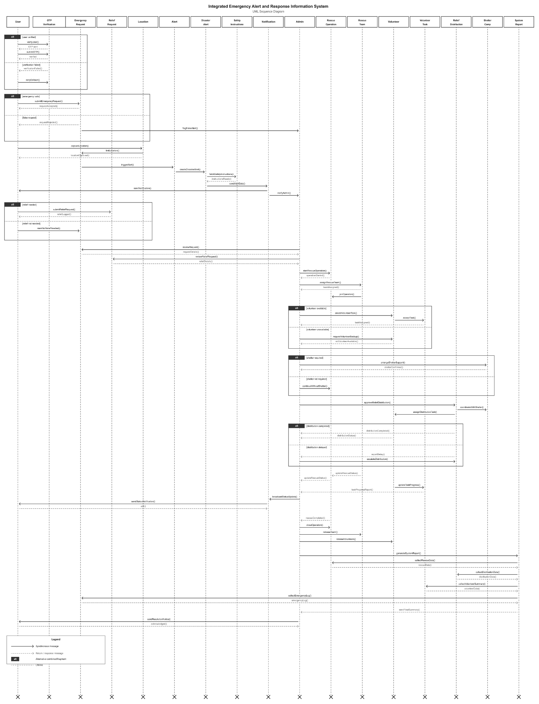
Figure 4.9: UML Sequence Diagram – Integrated Emergency Alert and Response Information System

Chapter 5. Conclusion

5.1 Discussion
The Integrated Emergency Alert and Response Information System represents a significant advancement in the domain of digital disaster management for Bangladesh and similar geographically vulnerable developing nations. By unifying disparate emergency response functions — seismic monitoring, multi-disaster alert dissemination, emergency service coordination, volunteer management, relief distribution, and shelter management — into a single cohesive platform, the system addresses longstanding inefficiencies in traditional disaster response frameworks.

The software engineering analysis conducted throughout this report demonstrates that the system is architecturally sound and functionally comprehensive. The use case models confirm that all four stakeholder groups (Users, Volunteers, Rescue Teams, and Administrators) are well-served by clearly defined, role-appropriate interactions. The class-based modeling exercise produced 15 well-defined domain classes with coherent responsibilities and collaborations, reflecting the real-world complexity of emergency management workflows without unnecessary over-engineering.

The behavioral models reinforce this assessment. The eight state diagrams capture the lifecycle dynamics of the system's most critical objects with precision, correctly identifying the conditions under which transitions occur and the states that must be maintained. The sequence diagram provides a comprehensive, end-to-end view of the system's most complex operational scenario — from user verification through emergency response to system report generation — demonstrating that the interaction design is logically consistent and practically implementable.

Perhaps most importantly, the system's design prioritizes public safety and usability. The earthquake early warning workflow, which transitions automatically from seismic detection to alert distribution with minimal administrative delay, exemplifies the platform's commitment to speed as a life-saving principle. Similarly, the natural disaster monitoring module's parallel handling of flood and cyclone events ensures that multi-disaster scenarios — a common reality in Bangladesh — can be managed simultaneously without resource conflicts or alert prioritization failures.

The integration of OTP-based multi-factor authentication, role-based access control, device tracking and recovery, and automated safety instruction generation collectively elevate the system beyond a simple notification platform into a comprehensive emergency management ecosystem. The administrative control panel, with its system-wide reporting capability, additionally supports post-disaster analysis and future preparedness planning, closing the loop of the complete emergency management lifecycle.

5.2 Limitations
Despite its comprehensive design, the system is subject to several important limitations that must be acknowledged and addressed in future development cycles:

- Internet and Connectivity Dependency: The system requires a stable internet connection to function effectively. In Bangladesh, disasters frequently disrupt telecommunications infrastructure, which could prevent users from receiving alerts or submitting emergency requests precisely when these capabilities are most needed. Offline functionality and SMS-based fallback mechanisms are not currently incorporated into the design.
- GPS and Location Accuracy: The device tracking and shelter location features depend on GPS signal accuracy. In densely built urban environments or during GPS outages caused by infrastructure damage, location data may be unreliable, reducing the effectiveness of these features.
- Digital Literacy Barriers: The platform assumes a baseline level of smartphone literacy among users. Elderly citizens, individuals in rural areas with limited digital exposure, and people with disabilities may face significant barriers to effective use, potentially excluding the most vulnerable populations from emergency alerts.
- Seismic Monitoring Integration Dependency: The Earthquake Early Warning module assumes integration with existing seismic monitoring infrastructure. The quality and coverage of this integration will directly determine the accuracy and timeliness of earthquake alerts. If the connected monitoring systems have latency or geographic blind spots, the system's early warning capability will be compromised.
- Scalability Under Extreme Load: During major national disasters, the system may face simultaneous access by millions of users. While availability is identified as a core architectural principle, the current analysis does not address specific load balancing, database sharding, or CDN strategies that would be required to maintain performance under such conditions.
- Data Privacy Concerns: The system collects sensitive personal data including NID numbers, phone numbers, Gmail addresses, and location data. Without robust data governance policies, encryption enforcement at all layers, and regulatory compliance frameworks, the platform could be vulnerable to data breaches or misuse.
- Volunteer and Rescue Team Verification: The current design does not include a rigorous credential verification process for volunteers beyond administrative approval. There is a risk that unqualified individuals could be assigned to tasks requiring specialized skills.

5.3 Future Plan (Software Design)
The following development priorities are recommended for future iterations of the system, aligned with addressing the identified limitations and expanding the platform's capabilities:

Short-Term Priorities (0–6 Months):
- Offline Mode and SMS Fallback: Implement basic offline functionality to cache the last known alert and emergency contact information. Integrate an SMS gateway to deliver critical alerts to feature phone users and to individuals without internet access during infrastructure disruptions.
- Accessibility Enhancements: Develop a simplified user interface mode with larger text, voice-guided navigation, and pictographic emergency request options to serve elderly and low-literacy users. Explore partnerships with local NGOs for community-level digital literacy support.
- Load Testing and Infrastructure Planning: Conduct large-scale load testing simulations to identify bottlenecks in the current architecture. Design and implement auto-scaling infrastructure, distributed caching, and database replication strategies to ensure platform stability during national-scale disaster events.

Medium-Term Priorities (6–18 Months):
- Mobile Application Development: Develop dedicated native mobile applications for Android and iOS platforms, incorporating push notification services (FCM/APNs), real-time location services, and optimized low-bandwidth modes for users in areas with limited connectivity.
- Multi-Language Support: Expand the platform to support Bangla as the primary interface language, with additional support for regional dialects. Translate all alert messages, safety instructions, and interface elements to maximize accessibility across Bangladesh's diverse linguistic communities.
- Advanced Volunteer Credentialing: Implement a structured skill-based verification process for volunteers, categorizing them by competency (e.g., medical first aid, water rescue, logistics) to enable more precise task-matching during disaster response.
- Predictive Analytics Module: Integrate machine learning models trained on historical disaster data, meteorological feeds, and population density maps to generate probabilistic risk forecasts. This would enable proactive pre-positioning of resources and pre-emptive evacuation advisories before disasters strike.

Long-Term Priorities (18+ Months):
- National Emergency Management API: Design and expose a standardized API that allows integration with government agencies (BDRCS, DDMC, BMDA), international relief organizations (UNDP, IFRC), and private sector partners, creating a unified national emergency data exchange ecosystem.
- Drone and IoT Integration: Explore integration with drone surveillance systems and IoT environmental sensors to augment disaster monitoring capabilities, enabling aerial damage assessment and real-time environmental data collection in areas inaccessible to ground teams.
- Blockchain-Based Aid Transparency: Implement a blockchain ledger for relief distribution tracking to ensure transparency and accountability in aid delivery, preventing corruption and enabling donors to verify that resources reached intended beneficiaries.
- Cross-Border Disaster Coordination: Extend the platform to support coordination with neighboring countries during cross-border disaster events (such as transboundary river flooding), enabling joint resource sharing and coordinated response between national emergency management agencies.

In summary, the Integrated Emergency Alert and Response Information System establishes a strong foundational architecture for next-generation emergency management in Bangladesh. The current analysis provides a clear, implementable blueprint that balances functional completeness with practical feasibility. As the platform matures through successive development cycles, it has the potential to become a nationally mandated infrastructure asset that measurably reduces disaster-related mortality, accelerates recovery timelines, and strengthens Bangladesh's overall resilience to natural and man-made catastrophes.

