Map Reduce: Analyzing the Big Data Exam Problems.

Nashidul Islam
Department of Computer Science, Georgia State University
33 Gilmor Stree, Atlanta, Georgia, USA.
nislam9@student.gsu.edu

Abstract—Map Reduce is a framework used to work with big amount of data that efficiently solves the big data analytics problem. This report is about how the map reduce paradigm was used in solving counting problems and filtering out a certain data from a large file. Mar Reduce is efficient specially in inter cluster network utilization. In this mapper it talks about the problem and solution of the exam problems that were given. It also summarizes the codes and It was coded that way.
Keywords—Mapper: The class that maps the data set to representable format.
Counter: The variable which counts the occurrence of some event.
Algorithm: A format or a solution paradigm that describes how a set of problem could be addressed and solved.

Introduction
Map Reduce Paradigm started from a paper published by google. The people working with Hadoop needed an algorithm that could utilize Hadoop and other large cluster data manipulation tool efficiently. Thus, in the year 2004, Google published a paper called as Map Reduce [1] – Simple Data Processing on Large Clusters.At first glance, many people do not realize that MapReduce is more of a framework than a tool. You have to fit your solution into the framework of map and reduce, which in some situations might be challenging[2]. MapReduce is not a feature, but rather a con‐ strain. The problem is summarizing the data fields and in process use a custom combiner which will take load off the reducer,

Analyzing the problem
Firstly , I would be required to design out a parser for parsing the CSV files. I had to split the lines by the split delimiter and then filter the “”. As data needed to be summarized, split and merge so I had to use 3 different algorithms. The two csv files contain two different information that’s why it needed merge and job chaining to use one output as input of another input. Initial analysis given an idea that I need to use file merge, job chaining and multiple output format.

Specific Tweets Word Count

Sollution Algorithm Word Count
The solution is of this problem is split into 3 parts. First a marper class needs to be defined to parse the values from the CSV file and save it in a String Array by splitting the line by the “, delimiter. Second part is to define a Reducer class that reduces the the output counts the occurrence. Third the driver method (main) method to manage the job and output it.
1.1) Mapper Code: The Mapper parses the input line. Splits it by “and saves by tokens in a String Array.Then in filters the tokens by removing space and “”. Then as I just need just the handles and tweets I save it in the two-different string. Then I check if the userhandle matches the one I are looking for which is taken as input from the user and if it matches I tokenize it and move to next step. I tokenize the tweet String and put it in a String Tokenizer object. I count the number of tokens that is the objects and set the Value Object as the Tweet word count of that tweet and Write in the context value. I also pass the Handle as KEY.
1.2) Reducer: The reducer basically adds the number by handle. As the words are filtered by handle in the map section reducer only gets word numbers of individual tweets only from that handle. It iterates through the values and adds all the word count passed from the mapper. Then writes the total word count in the context with the user handle as the KEY and total word count as Value.
1.4) Driver:
The driver part is really trial. It sets the mapper and reducer classes. It does the input and output format. I does this by JOb. One this that is special about it is the first argument that is taken from the user the handle that is set in the configuration. That later I use to compare it in the mapper section. The other segment is really straight forward and trival.

Experiemnt

I selected one random user to check the value. The experiment went well. Here is the screenshots of the experiment that provides the count of the user handle. The fig 1.1 is on how the run command look like.
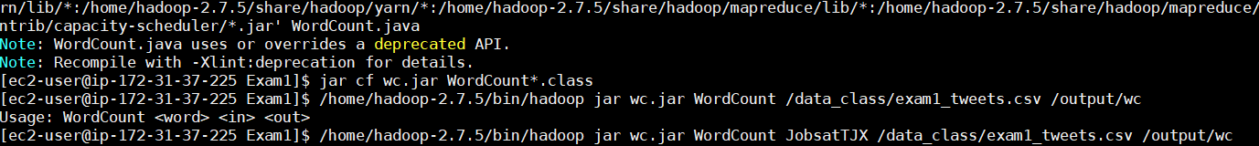
Fig:1.1
The fig 1.2 screenshot is the desired output.
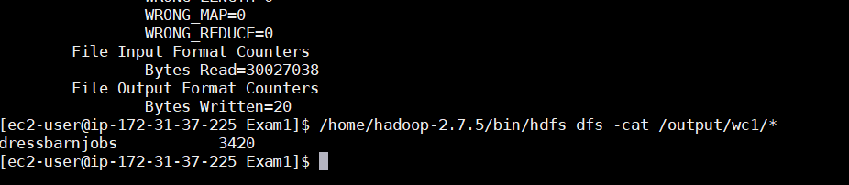
Fig: 2.2
The output made sense and wasn’t surprising at all.

Average Tweet Count

Sollution Algorithm Word Count
The solution is of this problem was quit challenging as I needed to filter it by user from Georgia. As the location information is from another file I needed filter by Georgia location and then merge both the files to get the desired output. So this is split into 2 major parts Job1 and Job 2. Each Job has their own mapper and reducers.
JOB1:
  - Mapper User: The Mapper parses the input line. Splits it by “and saves by tokens in a String Array. Then in filters the tokens by removing space and “”. Then as I just need just the handles and location I save it in the two-different string. Then I tokenize it and move to next step. I tokenize the tweet String and put it in a String Tokenizer object. I pass the location by adding a tag A before it and write context. The user handle is still the key
  - Mapper Tweets: This one does the same parsing. But instead of location I filter by tweets and add a Tag B before the tweets. I pass user handle as Key and write the tweets with tag and pass it to reducer.
  - Reducer: The reducer basically is the main aspect. It takes both the mapper values then checks what tag is the first character if it’s a store it in a Arraylist and if its B stores it in the different ArrayList. Then I use inner join to join the tweets and Handle but with only from Georgia. I basically filter the whole data set by Georgia location I pass the output file to the next job as input file.
JOB2:
  - Mapper Word Count: Here I Use out custom turple class which implements writable. It has integer and double variables which keeps count of the tweets and the word counts. So, I iterate through the tokens do the count and set in in the turple count. I set the tweet count to 1. Then I pass user Handle as key and the tuprle value is Value.
  - Reducer: The reducer gets the values by handle key adds all the words count and tweet count. Then the average is done by dividing total number of words by tweet count. I pass the average as average word and tweet count as average tweet per user. Here I have some GLOBAL variables that counts the over all user count, tweet count and sum of all tweet words. That is passed in the driver method to do a overall average and total user from Georgia.
  - Driver:
The driver part is important is basically divided into two jobs. Job1 does the filter and merge and outputs the initial filtered data where job 2 summarizes the data and counts. I have the regular mapper setter key value type declaration. One this that is special is the user of the global variable to get the overall count. I use the global variables to summarize the total tweet count user count and total word count that is printed as average too.

Experiemnt

I feed input in terms of this format
<Users file> <Tweets file> <output directory>.
As the mappers are designed chronologically it is required to input this way.
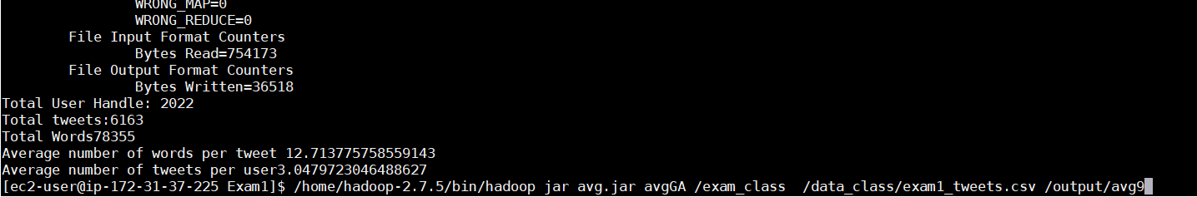
Fig: 2.1
The out put was really looking good. Although Hadoop was supposed to format it by having a certain name space, but it didn’t for some weird reason. I guess that was the challenge too. In fig 2.1 it showed the summaries overall data with 2022 users that made sense and average tweets per user was 3.04 that was acceptable. IN the fig 2.2 I get the output in terms of per user. It is stored as a file in the output folder.
Fig: 2.2
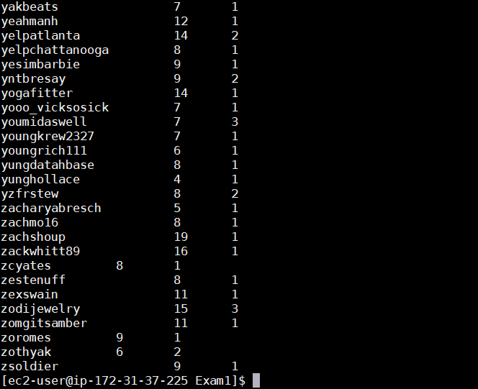

TOP 10 tweets

Sollution Algorithm Word Count
The solution is of this problem required to filter by top 10 in terms of favs then merge with user info files to get the desired output. So, this is split into 2 major parts Job1 and Job 2. Each Job has their own mapper and reducers.
JOB1:
  - Mapper Tweet: The Mapper parses the input line. Splits it by “and saves by tokens in a String Array. Then in filters the tokens by removing space and “”. Then as I just need just the handles and location I save it in the two-different string. Then I tokenize it and move to next step. I tokenize the tweet String and put it in a String Tokenizer object. I use null writable as key. The user handle and values are saved in the value section as an individual map. This part is basically trivial. I used API from the book for construct this part using my coded csv parser and pass the user handle filtering it by 10 each time in terms of favs and delete the ones more than 10 from the hash map.
  - Reducer: The reducer basically filters the local top 10 and adds the other local top 10 then filters it by fav and putting it together. It merges all top 10s from the mapper and makes the final top 10 and passes as key value pair.
JOB2:
  - Mapper Top 10 filter: Here I pass the top10 file as input. Filters the data and parses it. Put tag inform of it as A that I will use later in reduce section to merge it with the user information.
  - Mapper User Info: This one takes the user information file as input and filters data and parses the user information to the string with a B tag before it. It is then passed as a value to the context. The user handle is still the key for context.
  - Reducer: The reducer merges both the file like the previous problems and does a list of 10 with user Info of the top 10 tweeters. Inside our Reducer, I create two ArrayLists to hold the values from both Mappers. I have a for-loop that checks each value for their tag and removes the tag and places the value into its correct ArrayList. After all the values are places in its corresponding ArrayList I write out our final output with our key, which holds the handle, and B which holds the user details of the handles. Moreover, I output the user tweet count too in the print statement.
  - Driver:
The driver part is important is basically divided into two jobs. Job1 does top 10 part where job 2 does the merge and outputs the initial filtered data. I used job chaining for this purpose. The output format now has nullwrittable. The Other parts are similar to problem two with minor type change.

Experiemnt

I feed input in terms of this format
<Tweets file> <Users file> <output directory>.
As the mappers are designed chronologically it is required to input this way.
Fig: 3.1
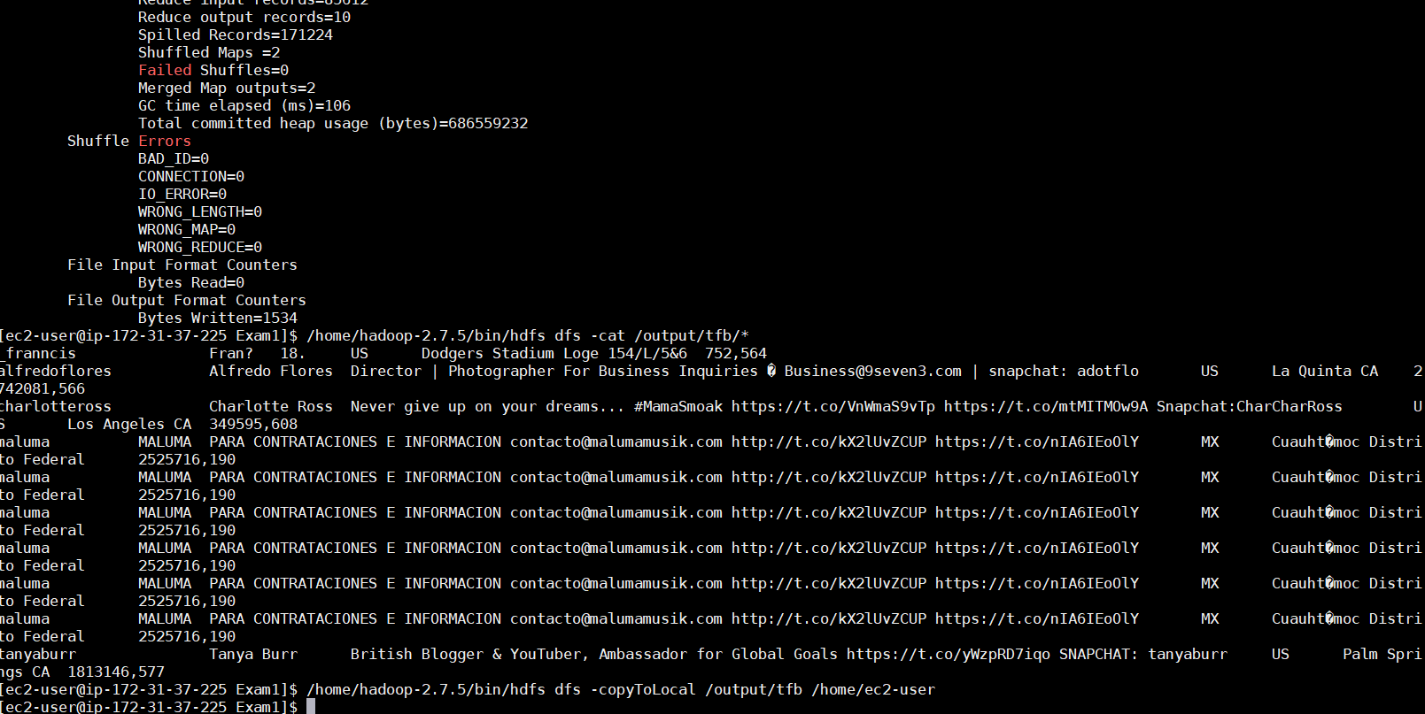
Fig 3.2
The result was mostly maluma. As he is really popular user. But francis wins the battle in terms of favs.

Top Tweets multiple output

Sollution Algorithm Word Count
The solution is of this problem required to merge both the files together in terms of tweets and then put it together the user info. The next step was to filter the tweet count by handle and separate them in terms of more than 10 and less than 10 and output them into two separate files. So, this is split into 2 major parts as well Job1 and Job 2. Each Job has their own mapper and reducers.
JOB1:
  - Mapper Tweet: The Mapper parses the input line. Splits it by “and saves by tokens in a String Array. Then in filters the tokens by removing space and “”. Then as I just need just the handles and location I save it in the two-different string. Then I tokenize it and move to next step. I tokenize the tweet String and put it in a String Tokenizer object. I use null writable as key. The user handle and values are saved in the value section as an individual map. This part is basically trivial. With putting a tag as A infront of them I output this as the values in the Context. The key still remains as the handle.
  - Mapper User Info: This one takes the user information file as input and filters data and parses the user information to the string with a B tag before it. It is then passed as a value to the context. The user handle is still the key for context.
  - Reducer: The reducer basically merges both files. I merge all the information by handle. Inside our Reducer, I create two ArrayLists to hold the values from both Mappers. I have a for-loop that checks each value for their tag and removes the tag and places the value into its correct ArrayList. After all the values are places in its corresponding ArrayList I write out our final output with our key, which holds the handle, and B which holds the user details of the handles. I merge both of them that gives us a output file that holds all the information of the users with the number of handle occurrence same as the number of tweeted. I use this logic as number of user occurrence will be the number of tweets in the later job2.

JOB2:
  - Mapper Word Count: This mapper function has not much of new implementation. This mapper has basic parser that refilters data if needed. Then it passes it in a string gets the data ready to be reduced in the reduce section. The key still remains the userhandle. And value the whole string of information.
  - Reducer: The reducer section is the smart part. Here I use the logic of the number of handle occurrence is the number of times the user tweeted. I use multiple output object mos that will help us to write into separate files. I have a setup method sets up the multiple output variable. The I do the tweet count by handle. I sum it if the sum is >10 I put it in tweet greater then 10 and if it is<10 then I put it in another file. I use mos write method to write in different file. I then had to have a cleanup method that closed the mos file.
1.4) Driver:
The driver part is important is basically divided into two jobs. Job1 does the merge where job 2 does the split of the tweet ahndles into two files. I used job chaining for this purpose. WE used mos writtable that was formatted the in terms of class types used. The file name was done in the reducer section. As there was no context so the summery shows 0 bytes written but it still wrote files in the mos segment. We set the fileoutputh path by the directory where the two files are created.

Experiemnt
I feed input in terms of this format
<Tweets file> <Users file> <output directory>.
As the mappers are designed chronologically it is required to input this way.
Fig: 4.1
The screen output is shown in the fig 4.2. It has an extra 2 print line that shows the number of users with more than 10 tweets and less then 10 tweets. There is a guide to where the out put goes. The output was 2032 that was more than 10 and 83570 that made sense as total tweets was 204005. The numbers made sense.
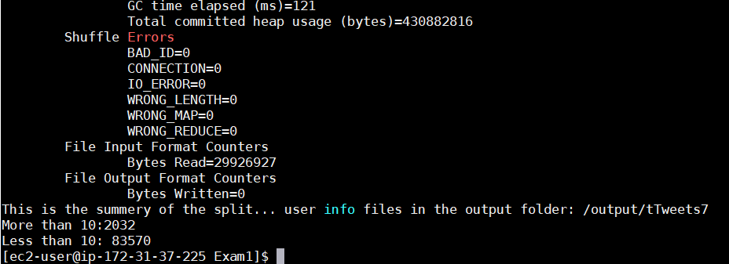
Fig 4.2
In figure 3 it shows the output file output. It provides line by line view in the editors.
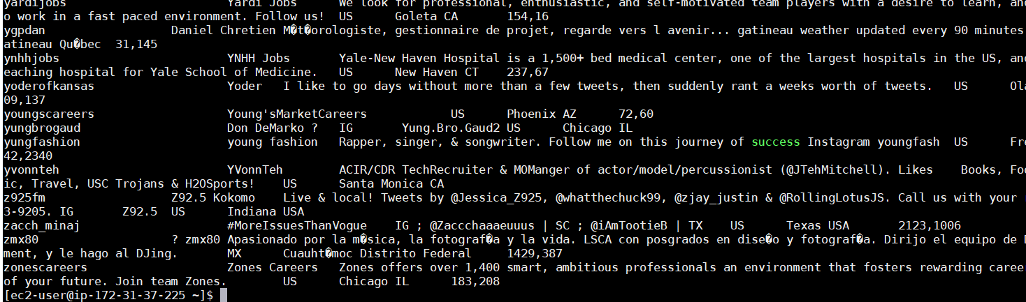
Fig 4.3

Challenges
The main challenge was to understand what the problem wants. Then find the right algorithm which will solve the problem. But the coding part wasn’t the headache. It was debugging the code and other errors that was faced. It was basically a test of java knowledge and Hadoop library use. I ran through JVM machine cannot allocate errors to array index out of bound errors. The job chain wasn’t closed so I had interrupted exception. Overall the challenge was used and time consuming, but It was a great learning experience.

References

- Donald Miner & Adam Shook, “Map Reduce Design Patterns,” Phil. O reily USA, First Edition, pp. 18–65, December 2012. (references)
- "Hadoop Counter." Counters (Apache Hadoop Main 2.7.0 API). N.p., 10 Apr. 2015. Web. 16 Feb. 2018..
- "History of Hadoop and Map Reduce." History of Hadoop and Map Reduce. N.p., 22 Sept. 2015. Web. 15 Feb. 2018

