SMART WARDROBE
PROJECT REPORT
Submitted To The University Of Calicut In Partial Fulfilment Of The Requirement For The Award Of The Degree Of
BACHELOR OF COMPUTER SCIENCE
Submitted By
NASHIF (UDAWSCS024)
Under The Guidance Of
Ms. NAFSEERA
(Assistant professor, Department of Computer Science)

MTM COLLEGE OF ARTS SCIENCE AND COMMERCE
(Affiliated To University Of Calicut)
PAZHANJI, VELIYANCODE-679579
MARCH 2022-2025
DEPARTMENT OF COMPUTER SCIENCE
MTM COLLEGE OF ARTS SCIENCE AND COMMERCE
(Affiliated To University Of Calicut)
PAZHANJI, VELIANCODE-679579
MARCH 2022-2025

CERTIFICATE
This is to certify that the project entitled “SMART WARDROBE” is a Bonafide record of work done NASHIF (UDAWSCS0)
and submitted in partial fulfilment of the requirement for acquiring the
degree of BACHELOR OF COMPUTER SCIENCE OF CALICUT
UNIVERSITY and has not formed on the basis for award of any degree /diploma/ associated/ fellowship or other similar titles to the candidate.
PRINCIPAL
PROJECT COORDINATOR
PROJECT GUIDE
Valued on: ……………..
INTERNAL EXAMINER EXTERNAL EXAMINER

DECLARATION
I, MOHAMMED ANSHIF U (REG NO: UDAWSCS013) do hereby declare that the project entitled “AI BASED SERVICE HUB” submitted to University of Calicut in partial fulfillment of requirement for the award of the degree of bachelor of Computer
Science, is an original work done by me under the supervision and guidance of Ms. RASEENA PM (Assistant Professor, Department of Computer Science) and no part of this has been submitted earlier for the award of any degree.
PLACE: VELIYANCODE
MOHAMMED ANSHIF U (UDAWSCS013) DATE:

ACKNOWLEDGEMENT
First and foremost let we sincerely thank the Lord Almighty for making us capable of completing me project work successfully and on time. We wish to express our heartfelt gratitude to our respected Principal Mr. JOHN JOSEPH P for providing the permission in taking up this project work.
We are extremely thankful to Ms. C M SULAIKHA, Head of the Department, Computer Science for the constant support and encouragement granted throughout this project.
We sincerely express gratitude to our project guide Ms. Raseena PM, Assistant Professor,Department of Computer Science for their invaluable guidance, support, and encouragement throughout this project.
We render our heartfelt thanks to all the other respected faculties of the Department of Computer Science, Librarian, Office staff for their assistance and co-operation given to our in regards to this work.
We would like to thank our parents and friends for providing support during the project work.
MOHAMMED ANSHIF U (UDAWSCS013)

CONTENTS
- Introduction...................................................................................................................................1
- System Study..................................................................................................................................2 Existing System...............................................................................................................................3
Scope...............................................................................................................................................4
Module Description.........................................................................................................................5
- Feasibility Study............................................................................................................................6
Technical Feasibility.......................................................................................................................6
Operational Feasibility....................................................................................................................6 Economic Feasibility.......................................................................................................................7
Behavioral Feasibility.....................................................................................................................7
- Software Requirement Specification...........................................................................................8
Purpose............................................................................................................................................8
External Interface Requirement.......................................................................................................9
Functional Requirement................................................................................................................10
Non Functional Requirement........................................................................................................11
System Specification.....................................................................................................................11
Python Libraries............................................................................................................................12
Jupyter Notebook...........................................................................................................................13
PyCharm........................................................................................................................................14
- System Design..............................................................................................................................15 Input Design..................................................................................................................................15
Output Design...............................................................................................................................15 Workflow of Proposed System.....................................................................................................16
Workflow of System.....................................................................................................................18
AI Powered Chatbot......................................................................................................................19
Database........................................................................................................................................21
UML Activity Diagram.................................................................................................................25
- System Implementation and Maintenance................................................................................29
Technical Specifications................................................................................................................29
- AI Description..............................................................................................................................35
Chatbot Description.......................................................................................................................35
- System Testing.............................................................................................................................37
Different Levels of Testing...........................................................................................................38
- Future Enhancement...................................................................................................................41
- Conclusion..................................................................................................................................42
- Bibliography...............................................................................................................................43
- Sample Screenshot.....................................................................................................................44
- Source Code...............................................................................................................................49

1.INTRODUCTION
Service centers play a crucial role in providing technical support, repairs, and maintenance for electronic devices. Authorized centers for brands like Apple, Samsung, Asus, HP, and DELL ensure users get expert assistance and genuine parts. However, finding the right place for repairs or dealing with minor technical issues can be frustrating. Most people search online, visit in person, and go through a manual complaint process, which takes time. For small issues, users often rely on YouTube or online forums, but the solutions they find may not always be relevant or effective.
To bridge this gap, our solution introduces an AI-powered chatbot system that assists users with troubleshooting before they seek professional help. The chatbot, available on our website, provides step-by-step solutions based on the user’s issue. Users answer a few simple questions, and the AI chatbot provides tailored troubleshooting steps to resolve minor issues— saving time and effort.
If the issue persists, users can manually register their complaints through the website, where they can also find details about authorized service centers and the services they provide. While the chatbot does not handle complaint registration or service tracking, our website serves as a one stop platform for both troubleshooting and service center information.
This system offers 24/7 AI-driven support, ensuring faster problem resolution, reducing dependency on external sources, and improving the overall user experience. With our AI-Powered Service Center Assistance & Troubleshooting System, users get quick, reliable solutions while maintaining easy access to professional support when needed.

2.SYSTEM STUDY

2.1 EXISTING SYSTEM
Now days if we want to know the service centers we can search through Google
then we can get the site name of particular service agency or its Phone number or it address and we directly go to the service center and register the complaints. Or if we want to get some ideas for basic trouble shooting we can search in YouTube and get the video about the trouble shooting but most of these cases it is not full fill our needs .
2.2 PROPOSED SYSTEM
Our system introduces an AI-powered chatbot designed to assist users in troubleshooting technical issues before seeking professional service. Instead of relying on scattered online sources, users can describe their problem to the chatbot, which then analyzes the issue and provides customized, step-by-step troubleshooting solutions using AIdriven logic. This enables users to resolve minor problems independently, reducing unnecessary service center visits and saving time.
If the chatbot’s troubleshooting steps do not resolve the issue, users can manually register a complaint through the website, where they can also book services, track their requests, and access details of authorized service centers along with the services they offer. The website serves as a platform for handling the entire service process, ensuring users can seamlessly transition from self-troubleshooting to professional assistance when needed.
With 24/7 AI-powered support, users benefit from faster problem resolution, reduced reliance on external searches, and a seamless troubleshooting experience—bridging the gap between selfservice and expert repair solutions.
Advantages of Proposed System:
- 24/7 Availability
- AI-Powered Troubleshooting
- Faster Resolution
- Seamless Complaint Management
- Personalized Assistance
- Efficient Escalation
- Centralized Service Information
- Reduced Dependency on Human Support
- Real-Time Status Updates
- Cost-Effective
- Improved User Experience
- Data-Driven Insights
- Remote Service Booking
- Enhanced Customer Satisfaction

2.3 SCOPE
The AI-Powered Service Center Assistance & Troubleshooting System
enhances technical support with an AI chatbot that provides step-by-step solutions for minor electronic issues, reducing reliance on external sources. Users can also access authorized service center details and manually register complaints if needed. Looking ahead, the system can evolve with predictive diagnostics, AR-based repair guidance, IoT connectivity for automated troubleshooting, and blockchain for secure service records. Future enhancements like multilingual voice support and integration with smart assistants will further streamline user experience, making technical support more efficient and accessible.

2.4 MODULE DESCRIPTIONN
- ADMIN
- SERVICE HUB
- USER
1. ADMIN: The Admin module manages service hubs, approves companies, and oversees user interactions. It ensures smooth operations by handling messages, feedback, and service center approvals.
- Login
- Add Company
- Approve Service Hub
- View Message
- Add Message
- View Feedback
2. SERVICE HUB: The Service Hub module manages service requests, bookings, and customer inquiries. It handles frequently asked questions, feedback, messages, and order tracking to ensure efficient service delivery.
- View Bookings
- Add Frequently asked Questions
- View Feedbacks
- Add Message
- View Message
- View Recent Orders
3. USER: The User module allows customers to access service center details, troubleshoot issues using AI, book service hubs, track request status, and communicate via messages and feedback for a seamless support experience.
- View Companies
- View Frequently Asked Questions
- View Status
- View Messages
- Add Messages
- Add Feedback
- Trouble Shoot (AI Powered Chatbot)
- Book Service Hub
5 2022-25

3.FEASIBILITY STUDY
The AI-Powered Troubleshooting System enhances technical support with 24/7 AI-driven assistance, reducing dependency on external sources and optimizing service center visits. While it does not facilitate complaint tracking, the platform provides centralized access to authorized service centers, ensuring a seamless transition to professional support. The proposed system will help to solving the problem more efficiently and accurately. The reports obtained after feasibility studies are given below, they are:
- Economic Feasibility
- Technical Feasibility
- Operational Feasibility
- Behavioral Feasibility
  - TECHNICAL FEASIBILITY:
The system is technically viable as it integrates Natural Language Processing (NLP) and Decision Tree Algorithms to provide AI-driven troubleshooting. The chatbot can be deployed on a website using existing web technologies such as Python (Flask/Django), JavaScript, and AI frameworks like TensorFlow or Dialogflow. The service center database can be managed using SQL databases. Since the chatbot does not handle complaint registration or service tracking, the system architecture remains simpler and more efficient, making implementation feasible with moderate technical resources.
  - OPERATIONAL FEASIBILITY:
The system simplifies the troubleshooting and service center lookup process, making it user-friendly for customers seeking quick solutions. Since the chatbot is available 24/7, it reduces wait times and dependence on external sources like YouTube or forums. Users can seamlessly switch to professional assistance when needed, ensuring a smooth transition from self-service to expert support. The low maintenance nature of the chatbot and website further enhances operational efficiency.
  - ECONOMIC FEASIBILITY:
The project requires initial investment in AI chatbot development, website creation, and database management. However, operational costs remain low as the system is automated and does not require human intervention. Cost-effective hosting solutions such as AWS, Google Cloud, or Azure can ensure scalability. In the long run, businesses and service centers can monetize the platform through partnerships, advertisements, or premium support services, making the project financially sustainable.
3.4 BEHAVIORAL FEASIBILITY:
Behavioral feasibility evaluates the user acceptance, adaptability, and willingness to adopt the proposed AI-powered chatbot system. It determines whether users will be comfortable using the chatbot for troubleshooting and how it will influence their existing habits related to service center visits and technical issue resolution.

4.SOFTWARE REQUIREMENT SPECIFICATION

4.1 PURPOSE
The software requirements specification (SRS) is a means of translating the ideas in
the minds of clients into a formal documentation. This document forms the development and software validation. The basic reason for the difficulty in software requirement specification comes from the fact that there are three interested parties-the clients, the end users and the software developer. The requirements document has to be such that the client and the user can understand easily, and the developers can use it as a basis for software development. Due to the diverse parties involved in software requirement specification, a communication gap exists. This gap arises when the client does not understand software or the software development processor when the developer does not understand the client’s problem and application area of SRS bridges this communication gap.
Problem analysis is done to obtain a clear understanding of the needs of the clients
and the users, and what exactly is desired from the software. Analysis leads to the actual specification. People performing the analysis called analysts, area also responsible for specifying the requirements.
The software project is initiated by the client’s needs. In the beginning these needs are in
the minds of various people in the client organization. The requirement analyst must identify their requirements by talking to these people and understanding their needs. These people and the existing documents about the current mode of operation are the basis source of information for the analyst.

4.2 EXTERNAL INTERFACE REQUIREMENTS
USER INTERFACE:
The user interface is based on the web browser. The application is developed
using python, Django CSS and HTML . The interface design is aimed at a flexible frontend communication. User interface is designed in a user-friendly manner and the user,
HARDWARE INTERFACE:
A desktop pc or laptop containing with windows operating
system, internet connection. The client is connected to the server and has the access to the database for accessing the Medi-file details of a user.
SOFTWARE INTERFACE:
Software selection is an important work in a project development
cycle. Software must be selected in accordance with the application and latest technology available. It is a general-purpose programming language used for web development and as a support language for software developers. It’s also widely used in scientific computing, data mining and machine learning. The continued growth and demand for machine learning developers may be driving the popularity of Python.
COMMUNICATION INTERFACE:
The system uses an internet connection to connect to the database. The code
itself though, does not specifically direct the network controllers to do any work. The connection between the client and the server uses connection-oriented communication, via
TCP/IP which implements reliable delivery of messages. Connection oriented communication makes programming easier because the protocol includes the mechanism for detecting and handling errors and acknowledgement mechanism between client and servers. HTTP will be used as the communication standard.

4.3 FUNCTIONAL REQUIREMENTS
- User Management
  - Users should be able to register and log in to the website.
- AI Chatbot for Troubleshooting
  - The chatbot should provide step-by-step troubleshooting solutions based on user queries.
  - It should analyze user responses and suggest tailored solutions using AI logic.
- Complaint Registration System
  - Users should be able to manually register a complaint if troubleshooting does not resolve the issue.
  - The complaint form should allow users to:
  - Select the device brand.
  - Describe the issue.
- Service Request Tracking
  - Users should be able to track the status of their complaint or service request.
- Knowledge Base & Resources
  - Frequently Asked Questions (FAQs) should be available for general support.
- Admin Panel
  - Admins can add, update, or remove service centers and their details.
  - Admins should have access to complaint and service request logs.
  - Admins can manage user complaints and update their statuses
- Security & Data Privacy
  - Only authorized users (admins, service centers) can access complaint details

4.4 NON-FUNCTIONAL REQUIREMENTS
- Error handling:
The system shall handle expected and non-expected errors in a way that
prevent loss in information.
- Performance Requirements
Speed of the system is an important constraint. • Safety Requirements
System use shall not cause any harm to human users
- Security Requirements
  - System will use secured database.
  - The system shall permit only administrator/owner to modify the contents.

4.5 SYSTEM SPECIFICATION
4.5.1Hardware Requirements :
- PROCESSOR Intel Core i3 – 3220 (3.3 Ghz) or above
- RAM 4 GB or above
- STORAGE 512 GB or above • OTHER Keyboard and Mouse
4.5.2 Software Requirements :
- Operating System : Windows 10 or above
- Front End : HTML, CSS, js,
- Back End : python ,MYSQL, Django
- Tool kit : XAMPP
- IDE : Notepad ++
4.6. PYTHON LIBRARIES:
    - Numpy:
Numpy, short for Numerical Python, is a Python package that deals with multidimensional arrays and offers a range of routines for array processing. It allows for mathematical and logical operations on arrays, Fourier transforms, shape manipulation, and linear algebra operations. Numpy is often used alongside packages like SciPy and Matplotlib for comprehensive data analysis and visualization.
    - Keras:
Keras is a high-level, user-friendly deep learning API built on top of lower-level libraries like TensorFlow, Theano, and Microsoft Cognitive Toolkit (CNTK). It was originally developed by François Chollet, and it is now primarily integrated into TensorFlow as tensorflow.keras. Keras is designed to be easy to use for beginners while still providing enough flexibility and power for researchers and industry professionals.

4.6.3 Nltk
NLTK (Natural Language Toolkit) is a popular open-source library in Python for working with human language data (text). It provides easy-to-use interfaces and tools to process and analyze text, making it an essential tool for natural language processing (NLP) tasks. NLTK supports various NLP operations, from basic text processing (tokenization, stemming, etc.) to more advanced operations like parsing, classification, and machine learning.

4.6.4 Tensorflow
TensorFlow is an open-source machine learning (ML) and deep learning framework developed by Google. It is widely used for building, training, and deploying machine learning models, particularly deep learning models, at scale. TensorFlow is known for its flexibility, scalability, and robust ecosystem, making it a go-to choice for both research and production-level ML applications.

4.6.5 pickle
In Python, pickle is a module used for serializing and deserializing Python objects. Serialization refers to the process of converting a Python object into a byte stream (i.e., a format that can be saved to a file, sent over a network, or stored in a database), while deserialization is the reverse process—converting the byte stream back into a Python object.
The pickle module is primarily used to save Python objects (such as lists, dictionaries, models, etc.) to disk so they can be later loaded and used again without needing to recreate them from scratch.

4.6.6 Json
JSON (JavaScript Object Notation) is a lightweight, text-based, and human-readable data interchange format that is commonly used for representing structured data. It is easy for humans to read and write and easy for machines to parse and generate. JSON is language-independent but is widely used in web development and APIs because of its simplicity and compatibility with most programming languages, including Python, JavaScript, and many others.

4.6.7 WordNetLemmatizer
The WordNetLemmatizer is a part of the Natural Language Toolkit (NLTK) in Python, and it is used for lemmatization—the process of reducing a word to its base or dictionary form (also known as a "lemma"). Unlike stemming, which cuts off prefixes or suffixes to reduce words, lemmatization ensures that the word is transformed into its proper base form that is valid according to a language's dictionary.
4.7 Jupyter Notebook:
Jupyter Notebook is an interactive web-based tool for developing and documenting
code, as well as generating results. It combines a web application with notebook documents that contain inputs, outputs, texts, and media. Jupyter Notebook enhances the interactive computing experience and supports various programming languages, including Python.

4.8 PyCharm:
PyCharm is a popular integrated development environment (IDE) for Python scripting language. It offers features like code completion, advanced debugging, and support for web programming frameworks such as Django and Flask. PyCharm is favored by developers for its user-friendly interface and robust functionality.
Dept. of Computer Science 14

5.SYSTEM DESIGN
The system design phase is a critical step in system development,
involving the creation of technical specifications for the proposed solution. It details features, input/output files, and data files, ensuring the system meets requirements in terms of information presentation, result accuracy, interaction methods, and overall reliability. The design aligns with established rules and practices, setting the foundation for successful implementation
 Input Design

.
Output Design

5.1 INPUT DESIGN
Input design involves converting user-oriented inputs into computer-compatible
formats, considering factors like record media, input methods, and speed of data entry.
Major Input Screen:
The following are the major output screens used.
- Login
The input screen is used for logging into the system by providing email and password
- Register
The input screen is used for registering for users and service centers

5.2 OUTPUT DESIGN
Output design is the process of formatting and presenting information from a computer system to users, ensuring clarity and effectiveness in conveying results.
When designing the output, system analyst must accomplish the following:
- Determine the information present.
- Decide whether to print, display the information and select output medium.
- Arrange information inacceptable format.
Major Output Screen:
The following are the major output screens used.
- View user details
Admin only can view the user details
- View user input
User can view the user input
- View result 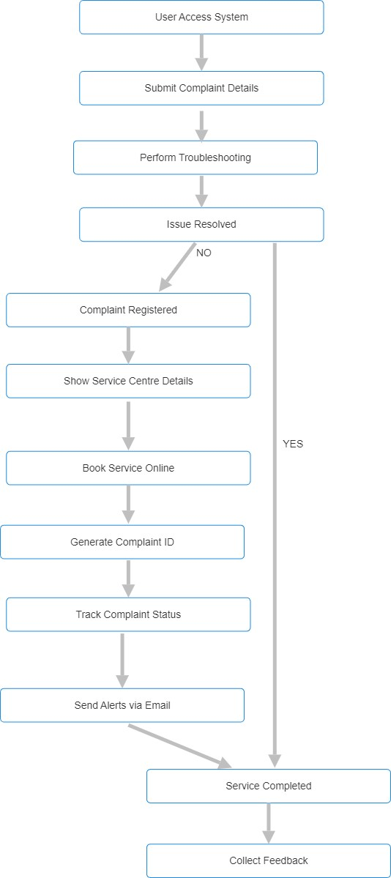
User can view the result
- Track Order
User can track the details
5.3 WORKFLOW OF PROPOSED SYSTEM
- User Access System:
The user logs into the system to access complaint services.
- Submit Complaint Details:
The user provides details about the issue they are facing.
- Perform Troubleshooting using AI Chatbot:
The system attempts to resolve the issue using an AI chatbot, which provide troubleshooting steps.
- Issue Resolved?
If the issue is resolved, the process moves directly to service completion. If the issue is not resolved, the system proceeds to the next steps.
- Register Complaint:
The user formally registers their complaint.
16
- Show Service Centre Details:
The system provides details of service centers15
- Book Service Online through Website:
The user can schedule a service appointment online.
- Service Completed:

Once the issue is resolved through service, the process moves forward.
- Collect Feedback:
The system collects feedback from the user regarding their service experience.

  - WORKFLOW OF SYSTEM
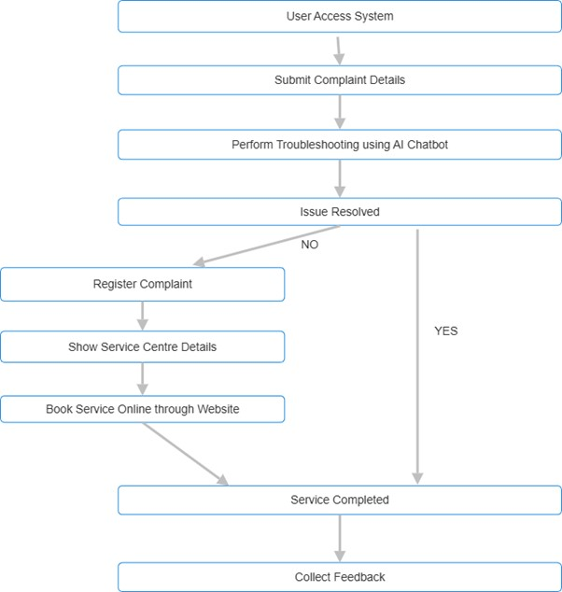
  - AI Powered Chatbot
An AI-powered chatbot is an advanced software program designed to simulate human conversations. It can engage with users via text or voice, answering questions, providing recommendations, or assisting with tasks automatically. Unlike traditional chatbots that follow a set of predefined rules, AI chatbots use machine learning (ML), natural language processing (NLP), and deep learning to understand, learn and improve responses over time.
These chatbots are commonly used in customer service, e-commerce, healthcare, and various other industries to improve user experience and automate repetitive tasks.
Working of AI Powered Chatbot:
1.User Input (Understanding the Message)
- The user types or speaks a question.
- The chatbot processes the text using Natural Language Processing (NLP) to understand the meaning
2.Processing the Request
- The chatbot identifies keywords, intent (purpose), and relevant details (e.g., names, dates, locations).
- It searches its database, knowledge base, or external sources (like websites or APIs) for an answer.
3.Generating a Response
- The chatbot selects the best response based on predefined rules or AI-generated answers.
- Advanced AI chatbots personalize responses based on past interactions.
4. Delivering the Response
- The chatbot sends the answer back in a human-like format via text or voice.
- It may also display images, links, or buttons for quick actions.
5. Learning & Improving Over Time
- If the chatbot makes a mistake or a user provides feedback, it learns and improves using Machine Learning (ML).
- It gets smarter by analyzing previous conversations and adjusting responses.
6. Multi-Platform Support
• AI chatbots work on websites, mobile apps, social media (WhatsApp, Facebook), and voice assistants (Alexa, Google Assistant).
20

5.6 DATABASE
The proposed system's database will consist of several interconnected tables to manage users, service centers, devices, complaints, troubleshooting steps, and updates. It will store user information, including their complaints and the devices involved, as well as details about authorized service centers for various brands like Apple, Samsung, and Dell. When users report an issue, the AI-powered chatbot will gather necessary details and offer troubleshooting steps. If the issue requires further assistance, the system will assign a service center based on location and generate a complaint ID for tracking. The system will also store complaint updates and email notifications, ensuring users receive timely status updates and can track their complaints through both the chatbot and email. This database structure will support efficient complaint management, troubleshooting, and service center coordination, offering 24/7 personalized assistance.
1) Table servicehub_app_add_brand
Field | Type | Null | Default
id | tinyint(4) | Yes | NULL
brand_name | varchar(7) | Yes | NULL
2)) Table servicehub_app_add_service
Field | Type | Null | Default
id | tinyint(4) | Yes | NULL
service_name | varchar(10) | Yes | NULL
brand_id | tinyint(4) | Yes | NULL
21
- Table servicehub_app_complaint
Field | Type | Null | Default
id | tinyint(4) | Yes | NULL
productname | varchar(7) | Yes | NULL
complaint | varchar(27) | Yes | NULL
complaintdate | varchar(0) | Yes | NULL
complaint_status | varchar(10) | Yes | NULL
servicehub_id | tinyint(4) | Yes | NULL
user_id | tinyint(4) | Yes | NULL
req_amount | varchar(5) | Yes | NULL
req_desc | varchar(27) | Yes | NULL
req_status | varchar(8) | Yes | NULL
service_amt | varchar(3) | Yes | NULL
total | varchar(5) | Yes | NULL
paymentstatus | varchar(7) | Yes | NULL
feedbacks | varchar(24) | Yes | NULL
- Table servicehub_app_faq
Field | Type | Null | Default
id | tinyint(4) | Yes | NULL
faq_question | varchar(68) | Yes | NULL
faq_answer | varchar(158) | Yes | NULL
servicehub_id | tinyint(4) | Yes | NULL
Dept. of Computer Science 22 2022-25
- Table servicehub_app_login_table
Field | Type | Null | Default
id | tinyint(4) | YES | NULL
password | varchar(88) | YES | NULL
last_login | varchar(10) | YES | NULL
is_superuser | tinyint(4) | YES | NULL
username | varchar(23) | YES | NULL
first_name | varchar(0) | YES | NULL
last_name | varchar(0) | YES | NULL
email | Varchar(15) | YES | NULL
is_staff | tinyint(4) | YES | NULL
is_active | tinyint(4) | YES | NULL
date_joined | varchar(10) | YES | NULL
user_type | varchar(10) | YES | NULL
view_password | varchar(12) | YES | NULL
- Table) servicehub_app_login_table_groups
Field | Type | Null | Default
id | varchar(0) | YES | NULL
login_table_id | varchar(0) | YES | NULL
group_id | varchar(0) | YES | NULL
- Table servicehub_app_login_table_user_permissions
Field | Type | Nul | Default
id | varchar(0) | YES | NULL
login_table_id | varchar(0) | YES | NULL
permission_id | varchar(0) | YES | NULL
- Table servicehub_app_send_message
Field | Type | Null | Default
id | tinyint(4) | YES | NULL
user_message | varchar(27) | YES | NULL
hub_reply | varchar(27) | YES | NULL
servicehub_id | tinyint(4) | YES | NULL
user_id | tinyint(4) | YES | NULL
23

- Table servicehub_app_servicehubreg
Field | Type | Null | Default
id | tinyint(4) | YES | NULL
fname | varchar(8) | YES | NULL
lname | varchar(4) | YES | NULL
servicelog_id | tinyint(4) | YES | NULL
status | varchar(8) | YES | NULL
brand_id | varchar(1) | YES | NULL
district | varchar(3) | YES | NULL
office | varchar(29) | YES | NULL
licence_upload | varchar(15) | YES | NULL
phone | mediumint(9) | YES | NULL
- Table servicehub_app_servicehubservice
Field | Type | Null | Default
id | tinyint(4) | YES | NULL
servicehub_id | tinyint(4) | YES | NULL
services_id | tinyint(4) | YES | NULL
- Table servicehub_app_userreg
Field | Type | Null | Default
id | tinyint(4) | YES | NULL
fname | varchar(7) | YES | NULL
lname | varchar(5) | YES | NULL
phone | bigint(20) | YES | NULL
district | varchar(6) | YES | NULL
userlog_id | tinyint(4) | YES | NULL
district | varchar(6) | YES | NULL
userlog_id | tinyint(4) | YES | NULL
24
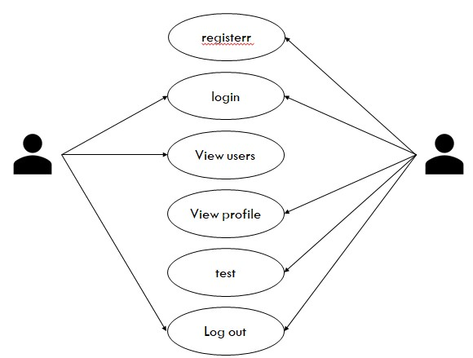
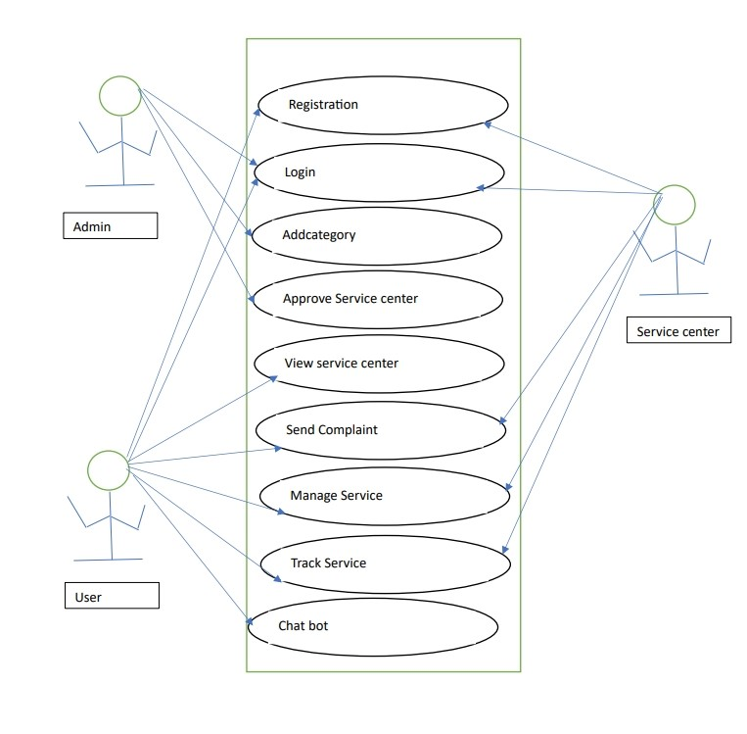
5.
7

UML ACTIVITY DIAGRAM

U
se
C
ase
D
iagram

Admin
User

AI
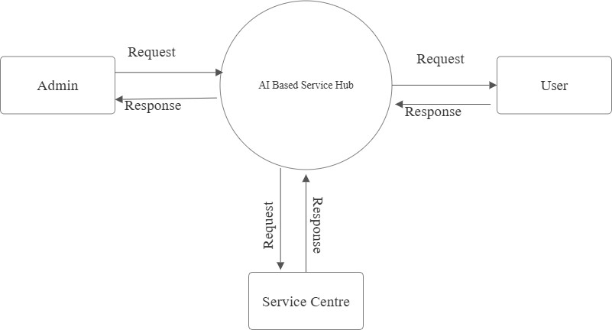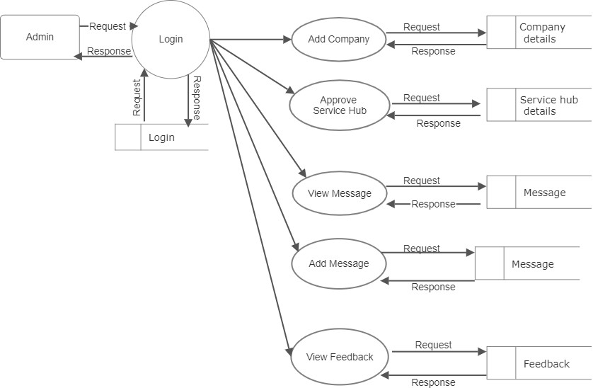
Data Flow Diagram

Le
v
el:
0
Le
v
el
1.1
:
Admin
1

Level 1.2: User
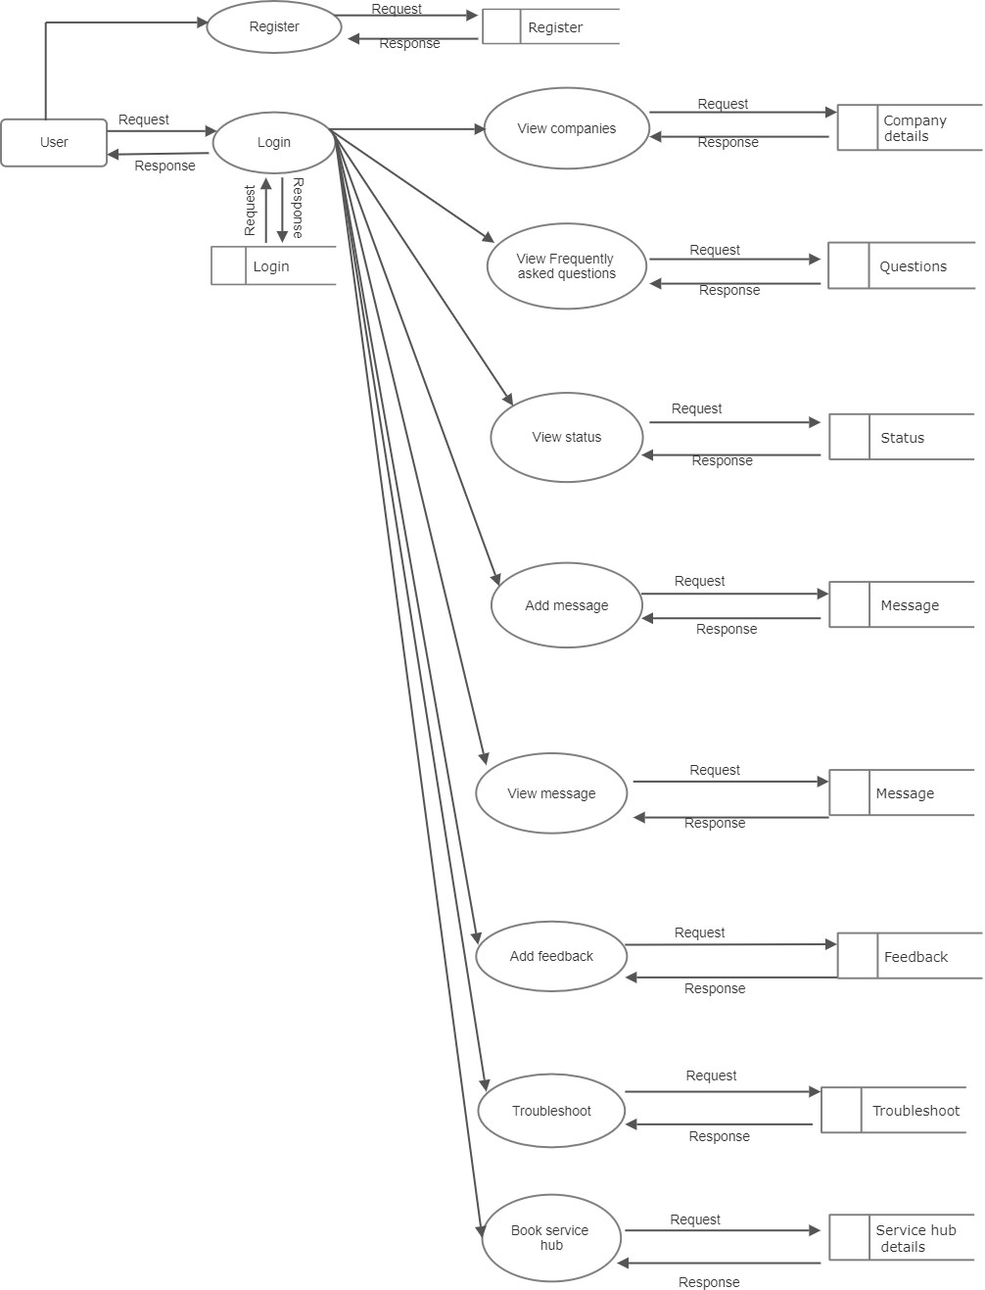
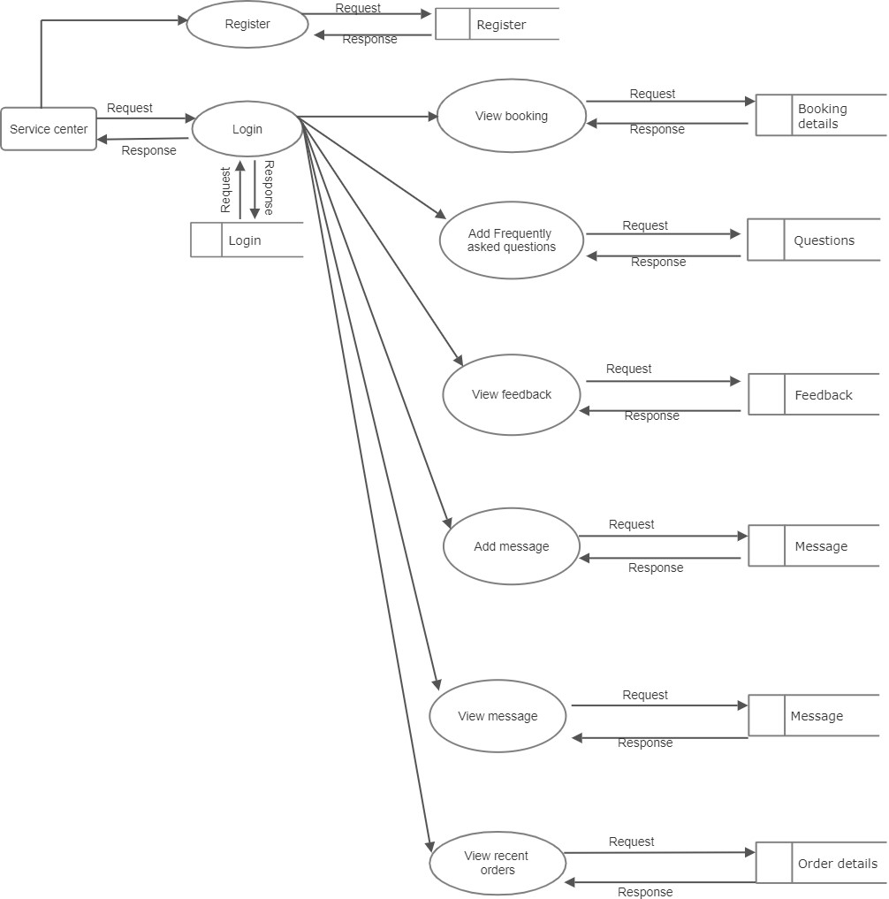
Level 1.3: Service Center

6. SYSTEM IMPLEMENTATION AND MAINTENANCE
The implementation of the proposed system involves designing a robust architecture that integrates an AI-powered chatbot, service center database, and user interfaces across web and mobile platforms. The chatbot, utilizing Natural Language Processing (NLP), will efficiently gather complaint details and provide personalized troubleshooting solutions. It will generate a unique complaint ID for tracking and offer seamless escalation to authorized service centers when necessary. The backend will be built to securely manage user data, complaint status, and service center information, while integrating with email systems for status updates. Cloud-based deployment ensures scalability, performance, and global access. Ongoing maintenance includes regular AI model updates based on user feedback and troubleshooting data, security audits to protect user data, performance optimizations to handle increasing traffic, and keeping service center information up to date. The system will also provide continuous monitoring to detect and address issues promptly, ensuring a smooth user experience with minimal downtime.

6.1 TECHNICAL SPECIFICATION
Python:
Python is an interpreted, object-oriented, high-level programming language
with dynamic semantics. Its high-level built-in data structures, combined with dynamic typing and dynamic binding, make it very attractive for rapid application development as well as for use as scripting or glue language to connect existing components together. Python’s simple, easy to learn syntax emphasizes readability and therefore reduces the cost of program maintenance supports modules and packages, which encourages program modularity and code reuse. The Python interpreter and the extensive standard library are available in source or binary form without charge for all major platforms and can be freely distributed.
Django:
Django is a high-level Python Web frame work that encourages rapid
development and clean, pragmatic design. Built by experienced developers, it takes care of much of the hassle of Web development, so you can focus on writing your app without needing to reinvent the wheel. It’s free and open source. Django's primary goal is to ease the creation of complex,database-driven websites. Django emphasizes reusability and "plug ability" of components,less code, low coupling, rapid development, and the principle of don't repeat yourself. Python is used throughout, even for settings files and data models. Django also provides an optional administrative create, read, update and delete interface that is generated dynamically through introspection and configured via admin models.
Visual studio code:
Visual Studio Code is a source code editor developed by Microsoft for Windows, Linux and mac OS. It includes support for debugging, embedded it control, syntax highlighting,intelligent code completion, snippets, and code refactoring. It is also customize able, so user can change the editor’s theme, keyboard shortcuts, and preferences. It is free and open- source,although the official download is under a proprietary license. Visual Studio Code is based on Electron, a framework which is used to deploy Node.js applications for the desktop running on the Blink layout engine. Although it uses the Electron framework, the software does not use Atom and instead employs the same editor component (codenamed "Monaco") used in Visual Studio Team Services (formerly called Visual Studio Online).Visual Studio Code is a source code editor. It supports a number of programming languages and a set of features that may or may not be available for a given language, Many of Visual Studio Code features are not exposed through menus or the user interface. Rather, they are accessed via the command palette or via a.json file(e.g., user preferences). The command palette is a command-line interface. However, it disappears if the user clicks anywhere outside it or presses a key combination on the keyboard to interact with something outside it. When this happens, the command in progress is cancelled.In the role of a source code editor,
Visual Studio Code features a lightning-fast source code editor, perfect for day- to-day use. With support for hundreds of languages, VS Code helps you be instantly productive with syntax highlighting, bracket-matching, auto-indentation, box-selection,snippets, and more. Intuitive keyboard shortcuts, easy customization and community-contributed keyboard shortcut mappings let you navigate your code with ease. For serious coding, you'll often benefit from tools with more code understanding than just blocks of text.Visual Studio Code includes built-in support for IntelliSense code completion, rich semantic code understanding and navigation, and code refactoring. And when the coding gets tough, the tough get debugging.
MySQL Server:
MySQL is an open-source relational database management system (RDBMS). The MySQL development project has made its source code available under the terms of the GNU General Public License, as well as under a variety of proprietary agreements. MySQL is offered under two different editions: the open-source MySQL Community Server and the proprietary Enterprise Server. MySQL Enterprise Server is differentiated by a series of proprietary extensions which install as server plugins, but otherwise shares the version numbering system and is built from the same code base.
Major features as available in MySQL5.6:
- A broad subset of ANSI SQL99, as well as extensions
- Cross-platform support
- Stored procedures, using a procedures all language that closely adheres to SQL/PSM
- Triggers
- Cursors
- Updatable views
Html:
Hypertext Markup Language is a scripting language used for writing data in web pages .It specifies the layout and linking commands present in the hypertext documents themselves .The word hypertext refers to the non-linear information on the document, which helps to navigate through the pages. An HTML document is a plain ASCII text file created using any text editor with codes inserted in the text to define elements in the document. Users have to provide formatting through their browser platform combination. HTML publishing tools are used for making webpages in the net.
Web Browsers:
A web browser is a software application that enables a user to display and interact with
text, images, video, music and other information typically located on a Web page at a website on the World Wide Web or a local area network. Text and images on a Web page can contain hyperlinks to other Web pages at the same or different website. Web browsers allow a user too quickly and easily access information provided on many Web pages at many websites by traversing these links. Web browsers format HTML information for display, so the appearance of a Web page may differ between browsers. Some of the Web browsers available for personal computers include Mozilla, Firefox, Safari and Opera.
CSS:
Cascading Style Sheets (CSS) is a style sheet language used to describe the
presentation (that is, the look and formatting) of a document written in a markup language. Its most common application is to style webpages written in HTML and XHTML, but the language can be applied to any kind of XML document, including SVG and XUL. CSS is designed primarily to enable the separation of document content from document presentation, including elements such as the colors, fonts and layout. This separation can improve content accessibility, provide more flexibility and control in the specification of presentation characteristics, enable multiple pages to share formatting, and reduce complexity and repetition in the structural content (such as by allowing for table less web design).

Machine learning
Machine learning is a subfield of artificial intelligence (AI) that focuses on the development of algorithms and statistical models that enable computers to improve their performance on a specific task through learning from data, without being explicitly programmed. In machine learning, computers are trained on large datasets to recognize patterns, make predictions, or perform tasks without explicit programming instructions. It is commonly used in various applications, including image and speech recognition, natural language processing, recommendation systems, and data analysis. Machine learning encompasses a range of techniques, such as supervised learning, unsupervised learning, and reinforcement learning, and has become a fundamental technology in the modern era, driving innovations across multiple industries.
Machine Learning Model Life Cycle:
The machine learning life cycle involves seven major steps, which are given below:
- Gathering Data
- Data preparation
- Data Wrangling • Analyse Data
- Train the model
- Test the model
- Deployment
In the complete life cycle process, to solve a problem, we create a machine learning system called "model", and this model is created by providing "training". But to train a model, we need data, hence, the life cycle starts by collecting data.
- Gathering Data: This initial step involves collecting relevant data from various sources to build a comprehensive dataset for machine learning.
- Data Preparation: In this phase, the collected data is cleaned, formatted, and organized to ensure it meets the requirements of the machine learning model
- Data Wrangling: Data wrangling focuses on handling missing values, outliers, and transforming the dataset to enhance its quality and usability for training the model.
- Analyze Data: This step involves exploring and understanding the dataset through statistical analysis and visualization to gain insights into patterns and relationships.
- Train the Model: The model is trained using the prepared dataset, employing algorithms to learn patterns and make predictions based on the input features.
- Test the Model: The trained model is evaluated on a separate dataset to assess its performance, ensuring it can generalize well to new, unseen data.
- Deployment: Once the model proves effective, it is deployed to a production environment, allowing it to make predictions on new data in real-world scenarios.
Natural Language Processing:
NLP stands for Natural Language Processing, which is a subfield of artificial intelligence (AI) that focuses on the interaction between computers and human language. NLP aims to enable machines to understand, interpret, and generate human language in a valuable way. It involves the development of algorithms and models that can perform tasks such as text analysis, sentiment analysis, language translation, speech recognition, and text generation. NLP plays a crucial role in a wide range of applications, including chatbots, virtual assistants, language translation services, content recommendation systems, and text analytics, making it a fundamental technology in today's digital world.
Algorithm Description:
The AI-Powered Service Center Assistance & Troubleshooting System follows a structured process to help users diagnose and fix minor technical issues before seeking professional help. When a user reports a problem through the chatbot, the system analyzes their input using AI and identifies the issue based on a built-in troubleshooting database. It then provides step-bystep solutions to resolve the problem. If the issue is fixed, the session ends; otherwise, the chatbot offers additional troubleshooting steps. If the problem persists, users can register a complaint and access details of authorized service centers. The system continuously learns from user feedback, improving its responses over time. This approach saves time, reduces unnecessary service visits, and ensures a smooth transition from self-help to expert assistance.

7.AI Description
Chatbot Description:
Our AI-powered chatbot leverages the Decision Tree Algorithm to provide a structured and efficient troubleshooting experience. When users report an issue, the chatbot processes their input using Natural Language Processing (NLP) and navigates a decision tree to identify the most likely cause. Through a series of step-by-step questions, the chatbot guides users toward a solution by following predefined troubleshooting paths. If the issue is resolved, the session concludes with feedback collection. If not, users can manually register a complaint on the website and book a service appointment for professional assistance. By combining structured problem-solving with AI-driven logic, the chatbot reduces unnecessary service center visits, speeds up issue resolution, and provides 24/7 support, ensuring a seamless transition from selfservice troubleshooting to expert repair solutions.
Decision Tree:
A decision tree is a type of algorithm used in machine learning for decision-making, classification, and regression tasks. It mimics human decision-making by breaking down a problem into a series of yes/no (true/false) questions, guiding the process step by step until a final decision is reached.
Structure of a Decision Tree:
- Root Node: The starting point that represents the entire dataset. It contains the most important decision or feature to split the data.
- Internal Nodes: These represent decision points where the data is split based on certain conditions.
- Branches: These connect nodes and represent different possible outcomes.
- Leaf Nodes: The final nodes that represent the decision or classification.
How it Works:
1.Feature Selection: The algorithm selects the best feature (variable) to split the data using techniques like Gini Impurity, Entropy, or Information Gain.
2.Splitting: The data is divided based on the chosen feature’s values (e.g., “Is the battery charging? Yes/No”).
3.Recursive Partitioning: The process is repeated for each subset until a stopping condition is met (such as reaching pure classifications or a set depth).
4.Decision Making: Once all conditions are checked, the final decision is made at the leaf node.

8.SYSTEM TESTING
Software testing is an empirical investigation conducted to provide stakeholders
with information about the quality of the product or service under test, with respect to the context in which it is intended to operate. Testing also provides an objective, independent view of the software to allow the business to appreciate and understand the risks at implementation of the software. Test techniques include, but are not limited to, the process of executing a program or application with the intent of finding software bugs. It can also be stated as the process of validating and verifying that a software program/application/product meets the business and technical requirements that guided its design and development, so that it works as expected and can be implemented with the same characteristics.
Software Testing, depending on the testing method employed, can be implemented at
any time in the development process, however the most test effort is employed after the requirements have been defined and coding process has been completed.

8.1 TESTING TECHNIQUES
Testing technique refers to the different methodologies followed during testing.
There are basically two types of techniques followed in software testing.
- Static testing: In static testing the program is not run or executed for testing purpose. Here basically involves some informal approaches of testing. Static testing involves code reviews, code reading, code walk throughs etc.
- Dynamic testing: In dynamic testing the program or software is executed and tested with test data. The program is traced and debugged. Here there exist two types of testing namely black box testing and white box testing.

8.2 DIFFERENT LEVELS OF TESTING
- Unit Testing:
It is the first level of testing. Each module is tested individually, and focus is given for
finding errors limited to each individual module and correcting them. The different modules of the system are tested individually and corrected all errors. Each module is focused to work satisfactorily with regard to the expected output from the module. In computer programming, Unit testing is successfully tested in our system .As an example code fragmentation of registration of branch by the admin module and adding hospital details admin are successfully tested.
- Integrated System Testing:
Integration testing (sometimes called integration and testing, abbreviated I&T) is the phase in software testing in which individual software modules are combined and tested as a group. Consider our system, Event module is first register with their details, which can be successfully viewed by the admin. This Communication flow is correctly implemented.
- Validation Testing:
For each input forms validation testing are done to ensure that only allowed values will be entered. Entering incorrect values does the validation testing and it is checked whether the errors are being considered. Incorrect values are to be discarded.
Eg: Consider User module in our system, User can register their details in Registration form. Registration form consist of some filed i.e username, contact number ,email etc, if they try to skip any filed then click the signup button, in this case validation will perform. This is the one type of validation.
- Output Testing:
After performing the validation testing, the next step is output testing of the proposed
system, since no system could be useful if it does not produce the required output in the specific format. The output generated by the system under considerations is tested by asking the users about the format required by them

SAMPLE TEST
- Chatbot troubleshooting basic issue
Prepared by: | Mohammed Anshif
Tested by: | Mohammed Anshif
Category: | Functional Testing
Test Objective: | To verify that the chatbot provides correct troubleshooting steps for common device issues.
Procedures: | - Open the chatbot on the website.  - Enter a basic issue (e.g., "WiFi not connecting").  - Follow the suggested troubleshooting steps.  - If unresolved, check if the chatbot suggests tocontact a service center.
Expected Result: | The chatbot should provide relevant troubleshooting steps. If the issue persists, it should suggest contacting a service center.
Actual Result: | As Expected.
Test Status: | Pass:✔ | Fail:
- Complaint registration process
Prepared by: | Mohammed Anshif
Tested by: | Mohammed Anshif
Category: | Usability Testing
Test Objective: | To ensure users can manually register complaints for unresolved issues.
Procedures: | - Attempt to register a complaint after anunsuccessful chatbot session.  - Fill in the required details (device type, issuedescription, contact details).  - Submit the complaint and verifyconfirmation.
Expected Result: | The system should accept the complaint, confirm submission, and provide tracking details.
Actual Result: | As Expected.
Test Status: | Pass:✔ | Fail:
39
- Service Center Information Access
Prepared by: | Mohammed Anshif
Tested by: | Mohammed Anshif
Category: | Functional Testing
Test Objective: | To ensure users can access details of authorized service centers.
Procedures: | - Navigate to the "Service Centers" section onthe website.  - Search for service centers based on brand  - Verify that the system displays accurate details (name, address, contact number, services offered).
Expected Result: | The website should display authorized service center details accurately.
Actual Result: | As Expected.
Test Status: | Pass:✔ | Fail:
- Chatbot Understanding User Queries
Prepared by: | Mohammed Anshif
Tested by: | Mohammed Anshif
Category: | AI Performance Testing
Test Objective: | To test the chatbot’s ability to understand different phrasings of the same issue.
Procedures: | - Ask the chatbot about a single issue usingdifferent phrasings (e.g., “Phone not charging” vs.  “My mobile won’t charge”).  - Check if the chatbot provides consistent andrelevant troubleshooting steps.
Expected Result: | The chatbot should correctly interpret different phrasings and provide relevant troubleshooting guidance.
Actual Result: | As Expected.
Test Status: | Pass:✔ | Fail:
0

9.FUTURE ENHANCEMENT
Future enhancements of the AI-Based Service Hub will focus on improving AI capabilities, user experience, and service efficiency. Advanced deep learning models and sentiment analysis will enhance the chatbot’s ability to understand complex queries and detect user frustration, enabling smoother interactions. Voice-enabled support with multilingual capabilities will make troubleshooting more accessible, while AI-driven complaint registration and real-time tracking will streamline issue resolution. Machine learning algorithms will be integrated for predictive maintenance, allowing early detection of potential device failures. IoT connectivity will enable real-time diagnostics, making troubleshooting more precise and reducing the need for manual interventions. A dedicated mobile app will provide on-the-go access to AI-driven support, allowing users to scan error messages for instant solutions. Additionally, service center automation with an AI-powered dashboard and automated appointment scheduling will optimize repair processes, reducing wait times and improving overall efficiency. These enhancements will create a smarter, faster, and more user-friendly system, ensuring seamless customer support and a more efficient service experience.
1

10.CONCLUSION
In Conclusion, The AI-Based Service Hub System enhances customer support by
providing instant AI-driven troubleshooting and easy access to authorized service centers. It reduces resolution time, minimizes reliance on unreliable sources, and streamlines complaint registration. With 24/7 availability and improved efficiency, this system ensures a seamless user experience while optimizing technical support. Future advancements like predictive maintenance and IoT-based diagnostics will further enhance its effectiveness
2

11.BIBLIOGRAPHY
1.Books & Research Papers
- Russell, S., & Norvig, P. (2020). Artificial Intelligence: A Modern Approach. Pearson.
- Goodfellow, I., Bengio, Y., & Courville, A. (2016). Deep Learning. MIT Press.
2. Web Sources
- IBM. (n.d.). "What is Artificial Intelligence (AI)?" Retrieved from https://
www.ibm.com
- Google AI. (n.d.). "Machine Learning Basics." Retrieved from https://ai.google
3. Technical Reports & White Papers
- OpenAI. (2023). "The Impact of AI on Customer Support Systems."
- Microsoft Research. (2022). "Enhancing Customer Service with NLP and Chatbots."
4. Articles & Journals
- Smith, J. (2021). "AI-Powered Chatbots in Technical Support." Journal of AI & Automation, 15(3), 45-60.
- Brown, L. (2020). "The Role of NLP in Customer Service." International Journal of Machine Learning Applications, 12(2), 78-92.
3
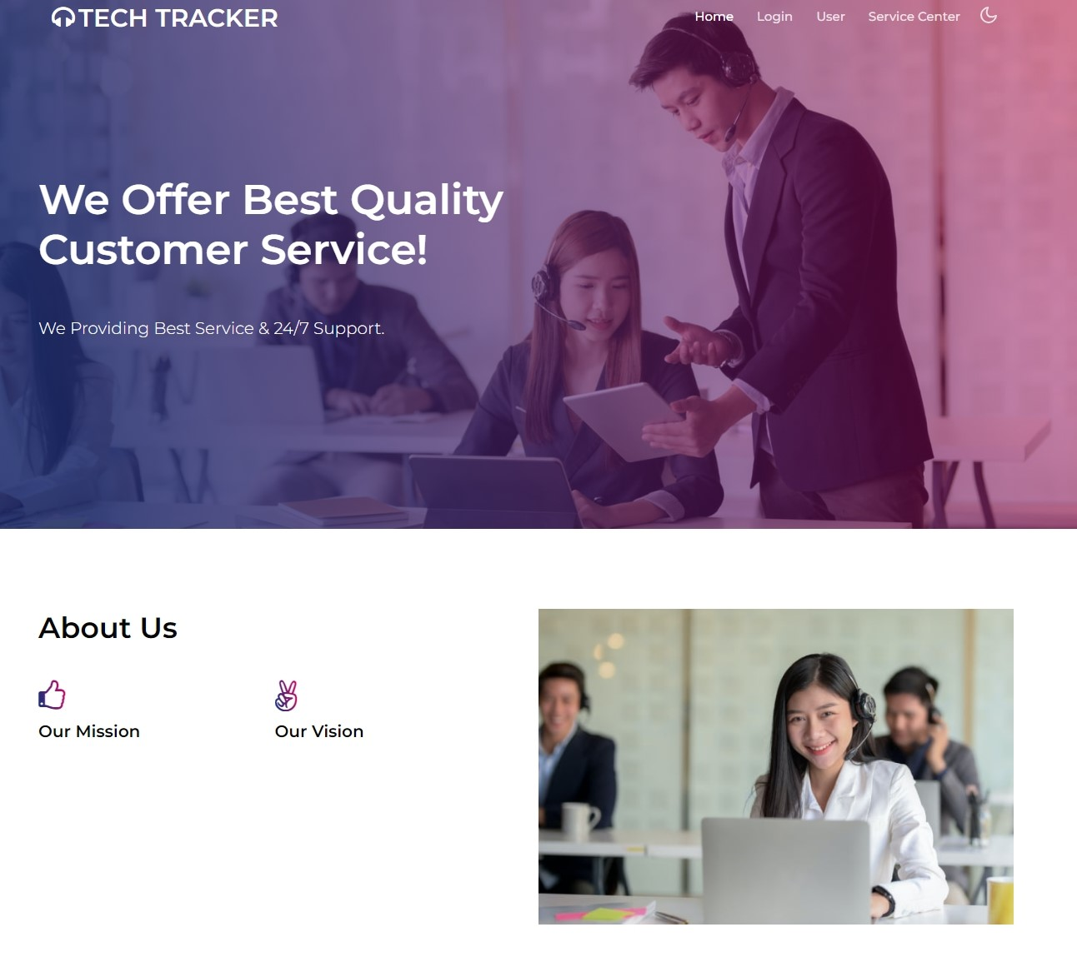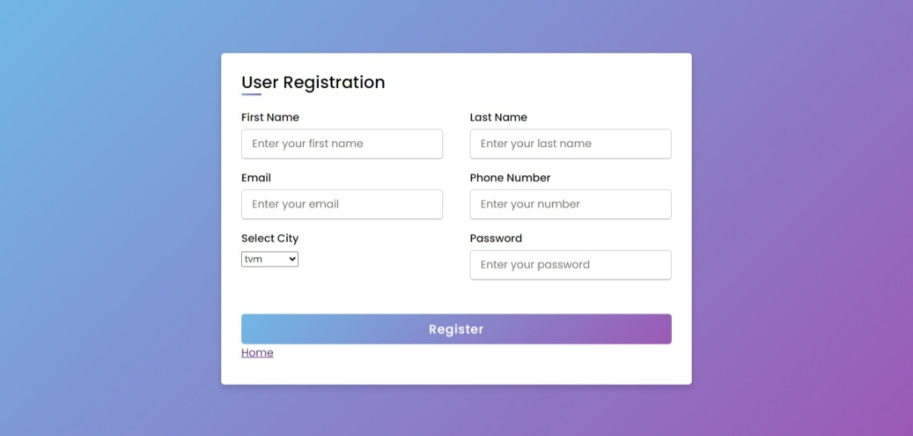
1
2
.SAMPLE SCREENSHOTS
Home page
Registration page

4
Login page
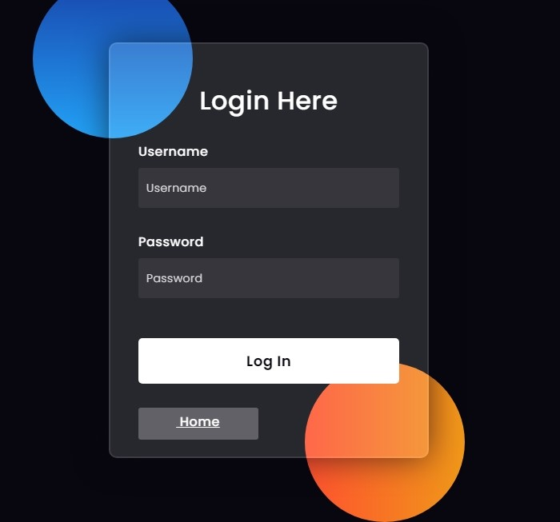
Service Centre Registration
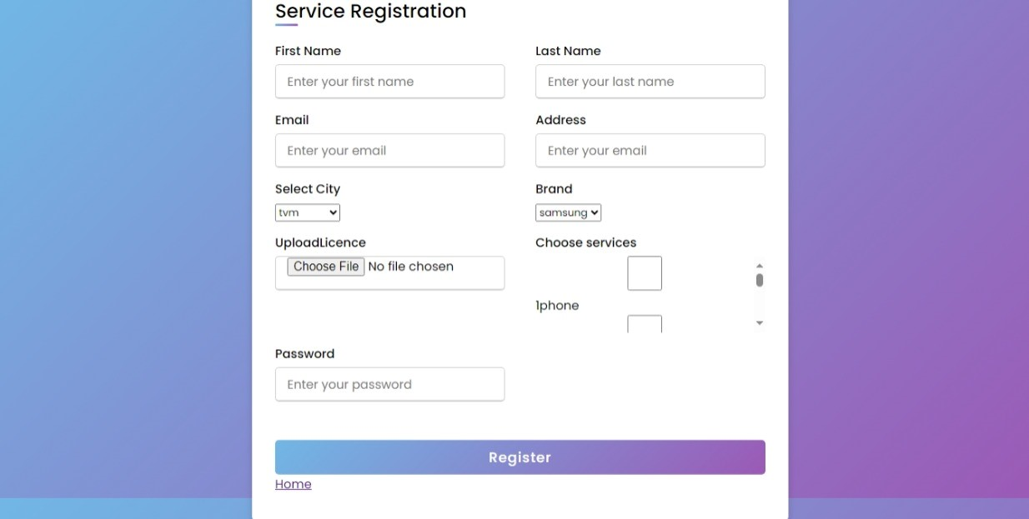
5

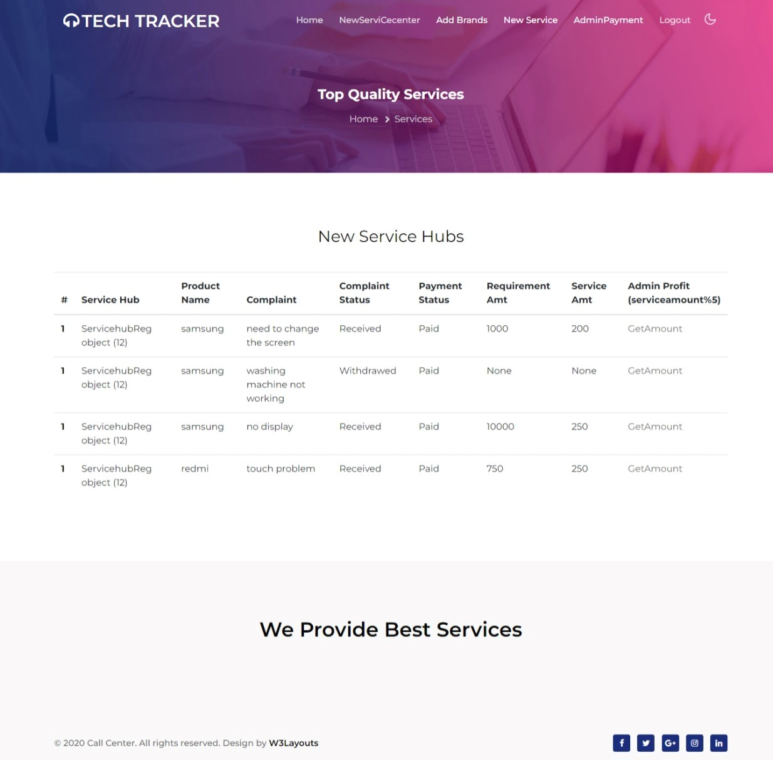
Vi
e
w Service Detals
6
Admin-Home Page

7
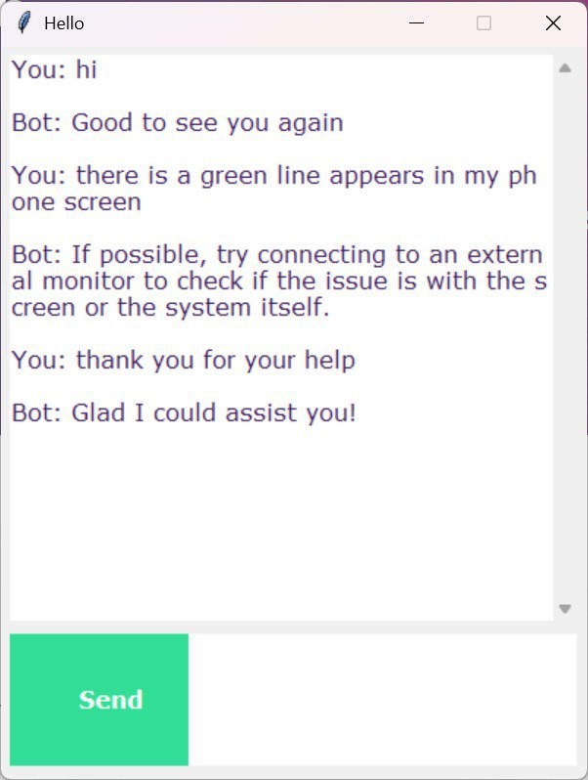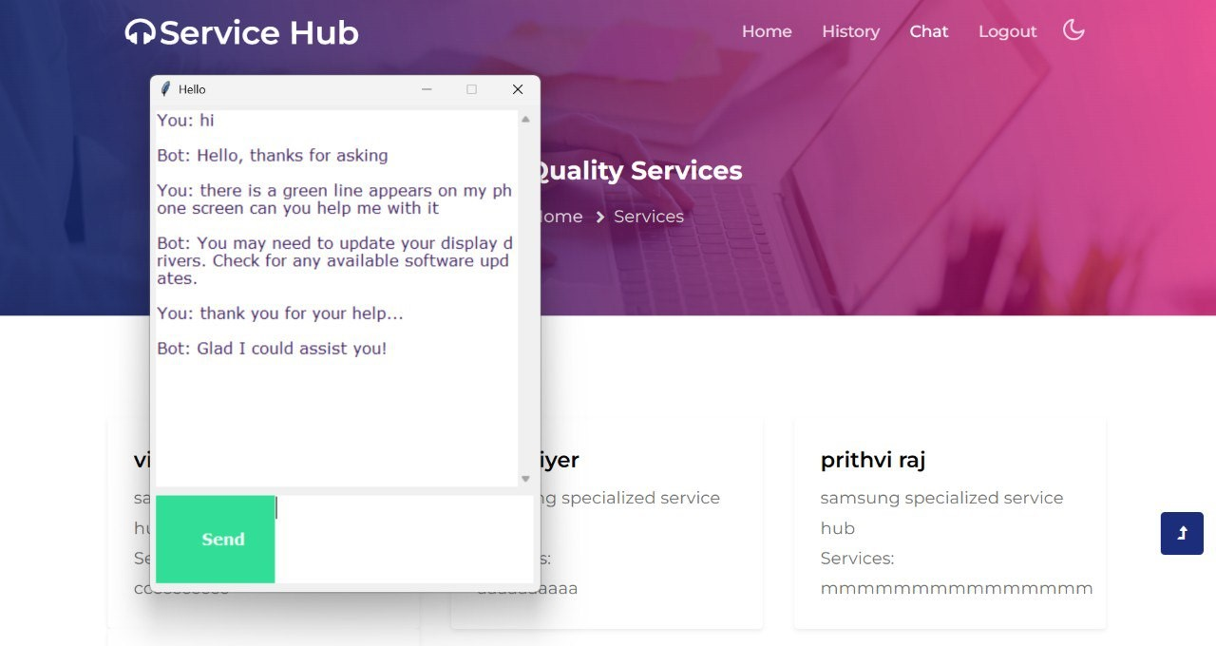
Ch
at
b
ot
8

13.SOURCE CODE
models.py
from django.db import models
from django.contrib.auth.models import AbstractUser # Create your models here. class Login_table(AbstractUser):
user_type=models.CharField(max_length=30) view_password=models.CharField(max_length=30)
class Add_brand(models.Model): brand_name=models.CharField(max_length=30)
class Add_service(models.Model):
brand=models.ForeignKey(Add_brand,on_delete=models.CASCADE) service_name=models.CharField(max_length=10)
class ServicehubReg(models.Model):
brand=models.ForeignKey(Add_brand,on_delete=models.CASCADE,null=True) servicelog=models.ForeignKey(Login_table,on_delete=models.CASCADE) fname=models.CharField(max_length=30) lname=models.CharField(max_length=30) office=models.TextField(null=True)
district=models.CharField(max_length=20,null=True) licence_upload=models.FileField(blank=True,null=True) phone=models.CharField(max_length=20,default='11111') status=models.CharField(max_length=10,default='Pending')
class Servicehubservice(models.Model):
servicehub=models.ForeignKey(ServicehubReg,on_delete=models.CASCADE) services=models.ForeignKey(Add_service,on_delete=models.CASCADE)
class UserReg(models.Model):
userlog=models.ForeignKey(Login_table,on_delete=models.CASCADE) fname=models.CharField(max_length=30) lname=models.CharField(max_length=30) phone=models.CharField(max_length=30) district=models.CharField(max_length=30)
49

class Faq(models.Model): servicehub=models.ForeignKey(ServicehubReg,on_delete=models.CASCADE) faq_question=models.CharField(max_length=30) faq_answer=models.TextField()
class Send_message(models.Model): user=models.ForeignKey(UserReg,on_delete=models.CASCADE) servicehub=models.ForeignKey(ServicehubReg,on_delete=models.CASCADE) user_message=models.TextField() hub_reply=models.TextField(blank=True)
class Complaint(models.Model): user=models.ForeignKey(UserReg,on_delete=models.CASCADE) servicehub=models.ForeignKey(ServicehubReg,on_delete=models.CASCADE) productname=models.CharField(max_length=30) complaint=models.CharField(max_length=30) complaintdate=models.DateField(auto_now_add=True) complaint_status=models.CharField(max_length=20,default='Pending') req_desc=models.CharField(max_length=30,null=True) req_amount=models.CharField(max_length=30,null=True) service_amt=models.CharField(max_length=30,null=True) req_status=models.CharField(max_length=30,default='Pending') total=models.CharField(max_length=30,null=True)
paymentstatus=models.CharField(max_length=10,default='pending') feedbacks=models.TextField(null=True)

admin.py
from django.contrib import admin
# Register your models here. from .models import * admin.site.register(Login_table) admin.site.register(ServicehubReg) admin.site.register(UserReg) admin.site.register(Servicehubservice) admin.site.register(Add_service) admin.site.register(Add_brand) admin.site.register(Send_message) admin.site.register(Faq) admin.site.register(Complaint)

chatgui.py
import nltk from nltk.stem import WordNetLemmatizer lemmatizer = WordNetLemmatizer()
import pickle import numpy as np
from keras.models import load_model model = load_model('chatbot_model.h5') import json
import random
intents = json.loads(open('intents.json').read()) words = pickle.load(open('words.pkl','rb')) classes = pickle.load(open('classes.pkl','rb'))
def clean_up_sentence(sentence): sentence_words = nltk.word_tokenize(sentence)
sentence_words = [lemmatizer.lemmatize(word.lower()) for word in sentence_words] return sentence_words
# return bag of words array: 0 or 1 for each word in the bag that exists in the sentence
def bow(sentence, words, show_details=True):
# tokenize the pattern sentence_words = clean_up_sentence(sentence) # bag of words - matrix of N words, vocabulary matrix bag = [0]*len(words) for s in sentence_words:
for i,w in enumerate(words):
if w == s:

# assign 1 if current word is in the vocabulary position bag[i] = 1 if show_details: print ("found in bag: %s" % w)
return(np.array(bag))
def predict_class(sentence, model): # filter out predictions below a threshold p = bow(sentence, words,show_details=False) res = model.predict(np.array([p]))[0]
ERROR_THRESHOLD = 0.25
results = [[i,r] for i,r in enumerate(res) if r>ERROR_THRESHOLD]
# sort by strength of probability results.sort(key=lambda x: x[1], reverse=True)
return_list = [] for r in results: return_list.append({"intent": classes[r[0]], "probability": str(r[1])}) return return_list
def getResponse(ints, intents_json):
tag = ints[0]['intent'] list_of_intents = intents_json['intents'] for i in list_of_intents: if(i['tag']== tag):
result = random.choice(i['responses']) break return result
def chatbot_response(msg):
ints = predict_class(msg, model) res = getResponse(ints, intents)
return res
#Creating GUI with tkinter import tkinter from tkinter import *
def send(): msg = EntryBox.get("1.0",'end-1c').strip() EntryBox.delete("0.0",END)
if msg != '':
ChatLog.config(state=NORMAL)
ChatLog.insert(END, "You: " + msg + '\n\n')
ChatLog.config(foreground="#442265", font=("Verdana", 12 ))
res = chatbot_response(msg)
ChatLog.insert(END, "Bot: " + res + '\n\n')
ChatLog.config(state=DISABLED) ChatLog.yview(END)
base = Tk()
base.title("Hello") base.geometry("400x500")
base.resizable(width=FALSE, height=FALSE)
#Create Chat window
ChatLog = Text(base, bd=0, bg="white", height="8", width="50", font="Arial",)
ChatLog.config(state=DISABLED)
#Bind scrollbar to Chat window
scrollbar = Scrollbar(base, command=ChatLog.yview, cursor="heart") ChatLog['yscrollcommand'] = scrollbar.set
#Create Button to send message
SendButton = Button(base, font=("Verdana",12,'bold'), text="Send", width="12", height=5, bd=0, bg="#32de97", activebackground="#3c9d9b",fg='#ffffff', command= send )
#Create the box to enter message
EntryBox = Text(base, bd=0, bg="white",width="29", height="5", font="Arial") #EntryBox.bind("<Return>", send)
#Place all components on the screen scrollbar.place(x=376,y=6, height=386) ChatLog.place(x=6,y=6, height=386, width=370)
EntryBox.place(x=128, y=401, height=90, width=265)
SendButton.place(x=6, y=401, height=90) base.mainloop()

train_chatbot.py
import nltk nltk.download('punkt') nltk.download('wordnet') from nltk.stem import WordNetLemmatizer lemmatizer = WordNetLemmatizer()
import json import pickle
import numpy as np
from keras.models import Sequential from keras.layers import Dense, Activation, Dropout from tensorflow.keras.optimizers import SGD import random
words=[]
classes = [] documents = [] ignore_words = ['?', '!'] data_file = open('intents.json').read() intents = json.loads(data_file)
for intent in intents['intents']: for pattern in intent['patterns']:
# take each word and tokenize it w = nltk.word_tokenize(pattern) words.extend(w) # adding documents
documents.append((w, intent['tag']))
# adding classes to our class list if intent['tag'] not in classes:

classes.append(intent['tag'])
words = [lemmatizer.lemmatize(w.lower()) for w in words if w not in ignore_words] words = sorted(list(set(words))) classes = sorted(list(set(classes)))
print (len(documents), "documents") print (len(classes), "classes", classes) print (len(words), "unique lemmatized words", words)
pickle.dump(words,open('words.pkl','wb')) pickle.dump(classes,open('classes.pkl','wb'))
# initializing training data training = [] output_empty = [0] * len(classes) for doc in documents:
# initializing bag of words
bag = []
# list of tokenized words for the pattern pattern_words = doc[0]
# lemmatize each word - create base word, in attempt to represent related words pattern_words = [lemmatizer.lemmatize(word.lower()) for word in pattern_words] # create our bag of words array with 1, if word match found in current pattern for w in words: bag.append(1) if w in pattern_words else bag.append(0)
# output is a '0' for each tag and '1' for current tag (for each pattern) output_row = list(output_empty) output_row[classes.index(doc[1])] = 1
training.append([bag, output_row]) # shuffle our features and turn into np.array random.shuffle(training) training = np.array(training)
# create train and test lists. X - patterns, Y - intents train_x = list(training[:,0]) train_y = list(training[:,1]) print("Training data created")
# Create model - 3 layers. First layer 128 neurons, second layer 64 neurons and 3rd output layer contains number of neurons
# equal to number of intents to predict output intent with softmax
model = Sequential()
model.add(Dense(128, input_shape=(len(train_x[0]),), activation='relu')) model.add(Dropout(0.5)) model.add(Dense(64, activation='relu'))
model.add(Dropout(0.5))
model.add(Dense(len(train_y[0]), activation='softmax'))
# Compile model. Stochastic gradient descent with Nesterov accelerated gradient gives good results for this model'
# sgd = SGD(learning_rate=0.01, decay_rate=1e-6, momentum=0.9, nesterov=True) sgd = SGD( initial_learning_rate=0.01, decay_steps=10000, decay_rate=0.9)
model.compile(loss='categorical_crossentropy', optimizer=sgd, metrics=['accuracy'])
#fitting and saving the model
hist = model.fit(np.array(train_x), np.array(train_y), epochs=200, batch_size=5, verbose=1)
model.save('chatbot_model.h5', hist) print("model created")

manage.py
#!/usr/bin/env python
"""Django's command-line utility for administrative tasks.""" import os import sys
def main():
"""Run administrative tasks.""" os.environ.setdefault('DJANGO_SETTINGS_MODULE', 'service_hub.settings') try:
from django.core.management import execute_from_command_line except ImportError as exc:
raise ImportError(
"Couldn't import Django. Are you sure it's installed and "
"available on your PYTHONPATH environment variable? Did you "
"forget to activate a virtual environment?"
) from exc execute_from_command_line(sys.argv)
if __name__ == '__main__': main()

