DEVELOPMENT TEAM PROFILES
RCC-APS Automated Payroll System
Republic Central Colleges (RCC)
[School Address]
[Course and Year]
[Date]

INTRODUCTION
The RCC-APS Automated Payroll System was developed by a team of Information Technology students of Republic Central Colleges (RCC). Each member contributed to the planning, design, development, and documentation of the system. Their individual profiles are presented below.

DEVELOPMENT TEAM PROFILE

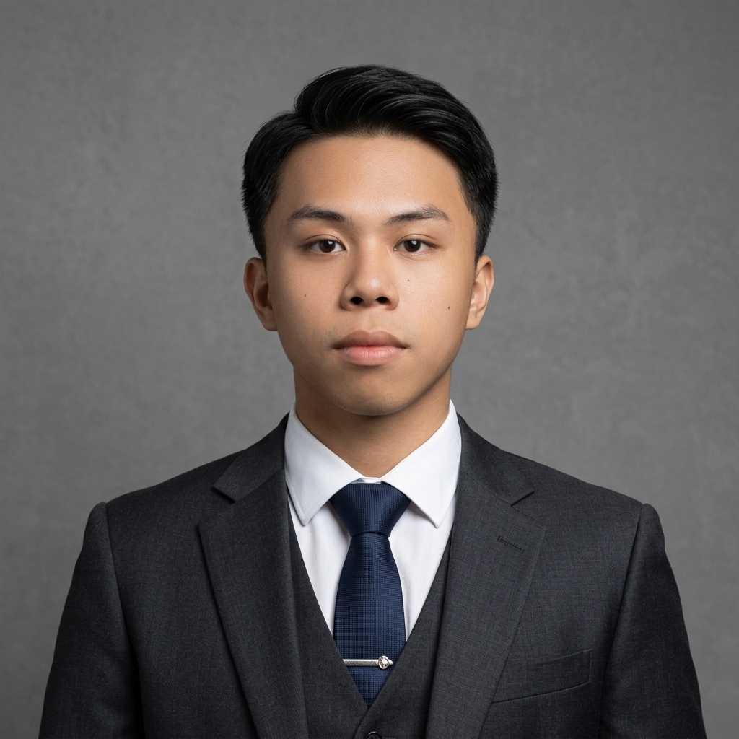
JHON GERALD P. BATUAAN
Programmer, Team Leader, Designer
BSIT-IV
jhon_batuaan@rcc.edu.ph
PERSONAL OBJECTIVE
To pursue a career in the field of Information Technology where I can apply my knowledge, develop my technical skills, gain valuable experience, and continuously learn and grow as an aspiring IT professional.
EDUCATIONAL ATTAINMENT
Elementary
- Sto. Rosario Elementary School, Grade 1–6, Angeles City (2011–2017)
Junior High School
- Republic Central Colleges, Grade 7–10, Angeles City (2017–2021)
Senior High School
- Republic Central Colleges, HUMSS, Angeles City (2021–2023) — With Honors

DEVELOPMENT TEAM PROFILE

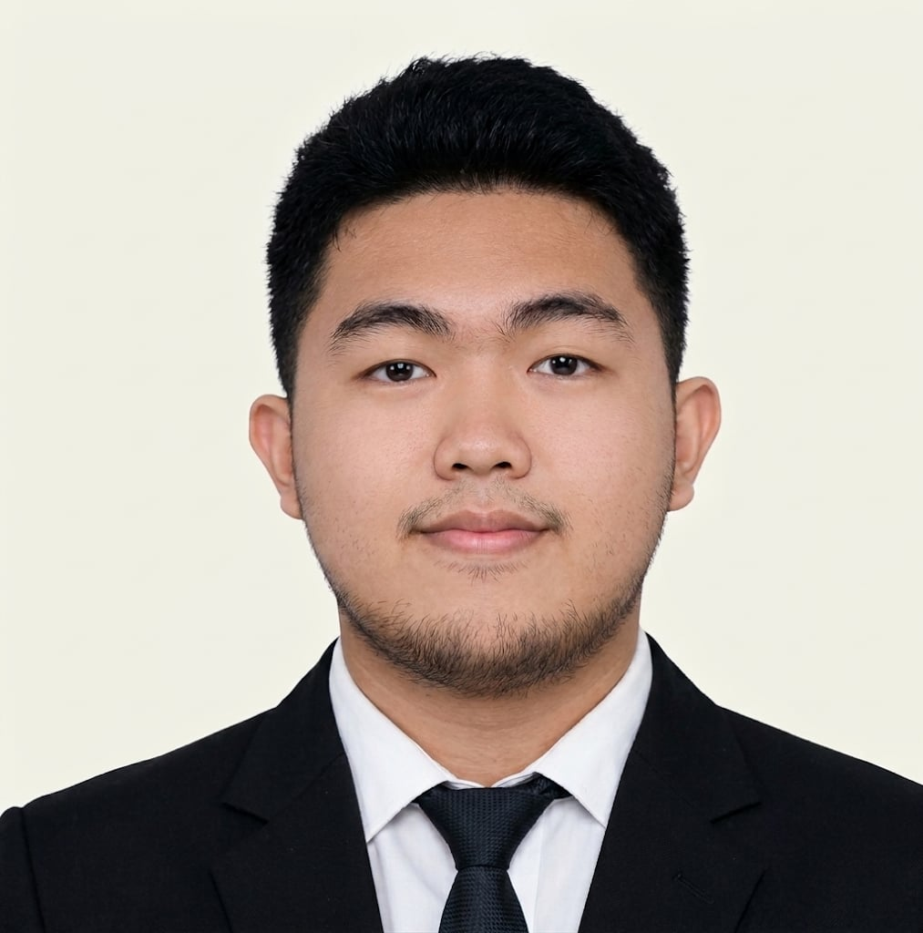
JOHN CARLO G. CABIGTING
Programmer, Documentation, Designer
BSIT-4
john_cabigting@rcc.edu.ph
PERSONAL OBJECTIVE
I may not know everything, but I’m eager to learn, grow, and contribute through determination and quality results.
EDUCATIONAL ATTAINMENT
Elementary
- Hillcrest Baptist Academy, Grade 1–6, Malabanias, Angeles City (2009–2015) — With Honors
Junior High School
- Republic Central Colleges, Grade 7–10, Plaridel St., Angeles City (2015–2019)
Senior High School
- Republic Central Colleges, GAS, Plaridel St., Angeles City (2019–2021)

DEVELOPMENT TEAM PROFILE

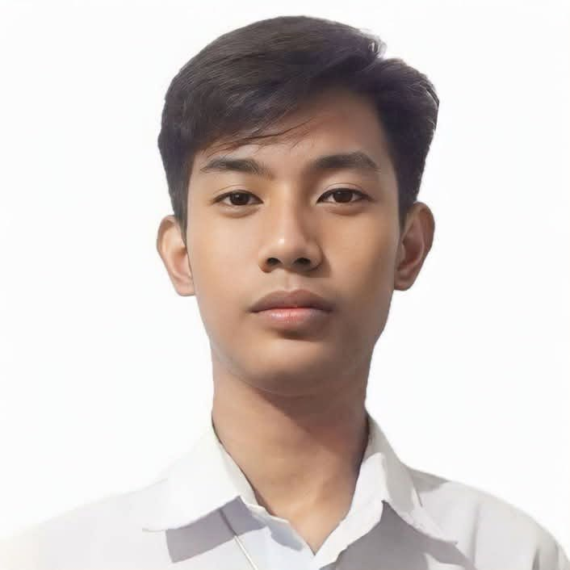
RICK NASH D. VALENCIA
Programmer, Documentation, Designer
BSIT-4
rick_valencia@rcc.edu.ph
PERSONAL OBJECTIVE
To pursue a career that allows me to grow professionally, strengthen my skills, and make a valuable contribution to the organization.
EDUCATIONAL ATTAINMENT
Elementary
- Bright Star Academy, Grade 1–5, Angeles City (2008–2014) — Top Student
- Republic Central Colleges, Grade 6, Angeles City (2014–2015)
Junior High School
- Republic Central Colleges, Grade 7–10, Angeles City (2015–2019) — Model Student
Senior High School
- Republic Central Colleges, Grade 11–12, Angeles City (2019–2023) — Model Student / Champion Intrams

