Putty

1. Download putty at:

<https://the.earth.li/~sgtatham/putty/latest/w64/putty-64bit-0.74-installer.msi>

1. Install by running the installer and pressing: Next, Next, Install
2. open Putty
3. Type the remote machine’s ip in the Session “Host name (or ip address)” field but **DON’T press open yet**:

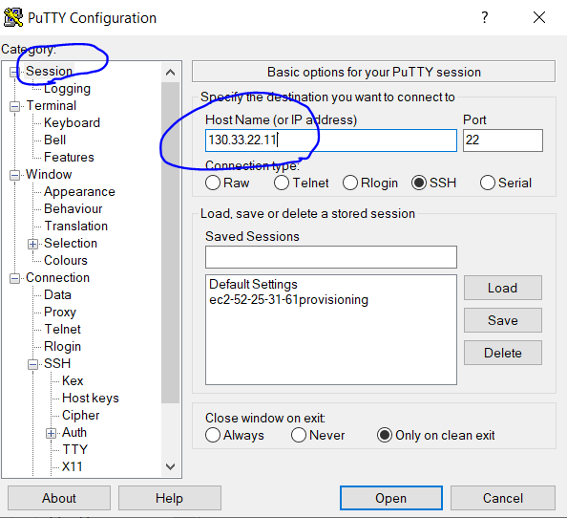

1. **Before you press open**, you need to authenticate. Make sure you have the authentication file - ssh-key-2020-11-19.ppk from the zoom chat or from: <https://github.com/nashpaz123/Please-Contain-Yourself-1/tree/main/OracleWeek_Keys>

( right click ssh-key-2020-11-19.ppk and choose “save as” to download )

1. In Putty, press the “**+**” next to the SSH category, then go to Auth.   
   Under “Private key for authentication” press “browse”. Choose the **private** key file ( ssh-key-2020-11-19.ppk ) from the folder where it is kept.

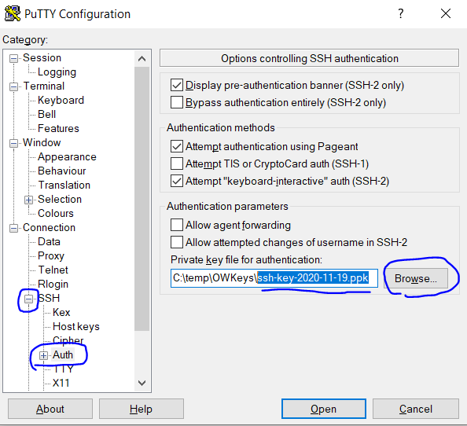

1. Go back to the Session category and press “open”

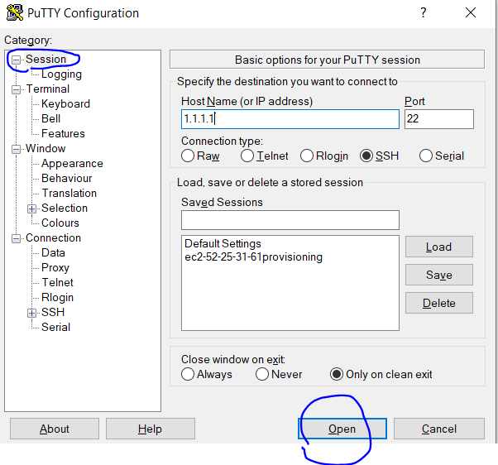

1. Press “yes” for the alert

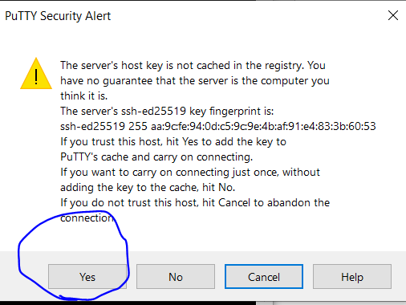

1. Login as: opc (type: opc and click Enter)

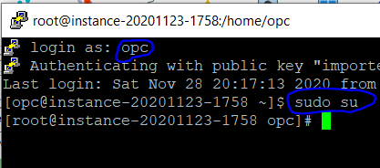

1. To log as root, type the command: sudo su and click Enter