Putty for windows

1. Download putty at:

<https://the.earth.li/~sgtatham/putty/0.75/w64/putty-64bit-0.75-installer.msi>  
Install by running the installer and pressing: Next, Next, Install

1. open Putty
2. Type the remote machine’s ip in the Session “Host name (or ip address)” field but **DON’T press open yet**:

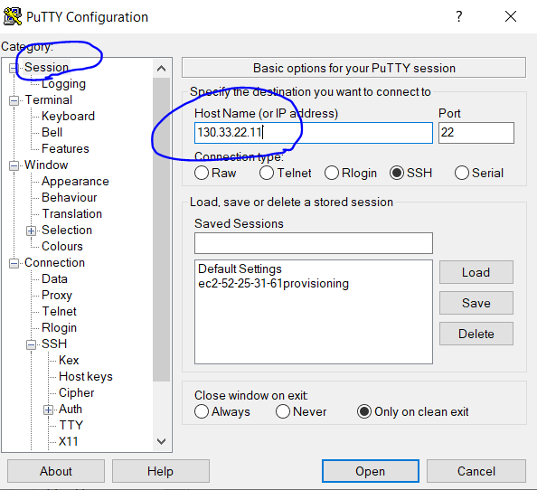

1. **Before you press open**, you need to authenticate. Make sure you have the authentication file - nash_paz.ppk , also available at  
   <https://drive.google.com/drive/folders/1u8vzQwBj9vtDn4wNDRfoLIbxRo1F-Ztl?usp=sharing>
2. In Putty, press the “**+**” next to the SSH category, then go to Auth.   
   Under “Private key for authentication” press “browse”. Choose the **private** key file ( nash_paz.ppk ) from the folder where it is kept.

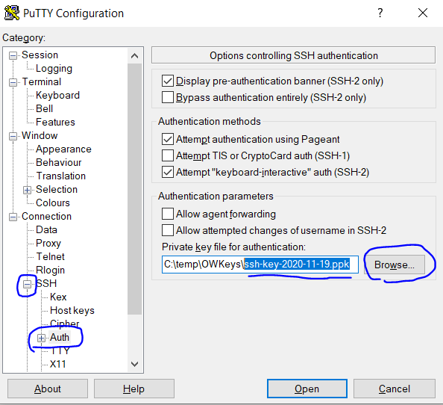

1. Go back to the Session category and press “**open**”
2. Press “yes” or "**accept**" for the alert

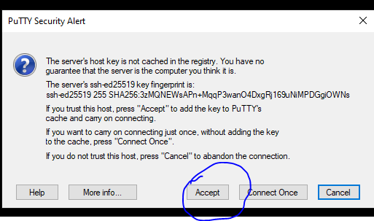

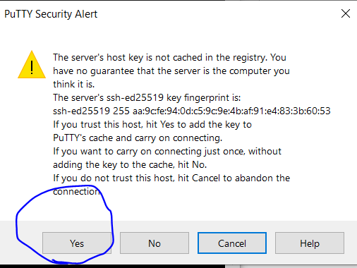

1. Login as: **ec2-user** (type: ec2-user and click Enter)
2. To log as root, type the command: **sudo su** and click Enter

