**1. What is the IP address and TCP port number used by the client computer (source) that is transferring the file to gaia.cs.umass.edu ? To answer this question, it’s probably easiest to select an HTTP message and explore the details of the TCP packet used to carry this HTTP message, using the “details of the selected packet header window” (refer to Figure 2 in the “Getting Started with Wireshark” Lab if you’re uncertain about the Wireshark windows.**

**2. What is the IP address of gaia.cs.umass.edu? On what port number is it sending and receiving TCP segments for this connection?**

**1. ans:** IP address 192.168.1.102 and TCP port number 1161 (source).

**2. ans:** IP address 128.119.245.12 and TCP port number 80

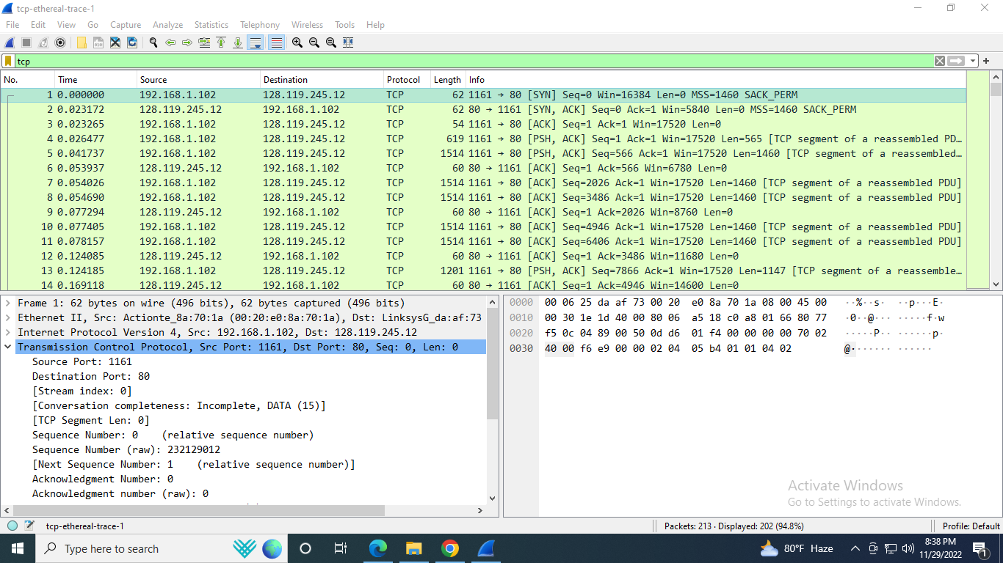

3. What is the IP address and TCP port number used by your client computer (source) to transfer the file to gaia.cs.umass.edu?

Ans:

**4. What is the sequence number of the TCP SYN segment that is used to initiate the TCP connection between the client computer and gaia.cs.umass.edu? What is it in the segment that identifies the segment as a SYN segment?**

**Ans:** Sequence number of the TCP SYN segment is 0.

The SYN is set to 1.

**5. What is the sequence number of the SYNACK segment sent by gaia.cs.umass.edu to the client computer in reply to the SYN? What is the value of the Acknowledgement field in the SYNACK segment? How did gaia.cs.umass.edu determine that value? What is it in the segment that identifies the segment as a SYNACK segment?**

**Ans:** Sequence number of the SYNACK segment sent by gaia.cs.umass.edu to the client is 0.

The Acknowledgement field in the SYNACK segment is 1.

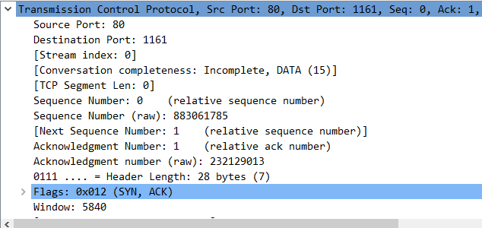

6. What is the sequence number of the TCP segment containing the HTTP POST command? Note that in order to find the POST command, you’ll need to dig into the packet content field at the bottom of the Wireshark window, looking for a segment with a “POST” within its DATA field.