QUARY 2 DATABASED APOTEK

SELECT * FROM `tb_dokter`

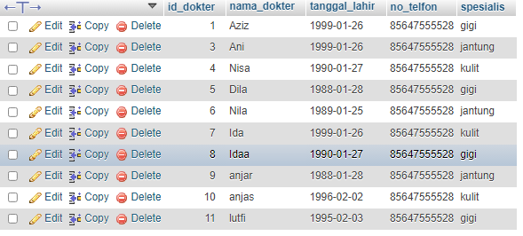

SELECT COUNT(*) FROM tb_dokter



SELECT nama_dokter, tanggal_lahir FROM `tb_dokter`

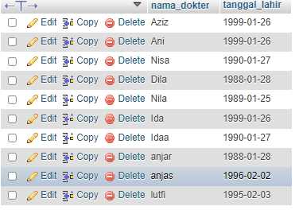

SELECT * FROM `tb_dokter` WHERE spesialis = 'gigi'

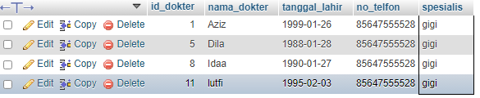

SELECT * FROM `tb_dokter` WHERE tanggal_lahir LIKE '%1999%'

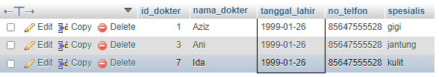

SELECT * FROM `tb_dokter` WHERE tanggal_lahir LIKE '%1999%' AND spesialis = 'gigi'



Updated data

UPDATE `tb_dokter` SET `no_telfon`=0851234567890

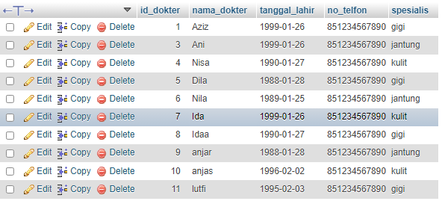

UPDATE `tb_dokter` SET `spesialis`= 'hati' WHERE nama_dokter = 'Aziz'

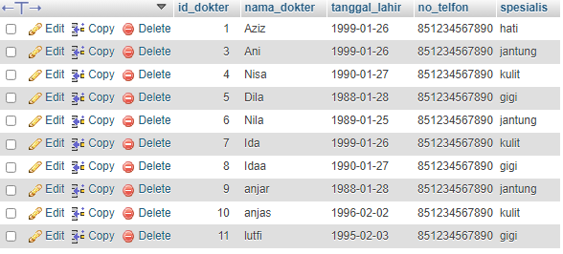

DELETE FROM `tb_dokter` WHERE nama_dokter = 'anjar'

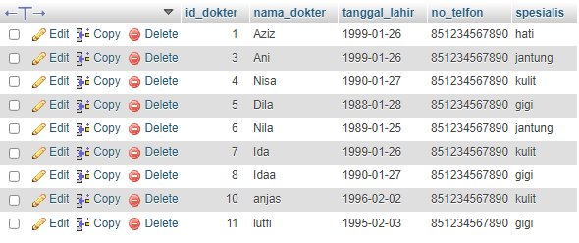

Join, Right Join and Left Join

SELECT nama, tb_resep.id_dokter, nama_dokter

FROM `tb_resep` JOIN tb_dokter ON tb_resep.id_dokter=tb_dokter.id_dokter

ORDER BY id_dokter ASC

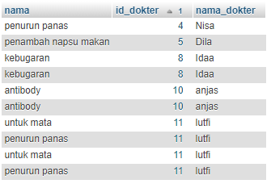

SELECT nama, tb_resep.id_dokter, nama_dokter, spesialis

FROM `tb_resep` JOIN tb_dokter ON tb_resep.id_dokter=tb_dokter.id_dokter

WHERE spesialis LIKE '%gigi%'

ORDER BY nama_dokter ASC

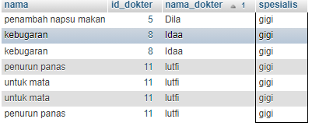

SELECT nama, tb_resep.id_obat, nama_obat, jenis_obat, COUNT(*)

FROM `tb_resep`

JOIN tb_obat ON tb_resep.id_obat=tb_obat.id_obat

GROUP BY nama_obat

ORDER BY nama_obat ASC

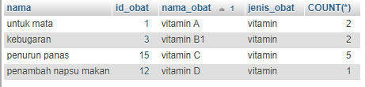

SELECT nama, tb_resep.id_obat, nama_obat, jenis_obat, COUNT(*)

FROM `tb_resep`

RIGHT JOIN tb_obat ON tb_resep.id_obat=tb_obat.id_obat

WHERE NOT nama LIKE '%NULL%'

GROUP BY nama_obat

ORDER BY nama_obat ASC

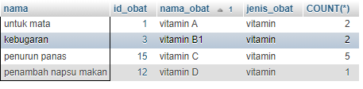

SELECT nama, tb_resep.id_obat, nama_obat, jenis_obat, COUNT(*)

FROM `tb_resep`

LEFT JOIN tb_obat ON tb_resep.id_obat=tb_obat.id_obat

GROUP BY nama_obat

ORDER BY nama_obat ASC

