1. SELECT * FROM `pelanggan` ORDER BY usia DESC;

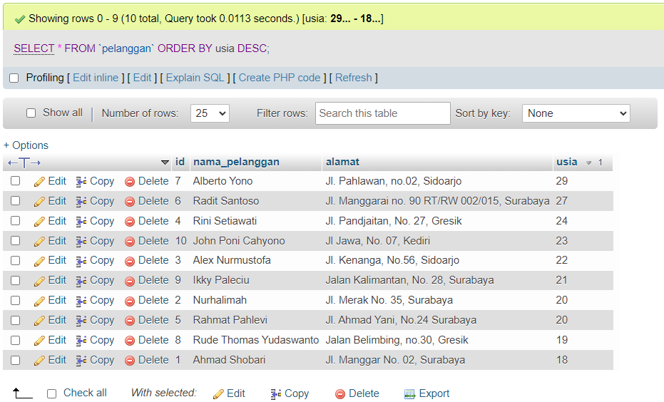

1. [SELECT](http://localhost/phpmyadmin/url.php?url=https://dev.mysql.com/doc/refman/8.0/en/select.html) * FROM `obat` ORDER by id_petunjuk_pemakaian ASC;

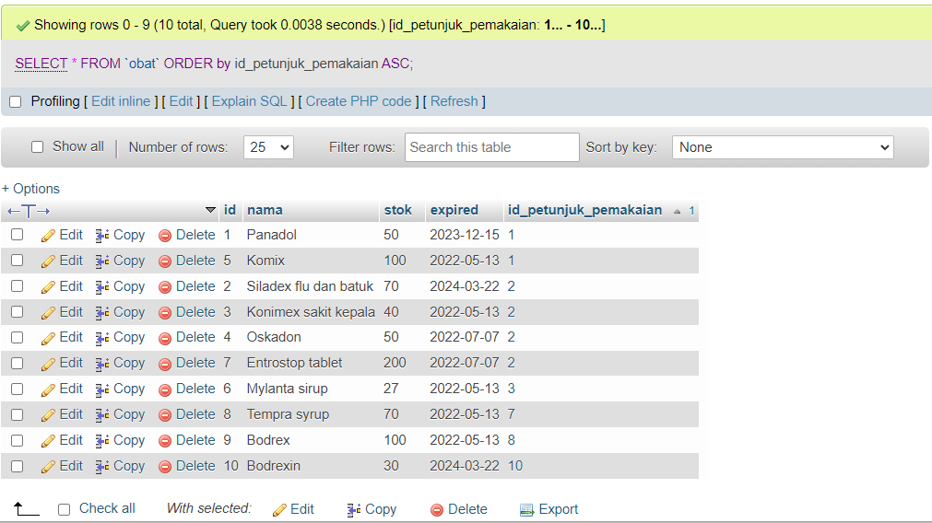

1. [SELECT](http://localhost/phpmyadmin/url.php?url=https://dev.mysql.com/doc/refman/8.0/en/select.html) * FROM `pelanggan` WHERE alamat [LIKE](http://localhost/phpmyadmin/url.php?url=https://dev.mysql.com/doc/refman/8.0/en/string-comparison-functions.html#operator_like) '%sidoarjo%';

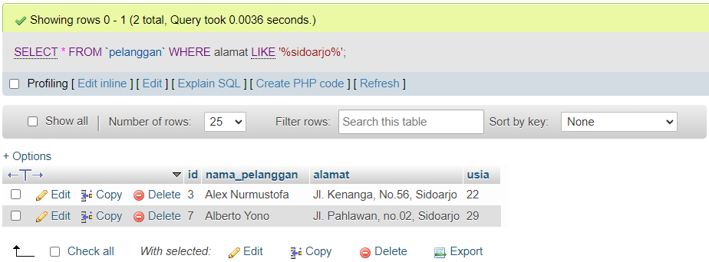

1. SELECT id_petunjuk_pemakaian, SUM(stok) as total FROM `obat`

GROUP BY id_petunjuk_pemakaian;

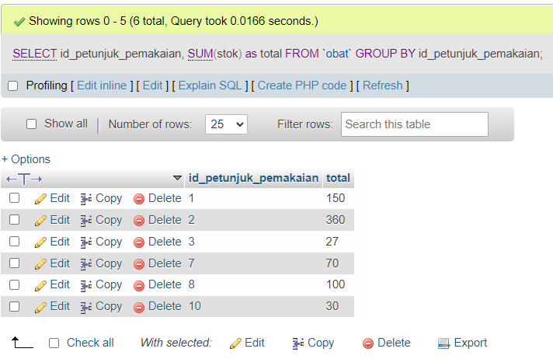

1. SELECT expired, SUM(stok) FROM `obat` GROUP BY expired;

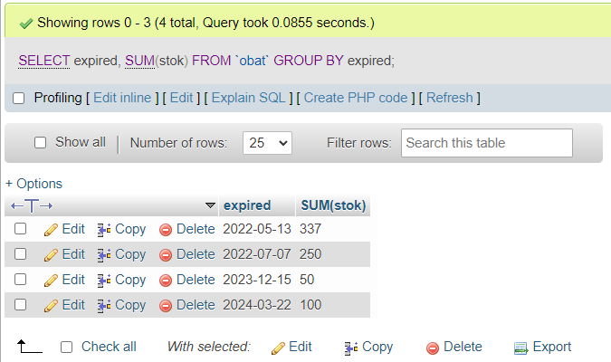

1. [SELECT](http://localhost/phpmyadmin/url.php?url=https://dev.mysql.com/doc/refman/8.0/en/select.html) expired, [SUM](http://localhost/phpmyadmin/url.php?url=https://dev.mysql.com/doc/refman/8.0/en/group-by-functions.html#function_sum)(stok) FROM `obat` WHERE expired >=2022

GROUP BY expired

ORDER BY expired DESC;

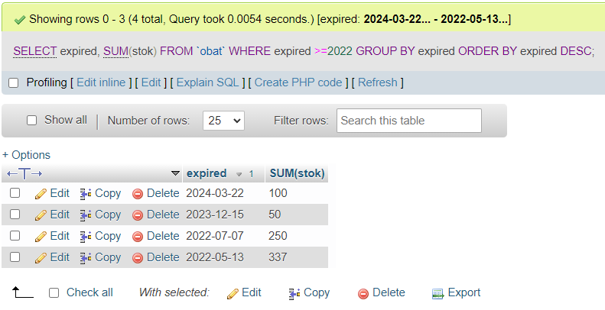

1. SELECT nama FROM `obat` WHERE nama LIKE ‘%x%’

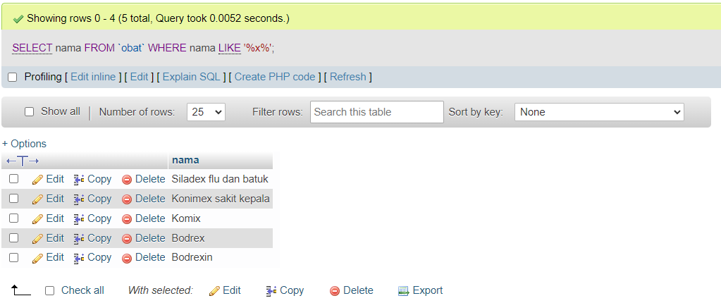

1. SELECT * FROM `detail_orders` WHERE harga LIKE ‘%6000%’

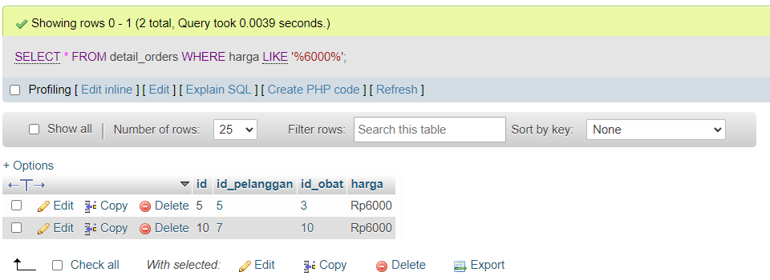

1. [SELECT](http://localhost/phpmyadmin/url.php?url=https://dev.mysql.com/doc/refman/8.0/en/select.html) nama, [SUM](http://localhost/phpmyadmin/url.php?url=https://dev.mysql.com/doc/refman/8.0/en/group-by-functions.html#function_sum)(stok) as jumlah_total FROM `obat` GROUP BY nama

ORDER BY nama ASC;

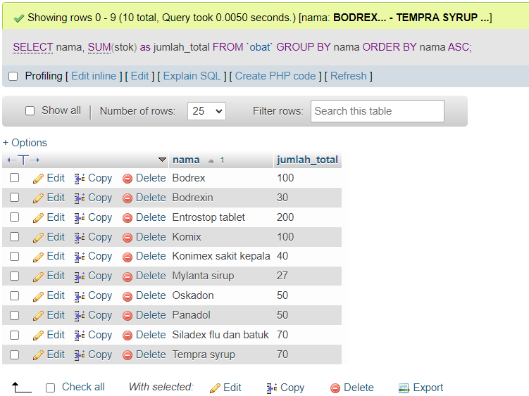

1. [SELECT](http://localhost/phpmyadmin/url.php?url=https://dev.mysql.com/doc/refman/8.0/en/select.html) id_petunjuk_pemakaian, [SUM](http://localhost/phpmyadmin/url.php?url=https://dev.mysql.com/doc/refman/8.0/en/group-by-functions.html#function_sum)(stok) as jumlah_total FROM `obat`

WHERE id_petunjuk_pemakaian > '6' GROUP BY id_petunjuk_pemakaian

ORDER BY id_petunjuk_pemakaian DESC;

