Using Helm to Deploy Micro-Services Application

Table of Contents
I. Introduction 3
I.1. Target 3
I.2. Demo Overview 3
I.3. Prequiresites 3
II. Instruction 4
II.1. General steps 4
II.2. Execution 4
III. Frequently Asked Questions 6
III.1. Demo source code 6
IV. References 7

Introduction

Target
The document shows readers how to deploy applications with Helm.

Demo Overview
In using Helm, we can simplify the process of application deployment.
In this demo, we will create the application on EKS.
The project used in this demo consists of 3 services:
- database
- backend
- frontend
Figure 1: Application Components
We will deploy a helm chart that consists of 3 subcharts (frontend, backend and mongo) and 1 dependency (NGINX controller). They can be found in “Demo source code”
Note: For the production environment, the database should be an external database service.

Prequiresites
- Helm CLI is locally installed
- EKS cluster is already created (refer to Create EKS Cluster).
- Kubernetes CLI gets configured (kubectl) (refer Configure kubectl)

Instruction

General steps
In order to get the application running, the following steps are required:
- Deploy the helm chart
- Verify the chart installation

Execution
- Deploy the helm chart:
# in the root folder
helm install my-release .
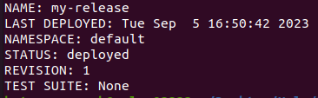

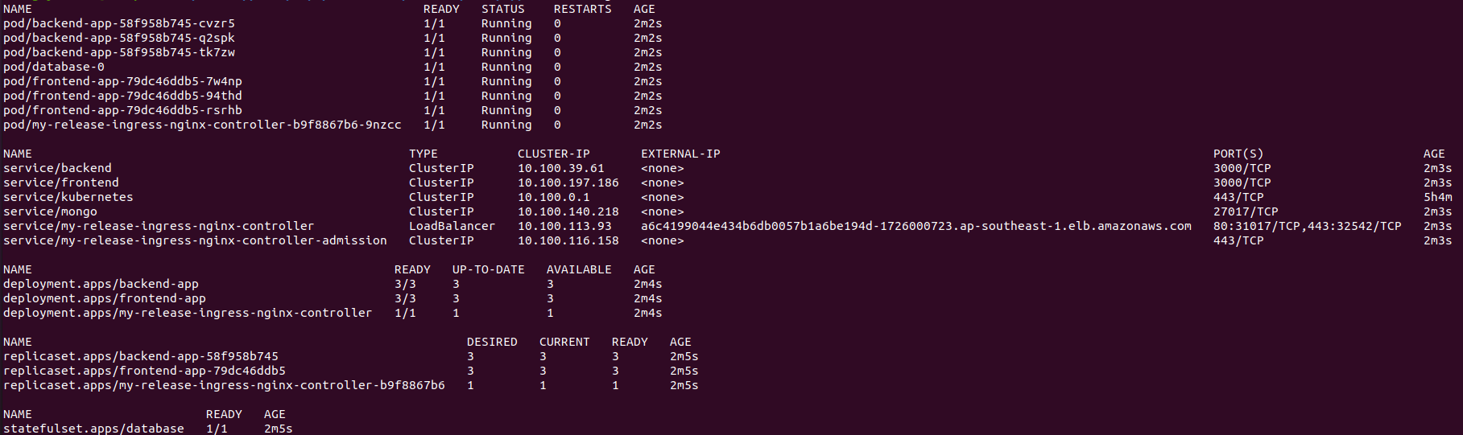
- Verify the chart installation
# verify the release
helm list
# verify the application resources
kubectl get all
# expose frontend service to access application
kubectl port-forward service/frontend 3000:3000
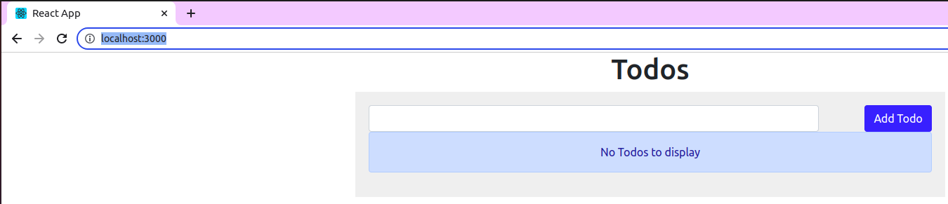
# open browser to access application at URL: locahost:3000
# verify application ingress
kubectl get ingress -o wide
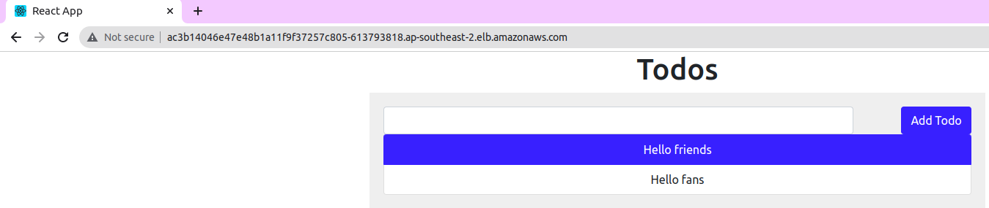
# open browser to access application at URL created by ingress controller (e.g: ac3b14046e47e48b1a11f9f37257c805-613793818.ap-southeast-2.elb.amazonaws.com)

Frequently Asked Questions

Demo source code
- https://github.com/nashtech-garage/azure-devops-ci-cd/tree/main/helm

References
- Source code for application: https://github.com/docker/awesome-compose/tree/master/react-express-mongodb

