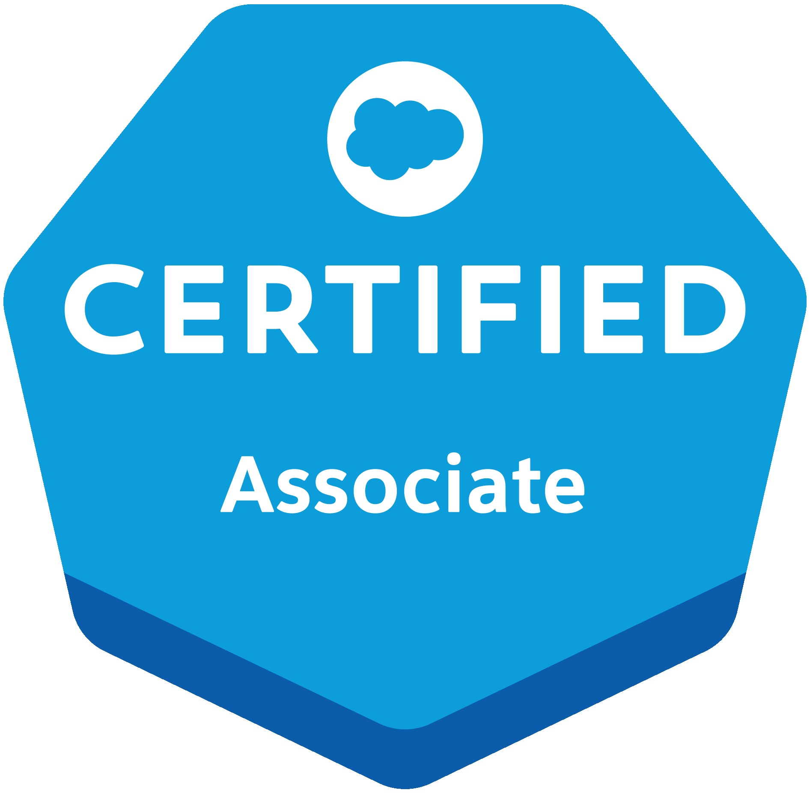 **Nasib Obaid Ahmed**

Email: sobaid46@gmail.com

Mobile: +918286292734

**Summary:**

* 5+ years of experience in Software Development Life Cycle (SDLC) including requirement analysis, design specification, code development, code integration, testing and deployment using Object Oriented Analysis and Design with JAVA. 3+ years of experience on Mule ESB Enterprise edition.
* Experience in Web Services approach for Service Oriented Architecture (SOA) and publishing web services both SOAP & REST (consume and implementations) that include several components like SOAP, WSDL, XSD.
* Extensively work on both Enterprise and Community edition of Mule. Have an experience working Mule API manager and RAML. In-depth experience in CRM business processes like Account Management, Case Management.
* Experience in Unit testing using POSTMAN. Good experience on version management tools like GIT,SVN.
* Experience in sending Mule Applications to Mule ESB and Mule CloudHub alongside involvement in arranging logs.
* Strong application combination encounter utilizing Mule ESB with connectors, changes, Routing and ActiveMQ.
* Experience in using Mule Connectors like FTP, AWS, SQL etc as part of Integration Usage.
* Good Exposure in Dataweave 2.0
* Very good Exposure in RAML Development
* Exposure in Azure,CI/CD.

**Project Accomplishments:**

**Project Title: Coca Cola**

**Role**: Designing and Implementation of frontend APIs using webmethods.io for uploading data from Salesforce to Mirakl i.e. based on Platform events.

* Creating Catalogs, Attributes, Products etc.
* Designing Flows and Data Transactions with Mirakl as an end system.
* File based transactions.
* Webmethods.io

**Technologies used**: webmethods.io, webmethods.mft, webmethods.gateway

**Project Title: PEGA Integration (Unilever)**

**Role**: Designing and Implementation of frontend APIs for PEGA team, integration involved end systems like ECC, Informatica MDM.

ECC to PEGA and PEGA to MDM data transfer using MQs and HTTP protocols.

* Designing Flows and Data Transactions for different end systems.
* Building Sequence Diagram and other Design Documents.
* Dataweave 2.0
* Preparing SIT and UAT Test Cases on all Environment.

**Technologies used**: Anypoint Studio, Anypoint Runtime Manager, API Manager, MSSQL Server, Exchange

**Project Title: Discover ASR**

* **Exception Handling Mechanism.**

**Role**:

1. Designing and Implementation for handling system layer exceptions and mapping Global Exceptions for Experience Layer.
2. Experience Layer can handle such exceptions and maintaining system layer exception records.
3. Building Sequence Diagram and other Design Documents.
4. Dataweave 2.0
5. Preparing SIT and UAT Test Cases on all Environment.

* **Auto Tagging Reservation.**

**Role**:

1. Automatically tagging newly created reservations and add those in user account. Reservations created using website and backend system.
2. Designing Implementation and API Integration.
3. Dataweave 2.0
4. Preparing SIT and UAT Test Cases on all Environment.

* **Property Management System Integration. (Discover ASR)**

**Role**:

1. Integration involving multiple Backend systems CRM, SQL Server etc. Retrieval of user specific information and transforming output as per requirement.
2. Developing RAML, API Integration and Queues for property related reservations.
3. Apis for user to book reservations and special request before and on arrival.
4. Testing APIs over dev, uat and prod Environments. Maintaining Version control with latest updates. Enhancements of APIs on regular basis. Maintaining Applications over CloudHub, policies.

* **XML to JSON conversion (Discover ASR)**

**Role**:

1. Converting existing XML based APIs to JSON. Building RAML from scratch with new types and traits.
2. Testing APIs over dev, uat and prod Environments. Maintaining Version control with latest updates.

* **PropertyBreakfastManagement APIs (Discover ASR)**

**Role**:

1. Building apis for property related maintenance for users, admin and staffs.
2. Apis for user to book special request before and on arrival. Testing APIs over dev, uat and prod Environments. Maintaining Version control with latest updates.

**Technologies used**: Anypoint Studio, Anypoint Runtime Manager, AnypointMQ, API Manager

**Project Title:Telecom APIs.(BanglaLink)**

* **Role**: Building and maintaining Mulesoft APIs for telecom service providers, for users to subscribe, unsubscribe, retrieve package and announce details over IVR.

**Technologies used**: Anypoint Studio, Genesys, Avaya.

**Project Title: World Bank project as Freelance Developer.**

* **Role**: Building Mulesoft API’s as well as batch processes to extract meta data from collibra as wellas synchronize the data from other system like azure with collibra.
* Hands on experience with multiple Mulesoft connectors such as Http, Collibra, Azure, Database, File etc.

**Technologies used**: Anypoint Studio

**Project Title: Automation at Europ Assistance**

* Europ Assistance is a third-party company which handles the request raised by a customer holding an insurance Policy with its respective Client.
* In this we have performed an automation where in every new request comes in through mail will be automatically handled and his inputs from e-mail will be stored in variables.
* A policy number will be extracted from Customer Email and will be stored for further processing. A Policy PDF will be downloaded from Clients Portal and data will be extracted from the PDF File.
* Validations are checked at the same time. If the customer claims a genuine claim then his/her claim will be raised in their CRM Application for further processing. Customer will receive a claim no in e-mail for tracking the raised claim.

**Role**: Designing UI, Database Connection.

**Technologies used**: AutomationEdge

**Project Title: HR BOT Automation**

* HR BOT is an application designed in Google Dialog Flow for connecting employees with their Company SAP Portal. Using this BOT, employees can check their leaves, apply leaves, etc.
* Whenever there is a new request in HR BOT an Automation will be triggered using a middleware service then will trigger the Automation Process for doing operations such as applying leaves, checking leave balance etc.

**Role**: Designing UI, Middleware.

**Technologies used**: Google Dialog flow

**Project Title: Cuisine Management System**

* Cuisine Management System is a Web Application which is designed to provide a better way of delivering Restaurant Menu system.
* When a Customer in the Restaurant visits the website, he willplace an order without any human interaction.

**Role**: Database Connection.

**Technologies used**: Eclipse, Mssql, J2EE Technology.

**CERTIFICATIONS:**

* Participated in National Creativity Aptitude Test (NCAT)
* Participated in Dale Carnegie Training for Professional Excellence
* Automation Edge and UiPathTrainig
* **Mulesoft Certified Developer MCD - Integration and API Associate (Mule 3.9)**
* **Mulesoft Certified Developer MCD - Integration and API Associate (Mule 4)**
* **Salesforce Associate Developer**

## EXPERIENCE:

**CURRENT EMPLOYER:**

* + Employer – Deloitte

Position – Consultant

Period - Oct 2022 till date

**PREVIOUS EMPLOYER:**

* + Employer – Hexaware Technologies Mumbai

Position – Senior Software Engineer

Period - Feb 2021 – Sep 2022

* Employer – Agc Networks Mumbai

Position – Engineer Digital Applications.

Period - Dec 2017 – Feb 2021

* Employer – JDA Bangalore

Position – Intern

Period - Jan 2017 – Jun 2017

**PROJECT ONSITE:**

Onsite Engineer for**ETISALAT(DUBAI)**Interactive Voice Response.

Onsite Engineer for**BANGLA LINK(Bangladesh)** for DBSS API Integration overInteractive Voice Response.

**INTERNSHIP:**

1. **JDA SOFTWARE PVT LTD (6 months)**

As part of Internship, I was working with Global Network Operations Team for a period of 6 months as a part of academics. During this period I had worked upon several tasks/projects as below

1. Alerts generated from Monitoring tools like Sitescope were converted into a Dashboard based on Customer wise by using Microsoft SQL DB and Excel Macros
2. Develop Scripts to start and stop JDA Applications using batch/powershell scripts which was used during Maintenance schedules for servers.

3) Worked upon backend scripts for Automation portal like self-helpline portal to enable and disable monitors.

4) Hands on Sitescope tool and its API to help the team on few reports generation.

**2.CORE IT SOLUTIONS (2 months)**

Completed 2 months of internship during the academic period while pursuing MCA. Understanding and working on Network related issues faced by customers on site and off site.

**TECHNOLOGY SKILLS:**

|  |  |
| --- | --- |
| Protocols | TCP/IP,HTTP, SOAP |
| Programming Languages | C,C++,Java |
| Development Tools | Eclipse, Anypoint Studio, Automation Edge |
| Database Technologies | MSSQL, DBDerby |
| Java EE | JSP, Servlet, Hibernate |
| Scripting | Windows Batch, JavaScript |
| Robotic Automation Tools | UiPath, Automation Edge, NICE |
| API Tools | SOAP UI, Postman, INSOMNIA |
| Cloud Applications | Mulesoft, Automation Edge, IVR Orchestration Designer, NICE |
| Web Services | REST API |
| Version Control | GIT & SVN |
| Servers | Mule runtime, Tomcat |

**EDUCATION QUALIFICATIONS:**

|  |  |  |  |  |
| --- | --- | --- | --- | --- |
| Subject | Board/University | College/Institution | Year of Passing | GPA |
|  |  |  |  |  |
| MCA | Mangalore University | St.Aloysius Institute of | 2017 | 6.5 |
|  |  | Management and Technology |  |  |
| Bsc-IT | Mumbai University | Vidyalankar School of IT | 2014 | 7.0 |
| HSC | Maharashtra Board | Somaiya College | 2011 | 6.0 |
| SSC | Maharashtra State Board | Karthika High School & Junior | 2009 | 7.0 |
|  |  | College |  |  |

**EXTRA CURRICULUM**

* Participated in a national level IT fest organized by VSIT, Mumbai.
* Attended Personal Development Training

**DECLARATION:**

I hereby declare that the above-mentioned information is correct up to my knowledge and I bear the responsibility for the correctness of the above-mentioned particulars.

Place: Mumbai

Date: 07th October 2023 (Nasib Obaid Ahmed)