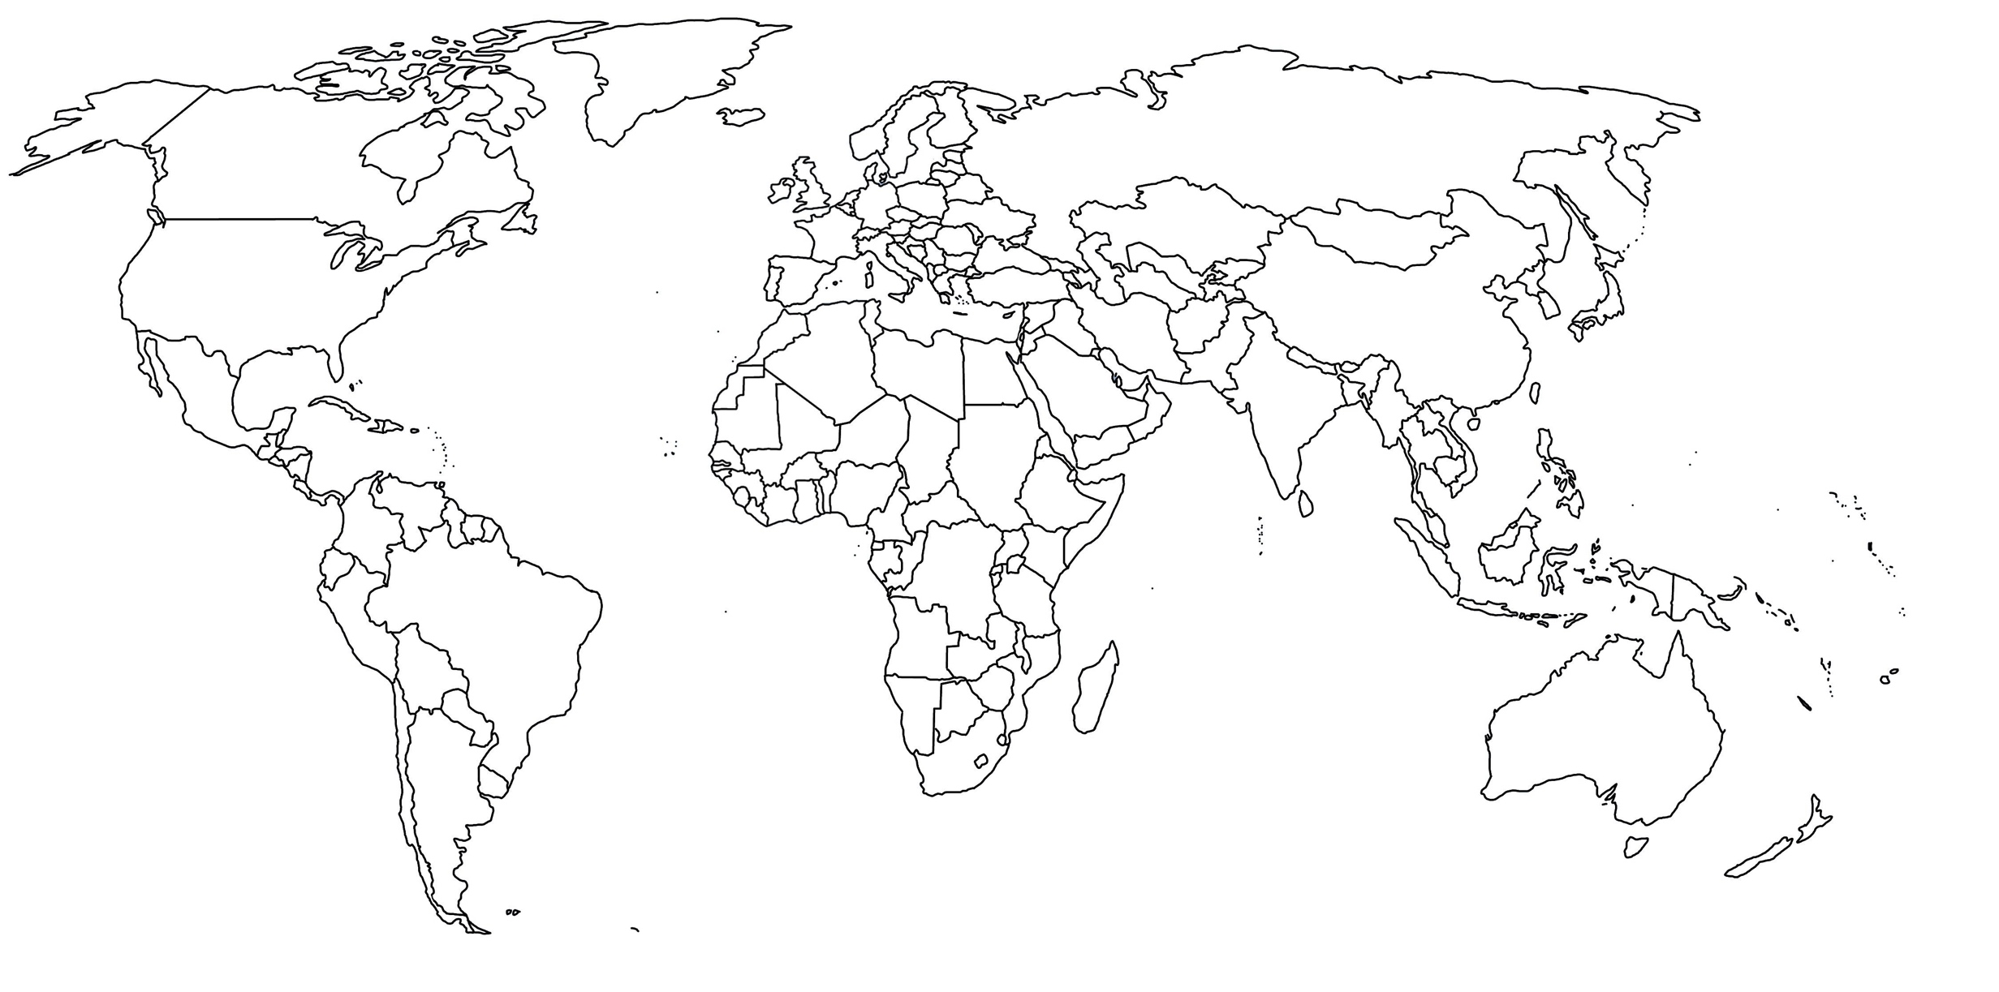

0

|  |  |  |  |
| --- | --- | --- | --- |
| 0 | Berlin | Deutschland | Hauptstadt |
| 1 | China |  |  |
| 2 | Oslo |  |  |
| 3 | Saudi-Arabien |  |  |
| 4 | Wellington |  |  |
| 5 | Panama |  |  |