Variable is a concept that exists between every programming languages out there. The basic concept is always the same. **A variable is a container that has a name on it and inside of that container we store a bit of data.** So we saw the basic primitive types things like numbers, strings and Booleans, and variables are just a place, a container, or a jar where we can put one of those in and give it a name where we can refer to it later and the name variable means that the data that we store in the jar or in the container can change, it can vary.

The syntax of variables is very simple. It is as given below,

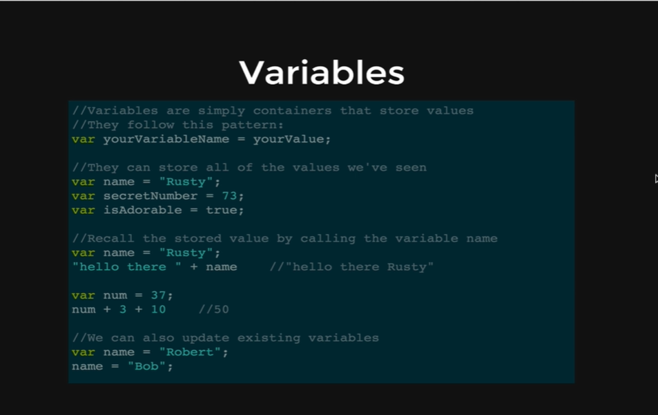

Console coding:

*var name = “Rusty”;*

*name;*

* *Rusty*

*name = “Tater”;*

*name;*

* *Tater*

*var friend = “Sally”;*

*“ hello there “ + friend*

* *“hello there Sally”*

*friend = “no one”;*

* *“no one”*

*“ hello there “ + friend;*

* *“hello there no one”*

*var num = 43;*

*num*

* *43;*

*num + 100*

* *143*

*num % 2;*

* *1*

One of the other important things of JavaScript is that we can change the value and we can also change the type

num = “fifty”

* *“fifty”*

So, here num was an integer which is changed to a string.