**The <form> tag**

<form action= “/my-form-submitting-page” method= “post”>

<!—All our inputs will go in here -->

</form>

* Action – the URL to send the form data to
* Method – the type of HTTP request such as Post, Get etc.

**Get request: We make a GET request when we are doing something like searching or retrieving data or we are trying to get information. For example: Google search.**

**Post request: We make a POST request when we are sending data that we want to be added to a database posted to a server. For example: Facebook or twitter sign up.**

**The <input> tag**

The Input tag creates interactive controls. The “type” attribute determines the type of input

**<input type= “text”>**

Mm/dd/yyyy

**<input type= “date”>**

**<input type= “color”>**

**<input type= “file”> Choose File _DSC0191.jpg**

**<input type= “checkbox”>**

**A Simple Form**

*<h1>Sign In</h1>*

*<form action= “/sign-in-url” method= “post”>*

*<input type= “text”>*

*<input type= “password”>*

*<button>Login</button>*

*</form>*

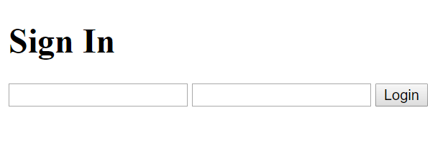

*<!DOCTYPE html>*

*<html>*

*<head>*

*<title>Form Demo</title>*

*</head>*

*<body>*

*<h1>Login</h1>*

*<input type= “text” placeholder= “username”>*

*<input type= “password” placeholder= “password”>*

*<button>Submit</button>*

*</body>*

*</html>*

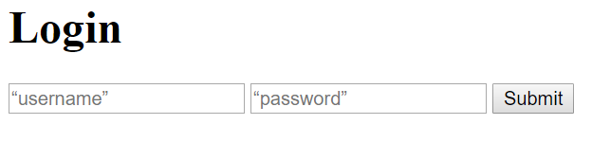

*<!DOCTYPE html>*

*<html>*

*<head>*

*<title>Form Demo</title>*

*<link rel= “stylesheet” type= “text/css” href= “app.css”>*

*</head>*

*<body>*

*<h1>Login</h1>*

*<form action=* [*http://wikipedia.org*](http://wikipedia.org) *method= “Get”>*

***<input type= “text” placeholder= “username”>***

***<input type= “password” placeholder= “password”>***

***<button>Submit</button>***

*</form>*

*</body>*

*</html>*

*// On clicking the submit button above the form goes to Wikipedia*

*// If there is no action on the form then the form stays on the same page.*

