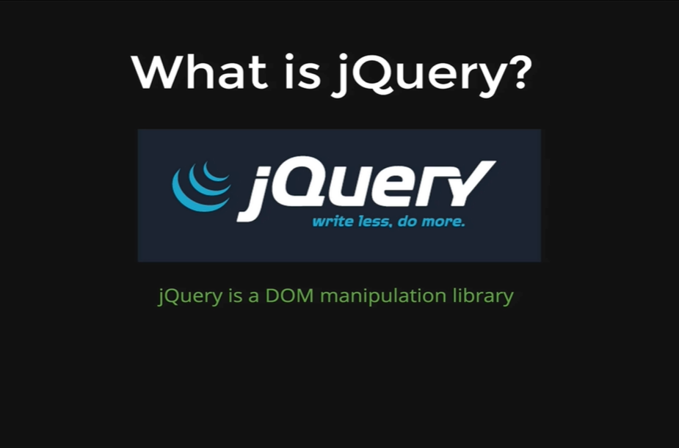

It is the most popular tool out there for JavaScript. It’s the most popular JavaScript library. It helps us manipulate the DOM.

jQuery is a fast, small, and feature-rich JavaScript library. It makes things like HTML document traversal and manipulation, event handling, animation, and Ajax much simpler with an easy-to-use API that works across a multitude of browsers. With a combination of versatility and extensibility, jQuery has changed the way that millions of people write JavaScript.

jQuery is a JavaScript library that makes our lives easier. It helps us do things like Selecting Elements, Manipulating Elements, Changing Styles, Adding Event-Handlers, Animating things and Ajax. The point of jQuery is it helps us do things faster and it makes it easier to do those things.

The concept of library in JavaScript is the one that exists in other programming languages as well. The core idea is that we can take code that someone else wrote and we can add it in our own project and use it in our own code.

That is all jQuery is. It is a single file that someone else or a team wrote with bunch of methods and properties inside of it and then we just add it to our own project so that we can use all of those methods.

