There are three more jQuery methods, we are going to learn in this lesson. They all are very similar, and they are associated with Classes.

*.addClass(className)- Adds the specified class(es) to each element in the set of matched elements.*

*.addClass(className) –*

*Type: String*

*One or more space-separated classes to be added to the class attribute of each matched elements.*

*Examples:*

1. *$(“p”).addClass(“my class your class”);*

*This will add two classes to all paragraphs.*

1. *$(“p”).removeClass(“myClass noClass”).addClass(“yourClass”);*

*This will remove the classes “myClass” and “noClass” from all paragraphs while add “yourClass” to all paragraphs.*

*<html>*

*<head>*

*<title>jQuery Methods</title>*

*<script type="text/javascript" src="https://cdnjs.cloudflare.com/ajax/libs/jquery/2.1.4/jquery.min.js"></script>*

*<style type="text/css">*

*.correct {*

*color: green;*

*}*

*.wrong {*

*color: red;*

*background: pink;*

*}*

*.done {*

*color: gray;*

*text-decoration: line-through;*

*}*

*</style>*

*</head>*

*<body>*

*<h1>jQuery Methods Demo Page</h1>*

*<input type="text" placeholder="your name">*

*<ul>*

*<li>Skittles</li>*

*<li>Starburst</li>*

*<li>Twix</li>*

*</ul>*

*<img src= “http://i.imgur.com/zvANQeG.jpg”>*

*<img src= “http://i.imgur.com/zvANQeG.jpg”>*

*<img src= “http://i.imgur.com/zvANQeG.jpg”>*

*</body>*

*</html>*

*Console coding:*

*$(‘h1’)*

* *[ <h1>jQuery Methods Demo Page</h1> ]*

*$(‘h1’).addClass(“correct”);*

* *[ <h1 class=“correct”>jQuery Methods Demo Page</h1> ]*



*$(‘h1’).removeClass(“correct”);*

* *[ <h1 class>jQuery Methods Demo Page</h1> ]*

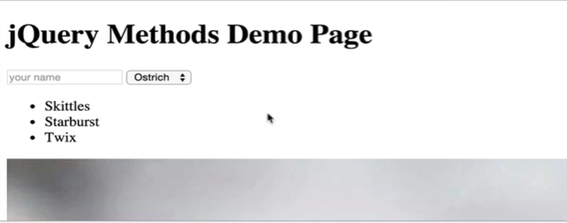

*$(“li”)*

* *[ <li>Skittles</li>, <li>Starburst</li>, <li>Twix</li> ]*

*$(“li”).addClass(“wrong”);*

* *[ <li class=“wrong”>Skittles</li>, <li class=“wrong”>Starburst</li>, <li class=“wrong”>Twix</li> ]*

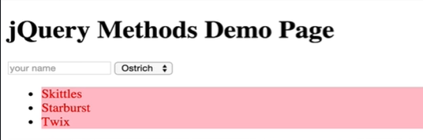

*$(“li”).removeClass(“wrong”);*

* *[ <li>Skittles</li>, <li>Starburst</li>, <li>Twix</li> ]*



*$(“li”).addClass(“correct”);*

* *[ <li class=“correct”>Skittles</li>, <li class=“correct”>Starburst</li>, <li class=“correct”>Twix</li> ]*

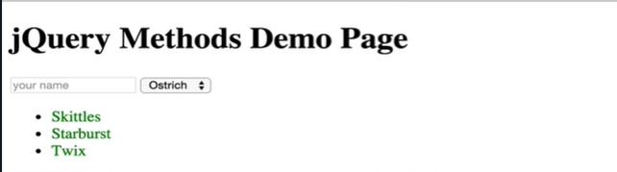

The last one that we will demonstrate is *toggleClass()* it takes a class name as an argument, and it will either apply that class or add it to the element or set of elements if those elements do not have that class, but if they do have that class, it will remove the class.

Let’s demonstrate it on our *li*s where we will pass the *correct* function in our *toggleClass()* method.

*Console coding:*

*$(‘li’).toggleClass(“correct”);*

* *[ <li class>Skittles</li>, <li class>Starburst</li>, <li class>Twix</li> ]*

The method has removed the *“correct”* classes from our *li*s.



As we can see the *.toggleClass()* method has removed the class from our *li*s as they have turned black.

Now we will run the method again.

*Console coding:*

*$(‘li’).toggleClass(“correct”);*

* *[ <li class=“correct”>Skittles</li>, <li class=“correct”>Starburst</li>, <li class=“correct”>Twix</li> ]*



As we can see running the *.toggleClass()* method has added the *“correct”* class again back to our *li*s.

Let’s do it a bit different this time. Now we will add a class only on the first *li* and we will toggle the class *“done”.*

*Console coding:*

*$(‘li”).first().toggleClass(“done”);*

* *[ <li class= “done”>Skittles</li> ]*

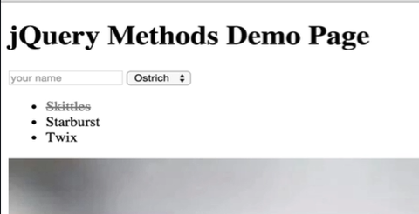

So, only the first *li* turned grey and it has the strike-through effect.

Now let’s select all the *li*s.

*Console coding:*

*$(“li”).toggleClass(“done”);*

* *[ <li class= “done”>Skittles</li>, <li class= “done”>Starburst</li>, <li class= “done”>Twix</li> ]*

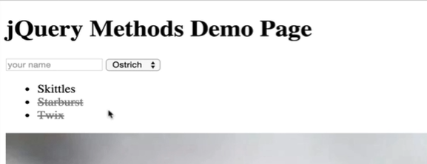

As we can see the *.toggleClass()* method has removed the class from the first *li,* which previously had the *“done”* class on it, and it has added the class on *Starburst* and *Twix* which previously did not have that class added to them.