*Objectives:*

* *val()*
* *text()*
* *attr()*
* *html()*
* *addClass()*
* *removeClass()*
* *toggleClass()*

In this lesson we are going to learn about some common jQuery methods. On the objectives we have highlighted the seven methods that we will be discussing.

We will be using an HTML page to demonstrate how all these methods work.

*<html>*

*<head>*

*<title>jQuery Methods</title>*

*<script type="text/javascript" src="https://cdnjs.cloudflare.com/ajax/libs/jquery/2.1.4/jquery.min.js"></script>*

*</head>*

*<body>*

*<h1>jQuery Methods Demo Page</h1>*

*<input type="text" placeholder="your name">*

*<ul>*

*<li>Skittles</li>*

*<li>Starburst</li>*

*<li>Twix</li>*

*</ul>*

*</body>*

*</html>*

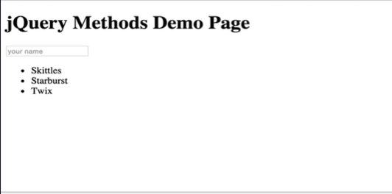

*Console coding:*

*$(h1)*

* *[ <h1>jQuery Methods Demo Page</h1> ]*

*.text() – Gets the combined text contents of each element in the set of matched elements, including their descendants, or set the text contents of the matched elements.*

*$(h1).text;*

* *“jQuery Methods Demo Page”*

*$(‘ul’).text();*

* *“ Skittles Starburst Twix ”*

*$(‘li’)*

* *[ <li>Skittles</li>, <li>Starburst</li>, <li>Twix</li> ]*

*$(‘li’).text();*

* *“SkittlesStarburstTwix”*

*$(“h1”).text(“New Text!!!”);*

* *[ <h1>New Text</h1> ]*



*$(“h1”).text();*

* *“New Text!!!”*

*$(‘li’).text(“Rusty, Colt’s dog, is adorable”);*

* *[ <li>Rusty, Colt’s dog, is adorable</li>, <li>Rusty, Colt’s dog, is adorable</li>, <li>Rusty, Colt’s dog, is adorable</li> ]*

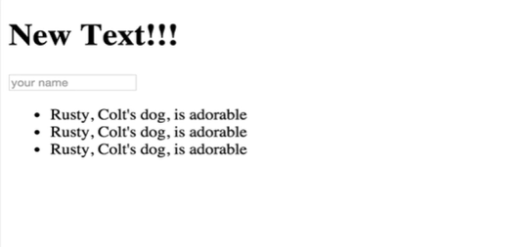

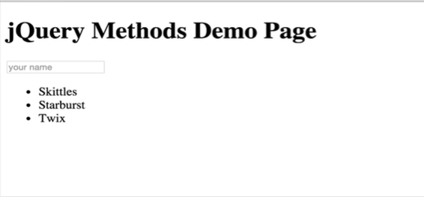

*.html() – Gets the HTML contents of the first element in the set of matched elements or set the HTML contents of every matched element.*

*Console coding:*

*$(‘ul’).html;*

* *“<li>Skittles</li> <li>Starburst</li> <li>Twix</li>”*

*$(‘ul’).html(“<li>I Hacked your UL!</li><li>Rusty is still adorable</li>);*

* *[ > <ul>…</ul>]*

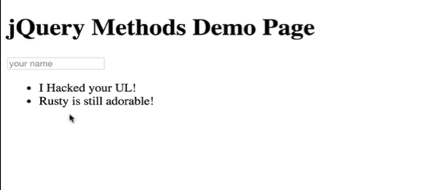

*$(‘li’).html(“<a href= ‘google.com’>CLICK ME TO GO TO GOOGLE</a>”)*

* *[><li>…</li>, ><li>…</li>]*

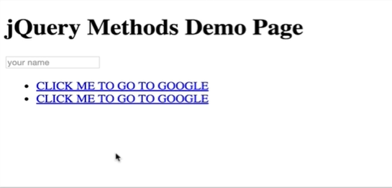

*<html>*

*<head>*

*<title>jQuery Methods</title>*

*<script type="text/javascript" src="https://cdnjs.cloudflare.com/ajax/libs/jquery/2.1.4/jquery.min.js"></script>*

*</head>*

*<body>*

*<h1>jQuery Methods Demo Page</h1>*

*<input type="text" placeholder="your name">*

*<ul>*

*<li>Skittles</li>*

*<li>Starburst</li>*

*<li>Twix</li>*

*</ul>*

*<img src= “*[*http://i.imgur.com/zvANQeG.jpg*](http://i.imgur.com/zvANQeG.jpg)*”>*

*</body>*

*</html>*

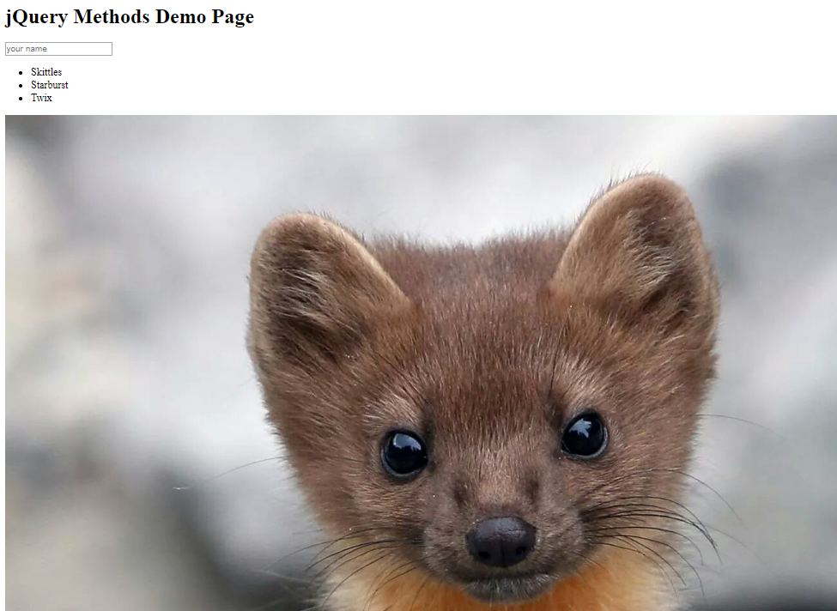

*.attr() – stands for “attribute”. Gets the value of an attribute for the first element in the set of matched elements or set one or more attributes for every matched element.*

*Console coding:*

*$(‘img’).css(“width”)*

* *“1533px”*

*$(‘img’).css(“width”, “500px”);*

* *[ <img src= “*[*http://i.imgur.com/zvANQeG.jpg*](http://i.imgur.com/zvANQeG.jpg)*” style= “width: 500px;”>]*

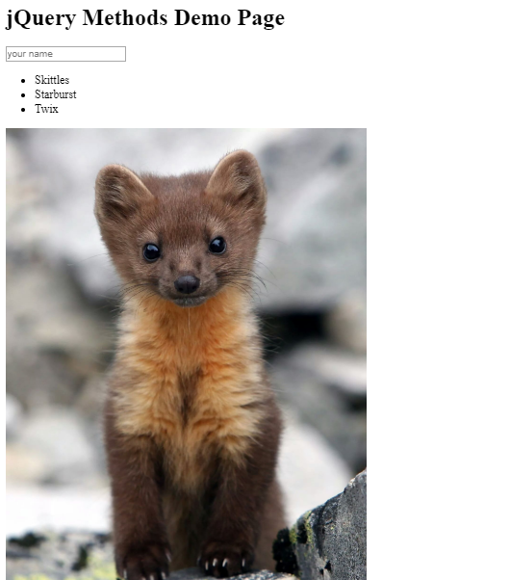

*Console coding:*

*$(‘img’).attr(“src”);*

* *“*[*http://i.imgur.com/zvANQeG.jpg*](http://i.imgur.com/zvANQeG.jpg)*”*

*$(‘img’).attr(“src”, “*[*https://c3.staticflickr.com/3/2418/2243463214_f32ab004af_b.jpg*](https://c3.staticflickr.com/3/2418/2243463214_f32ab004af_b.jpg)*”);*

* *[ <img src= “*[*https://c3.staticflickr.com/3/2418/2243463214_f32ab004af_b.jpg*](https://c3.staticflickr.com/3/2418/2243463214_f32ab004af_b.jpg)*” style= “width: 200px;”> ]*

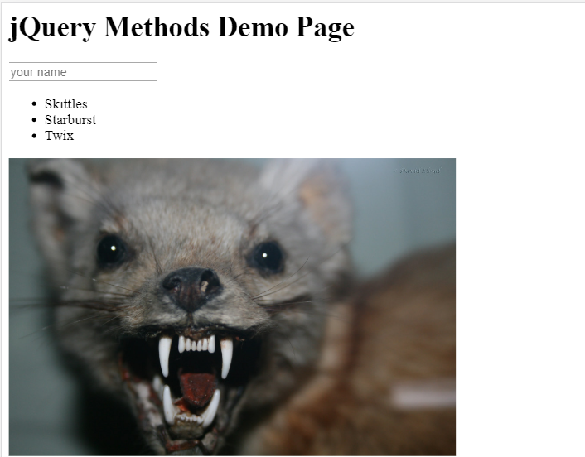

Here, as we can see we have changed the image in our page by selecting the image *(img)* attribute. That is one example.

Another thing that we can do here is select the *“input”* which is *“type = text”* and we can change the value of the type attribute.

*Console coding:*

*$(“input”)*

* *[ <input type= “text” placeholder= “your name”> ]*

*$(“input”).attr(“type”);*

* *“text”*

*$(“input”).attr(“type”, “color”);*

* *[ <input type= “color” placeholder= “your name”> ]*

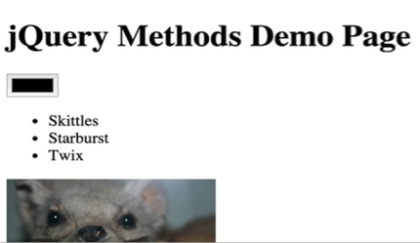

As we can see the input field has changed into a color input. We cam also change it to a checkbox following the same method.

*Console coding:*

*$(“input”).attr(“type”, “checkbox”);*

* *[ <input type= “checkbox” placeholder= “your name”> ]*

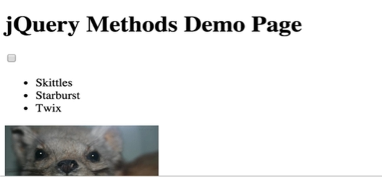

*<html>*

*<head>*

*<title>jQuery Methods</title>*

*<script type="text/javascript" src="https://cdnjs.cloudflare.com/ajax/libs/jquery/2.1.4/jquery.min.js"></script>*

*</head>*

*<body>*

*<h1>jQuery Methods Demo Page</h1>*

*<input type="text" placeholder="your name">*

*<ul>*

*<li>Skittles</li>*

*<li>Starburst</li>*

*<li>Twix</li>*

*</ul>*

*<img src= “*[*http://i.imgur.com/zvANQeG.jpg*](http://i.imgur.com/zvANQeG.jpg)*”>*

*<img src= “*[*http://i.imgur.com/zvANQeG.jpg*](http://i.imgur.com/zvANQeG.jpg)*”>*

*<img src= “*[*http://i.imgur.com/zvANQeG.jpg*](http://i.imgur.com/zvANQeG.jpg)*”>*

*</body>*

*</html>*

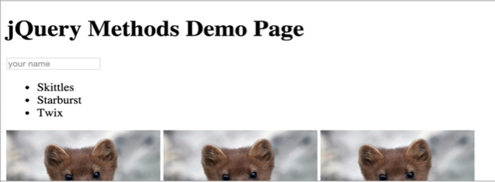

So, we have added three images here and let’s suppose now we want to only change the first image.

If we select the image (*img*) attribute using the CSS selector then it will select all three images.

*Console coding:*

*$(“img”)*

* *[ <img src= “*[*http://i.imgur.com/zvANQeG.jpg*](http://i.imgur.com/zvANQeG.jpg)*” style= “width: 200px;”>, <img src= “*[*http://i.imgur.com/zvANQeG.jpg*](http://i.imgur.com/zvANQeG.jpg)*” style= “width: 200px;”>, <img src= “*[*http://i.imgur.com/zvANQeG.jpg*](http://i.imgur.com/zvANQeG.jpg)*” style= “width: 200px;”> ]*

As we can see the image (*img*) tag selected all the three images but we only want to change the first image and not all the three.

To select only the first image, we can follow the method below,

*Console coding:*

*$(“img: first)*

* *[ <img src=* [*http://i.imgur.com/zvANQeG.jpg*](http://i.imgur.com/zvANQeG.jpg) *style= “width: 200px;”> ]*

So, as we can see that adding *first* with a colon after the *img* tag selects the first image. Now, we will change the first image.

*Console coding:*

*$(“img”:first).attr(“src”, “*[*https://c3.staticflickr.com/3/2418/2243463214_f32ab004af_b.jpg*](https://c3.staticflickr.com/3/2418/2243463214_f32ab004af_b.jpg)*”);*

* *[ <img src= “*[*https://c3.staticflickr.com/3/2418/2243463214_f32ab004af_b.jpg*](https://c3.staticflickr.com/3/2418/2243463214_f32ab004af_b.jpg)*” style= “width: 200px;”> ]*

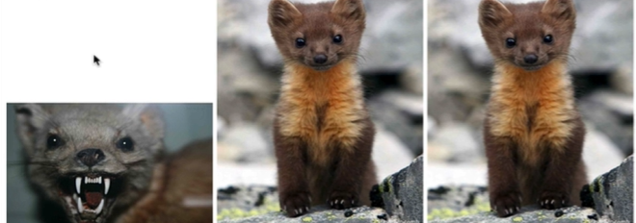

As we can see we have changed the first image, now if we want to change the last image, we have few options,

We can use the *.last()* method and it will return us the last element from a given selector,

*Console coding:*

*$(“img”).last()*

This selects all three images and return us the last one, and then we can connect the *attr()* method passing the source of the image that we want to add.

*Console coding:*

*$(“img”).last().attr(“src”, “*[*https://c3.staticflickr.com/3/2418/2243463214_f32ab004af_b.jpg*](https://c3.staticflickr.com/3/2418/2243463214_f32ab004af_b.jpg)*”);*

* *[ <img src= “*[*https://c3.staticflickr.com/3/2418/2243463214_f32ab004af_b.jpg*](https://c3.staticflickr.com/3/2418/2243463214_f32ab004af_b.jpg)*” style= “width: 200px;”> ]*

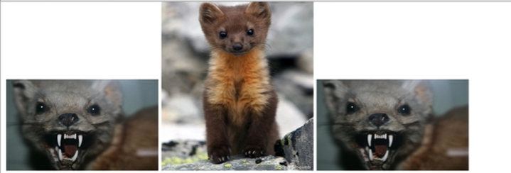

As we can see our last image has changed as well.

Now we will change all three images.

*Console coding:*

*$(“img”).attr(“src”, “*[*https://upload.wikimedia.org/wikipedia/commons/8/8e/Newfoundland_Pine_Marten.jpg*](https://upload.wikimedia.org/wikipedia/commons/8/8e/Newfoundland_Pine_Marten.jpg)*”);*

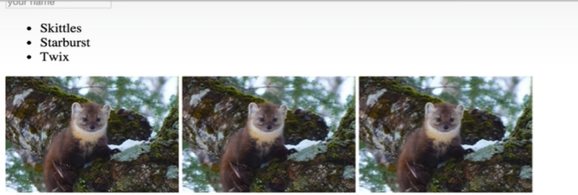

As we can see all three images of our page has changed simultaneously.

To summarize *attr()* method if we just give it one argument like *src* but we do not pass in a second argument, it will just return the value of *src.* Then if we provide a second argument like a link of a new image that will update the source (*src*) on every single element that we selected previously.

*.val() – Gets the current value of the first element in the set of matched elements or set the value of every matched element.*

It helps us extract a value from an input. We will use this method to get input from the input field on our page.

*Console coding:*

*$(“input”).val();*

* *“”*

The method returns us an empty string, that is because there is no value in our input field which is why nothing is returned to us.

Now, lets type something on the input field and then ask for the value.

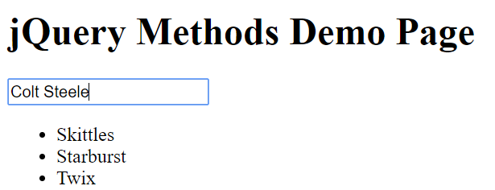

*Console coding:*

*$(“input”).val();*

* *“Colt Steele”*

As we can see whatever we enter in our input field, the *.val()* method will select that and return it to us.

And like all the other methods that we have seen, it will also act like a setter method. So, if we pass in a value in the *.val()* method, jQuery will put that value on the input field.

*Console coding:*

*$(“input”).val(“Rusty Steele”);*

* *[ <input type= “text” placeholder= “your name”> ]*

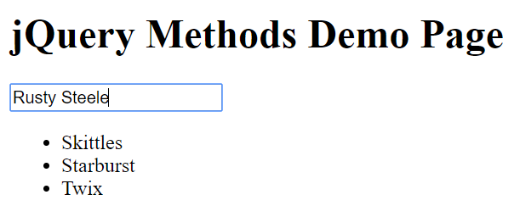

We can also use the *.val()* method to erase an input from our input field. This time we just need to pass in an empty string and that will remove whatever there is on our input field.

*Console coding:*

*$(“input”).val(“”);*

* *[ <input type= “text” placeholder= “your name”> ]*

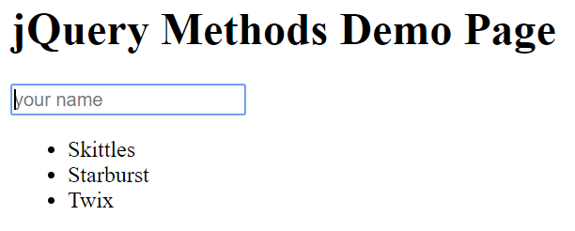

*.val()* method also works on drop-down menus. For example we give our user to select an option from some of the choices, then we can use the *.val()* method to select the option that is selected by the user.

*<html>*

*<head>*

*<title>jQuery Methods</title>*

*<script type="text/javascript" src="https://cdnjs.cloudflare.com/ajax/libs/jquery/2.1.4/jquery.min.js"></script>*

*</head>*

*<body>*

*<h1>jQuery Methods Demo Page</h1>*

*<input type="text" placeholder="your name">*

*<select>*

*<option>Ostrich</option>*

*<option>Turtle</option>*

*<option>Toad</option>*

*<ul>*

*<li>Skittles</li>*

*<li>Starburst</li>*

*<li>Twix</li>*

*</ul>*

*<img src= “*[*http://i.imgur.com/zvANQeG.jpg*](http://i.imgur.com/zvANQeG.jpg)*”>*

*<img src= “*[*http://i.imgur.com/zvANQeG.jpg*](http://i.imgur.com/zvANQeG.jpg)*”>*

*<img src= “*[*http://i.imgur.com/zvANQeG.jpg*](http://i.imgur.com/zvANQeG.jpg)*”>*

*</body>*

*</html>*



*Console coding:*

*$(“select”)*

* *[> <select>…</select>]*

*$(“select”).val();*

* *“Toad”*

As we can see, jQuery returns us the option selected by the user.